**Hands-On**

Follow the below steps to create a Dockerfile, Image & Container.

**Step 1:** First you have to install Docker. To learn how to install it, you can click [here.](https://www.edureka.co/blog/install-docker/)

**Step 2:** Once installation is complete use the below command to check the version.

|  |  |
| --- | --- |
| 1 | docker -v |

**Snapshot Of Demo - Docker Explained - EdurekaStep 3:** Now create a folder in which you can create a DockerFile and change the current working directory to that folder.

|  |  |
| --- | --- |
| 1  2 | mkdir images  cd images |

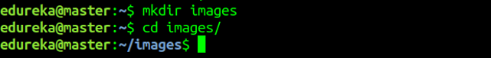**Step 4.1:** Now create a Dockerfile by using an editor. In this case, I have used the nano editor.

|  |  |
| --- | --- |
| 1 | nano Dockerfile |

**Snapshot Of Demo - Docker Explained - EdurekaStep 4.2:** After you open a Dockerfile, you have to write it as follows.

|  |  |
| --- | --- |
| 1  2  3  4  5  6 | FROM ubuntu:latest  MAINTAINER Sahiti (email@domain.com)  RUN apt-get update  RUN apt-get install -y nginx  ENTRYPOINT ["/usr/sbin/nginx","-g","daemon off;"]  EXPOSE 80 |

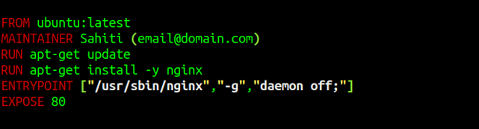

* **FROM:** Specifies the image that has to be downloaded
* **MAINTAINER:** Metadata of the owner who owns the image
* **RUN:** Specifies the commands to be executed
* **ENTRYPOINT:** Specifies the command which will be executed first
* **EXPOSE:** Specifies the port on which the container is exposed

**Step 4.3:** Once you are done with that, just save the file.

**Step 5:** Build the Dockerfile using the below command.

|  |  |
| --- | --- |
| 1 | docker build . |

**\*\*** “.” is used to build the Dockerfile in the present folder **\*\***

**Snapshot Of Demo - Docker Explained - EdurekaStep 6:** Once the above command has been executed the respective docker image wii be created. To check whether Docker Image is created or not, use the following command.

|  |  |
| --- | --- |
| 1 | docker images |

**Snapshot Of Demo - Docker Explained - EdurekaStep 7:** Now to create a container based on this image, you have to run the following command:

|  |  |
| --- | --- |
| 1 | docker run -it -p port_number -d image_id |

Where *-it* is to make sure the container is interactive, *-p* is for port forwarding, and *-d* to run the daemon in the background.