-- =========================================================
-- STEP 1 : CREATE DATABASE & SCHEMAS
-- =========================================================

CREATE or replace DATABASE CUSTOMER_DB;
USE DATABASE CUSTOMER_DB;

CREATE SCHEMA RAW;
CREATE SCHEMA CURATED;
CREATE SCHEMA DT;

USE SCHEMA RAW;

-- =========================================================
-- STEP 2 : CREATE RAW TABLE
-- =========================================================

CREATE TABLE CUSTOMERS
LIKE PROJECT_DB.PUBLIC.MY_CUSTOMER;

-- =========================================================
-- STEP 3 : CREATE FILE FORMAT
-- Pipe Delimited Customer Files
-- =========================================================

CREATE OR REPLACE FILE FORMAT CUSTOMER_PIPE_FORMAT
TYPE = CSV
FIELD_DELIMITER = '|'
SKIP_HEADER = 1
ERROR_ON_COLUMN_COUNT_MISMATCH = FALSE;

-- =========================================================
-- STEP 4 : CREATE EXTERNAL STAGE (Azure Blob)
-- =========================================================

CREATE OR REPLACE STAGE EXT_STAGE
URL='azure://hxwjulystorageaccount.blob.core.windows.net/datalake2'
CREDENTIALS=(
AZURE_SAS_TOKEN='sv=2026-02-06&ss=bfqt&srt=co&sp=rwdlacupiytfx&se=2026-08-04T18:29:07Z&st=2026-08-03T10:14:07Z&spr=https&sig=UsNo%2Fh%2BZO36Y84mswfOW11DDQbo%2BoZwWd%2F%2FFp7S9auc%3D'
)
FILE_FORMAT=(FORMAT_NAME='CUSTOMER_PIPE_FORMAT');

LIST @EXT_STAGE;

-- =========================================================
-- STEP 5 : CREATE STREAM
-- Captures CDC from RAW.CUSTOMERS
-- =========================================================

CREATE OR REPLACE STREAM STR_CUSTOMERS
ON TABLE CUSTOMERS;

-- =========================================================
-- STEP 6 : CREATE TASK TO LOAD RAW TABLE
-- Loads customer files from Azure Stage every minute
-- =========================================================

CREATE OR REPLACE TASK TASK_LOAD_CUSTOMERS
WAREHOUSE = COMPUTE_WH
SCHEDULE = '1 MINUTE'
AS
COPY INTO CUSTOMER_DB.RAW.CUSTOMERS
FROM @CUSTOMER_DB.RAW.EXT_STAGE
FILE_FORMAT = (
FORMAT_NAME = 'CUSTOMER_DB.RAW.CUSTOMER_PIPE_FORMAT'
)
ON_ERROR='CONTINUE';

ALTER TASK TASK_LOAD_CUSTOMERS RESUME;

select * from CUSTOMER_DB.RAW.CUSTOMERS;

EXECUTE TASK TASK_LOAD_CUSTOMERS;

SELECT *
FROM RAW.STR_CUSTOMERS;
Raw Table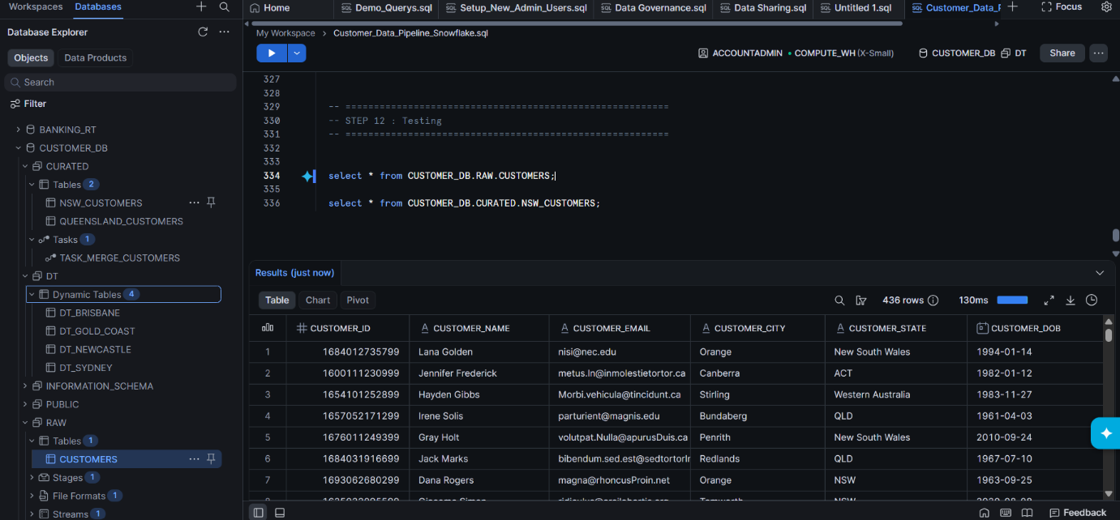

-- =========================================================
-- STEP 7 : CREATE CURATED TABLES
-- =========================================================

CREATE TABLE CURATED.NSW_CUSTOMERS
LIKE RAW.CUSTOMERS;

CREATE TABLE CURATED.QUEENSLAND_CUSTOMERS
LIKE RAW.CUSTOMERS;

SELECT DISTINCT CUSTOMER_STATE
FROM CUSTOMER_DB.RAW.CUSTOMERS;

Curated Tables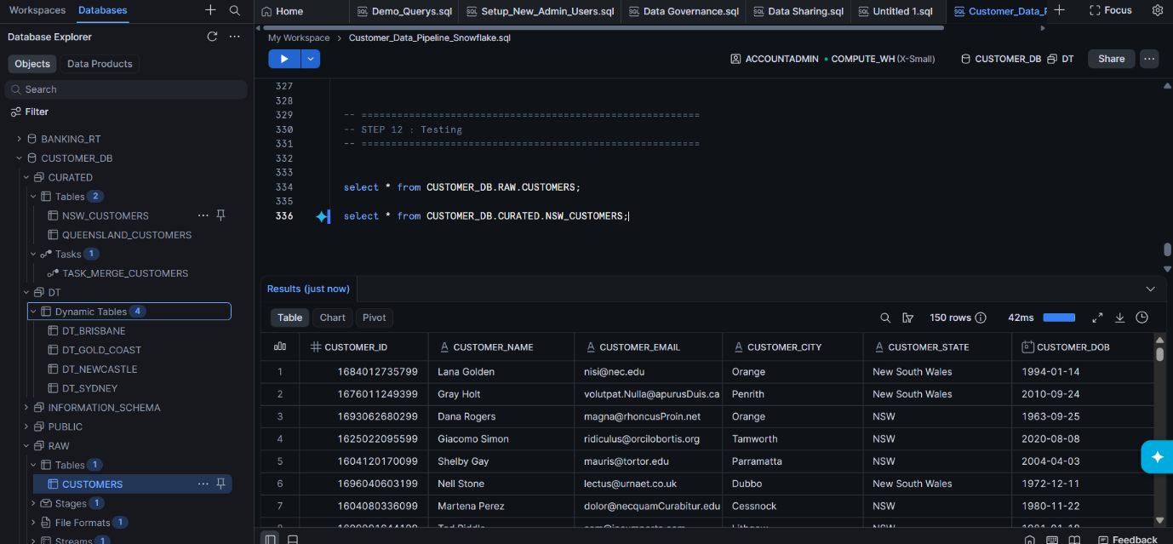

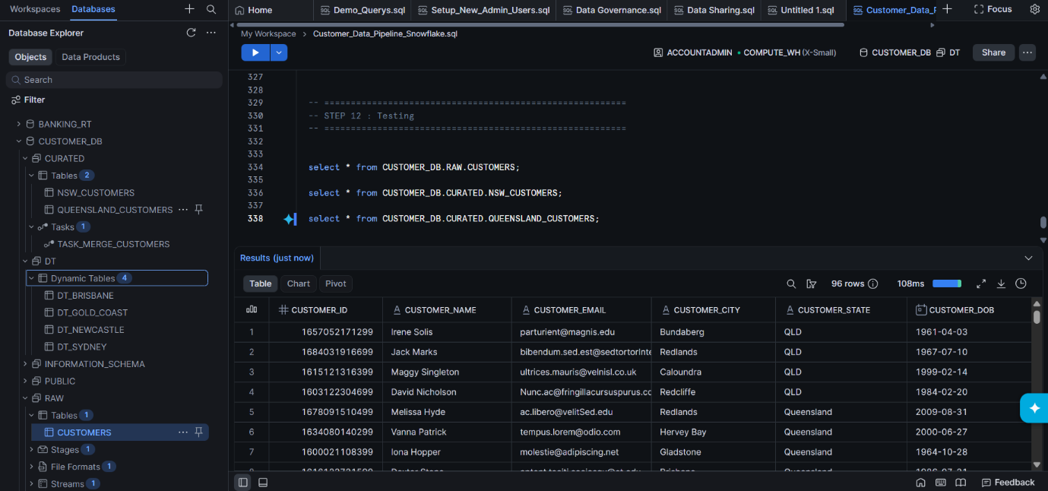

-- =========================================================
-- STEP 8 : CREATE MERGE TASK
-- Reads CDC from Stream and populates Curated Tables
-- =========================================================

USE SCHEMA CURATED;

CREATE OR REPLACE TASK TASK_MERGE_CUSTOMERS
WAREHOUSE = COMPUTE_WH
SCHEDULE = '1 MINUTE'
WHEN SYSTEM$STREAM_HAS_DATA('CUSTOMER_DB.RAW.STR_CUSTOMERS')
AS
BEGIN
MERGE INTO CURATED.NSW_CUSTOMERS T
USING
(
SELECT *
FROM CUSTOMER_DB.RAW.STR_CUSTOMERS
WHERE CUSTOMER_STATE IN ('NSW','New South Wales')
) S
ON T.CUSTOMER_ID = S.CUSTOMER_ID

WHEN MATCHED THEN
UPDATE SET
CUSTOMER_NAME = S.CUSTOMER_NAME,
CUSTOMER_EMAIL = S.CUSTOMER_EMAIL,
CUSTOMER_CITY = S.CUSTOMER_CITY,
CUSTOMER_STATE = S.CUSTOMER_STATE,
CUSTOMER_DOB = S.CUSTOMER_DOB

WHEN NOT MATCHED THEN
INSERT
(
CUSTOMER_ID,
CUSTOMER_NAME,
CUSTOMER_EMAIL,
CUSTOMER_CITY,
CUSTOMER_STATE,
CUSTOMER_DOB
)
VALUES
(
S.CUSTOMER_ID,
S.CUSTOMER_NAME,
S.CUSTOMER_EMAIL,
S.CUSTOMER_CITY,
S.CUSTOMER_STATE,
S.CUSTOMER_DOB
);

MERGE INTO CURATED.QUEENSLAND_CUSTOMERS T
USING
(
SELECT *
FROM CUSTOMER_DB.RAW.STR_CUSTOMERS
WHERE CUSTOMER_STATE IN ('QLD','Queensland')
) S
ON T.CUSTOMER_ID = S.CUSTOMER_ID
WHEN MATCHED THEN
UPDATE SET
CUSTOMER_NAME = S.CUSTOMER_NAME,
CUSTOMER_EMAIL = S.CUSTOMER_EMAIL,
CUSTOMER_CITY = S.CUSTOMER_CITY,
CUSTOMER_STATE = S.CUSTOMER_STATE,
CUSTOMER_DOB = S.CUSTOMER_DOB

WHEN NOT MATCHED THEN
INSERT
(
CUSTOMER_ID,
CUSTOMER_NAME,
CUSTOMER_EMAIL,
CUSTOMER_CITY,
CUSTOMER_STATE,
CUSTOMER_DOB
)
VALUES
(
S.CUSTOMER_ID,
S.CUSTOMER_NAME,
S.CUSTOMER_EMAIL,
S.CUSTOMER_CITY,
S.CUSTOMER_STATE,
S.CUSTOMER_DOB
);
END;

ALTER TASK TASK_MERGE_CUSTOMERS RESUME;

show tasks;

SELECT * FROM CURATED.NSW_CUSTOMERS;

SELECT * FROM CURATED.QUEENSLAND_CUSTOMERS;

SELECT COUNT(*) FROM CUSTOMER_DB.RAW.STR_CUSTOMERS;

-- =========================================================
-- STEP 9 : CREATE DYNAMIC TABLES (City Wise)
-- =========================================================

USE SCHEMA DT;

CREATE OR REPLACE DYNAMIC TABLE DT_SYDNEY
TARGET_LAG = '1 minute'
WAREHOUSE = COMPUTE_WH
AS
SELECT *
FROM CUSTOMER_DB.CURATED.NSW_CUSTOMERS
WHERE CUSTOMER_CITY = 'Sydney';

CREATE OR REPLACE DYNAMIC TABLE DT_NEWCASTLE
TARGET_LAG = '1 minute'
WAREHOUSE = COMPUTE_WH
AS
SELECT *
FROM CUSTOMER_DB.CURATED.NSW_CUSTOMERS
WHERE CUSTOMER_CITY = 'Newcastle';

CREATE OR REPLACE DYNAMIC TABLE DT_BRISBANE
TARGET_LAG = '1 minute'
WAREHOUSE = COMPUTE_WH
AS
SELECT *
FROM CUSTOMER_DB.CURATED.QUEENSLAND_CUSTOMERS
WHERE CUSTOMER_CITY = 'Brisbane';

CREATE OR REPLACE DYNAMIC TABLE DT_GOLD_COAST
TARGET_LAG = '1 minute'
WAREHOUSE = COMPUTE_WH
AS
SELECT *
FROM CUSTOMER_DB.CURATED.QUEENSLAND_CUSTOMERS
WHERE CUSTOMER_CITY = 'Gold Coast';

SHOW DYNAMIC TABLES;

SELECT COUNT(*) FROM DT.DT_SYDNEY;

SELECT COUNT(*) FROM DT.DT_NEWCASTLE;

SELECT COUNT(*) FROM DT.DT_BRISBANE;

SELECT COUNT(*) FROM DT.DT_GOLD_COAST;

Dynamic Tables by City Wise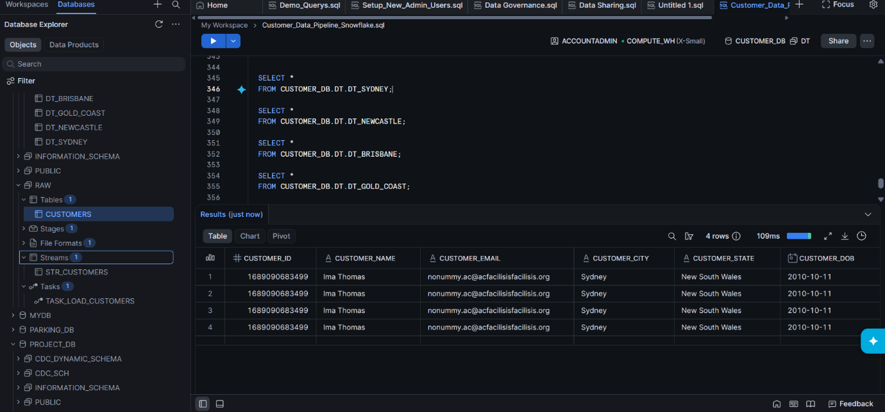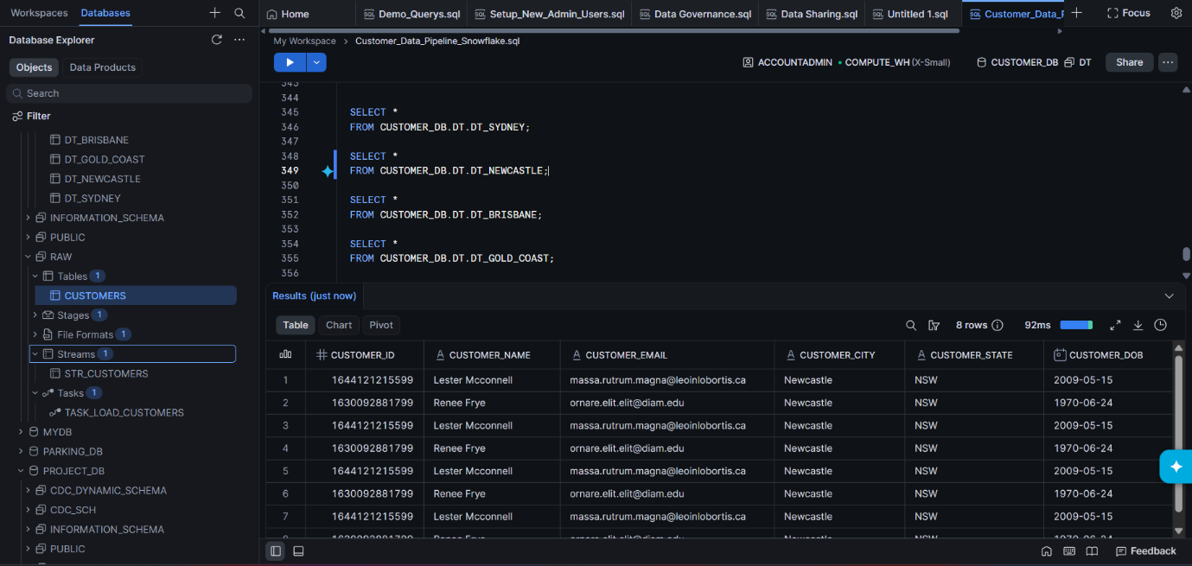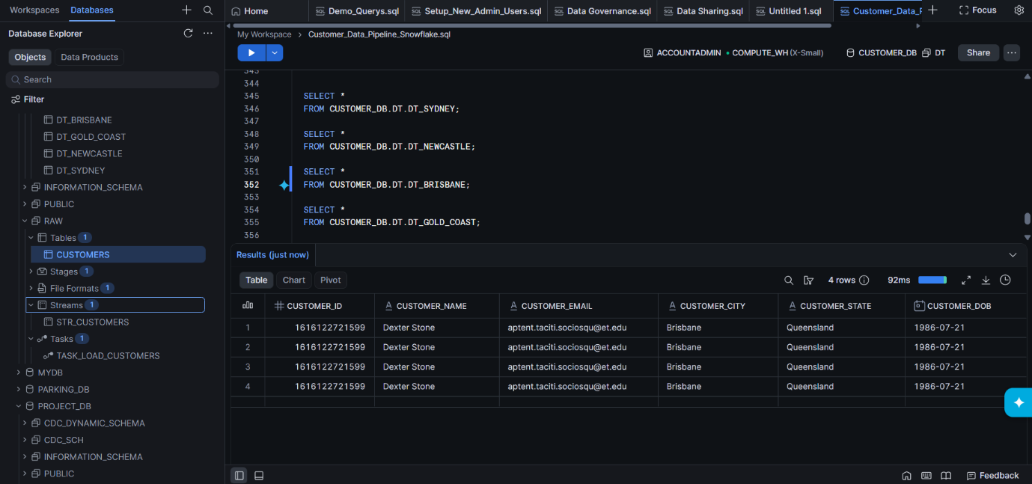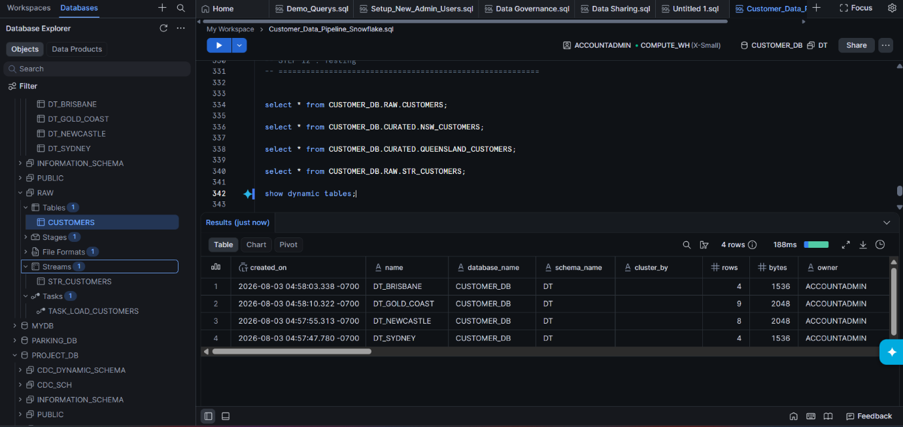

-- =========================================================
-- STEP 10 : RBAC (Roles & Users)
-- =========================================================

CREATE ROLE NSW_MANAGER;

CREATE ROLE QLD_MANAGER;

CREATE USER NSW_USER
PASSWORD='doe'
DEFAULT_ROLE=NSW_MANAGER
DEFAULT_WAREHOUSE=COMPUTE_WH;

CREATE USER QLD_USER
PASSWORD='doe'
DEFAULT_ROLE=QLD_MANAGER
DEFAULT_WAREHOUSE=COMPUTE_WH;

GRANT ROLE NSW_MANAGER TO USER NSW_USER;

GRANT ROLE QLD_MANAGER TO USER QLD_USER;

GRANT USAGE ON WAREHOUSE COMPUTE_WH TO ROLE NSW_MANAGER;

GRANT USAGE ON DATABASE CUSTOMER_DB TO ROLE NSW_MANAGER;

GRANT USAGE ON SCHEMA CUSTOMER_DB.RAW TO ROLE NSW_MANAGER;

GRANT SELECT ON TABLE CUSTOMER_DB.RAW.CUSTOMERS TO ROLE NSW_MANAGER;

GRANT USAGE ON WAREHOUSE COMPUTE_WH TO ROLE QLD_MANAGER;

GRANT USAGE ON DATABASE CUSTOMER_DB TO ROLE QLD_MANAGER;

GRANT USAGE ON SCHEMA CUSTOMER_DB.RAW TO ROLE QLD_MANAGER;

GRANT SELECT ON TABLE CUSTOMER_DB.RAW.CUSTOMERS TO ROLE QLD_MANAGER;

-- =========================================================
-- STEP 11 : ROW ACCESS POLICY
-- Restricts rows based on CUSTOMER_STATE
-- =========================================================

CREATE OR REPLACE ROW ACCESS POLICY STATE_POLICY
AS (CUSTOMER_STATE STRING)
RETURNS BOOLEAN ->
CASE
WHEN CURRENT_ROLE() = 'ACCOUNTADMIN' THEN TRUE

WHEN CURRENT_ROLE() = 'NSW_MANAGER'
THEN CUSTOMER_STATE IN ('NSW','New South Wales')

WHEN CURRENT_ROLE() = 'QLD_MANAGER'
THEN CUSTOMER_STATE IN ('QLD','Queensland')

ELSE FALSE
END;

ALTER TABLE CUSTOMER_DB.RAW.CUSTOMERS
ADD ROW ACCESS POLICY STATE_POLICY
ON (CUSTOMER_STATE);

Using Different Roles Accessing data
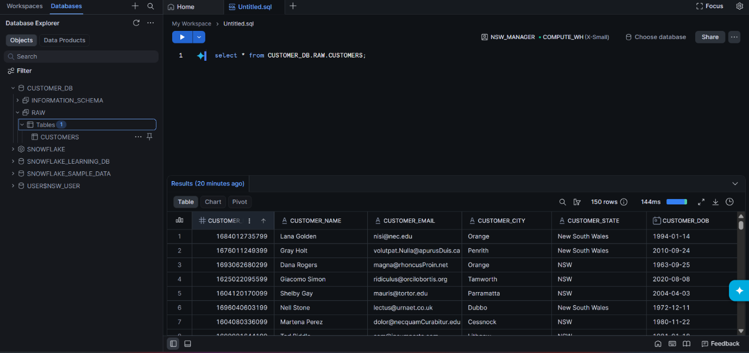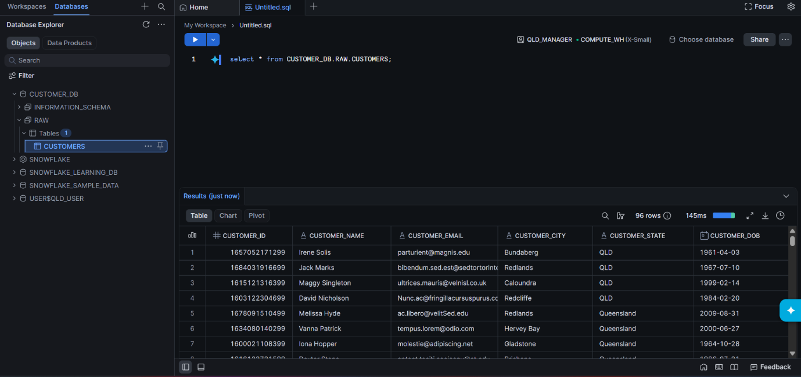

Project Structure

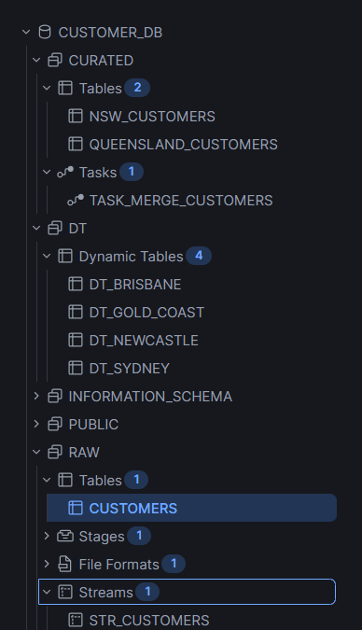

-- =========================================================
-- STEP 12 : Testing
-- =========================================================

select * from CUSTOMER_DB.RAW.CUSTOMERS;

select * from CUSTOMER_DB.CURATED.NSW_CUSTOMERS;

select * from CUSTOMER_DB.CURATED.QUEENSLAND_CUSTOMERS;

select * from CUSTOMER_DB.RAW.STR_CUSTOMERS;

show dynamic tables;

SELECT *
FROM CUSTOMER_DB.DT.DT_SYDNEY;

SELECT *
FROM CUSTOMER_DB.DT.DT_NEWCASTLE;

SELECT *
FROM CUSTOMER_DB.DT.DT_BRISBANE;

SELECT *
FROM CUSTOMER_DB.DT.DT_GOLD_COAST;

SHOW ROW ACCESS POLICIES;

