Opened DevOps

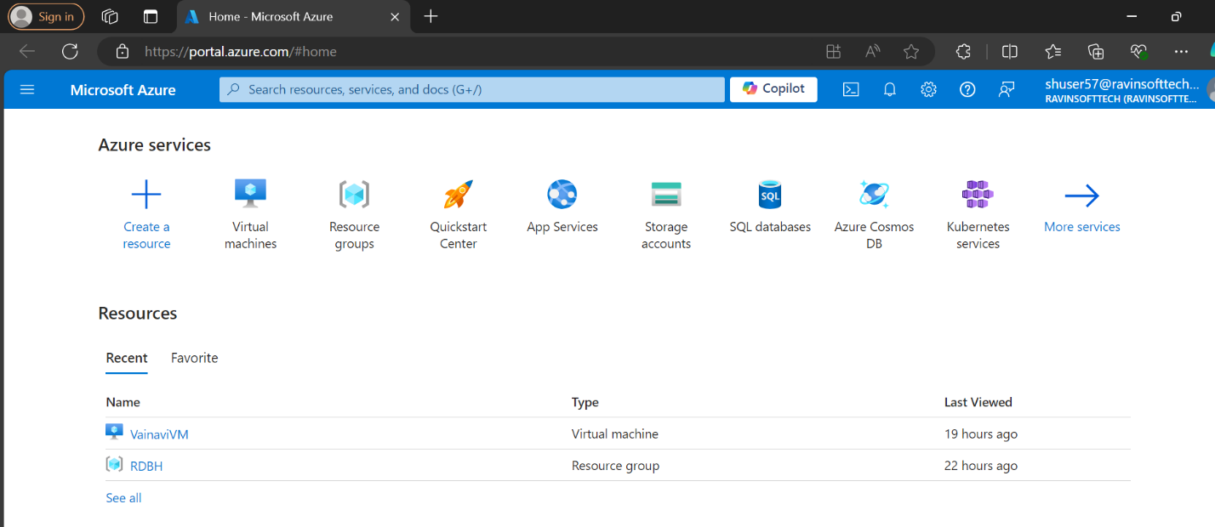

Create a virtual machine

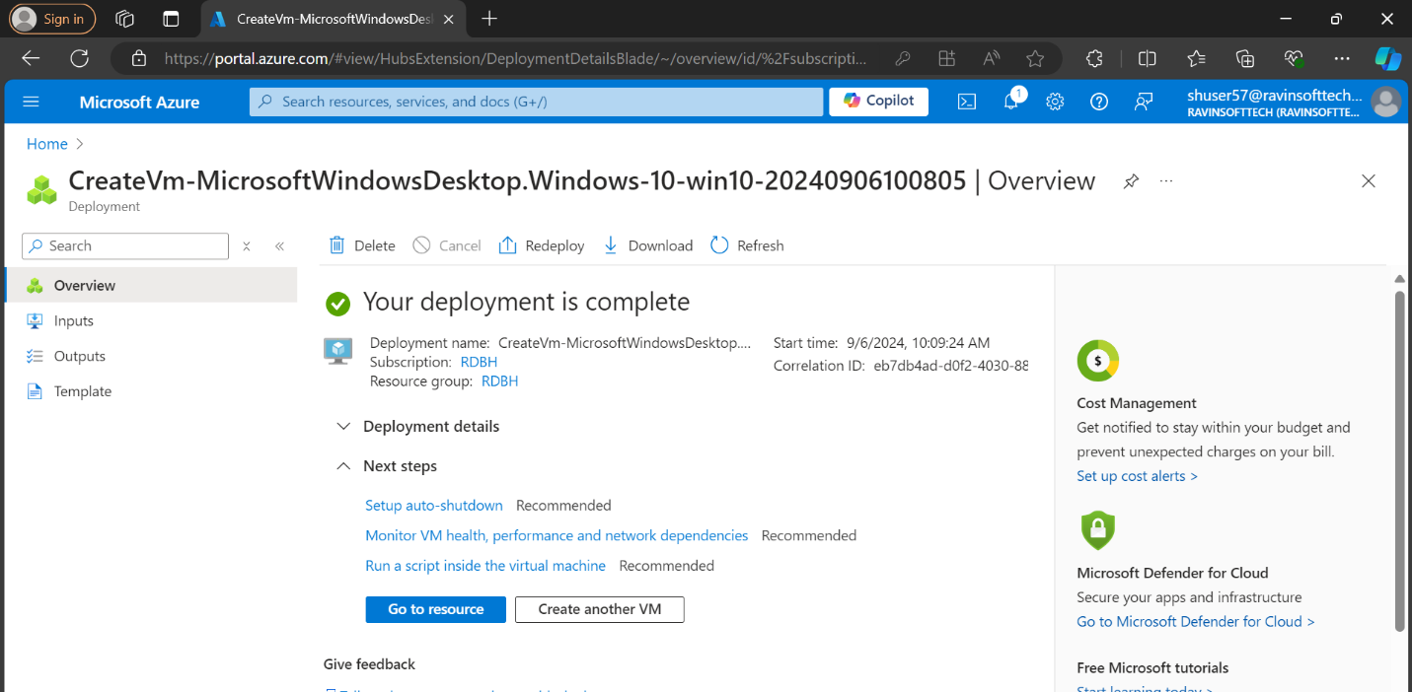

Login into azure devops portal

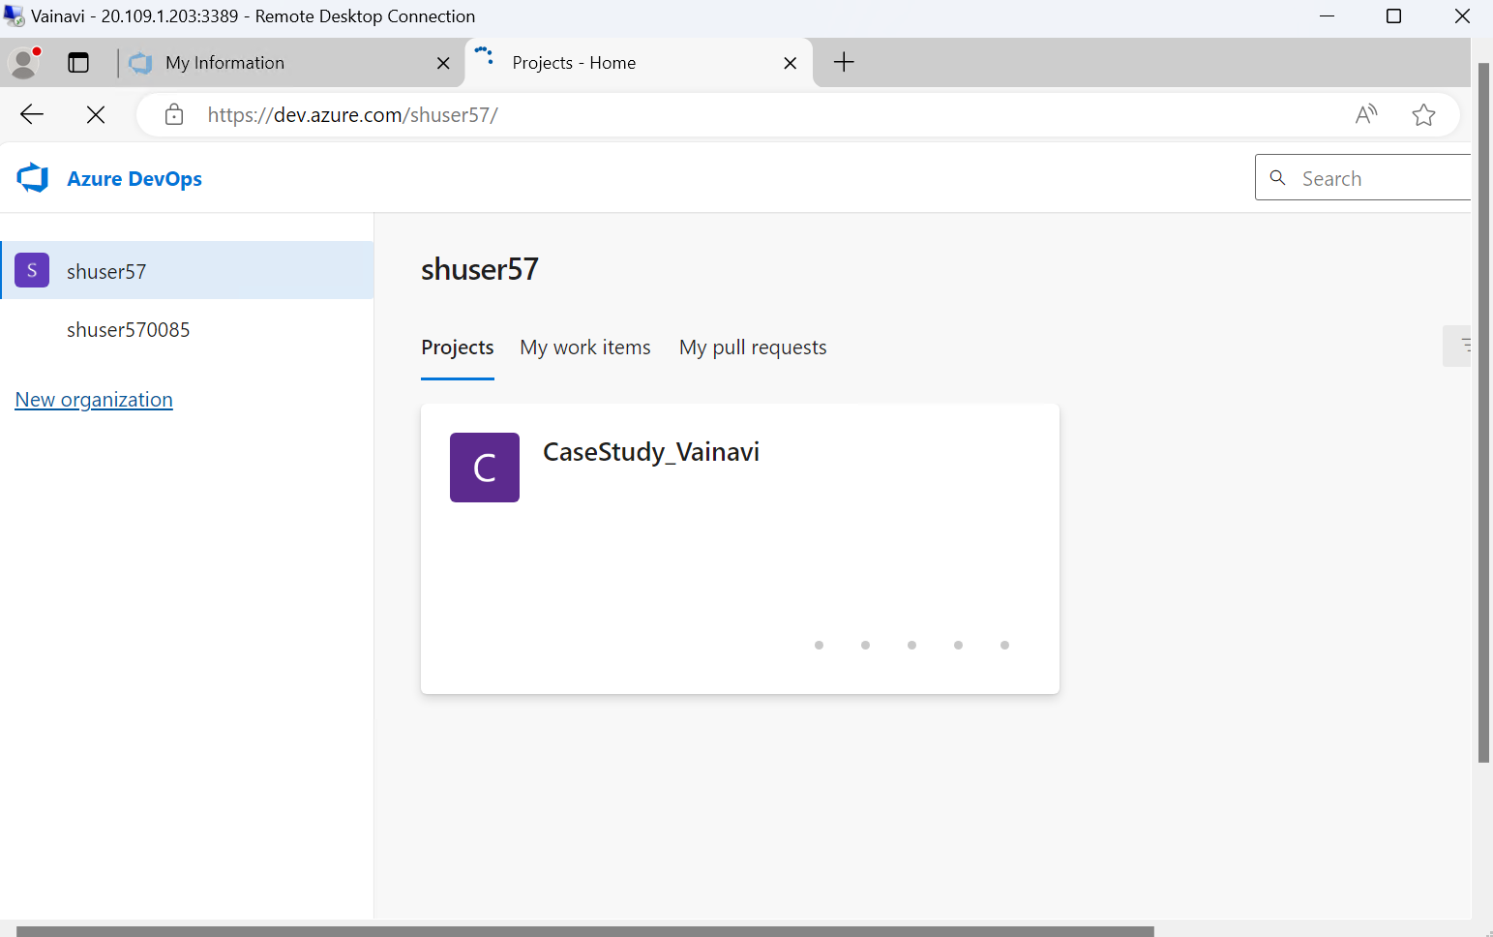

A new sprint is created with 5 user stories.

1. Manager Login

2. Recruiter Job Posting

3. Employee Personal Information Update

4. Admin Attendance Report

5. Employee Leave Request

Each user story has 5 test cases- all are in the excel

USER STORY 1

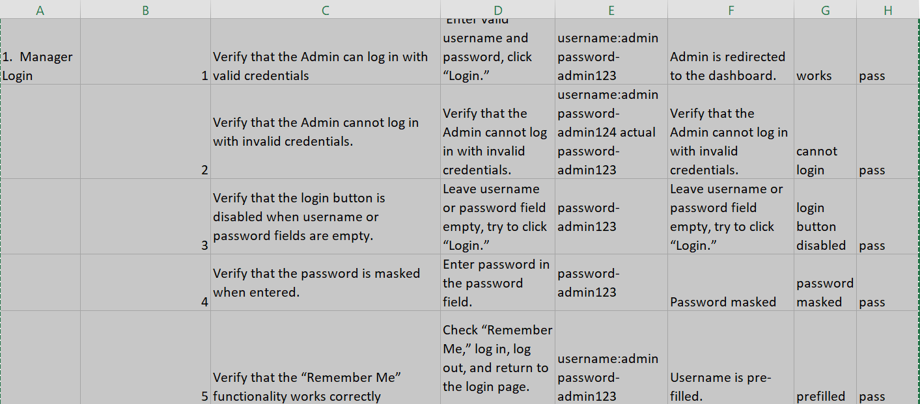

USER STORY2

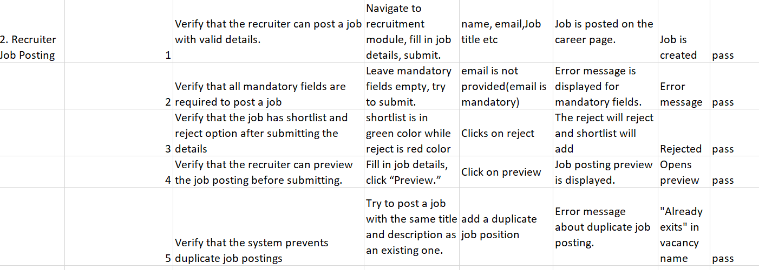

USER STORY 3

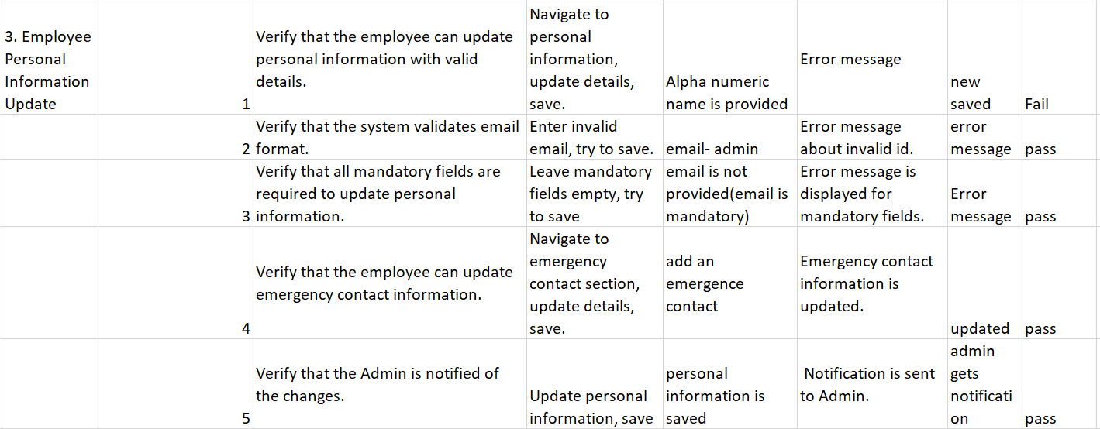

USER STORY4

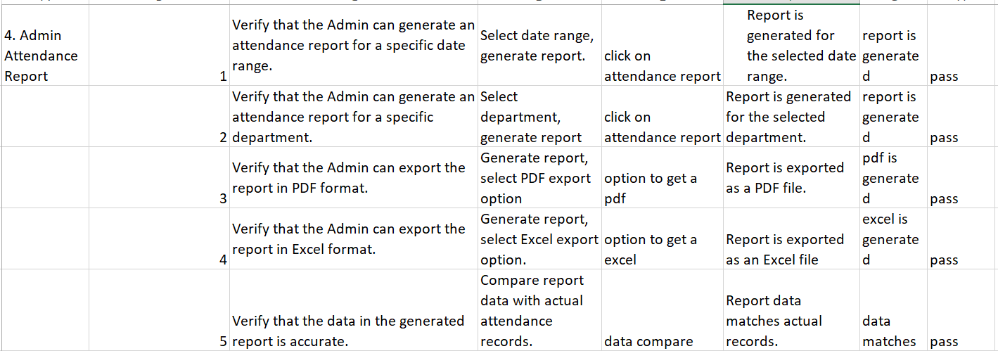

USER STORY 5

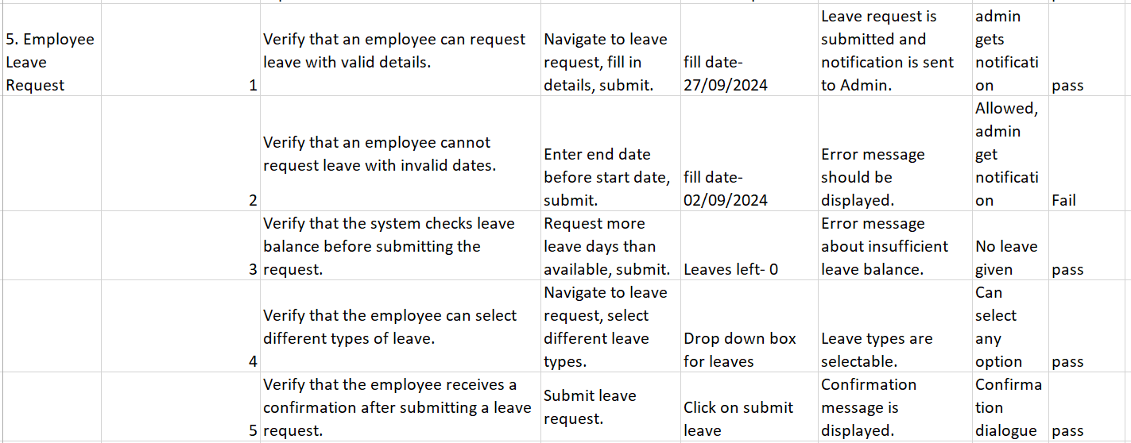

Screenshots of everything in dev azure

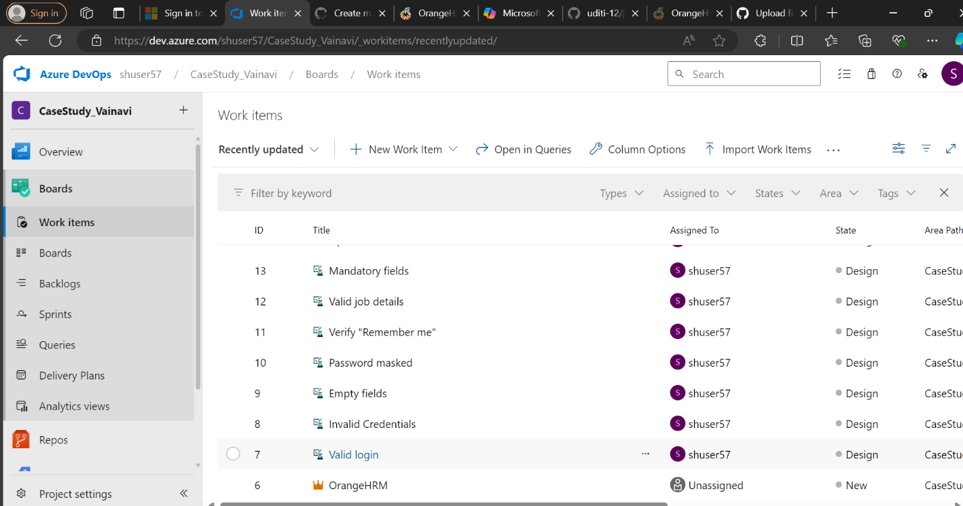

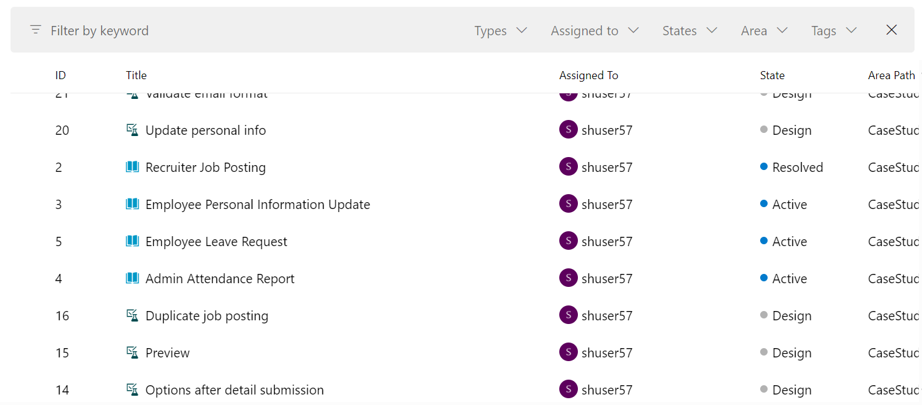

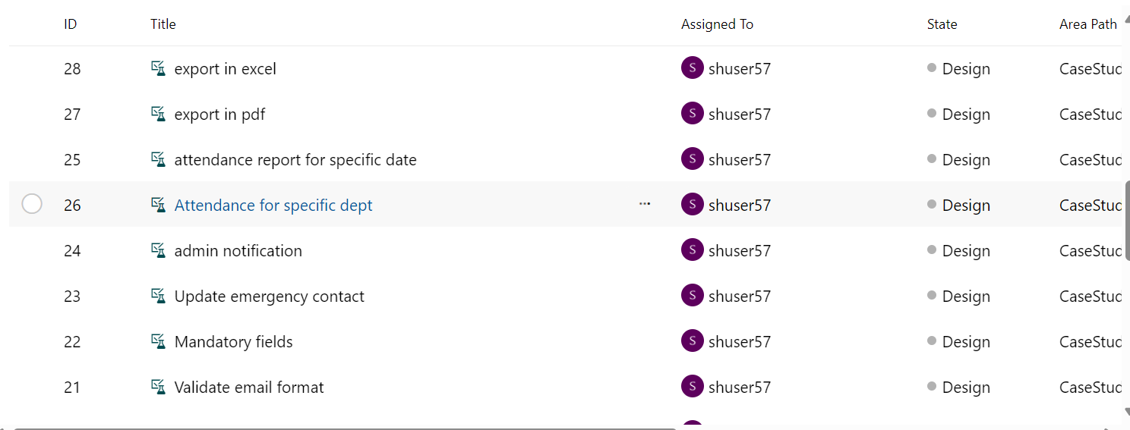

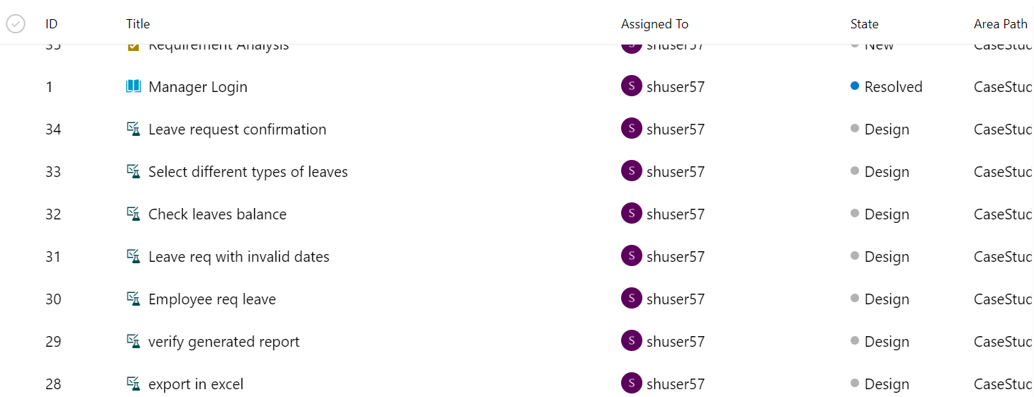

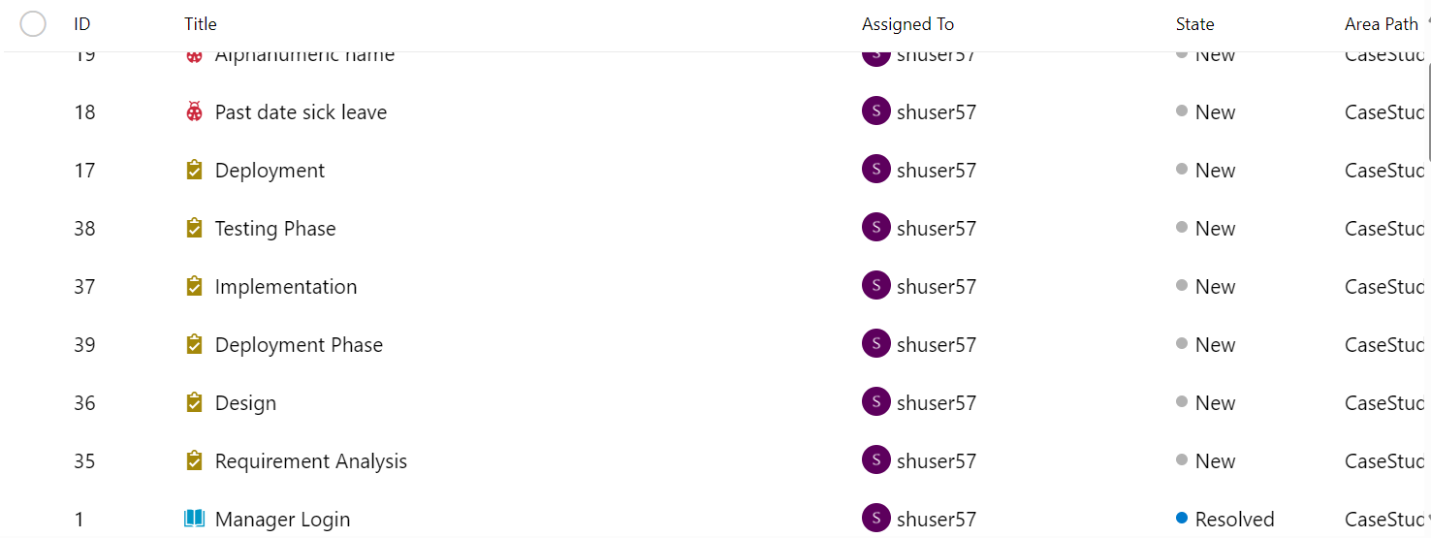

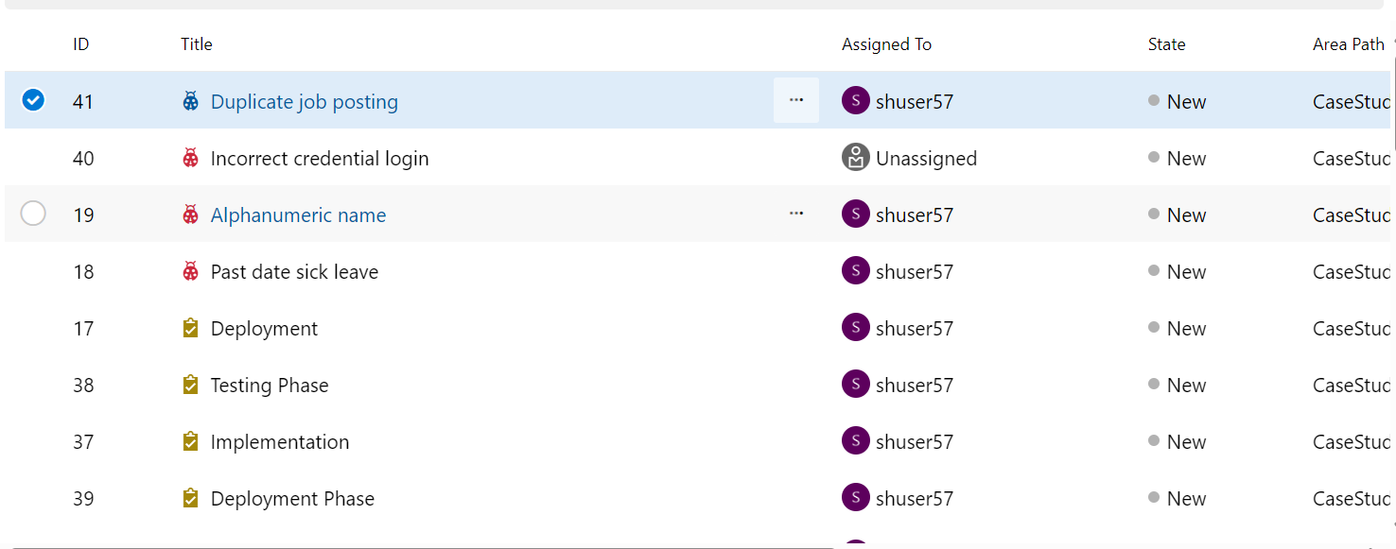

Epic

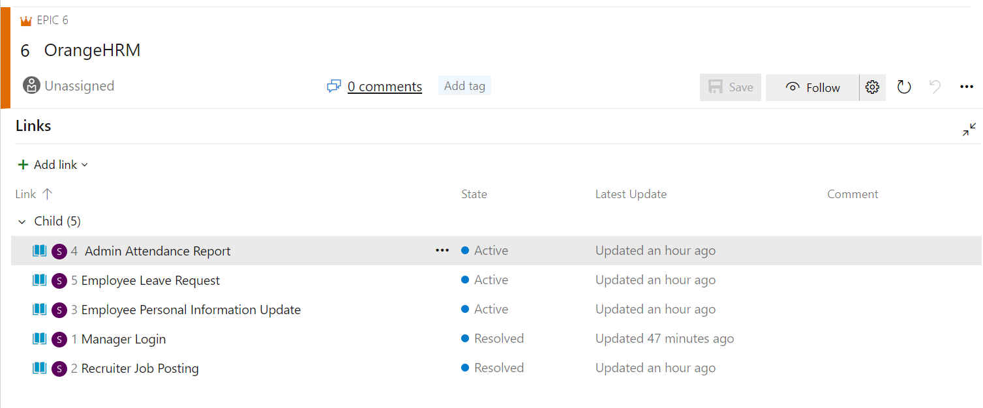

Links for user story1

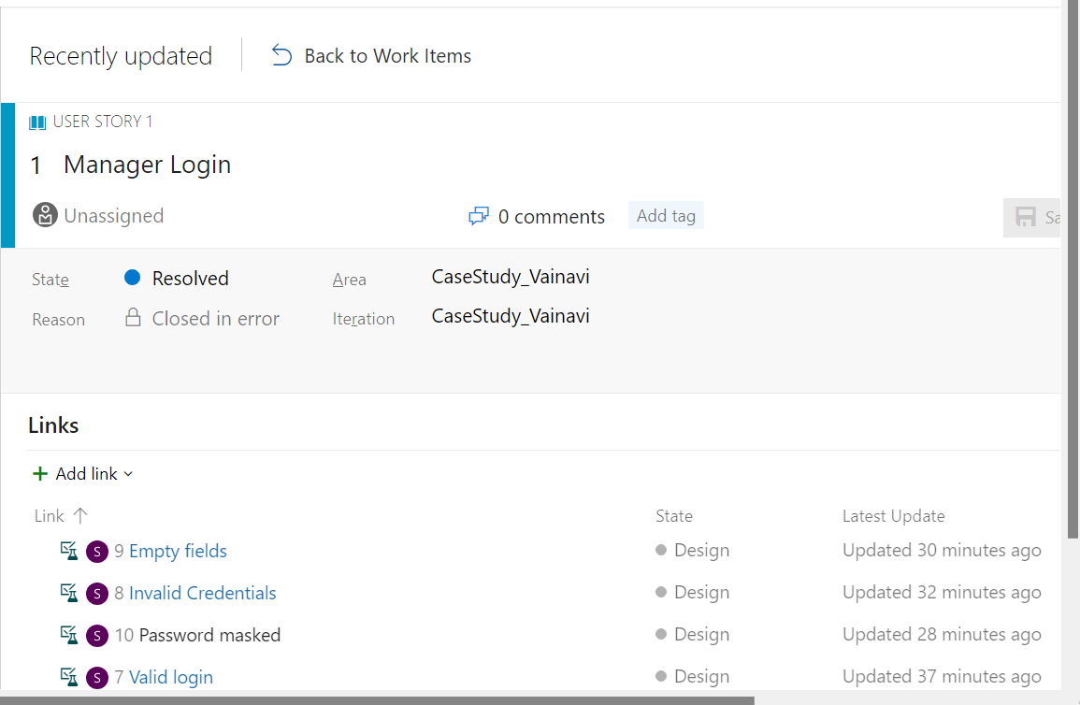

Link for user story 2

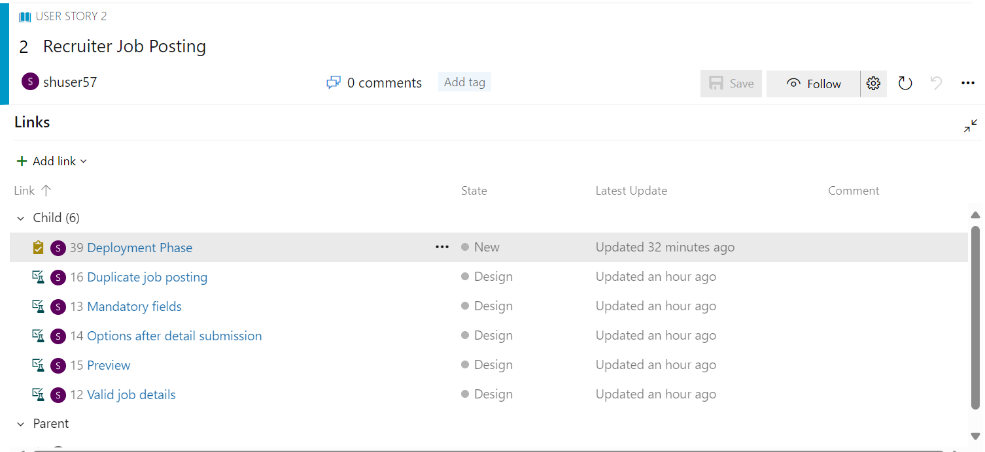

User story 3

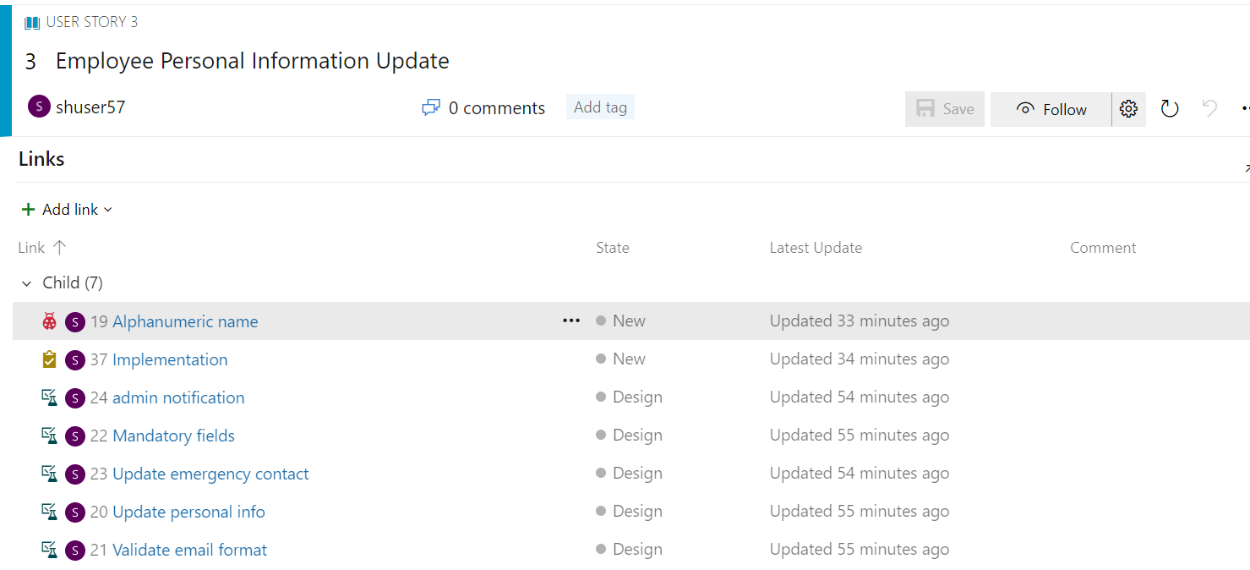

User story 4

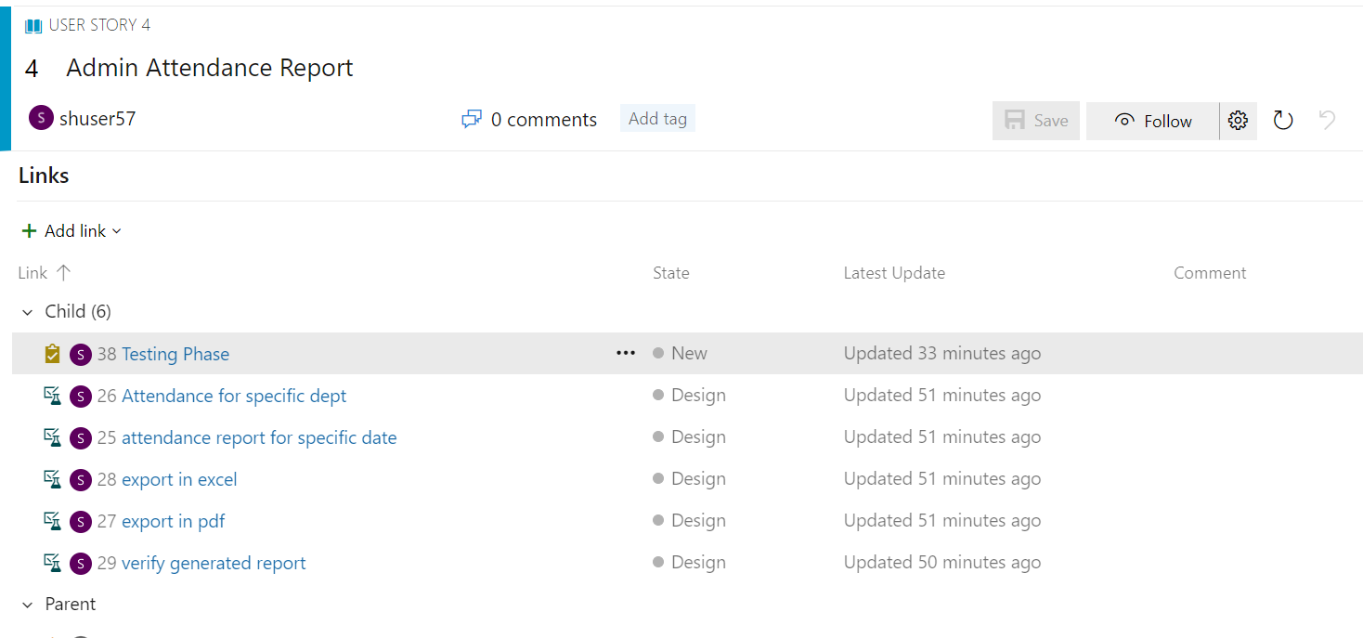

User story 5

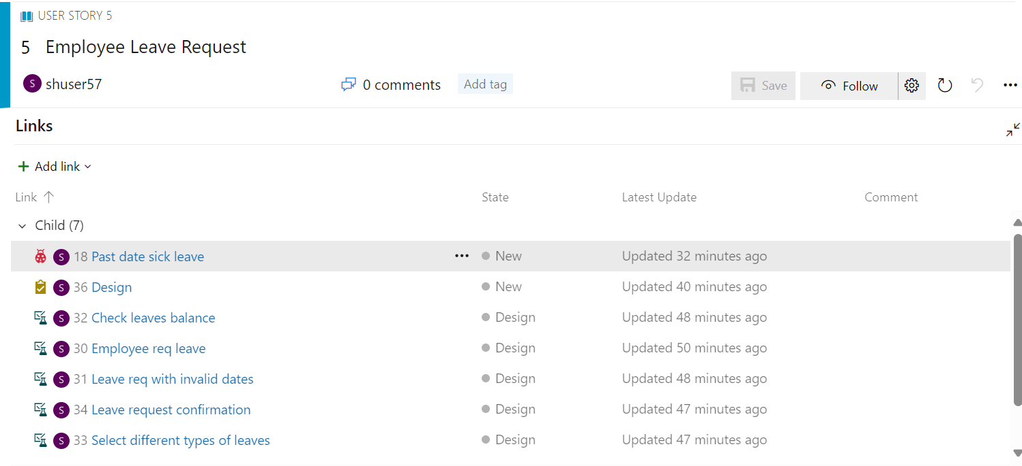

Tasks and subtasks are defined for each User story based on SDLC methods.

Functional testing is done to get all the test cases

Admin info

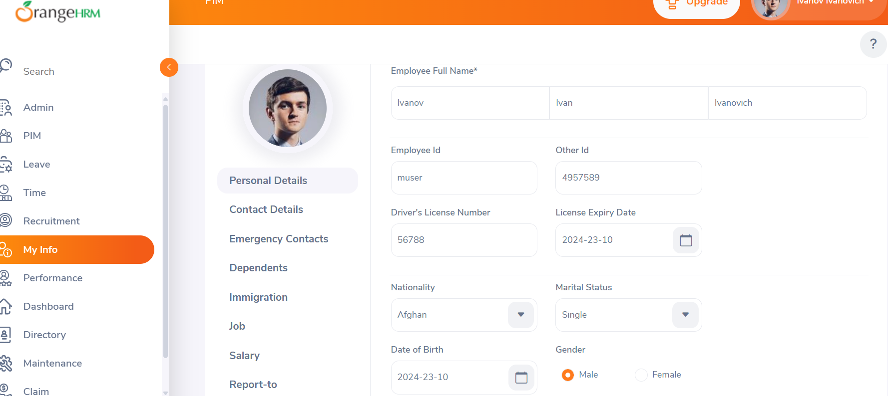

User management records

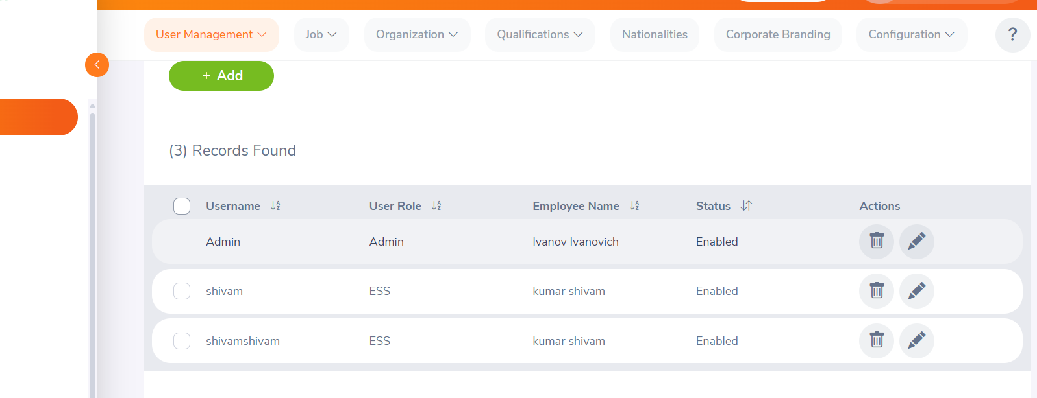

Recruitments

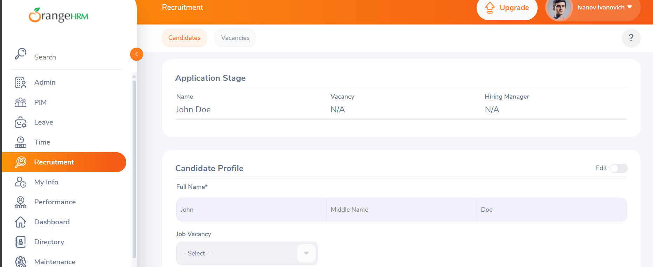

Leaves

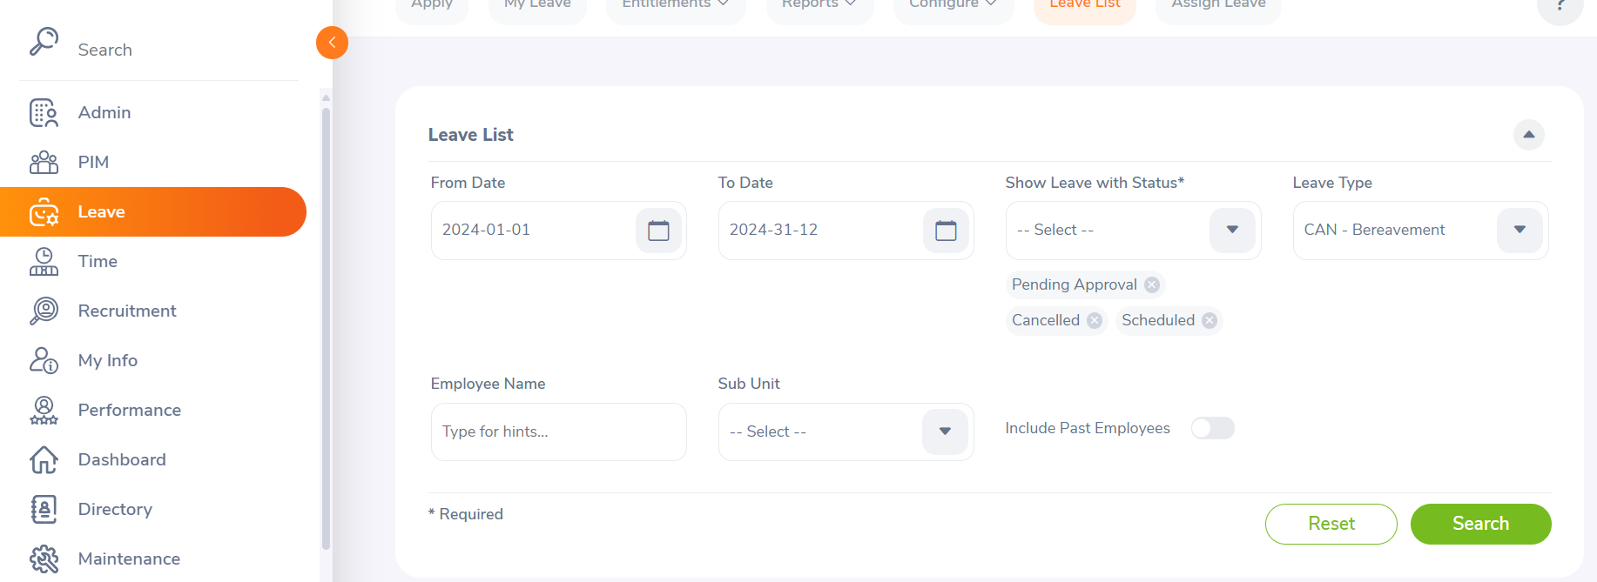

CI/CD testing

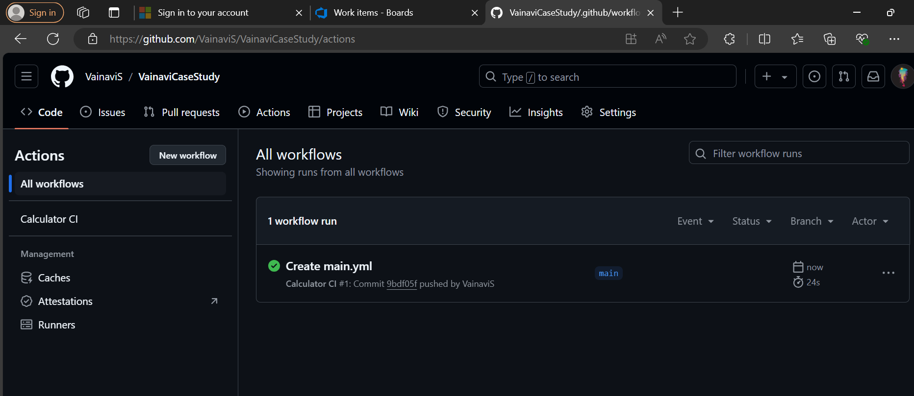

Defects

|  |  |  |  |
| --- | --- | --- | --- |
| Defect | Defect description | severity | status |
| Alphanumeric name | The name field in the employee profile allows the entry of alphanumeric characters, which should be restricted to alphabetic characters only. | medium | open |
| Past date sick leave | The system allows employees to submit sick leave requests for past dates, which should not be permitted. | high | open |
| Incorrect login credentials | Enter an incorrect username (e.g., “admin”) and the correct password (e.g., “admin123”) | high | open |
| Duplicate Job posting | The system allows posting duplicate job listings. | medium | open |