Ex.no: 1a | Setting Up Python Environment And Libraries – Jupyter Notebook

AIM:
To install Python, configure Jupyter Notebook, understand the notebook environment, execute Python programs, create Markdown cells, and use basic Jupyter Notebook features for Data Analytics applications.

ALGORITHM:
Algorithm 1: Installing Python
- Download Python from python.org
- Run the installer
- Select "Add Python to PATH"
- Click Install Now
- Verify installation using: python --version
- Observe installed Python version
Algorithm 2: Installing Jupyter Notebook
- Open Command Prompt
- Install Jupyter pip install notebook
- Launch Jupyter Notebook jupyter notebook
- Browser automatically opens Notebook Dashboard.
Algorithm 3: Creating a Notebook
- Open Jupyter Dashboard
- Select New → Python 3
- Create Notebook
- Rename Notebook
- Create Code and Markdown Cells
- Execute cells using Shift + Enter
PROGRAM:
Program 1 — Simple Python Program
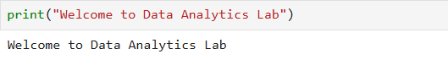
Program 2 — Arithmetic Operations
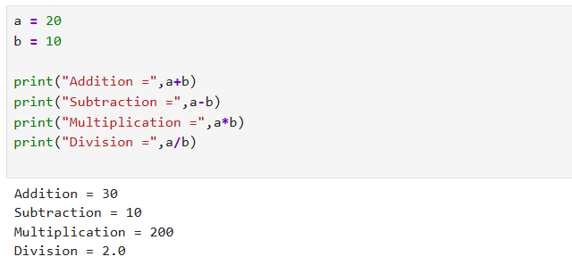
Program 3 — Display Student Details
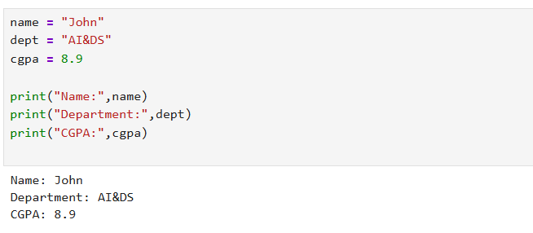
Program 4 — Using NumPy Library
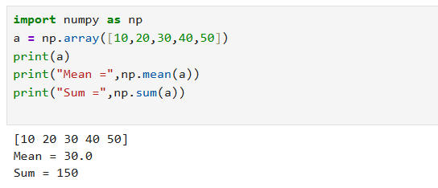
Program 5 — Using Pandas Library
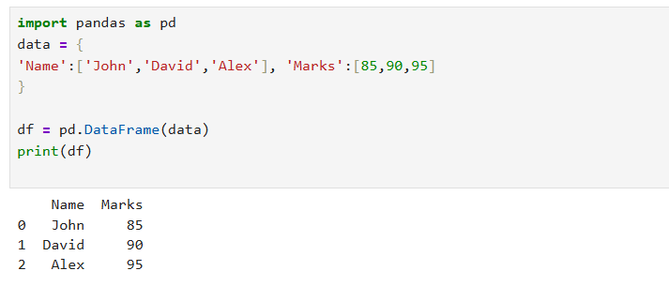
Program 7 — Data Visualization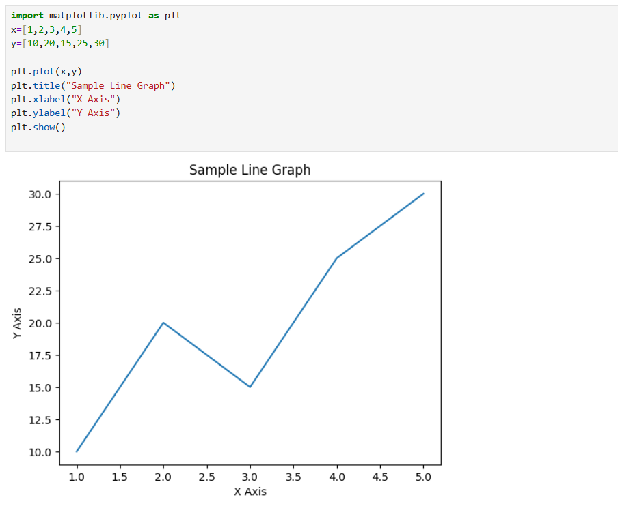
RESULT:

