Ex.no: 1b | EDA – Data Science Frameworks(CRISPDM, SEMMA, KDD)

AIM:
To analyze insurance data using Exploratory Data Analysis (EDA), visualize important patterns in medical charges, preprocess the dataset, build a Machine Learning model to predict insurance charges, evaluate the model, and export the processed data to Excel.
ALGORITHM:
- Load the Insurance dataset using Pandas.
- Import the required Python libraries such as Pandas, Matplotlib, Seaborn, and Scikit-learn.
- Display the first few records, dataset shape, information, and missing values.
- Check and remove duplicate records.
- Analyze important features such as age, BMI, number of children, smoking status, sex, and region.
- Handle missing values in the dataset.
- Convert categorical features such as sex, smoker, and region into numerical form.
- Visualize the distribution of insurance charges using a histogram.
- Create a correlation heatmap to identify relationships between numerical features.
- Separate the input features (X) and target variable (y), where charges is the target.
- Split the dataset into training and testing data.
- Train a Machine Learning model using the training data.
- Predict insurance charges using the test data.
- Evaluate the model using Mean Absolute Error (MAE) and R² score.
- Export the processed insurance data to an Excel file.
- Display the analysis results.

PROGRAM:
import pandas as pd
import matplotlib.pyplot as plt
import seaborn as sns
from sklearn.model_selection import train_test_split
from sklearn.ensemble import RandomForestRegressor
from sklearn.metrics import mean_absolute_error, r2_score
df = pd.read_csv("insurance.csv")
print(df.head())
OUTPUT:
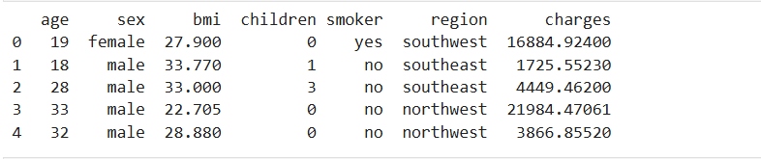
OUTPUT:
print("Shape:", df.shape)
print(df.info())
OUTPUT:
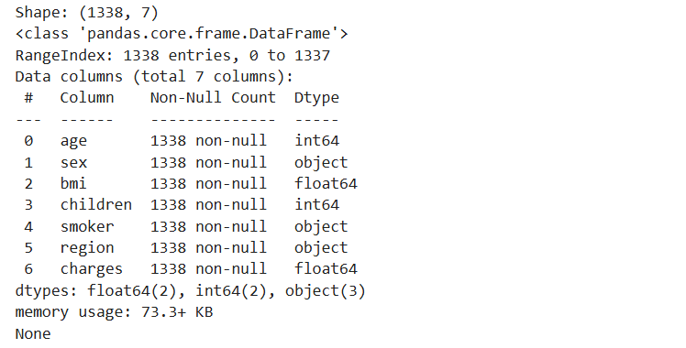
PROGRAM:
print(df.isnull().sum())
OUTPUT:
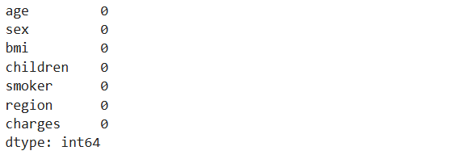

PROGRAM:
df = df.drop_duplicates()
print("Shape after removing duplicates:", df.shape)
OUTPUT:
PROGRAM:
features = [
"age",
"sex",
"bmi",
"children",
"smoker",
"region"
]
df = df.dropna(subset=features + ["charges"])
df = pd.get_dummies(
df,
columns=["sex", "smoker", "region"],
drop_first=True
)
sns.histplot(df["charges"], bins=20, kde=True)
OUTPUT:
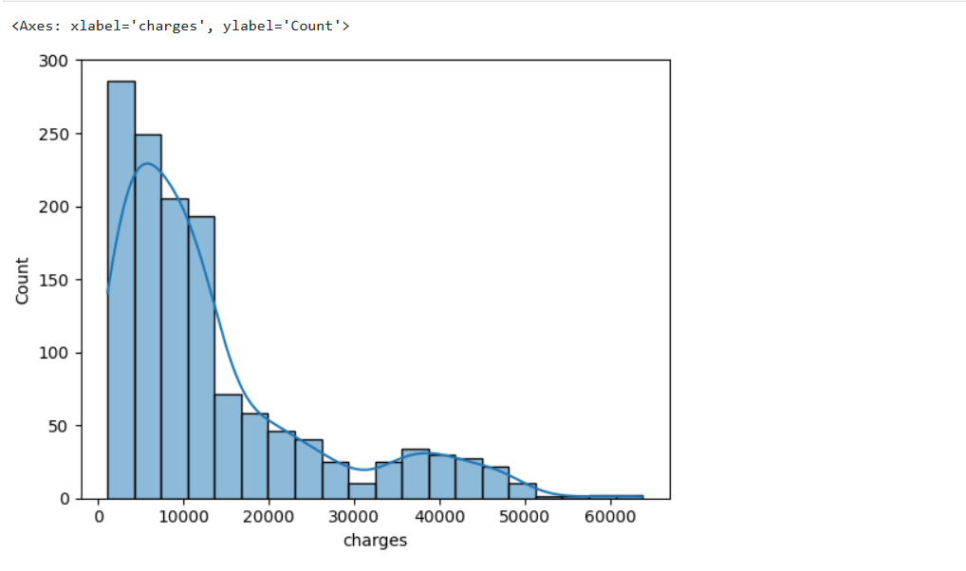
PROGRAM:
plt.figure(figsize=(10, 6))
sns.heatmap(
df.corr(),
annot=True,
cmap="coolwarm"
)
plt.title("Correlation of Insurance Features")
plt.show()
OUTPUT:
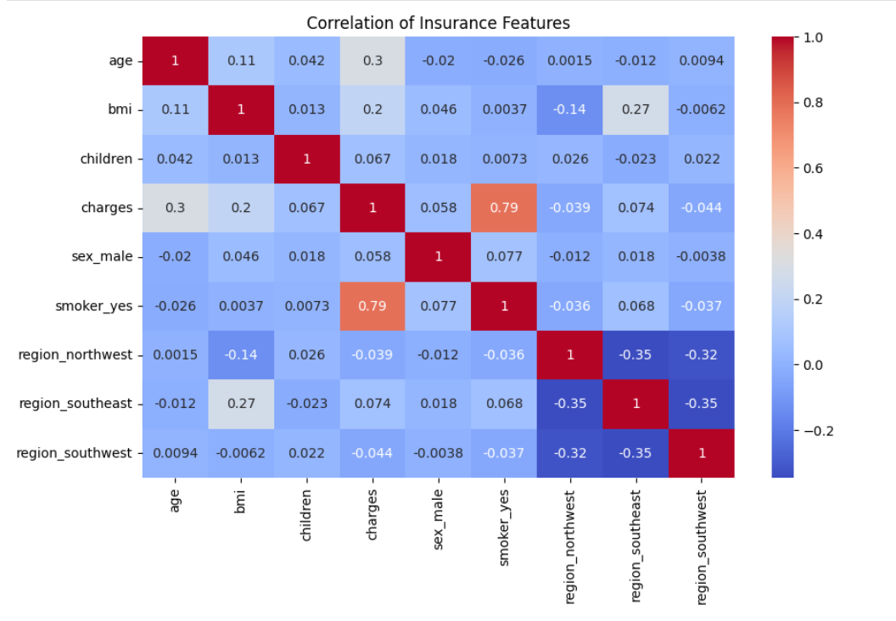
PROGRAM:
X = df.drop("charges", axis=1)
y = df["charges"]
X_train, X_test, y_train, y_test = train_test_split(
X,
y,
test_size=0.2,
random_state=42
)
model = RandomForestRegressor(
n_estimators=100,
random_state=42
)
model.fit(X_train, y_train)
y_pred = model.predict(X_test)
mae = mean_absolute_error(y_test, y_pred)
r2 = r2_score(y_test, y_pred)
print("Mean Absolute Error:", mae)
print("R2 Score:", r2)
OUTPUT:

RESULT:

