Ex.no: 2 | Exploratory Data Analysis (EDA) – Data Import and Export

AIM:
To install Python, configure Jupyter Notebook, understand the notebook environment, execute Python programs, create Markdown cells, and use basic Jupyter Notebook features for Data Analytics applications.
ALGORITHM:
- Download Python from the official Python website.
- Run the installer, enable "Add Python to PATH", and complete the installation.
- Verify that Python is installed successfully.
- Install Jupyter Notebook using the Python package manager.
- Launch Jupyter Notebook and open the Notebook Dashboard.
- Create a new Python 3 notebook.
- Rename the notebook.
- Create Code and Markdown cells.
- Enter the required code or text in the cells.
- Execute the cells and observe the output.
- Save the notebook.
PROGRAM:
import pandas as pd
df = pd.read_csv("231401024.csv")
print(df)
OUTPUT:
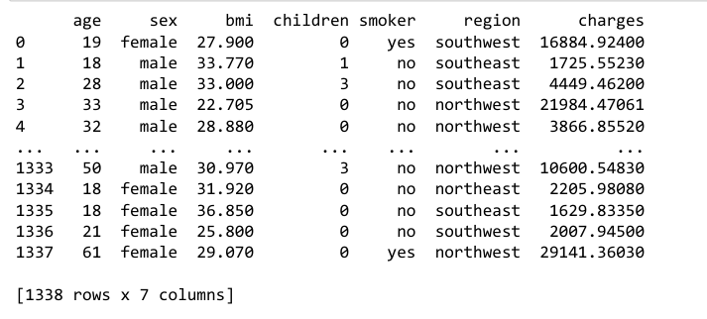
PROGRAM:
print(df.head())
print(df.info())
print(df.describe())
OUTPUT:
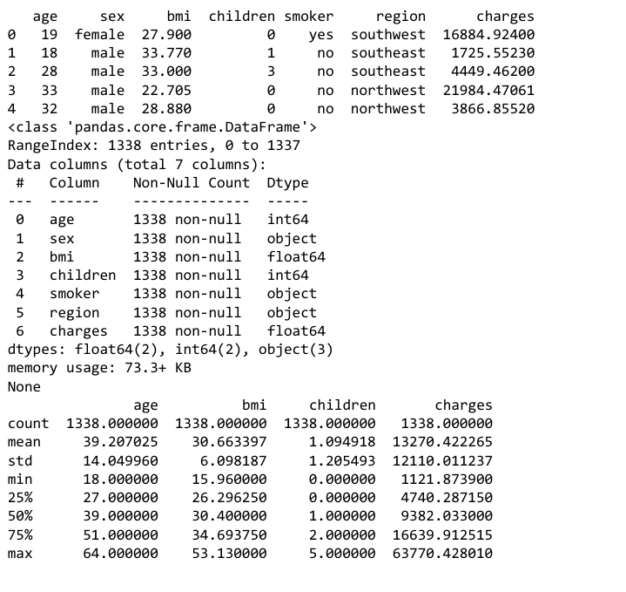
PROGRAM:
data = pd.read_excel("insurance.xlsx")
print(data)
OUTPUT:
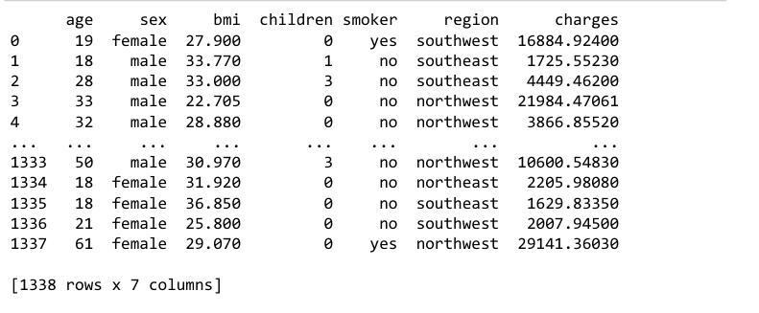
PROGRAM:
import sqlite3
import pandas as pd
df = pd.read_csv("231401024.csv")
conn = sqlite3.connect("insurance.db")
df.to_sql("insurance", conn, if_exists="replace", index=False)
OUTPUT:
PROGRAM:
import sqlite3
import pandas as pd
conn = sqlite3.connect("insurance.db")
query = "SELECT * FROM insurance"
df = pd.read_sql(query, conn)
print(df) conn.close()
OUTPUT:
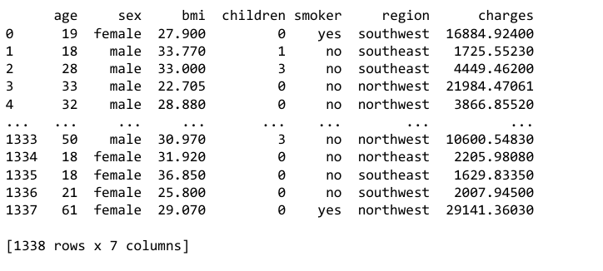
PROGRAM:
df.to_csv("diabetes_export.csv", index=False)
df.to_excel("diabetes_export.xlsx", index=False)
df.to_json("diabetes_export.json", orient="records")
import sqlite3
conn = sqlite3.connect("diabetes.db")
df.to_sql("diabetes", conn, if_exists="replace", index=False) c
onn.close()
url = "231401024.csv"
df = pd.read_csv(url)
print(df.head())
OUTPUT:
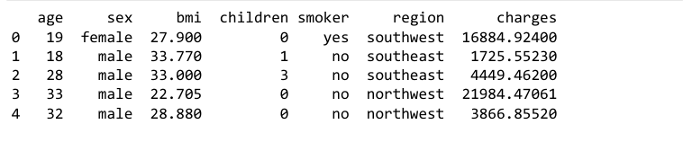

PROGRAM:
df.to_csv('231401024.csv', index=False)
print("CSV File Exported")
OUTPUT:

RESULT:

