Ex.no: 3 | Exploratory Data Analysis (EDA) – Data Cleaning and Data Transformation

AIM:
To identify and handle missing values, duplicate records, outliers, inconsistent data, and perform data transformation techniques such as normalization and encoding using Python Pandas.

ALGORITHM:
- Import the required Python libraries.
- Load the dataset into a Data Frame.
- Identify missing values and count them.
- Calculate the mean (or appropriate statistic) and replace missing values.
- Verify that the missing values have been replaced.
- Identify duplicate records and count them.
- Remove duplicate records from the dataset.
- Verify that duplicates have been removed.
- Calculate the first quartile (Q1) and third quartile (Q3).
- Compute the Interquartile Range (IQR).
- Calculate the lower and upper bounds for outlier detection.
- Identify the outliers in the dataset.
- Display the cleaned dataset and the detected outliers.

PROGRAM:
import pandas as pd
df = pd.read_csv("insurance.csv")
print(df.isnull())
OUTPUT:
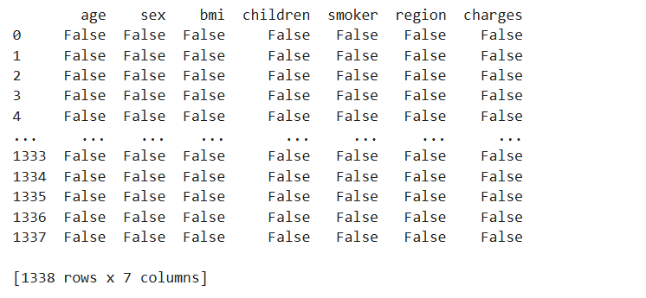
PROGRAM:
df.head()
OUTPUT:
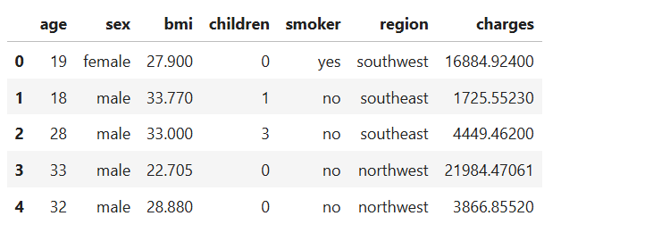
PROGRAM:
print(df.isnull().sum())
OUTPUT:
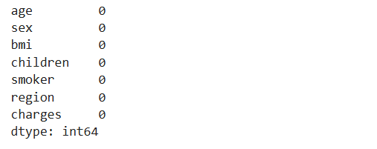

PROGRAM:
df["age"] = df["age"].fillna(df["age"].mean())
df["bmi"] = df["bmi"].fillna(df["bmi"].mean())
print(df)
OUTPUT:
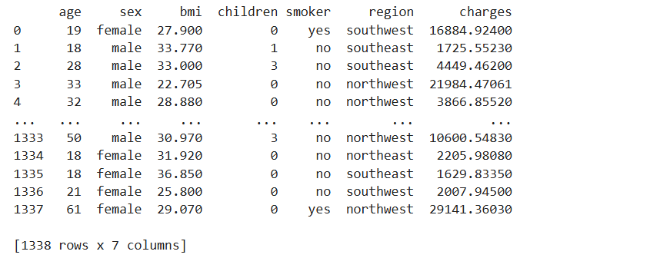

PROGRAM:
print(df.duplicated())
df.drop_duplicates(inplace=True)
print(df)
OUTPUT:
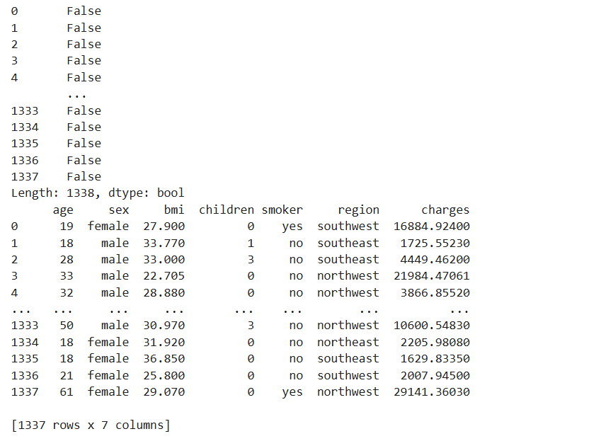
PROGRAM:
Q1 = df['charges'].quantile(0.25)
Q3 = df['charges'].quantile(0.75)
IQR = Q3 - Q1
lower = Q1 - 1.5 * IQR
upper = Q3 + 1.5 * IQR
outliers = df[(df['charges'] < lower) |
(df['charges'] > upper)]
print(outliers)
OUTPUT:
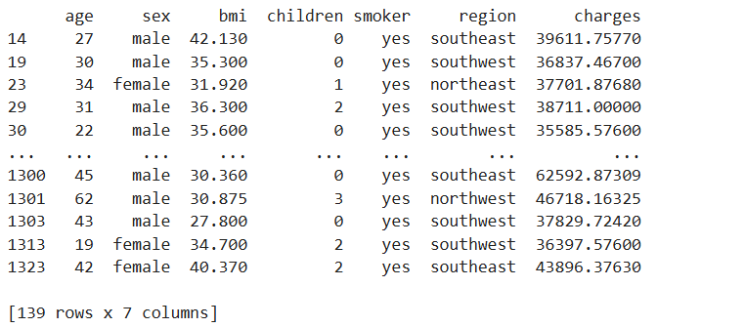
PROGRAM:
from sklearn.preprocessing import MinMaxScaler
scaler = MinMaxScaler()
df[['charges']] = scaler.fit_transform(df[['charges']])
print(df[['charges']])
OUTPUT:
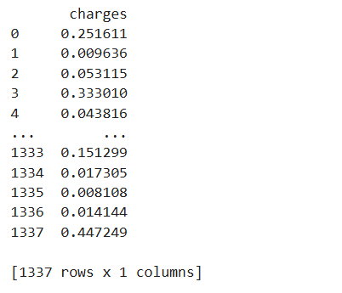

PROGRAM:
from sklearn.preprocessing import LabelEncoder
encoder = LabelEncoder()
df['sex'] = encoder.fit_transform(df['sex'])
print(df.head())
OUTPUT:
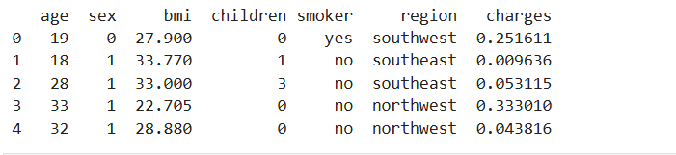
PROGRAM:
pd.get_dummies(df['region'])
OUTPUT:
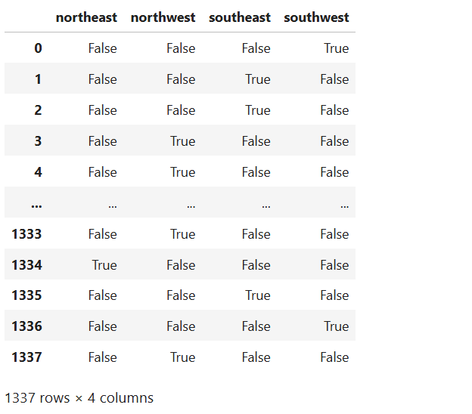
RESULT:

