Ex.no: 5b | Data Visualization Using Matplotlib – medical data

AIM:
To create and analyze various data visualizations such as Line Charts, Bar Charts, Pie Charts, Histograms, Scatter Plots, and Box Plots using Matplotlib for effective data interpretation.
ALGORITHM:
- Import Matplotlib library.
- Create or load the required dataset.
- Select the required data and visualization type.
- Apply the appropriate visualization function such as plot(), bar(), pie(), or boxplot().
- Add a suitable title, axis labels, legends, and percentage labels if required.
- Customize the chart if necessary.
- Display the visualization using show().
PROGRAM: 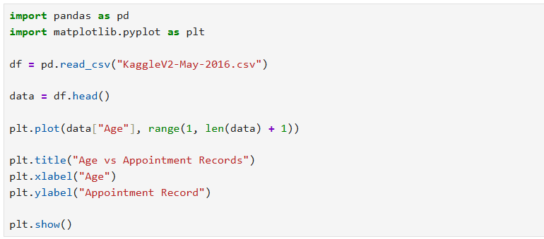
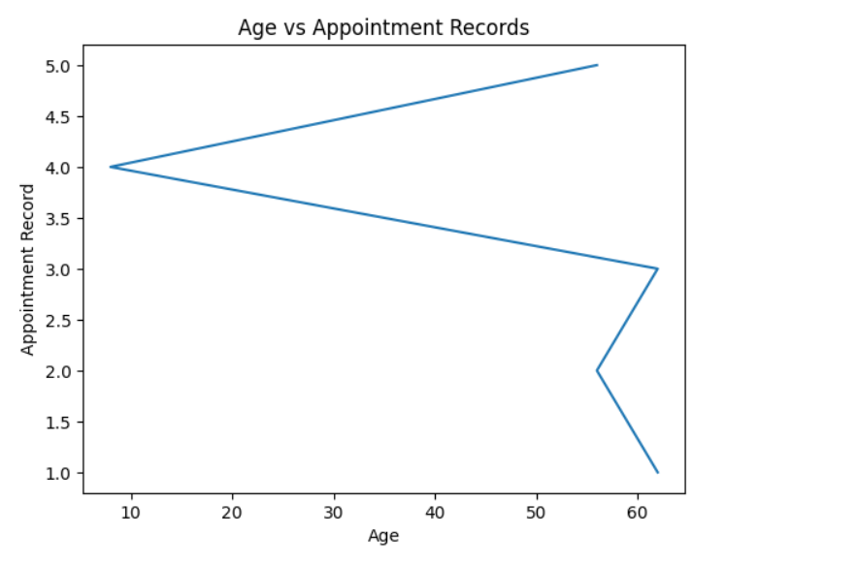
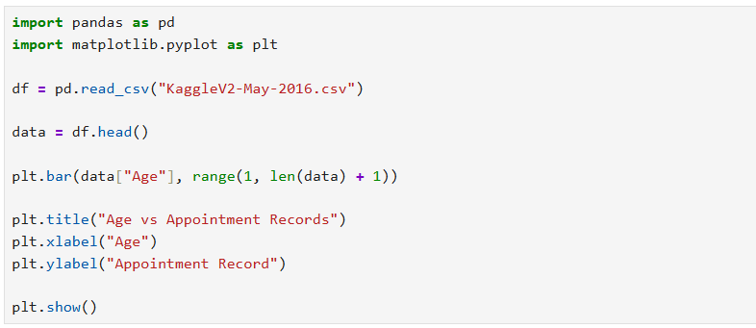
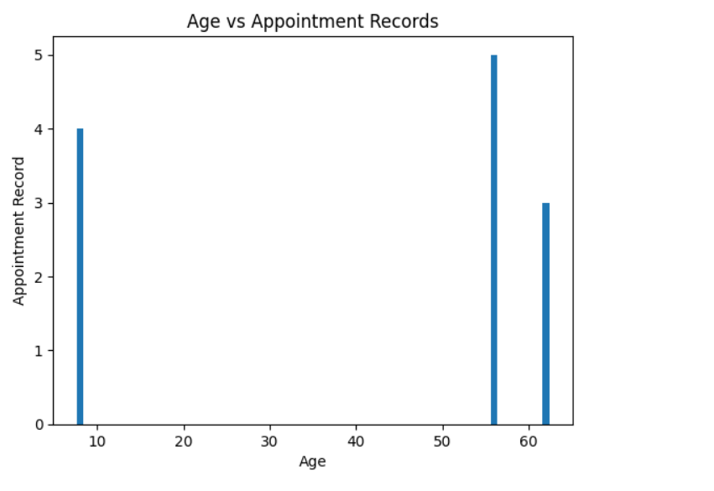
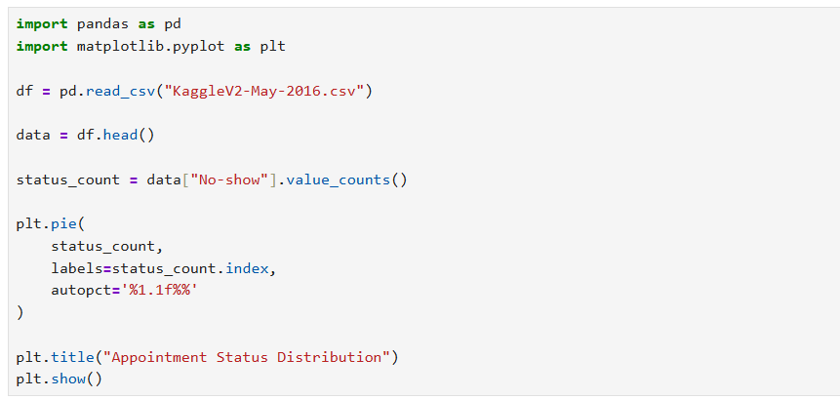
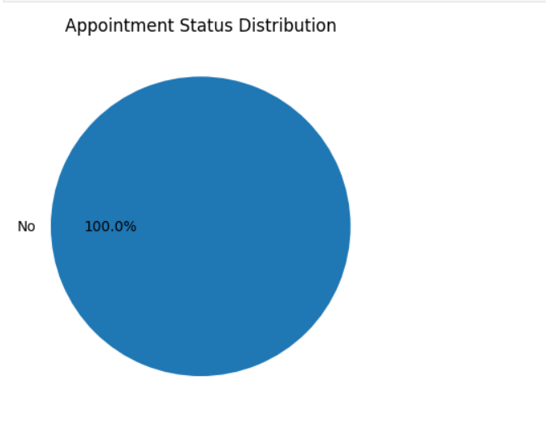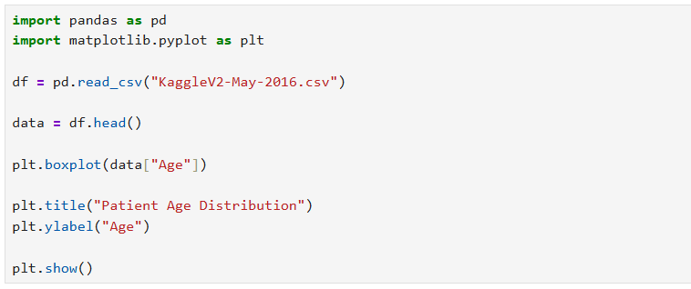
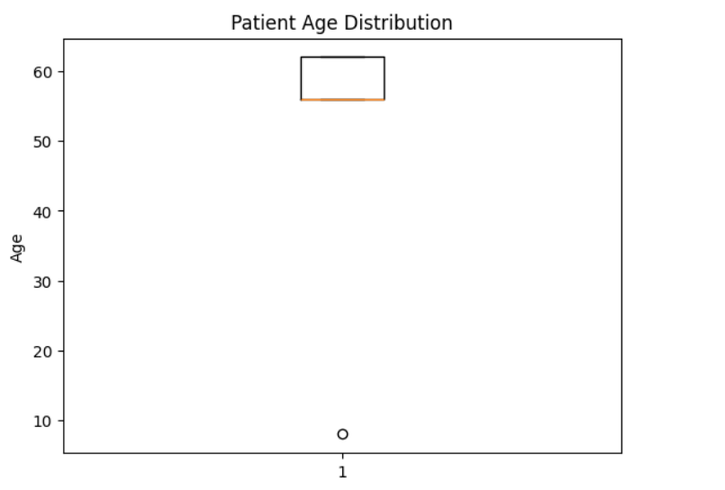

RESULT:

