Ex.no: 7b | Data Visualization Using Tableau – insurance data

AIM:
To connect, analyze, visualize, and create an interactive dashboard using Tableau for effective analysis of insurance data.
ALGORITHM:
- Open Tableau Desktop and connect to the insurance.csv dataset.
- Verify the imported data and data types such as Age, Sex, BMI, Children, Smoker, Region, and Charges.
- Create a worksheet to analyze region-wise insurance charges.
- Create a bar chart to compare insurance charges based on Smoker status.
- Create a pie chart to visualize the contribution of different Regions to total insurance charges.
- Create a line chart to analyze the relationship between Age and Charges.
- Create a calculated field named Charges in Thousands using the formula [Charges] / 1000.
- Apply Smoker and Region filters to analyze selected insurance records.
- Create a Minimum Charges parameter to display records based on the selected minimum insurance charge.
- Create a new dashboard and add the required worksheets and visualizations.
- Add KPI cards for Total Charges, Average Charges, and Number of Customers.
- Arrange and format the charts, KPI cards, filters, and parameter.
- Save the completed Insurance Analysis Dashboard.

OUTPUT:
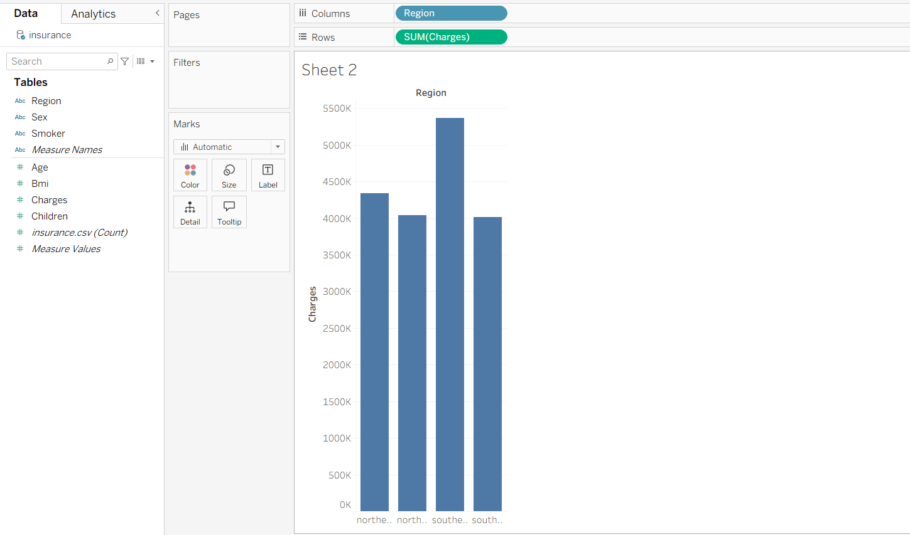
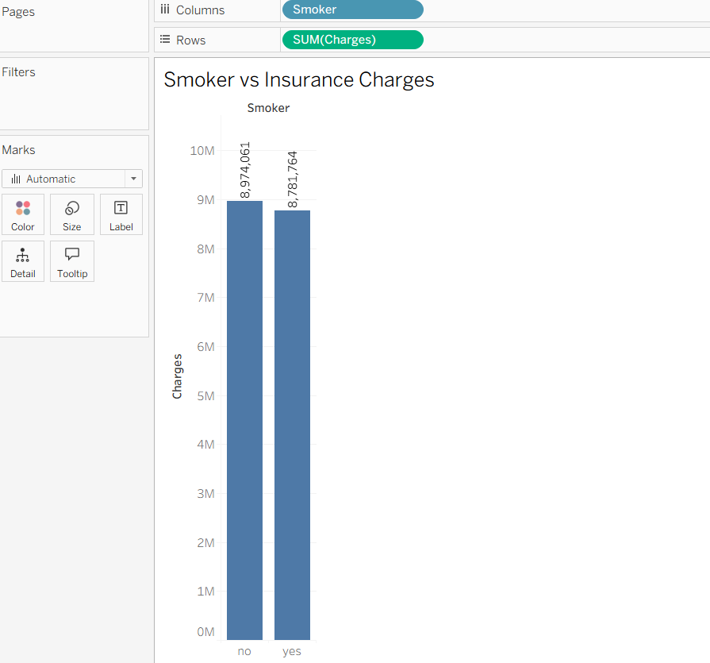
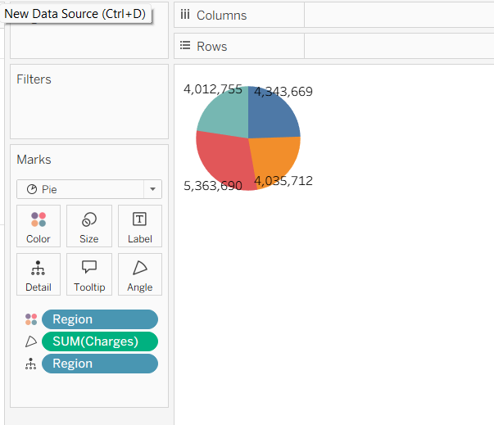
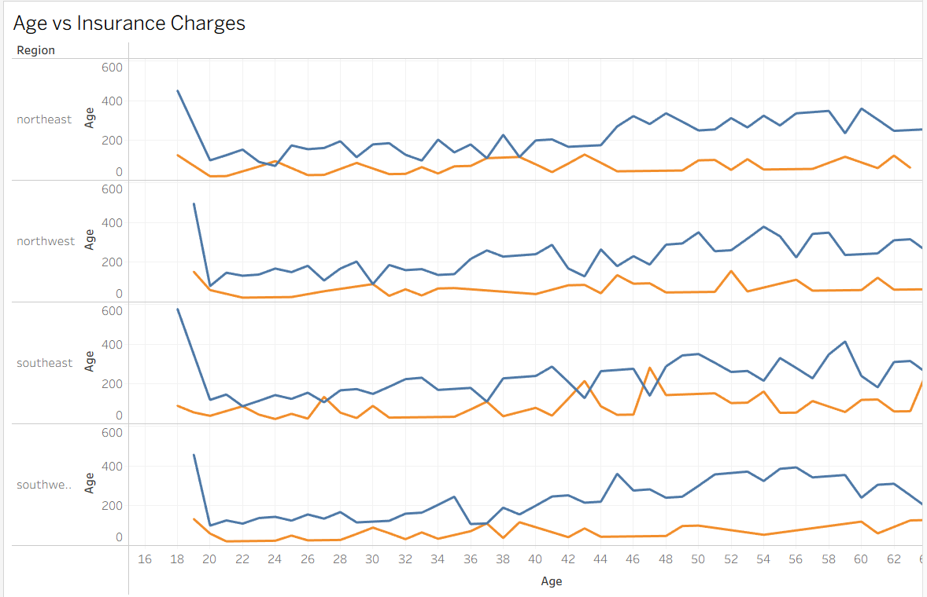
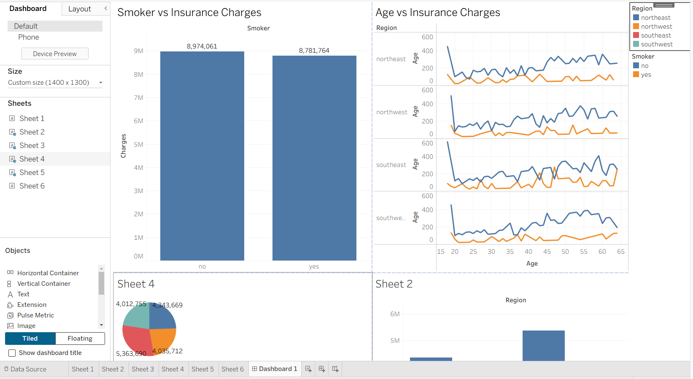

RESULT:

