Ex.no: 8 | Mini Project - Healthcare Data Analytics

AIM:
To develop an interactive Healthcare Data Analytics dashboard using SQL Server, Power BI, and Tableau to analyze patient demographics, medical conditions, treatment costs, hospital stay duration, readmission patterns, insurance claims, and patient outcomes, enabling effective data-driven healthcare analysis and decision-making.
DOMAIN AND PROBLEM STATEMENT:
Domain: Healthcare Data Analytics
Problem Statement:
Healthcare organizations generate large volumes of patient, treatment, admission, insurance, and medical data. However, raw healthcare data can be difficult to analyze and use for identifying important trends and patterns. This project addresses these challenges by transforming raw healthcare records into structured business intelligence using SQL Server, Power BI, and Tableau. The project enables analysis of patient demographics, medical conditions, treatment costs, length of stay, readmission patterns, insurance claims, and patient outcomes to support data-driven healthcare management and decision-making.
DATASET DESCRIPTION:
Dataset Name: Healthcare Analytics Dataset
Granularity: Each row represents a single healthcare/patient record.
Timeframe Covered: Healthcare admission and treatment records covering multiple years.
Key Entities & Attributes:
- Patient Details: Patient ID, First Name, Last Name, Gender, Date of Birth, Registration Date.
- Medical Information: Medical Condition, Medication, Admission Type, Patient State, Outcome.
- Hospitalization Details: Admission Date, Discharge Date, Length of Stay, Readmission Status.
- Financial & Insurance Details: Insurance Provider, Insurance Claim Amount, Total Treatment Cost.

Tools Used:
- SQL Server – Data storage and management
- Power BI – Interactive dashboard and business intelligence
- Tableau – Data visualization and analysis
PROGRAM:
Python – Data cleaning and processing
import pandas as pd
df = pd.read_csv("healthcare_dataset.csv")
print("First 5 records:")
print(df.head())
print("\nDataset Information:")
print(df.info())
print("\nDataset Shape:")
print(df.shape)
print("\nMissing Values:")
print(df.isnull().sum())
print("\nNumber of Duplicate Records:")
print(df.duplicated().sum())
df = df.drop_duplicates()
df['Admission_Date'] = pd.to_datetime(df['Admission_Date'], errors='coerce')
df['Discharge_Date'] = pd.to_datetime(df['Discharge_Date'], errors='coerce')
df['Length_of_Stay'] = (
df['Discharge_Date'] - df['Admission_Date']
).dt.days
numeric_columns = df.select_dtypes(include=['int64', 'float64']).columns
for column in numeric_columns:
df[column] = df[column].fillna(df[column].median())
categorical_columns = df.select_dtypes(include=['object']).columns
for column in categorical_columns:
df[column] = df[column].fillna(df[column].mode()[0])
df = df[df['Length_of_Stay'] >= 0]
for column in categorical_columns:
df[column] = df[column].astype(str).str.strip()
print("\nMissing Values After Cleaning:")
print(df.isnull().sum())
print("\nDuplicate Records After Cleaning:")
print(df.duplicated().sum())
print("\nCleaned Dataset:")
print(df.head())
df.to_csv("healthcare_cleaned.csv", index=False)
print("\nData cleaning completed successfully!")
print("Cleaned file saved as healthcare_cleaned.csv")
SQL SERVER CONNECTIVITY
Create database named HospitalAnalytics
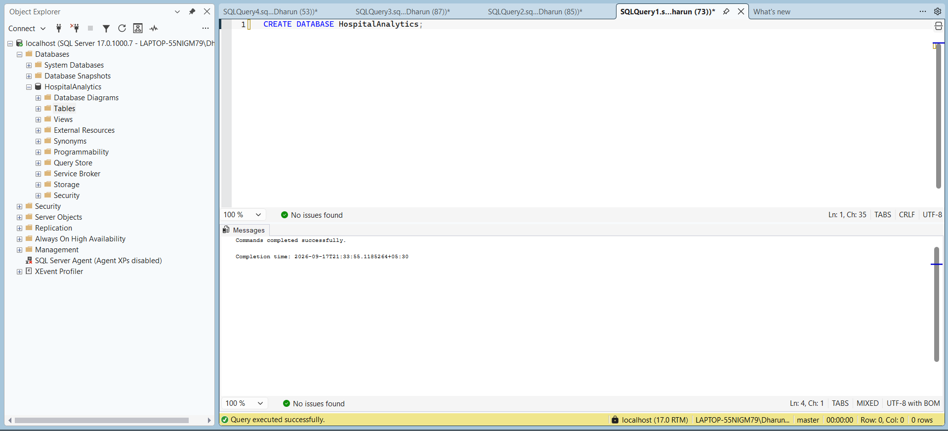
Import csv file if the dataset:
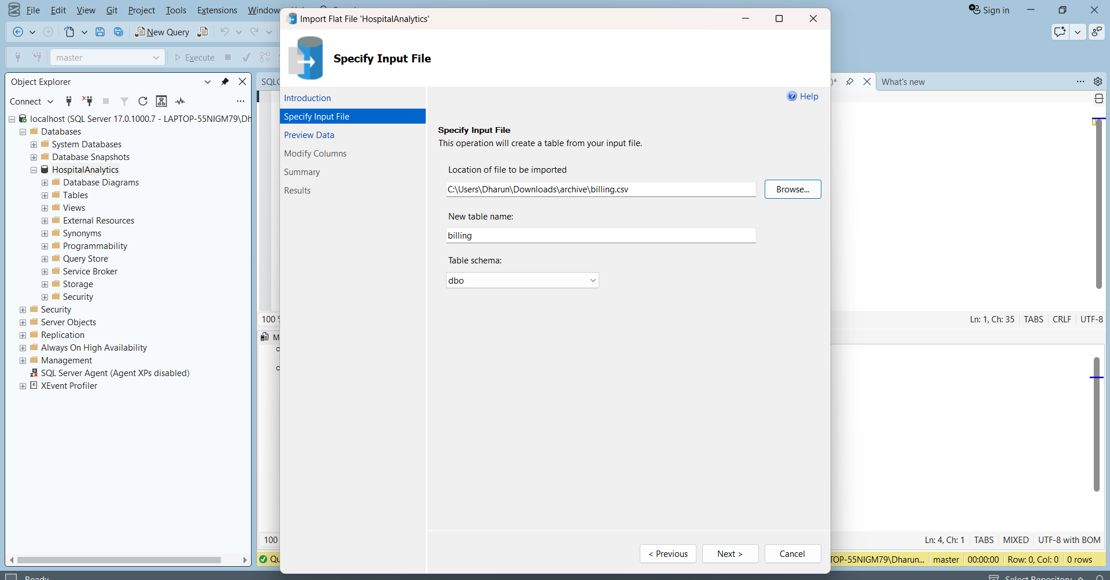
POWERBI DESKTOP:
Import data from sql server
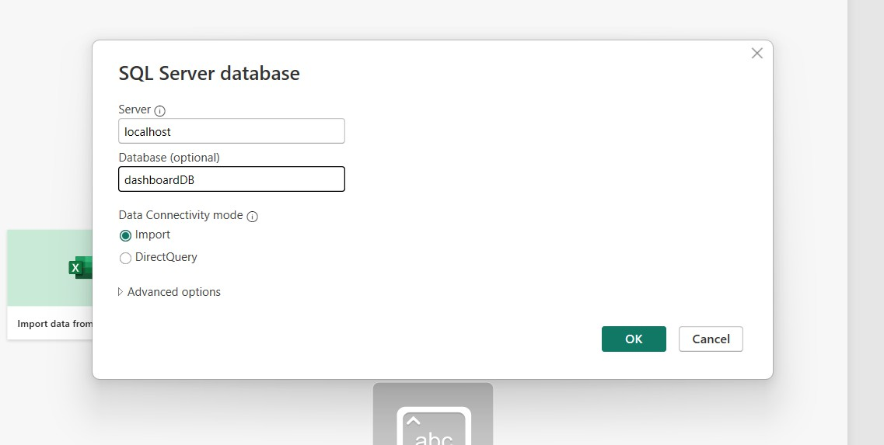
Table view of dataset in powerbi
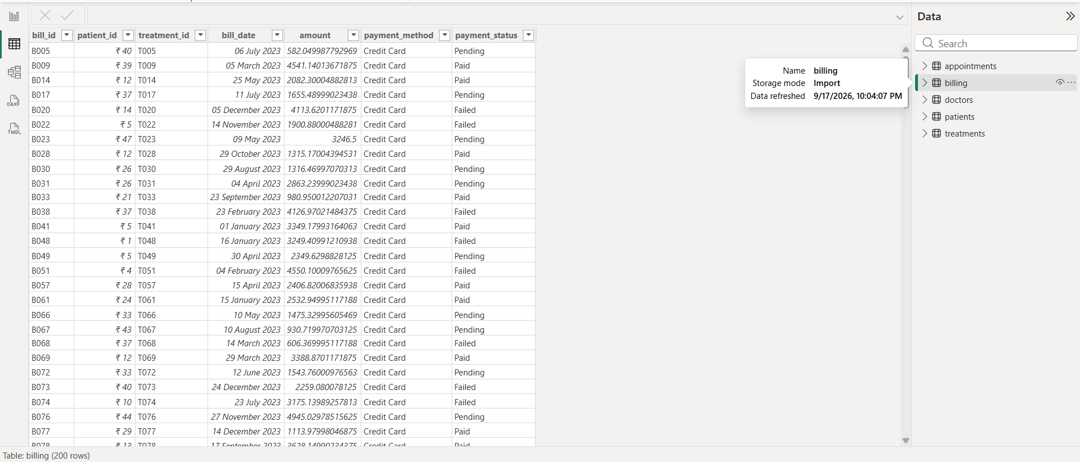
Powerbi dashboard:
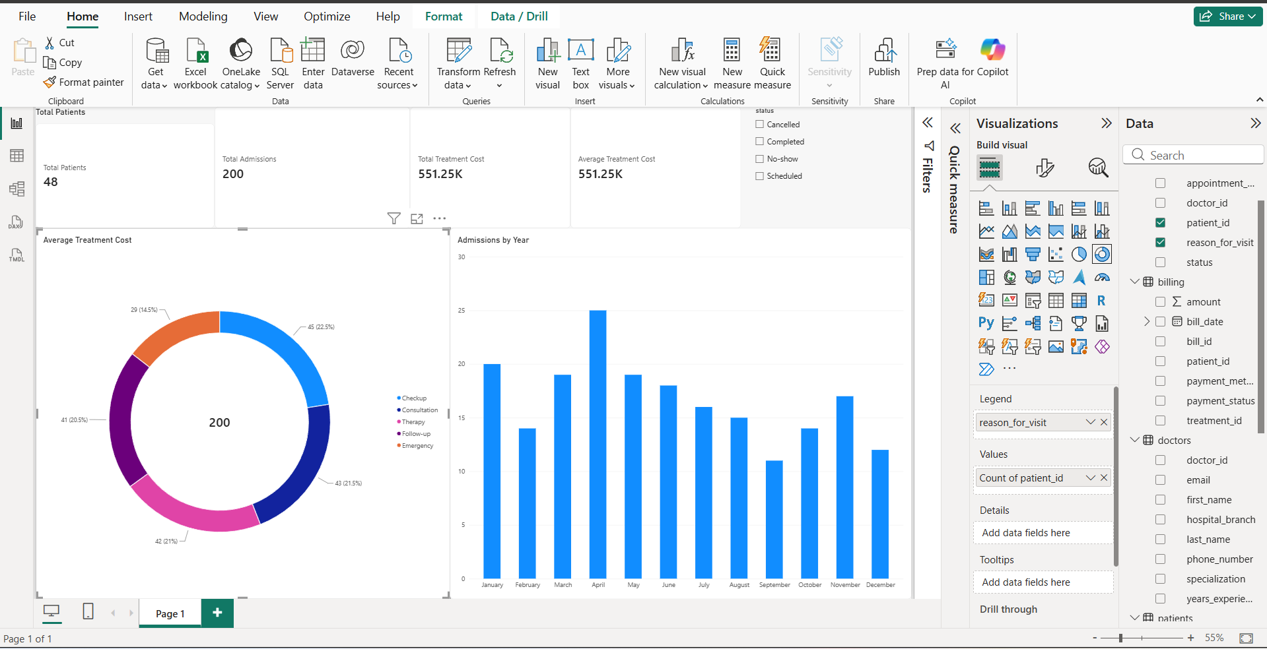
TABLEAU :
Import data from sql server
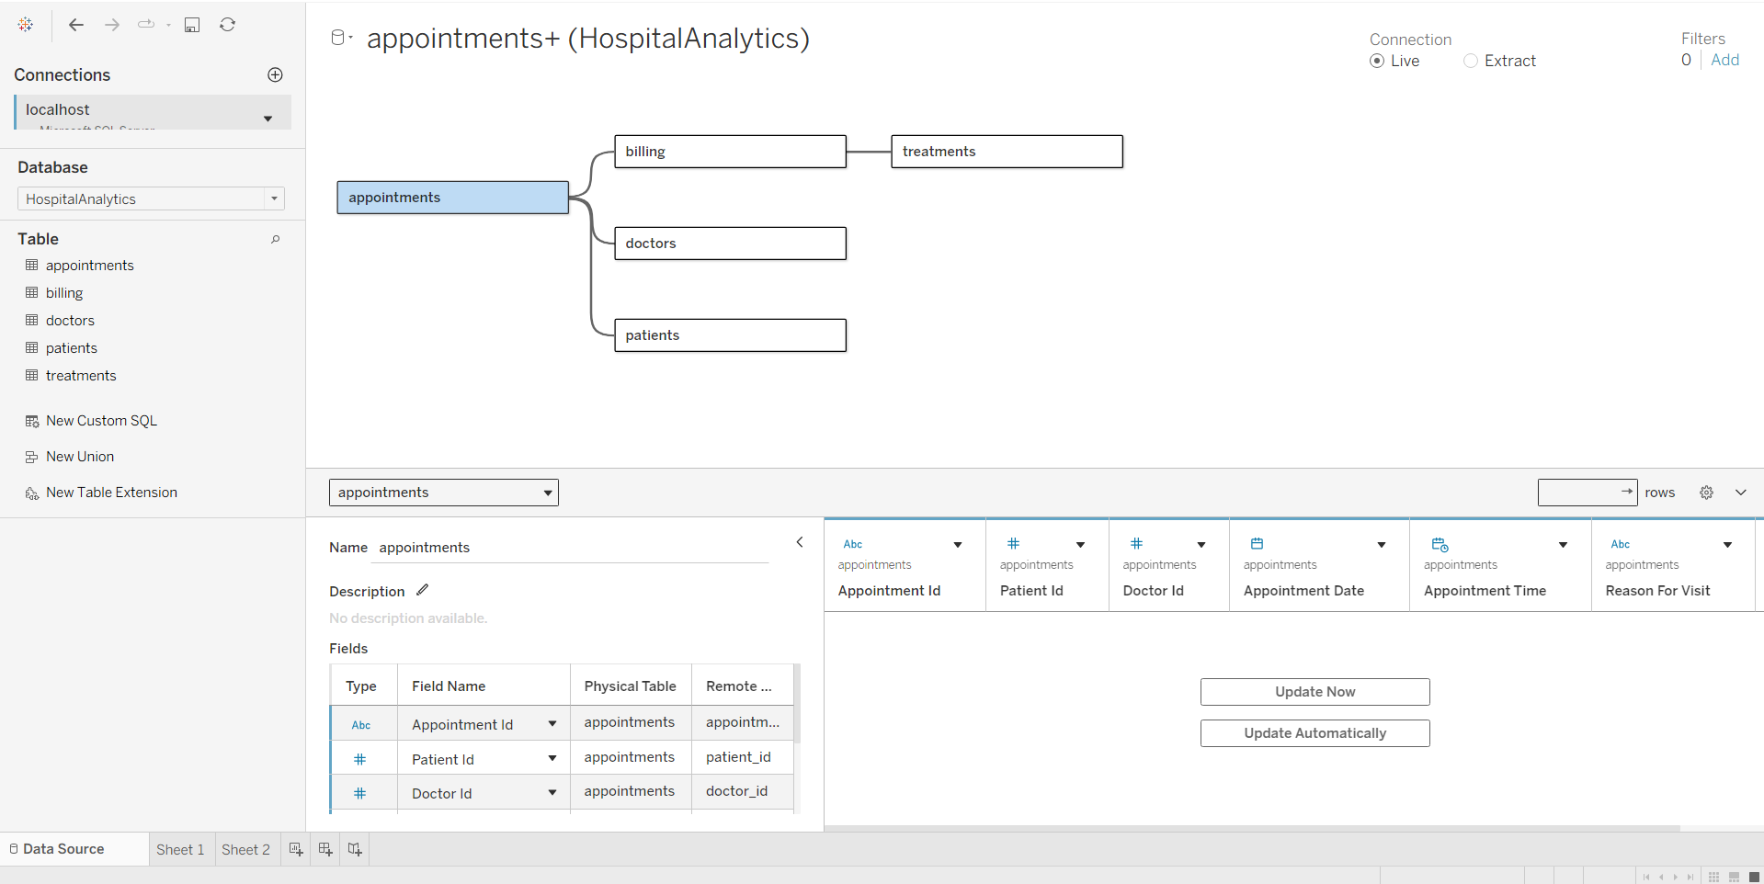
Dashboard
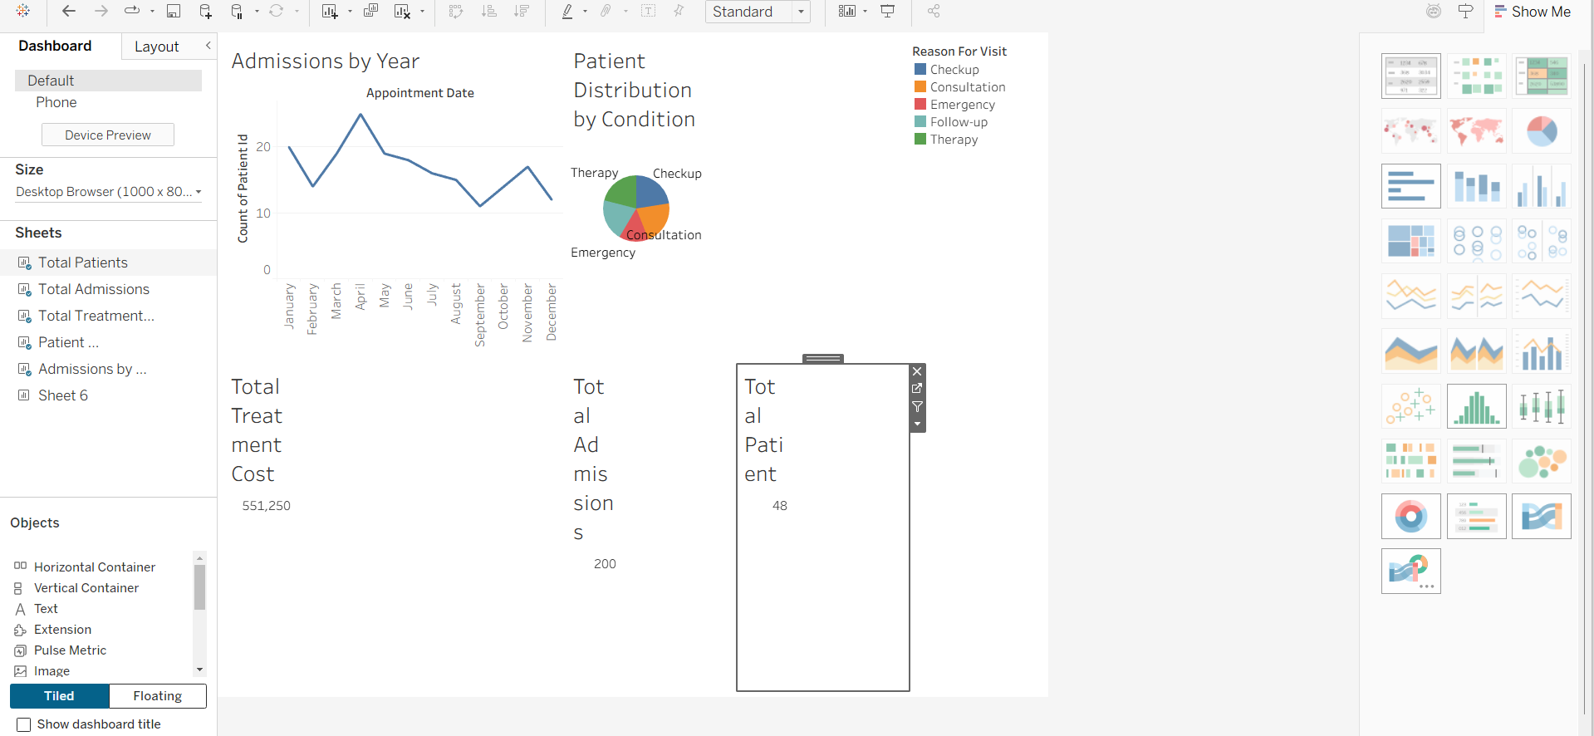

RESULT:

