Ex.no: 8 | Mini Project - Financial Data Analytics

AIM:
To develop an interactive Financial Data Analytics dashboard using SQL Server, Power BI, and Tableau to analyze customer demographics, account types, account status, financial transactions, loan details, and customer financial patterns, enabling effective data-driven financial analysis and decision-making.
DOMAIN AND PROBLEM STATEMENT:
Domain: Financial Data Analytics
Problem Statement:
Financial institutions generate large volumes of customer, account, loan, transaction, and financial data. However, raw financial data can be difficult to analyze and use for identifying important trends and patterns. This project addresses these challenges by transforming raw financial records into structured business intelligence using SQL Server, Power BI, and Tableau. The project enables analysis of customer demographics, account types, account status, loan details, transaction patterns, and financial activities to support data-driven financial management and decision-making.
DATASET DESCRIPTION:
Dataset Name: Financial Analytics Dataset
Granularity: Each row represents a single record related to customers, accounts, loans, or financial transactions.
Timeframe Covered: Financial customer, account, loan, and transaction records covering multiple years.
Key Entities & Attributes:
- Customer Details: Customer ID, Customer Name, Customer Type, Gender, Date of Birth, City, State.
- Account Details: Account ID, Customer ID, Account Type, Account Status, Opening Date, Balance.
- Loan Details: Loan ID, Customer ID, Loan Type, Loan Amount, Loan Status, Interest Rate.
- Transaction Details: Transaction ID, Account ID, Customer ID, Transaction Type, Transaction Date, Amount, Branch.
Tools Used:
- SQL Server – Data storage and management
- Power BI – Interactive dashboard and business intelligence
- Tableau – Data visualization and analysis
PROGRAM:
Python – Data cleaning and processing
import pandas as pd
customers = pd.read_csv("customers.csv")
accounts = pd.read_csv("accounts.csv")
loans = pd.read_csv("loans.csv")
transactions = pd.read_csv("transactions.csv")
print("Customers - First 5 Records:")
print(customers.head())
print("\nAccounts - First 5 Records:")
print(accounts.head())
print("\nLoans - First 5 Records:")
print(loans.head())
print("\nTransactions - First 5 Records:")
print(transactions.head())
print("\nCustomers Shape:")
print(customers.shape)
print("\nAccounts Shape:")
print(accounts.shape)
print("\nLoans Shape:")
print(loans.shape)
print("\nTransactions Shape:")
print(transactions.shape)
print("\nMissing Values in Customers:")
print(customers.isnull().sum())
print("\nMissing Values in Accounts:")
print(accounts.isnull().sum())
print("\nMissing Values in Loans:")
print(loans.isnull().sum())
print("\nMissing Values in Transactions:")
print(transactions.isnull().sum())
print("\nDuplicate Records:")
print("Customers:", customers.duplicated().sum())
print("Accounts:", accounts.duplicated().sum())
print("Loans:", loans.duplicated().sum())
print("Transactions:", transactions.duplicated().sum())
customers = customers.drop_duplicates()
accounts = accounts.drop_duplicates()
loans = loans.drop_duplicates()
transactions = transactions.drop_duplicates()
customers = customers.dropna(subset=["Customer_ID"])
accounts = accounts.dropna(subset=["Account_ID"])
loans = loans.dropna(subset=["Loan_ID"])
transactions = transactions.dropna(subset=["Transaction_ID"])
categorical_datasets = [customers, accounts, loans, transactions]
for data in categorical_datasets:
categorical_columns = data.select_dtypes(include=["object"]).columns
for column in categorical_columns:
data[column] = data[column].astype(str).str.strip()
numeric_datasets = [customers, accounts, loans, transactions]
for data in numeric_datasets:
numeric_columns = data.select_dtypes(include=["int64", "float64"]).columns
for column in numeric_columns:
data[column] = data[column].fillna(data[column].median())
print("\nMissing Values After Cleaning:")
print("Customers:")
print(customers.isnull().sum())
print("\nAccounts:")
print(accounts.isnull().sum())
print("\nLoans:")
print(loans.isnull().sum())
print("\nTransactions:")
print(transactions.isnull().sum())
customers.to_csv("customers_cleaned.csv", index=False)
accounts.to_csv("accounts_cleaned.csv", index=False)
loans.to_csv("loans_cleaned.csv", index=False)
transactions.to_csv("transactions_cleaned.csv", index=False)
print("\nData cleaning completed successfully!")
print("Cleaned files saved:")
print("customers_cleaned.csv")
print("accounts_cleaned.csv")
print("loans_cleaned.csv")
print("transactions_cleaned.csv")
SQL SERVER CONNECTIVITY
Create database named FinancialAnalytics
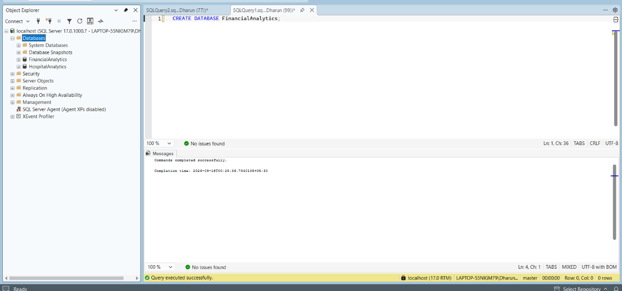
Import csv file if the dataset:
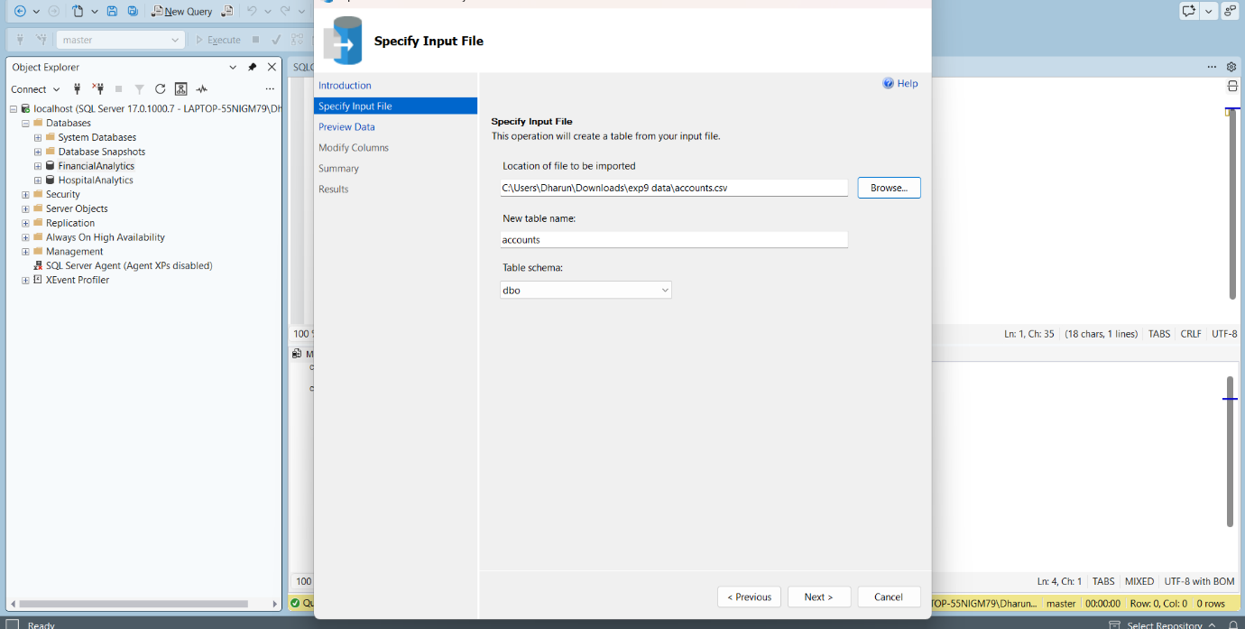
POWERBI DESKTOP:
Import data from sql server
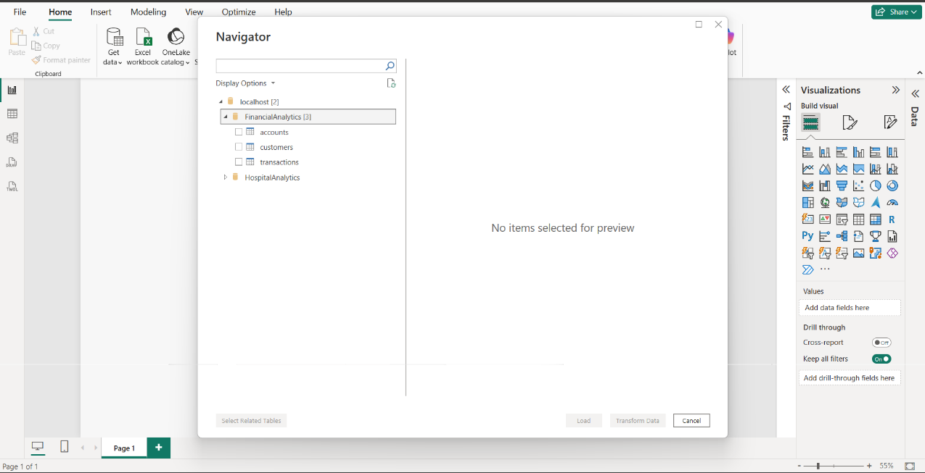
Table view of dataset in powerbi
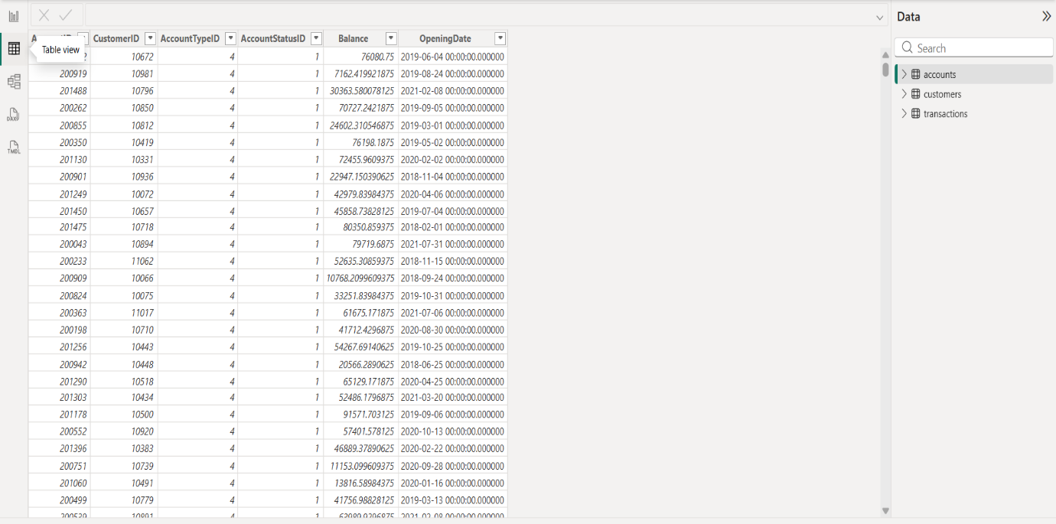
Powerbi dashboard:
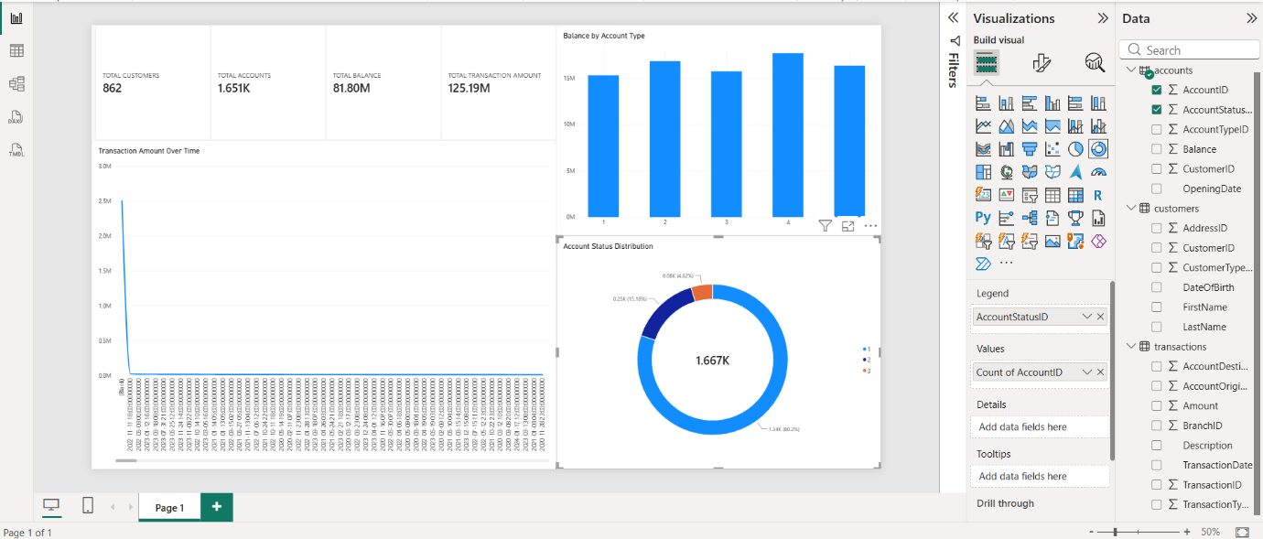
TABLEAU :
Import data from sql server
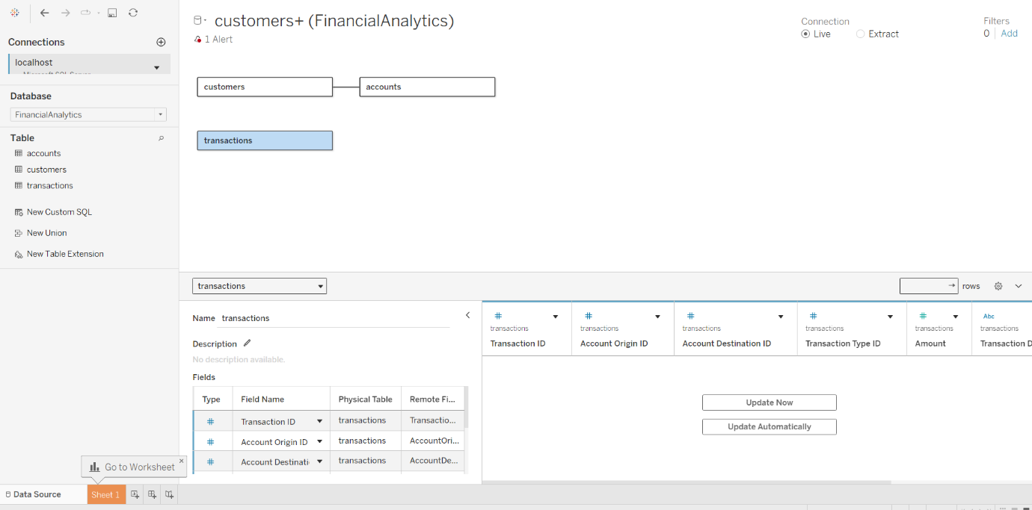
Dashboard
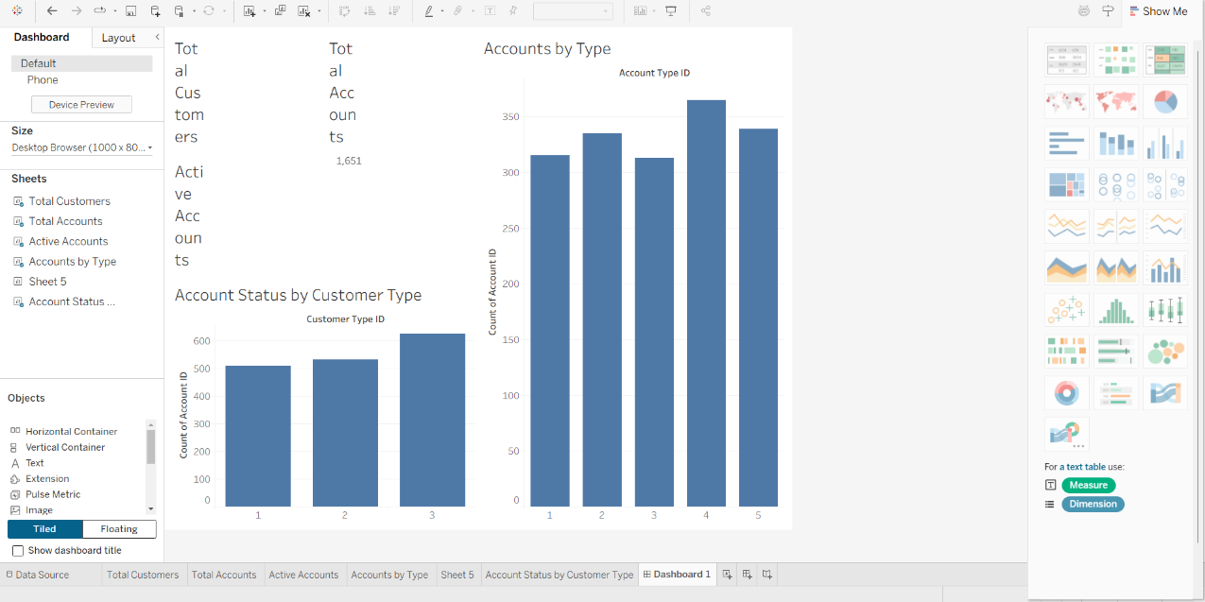

RESULT:

