Experiment No: 02

Aim: To study the process of normalization and apply normal forms. Eliminate data redundancy and improve database design. Given an un-normalized student database.

CREATE TABLE Student (
StudentID INT PRIMARY KEY,
StudentName VARCHAR(50) NOT NULL,
Address VARCHAR(100)
);

SELECT * FROM Student;

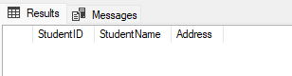
CREATE TABLE Course (
CourseID INT PRIMARY KEY,
CourseName VARCHAR(50) NOT NULL
);

SELECT * FROM Course;

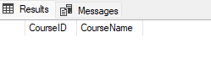
/*enrollment table*/
CREATE TABLE Enrollment (
StudentID INT,
CourseID INT,
Grade CHAR(1),
PRIMARY KEY (StudentID, CourseID),
FOREIGN KEY (StudentID) REFERENCES Student(StudentID),
FOREIGN KEY (CourseID) REFERENCES Course(CourseID)
);

SELECT * FROM Enrollment;

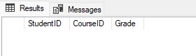

/* insert data*/
-- Students
INSERT INTO Student VALUES (1, 'Amit', '123 Main St');
INSERT INTO Student VALUES (2, 'Bob', '456 Park Ave');

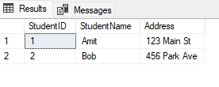
-- Courses
INSERT INTO Course VALUES (1, 'Math');
INSERT INTO Course VALUES (2, 'Science');
INSERT INTO Course VALUES (3, 'History');

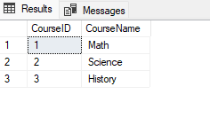

-- Enrollments
INSERT INTO Enrollment VALUES (1, 1, 'A'); -- Amit - Math
INSERT INTO Enrollment VALUES (1, 2, 'B'); -- Amit - Science
INSERT INTO Enrollment VALUES (2, 1, 'C'); -- Bob - Math
INSERT INTO Enrollment VALUES (2, 2, 'A'); -- Bob - Science
INSERT INTO Enrollment VALUES (2, 3, 'B'); -- Bob – History

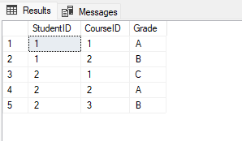

/*Get all courses for Amit*/

SELECT s.StudentName, c.CourseName, e.Grade
FROM Enrollment e
JOIN Student s ON e.StudentID = s.StudentID
JOIN Course c ON e.CourseID = c.CourseID
WHERE s.StudentName = 'Amit';

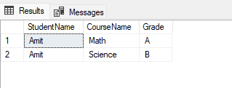

Experiment No :03

Aim :To implement data defination language (DDL) Queries for creating, altering, & dropping database: tables. Design & execute sql Queries for creating, altering & dropping table for library management system.

CREATE TABLE Books ( BookID INT PRIMARY KEY, Title VARCHAR(100), Author VARCHAR(100),
Publisher VARCHAR(100), YearPublished INT, Price DECIMAL(10,2)
);

select * from Books;


CREATE TABLE Members ( MemberID INT PRIMARY KEY,
MemberName VARCHAR(100), Email VARCHAR(100), Phone VARCHAR(15),
JoinDate DATE
);

select * from Members;
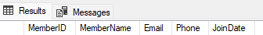

CREATE TABLE IssuedBooks ( IssueID INT PRIMARY KEY, BookID INT,
MemberID INT, IssueDate DATE, ReturnDate DATE,
FOREIGN KEY (BookID) REFERENCES Books(BookID),
FOREIGN KEY (MemberID) REFERENCES Members(MemberID)
);
select * from IssuedBooks;

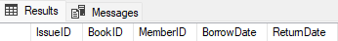

/* add*/
ALTER TABLE Books
ADD Category VARCHAR(50);
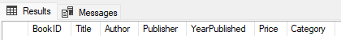

/*modify*/
ALTER TABLE Members ALTER COLUMN Phone VARCHAR(10);
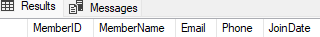

ALTER TABLE Books
ALTER COLUMN Price DECIMAL(10,2) NOT NULL;
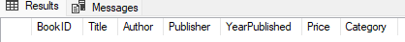

/*rename*/
EXEC sp_rename 'IssuedBooks', 'BorrowBooks'; select * from BorrowBooks;
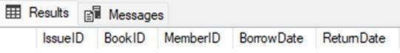

/*drop*/
DROP TABLE IssuedBooks; DROP TABLE Members; DROP TABLE Books;

/*truncate*/
truncate TABLE IssuedBooks; truncate TABLE Members; truncate TABLE Books;

Experiment No : 04

Aim :Implement DML queries (inserting, deleting, updating, and displaying records) on the Library Management System
database created in the previous practical to perform data operations on the Author, Book, and Member tables.
Create table Author( AuthorID int, AuthorName varchar(50),
Nationality varchar(50),
);
select * from Author;



create table Book( BookID int,
Title varchar(50), AuthorID int, AvailableCopies int, totalcopies int
);
select * from Book;
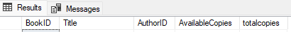

create table Member3( MemberID int, MemberName varchar(50),
addr varchar(50), phone varchar(10)
);
select * from Member3;


insert into Author values(1,'Chetan Bhagat','India'); insert into Author values(2,'J.K. Rowling','UK'); insert into Author values(3,'R.K. Narayan','India');

select * from Author;

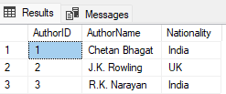

insert into Book values(101,'Five Point Someone',1,5,20); insert into Book values(102,'Harry Potter',2,4,15);
insert into Book values(103,'Swami and Friends',3,6,30); select * from Book;
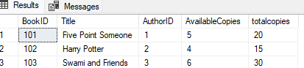

insert into Member3 values(11,'Amit Sharma','Pune',9876543210); insert into Member3 values(12,'Neha Patil','Mumbai',8898765456); insert into Member3 values(13,'Rahul Verma','Nagpur',9767854534);

select * from Member3;

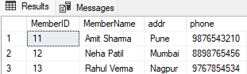

update Author set Nationality='United Kingdom' where AuthorID=2;
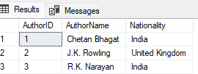

delete from Author where AuthorID=3;
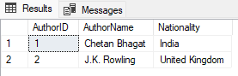

update Book set AvailableCopies=3 where BookID=103;
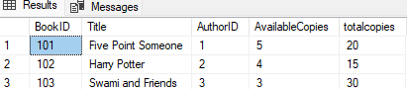

delete from Book where BookID=101;
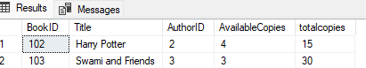

update Member3 set addr='Nashik' where MemberID=11;
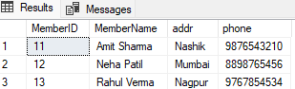
delete from Member3 where MemberID=13
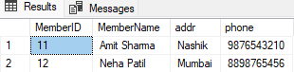

Experiment No :05

Aim.Consider two tables Students and Student_IT representing students enrolled in Computer Science and
Information Technology departments. Perform SQL set operations to combine and compare their data.
create table Students( studid int, studname varchar(50)
);
select * from Students;
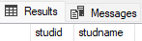

create table Student_IT( studid int,
studname varchar(50)
);
select * from Student_IT;


insert into Students values(1,'Raj'); insert into Students values(2,'Siya'); insert into Students values(3,'Prisha'); insert into Students values(4,'Shlok');

select * from Students;
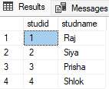

insert into Student_IT values(3,'Prisha'); insert into Student_IT values(4,'Shlok'); insert into Student_IT values(5,'Yogesh'); insert into Student_IT values(6,'Pravin');

select * from Student_IT;

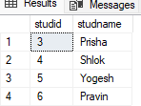

/*UNION – Combine and remove duplicates*/ SELECT * FROM Students
UNION
SELECT * FROM Student_IT;
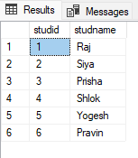

/*UNION ALL – Combine and keep duplicates*/ SELECT * FROM Students
UNION ALL
SELECT * FROM Student_IT;
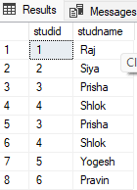

/*INTERSECT – Common students (in both departments)*/ SELECT * FROM Students
INTERSECT
SELECT * FROM Student_IT;
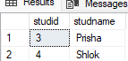

/*EXCEPT (or MINUS in Oracle) – Students only in Computer Science*/ SELECT * FROM Students
EXCEPT
SELECT * FROM Student_IT;

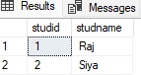

/*Reverse EXCEPT – Students only in IT*/ SELECT * FROM Student_IT
EXCEPT
SELECT * FROM Students;
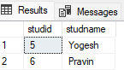

Name: Saniya Isak Ambekari

Branch: MCA Class: FY

Roll No: 03 Sub: DBMS Lab

Experiment No :06

Aim :Design two tables — Department and Employee — and demonstrate all SQL join operations to retrieve related data.
create table Department( deptid int,
deptname varchar(50)
);
select * from Department;


create table Employee( empid int,
empname varchar(50), deptid int
);
select * from Employee;


insert into Department values(1,'HR'); insert into Department values(2,'IT'); insert into Department values(3,'Finance'); insert into Department values(4,'Marketing');
select * from Department;
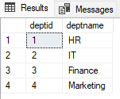

insert into Employee values(101,'Raj',1); insert into Employee values(102,'Sonali',2); insert into Employee values(103,'Alisha',3); insert into Employee values(104,'Sanika',5); insert into Employee values(105,'Pravin',NULL);

select * from Employee;
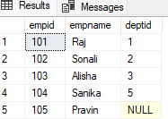

/*inner join*/

SELECT Employee.empid, empname, Department.deptname FROM Employee
INNER JOIN Department
ON Employee.deptid = Department.deptid;
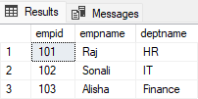

/*left join*/

SELECT empid,empname,deptname FROM Employee
LEFT JOIN Department
ON Employee.deptid= Department.deptid;
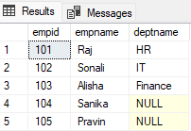

/*right join*/
SELECT empid,empname,deptname FROM Employee
RIGHT JOIN Department
ON Employee.deptid= Department.deptid;

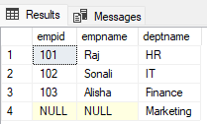

/*FULL OUTER JOIN */
SELECT empid,empname,deptname FROM Employee
FULL OUTER JOIN Department
ON Employee.deptid= Department.deptid;
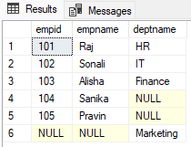

/*CROSS JOIN*/
SELECT empname,deptname FROM Employee
CROSS JOIN Department;
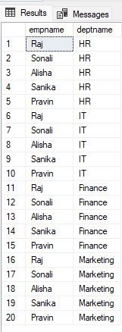

/*self join*/
SELECT D1.deptname AS Dept1, D2.deptname AS Dept2 FROM Department D1
JOIN Department D2
ON D1.deptid < D2.deptid;
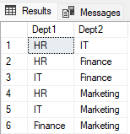

Name: Saniya Isak Ambekari

Branch: MCA Class: FY

Roll No: 03 Sub: DBMS Lab

Experiment No :07

Aim :Create a table named Employee and demonstrate the use of aggregate functions along with GROUP BY
and HAVING clauses.

CREATE TABLE Employee1 ( EmpID INT PRIMARY KEY, EmpName VARCHAR(50),
Department VARCHAR(50), Salary INT
);
select * from Employee1;
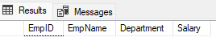

INSERT INTO Employee1 VALUES (1, 'Siya', 'HR', 35000),
(2, 'Meera', 'Finance', 55000),
(3, 'Rahul', 'HR', 38000),
(4, 'Sara', 'IT', 60000),
(5, 'Pravin', 'Finance', 52000),
(6, 'Rita', 'IT', 62000);
select * from Employee1;
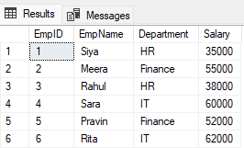

SELECT Department,
COUNT(*) AS TotalEmployees, SUM(Salary) AS TotalSalary, AVG(Salary) AS AvgSalary, MAX(Salary) AS HighestSalary, MIN(Salary) AS LowestSalary
FROM Employee1 GROUP BY Department;

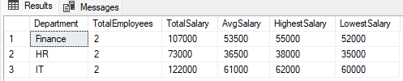

SELECT Department,SUM(Salary) AS TotalSalary FROM Employee1 GROUP BY Department
HAVING SUM(Salary) > 100000;

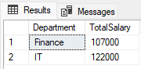

Experiment No: 8

Aim: Create and demonstrate the use of built-in and user-defined functions in SQL using an Employee table.

CREATE TABLE Employee1 (
EmployeeID INT PRIMARY KEY,
FirstName VARCHAR(50),
LastName VARCHAR(50),
Salary DECIMAL(10,2),
Department VARCHAR(50),
DateOfJoining DATE
);

SELECT * FROM Employee1;

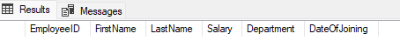
INSERT INTO Employee1 VALUES
(1, 'Amit', 'Sharma', 5000, 'HR', '2020-01-15'),
(2, 'Jane', 'Smith', 7000, 'IT', '2018-03-10'),
(3, 'Bob', 'Johnson', 6000, 'Finance', '2019-07-25'),
(4, 'Charlie', 'Brown', 8000, 'IT', '2017-11-30');

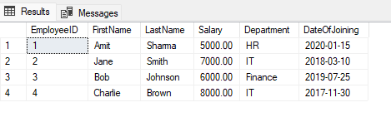
/*built-in*/
/*concat*/
SELECT EmployeeID, CONCAT(UPPER(FirstName), ' ', UPPER(LastName)) AS FullName
FROM Employee1;

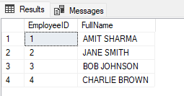

/*year & gatdate*/
SELECT EmployeeID, FirstName, LastName,
YEAR(GETDATE()) - YEAR(DateOfJoining) AS YearsWorked
FROM Employee1;
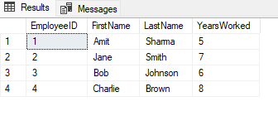
--round
SELECT EmployeeID, FirstName, Salary, ROUND(Salary, -3) AS RoundedSalary
FROM Employee1;

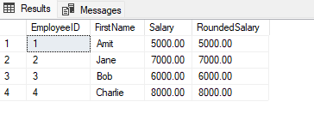
/*user defined*/
/*Scalar-valued function*/
CREATE FUNCTION dbo.Calculate_Bonus (@Salary DECIMAL(10,2))
RETURNS DECIMAL(10,2)
AS
BEGIN
DECLARE @Bonus DECIMAL(10,2);
SET @Bonus = @Salary * 0.10;
RETURN @Bonus;
END;

SELECT EmployeeID, FirstName, Salary, dbo.CalculateBonus(Salary) AS Bonus
FROM Employee1

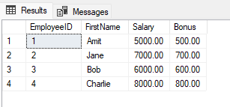

Experiment No :09

Aim: Write PL/SQL blocks to demonstrate predefined and user-defined exception handling.
/*Predefined Exception Handling*/

/*Divide-by-zero error (predefined)*/

BEGIN TRY
DECLARE @num1 INT = 10;
DECLARE @num2 INT = 0;
DECLARE @result INT;

SET @result = @num1 / @num2; -- Divide by zero
PRINT 'Result: ' + CAST(@result AS VARCHAR);
END TRY
BEGIN CATCH
PRINT 'Error occurred: ' + ERROR_MESSAGE();
END CATCH;

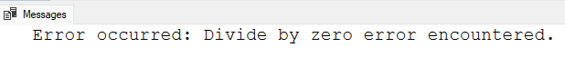

/*User-Defined Exception*/

BEGIN TRY
DECLARE @v_employee_salary INT = 500;
DECLARE @v_min_salary INT = 1000;

PRINT 'Checking salary...';

-- Raise a user-defined exception if salary is below minimum
IF @v_employee_salary < @v_min_salary
THROW 51001, 'Error: Employee salary is below the minimum required amount.', 1;

PRINT 'Salary is valid.';
END TRY
BEGIN CATCH
PRINT 'An error occurred: ' + ERROR_MESSAGE();
END CATCH;

Experiment No: 10

Aim: Create and execute stored procedures to perform different operations such as inserting, updating, and displaying employee records.

CREATE TABLE employees (
emp_id INT IDENTITY(1,1) PRIMARY KEY,
first_name VARCHAR(50),
last_name VARCHAR(50),
department VARCHAR(50),
salary DECIMAL(10,2)
);

SELECT * FROM employees;

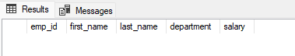

/*insert procedure*/
CREATE PROCEDURE insert_employe
@first_name VARCHAR(50),
@last_name VARCHAR(50),
@department VARCHAR(50),
@salary DECIMAL(10,2)
AS
BEGIN
INSERT INTO employee(first_name, last_name, department, salary)
VALUES (@first_name, @last_name, @department, @salary);
END;

--execute
EXEC insert_employe 'Amit', 'Sharma', 'HR', 50000;

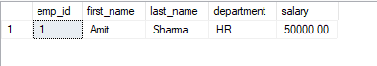

/*update procedure*/
CREATE PROCEDURE update_employee_salary
@emp_id INT,
@new_salary DECIMAL(10,2)
AS
BEGIN
UPDATE employee
SET salary = @new_salary
WHERE emp_id = @emp_id;
END;

--execute
EXEC update_employee_salary 1, 60000;
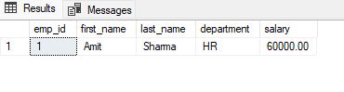
/*display procedure*/
CREATE PROCEDURE get_all_employee
AS
BEGIN
SELECT * FROM employee;
END;

--execute
EXEC get_all_employee;

