Name- Vaishnavi Pulikkal
Section- B4 Batch- B2
Rll no- 27
Sem V
SEPM LAB
Practical 2-a
Project Title- Online Food Delivery System
Aim: Identify requirement- Functional requirement, non functional requirement.
Functional Requirements
Functional Requirements for online food delivery system:
1. User Registration- The system should allow new users to create an account using their email ID or mobile number. Each user should have a unique username and password.
2. User Login- Registered users should be able to log in using their username and password. The system should verify the entered credentials before providing access.
3. Manage User Profile- Users should be able to update their personal information such as name, phone number, and delivery address whenever required.
4. View Restaurants- Customers should be able to view the list of available restaurants. The system should display restaurant details including name, rating, menu, and estimated delivery time.
5. View Food Menu- Users should be able to see all food items offered by a selected restaurant. Each item should contain its name, price, description, and image.
6. Search Food- The application should provide a search facility to find food items or restaurants. Users should also be able to filter the results based on category, price, or rating.
7. Add Items to Cart- Customers should be able to add food items to the cart, update item quantities, and remove items if needed.
8. Place Order- After confirming the cart items, users should be able to place an order. The system should generate a unique order number for every successful order.
9. Payment- The system should support multiple payment methods such as UPI, Credit/Debit Card, Net Banking, and Cash on Delivery.
10. Order Tracking- Customers should be able to track their orders. The order status should show stages such as Order Confirmed, Preparing Food, Out for Delivery, and Delivered.
11. Ratings and Reviews- After receiving the order, customers should be able to give ratings and write reviews for the food and restaurant.
12. Order History- Users should be able to view all previous orders and have the option to reorder the same items.
13. Admin Module- The admin should be able to manage restaurants, food items, customer orders, and users. The admin should also be able to generate reports related to the system.
Non-Functional Requirements
Non-functional requirements of the system are:
1. Performance- The application should respond quickly to user actions. Searching for food items and placing orders should be completed within a few seconds.
2. Security- User passwords should be stored securely, and payment information should be protected. Access to the admin panel should be restricted to authorized users only.
3. Reliability- The system should operate without frequent crashes or errors, and customer orders should be processed correctly every time.
4. Availability- The application should be available 24 hours a day and 7 days a week so that users can access it at any time.
5. Scalability- The system should be capable of handling an increasing number of users, restaurants, and orders as the business grows.
6. Usability- The user interface should be simple, clear, and easy to use, even for first-time users.
7. Maintainability- The system should be easy to maintain and update. New features should be added without affecting existing functionality.
8. Compatibility- The application should work properly on Android phones, iPhones, laptops, and desktop computers, and it should support popular web browsers such as Chrome, Edge, and Firefox.
9. Data Integrity- Customer, restaurant, and order data should be stored accurately, and duplicate or incorrect records should be avoided.
10. Backup and Recovery- The database should be backed up regularly, and data should be recoverable in case of system failure.
11. Privacy- Customer information should remain confidential, and personal details should not be shared without the user’s permission.
Use Case diagram created on Star UML (offline platform)-
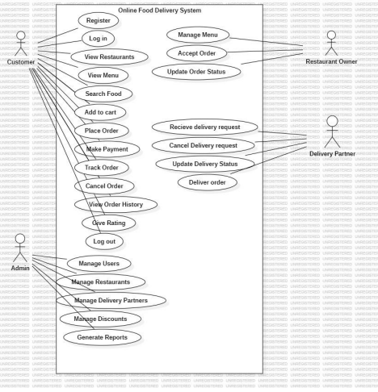
Practical 2-b
Activity Diagram
1. User Login:
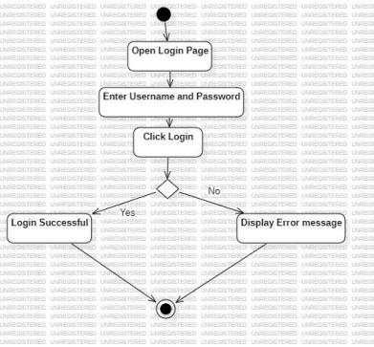
2. Place Order:
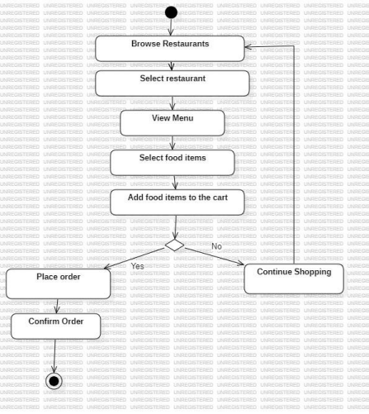
3. Make Payment:
