Name- Vaishnavi Pulikkal
Section- B4 Batch- B2
Roll No.- 27
Sem V
SEPM LAB PRACTICAL 4
Project Title- Online Food Delivery System
A sequence diagram is a type of interaction diagram in Unified Modeling Language (UML) that illustrates how objects interact with each other in a particular scenario of a system. It emphasizes the time order of messages exchanged between objects, showing the dynamic behavior of the system. In the context of our project- ‘Online Food Delivery System’, the sequence diagram models the flow of activities such as browsing food items, placing an order, making payment, tracking delivery, etc.
1] User Login Sequence Diagram
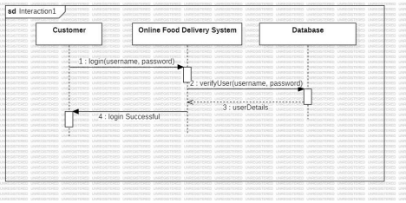
2] Place Order Sequence Diagram
