Name- Vaishnavi Pulikkal
Section- B4 Batch- B2
Roll No- 27
Sem V
SEPM LAB PRACTICAL 5
Project Title: Online Food Delivery System
State Diagram
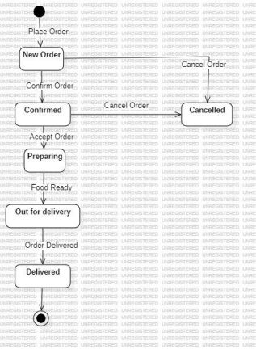

Deployment Diagram
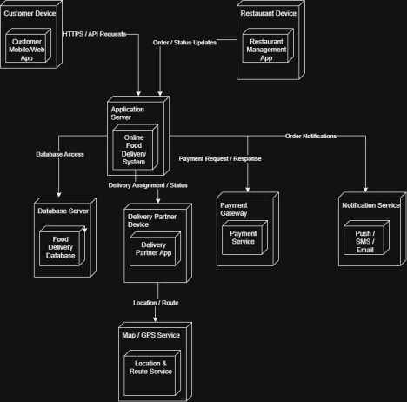

Component Diagram
