Name- Vaishnavi Pullikkal
Section- B4 Batch- B2
Roll No- 27
Sem V
SEPM LAB PRACTICAL 7
Gantt Chart
Project Title- Online Food Delivery System
Rough Project Schedule:
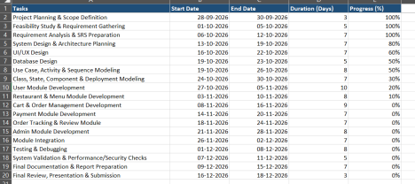Gantt Chart:
