Name- Vaishnavi Pulikkal
Section- B4 Batch- B2
Roll No- 27
Sem V
SEPM LAB PRACTICAL 8
Aim: To study white-box testing and path testing, draw a Control Flow Graph (CFG) for a program, calculate cyclomatic complexity, identify independent paths, and prepare test cases.
What is White-Box Testing:
White-box testing is a software testing technique in which the internal structure, source code, statements, conditions, and control flow of a program are examined. The tester uses knowledge of the program code to design test cases.
Objectives:
● To verify the internal logic of a program.
● To identify logical errors.
● To check statements, branches, and paths.
● To improve test coverage.
What is Path Testing: Path testing is a white-box testing technique in which test cases are designed to execute selected paths through a program's Control Flow Graph (CFG). A path is a sequence of nodes and edges followed during program execution. Path testing helps verify different possible execution routes through the program.
Program:
Write a Python program that accepts a student's marks and checks whether the marks are valid. Marks outside the range 0 to 100 are invalid. For valid marks, the program displays Pass if marks are 40 or above; otherwise, it displays Fail.
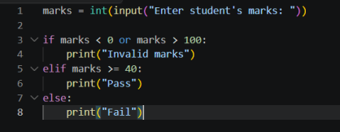
Control Flow Graph (CFG):
A Control Flow Graph represents the flow of execution in a program. Nodes represent statements or conditions, and directed edges represent the flow between them.
Nodes:
1 – Start
2 – Input marks
3 – Check marks < 0 or marks > 100
4 – Print Invalid marks
5 – Check marks >= 40
6 – Print Pass
7 – Print Fail
8 – End
Edges:
1 → 2
2 → 3
3 (True) → 4
3 (False) → 5
4 → 8
5 (True) → 6
5 (False) → 7
6 → 8
7 → 8
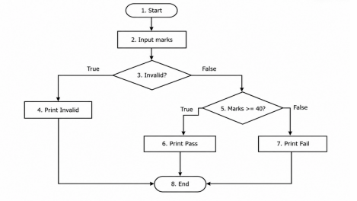
Cyclomatic Complexity:
Cyclomatic complexity gives the number of linearly independent paths in a program. Formula: V(G) = E − N + 2P
Where E = number of edges, N = number of nodes, and P = number of connected components. For this program:
E = 9, N = 8, P = 1
V(G) = 9 − 8 + 2(1) = 3
There are 2 decision points, so V(G) = 2 + 1 = 3.
Therefore, the cyclomatic complexity is 3.
Independent Paths:
Since the cyclomatic complexity is 3, three independent paths are identified:
Path 1 – Invalid marks: 1 → 2 → 3 (True) → 4 → 8
Path 2 – Pass: 1 → 2 → 3 (False) → 5 (True) → 6 → 8
Path 3 – Fail: 1 → 2 → 3 (False) → 5 (False) → 7 → 8
Test Cases:
Test Case ID | Input Marks | Expected Output | Path
TC-01 | -5 | Invalid marks | Path 1
TC-02 | 75 | Pass | Path 2
TC-03 | 28 | Fail | Path 3

