SOFTWARE REQUIREMENTS SPECIFICATION
FOR
ONLINE FOOD DELIVERY SYSTEM
Release Version 1.1
Prepared By: Vaishnavi Pulikkal
Section: B4 Batch: B2 Roll No: 27
Programme: B.Tech Computer Science and Engineering (Data Science & Analytics)
Ramdeobaba University, Nagpur
Submitted To: Prof. Nikita Jamgade
Department: Data Science
Academic Year: 2026–2027

Document Control and Revision History
Table 0.1: Revision History
Version | Date | Description of Changes | Author | Reviewer
1.1 | 21-Oct-2026 | Condensed and restructured to the standard SRS format. | Project Team | Prof. Nikita Jamgade
1.0 | 05-Oct-2026 | First complete baseline of the SRS. | Project Team | Prof. Nikita Jamgade
0.9 | 28-Sep-2026 | Added architecture diagrams and interface details. | Project Team | Prof. Nikita Jamgade
0.5 | 10-Sep-2026 | Added behavioral models and database design. | Project Team | Prof. Nikita Jamgade
0.1 | 15-Aug-2026 | Initial requirements and scope. | Project Team | Prof. Nikita Jamgade

Table of Contents
1. Introduction 4
1.1 Purpose 4
1.2 Problem Statement 4
1.3 Objectives 4
1.4 Scope 4
1.5 Definitions, Acronyms and Abbreviations 5
1.6 References 5
1.7 Overview of the Document 5
2. Overall Description 6
2.1 Product Perspective 6
2.2 Product Functions 6
2.3 User Classes and Characteristics 6
2.4 Operating Environment 6
2.5 Design and Implementation Constraints 6
2.6 Assumptions and Dependencies 7
3. External Interface Requirements 7
3.1 User Interfaces 7
3.2 Hardware Interfaces 7
3.3 Software Interfaces 7
3.4 Communication Interfaces 7
4. Specific Requirements 7
4.1 Functional Requirements 7
4.2 Non-Functional Requirements 10
4.3 Logical Database Requirements 12
5. UML Diagrams 13
5.1 Use Case Diagram 13
5.2 Activity Diagram – Login 14
5.3 Activity Diagram – Place Order 15
5.4 Activity Diagram – Payment 16
5.5 Class Diagram 16
5.6 Sequence Diagram – User Login 17
5.7 Sequence Diagram – Place Order 17
5.8 State Machine Diagram – Order Lifecycle 18
5.9 Deployment Diagram 19
5.10 Component Diagram 20
6. Project Scheduling 21
6.1 Overview 21
6.2 Tasks and Milestones 22
6.3 Gantt Chart 23
7. System Test Cases 24
7.1 Test Strategy 24
7.2 Test Cases 24
8. Appendices 25
Appendix A: Future Scope (TBD Items) 25
Appendix B: Requirements Traceability Matrix 26

1. Introduction

1.1 Purpose
This Software Requirements Specification (SRS) describes the requirements of the Online Food Delivery System. It defines what the system shall do, the interfaces it uses, its quality requirements and how it will be tested. It is intended for the project guide, developers, testers and evaluators, and follows the IEEE 830 / ISO 29148 structure.

1.2 Problem Statement
Ordering food by phone or through separate restaurant counters is slow and error-prone. Orders are misheard, customers cannot see menus, prices or availability, payments are handled manually, and nobody can see where an order is once it leaves the kitchen. Restaurants have no organized way to receive orders, and there is no central place to coordinate delivery partners. A single online system is needed to connect customers, restaurants and delivery partners.

1.3 Objectives
- Provide a single online platform for customers to browse restaurants, order food and pay digitally.
- Give restaurants a simple dashboard to manage menus and incoming orders.
- Automate delivery partner assignment and provide live order tracking.
- Reduce order errors and order turnaround time compared with phone-based ordering.
- Give administrators control over users, restaurants, discounts and reports.
- Keep user and payment data secure and the system reliable under peak load.

1.4 Scope
The Online Food Delivery System is a web and mobile application that supports four types of users:
- Customer: register, log in, search restaurants, manage cart, place and pay for orders, track and cancel orders, view history and rate.
- Restaurant: manage menu and availability, accept or reject orders, update preparation status.
- Delivery Partner: receive delivery requests, update pickup and delivery status.
- Administrator: manage users, restaurants, delivery partners and discounts, and generate reports.
The system does not include restaurant inventory management, accounting software or the operation of the payment, map and messaging services, which are used as external services.

1.5 Definitions, Acronyms and Abbreviations
Table 1.1: Definitions and Abbreviations
Term | Meaning
SRS | Software Requirements Specification
UML | Unified Modeling Language
RDBMS | Relational Database Management System
API | Application Programming Interface
REST | Representational State Transfer – HTTP-based service style
HTTPS / TLS | Encrypted web communication protocol
GPS | Global Positioning System
OTP | One-Time Password
ACID | Atomicity, Consistency, Isolation, Durability
RBAC | Role-Based Access Control
UPI | Unified Payments Interface
COD | Cash on Delivery
FR / NFR | Functional / Non-Functional Requirement
TBD | To Be Determined

1.6 References
[1] IEEE Std 830-1998, IEEE Recommended Practice for Software Requirements Specifications.
[2] ISO/IEC/IEEE 29148:2018, Systems and software engineering – Life cycle processes – Requirements engineering.
[3] Pressman, R. S., & Maxim, B. R. (2020). Software Engineering: A Practitioner’s Approach (9th ed.). McGraw-Hill.
[4] Sommerville, I. (2015). Software Engineering (10th ed.). Pearson.
[5] Booch, G., Rumbaugh, J., & Jacobson, I. (2005). The Unified Modeling Language User Guide (2nd ed.). Addison-Wesley.
[6] Elmasri, R., & Navathe, S. B. (2015). Fundamentals of Database Systems (7th ed.). Pearson.

1.7 Overview of the Document
Section 2 gives the overall description of the product. Section 3 lists the external interfaces. Section 4 specifies the functional and non-functional requirements and the database. Section 5 presents the UML diagrams, Section 6 the project schedule with the Gantt chart, and Section 7 the test cases. Section 8 lists the appendices.

2. Overall Description

2.1 Product Perspective
The system is a standalone client–server application with three layers: a presentation layer (web browser and mobile apps), an application layer containing the business logic, and a database layer. It connects to three external services: a payment gateway, a map/geolocation service and a notification service (push, SMS, email). Communication is through secure REST APIs and WebSocket.

2.2 Product Functions
- User registration, authentication and role-based access
- Restaurant discovery, search and filtering
- Menu browsing and cart management
- Order placement, cancellation and payment
- Order tracking and notifications
- Restaurant order and menu management
- Delivery dispatch and status updates
- Order history and ratings
- Administration and reporting

2.3 User Classes and Characteristics
Table 2.1: User Classes
User Class | Technical Skill | Main Activities | Access Level
Customer | Basic smartphone / computer skills | Browse, order, pay, track, rate | Own profile and orders only
Restaurant Owner | Moderate | Manage menu, accept orders, update status | Own restaurant only
Delivery Partner | Basic smartphone skills | Accept deliveries, update status | Assigned deliveries only
Administrator | Advanced | Manage users, restaurants, discounts, reports | Full system access

2.4 Operating Environment
- Client: Android 9+, iOS 13+, or desktop browsers (Chrome, Firefox, Edge, Safari – recent versions).
- Server: Linux server or cloud instance running the application server.
- Database: MySQL 8+ or PostgreSQL 13+.
- Network: TCP/IP with HTTPS (port 443) and secure WebSocket.

2.5 Design and Implementation Constraints
- Layered (MVC) architecture separating presentation, business logic and data.
- Passwords must be stored only as salted hashes (bcrypt/PBKDF2).
- All data in transit must use TLS 1.2 or higher.
- Card numbers and CVV must never be stored; payments use a PCI-DSS compliant gateway.
- Referential integrity enforced through primary and foreign keys.

2.6 Assumptions and Dependencies
- Users have internet-enabled devices with stable connectivity.
- Users provide valid addresses and contact details; restaurants keep menus and prices up to date.
- Third-party payment, map and notification services are available when needed.

3. External Interface Requirements

3.1 User Interfaces
Responsive web and mobile screens for each role: login/registration, restaurant listing with search, menu and cart, checkout and payment, live tracking, order history; restaurant order queue and menu editor; delivery task screen; admin console. Touch targets of at least 48 dp and WCAG 2.1 AA contrast are used.

3.2 Hardware Interfaces
No special hardware. Client devices need a browser or Android/iOS app (2 GB RAM minimum); mobile devices need GPS for delivery partner tracking. The server needs a quad-core CPU, 16 GB RAM and SSD storage.

3.3 Software Interfaces
RDBMS (MySQL/PostgreSQL) through JDBC/connection pooling with prepared statements; payment gateway (e.g., Razorpay/Stripe) via REST API; map and geolocation service (e.g., Google Maps) for routing; notification services (FCM, SMS, email).

3.4 Communication Interfaces
HTTPS with TLS for all client–server traffic; RESTful JSON APIs using GET/POST/PUT/DELETE; WebSocket (WSS) for live order and location updates.

4. Specific Requirements

4.1 Functional Requirements
Each requirement has a unique ID. The word “shall” marks a mandatory requirement.

4.1.1 Registration and Login
Allows users to create accounts and access the system according to their role.
Table 4.1: Registration and Login Requirements
ID | Requirement
FR-REG-01 | The system shall capture and validate name, email, phone, address and password during registration.
FR-REG-02 | The system shall reject duplicate registrations with an existing email or phone number.
FR-REG-03 | The system shall hash all passwords before storing them.
FR-LOG-01 | The system shall authenticate users of all roles against stored credentials.
FR-LOG-02 | The system shall restrict each role to its own interface (e.g., customers cannot open admin pages).
FR-LOG-03 | The system shall provide a logout function that ends the active session.

4.1.2 Search and Menu Browsing
Helps customers find restaurants and view their menus.
Table 4.2: Search and Menu Browsing Requirements
ID | Requirement
FR-SCH-01 | The system shall support keyword search on restaurant names, food items and cuisines.
FR-SCH-02 | The system shall allow filtering by dietary type, rating and price range.
FR-MNU-01 | The system shall display menus grouped by food category.
FR-MNU-02 | The system shall show real-time availability of food items.

4.1.3 Cart Management
Lets customers collect items before checkout.
Table 4.3: Cart Management Requirements
ID | Requirement
FR-CRT-01 | The system shall allow customers to add, increase, decrease and remove cart items.
FR-CRT-02 | The system shall restrict a cart to items from a single restaurant.
FR-CRT-03 | The system shall calculate item subtotals and the cart total in real time.

4.1.4 Order Placement and Payment
Converts the cart into an order and settles payment.
Table 4.4: Order Placement and Payment Requirements
ID | Requirement
FR-ORD-01 | The system shall validate the cart, delivery address and item availability at checkout.
FR-ORD-02 | The system shall generate a unique Order ID and fix item prices when the order is placed.
FR-ORD-03 | The system shall allow a customer to cancel an order before food preparation begins.
FR-PAY-01 | The system shall support Card, Net Banking, UPI and Cash on Delivery.
FR-PAY-02 | The system shall record the status and reference of every payment attempt.
FR-PAY-03 | The system shall set the order status to Confirmed once payment is verified.

4.1.5 Order Tracking and Notifications
Keeps the customer informed about the order.
Table 4.5: Order Tracking and Notifications Requirements
ID | Requirement
FR-TRK-01 | The system shall display order progress through the stages New, Confirmed, Preparing, Out for Delivery and Delivered.
FR-TRK-02 | The system shall show courier details and route once the order is out for delivery.
FR-NTF-01 | The system shall send push/SMS/email notifications on key order status changes.

4.1.6 Restaurant Management
Lets restaurants handle orders and maintain their menu.
Table 4.6: Restaurant Management Requirements
ID | Requirement
FR-RST-01 | The system shall show incoming orders to the restaurant in real time with an alert.
FR-RST-02 | The system shall allow the restaurant to accept (with preparation time) or reject an order.
FR-RST-03 | The system shall allow the restaurant to add, edit, remove and enable/disable dishes.

4.1.7 Delivery Management
Assigns and tracks deliveries.
Table 4.7: Delivery Management Requirements
ID | Requirement
FR-DEL-01 | The system shall send delivery requests to nearby available delivery partners.
FR-DEL-02 | The system shall record pickup and delivery milestones.
FR-DEL-03 | The system shall mark the delivery partner available again after delivery.

4.1.8 Order History and Ratings
Maintains past orders and feedback.
Table 4.8: Order History and Ratings Requirements
ID | Requirement
FR-HST-01 | The system shall keep a chronological record of completed and cancelled orders.
FR-HST-02 | The system shall allow a 1–5 star rating and text review for each delivered order.

4.1.9 Administration
Gives administrators control over the platform.
Table 4.9: Administration Requirements
ID | Requirement
FR-ADM-01 | The system shall allow admins to onboard restaurants and delivery partners and suspend users.
FR-ADM-02 | The system shall allow admins to create and manage discount codes.
FR-ADM-03 | The system shall generate order and revenue reports.

4.2 Non-Functional Requirements
Table 4.10: Performance Requirements
ID | Aspect | Requirement
PR-01 | Page load | Login and home pages shall load in under 2 seconds.
PR-02 | Login | Authentication shall complete in under 1 second.
PR-03 | Search | Search results shall appear within 500 ms.
PR-04 | Cart | Cart updates shall reflect within 200 ms.
PR-05 | Checkout | Order placement shall complete in under 2 seconds.
PR-06 | Live updates | Status changes shall reach the customer within 3 seconds.
PR-07 | Capacity | The system shall support at least 10,000 concurrent sessions.

Table 4.11: Security, Reliability, Availability and Other Requirements
ID | Category | Requirement
SEC-01 | Security | Passwords are stored as salted bcrypt/PBKDF2 hashes; no plain-text storage.
SEC-02 | Security | Role-based access control; each role can access only its own functions.
SEC-03 | Security | All traffic uses HTTPS/TLS; database queries are parameterized to prevent SQL injection; input is validated to prevent XSS.
SEC-04 | Security | Card data is handled only by the payment gateway (PCI-DSS); admin actions and failed logins are logged.
REL-01 | Reliability | Order and payment updates use ACID transactions; a failed payment must not leave a confirmed order.
REL-02 | Reliability | If the map service is down, the system shall fall back to showing the text address.
AVL-01 | Availability | Target availability of 99.9%; maintenance only in low-traffic hours; database backups at least daily.
USB-01 | Usability | A first-time user shall be able to place an order within 5 minutes without training; error messages shall be clear and actionable.
MNT-01 | Maintainability | Modular, loosely coupled code with documented APIs; core logic covered by unit tests.
SCL-01 | Scalability | Stateless application tier that can scale horizontally behind a load balancer.
POR-01 | Portability | Works on all major browsers and on Android and iOS with a responsive layout.

4.3 Logical Database Requirements
The system uses a relational database with primary keys, foreign keys and unique constraints to maintain data integrity. The main entities are shown in Table 4.12.
Table 4.12: Database Entities and Attributes
Entity | Attributes
Customer | customerId (PK), name, email (unique), phone, password (hash), address
Restaurant | restaurantId (PK), name, address, phone, email (unique), rating, status
FoodItem | foodId (PK), restaurantId (FK), name, description, price, category, availability
Order | orderId (PK), customerId (FK), restaurantId (FK), orderDate, totalAmount, deliveryAddress, status
OrderItem | orderItemId (PK), orderId (FK), foodId (FK), quantity, price, subtotal
Payment | paymentId (PK), orderId (FK, unique), paymentDate, amount, paymentMethod, paymentStatus
Delivery | deliveryId (PK), orderId (FK, unique), partnerId (FK), deliveryAddress, deliveryStatus, deliveryDate
DeliveryPartner | partnerId (PK), name, phone (unique), email (unique), vehicleNumber, availability
Admin | adminId (PK), name, email (unique), password (hash), role

Relationships between entities:
- Customer to Order: 1 to 0..* (one customer can place many orders).
- Restaurant to FoodItem: 1 to 1..* (a restaurant offers one or more items).
- Order to OrderItem: 1 to 1..* (an order contains one or more items).
- Order to Payment: 1 to 1, and Order to Delivery: 1 to 1.
- DeliveryPartner to Delivery: 1 to 0..* (a partner handles many deliveries over time).

5. UML Diagrams
This section presents the UML models of the system: the use case, activity, class, sequence, state, deployment and component diagrams.

5.1 Use Case Diagram
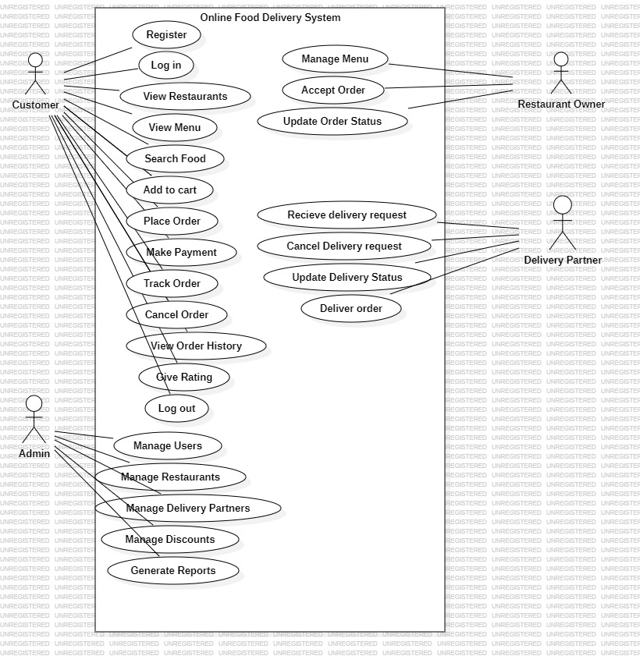
Figure 5.1: Use Case Diagram of Online Food Delivery System
Four actors interact with the system. The Customer registers, logs in, views restaurants and menus, searches food, adds to cart, places and pays for orders, tracks or cancels orders, views history and gives ratings. The Restaurant Owner manages the menu, accepts orders and updates order status. The Delivery Partner receives and updates delivery requests. The Admin manages users, restaurants, delivery partners and discounts and generates reports.

5.2 Activity Diagram – Login
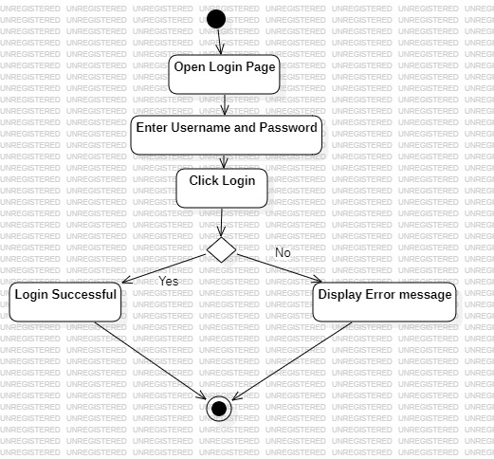
Figure 5.2: Activity Diagram for User Login
The user opens the login page, enters username and password and clicks Login. If the credentials are valid, login is successful; otherwise an error message is displayed.

5.3 Activity Diagram – Place Order
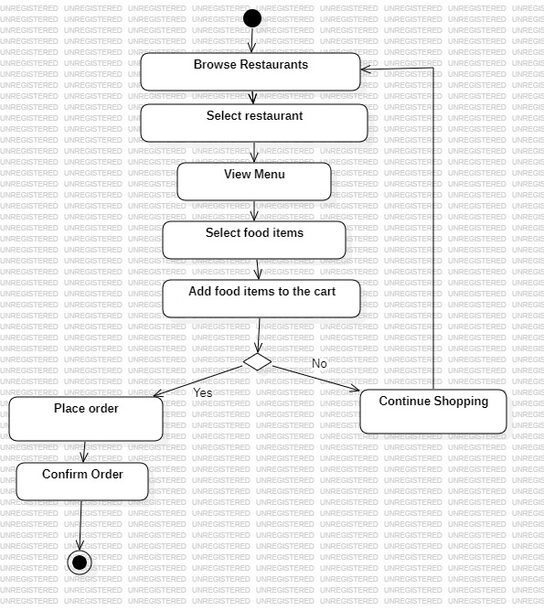
Figure 5.3: Activity Diagram for Place Order
The customer browses restaurants, selects a restaurant, views the menu, selects items and adds them to the cart. If the customer proceeds, the order is placed and confirmed; otherwise the customer continues shopping.

5.4 Activity Diagram – Payment
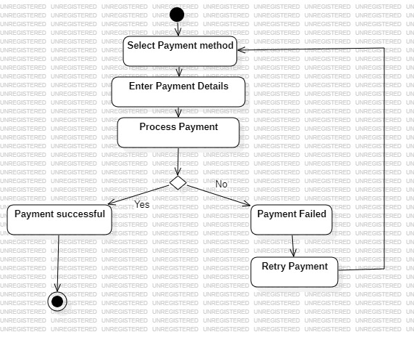
Figure 5.4: Activity Diagram for Payment
The customer selects a payment method, enters details and the payment is processed. On success the payment is confirmed; on failure the customer can retry with the same or another method.

5.5 Class Diagram
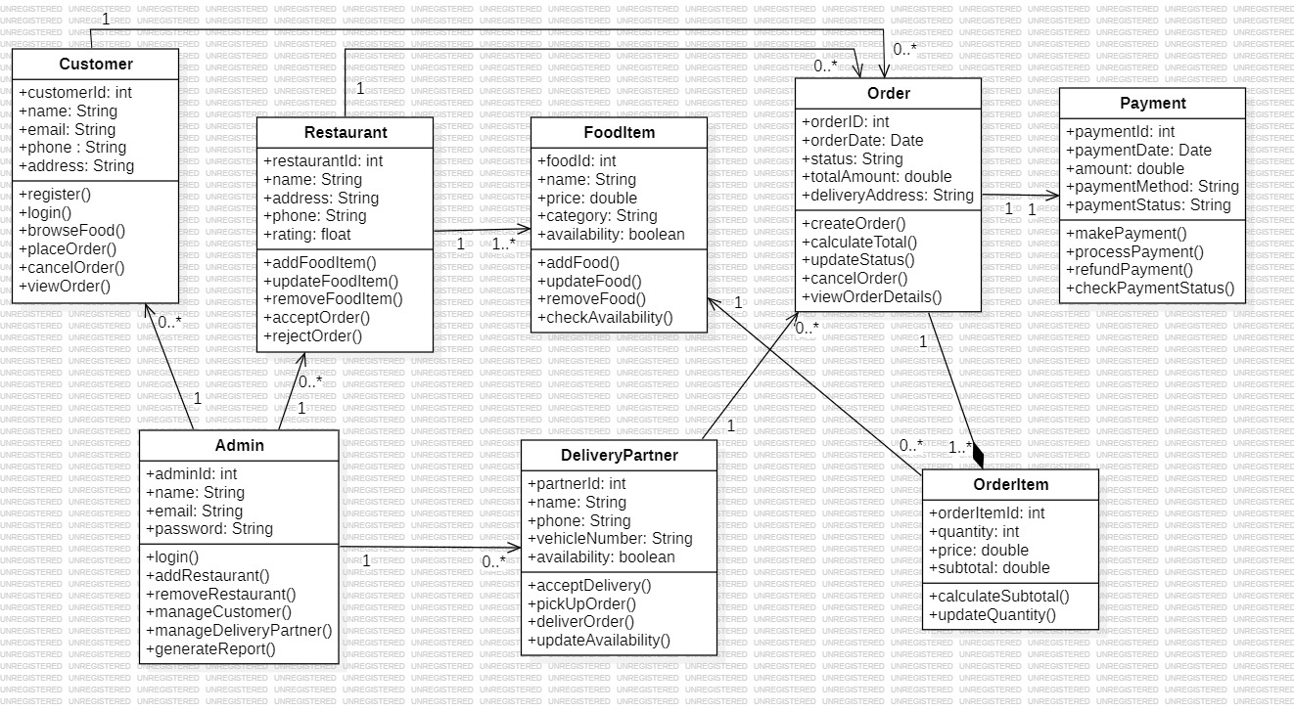
Figure 5.5: Class Diagram of Online Food Delivery System
The main classes are Customer, Restaurant, FoodItem, Order, OrderItem, Payment, DeliveryPartner and Admin. An Order contains one or more OrderItems, has one Payment, and is delivered by one DeliveryPartner. A Customer can place many Orders and a Restaurant offers many FoodItems.

5.6 Sequence Diagram – User Login
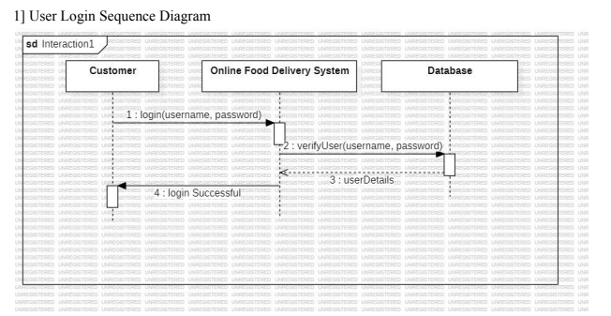
Figure 5.6: Sequence Diagram for User Login
The Customer sends login details to the system, the system verifies them with the Database, the Database returns the user details and the system confirms a successful login.

5.7 Sequence Diagram – Place Order
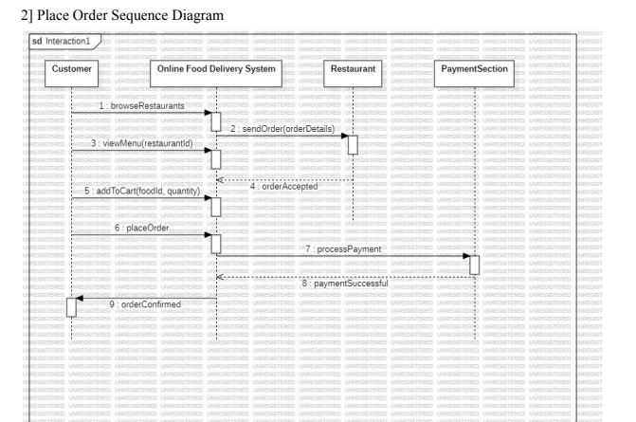
Figure 5.7: Sequence Diagram for Place Order
The Customer browses restaurants, views the menu, adds items to the cart and places the order. The system sends the order to the Restaurant, forwards the payment to the Payment section and, once payment succeeds, confirms the order to the Customer.

5.8 State Machine Diagram – Order Lifecycle
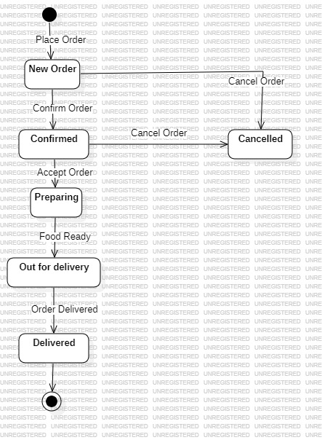
Figure 5.8: State Machine Diagram for Order Lifecycle
An order starts as New Order and becomes Confirmed or Cancelled. A confirmed order can be cancelled or accepted by the restaurant (Preparing), then becomes Out for Delivery when the food is ready, and finally Delivered.

5.9 Deployment Diagram
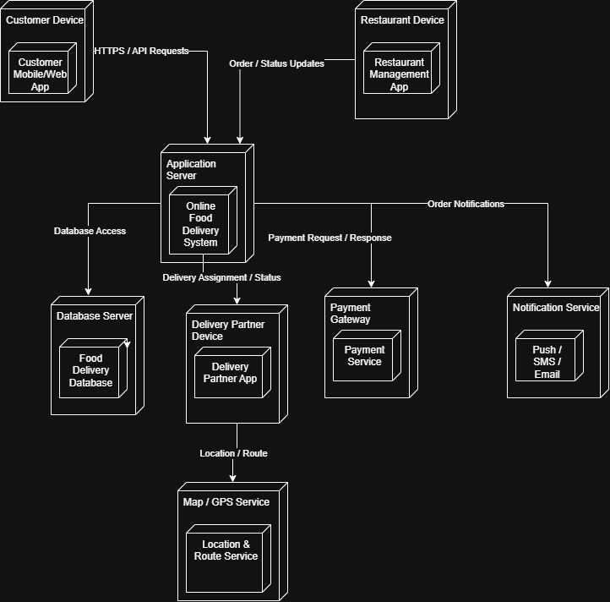
Figure 5.9: Deployment Diagram of Online Food Delivery System
Customer, Restaurant and Delivery Partner devices run their apps and communicate over HTTPS with the Application Server. The Application Server connects to the Database Server, the Payment Gateway and the Notification Service, and the delivery app uses the Map/GPS Service.

5.10 Component Diagram
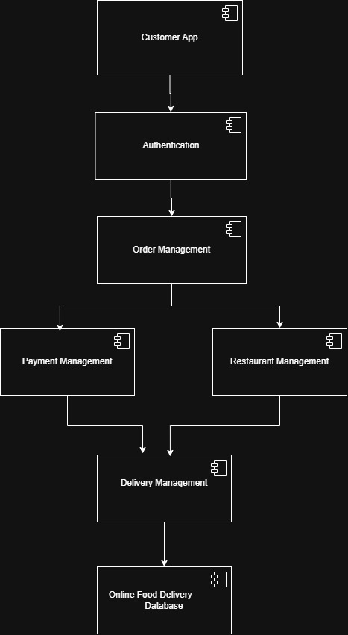
Figure 5.10: Component Diagram of Online Food Delivery System
The Customer App uses Authentication, which feeds Order Management. Order Management works with Payment Management and Restaurant Management; Restaurant Management coordinates with Delivery Management. All four management components store data in the Online Food Delivery Database.

6. Project Scheduling

6.1 Overview
The project follows an iterative development model. Work is organized into five phases, as listed below:
- Planning and requirements (T-01 to T-03): project planning, feasibility study and SRS preparation.
- Design (T-04 to T-08): system design, UI/UX, database design and UML modeling.
- Development (T-09 to T-15): user, restaurant, cart/order, payment, tracking, admin modules and integration.
- Testing and validation (T-16 to T-17): testing, debugging and performance/security checks.
- Documentation and submission (T-18 to T-19): final report, review, presentation and submission.

6.2 Tasks and Milestones
Table 6.1 lists each task with its start date, end date, duration (days) and progress.
Table 6.1: Project Milestones and Development Deliverables
Task ID | Tasks | Start Date | End Date | Duration | Progress
T-01 | Project Planning & Scope Definition | 15-07-2026 | 17-07-2026 | 3 | 100%
T-02 | Feasibility Study & Requirement Gathering | 18-07-2026 | 22-07-2026 | 5 | 100%
T-03 | Requirement Analysis & SRS Preparation | 23-07-2026 | 29-07-2026 | 7 | 100%
T-04 | System Design & Architecture Planning | 30-07-2026 | 05-08-2026 | 7 | 100%
T-05 | UI/UX Design | 02-08-2026 | 08-08-2026 | 7 | 100%
T-06 | Database Design | 05-08-2026 | 09-08-2026 | 5 | 100%
T-07 | Use Case, Activity & Sequence Modeling | 05-08-2026 | 12-08-2026 | 8 | 100%
T-08 | Class, State, Component & Deployment Modeling | 10-08-2026 | 16-08-2026 | 7 | 100%
T-09 | User Module Development | 13-08-2026 | 22-08-2026 | 10 | 80%
T-10 | Restaurant & Menu Module Development | 20-08-2026 | 27-08-2026 | 8 | 70%
T-11 | Cart & Order Management Development | 25-08-2026 | 02-09-2026 | 9 | 60%
T-12 | Payment Module Development | 31-08-2026 | 06-09-2026 | 7 | 40%
T-13 | Order Tracking & Review Module | 04-09-2026 | 10-09-2026 | 7 | 30%
T-14 | Admin Module Development | 07-09-2026 | 14-09-2026 | 8 | 20%
T-15 | Module Integration | 12-09-2026 | 18-09-2026 | 7 | 10%
T-16 | Testing & Debugging | 17-09-2026 | 24-09-2026 | 8 | 0%
T-17 | System Validation & Performance/Security Checks | 23-09-2026 | 27-09-2026 | 5 | 0%
T-18 | Final Documentation & Report Preparation | 25-09-2026 | 01-10-2026 | 7 | 05
T-19 | Final Review, Presentation & Submission | 02-10-2026 | 04-10-2026 | 3 | 0%

6.3 Gantt Chart
The Gantt chart below shows the project schedule, including task durations, timelines and overlapping activities.
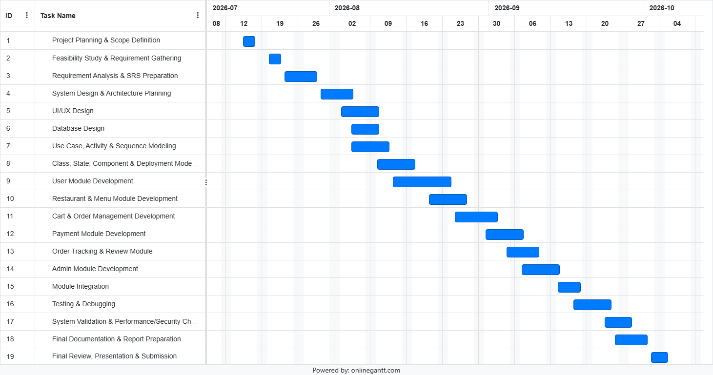
Figure 6.1: Project Development Schedule – Gantt Chart

7. System Test Cases

7.1 Test Strategy
The system is tested using black-box functional testing, covering valid inputs, invalid inputs and error paths for every major module. Each test case has a unique ID that maps to the functional requirements (see Appendix B). The Actual Result is recorded during test execution; all test cases are currently Not Executed.

7.2 Test Cases
Table 7.1: System Test Cases
Test ID | Test Scenario | Steps and Input Data | Expected Result | Status
TC-REG-01 | Registration with valid details | Pre: email not registered. 1. Fill registration form. 2. Click Register. Data: Name: Rahul Verma; Email: rahul.v@test.com; Phone: 9876543210; Pass: P@ssw0rd123 | Customer record created, password hashed, confirmation shown. | Not Executed
TC-REG-02 | Registration with duplicate email | Pre: account exists. 1. Enter existing email. 2. Click Register. Data: Email: rahul.v@test.com | Registration blocked; error “An account with this email already exists.” | Not Executed
TC-LOG-01 | Login with valid credentials | Pre: account exists. 1. Open Login. 2. Enter email and password. 3. Click Login. Data: rahul.v@test.com / P@ssw0rd123 | Session created and dashboard displayed. | Not Executed
TC-LOG-02 | Login with invalid password | Pre: account exists. 1. Enter email with wrong password. 2. Click Login. Data: rahul.v@test.com / WrongPassword | Login rejected; “Invalid email or password.” shown. | Not Executed
TC-SCH-01 | Search restaurant by keyword | Pre: restaurants in database. 1. Click search bar. 2. Type keyword. 3. Press Enter. Data: Keyword: Pizza | Matching restaurants listed within 500 ms. | Not Executed
TC-SCH-02 | Filter by diet and category | Pre: on listing screen. 1. Apply Vegetarian filter. 2. Select Desserts. Data: Filter: Pure Veg; Category: Desserts | Only vegetarian desserts are displayed. | Not Executed
TC-MNU-01 | View restaurant menu | Pre: restaurant active. 1. Click restaurant. 2. Open menu tabs. Data: Restaurant ID: 101 | Menu shown by category with name, price and veg icon. | Not Executed
TC-CRT-01 | Add item to cart | Pre: menu open, cart empty. 1. Click Add to Cart. 2. Open cart. Data: Paneer Butter Masala, 280.00 | Item added with quantity 1; subtotal 280.00. | Not Executed
TC-CRT-02 | Update and remove cart item | Pre: item in cart. 1. Click + to make quantity 2. 2. Click − twice. Data: Unit price: 280.00 | Subtotal becomes 560.00; item removed at quantity 0. | Not Executed
TC-ORD-01 | Place order with valid address | Pre: logged in, cart not empty. 1. Proceed to Checkout. 2. Select address. 3. Confirm. Data: Cart: 2 items, 450.00; 42 Park Avenue, Nagpur | Order created with status New; user sent to payment. | Not Executed
TC-ORD-02 | Checkout with empty address or cart | Pre: on checkout. 1. Submit without address. 2. Submit with empty cart. Data: Address: empty; Cart: 0 items | Submission blocked and missing field highlighted. | Not Executed
TC-PAY-01 | Successful payment | Pre: order New. 1. Select method. 2. Enter valid details. 3. Submit. Data: Card; Amount: 450.00 | Payment successful; order status set to Confirmed. | Not Executed
TC-PAY-02 | Failed payment and retry | Pre: order New. 1. Enter invalid CVV. 2. Submit. Data: Card; CVV: 000 (simulated decline) | Payment logged as Failed; retry option shown. | Not Executed
TC-CNF-01 | Order confirmation and invoice | Pre: payment verified. 1. View confirmation screen. 2. Open invoice. Data: Order ID: 5001 | Confirmation, estimated time and receipt displayed. | Not Executed
TC-TRK-01 | Live order tracking | Pre: order Confirmed. 1. Open Track Order. 2. Restaurant accepts order. Data: Order ID: 5001; event: Accept Order | Progress changes from Confirmed to Preparing in real time. | Not Executed
TC-CAN-01 | Cancel order in allowed window | Pre: order New/Confirmed. 1. Click Cancel Order. 2. Confirm. Data: Order ID: 5001 | Status becomes Cancelled; restaurant alerted; refund started. | Not Executed
TC-HST-01 | View order history | Pre: past orders exist. 1. Open Order History. Data: Customer ID: 101 | Past orders listed by date with items and cost. | Not Executed
TC-RST-01 | Restaurant menu management | Pre: restaurant logged in. 1. Open Menu Management. 2. Turn off an item. 3. Add a dish. Data: Garlic Bread: unavailable; Veg Biryani: 220.00 | Item shows unavailable to customers; new dish saved. | Not Executed
TC-ADM-01 | Admin login and dashboard | Pre: admin account exists. 1. Open admin portal. 2. Enter credentials. Data: admin@fooddelivery.com | Admin console and reports are displayed. | Not Executed

8. Appendices

Appendix A: Future Scope (TBD Items)
Table A.1: Items to be Determined
ID | Future Feature
TBD-01 | Multi-language and multi-currency support
TBD-02 | Personalized food recommendations
TBD-03 | Biometric login on mobile devices
TBD-04 | Dynamic delivery fee based on demand

Appendix B: Requirements Traceability Matrix
Table B.1: Modules, Requirements and Test Cases
Module | Functional Requirements | Test Cases
Registration & Login | FR-REG-01 to 03, FR-LOG-01 to 03 | TC-REG-01/02, TC-LOG-01/02
Search & Menu | FR-SCH-01/02, FR-MNU-01/02 | TC-SCH-01/02, TC-MNU-01
Cart | FR-CRT-01 to 03 | TC-CRT-01/02
Order & Payment | FR-ORD-01 to 03, FR-PAY-01 to 03 | TC-ORD-01/02, TC-PAY-01/02, TC-CNF-01, TC-CAN-01
Tracking | FR-TRK-01/02, FR-NTF-01 | TC-TRK-01
Restaurant | FR-RST-01 to 03 | TC-RST-01
History & Ratings | FR-HST-01/02 | TC-HST-01
Administration | FR-ADM-01 to 03 | TC-ADM-01

