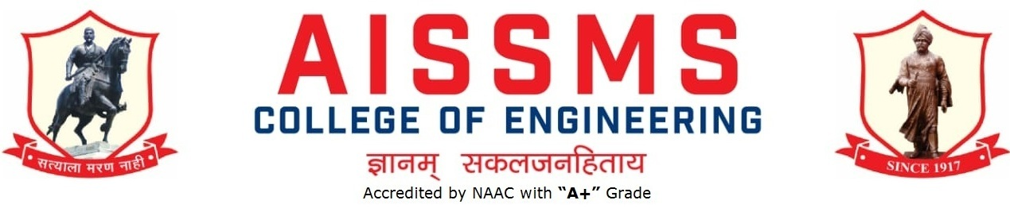

**Department of Computer Engineering**

C E R T I F I C A T E

This is to certify that **Ms. Sai Jagdale (20CO039)** from third year, Branch **COMPUTER-I** has completed the report under Database Management System (310246) on the topic Project entitled *“****Restaurant Management System****”* under my supervision, in the partial fulfillment of Third Year Bachelor of Engineering (Choice Based Credit System) (2019 Course) of Savitribai Phule University of Pune.

Date: 9/11/2022

Place: Pune

**Prof. V. V. Navale Dr. S. V. Athawale Dr. D. S. Bormane**

GUIDE HOD PRINCIPAL



**Department of Computer Engineering**

C E R T I F I C A T E

This is to certify that **Mr. Atharva Gokhare (20CO028)** from third year, Branch **COMPUTER-I** has completed the report under Database Management System (310246) on the topic Project entitled *“****Restaurant Management System****”* under my supervision, in the partial fulfillment of Third Year Bachelor of Engineering (Choice Based Credit System) (2019 Course) of Savitribai Phule University of Pune.

Date: 9/11/2022

Place: Pune

**Prof. V. V. Navale Dr. S. V. Athawale Dr. D. S. Bormane**

GUIDE HOD PRINCIPAL



**Department of Computer Engineering**

C E R T I F I C A T E

This is to certify that **Mr. Pranay Dhopate (20CO022)**,from third year, Branch **COMPUTER-I** has completed the report under Database Management System (310246) on the topic Project entitled *“****Restaurant Management System****”* under my supervision, in the partial fulfillment of Third Year Bachelor of Engineering (Choice Based Credit System) (2019 Course) of Savitribai Phule University of Pune.

Date: 9/11/2022

Place: Pune

**Prof. V. V. Navale Dr. S. V. Athawale Dr. D. S. Bormane**

GUIDE HOD PRINCIPAL