**BU6810992**

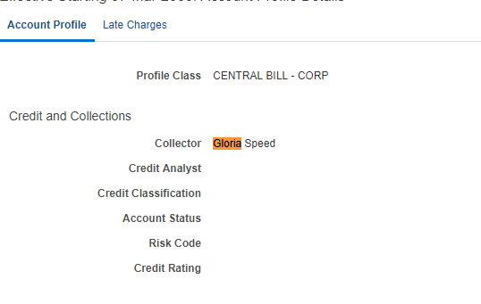

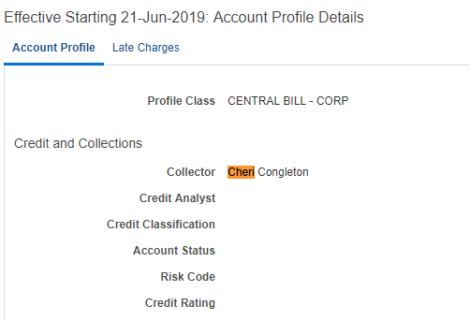



**BU6811004**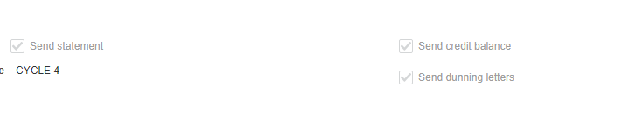

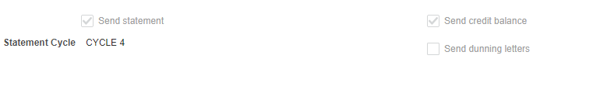



**BU6811094**

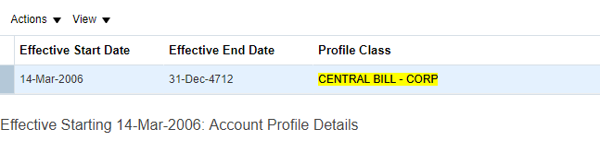

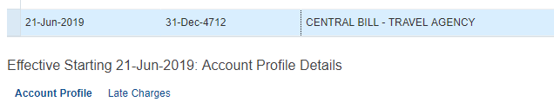



**Request with only CustAccountId**

