**AV76900040428**

Dunning Flag: Y

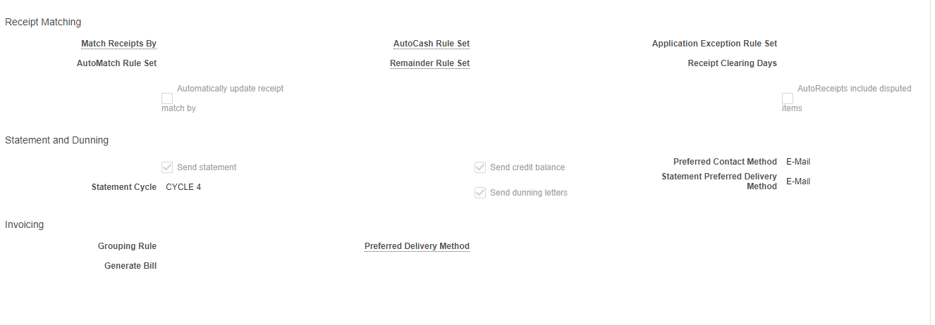

Old entry end dated and new entry created with Dunning Flag - N

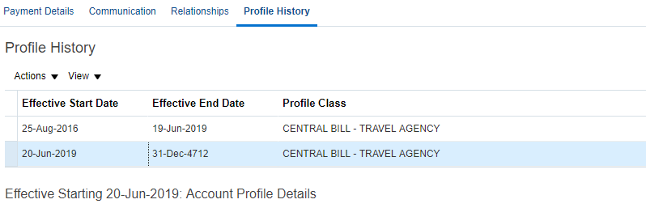

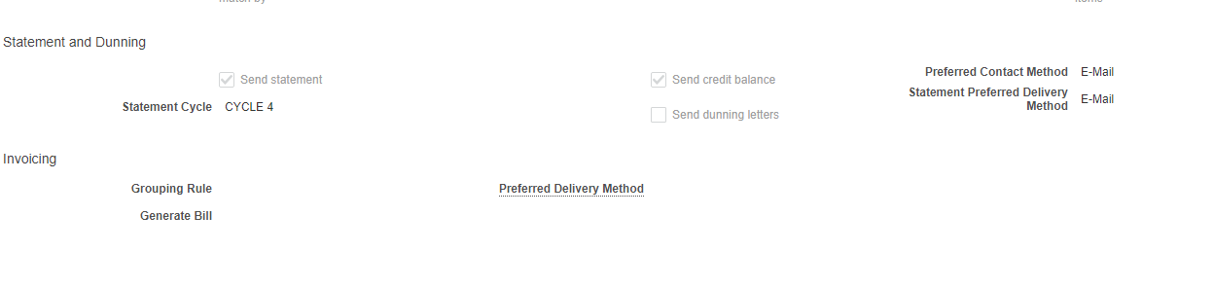



**AV76900040383**

Profile Class Name – CENTRAL BILL – TRAVEL AGENCY

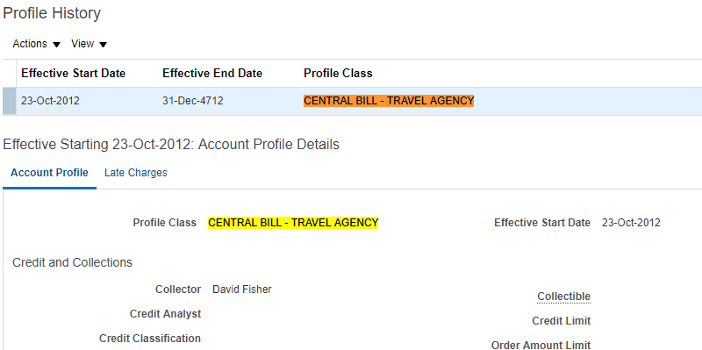

Profile Class Name – CENTRAL BILL – CORP

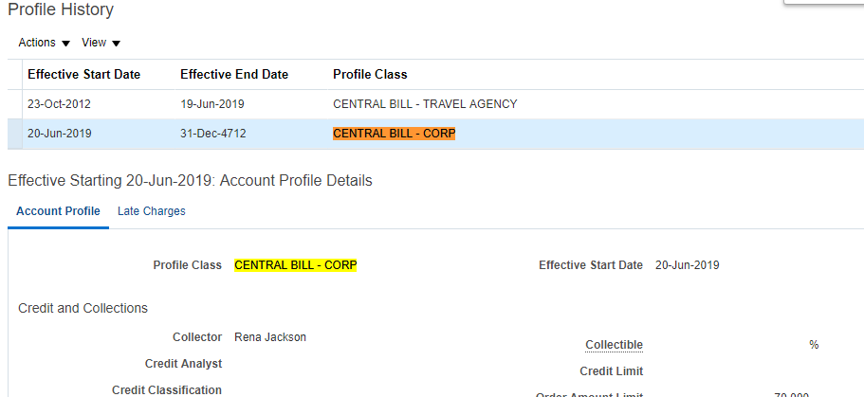



**AV76900040423**

Collector – Cheri Congoleton

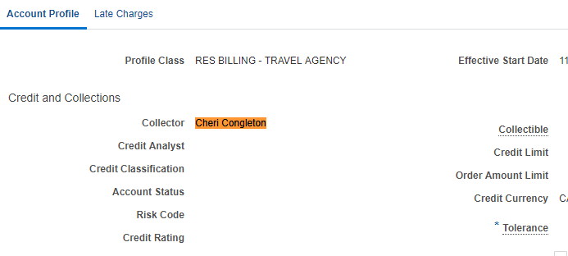

Collector – David Fisher

