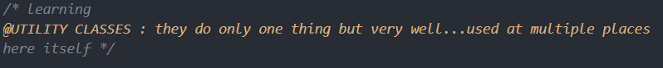

<https://css-tricks.com/almanac/properties/p/place-items/>

**REVISE GRIDS!**

max() in CSS ?

VERY USEFUL!!!!! :

It’s like using a button as a controller for another element

Learn this!

<https://www.w3schools.com/css/css_combinators.asp>

<https://www.w3schools.com/cssref/tryit.asp?filename=trycss_func_min>

<https://www.w3schools.com/cssref/tryit.asp?filename=trycss_func_max>

GLASSMORPHISM

Look out for more **@supports**

------------------------------------------------------------------------------------------

**Using custom attributes**

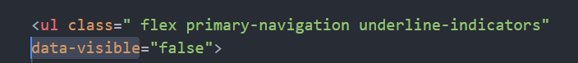

------------------------------------------------------------------------------------------

Learn more about min(),max(),clamp()

<https://css-tricks.com/min-max-and-clamp-are-css-magic/>

