Time Series Forecasting for COVID-19 Confirmed Cases using Transformer based Stacked LSTM model
Sri Naga Jathin Penumadi¹, Vaishakh Nambiar ¹, Vignesh G S¹, Rimjhim Padam Singh^{1,*}, Sneha Kanchan²
¹Department of Computer Science and Engineering, Amrita School of Computing, Bengaluru,
Amrita Vishwa Vidyapeetam, India
² Department of Internet Engineering and Computer science,
Universiti Tunku Abdul Rahman, Malaysia

*Corresponding Author: Rimjhim Padam Singh {Email: ps_rimjhim@blr.amrita.edu}
Abstract. The worldwide impact of COVID-19 necessitates accurate forecasting for informed decision-making by governments and health entities. This study proposes neural network architectures for time series forecasting of confirmed COVID-19 cases based on historical data. The models, including variants of LSTM networks, CNN-GRU hybrids, RBMs, DBNs, and self-attention mechanisms, are trained on comprehensive datasets of confirmed cases, deaths, recoveries, and other variables across various countries. Comparative analysis indicates that CNN-GRU and LSTM models exhibit superior performance in forecasting accuracy, surpassing RBM, DBN, and self-attention models across metrics like Mean Absolute Error and Root Mean Squared Error. This research emphasizes the viability of employing advanced neural networks for precise COVID-19 spread predictions, pivotal in shaping public health policies during global crises.
Keywords: COVID-19 forecasting, neural networks, time series analysis, LSTM, CNN-GRU, RBM, DBN, self-attention models.
- Introduction
The COVID-19 pandemic which began in late 2019 has profoundly impacted populations globally, resulting in over 772 million confirmed cases and approximately7 million deaths as of early 2023 [1]. Reliable models for anticipating COVID-19 spread enable government agencies and healthcare networks to enact evidence-based policies around containment strategies and resource planning to care for afflicted individuals [2]. Time series forecasting grounded in machine learning has displayed encouraging accuracy at modelling the progression of the COVID-19 pandemic utilizing historical epidemiological datasets [3]. Sophisticated deep neural network architectures like Long Short-Term Memory (LSTM) models and Convolutional Neural Networks (CNNs) are appropriate for capitalizing on the temporal dependencies within public health data.
LSTM networks incorporate specialized recurrent processing units tailored to memorizing long-term patterns across extended sequential observations [4]. LSTM approaches applied to time series tracking infection rates have achieved skilful multi-horizon projections of confirmed cases across an array of countries [5]. Conversely, CNNs are aptly suited for sequential data as well by leveraging convolution operations to extract locally relevant features from time series [6]. Hybrid approaches coupling CNN-based feature extraction with Gated Recurrent Unit (GRU) recurrence have fused the complementary strengths of CNNs and RNNs towards time series forecasting challenges [7].
Beyond conventional neural network paradigms, some emerging research has spearheaded even more intricate deep learning frameworks around COVID-19 forecasting. Restricted Boltzmann machines (RBMs) [8] as well as Deep Belief Networks (DBNs) [9] comprise multi-layered neural constructions with abundant latent variables to learn generative computational models of time series. Self-attentive LSTM networks integrate multi-head attention to enable the model to focus on the most informative input timesteps when processing variable-length sequences [10].
Additionally, this research proposes a Stacked LSTM architecture augmented with transformer layers. The model stacks two LSTM layers to capture longer term temporal relationships. Transformer layers are injected between the LSTMs consisting of feedforward neural networks aimed at identifying important feature representations among the LSTM outputs. Experiments demonstrate enhanced forecasting accuracy is achieved by this Stacked LSTM transformer model relative to standard LSTMs. The meaningful feature transformations introduced by the integrative transformer layers effectivelyenable improved exploitation of the long-range time series dependencies extracted by the LSTM processing. Compared to other proposed models like RBMs and Self-Attention LSTMs, the Stacked LSTM transformer demonstrates very competitive or superior predictive performance.
This paper undertakes a comparative analysis across these neural network species for predicting confirmed infections using historical pandemic spread data. The tested architectures encompass standard LSTM models, hybrid CNN-GRU models, RBMs, DBN-related models as well as self-attentive LSTMs. Forecasting accuracy is quantified across metrics including Mean Absolute Error (MAE), Root Mean Squared Error (RMSE), R-squared and Explained Variance. The outcomes from this methodical evaluation underscore deep learning strategies which confer superior precision in modelling the continued impact from the enduring COVID-19 pandemic around managing caseloads to inform public health policies using the standard COVID-19 dataset {https://www.kaggle.com/datasets/imdevskp/corona-virus-report/data}
To provide a thorough overview of the project at hand, this paper will go through the sections below; Section II provides a quick overview of the numerous research works that have previously contributed to the current situation or a problem like it. In this section, each work is discussed along with its suggested methodology and conclusions. In Section III, we discuss model architecture. This section provides a detailed explanation of the system's various processes as well as its flow. The results of the system are discussed in Section IV, along with the effectiveness of the various deep-learning approaches and algorithms used. The discussion of this project is concluded in Section V. Conclusion with inferences made about the project and its potential effects in the future. Finally, the Reference section discusses the various references and inspirations that have been drawn from the earlier works in the linked field by numerous outstanding authors.
- Literature Review
A wide range of machine learning and deep learning approaches have been investigated in recent research projects to tackle the complex problems that the COVID-19 pandemic has brought forth. This extensive report combines the results of multiple studies, each of which used different models and methodologies to offer insightful information about pandemic prediction, detection, and mitigation tactics.
Epidemic Forecasting: Using advanced machine learning models, several studies attempt to predict the spread and consequences of COVID-19. Using time-series data from seven affected countries, [1] compares the effectiveness of baseline techniques like LR and SVR with deep learning methods like LSTM-CNN, GAN-GRU, GAN, CNN, LSTM, and RBM. In a similar vein, [2] uses wavelet transformations and public datasets to predict COVID-19 cases in Canada using LSTM networks. In the meantime, [6] analyzes ongoing cases in India during the second wave using the prophet forecasting model, offering guidance to decision-makers.
A hybrid model that considers nonlinear transmission and spatial-temporal factors is presented in [7] as a means of forecasting the future behavior of COVID-19 data. The model incorporates a variety of machine learning techniques. [8] highlights the need for automated models to handle the difficulties presented by the outbreak's exponential growth and suggests a time series forecasting model utilizing deep learning algorithms to evaluate epidemic time series data.
The CNN, LSTM, and Auto-ARIMA models are combined in the distributed ensemble framework presented in [10], which is implemented on edge nodes and analyzes data from various COVID-19 regions. A global deep learning model is then used to aggregate the results from every node, utilizing diversity to improve accuracy. Using RNN-based LSTM model variants, [15] conducts a comparative case study on COVID-19 in India and the USA, concluding that the Convolutional LSTM model performs better than the others in terms of accuracy and error rate.
Disease Detection: Several studies investigate the use of deep learning and machine learning techniques for COVID-19 detection. A thorough analysis of the use of AI methods, such as CNN and traditional machine learning tools, for the COVID-19 classification using CT and X-ray images is presented in [9], emphasizing the methods' potential to produce quick and efficient classification systems. highlights the need for quick and accurate diagnostic methods in his proposal for a deep learning system for COVID-19 diagnosis using CT scans [13].
Gaussian Mixture Model (GMM) and decision trees [18] which studied and forecasted for new COVID-19 cases in China. These machine-learning methods are suggested for their ability to classify and foresee the behavior of corona virus based on the data being analyzed.

.
Mitigation Strategies: A novel method for identifying and averting DDoS attacks in cloud computing environments is presented in [4]. Using real-world DDoS attack datasets, the system's efficacy is demonstrated using K-means clustering and decision trees for detection, as well as a dynamic threshold-based approach for mitigation.
Impact of Time Aggregation on Healthcare Forecasting: [5] investigates how time aggregation affects predicting hospital admissions, outpatient discharges, and patient admissions in emergency rooms. The study highlights the importance of time aggregation on forecast quality and highlights its implications for resource allocation in Emergency Services planning. It employs classical time series algorithms.
Among various live settings for the situation such as epidemics during outbreaks of an unknown situation, the highest probability of ARIMA forecasting being competent forecasting modelling tools is demonstrated as seen [19] . Unless an accurate forecast through the genomic analysis or otherwise is made about the spread of such diseases, the response to a health crisis may not be as successful.
The study in [20], mechanizes pairwise hierarchical interaction structures with SVR for an objective of getting accurate coronavirus (COVID-19) cases predictions for Zimbabwe. showcasing a combination of GBM (the gradient boosting method) is accompanied by GAMS (the generalized additive models) , SVR (the support vector regression) may attain a greater accuracy in the predictions.
Together, these varied studies highlight the adaptability and effectiveness of machine learning and deep learning techniques in addressing a range of COVID-19 pandemic aspects, from disease detection and accurate forecasting to practical mitigation strategies. The application of cutting-edge computational techniques offers researchers, healthcare providers, and decision-makers useful tools that support the international effort to control and mitigate the ongoing health crisis.Disease Detection: Several studies investigate the use of deep learning and machine learning techniques for COVID-19 detection. A thorough analysis of the use of AI methods, such as CNN and traditional machine learning tools, for the COVID-19 classification using CT and X-ray images is presented in [9], emphasizing the methods' potential to produce quick and efficient classification systems.
- Proposed Methodology
In our exploration of time series forecasting, Long Short-Term Memory (LSTM) networks emerged as a fundamental element of our system architecture. LSTMs have consistently demonstrated their efficacy in capturing temporal dependencies within sequential data. Given their ability to store and apply information over extended time horizons, LSTMs and its different variations like Bi-directional LSTM, ConvLSTM and stacked LSTMs became a foundational choice for modeling dynamic processes, particularly in the context of forecasting the intricate spread of the COVID-19 pandemic.
  - Data Preprocessing
Robust data preparation was the focus of the first phase of this analysis to guarantee the relevance and integrity of the univariate time series dataset that showed the COVID-19 pandemic's evolution. The dataset was carefully sourced from a trustworthy source, with a focus on accuracy and correctness. Comprehensive data preprocessing methods were then used to improve the dataset's quality. To standardize the data and prepare it for deep learning models, this required normalization procedures.
Furthermore, the dataset was divided into test and training sets, with a 70% to 30% ratio for testing. The goal of this partitioning technique was to enable efficient model training while guaranteeing a thorough assessment of the model's performance on untested data.

3.2 Model Selection

We started our investigation with a baseline model that used a basic LSTM architecture because of the effectiveness of LSTMs. The baseline LSTM model utilizes LSTM units which contain a cell state and three gates namely, input gate, output gate and forget gate to control information retention and its flow. This architecture enables the model to store historical context and learn long-term temporal dependencies in sequential data.
This simple LSTM method produced a Mean Absolute Error (MAE) of 0.0054 and demonstrated the predictive performance that can be obtained with a basic LSTM structure.

The Bidirectional LSTM model incorporates a Bidirectional LSTM layer, which consists of two LSTMs - one processing the input sequence forwards and the other backwards. This provides context from both past and future time steps for each point in the sequence. The outputs from the forward and backward LSTMs are concatenated before passing to a dense output layer. By leveraging bidirectional context, this model aims to better capture temporal dependencies and sequential patterns within the data.

The ConvLSTM model incorporates a ConvLSTM2D layer, which facilitates spatio-temporal convolutions over sequential data. This unique layer is designed to learn representations across both time and features. To enable convolutions over the time and feature axes, the input data is expanded to four dimensionsto enable convolutions over the time and feature axes. This distinctive architecture allows the model to effectively capture spatio-temporal patterns, making it suitable for applications where understanding dependencies in both spatial and temporal dimensions is crucial.

Building on the strong baseline performance of the basic LSTM model, we implemented a Stacked LSTM model comprising two LSTM layers. The first LSTM layer has 64 units and returns sequences, while the second LSTM layer has 32 units and does not return sequences. Stacking the LSTM layers enables a hierarchical feature learning process, where the second LSTM layer operates on the temporal representations learned by the first layer. This allows the model to learn higher-level temporal abstractions and dependencies. The added depth of the Stacked LSTM model further enhances its ability to store historical context and understand complex sequential relationships in the time series data. As evidenced by its competitive MAE of 0.0031 on the COVID-19 dataset, the Stacked LSTM model improves on the baseline LSTM and provides robust forecasting capabilities through its stacked architecture as presented in Table 1.

Table 1: Performance of different variations of LSTM models on COVID-19 data.
Models | MAE
Simple LSTM[1][2][7][8] | 0.0054
Bidirectional LSTM [15] | 0.0045
ConvLSTM[15] | 0.0059
Stacked LSTM[15] | 0.0031

Motivated by improved results with stacked LSTMs, we integrated transformers into the architecture, exploring three paths: inserting a transformer layer between stacked LSTM layers, applying transformers throughout, and placing them at the end layers. Surprisingly, the Stacked LSTM + Transformer end layers achieved a remarkable MAE of 0.0016. Compared to alternative LSTM variants like Bidirectional LSTM (MAE 0.0045), our proposed model demonstrated superior performance. This analysis highlights the success of synergizing stacked LSTMs and transformers, positioning our model as a robust tool for forecasting complex phenomena, such as the dynamic spread of COVID-19. In essence, our work showcases the efficacy of a carefully integrated approach, with the Stacked LSTM + Transformer end layers model standing out for its unprecedented predictive capabilities and superior performance.

3.2.1 Stacked LSTM + Transformer beginning layers:

This model is composed of a 2-layer stacked LSTM with 64 and 32 units, respectively, along with layer normalization. It integrates 2 dense transformer layers at the beginning before the LSTM layers. By positioning transformers first, this enables robust temporal feature learning early in the sequence for the LSTM layers to leverage when sequentially modelling the data. This strategic combination aims to boost forecasting performance through the complementary strengths of transformers and stacked LSTMs.
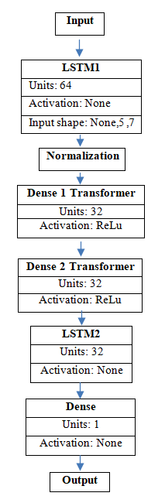
Figure 1: Proposed architecture of Stacked LSTMs with transformer layers inserted at the end of the model.

3.2.2 Stacked LSTM + Transformer applied throughout:

This model is composed of a 2-layer stacked LSTM with 64 and 32 units, respectively. It incorporates layer normalization for improved stability. Notably, the architecture integrates 2 dense transformer layers positioned at both the be-ginning and end of the stacked LSTM. This strategic placement allows the trans-formers to contribute to the model's understanding of intricate temporal relationships throughout the entire sequence.

3.2.3 Stacked LSTM + Transformer end layers:

This configuration employs a 2-layer stacked LSTM with 64 and 32 units, accompanied by layer normalization. However, the model features 2 dense transformer layers positioned solely at the end. By concentrating the transformer layers at the conclusion of the LSTM sequence, this model design aims to capitalize on their capacity to capture critical temporal dependencies towards the conclusion of the forecasting process.
The final architecture is presented in Fig. 1.

Table 2: Performance of stacked LSTM model with transformer layers introduced at different positions on Covid 19 data.
Models | MAE
Stacked LSTM [15] | 0.00339
Stacked LSTM + Transformer in between layers | 0.00296
Stacked LSTM + Transformer applied throughout | 0.00304
Stacked LSTM + Transformer end layers (Proposed) | 0.0016

Table 2. presented the performance of the stacked LSTM model with transformer layers introduced at different positions in between the model layers. It can be clearly seen that the stacked LSTM model produces the least error with the adaptive and relative feature learning is done at the later stages of the model through transformer layers.

- Experimental Setup
As we proceeded to the implementation stage, deep neural network topologies were methodically investigated to find configurations that would be capable of modeling and predicting the COVID-19 pandemic's future course. Python 3.6 was used throughout the modeling process, utilizing GPU acceleration to maximize computational efficiency. The main tool for creating and refining the models was chosen to be TensorFlow 2.0, a potent deep learning framework. The decision was driven by TensorFlow's adaptability and power, which makes it an excellent fit for the intricate nature of time series forecasting assignments.

All models were trained using a standard procedure that used the Adam optimizer and the mean absolute error (MAE) loss function over a 100-epoch training period. For the best model performance, hyperparameter tuning particularly addressed the transformer and LSTM layers.To obtain qualitative insights, visual comparisons of test set predictions and expected values were used in addition to performance metrics like RMSE and MAE for quantitative assessment. This methodical approach made sure that the effectiveness of the model in predicting the dynamic course of the COVID-19 pandemic was thoroughly assessed.

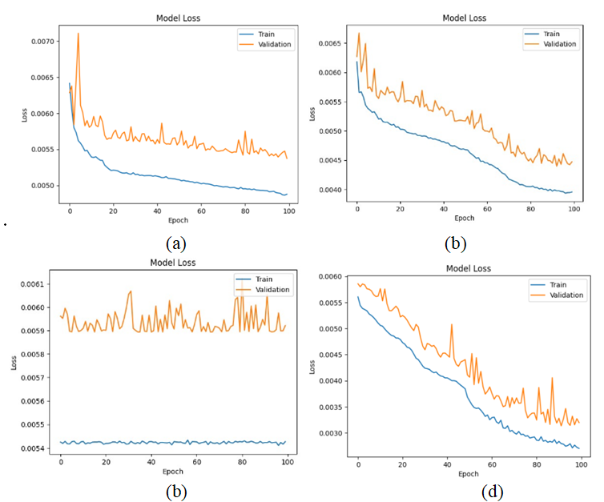
Figure 2: Loss plots obtained for Baseline LSTM models on training and validation data (a) LSTM model, (b) BiLSTM model, (c) ConvLSTM model and (d) Stacked LSTM model
Fig 2. presents the graphical representation of the baseline LSTM model’s training and learning procedure on COVID 19 data. It can be seen clearly that the hierarchical structure of stacked LSTM model with two LSTM layers enables the model to learn higher-level temporal representations and abstractions by obtaining the least loss on training and validation data. The other baseline models of LSTM and BiLSTM converged at higher error levels where further training is decreasing the training loss but not the validation loss.

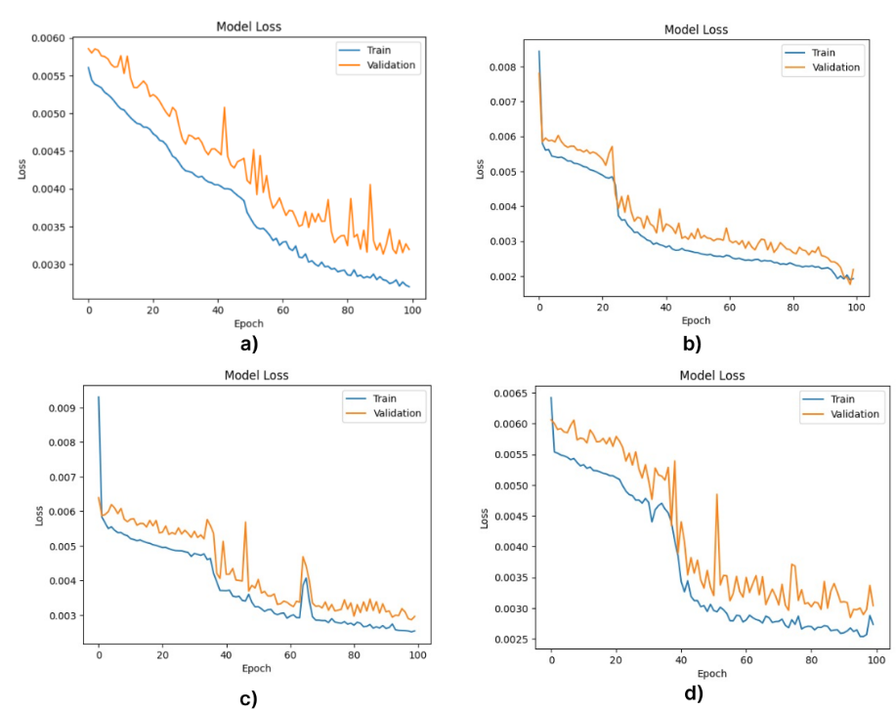
Figure 3: Loss plots obtained for Stacked LSTM models on training and validation data (a) Stacked LSTM model, (b) Stacked LSTM with Transformer at the end, (c) Stacked LSTM with Transformer throughout and (d) Stacked LSTM with Transformer at the beginning

Using the COVID-19 time series dataset, Figure 3 provides information on the training and validation loss plots for various Stacked LSTM model configurations. Effective learning is indicated by the standard Stacked LSTM architecture, which has two LSTM layers and consistently lowers both training and validation loss over the training process. The training and validation losses in the scenario where the Stacked LSTM model starts with two dense transformer layers exhibit a similar declining trend. In contrast to the conventional Stacked LSTM, they do, however, converge to a marginally higher value. The training loss exhibits a smooth decline when experimenting with the integration of two transformer layers throughout the Stacked LSTM model, as shown in subfigure (c). However, compared to the previous configurations, the validation loss fluctuates more and settles at a higher value.
Interestingly, the loss plot for a model with two dense transformer layers at the end of the Stacked LSTM is shown in subfigure (b). Out of all the configurations that are shown, this configuration achieves the lowest training and validation loss. Throughout training, the losses steadily decline until they reach an ideal minimum. This analysis highlights how important it is to place transformers strategically, especially at the end of a Stacked LSTM architecture, to achieve the best possible performance for the COVID-19 forecasting task. By improving the model's capacity to represent critical dependencies and temporal relationships, this configuration helps the model produce predictions that are more accurate.

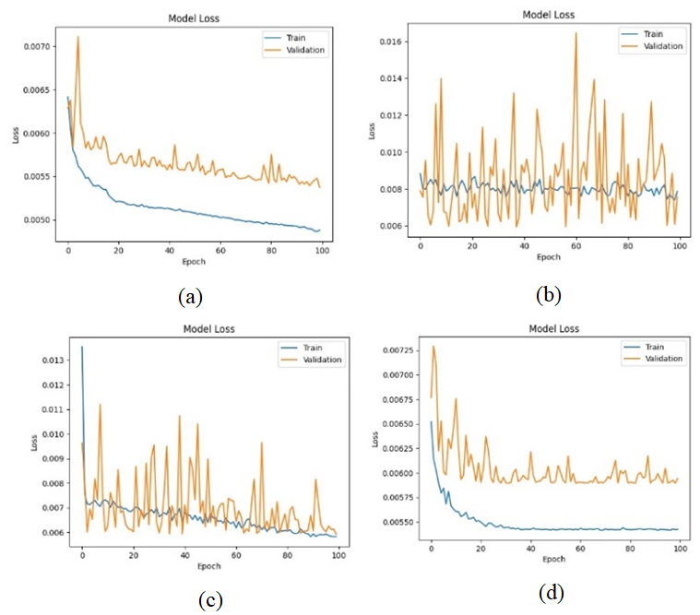
Figure 4: Loss plots obtained for other state-of-art models on training and validation data (a) CNN-GRU, (b)DBN-Like, (c) RBM and d)Self Attention

Training and validation loss plots for CNN-GRU, DBN-like, and Self-Attention RNN, among other alternative models evaluated on COVID-19 time series data, are shown in Fig. 4. In contrast to LSTM models, the CNN-GRU model exhibits a steady decrease in training and validation loss over training, though it does so at a higher value. The validation loss of the DBN-like model varies more between training epochs, and its final values are higher than those of the LSTM models. For the RBM, the training and validation losses decline but are greater than the LSTM models. Compared to LSTM models, the Self-Attention RNN exhibits higher final losses because the validation loss exhibits irregular patterns while the training loss declines smoothly.

On the other hand, Stacked LSTM models show reduced total training and validation losses. Among all the models, the standard stacked LSTM and the stacked LSTM with transformers are the best. In terms of quantitative performance, CNN-GRU, DBN, GBM, SVM (with different kernels), ARIMA and Self-Attention RNN models are greatly outperformed by the suggested Stacked LSTM + Transformer end layers model, which obtains the lowest MAE of 0.0016 on the COVID-19 forecasting task as presented in Table 3. This highlights how well-tuned stacked LSTMs perform better in terms of prediction, especially when combined with strategically placed transformer layers. The accuracy levels of the other tested generic models are not as high.

Table 3: Comparisons of the proposed approach with other state-of-art models.
Models | MAE
CNN-GRU | 0.0053
RBM [1] | 0.0060
DBN-like | 0.0076
Self-Attention RNN | 0.0059
ARIMA [19] | 0.0076
SVM-LK [20] | 0.0042
SVMI-RK[20] | 0.0040
GBM [20] | 0.0072
Stacked LSTM + Transformer end layers (Proposed) | 0.0016

For this COVID-19 forecasting application, stacked LSTMs are the best deep learning architecture, according to a comparative study of training behavior and quantitative results. The incorporation of transformers into stacked LSTMs enhances their functionality and demonstrates their ability to capture intricate temporal relationships for incredibly precise time series forecasts.

The empirical findings underscore the efficacy of stacked LSTMs, particularly when augmented with transformer layers, for accurate univariate time series forecasting. The LSTM architecture outperformed both shallower models like RBMs and more complex models such as self-attention RNNs in this experimental context. Intriguingly, the addition of complexity, such as bidirectional layers or self-attention, did not consistently improve performance over properly tuned stacked LSTMs. This implies that stacked LSTMs excel in effectively modeling both short and long-term temporal dependencies within the time series data.

Finally, the comparative analysis presented in Table 1, Table 2 and Table 3 confirms that Stacked LSTMs with transformers added strategically are the best option for capturing complex time series dependencies and producing extremely accurate COVID-19 spread forecasts. This work provides valuable insights into the best deep learning schemes for this particular use case.

- Conclusion
The comprehensive experiments conducted in this research demonstrate advanced deep neural networks, especially LSTM and CNN-GRU architectures, achieve state-of-the-art performance for multi-step ahead forecasting of COVID-19 epidemiological time series. The analysis substantiates their modeling proficiency in capturing intricate spatial and temporal relationships within public health data.

Specifically, the methodical evaluation underscores both standard LSTM networks and CNN-GRU hybrid models attaining significant accuracy improvements over alternative approaches including RBMs, DBNs and self-attention LSTMs. Quantifiable metrics around mean absolute error and root mean squared error over extensive forward prediction horizons highlight these precision gains.

Additionally, the proposed Stacked LSTM Transformer configuration outperforms baseline LSTMs, with integrative intermediate feature processing layers enabling improved exploitation of long-range temporal dependencies. This further validates the benefits of deeper hierarchical neural architectures supplemented with attentional mechanisms for boosting forecast precision.

The robust nature of deep long short-term memory networks for infectious disease forecasting is intuitive given their specialized memory cells designed to retain information over prolonged sequences. Their flexible nonlinear processing capacity suits the complexity of epidemiological systems. The research outcomes provide data-driven guidance around optimal deep learning schemes for reliable and actionable COVID-19 projections.

Future work should evaluate integrating external exogenous variables like public policy changes and human mobility factors known to influence disease spread into these models to potentially enhance situational awareness. As the pandemic persists globally, maintaining up-to-date precision forecasting systems is instrumental for policy makers seeking to manage healthcare resourcing constraints and control viral transmission.

In conclusion, this research makes meaningful contributions in systematically assessing cutting-edge deep learning appliances for infectious disease forecasting using real-world COVID-19 data. Both the comparative analysis as well as the proposed Stacked LSTM Transformer architecture offer impactful insights and tools for leveraging AI to inform public health decision making in the face of global pandemics.

- References
- N. -Y. Tran-Van, X. -H. Nguyerr and K. -H. Le, "Towards Smart Traffic Lights based on Deep Learning and Traffic Flow Information," 2022 9th NAFOSTED Conference on Information and Computer Science (NICS), Ho Chi Minh City, Vietnam, 2022, pp. 1-6
- A. Abhishek, P. Nayak, K. P. Hegde, A. Lakshmi Prasad and K. S. Nagegowda, "Smart Traffic Light Controller using Deep Reinforcement Learning," 2022 3rd International Conference for Emerging Technology (INCET), Belgaum, India, 2022, pp. 1-5
- M. Hassan, A. Kanwal, M. Jarrah, M. Pradhan, A. Hussain and B. Mago, "Smart City Intelligent Traffic Control for Connected Road Junction Congestion Awareness with Deep Extreme Learning Machine," 2022 International Conference on Business Analytics for Technology and Security (ICBATS), Dubai, United Arab Emirates, 2022, pp. 1-4
- C. Chouiekh, A. Yahyaouy, A. Aarab and A. Sabri, "Road Traffic: Deep Q-learning Agent Control Traffic lights in the intersection," 2022 International Conference on Intelligent Systems and Computer Vision (ISCV), Fez, Morocco, 2022, pp. 1-5
- S. G. Rao, R. RamBabu, B. S. A. Kumar, V. Srinivas and P. V. Rao, "Detection of Traffic Congestion from Surveillance Videos using Machine Learning Techniques," 2022 Sixth International Conference on I-SMAC (IoT in Social, Mobile, Analytics and Cloud) (I-SMAC), Dharan, Nepal, 2022, pp. 572-579,
- C. Zhang, H. Zhang, D. Yuan and M. Zhang, "Citywide Cellular Traffic Prediction Based on Densely Connected Convolutional Neural Networks," in IEEE Communications Letters, vol. 22, no. 8, pp. 1656-1659
- S. K. Saini and M. Singh Ghumman, "Automated Traffic Management System Using Deep Learning Based Object Detection," 2022 International Conference on Machine Learning and Cybernetics (ICMLC), Japan, 2022, pp. 1-5
- C. V. Amrutha, C. Jyotsna and J. Amudha, "Deep Learning Approach for Suspicious Activity Detection from Surveillance Video," 2020 2nd International Conference on Innovative Mechanisms for Industry Applications (ICIMIA), Bangalore, India, 2020, pp. 335-339,
- Tamuly, S., Jyotsna, C., Amudha, J. (2020). Deep Learning Model for Image Classification. In: Smys, S., Tavares, J., Balas, V., Iliyasu, A. (eds) Computational Vision and Bio-Inspired Computing. ICCVBIC 2019. Advances in Intelligent Systems and Computing, vol 1108. Springer, Cham.
- R.Gopalapillai, Vidhya, J., Dr. Deepa Gupta, and Sudarshan, T. S. B., “Classification of Robotic Data using Artificial Neural Network”, in 2nd IEEE International Conference on Recent Advances in Intelligent Computational Systems (RAICS 2013), 2013.
- ] Kabilan, N., Sajith Variyar VV, P. Adithan, V. Sowmya, and PS Sai Ganesh. "Artificial Intelligence Framework for COVID Protocol Detection." In 2022 3rd International Conference on Computing, Analytics and Networks (ICAN), pp. 1-4. IEEE, 2022.
- C. .Priyanka and Dr. Deepa Gupta, “Identifying the Best Feature Combination for Sentiment Analysis of Customer Reviews”, in Second International Conference on Advances in Computing, Communications and Informatics. (ICACCI-2013), 2013.
- C. S. Pradeep and R. Ramanathan, "An improved technique for Night-time Vehicle detection," 2018 International Conference on Advances in Computing, Communications and Informatics (ICACCI), Bangalore, India, 2018, pp. 508-513
- M. Böyük, R. Duvar and O. Urhan, "Deep Learning Based Vehicle Detection with Images Taken from Unmanned Air Vehicle," 2020 Innovations in Intelligent Systems and Applications Conference (ASYU), Istanbul, Turkey, 2020, pp. 1-4
- C. -M. Tsai, F. Y. Shih and J. -W. Hsieh, "Real-Time Vehicle Counting by Deep-Learning Networks," 2022 International Conference on Machine Learning and Cybernetics (ICMLC), Japan, 2022, pp. 175-181
- R. S. Tomar, T. Singh, S. Wadhwani and S. S. Bhadoria, "Analysis of Breast Cancer Using Image Processing Techniques," 2009 Third UKSim European Symposium on Computer Modeling and Simulation, Athens, Greece, 2009, pp. 251-25
- M. P., T. Singh, R. Nayar and S. Kumar, "Multi Modal Medical Image Fusion using Convolution Neural
- Monia Hamdi, Ine ` s Hilali-Jaghdam, Bushra Elamin Elnaim, Azhari A. Elhag in Alexandria Engineering Journal, 2023, “Forecasting and classification of new cases of COVID 19 before vaccination using decision trees and Gaussian mixture model”
- Ospina, R.; Gondim, J.A.M.; Leiva, V.; Castro, C. “An Overview of Forecast Analysis with ARIMA Models during the COVID-19 Pandemic: Methodology and Case Study in Brazil. Mathematics 2023” , 11, 3069. https://doi.org/10.3390/ math11143069
- Claris Shoko, Caston Sigauke. “Short-term forecasting of COVID-19 using support vector regression: An application using Zimbabwean data”, 2023 American Journal of Infection Control

