IR Project Document
Task 2 – Text Classification Battle

Name: K R Vaishak
Reg No: RA2411026050018
Class: CSE AIML A
Year: 3rd Year
GitHub Repository
https://github.com/Vaishakkr/IR-Text-Classification-Battle
Project Overview
This project compares four text classifiers – Decision Tree, K-Nearest Neighbours (KNN), Support Vector Machine (SVM) and Naive Bayes – on the BBC News dataset, which has 2,225 real news articles in five classes: business, entertainment, politics, sport and tech. After removing 99 duplicate articles, 2,126 documents were used. Every article is preprocessed with lowercasing, tokenization, stop word removal and Porter stemming, then converted into TF-IDF features. All four models use the same features and the same stratified 80/20 train-test split, and are evaluated with Accuracy, Precision, Recall, F1-score and confusion matrices. Two what-if experiments were also run: changing the TF-IDF vocabulary size and changing the value of k in KNN.
Code and Execution Screenshots
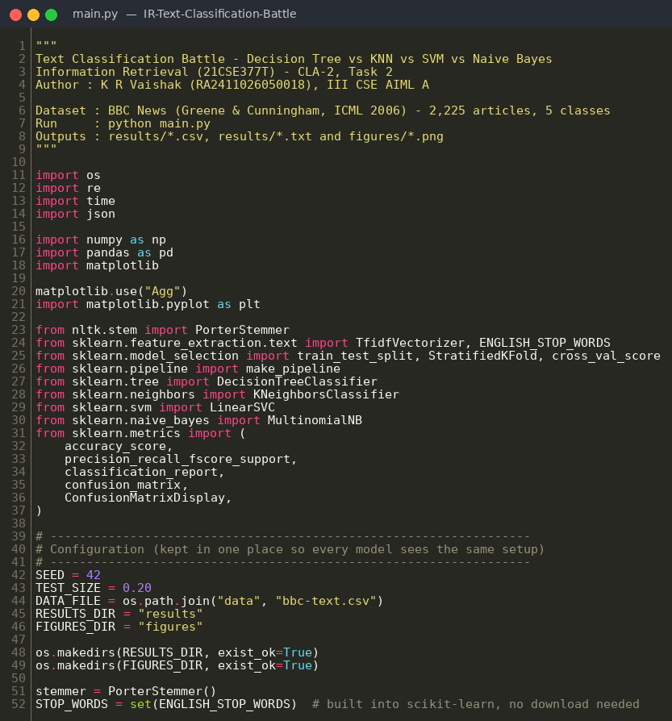
Figure 1: Imports and configuration
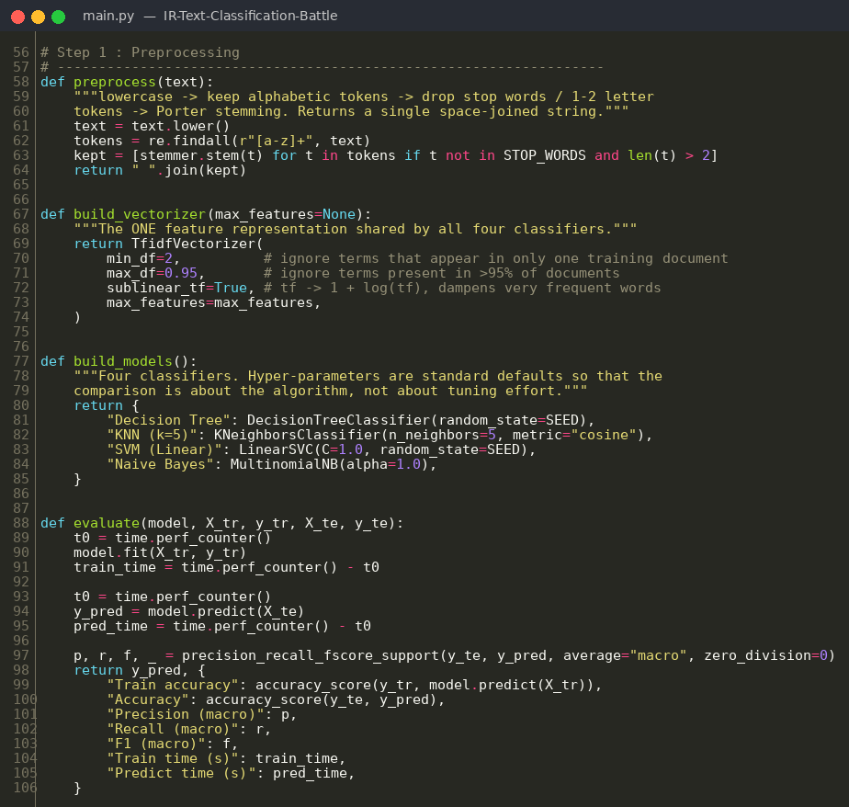
Figure 2: Preprocessing, TF-IDF vectorizer, models and evaluation function
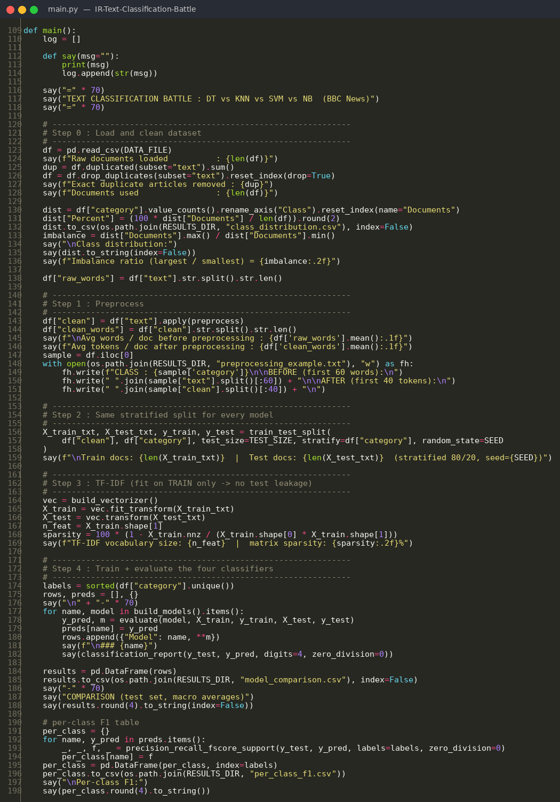
Figure 3: Loading data, preprocessing, train-test split, TF-IDF and model training
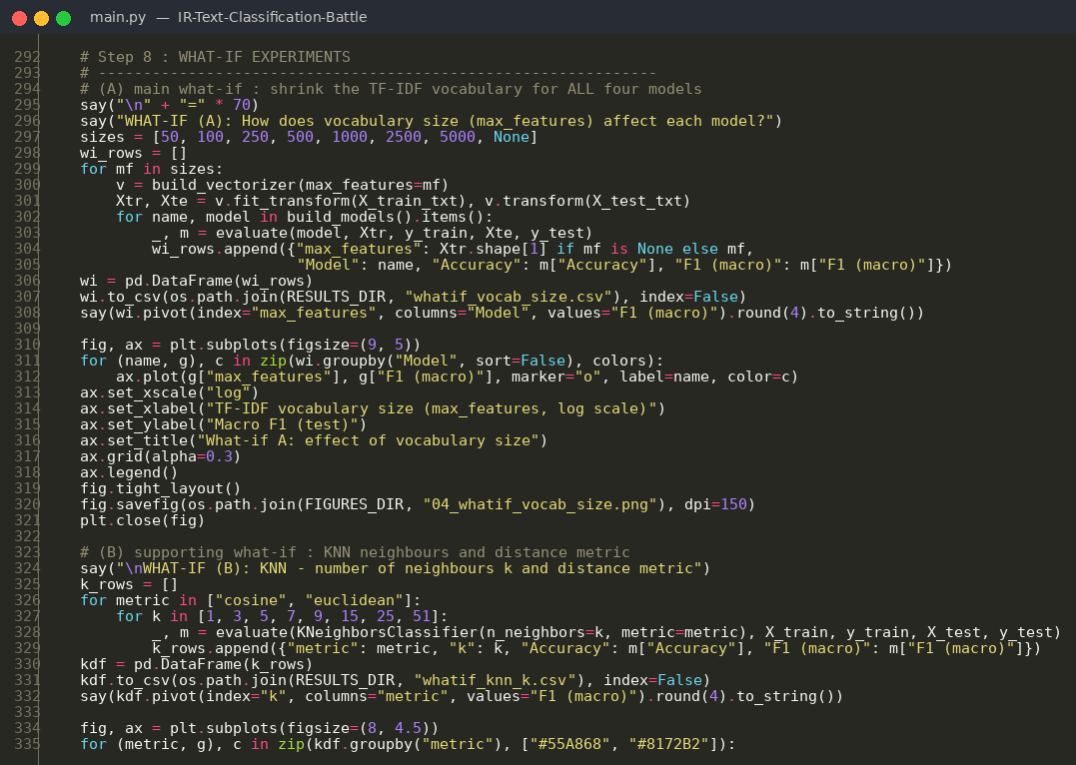
Figure 4: What-if experiments
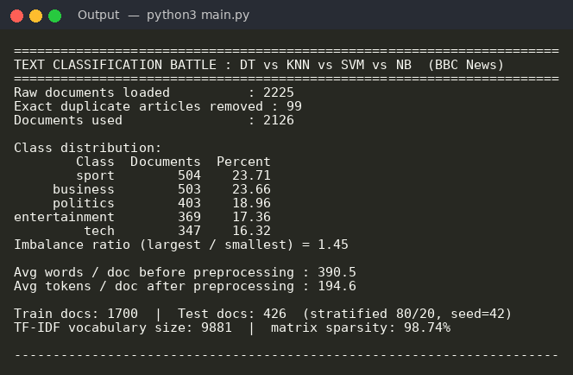
Figure 5: Execution output – dataset and preprocessing details
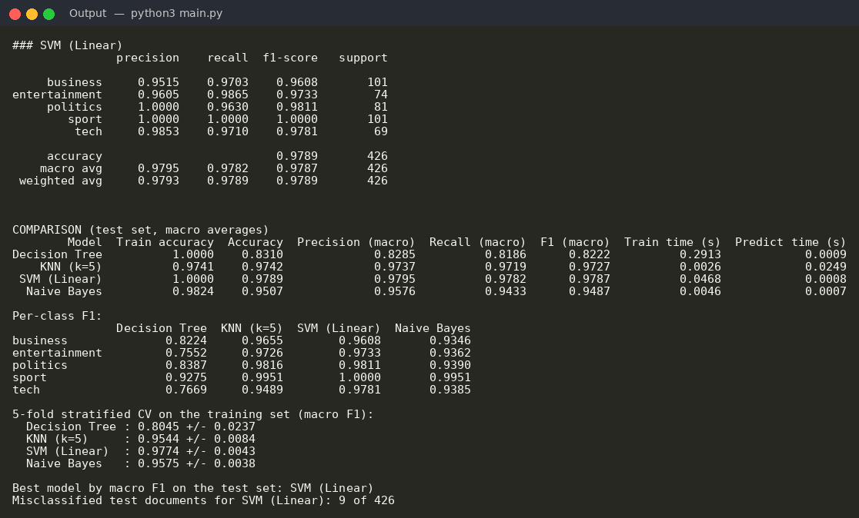
Figure 6: Execution output – SVM report, model comparison and cross-validation
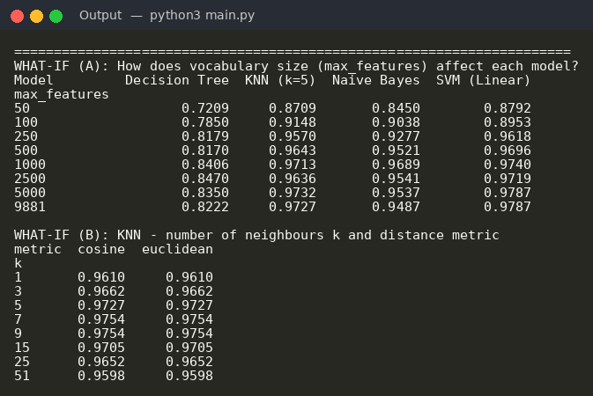
Figure 7: Execution output – what-if experiment results
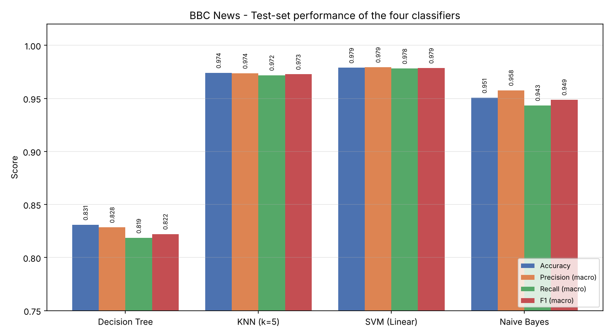
Figure 8: Performance comparison of the four classifiers
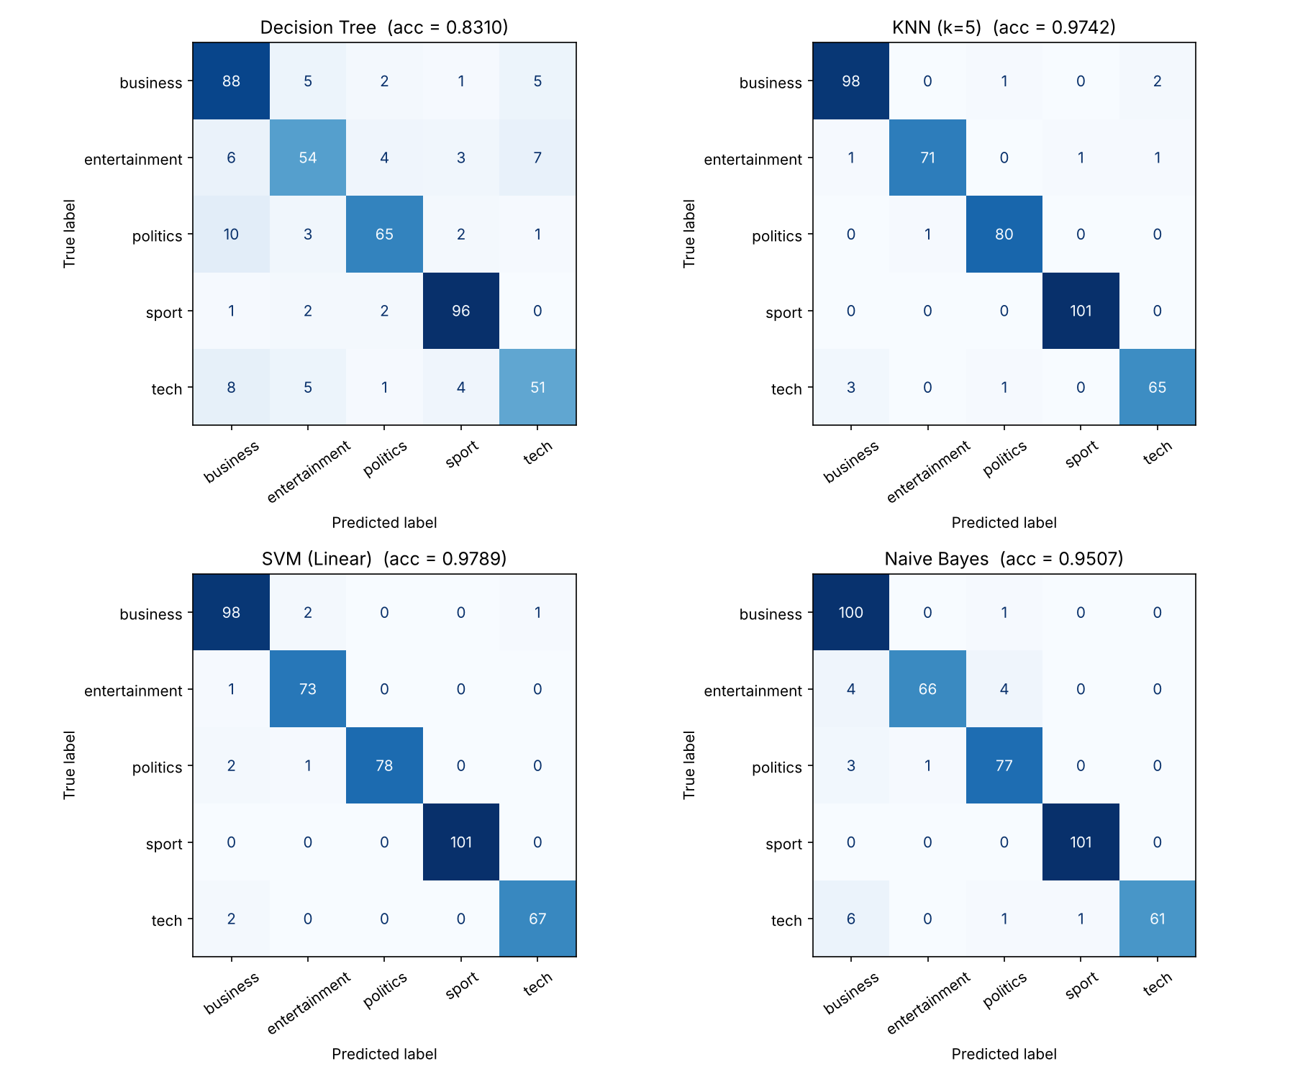
Figure 9: Confusion matrices of the four classifiers
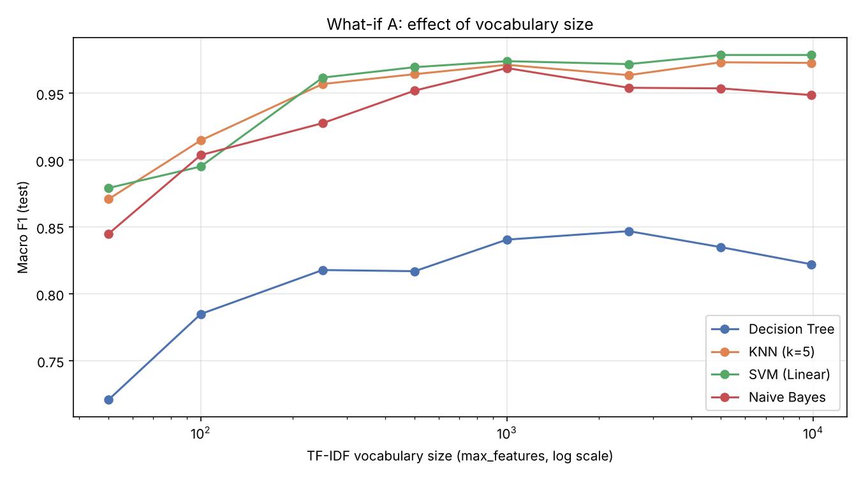
Figure 10: What-if experiment – effect of vocabulary size
Project Result
The execution successfully loaded 2,126 news articles and completed preprocessing, TF-IDF feature extraction with 9,881 terms, and training of all four classifiers. Linear SVM was the best-performing model, with an accuracy of 0.9789 and a macro F1-score of 0.9787, correctly classifying 417 of the 426 test articles. It was followed by KNN (F1 0.9727), Naive Bayes (F1 0.9487) and Decision Tree (F1 0.8222). The Decision Tree overfit, scoring 100% on training data but 83.1% on test data. In the what-if experiments, Naive Bayes performed best with 1,000 features (F1 0.9689), and KNN performed best at k = 7 to 9 (F1 0.9754). Based on these results, Linear SVM is recommended for this news classification task.

