Report On A Recent Internet Protocol Development

The journey of internet protocols from their inception in the 1970s to the present day is a fascinating tale of innovation, adaptation, and global collaboration. These protocols, the rules governing the exchange of data over the internet, have transformed from simple, foundational frameworks to complex systems enabling the global, interconnected digital world we live in today.

The Genesis of Internet Protocols
In the early 1970s, the need for a standardized set of protocols to facilitate the sharing of information across diverse computer networks became apparent. This need led to the development of the Transmission Control Protocol/Internet Protocol (TCP/IP) suite by Vint Cerf and Bob Kahn, marking the birth of the internet as we know it. TCP/IP was revolutionary, providing a reliable method for transmitting data packets across different networks, thus laying the groundwork for the internet’s expansion.
- 1970s-1980s: The TCP/IP protocol suite is developed, with early versions focusing on connectivity and data transmission reliability.
- 1983: TCP/IP becomes the standard communication protocol for ARPANET, effectively birthing the modern internet.
- 1984: The Domain Name System (DNS) is introduced, translating numerical IP addresses into human-readable domain names.

- 1989: Tim Berners-Lee proposes the World Wide Web, utilizing HTTP to navigate the burgeoning internet.

- 1990s: The internet explodes in popularity, with protocols like FTP, SMTP, and HTTP becoming widely adopted.

HTTP/3 is the latest version of the Hypertext Transfer Protocol (HTTP), which is foundational for data communication on the World Wide Web. Developed by the Internet Engineering Task Force (IETF), HTTP/3 introduces several significant improvements over its predecessor, HTTP/2. This report highlights the key features, advantages, and implications of HTTP/3.

HTTP/3 represents a significant advancement in internet protocol development, addressing the limitations of previous versions and enhancing performance, security, and user experience. As it continues to gain traction among developers and service providers, HTTP/3 is poised to play a crucial role in shaping the future of web communication.

IPv6, or Internet Protocol Version 6, is the latest version of the Internet Protocol designed to replace IPv4. Developed in the late 1990s, IPv6 addresses the limitations of its predecessor, particularly the exhaustion of available IP addresses. This report highlights the key features, advantages, challenges, and current status of Ipv6.

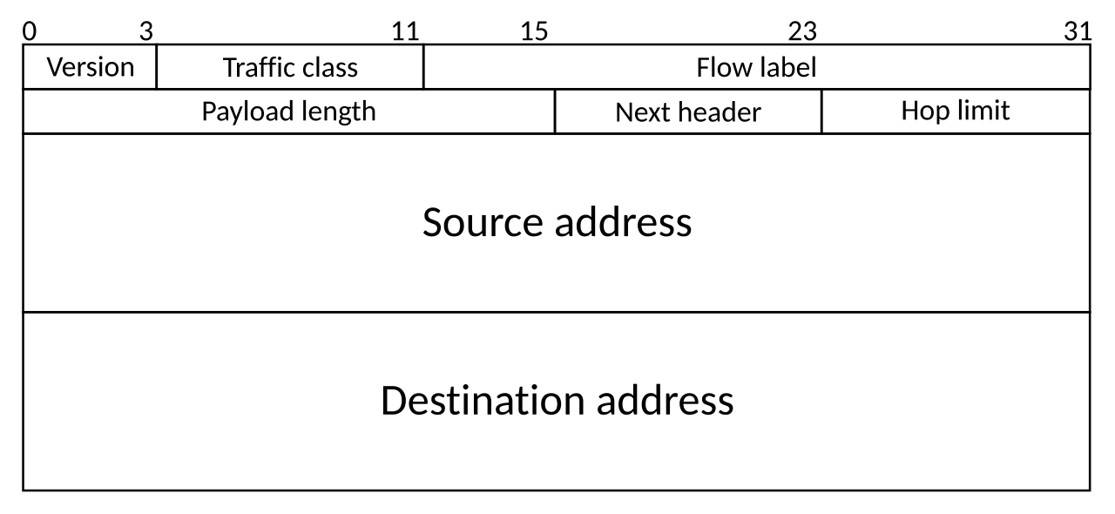
IPv6 is a critical advancement in internet protocol development, addressing the limitations of IPv4 and ensuring the scalability of the internet. Its extensive features and capabilities make it essential for the growing number of devices and users online. Continued efforts to promote its adoption will be vital for the future of global connectivity.

Key Features of IPv6
- Expanded Address Space:
  - IPv6 uses a 128-bit address format, allowing for approximately 3.4×1038 unique IP addresses. This vast address space can accommodate the growing number of devices connected to the internet.
- Improved Security:
  - IPv6 was designed with security in mind, incorporating IPsec (Internet Protocol Security) as a mandatory feature. This provides data confidentiality, integrity, and authentication.
- Simplified Packet Header:
  - The packet header in IPv6 is simplified compared to IPv4, improving the efficiency of routing and processing by network devices.
- Auto-Configuration:
  - IPv6 supports stateless address auto-configuration (SLAAC), allowing devices to automatically configure their IP addresses without the need for a DHCP server.

Advantages
- Elimination of Address Exhaustion: With its extensive address space, IPv6 solves the problem of IPv4 address exhaustion, ensuring that new devices can connect to the internet without issues.
- Enhanced Performance: Improved routing efficiency and simplified headers contribute to better network performance.
- Built-in Security Features: The integration of IPsec enhances the security of communications over the internet.

Challenges
- Adoption Rate: Despite its benefits, the transition from IPv4 to IPv6 has been slow. Many organizations still rely on IPv4 due to compatibility concerns and the complexity of transitioning.
- Interoperability: Ensuring seamless communication between IPv4 and IPv6 networks remains a challenge as both protocols coexist.

