Report View

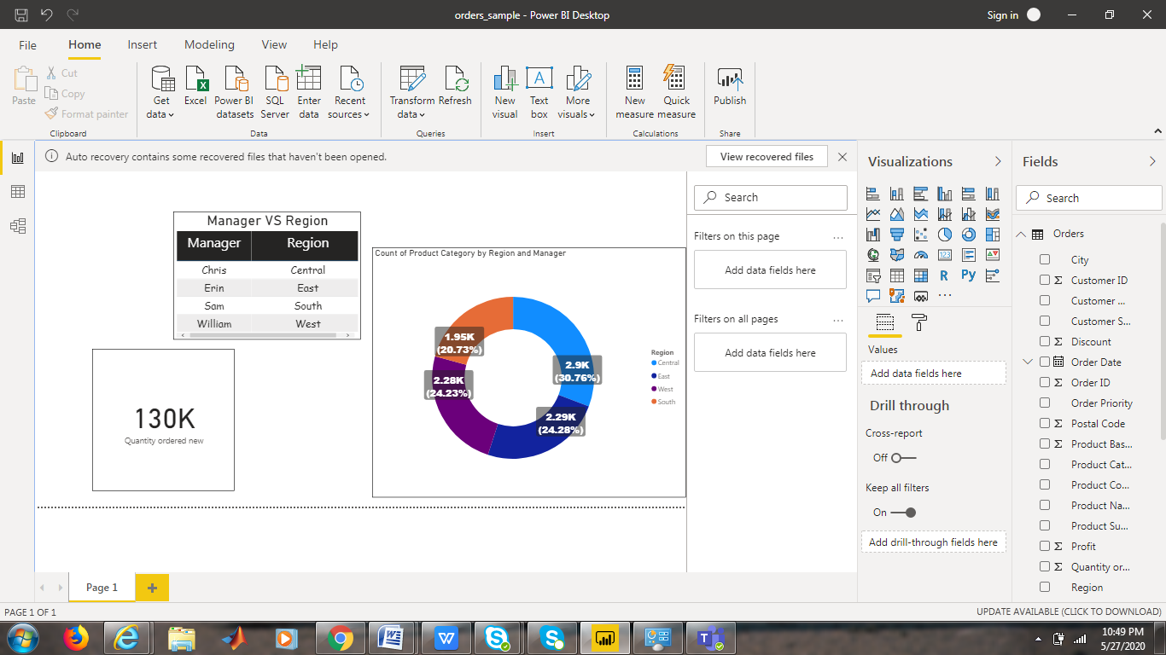

Data View

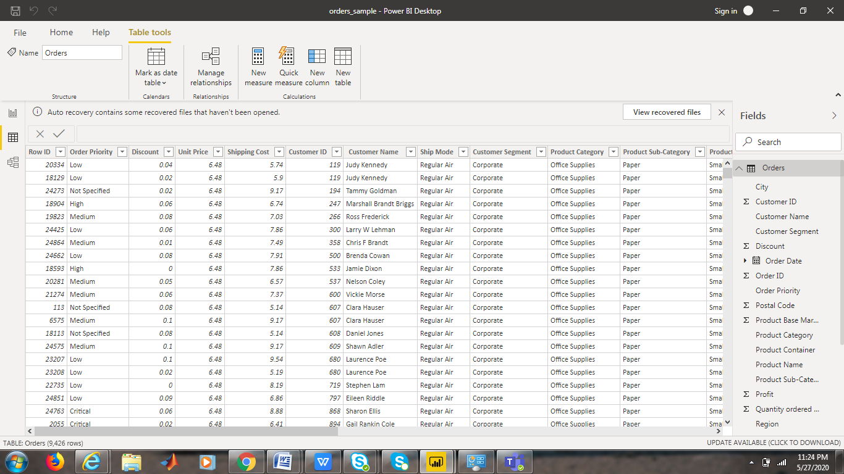

Model View

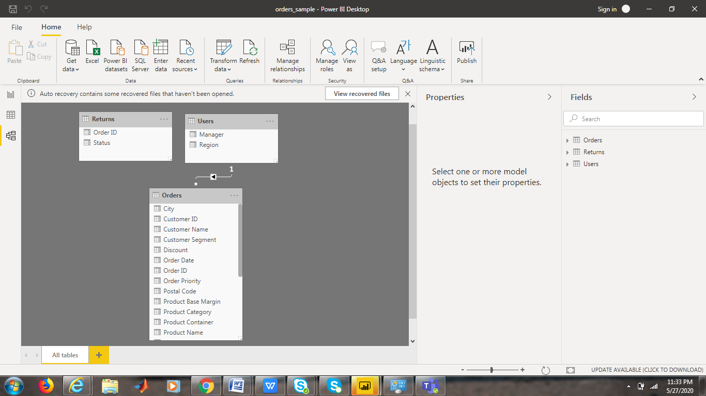

Power Query Editor

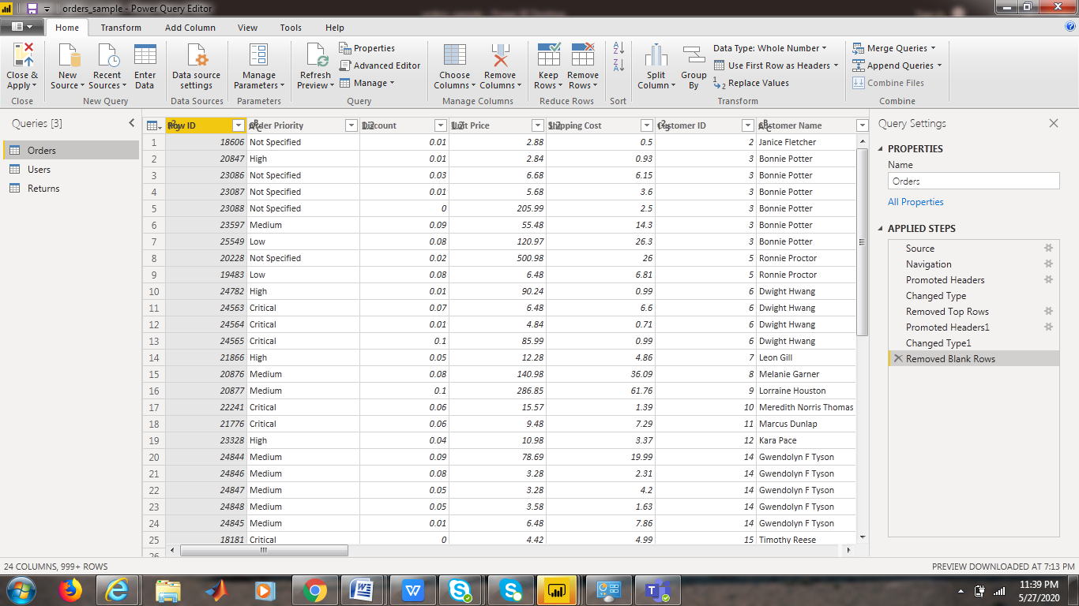

Advanced Editor

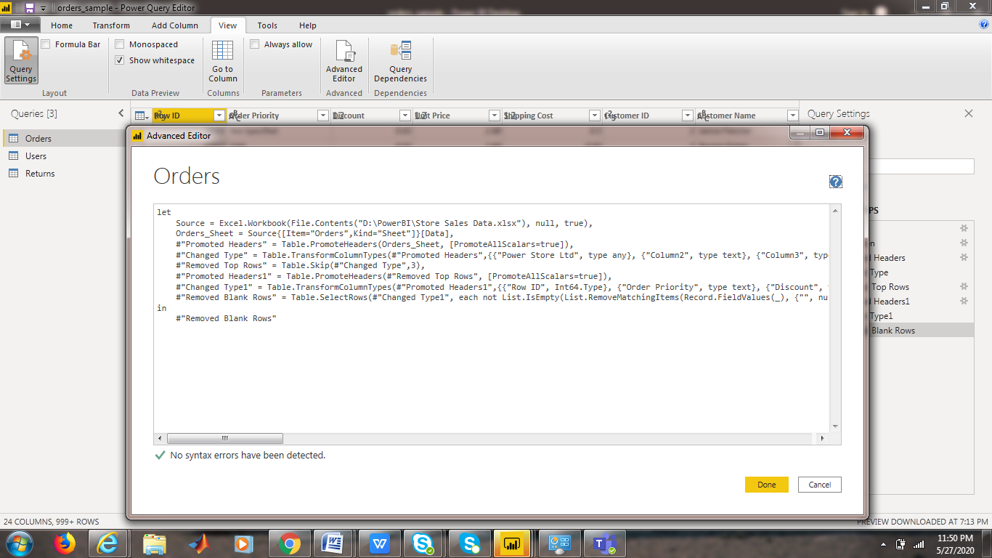

COMPARISON BETWEEN POWER BI DESKTOP, POWER BI PRO, POWER BI PREMIUM

|  |  |  |
| --- | --- | --- |
| **POWER BI DESKTOP** | **POWER BI PRO** | **POWER BI PREMIUM** |
| User based licensing | User based licensing | Capacity or cloud compute based licensing |
| Access content from a premium backed shared workspace. | Create, publish, access, share content to a shared workspace. | Designing a premium backed shared dashboard. |
| 10K rows / hr support for data streaming | 1M rows/hr support of data streaming | 1M rows / hr support of data streaming |
| Dataset capacity of 1 GB | Dataset capacity of 10 GB | Dataset capacity upto 10 GB |
| 8 data refreshes per day | 8 data refreshes per day | 48 data refreshes per day |
| Storage Limit of 10 GB | Storage limit of 10 GB | Storage limit of 100TB |
| PRICING = FREE | PRICING = $99 per user / month | PRICING = Capacity based , per node per month |