Target Case study
- Import the dataset and do usual exploratory analysis steps like checking the structure & characteristics of the dataset.
- Data type of all columns in the “customers” table.
Select column_name, data_type
from TargetSQL.INFORMATION_SCHEMA.COLUMNS
where table_name = "customers"

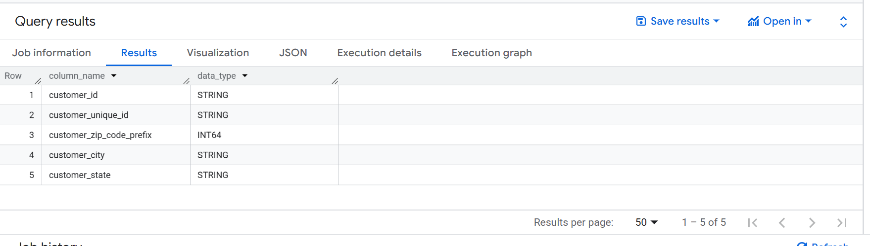
Insight: From the query result we can see almost all the columns are string type except the customer_zip_code column.

- Get the time range between which the orders were placed.
Select max(order_purchase_timestamp) as last_order, min(order_purchase_timestamp)as first_order from `TargetSQL.orders`;
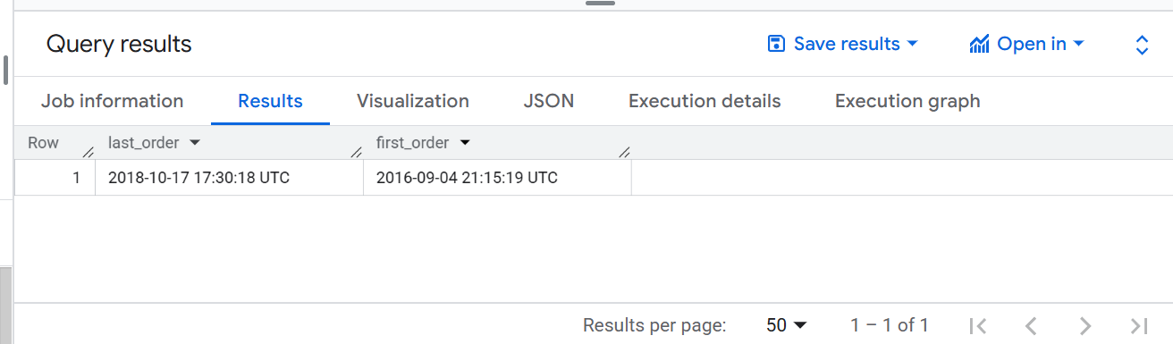
Insight: Orders were placed between 04 sept 2016 to 17 oct 2018.

- Count the Cities & States of customers who ordered during the given period.

Select count(distinct(customer_city)) as unique_city, count(distinct(customer_state)) as unique_state
from `TargetSQL.customers` c
join `TargetSQL.orders` o
on c.customer_id = o.customer_id
where o.order_purchase_timestamp between (Select min(order_purchase_timestamp) from `TargetSQL.orders`)
and (Select max(order_purchase_timestamp) from `TargetSQL.orders`);
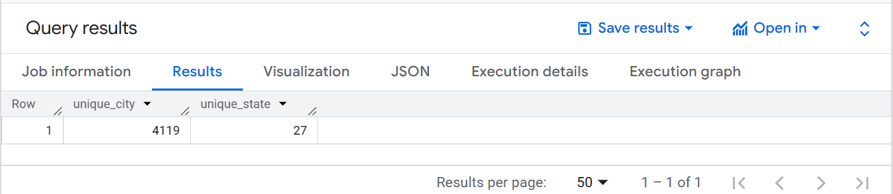

Insight: Orders were placed by 4119 unique cities and 27 state

II. In-depth Exploration:
A. Is there a growing trend in the no. of orders placed over the past years?
Select extract(year from order_purchase_timestamp) as order_year,
extract(month from order_purchase_timestamp) as order_month,
count(order_id) as total_orders
from `TargetSQL.orders`
group by 1,2
order by 1,2
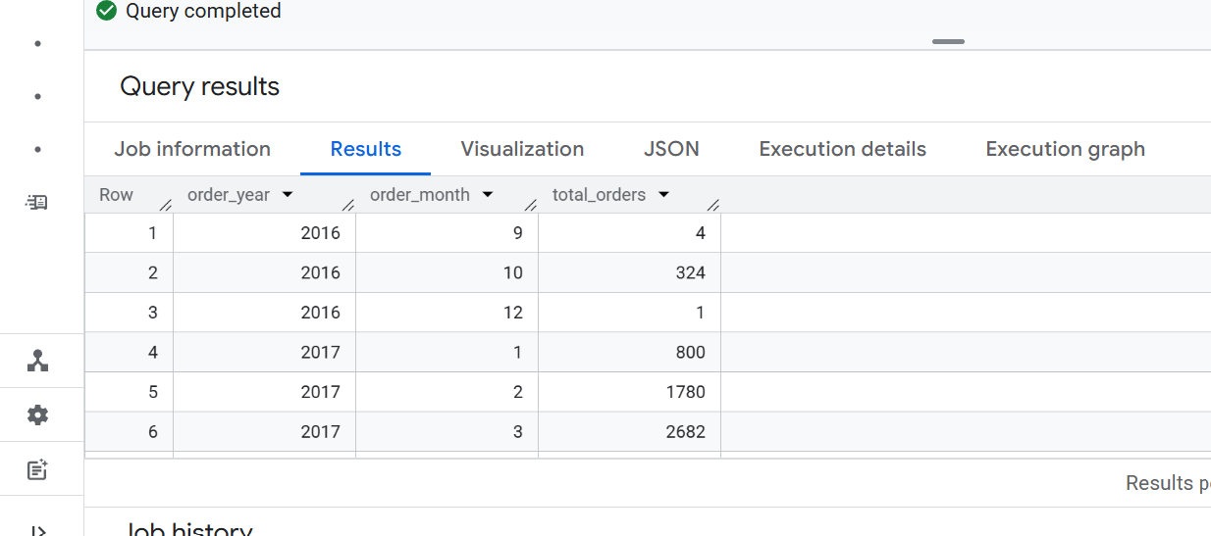

It’s been observed that order has increased over the year. But in the year 2018 in the month of November and December significant decrease in the order can be observed.

B. Can we see some kind of monthly seasonality in terms of the no. of orders being placed?
Select extract(month from order_purchase_timestamp) as order_month,
count(order_id) as total_orders
from `TargetSQL.orders`
group by 1
order by 1;
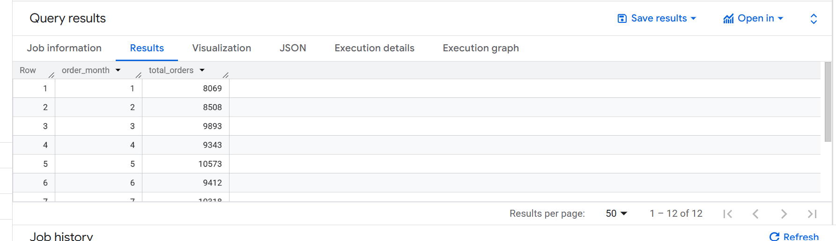
Insights: Maximum numbers of orders were placed from the month of May to Aug, which is generally a vacation time. March and April also has good amount of orders. However, least numbers of orders were placed during the month of sept, octand december.

C. During what time of the day, do the Brazilian customers mostly place their orders? (Dawn, Morning, Afternoon or Night) ● 0-6 hrs : Dawn ● 7-12 hrs : Mornings ● 13-18 hrs : Afternoon ● 19-23 hrs : Night
Select
case
when extract(hour from order_purchase_timestamp ) between 0 and 6 then 'Dawn'
when extract(hour from order_purchase_timestamp ) between 7 and 12 then 'Morning'
when extract(hour from order_purchase_timestamp ) between 13 and 18 then 'Afternoon'
else 'Night'
end as time_of_day,
count(order_id) as total_orders
from `TargetSQL.orders` o
join `TargetSQL.customers` c
on o.customer_id = c.customer_id
GROUP BY time_of_day
ORDER BY total_orders DESC;

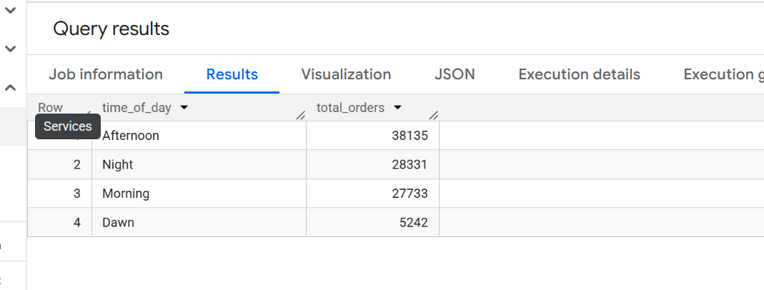
Insight: From the table we see that most orders were placed during afternoon followed by Night and Morning.

III. Evolution of E-commerce orders in the Brazil region:
- Get the month on month no. of orders placed in each state.
SELECT
c.customer_state,
extract(month from o. order_purchase_timestamp ) as order_month,
count(o.order_id) as total_orders
from `TargetSQL.customers` c
join `TargetSQL.orders` o
on c.customer_id = o.customer_id
group by customer_state, order_month
order by customer_state, order_month
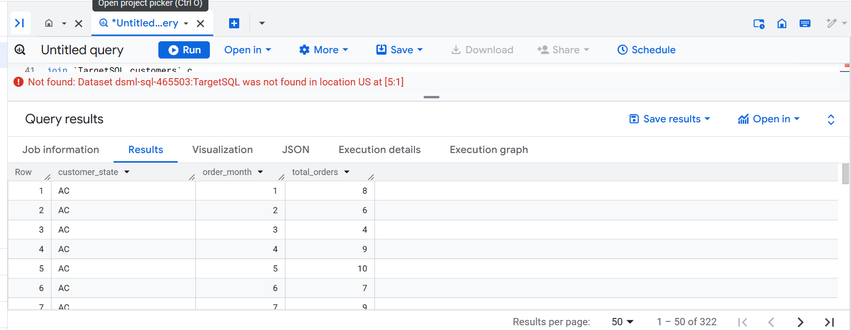
State BA has the largest number order placed. State AL also has a significant amount of orders placed throughout each year.

- How are the customers distributed across all the states?
Select
customer_state,
count(distinct customer_id) as unique_customers
from `TargetSQL.customers`
group by customer_state
order by unique_customers desc;
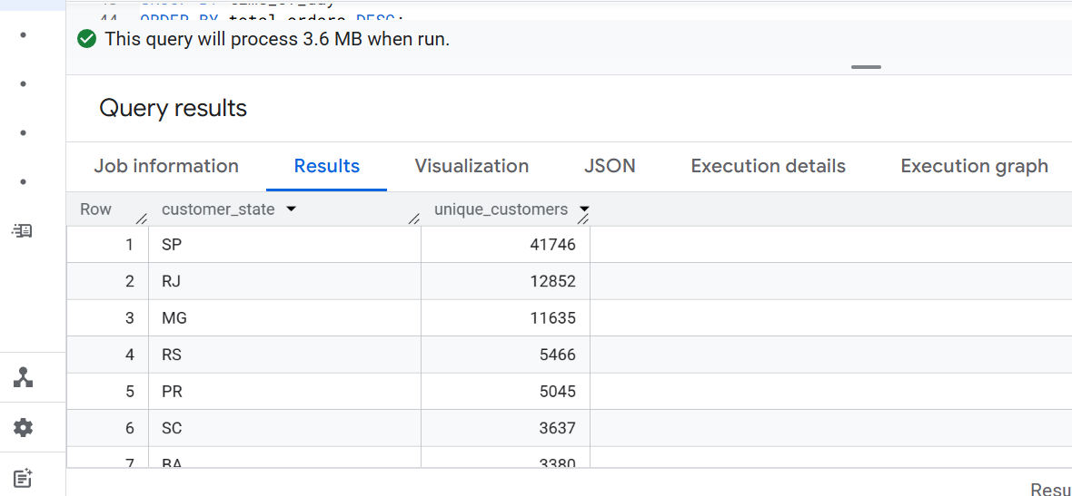

Insight: Target has a huge market in SP followed by RJ and MG. Least amount of sales was observed in AC, AP and RR.

IV. Impact on Economy: Analyze the money movement by e-commerce by looking at order prices, freight and others.
- Get the % increase in the cost of orders from year 2017 to 2018 (include months between Jan to Aug only).
with order_ct as(
Select
extract(year from o.order_purchase_timestamp ) as order_yr,
sum(p.payment_value) as total_pay
from `TargetSQL.orders` o
join `TargetSQL.payments` p
on o.order_id = p.order_id
where extract(month from o.order_purchase_timestamp) between 1 and 8
group by order_yr
having order_yr in (2017,2018))
Select
max(case when order_yr = 2017 then total_pay end) as total_17,
max(case when order_yr = 2018 then total_pay end) as total_18,
round(
(max(case when order_yr = 2018 then total_pay end) -
max(case when order_yr = 2017 then total_pay end))/
max(case when order_yr = 2017 then total_pay end) * 100, 2) as pct_inc
from order_ct;
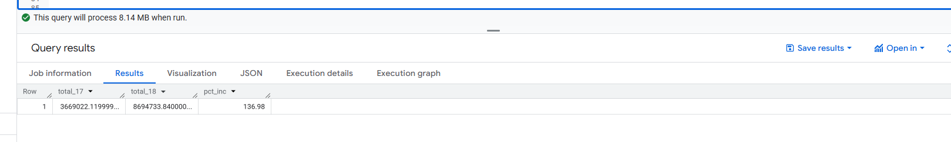
Insight: 136.8 % increase observed from the year 2017 to 2018.

B. Calculate the Total & Average value of order price for each state.
Select
c.customer_state,
round(sum(oi.order_total),2) as total_value,
round(avg(order_total),2) as avg_order
from `TargetSQL.customers` c
join `TargetSQL.orders` o
on c.customer_id = o.customer_id
join(select order_id , sum(price)as order_total
from `TargetSQL.order_items` oi
group by order_id) oi on o.order_id = oi.order_id group by c. customer_state order by c.customer_state;
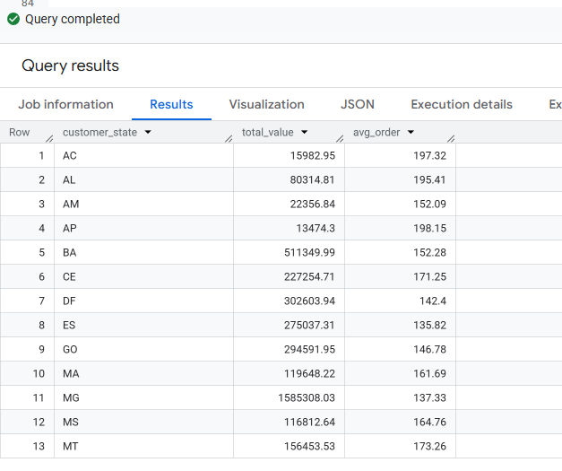

C. Calculate the Total & Average value of order freight for each state.
SELECT
c.customer_state,
ROUND(SUM(oi.order_freight), 2) AS total_freight_value,
ROUND(AVG(oi.order_freight), 2) AS avg_freight_value
from `TargetSQL.customers` c
join `TargetSQL.orders` o
ON c.customer_id = o.customer_id
JOIN (
-- calculate freight per order
SELECT order_id, SUM(freight_value) AS order_freight
FROM `TargetSQL.order_items`
GROUP BY order_id
) oi
ON o.order_id = oi.order_id
GROUP BY c.customer_state
ORDER BY c.customer_state;

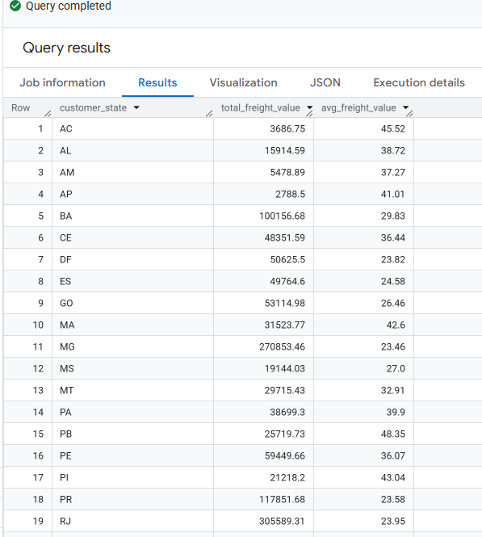

V. Analysis based on sales, freight and delivery time.
- Find the no. of days taken to deliver each order from the order’s purchase date as delivery time.
SELECT
order_id,
DATE_DIFF(order_delivered_customer_date, order_purchase_timestamp, DAY) AS time_to_deliver,
DATE_DIFF(order_estimated_delivery_date, order_delivered_customer_date, DAY) AS diff_estimated_delivery
FROM `TargetSQL.orders`
WHERE order_delivered_customer_date IS NOT NULL
ORDER BY order_id;
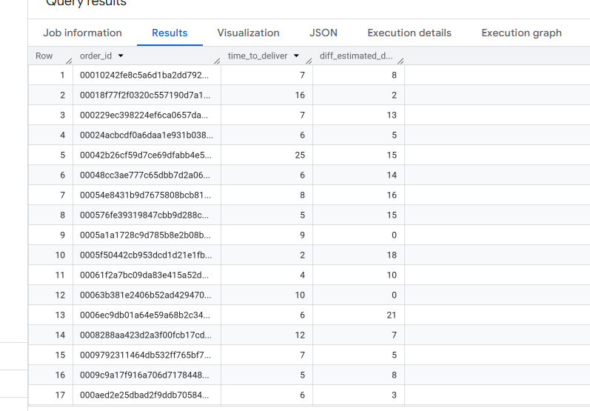
Insight: Maximum amount of days were 25 which is almost a month to receive an order. The place can be in suburbs due to which it look so long time to deliver the order.
- Find out the top 5 states with the highest & lowest average freight value.
WITH freight AS (
SELECT
c.customer_state,
round( AVG(oi.freight_value),2) AS avg_freight
FROM`TargetSQL.orders` o
JOIN `TargetSQL.customers` c
ON o.customer_id = c.customer_id
JOIN `TargetSQL.order_items` oi
ON o.order_id = oi.order_id
GROUP BY c.customer_state
),
ranked AS (
SELECT
customer_state,
avg_freight,
RANK() OVER (ORDER BY avg_freight ASC) AS rnk_asc,
RANK() OVER (ORDER BY avg_freight DESC) AS rnk_desc
FROM freight
)
SELECT customer_state, avg_freight
FROM ranked
WHERE rnk_asc <= 5 OR rnk_desc <= 5
ORDER BY avg_freight ASC;

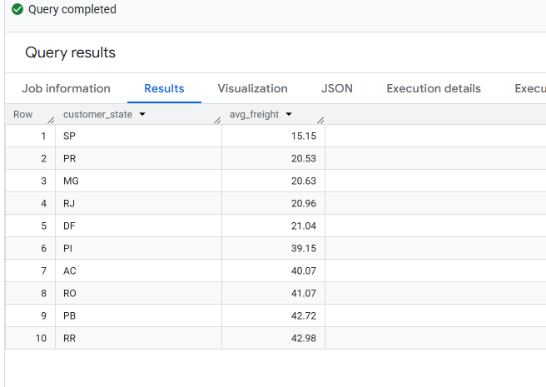
C. Find out the top 5 states with the highest & lowest average delivery time.
WITH state_delivery AS (
SELECT
c.customer_state,
round(AVG(DATE_DIFF(o.order_delivered_customer_date, o.order_purchase_timestamp, DAY)),2) AS avg_delivery_time
FROM `TargetSQL.orders` o
JOIN `TargetSQL.customers` c
ON o.customer_id = c.customer_id
WHERE o.order_delivered_customer_date IS NOT NULL
GROUP BY c.customer_state
),
ranked AS (
SELECT
customer_state,
avg_delivery_time,
RANK() OVER (ORDER BY avg_delivery_time ASC) AS rnk_asc,
RANK() OVER (ORDER BY avg_delivery_time DESC) AS rnk_desc
FROM state_delivery
)
SELECT customer_state, avg_delivery_time
FROM ranked
WHERE rnk_asc <= 5 OR rnk_desc <=5
ORDER BY avg_delivery_time ASC;
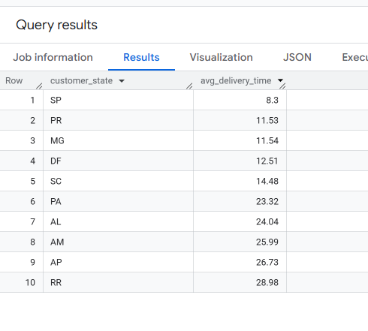
D. Find out the top 5 states where the order delivery is really fast as compared to the estimated date of delivery.
WITH state_delivery AS (
SELECT
c.customer_state,
round(AVG(DATE_DIFF(o.order_estimated_delivery_date, o.order_delivered_customer_date, DAY)),2) AS avg_days_early
FROM `TargetSQL.orders` o
JOIN `TargetSQL.customers` c
ON o.customer_id = c.customer_id
WHERE o.order_delivered_customer_date IS NOT NULL
GROUP BY c.customer_state
)
SELECT customer_state, avg_days_early
FROM state_delivery
ORDER BY avg_days_early DESC
LIMIT 5;
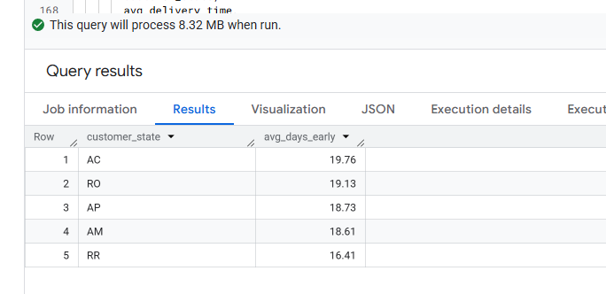

VI. Analysis based on the payments
- Find the month on month no. of orders placed using different payment types.
SELECT
extract(year from o.order_purchase_timestamp) AS order_year,
extract(month from o.order_purchase_timestamp) AS order_month,
SUM(CASE WHEN p.payment_type = 'credit_card' THEN 1 ELSE 0 END) AS credit_card_orders,
SUM(CASE WHEN p.payment_type = 'UPI' THEN 1 ELSE 0 END) AS UPI_orders,
SUM(CASE WHEN p.payment_type = 'voucher' THEN 1 ELSE 0 END) AS voucher_orders,
SUM(CASE WHEN p.payment_type = 'debit_card' THEN 1 ELSE 0 END) AS debit_card_orders,
SUM(CASE WHEN p.payment_type = 'not_defined' THEN 1 ELSE 0 END) AS not_defined_orders,
COUNT(DISTINCT o.order_id) AS total_orders

FROM `TargetSQL.orders` o
INNER JOIN `TargetSQL.payments` p ON o.order_id = p.order_id
WHERE o.order_purchase_timestamp IS NOT NULL
AND o.order_status NOT IN ('cancelled', 'unavailable')
GROUP BY
order_year,
order_month
ORDER BY
Order_year,order_month
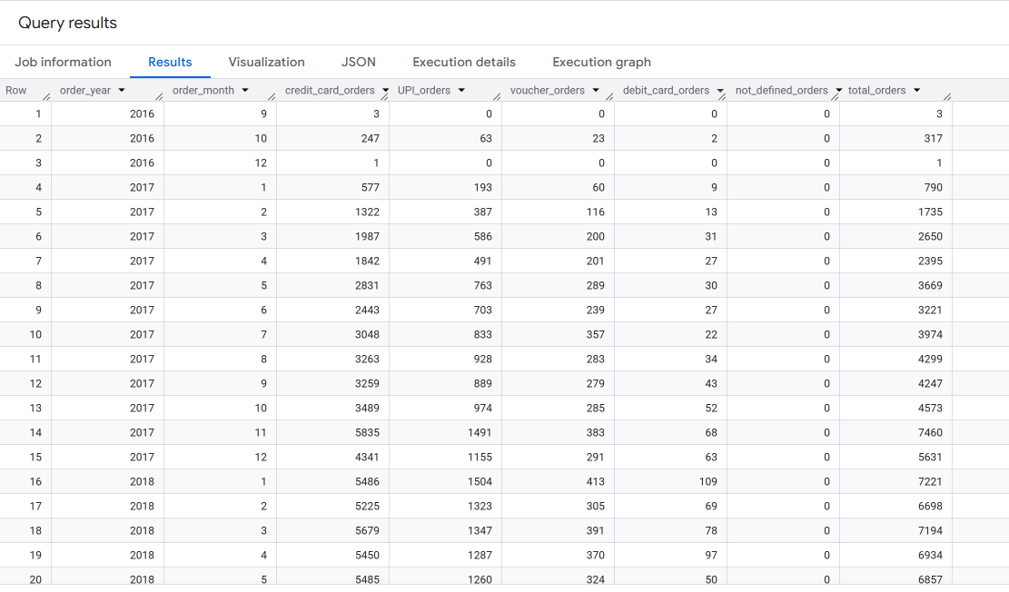

- Find the no. of orders placed on the basis of the payment installments that have been paid.

SELECT
payment_installments,
COUNT(DISTINCT p.order_id) as order_count,
from `TargetSQL.payments` p
inner join `TargetSQL.orders` o
on p.order_id = o.order_id
WHERE o.order_status IN ('delivered', 'shipped', 'processing', 'invoiced')
AND p.payment_value > 0
GROUP BY p.payment_installments
