Was about to complete assignment before deadline. But VM not working. Raised ticket for the same. Could you please consider task 2,3,4 without screenshots.

Task 1 -

Check whether /user/acadgild directory exists or not in the HDFS.

If it doesn't exist, then create this.

Create a directory /user/acadgild/hadoop.

Solution-

By using ls command check /user/acadgild directory exists in hdfs as below-

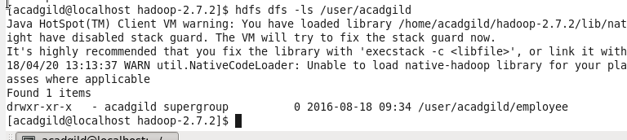

/user/acadgild/hadoop created using -mkdir command. Ls command shows all direcorties in hdfs direcory

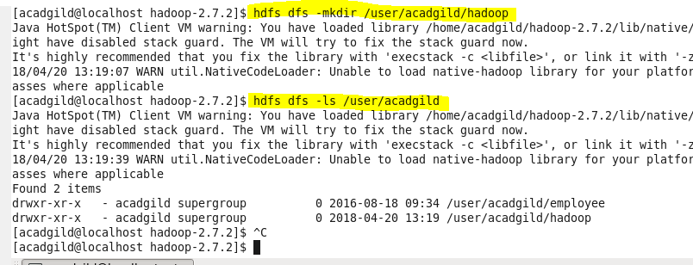

Task 2 –

Create a file in HDFS under directory /user/acadgild/hadoop, with name word-count.txt.

Whatever we type on screen should get appended to the file.

Try to type (on screen) few lines from any online article or textbook.

* File word-count.txt created using vi editor
* Local file created named abc.txt
* hdfs dfs –appendToFile abc.txt /user/acadgild/hadoop/word-count.txt

**Task 3:**

Create a file max-temp.txt in local FS.

Put some 10-15 records of date and temperature example:

dd-mm-yyyy,temperature

Example:

10-01-1990,10

10-02-1991,20

* max-temp.txt File created in local system using vi editor

**Task 4:**

Change the permission of the file /user/acadgild/hadoop/max-temp.txt, such that only the owner and

the group members have full control over the file.Others do not have any control over it.

File placed on hdfs using put command

* hdfs dfs –put max-temp.txt /user/acadgild/hadoop/

Changed permission for user and group using chmod command

* hdfs dfs –chmod ug+rwx a-rwx /user/acadgild/hadoop/ max-temp.txt