1. ABSTRACT
The rapid growth of online learning platforms has created numerous opportunities for students and professionals to improve their skills. Platforms such as Coursera, Udemy, and edX offer thousands of courses in different domains including Data Science, Artificial Intelligence, Web Development, Cyber Security, and Marketing. However, the availability of a large number of courses often creates confusion among learners when selecting the most suitable course.
Many learners invest time and money in courses without properly evaluating their relevance to career goals, market demand, or cost effectiveness. As a result, learners may choose courses that provide limited practical benefits. To address this issue, the LearnSure – AI Driven Smart Course Evaluation System is proposed.
The LearnSure system is an intelligent web-based application that evaluates online courses using machine learning techniques. The system analyzes multiple factors such as domain relevance, market demand, experience level, and course cost efficiency to determine whether a course is worth taking.
The system collects user input through a web interface and processes the information using a machine learning model and a weighted scoring mechanism. Based on the evaluation score, the system classifies the course as “Worth It” or “Not Worth It.” The system also provides a detailed breakdown of evaluation parameters to help users understand the decision.
The proposed system is implemented using Python, Flask framework, and machine learning algorithms such as Random Forest Regression. The system provides a user-friendly interface that allows learners to evaluate courses quickly and efficiently.
By combining artificial intelligence with decision support techniques, the LearnSure system helps learners make informed decisions and select courses that align with industry demand and career development.
2. INTRODUCTION
The advancement of digital technologies has significantly transformed the education sector. Online learning platforms have become an important source of knowledge for students and professionals across the world. Platforms such as Coursera, Udemy, edX, and other online learning portals provide thousands of courses in different domains including Data Science, Artificial Intelligence, Web Development, Cyber Security, Marketing, and Finance. These platforms allow learners to acquire new skills conveniently without geographical limitations.
However, the availability of a large number of courses also creates a major challenge for learners when selecting the most suitable course. Many students choose courses based on popularity, advertisements, or limited information without properly evaluating whether the course aligns with their career goals or current industry demand. As a result, learners may invest significant time and financial resources in courses that do not provide substantial career benefits.
In recent years, Artificial Intelligence and Machine Learning technologies have been widely used to develop intelligent recommendation systems that assist users in making better decisions. These systems analyze various parameters and provide personalized suggestions based on user preferences and data patterns. Applying such intelligent techniques to evaluate online courses can help learners select courses more effectively.
The proposed system, LearnSure – AI Driven Smart Course Evaluation System, is designed to address this challenge by providing an intelligent mechanism to evaluate online courses before enrollment. The system analyzes multiple parameters including domain relevance, market demand, user experience level, and course cost efficiency. These factors are processed using machine learning techniques to generate an overall evaluation score.
The system is implemented as a web-based application developed using the Flask framework and Python programming language. The machine learning model processes the input parameters and predicts the usefulness of the course based on learned patterns. The system then provides a recommendation indicating whether the course is “Worth It” or “Not Worth It”.
The main objective of this research is to develop a smart evaluation system that supports learners in making informed decisions when selecting online courses. By integrating machine learning techniques with a user-friendly web interface, the LearnSure system aims to reduce the risk of choosing ineffective courses and promote smarter learning choices.
3. LITERATURE SURVEY
With the rapid development of online education platforms, several studies have explored the use of intelligent systems to assist learners in selecting suitable courses. Researchers have proposed various recommendation systems and machine learning models to analyze user preferences, course features, and market demand to provide better learning suggestions.
One of the widely used techniques in decision support systems is Machine Learning, which enables systems to learn patterns from data and make predictions based on input parameters. Machine learning algorithms such as Decision Trees, Random Forest, and Support Vector Machines have been widely applied in recommendation systems and predictive analytics. These models help analyze complex relationships between multiple factors and generate accurate results.
Breiman (2001) introduced the Random Forest algorithm, which is an ensemble learning technique that combines multiple decision trees to improve prediction accuracy. Random Forest has been widely used in many applications including classification, regression, and recommendation systems due to its robustness and ability to handle multiple input features.
Several researchers have also developed course recommendation systems that suggest courses to learners based on their interests and learning history. These systems often use collaborative filtering or content-based filtering techniques to recommend relevant courses. However, most existing systems mainly focus on recommending courses rather than evaluating the overall value of a course in terms of cost efficiency, market demand, and career relevance.
Recent studies have highlighted the importance of integrating market demand analysis into educational recommendation systems. By considering industry trends and job market requirements, such systems can provide more practical recommendations that align with real-world career opportunities.
Although many recommendation systems exist, there is still a need for systems that evaluate the overall usefulness of a course rather than simply recommending courses based on popularity or user preferences. The proposed LearnSure system addresses this gap by combining machine learning techniques with a structured scoring mechanism to evaluate courses based on domain relevance, market demand, user experience level, and cost efficiency.
This research builds upon previous work in machine learning and decision support systems to develop an intelligent course evaluation platform that helps learners make more informed educational choices.
4. PROPOSED METHODOLOGY
The proposed system, LearnSure – AI Driven Smart Course Evaluation System, is designed to help learners evaluate online courses using machine learning techniques and a structured scoring mechanism. The methodology of the system focuses on collecting course information, processing input parameters, applying machine learning analysis, and generating a final evaluation score.
The first step in the methodology is user input collection. The system provides a web interface where users can enter course-related information such as course domain, course fee, course duration, experience level, and market demand level. These inputs represent the key factors that influence the usefulness of an online course.
Once the input data is collected, the system performs feature processing. In this stage, the textual inputs are converted into numerical values so that they can be processed by the machine learning model. For example, different course domains are assigned domain relevance scores, and market demand levels are mapped to numerical values representing the popularity of the domain in the job market.
The system also calculates cost efficiency, which is determined by calculating the cost per month of the course using the course fee and duration. This helps evaluate whether the course is financially reasonable for the learner.
After preprocessing the data, the system applies a machine learning model to evaluate the course. In this project, the Random Forest Regression algorithm is used to analyze the relationship between the input parameters and the final evaluation score. Random Forest is selected because it provides high prediction accuracy and performs well when handling multiple input features.
Once the evaluation score is calculated, the system applies a decision mechanism that determines whether the course is “Worth It” or “Not Worth It.” The system also generates a breakdown of evaluation parameters such as domain relevance, market demand, experience alignment, and cost efficiency. This information helps users understand how the final decision was made.
Finally, the results are displayed on the web interface where the user can view the evaluation score and recommendation. This methodology ensures that the system provides an intelligent and transparent mechanism for evaluating online courses.
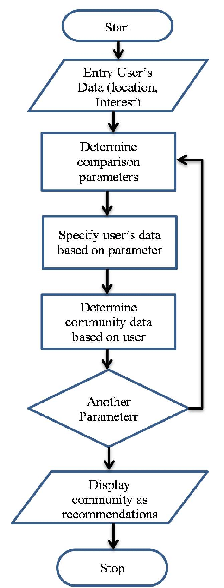
Figure 4.1: Proposed Methodology of LearnSure Course Evaluation System
5. ARCHITECTURE DIAGRAM
The architecture of the LearnSure – AI Driven Smart Course Evaluation System represents the overall structure and interaction between different components of the system. The architecture is designed to ensure efficient data flow between the user interface, processing modules, machine learning model, and result generation system.
The system begins with the user interface, where the learner enters course details such as course domain, course fee, duration, experience level, and market demand level. This interface is developed using HTML, CSS, and JavaScript, and it allows users to interact with the system through a web browser.
Once the user submits the course information, the data is sent to the Flask web application, which acts as the backend server of the system. The Flask framework processes user requests, handles input data, and forwards the information to the processing module for further analysis.
The next component is the feature processing module, where the input parameters are converted into numerical scores. For example, domain types and market demand levels are mapped to predefined numerical values. The system also calculates cost efficiency by determining the cost per month of the course.
After preprocessing the data, the information is sent to the machine learning model, which is trained using the Random Forest Regression algorithm. The model analyzes the relationship between input parameters and the final evaluation score. Based on this analysis, the model generates a predicted score representing the usefulness of the course.
Finally, the result generation module displays the evaluation results to the user. The system provides the final score, course recommendation status, and a breakdown of evaluation factors. The results are displayed on the web interface, allowing the user to easily understand the evaluation outcome.
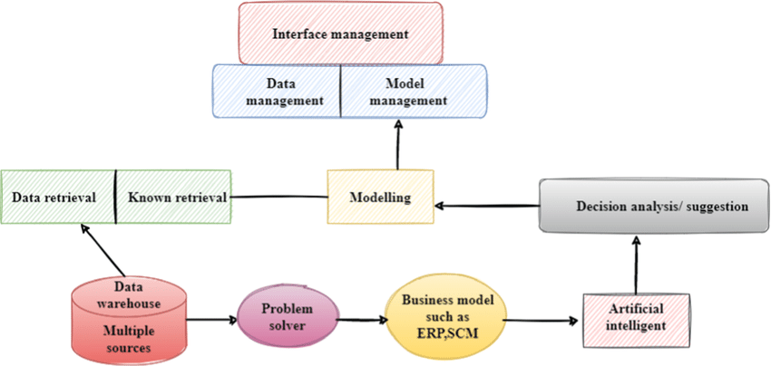
Figure 5.1: System Architecture of LearnSure Course Evaluation System
6. VARIOUS PHASES / METHODOLOGIES
The development of the LearnSure – AI Driven Smart Course Evaluation System is carried out through several phases to ensure the proper design, implementation, and functioning of the system. Each phase plays an important role in building an intelligent course evaluation platform.
Phase 1: Data Collection
The first phase of the system involves collecting and preparing the dataset required for training the machine learning model. The dataset contains parameters related to course evaluation such as domain relevance score, market demand score, experience level score, and cost per month. These attributes represent the factors that influence the usefulness of an online course.
Phase 2: Data Preprocessing
In this phase, the collected data is cleaned and prepared for machine learning processing. Text-based values such as domain names and demand levels are converted into numerical values so that they can be analyzed by the machine learning algorithm. This step is important because machine learning models require structured numerical input data.
Phase 3: Model Training
After preprocessing the dataset, the machine learning model is trained using the Random Forest Regression algorithm. The model learns the relationship between the input features and the final course evaluation score. During the training process, multiple decision trees are generated and combined to improve prediction accuracy.
Phase 4: Web Application Development
Once the machine learning model is trained, it is integrated into a web application developed using the Flask framework. The web application provides a user-friendly interface where users can enter course details and submit them for evaluation.
Phase 5: Course Evaluation and Result Generation
In the final phase, the system processes the user input values and sends them to the trained machine learning model. The model calculates the evaluation score based on the input parameters and determines whether the course is “Worth It” or “Not Worth It.” The results are then displayed on the web interface along with a breakdown of evaluation factors.
These phases ensure that the LearnSure system is developed in a structured and systematic manner, resulting in an intelligent and reliable course evaluation platform.
7. INPUT
The LearnSure system requires several input parameters from the user in order to evaluate the usefulness of an online course. These inputs represent important factors that influence the value and effectiveness of a course for a learner. The system collects these inputs through a web-based interface where the user enters course-related information.
The first input parameter is the Course Domain. This refers to the subject area of the course such as Data Science, Artificial Intelligence, Web Development, Cyber Security, Marketing, Finance, or other fields. The domain plays an important role because some domains have higher industry demand and better career opportunities than others.
The second input parameter is the Course Fee, which represents the total cost required to enroll in the course. This value is important because the system evaluates whether the cost of the course is reasonable compared to the knowledge and benefits it provides.
The third input parameter is the Course Duration, which indicates the total length of the course in months. The duration helps the system calculate the cost efficiency of the course by determining the cost per month.
Another important input parameter is the Experience Level of the User. The system allows users to select whether they are a student or a working professional. This factor helps determine whether the course difficulty level is appropriate for the learner’s background.
The final input parameter is Market Demand Level, which represents the popularity and demand of the course domain in the job market. The demand level can be categorized as Low, Medium, or High depending on the industry trends.
After collecting these input values, the system converts them into numerical scores that can be processed by the machine learning model. These processed inputs are then used to evaluate the course and generate the final recommendation.
8. PSEUDO CODE AND IMPLEMENTATION
The LearnSure system evaluates online courses by processing user input parameters and applying a machine learning based scoring mechanism. The system follows a sequence of logical steps to analyze the course information and generate a final recommendation. These steps can be represented using pseudocode, which describes the algorithm of the system in a simplified and structured manner.
Pseudocode of the LearnSure System
Start
Input course domain
Input course fee
Input course duration
Input user experience level
Input market demand level
Convert domain into domain score
Convert demand level into market score
Convert experience level into experience score

Calculate cost_per_month = course fee / course duration
Create feature vector:
(domain_score, market_score, experience_score, cost_per_month)
Apply scoring mechanism or machine learning model
Calculate final evaluation score
If score >= threshold
Status = "Worth It"
Else
Status = "Not Worth It"
Display score and recommendation to user
End
9. OUTPUT
The output of the LearnSure system represents the final evaluation results generated after processing the user inputs through the machine learning model and scoring mechanism. The system analyzes the input parameters such as course domain, course fee, course duration, experience level, and market demand level to determine the usefulness of the selected course.
After receiving the input values from the user, the system converts the parameters into numerical scores and processes them using the trained machine learning model. Based on this analysis, the system calculates the final course evaluation score, which represents the overall value of the course.
The primary output generated by the system is the evaluation score, which is expressed as a percentage. This score indicates how beneficial the course is for the learner based on the analyzed parameters. A higher score indicates that the course has better relevance, higher market demand, and reasonable cost efficiency.
In addition to the evaluation score, the system also provides a course recommendation status. The course is classified as either “Worth It” or “Not Worth It” depending on whether the evaluation score meets the predefined threshold value.
The system also generates a detailed breakdown of evaluation factors such as domain relevance, market demand, experience alignment, and cost efficiency. This breakdown helps users understand how each parameter contributes to the final evaluation score.
Finally, the output is displayed on the web interface through the result page. The user can view the evaluation score, recommendation status, and analysis summary in a clear and interactive format. This output enables learners to make informed decisions when selecting online courses.
10. RESULT AND DISCUSSION
The LearnSure system was tested with different combinations of input parameters to evaluate its performance and effectiveness in analyzing online courses. The testing process involved providing various course details such as domain type, course fee, course duration, user experience level, and market demand level through the web interface.
During the evaluation process, the system converted the user inputs into numerical scores representing domain relevance, market demand, experience alignment, and cost efficiency. These parameters were then processed using the machine learning model and the weighted scoring mechanism to calculate the final course evaluation score.
The results generated by the system classified courses into two categories: “Worth It” and “Not Worth It.” Courses that had higher market demand, strong domain relevance, and reasonable cost efficiency produced higher evaluation scores. These courses were classified as worthwhile investments for learners.
On the other hand, courses that had lower market demand or higher cost compared to their duration produced lower evaluation scores. Such courses were categorized as “Not Worth It,” indicating that they may not provide significant benefits for the learner.
The system also displayed a breakdown of evaluation parameters, showing how each factor contributed to the final evaluation score. This feature helps users understand the reasoning behind the recommendation provided by the system.
The testing results demonstrate that the LearnSure system is capable of effectively analyzing course parameters and generating meaningful recommendations. The integration of machine learning techniques with a web-based interface enables the system to provide quick and reliable course evaluations.
Overall, the system provides a practical decision-support tool that helps learners select courses that align with industry demand and career growth.
11. SCREENSHOTS / CHARTS / GRAPHS
The LearnSure system provides an interactive web interface that allows users to evaluate online courses using machine learning analysis. To demonstrate the functionality of the system, several screenshots of the application interface are presented below. These screenshots illustrate the different stages of the course evaluation process.
11.1 Home Page of LearnSure System
The home page provides an introduction to the LearnSure platform and explains the purpose of the system. It presents the main features of the platform and guides users to the course evaluation section.
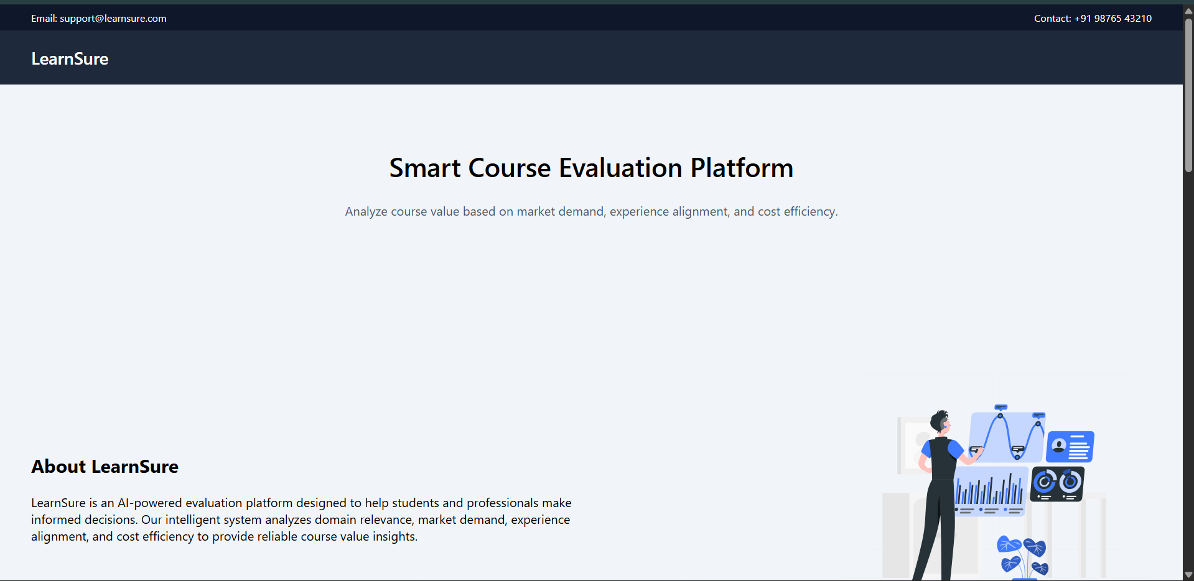
Figure 11.1: Home Page of LearnSure Course Evaluation System
11.2 Course Evaluation Input Form
The input form allows users to enter course details such as course domain, course fee, duration, experience level, and market demand level. These inputs are required for the system to analyze and evaluate the usefulness of the selected course.

Figure 11.2: Course Evaluation Input Interface
11.3 Course Evaluation Result Page
After submitting the course information, the system processes the input parameters and generates the evaluation results. The result page displays the final evaluation score, course recommendation status, and a breakdown of evaluation factors. This helps users understand whether the course is worth taking.


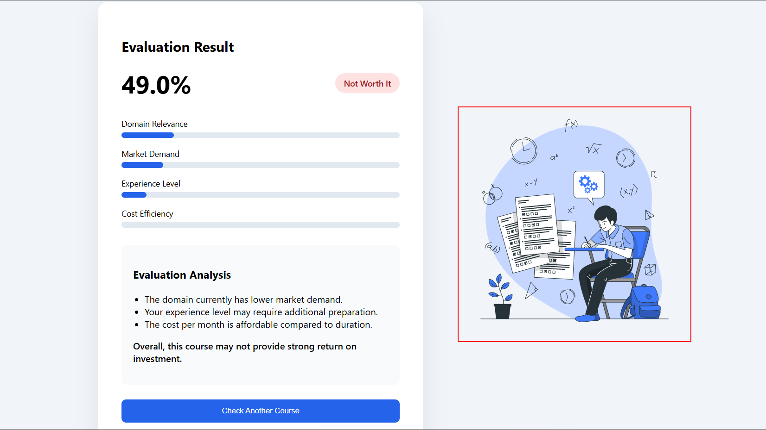
Figure 11.3: Course Evaluation Result Page
12. CONCLUSION
The LearnSure – AI Driven Smart Course Evaluation System was developed to assist learners in selecting appropriate online courses based on multiple evaluation parameters. With the increasing availability of online courses across different learning platforms, students often face difficulties in identifying courses that provide real career benefits. The proposed system addresses this challenge by using machine learning techniques to analyze important factors such as domain relevance, market demand, user experience level, and course cost efficiency.
The system collects user input through a web-based interface and processes the information using a trained machine learning model along with a weighted scoring mechanism. Based on the evaluation score, the system determines whether a course is “Worth It” or “Not Worth It.” The system also provides a breakdown of evaluation parameters to help users understand the reasoning behind the recommendation.
The implementation of the LearnSure system using Python and the Flask web framework demonstrates that machine learning techniques can effectively support decision making in online education. The system provides a simple and user-friendly interface that allows learners to quickly evaluate courses before enrolling in them.
The experimental results show that the system can analyze course parameters efficiently and generate meaningful recommendations. By helping users select courses that align with industry demand and career development, the LearnSure system reduces the risk of investing time and money in courses that provide limited value.
In the future, the system can be enhanced by integrating real-time job market data, user feedback analysis, and advanced recommendation algorithms. These improvements would further increase the accuracy and intelligence of the system, making it a more powerful tool for guiding learners in their educational journey.

