LEARN SURE – AI DRIVEN SMART COURSE EVALUATION SYSTEM

R. VAISHALI
II M.Sc. DATASCIENCE AND BUSINESS ANALYTICS
GUIDE NAME: Dr. K. ABIRAMI.
- INTRODUCTION

The rapid growth of digital technology has significantly transformed the education sector. In recent years, online learning platforms such as Coursera, Udemy, edX, and Skill share have become popular sources of knowledge for students and professionals. These platforms offer a wide range of courses in domains such as Data Science, Artificial Intelligence, Web Development, Cyber Security, Marketing, and Finance. Online learning allows individuals to improve their skills from anywhere in the world.
However, the large number of available courses often creates confusion for learners when choosing the right course. Many students enrol in courses without properly analysing whether the course is relevant to their career goals or the current market demand. Some courses may be expensive but offer limited practical value, while others may not match the learner's experience level. As a result, learners may invest time and money in courses that do not provide significant benefits.
To address this problem, the Learn Sure – AI Driven Smart Course Evaluation System is proposed. The main objective of this project is to help students evaluate online courses before enrolling in them. The system uses artificial intelligence and machine learning techniques to analyse course parameters and determine whether the course is worth taking.
The system evaluates courses based on several important factors such as domain relevance, market demand, user experience level, and course cost. These parameters are used to calculate an evaluation score which helps determine the usefulness of the course. Based on this score, the system provides a recommendation indicating whether the course is beneficial or not.
The Learn Sure system is developed using Python programming language and the Flask web framework. Machine learning techniques are used to analyse input parameters and generate a reliable evaluation score. The system also provides a detailed explanation of the evaluation results so that users can clearly understand the decision.
The primary goal of this project is to support students in making better learning decisions and avoid enrolling in courses that do not provide sufficient value. By using an intelligent evaluation mechanism, the system helps learners select courses that align with market demand and career development.

2. PROPOSED WORK

The proposed system, Learn Sure, is an intelligent web-based application designed to evaluate online courses using machine learning techniques. The system aims to assist students and professionals in selecting the most beneficial courses based on various evaluation parameters.
In the proposed system, users provide information about the course they are interested in. The input parameters include course domain, course fee, course duration, user experience level, and the demand level of the domain in the job market. These inputs are collected through a simple web interface developed using the Flask framework.
After receiving the input data, the system performs feature processing where the input values are converted into numerical scores. For example, each domain is assigned a domain relevance score based on its importance in the current industry. Similarly, market demand levels are mapped to numerical values that represent the popularity of the domain in the job market.
The system also calculates the cost per month of the course by dividing the course fee by the course duration. This helps determine whether the course is economically reasonable for the learner.
The processed data is then passed to a machine learning model which evaluates the overall value of the course. The system uses a Random Forest Regression algorithm to analyse the relationship between the input parameters and the final evaluation score. Random Forest is selected because it provides high prediction accuracy and handles multiple features effectively.
Based on the calculated score, the system classifies the course into two categories: Worth It or Not Worth It. The system also generates a detailed breakdown showing how different parameters contributed to the final evaluation score.
The proposed system helps users avoid poor course investments and choose courses that offer better career opportunities and skill development.

3. SYSTEM MODULES
The Learn Sure system is divided into three major modules to ensure efficient processing of user inputs and accurate course evaluation. Each module performs a specific function in the system, starting from collecting user information to generating the final course evaluation result.

MODULE 1: USER INPUT AND DATA COLLECTION MODULE
This module is responsible for collecting the required information from the user through the web interface. The system provides an interactive form where users can enter course-related details. The input parameters include course domain, course fee, course duration, experience level of the learner, and market demand level. These parameters are essential for evaluating the usefulness of the selected course.
Once the user enters the required details, the system performs basic validation to ensure that the inputs are correct and complete. After validation, the data is sent to the next module for further processing. This module acts as the entry point of the system and ensures that accurate data is collected for analysis.

MODULE 2: FEATURE PROCESSING AND MACHINE LEARNING MODULE
This module performs the core data processing and analysis required for course evaluation. The collected user inputs are first converted into numerical values through a process called feature engineering. The system assigns numerical scores to different parameters such as domain relevance, market demand level, and user experience level.
The cost efficiency is calculated by determining the cost per month based on the course fee and duration. These processed values are used as input features for the machine learning model. The system uses a Random Forest Regression model to analyse the relationship between the input parameters and the final course evaluation score.
The model has been trained using a dataset containing course evaluation features and their corresponding scores. This module ensures that the system can intelligently analyse course information and generate a reliable evaluation score.

MODULE 3: EVALUATION AND RESULT GENERATION MODULE
This module generates the final course evaluation result based on the processed input features. After receiving the analysed data from the machine learning module, the system calculates the overall course evaluation score. The system applies a weighted scoring mechanism that considers domain relevance, market demand, experience level, and cost efficiency. Each factor contributes a specific percentage to the final evaluation score. Based on the calculated score, the system determines whether the course is “Worth It” or “Not Worth It.” If the evaluation score exceeds the predefined threshold, the course is considered a worthwhile investment for the learner. In addition to the final decision, the system also provides a detailed breakdown of the evaluation factors and generates reasoning messages explaining the results. This helps users understand why a particular course received a certain evaluation. The final results are then displayed on the web interface for the user to review. The Flask application processes the input data and returns the evaluation results dynamically through the result page. This module ensures that users receive clear, understandable, and informative feedback regarding the value of the selected course.
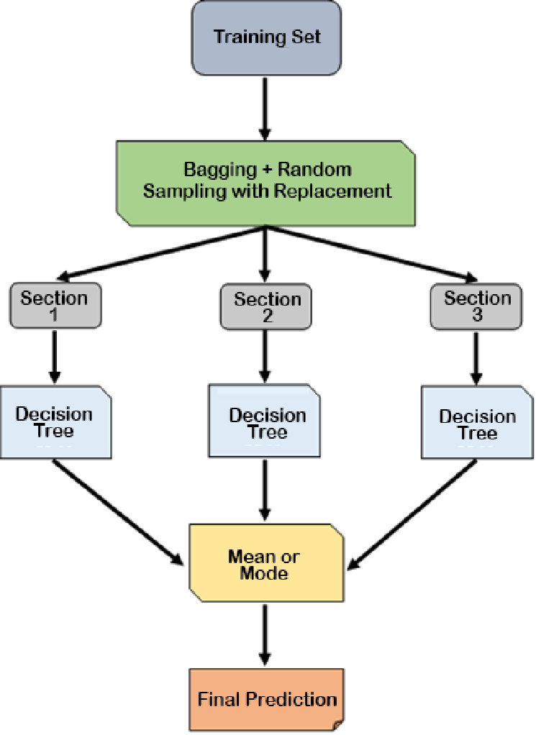
Figure 3.1: Flowchart Representation of Learn Sure System Modules
4. METHODOLOGIES
The LearnSure system is developed using a systematic methodology that integrates machine learning techniques with web application development. The methodology defines the sequence of steps followed in designing, developing, and implementing the intelligent course evaluation system.
The first step in the methodology is data collection and preparation. In this stage, a dataset containing various course evaluation parameters is prepared. The dataset includes important attributes such as domain relevance score, market demand score, experience level score, and cost per month. These attributes are used as input features for the machine learning model. The dataset helps the model learn how different parameters influence the final course evaluation score.
The next step is data preprocessing and feature engineering. In this stage, raw input values are converted into numerical scores that can be used by the machine learning algorithm. Parameters such as domain type, demand level, and user experience are mapped to numerical values to make them suitable for model processing.
After preprocessing, the system performs model training using the Random Forest Regression algorithm. Random Forest is chosen because it is capable of handling multiple input variables and producing accurate predictions. The model is trained using the prepared dataset so that it can learn patterns and relationships between the input features and the final evaluation score.
Once the model is trained, it is saved and integrated into the web application. The system is developed using the Flask web framework, which allows users to interact with the system through a browser interface. When the user submits course information, the system processes the input values and sends them to the trained model for evaluation.
The trained model calculates the course evaluation score based on the input parameters. A weighted scoring mechanism is applied to determine the overall value of the course. Based on the final score, the system generates a recommendation indicating whether the course is “Worth It” or “Not Worth It.”.
Finally, the system displays the results on the web interface along with a detailed breakdown of evaluation factors. This methodology ensures that the system provides accurate, transparent, and intelligent course evaluation results.
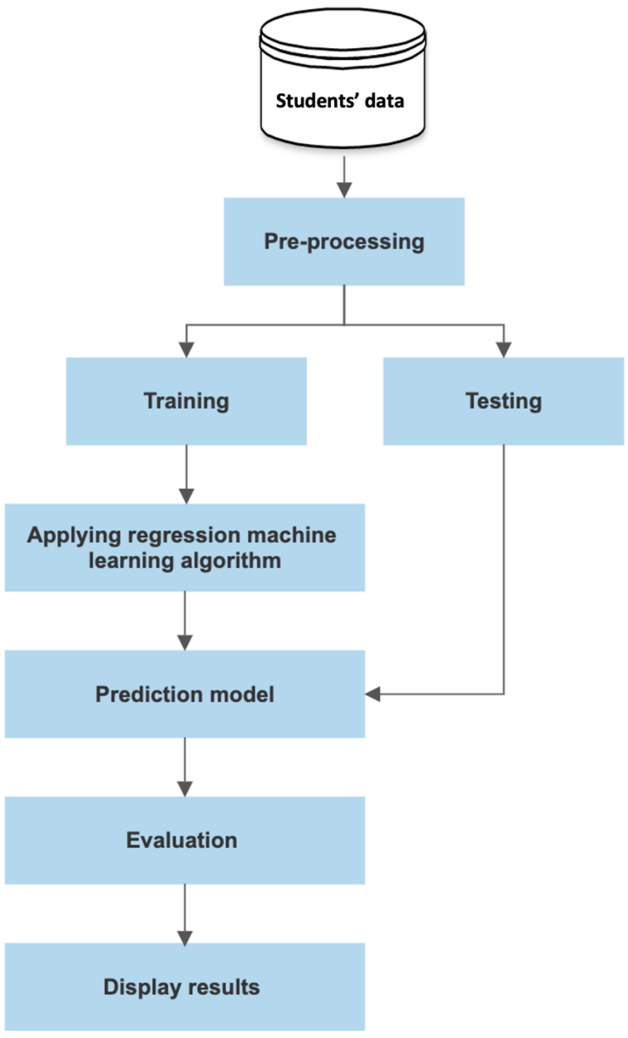

Fig: 4.1 Methodologies

5. CODING
5.1 APP.PY

from flask import Flask, render_template, request
import pickle
import numpy as np
app = Flask(__name__)
# Load trained model
with open("model.pkl", "rb") as f:
model = pickle.load(f)
@app.route("/")
def index():
return render_template("index.html")
@app.route("/result", methods=["POST"])
def result():
try:
domain = request.form["domain"]
fee = float(request.form["fee"])
duration = float(request.form["duration"])
level = request.form["level"]
demand = request.form["demand"]
# Domain scoring (expanded)
domain_map = {
"Web Development": 75,
"Data Science": 88,
"AI / ML": 92,
"Finance": 80,
"Commerce": 70,
"Mathematics": 78,
"Biology": 76,
"Marketing": 77,
"Cyber Security": 90,
"UI/UX Design": 85
}
level_map = {
"Student": 60,
"Working Professional": 85
}
demand_map = {
"Low": 50,
"Medium": 75,
"High": 95
}
# Feature engineering
domain_score = domain_map.get(domain, 70)
market_score = demand_map.get(demand, 70)
experience_score = level_map.get(level, 60)
cost_per_month = fee / duration
X = np.array([[
domain_score,
market_score,
experience_score,
cost_per_month
]])
# Manual weighted scoring system
score = (
domain_score * 0.30 +
market_score * 0.30 +
experience_score * 0.20 +
(100 - min(cost_per_month, 100)) * 0.20
)
score = round(score / 100, 2) * 100
# Balanced threshold
status = "Worth It" if score >= 50 else "Not Worth It"
# Breakdown
breakdown = {
"Domain Relevance": round(domain_score * 0.25, 2),
"Market Demand": round(market_score * 0.30, 2),
"Experience Level": round(experience_score * 0.15, 2),
"Cost Efficiency": round((100 - min(cost_per_month, 100)) * 0.30, 2)
}
# Dynamic reasoning
reasons = []
if market_score >= 85:
reasons.append("The selected domain has strong market demand.")
elif market_score >= 70:
reasons.append("The domain shows moderate demand in the job market.")
else:
reasons.append("The domain currently has lower market demand.")
if experience_score >= 80:
reasons.append("Your experience level aligns well with this course.")
else:
reasons.append("Your experience level may require additional preparation.")
if cost_per_month <= 3000:
reasons.append("The cost per month is affordable compared to duration.")
elif cost_per_month <= 6000:
reasons.append("The pricing is moderate and should be evaluated carefully.")
else:
reasons.append("The course appears expensive relative to its duration.")
if score >= 50:
conclusion = "Overall, this course is a worthwhile investment based on evaluated parameters."
else:
conclusion = "Overall, this course may not provide strong return on investment."
return render_template(
"result.html",
score=score,
status=status,
breakdown=breakdown,
domain=domain,
reasons=reasons,
conclusion=conclusion
)
except Exception as e:
return f"Error: {str(e)}"
if __name__ == "__main__":
app.run(debug=True)

5.2 TRAIN_MODEL.PY

import pandas as pd
import pickle
from sklearn.ensemble import RandomForestRegressor
# Load dataset
df = pd.read_csv("learnsure_dataset.csv")

# Features
X = df[[
"domain_score",
"market_score",
"experience_score",
"cost_per_month"
]]
# Target
y = df["final_score"]
# Train model
model = RandomForestRegressor(n_estimators=100, random_state=42)
model.fit(X, y)
# Save model
with open("model.pkl", "wb") as f:
pickle.dump(model, f)
print("Model retrained successfully!")

5.3 STYLE.CSS

body {
margin: 0;
font-family: 'Segoe UI', sans-serif;
background: #f1f5f9;
}
.top-bar {
background: #0f172a;
color: white;
font-size: 13px;
padding: 8px 40px;
display: flex;
justify-content: space-between;
}

.navbar {
background: #1e293b;
padding: 20px 40px;
}

.brand {
color: white;
font-size: 22px;
font-weight: 600;
}
.hero {
text-align: center;
padding: 60px 20px;
}
.hero h1 {
font-size: 34px;
font-weight: 600;
}
.hero p {
color: #475569;
margin-top: 10px;
}
.about {
display: flex;
justify-content: space-between;
align-items: center;
padding: 80px 40px;
gap: 40px;
}
.about-text {
width: 50%;
}
.about-image img {
width: 400px;
max-width: 100%;
}
.highlights {
padding: 60px 40px;
text-align: center;
}

.highlight-grid {
display: grid;
grid-template-columns: repeat(2, 1fr);
gap: 25px;
margin-top: 30px;
}
.highlight-card {
background: white;
padding: 25px;
border-radius: 12px;
box-shadow: 0 8px 20px rgba(0,0,0,0.05);
}
.container {
display: flex;
justify-content: center;
padding: 80px 20px;
}
.card {
background: white;
padding: 35px;
border-radius: 12px;
width: 400px;
box-shadow: 0 10px 25px rgba(0,0,0,0.08);
}
.card label {
display: block;
margin-top: 15px;
}
.card input,
.card select {
width: 100%;
padding: 8px;
margin-top: 5px;
}
.card button {
width: 100%;
margin-top: 20px;
padding: 12px;
border: none;
border-radius: 8px;
background: #2563eb;
color: white;
font-size: 15px;
cursor: pointer;
}
.showcase {
display: flex;
justify-content: center;
gap: 40px;
padding: 60px 40px;
}

.showcase img {
width: 350px;
border-radius: 12px;
box-shadow: 0 8px 20px rgba(0,0,0,0.08);
}

.result-container {
display: flex;
justify-content: center;
padding: 80px 20px;
background: #f1f5f9;
min-height: 100vh;
}
.result-card {
background: white;
width: 500px;
padding: 40px;
border-radius: 15px;
box-shadow: 0 15px 40px rgba(0,0,0,0.08);
}
.score-box {
display: flex;
justify-content: space-between;
align-items: center;
}
.score-box h1 {
font-size: 40px;
margin: 0;
}
.status {
padding: 8px 15px;
border-radius: 20px;
font-size: 14px;
font-weight: 600;
}
.status-good {
background: #dcfce7;
color: #166534;
}
.status-bad {
background: #fee2e2;
color: #991b1b;
}
.status-good {
background: #dcfce7;
color: #166534;
}
.status-bad {
background: #fee2e2;
color: #991b1b;
}
..result-image img {
width: 400px;
}
.result-image {
border: 2px solid red;}
5.4 SCRIPT.JS

function submitForm() {
const data = {
domain: document.getElementById("domain").value,
fee: document.getElementById("fee").value,
duration: document.getElementById("duration").value,
level: document.getElementById("level").value,
demand: document.getElementById("demand").value
};
fetch("/predict", {
method: "POST",
headers: {
"Content-Type": "application/json"
},
body: JSON.stringify(data)
})
.then(response => response.json())
.then(result => {
if (result.error) {
document.getElementById("error").innerText = result.error;
return;
}
document.getElementById("finalScore").innerText =
"Final Score: " + result.score + "%";

document.getElementById("status").innerText =
"Status: " + result.status;
})
.catch(error => {
document.getElementById("error").innerText =
"Server error. Please try again.";
});
}

5.5 INDEX.HTML

<!DOCTYPE html>
<html>
<head>
<title>LearnSure - Smart Course Evaluation</title>
<link rel="stylesheet" href="{{ url_for('static', filename='css/style.css') }}">
</head>
<body>
<!-- Top Contact Bar -->
<div class="top-bar">
<span>Email: support@learnsure.com</span>
<span>Contact: +91 98765 43210</span>
</div>

<!-- Navbar -->
<div class="navbar">
<span class="brand">LearnSure</span>
</div>
<!-- Hero Section -->
<div class="hero">
<h1>Smart Course Evaluation Platform</h1>
<p>
Analyze course value based on market demand,
experience alignment, and cost efficiency.
</p>
</div>
<!-- About Section -->
<div class="about">
<div class="about-text">
<h2>About LearnSure</h2>
<p>
LearnSure is an AI-powered evaluation platform designed to help
students and professionals make informed decisions.
Our intelligent system analyzes domain relevance,
market demand, experience alignment, and cost efficiency
to provide reliable course value insights.
</p>
</div>
<div class="about-image">
<img src="{{ url_for('static', filename='assets/analysis.png') }}" alt="Analytics Illustration">
</div>
</div>
<!-- Key Features Section -->
<div class="highlights">
<h2>Our Key Features</h2>
<div class="highlight-grid">
<div class="highlight-card">
<h4>AI-Based Evaluation</h4>
<p>Smart prediction using machine learning models.</p>
</div>
<div class="highlight-card">
<h4>Market Demand Analysis</h4>
<p>Evaluates real-world industry demand trends.</p>
</div>
<div class="highlight-card">
<h4>Cost Efficiency Calculation</h4>
<p>Analyzes pricing against course duration.</p>
</div>
<div class="highlight-card">
<h4>Experience Alignment Check</h4>
<p>Matches course difficulty with user background.</p>
</div>
</div>
</div>
<!-- Showcase Images Section -->
<div class="showcase">
<img src="{{ url_for('static', filename='assets/teacher.png') }}" alt="Analytics">
<img src="{{ url_for('static', filename='assets/course.png') }}" alt="Learning Platform">
</div>
<!-- Course Evaluation Form Section -->
<div class="container">
<div class="card">
<h2>Course Evaluation System</h2>
<form action="/result" method="POST">
<label>Course Domain</label>
<select name="domain" required>
<option>Web Development</option>
<option>Data Science</option>
<option>AI / ML</option>
<option>Finance</option>
<option>Commerce</option>
<option>Mathematics</option>
<option>Biology</option>
<option>Marketing</option>
<option>Cyber Security</option>
<option>UI/UX Design</option>
</select>
<label>Course Fee (₹)</label>
<input type="number" name="fee" required>
<label>Duration (Months)</label>
<input type="number" name="duration" required>
<label>Your Level</label>
<select name="level" required>
<option>Student</option>
<option>Working Professional</option>
</select>
<label>Market Demand</label>
<select name="demand" required>
<option>Low</option>
<option>Medium</option>
<option>High</option>
</select>
<button type="submit">Evaluate Course</button>
</form>
</div>
</div>
</body>
</html>

5.6 RESULTS.HTML

<!DOCTYPE html>
<html>
<head>
<title>Evaluation Result - LearnSure</title>
<link rel="stylesheet" href="{{ url_for('static', filename='css/style.css') }}">
</head>
<body>
<div class="navbar">
<span class="brand">LearnSure</span>
</div>
<div class="result-container">
<div class="result-layout">
<!-- LEFT SIDE RESULT CARD -->
<div class="result-card">
<h2>Evaluation Result</h2>
<div class="score-box">
<h1>{{ score }}%</h1>
{% if status == "Worth It" %}
<span class="status status-good">Worth It</span>
{% else %}
<span class="status status-bad">Not Worth It</span>
{% endif %}
</div>
<div class="progress-section">
{% for k, v in breakdown.items() %}
<div class="progress-item">
<label>{{ k }}</label>
<div class="progress-bar">
<div class="progress-fill" style="width: {{ v }}%;"></div>
</div>
</div>
{% endfor %}
</div>
<div class="analysis-box">
<p class="conclusion">{{ conclusion }}</p>
</div>
<a href="/">
<button class="back-btn">Check Another Course</button>
</a>
</div>
<!-- RIGHT SIDE IMAGE -->
<div class="result-image">
<img src="{{ url_for('static', filename='assets/result.png') }}" alt="Result Illustration">
</div>
</div>
</div>
</body>
</html>
6. SNAPSHOTS

6.1 HOMEPAGE
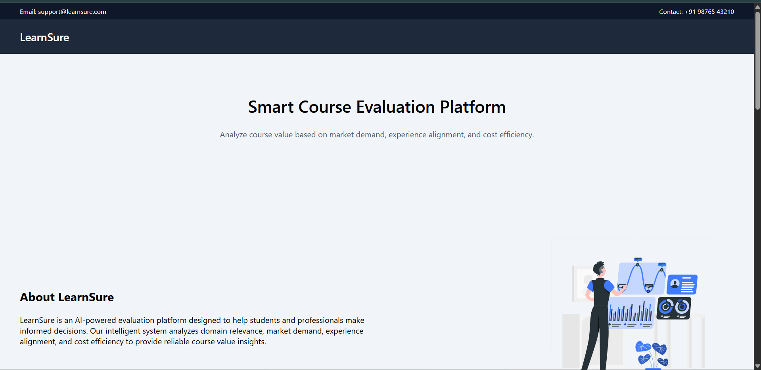

6.2 COURSE EVALUATION FORM


6.3 RESULT PAGE
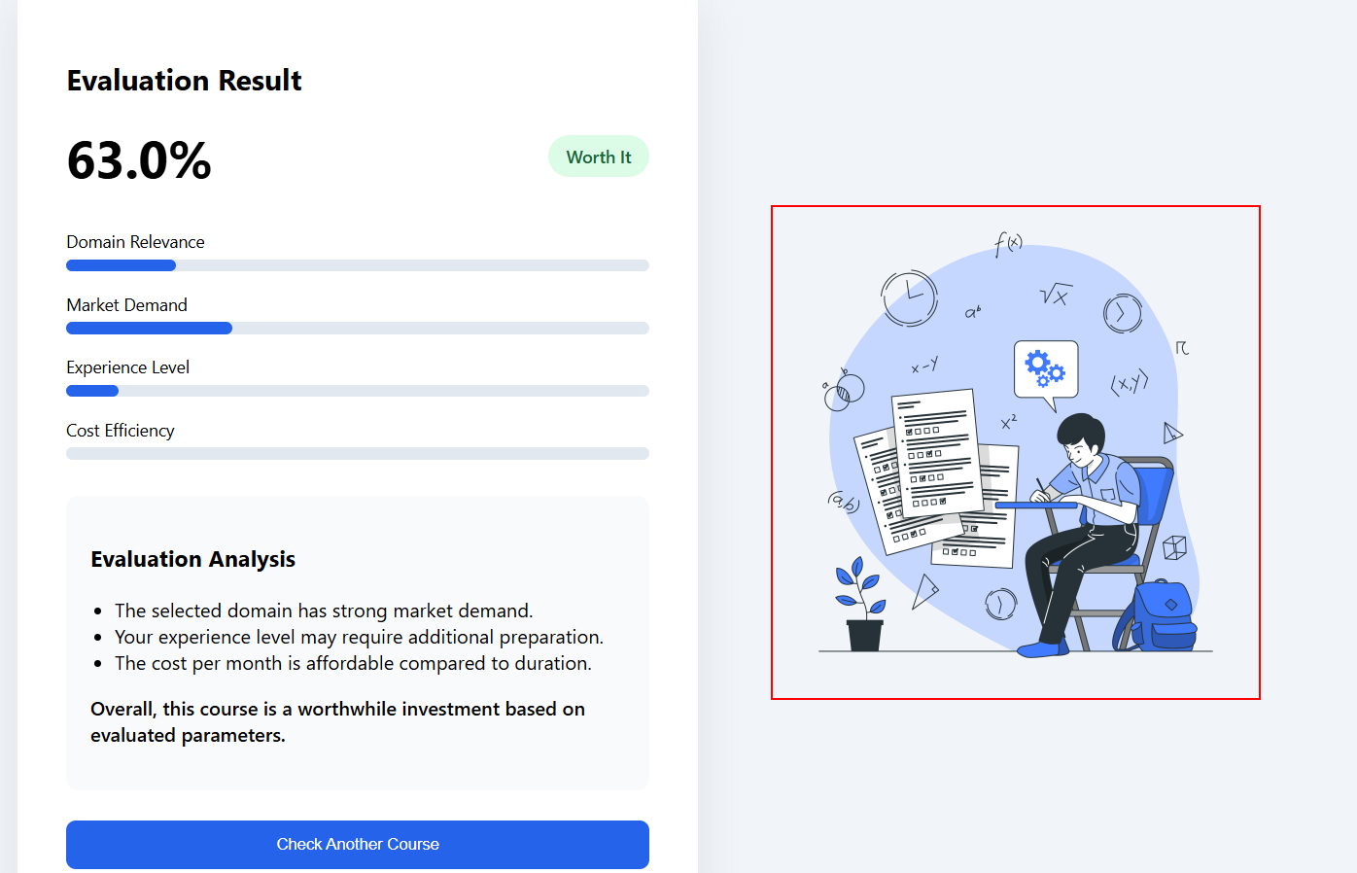

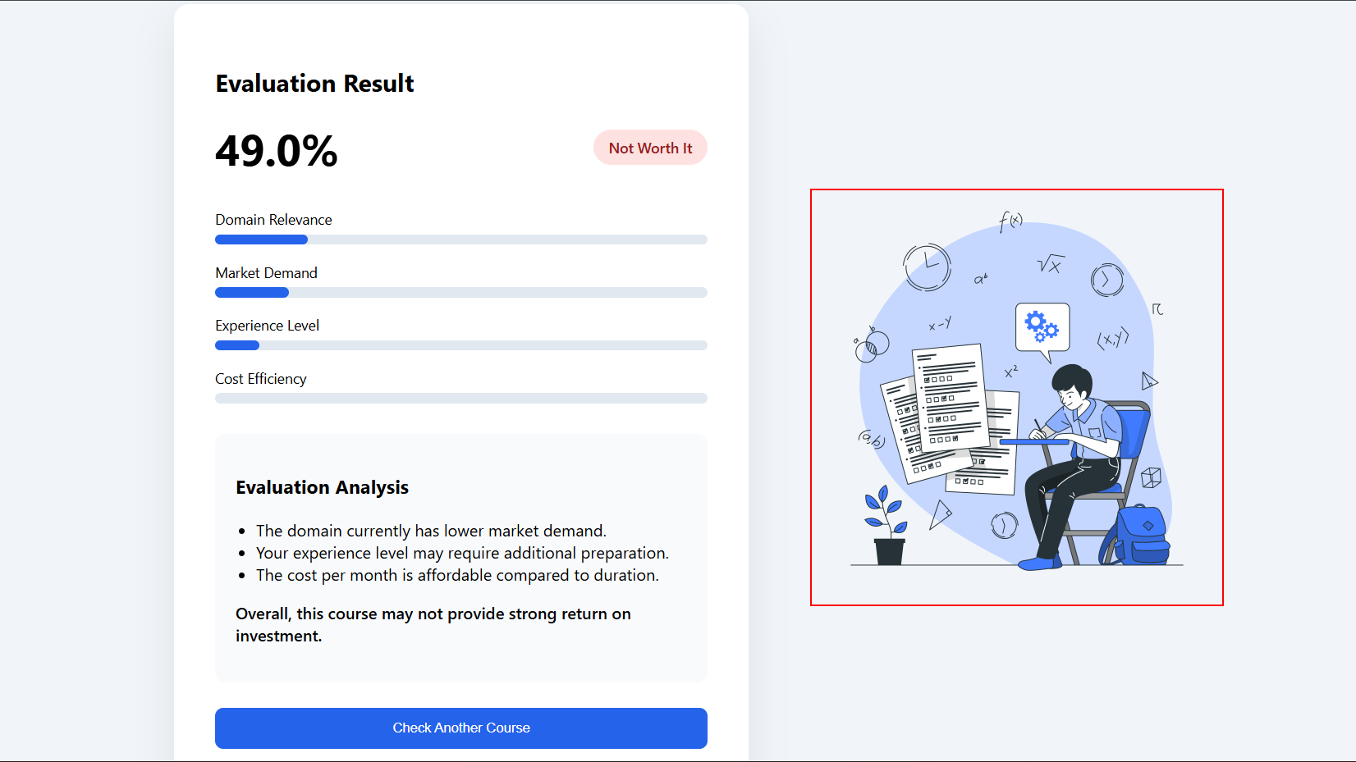

7. RESULTS AND CONCLUSION

The LearnSure system was successfully implemented as a web-based application integrated with a machine learning model to evaluate online courses. The system was tested using different input parameters such as course domain, course fee, duration, experience level, and market demand level. These inputs were processed by the system to generate an evaluation score that determines whether a course is worth taking.
During the testing phase, the system converted user inputs into numerical values such as domain score, market demand score, experience score, and cost efficiency score. These parameters were then analyzed using the trained machine learning model and the weighted scoring mechanism. Based on the calculated score, the system classified the course as either “Worth It” or “Not Worth It.”
The results showed that courses with high market demand and strong domain relevance received higher evaluation scores. Courses that were expensive relative to their duration or had low demand in the job market received lower scores. The system also provided a breakdown of evaluation parameters, which helped users understand how each factor contributed to the final score.
The web application successfully displayed the results to the user through an interactive interface. The system processed the input data efficiently and generated instant recommendations. The integration of the machine learning model with the Flask web application ensured that the evaluation process was accurate and user friendly.
Overall, the LearnSure system demonstrates how machine learning can be used to support decision making in online education. The system helps learners choose courses that align with market demand and career growth, thereby reducing the risk of investing in courses that provide limited value. Future improvements may include integrating real-time job market data and advanced recommendation techniques to further enhance the accuracy and effectiveness of the system.

8. REFERENCES
[1] T. Hastie, R. Tibshirani, and J. Friedman, The Elements of Statistical Learning: Data Mining, Inference, and Prediction, Springer, 2009.
[2] L. Breiman, “Random Forests,” Machine Learning Journal, vol. 45, no. 1, pp. 5–32, 2001.
[3] Aurélien Géron, Hands-On Machine Learning with Scikit-Learn, Keras, and TensorFlow, O’Reilly Media, 2019.
[4] F. Chollet, Deep Learning with Python, Manning Publications, 2018.
[5] Flask Documentation, “Flask Web Framework,” Available: https://flask.palletsprojects.com
[6] Scikit-learn Documentation, “Machine Learning in Python,” Available: https://scikit-learn.org
[7] J. Han, M. Kamber, and J. Pei, Data Mining: Concepts and Techniques, Morgan Kaufmann, 2012.
[8] Coursera Online Learning Platform, Available: https://www.coursera.org

