# **KICKSTARTER ANALYSIS REPORT**

|  |  |
| --- | --- |
| **Assignment No:** | 1 |
| **Topic:** | Data Analysis in MS Excel |
| **Date:** | January 31, 2020 |
| **Document Author:** | Vaishali Tanwar |

**Table of Contents**

Objective 3

Problem Statement 3

Analysis Summary 3

Additional Links 6

# Objective

The objective of this report is to outline the analysis performed on the provided data set of crowdfunding service, Kickstarter, in order to determine any hidden trends that contribute towards its successful campaigns.

# Problem Statement

Over $2 billion has been raised using the massively successful crowdfunding service, Kickstarter, but not every project has found success. Of the more than 300,000 projects launched on Kickstarter, only a third have made it through the funding process with a positive outcome.

Getting funded on Kickstarter requires meeting or exceeding the project's initial goal, so many organizations spend months looking through past projects in an attempt to discover some trick for finding success. Analysis of database of 4,000 past projects is required in order to uncover any hidden trends.

# Analysis Summary

I have used different color to represent the state of each project in the provided dataset. One major rule of Kickstarter is that of all or nothing so initially I have calculated the percentage funded of each project using the goal and the pledged amount and used a three-color scheme to represent this column, a dark shade of red at 0 transitioning to green at 100 and blue at 200. I have also calculated the average donation received for each project (see figure 1).

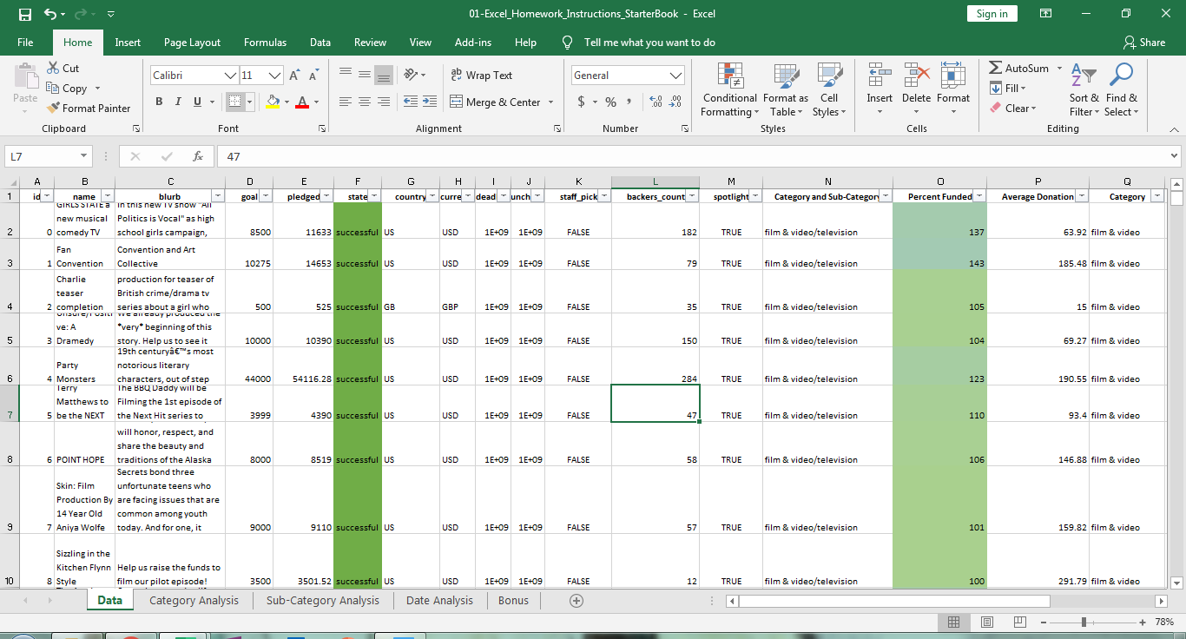

*Figure 1*

Also, I have done the analysis between the category and count of state of the projects filtering it country wise and between subcategory and count of state of the projects filtering it country and category wise, by creating pivot tables and pivot charts (see figure 2, 3).

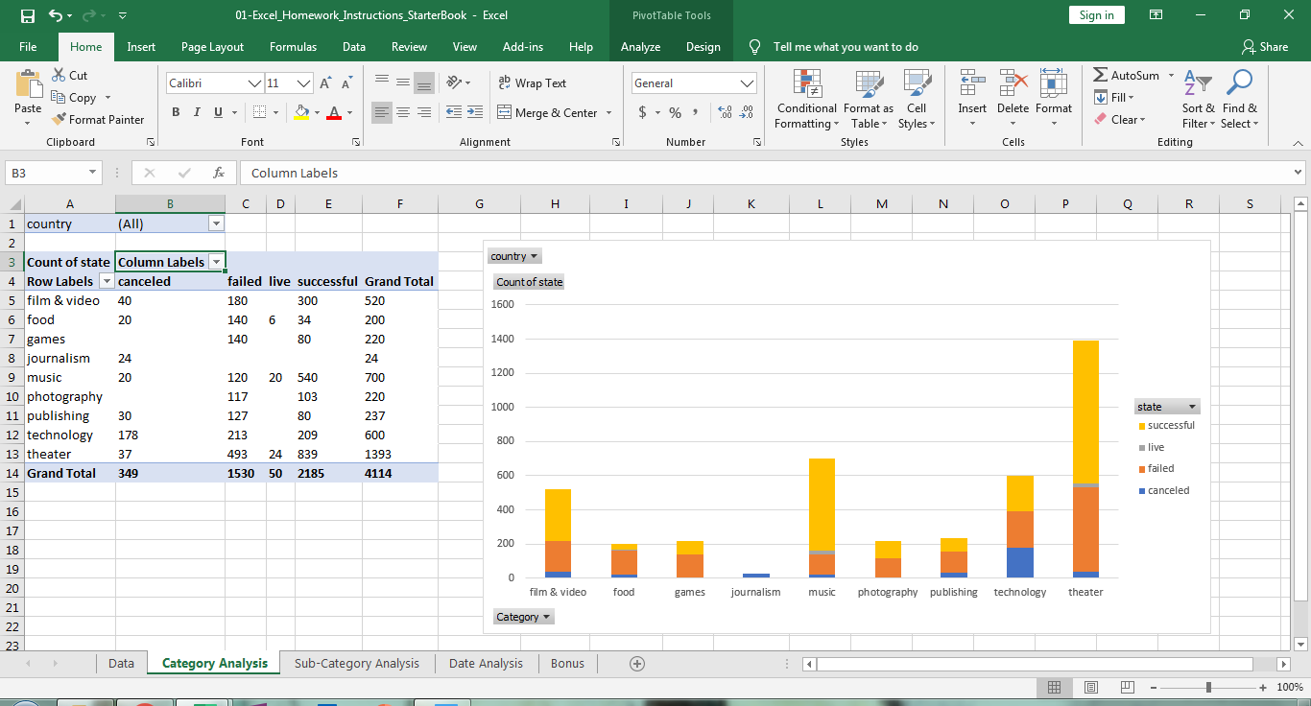

*Figure 2*

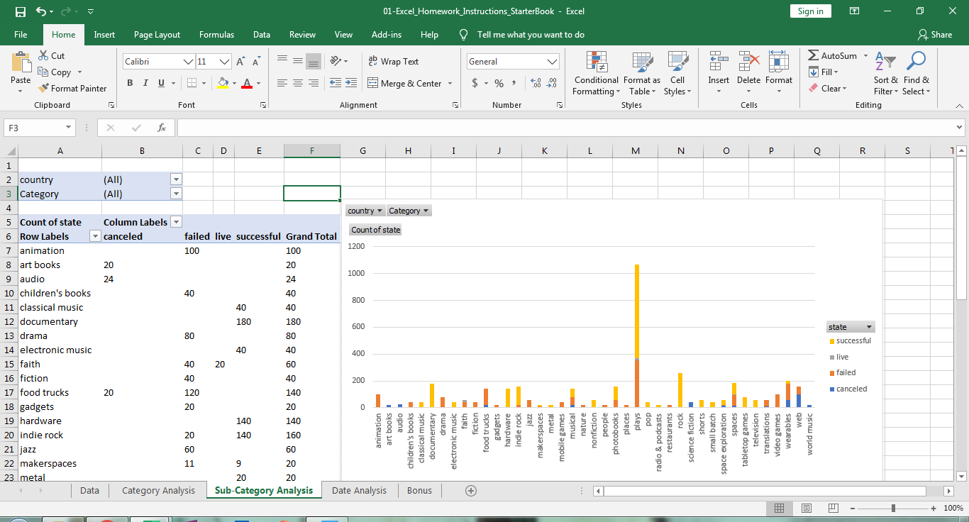

*Figure 3*

I have analysed the date of creation of a campaign obtained after conversion from Unix timestamp to Excel’s date format with the count of state which can be filtered by category and year (see figure 4).

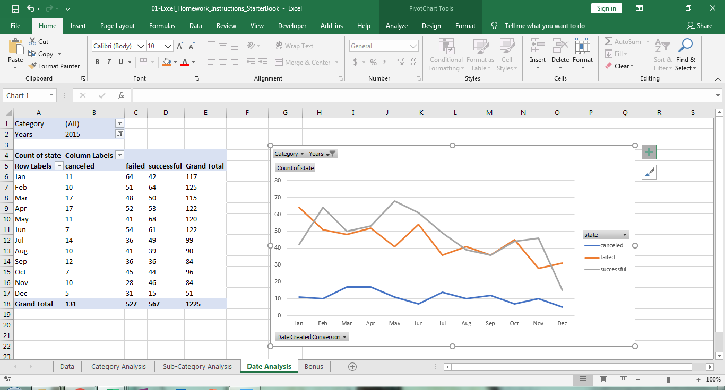

*Figure 4*

A bonus sheet which compiled the number and percentage of successful, failed and cancelled campaigns on the basis of the goal amount set for each project have been created (see figure 5,6).

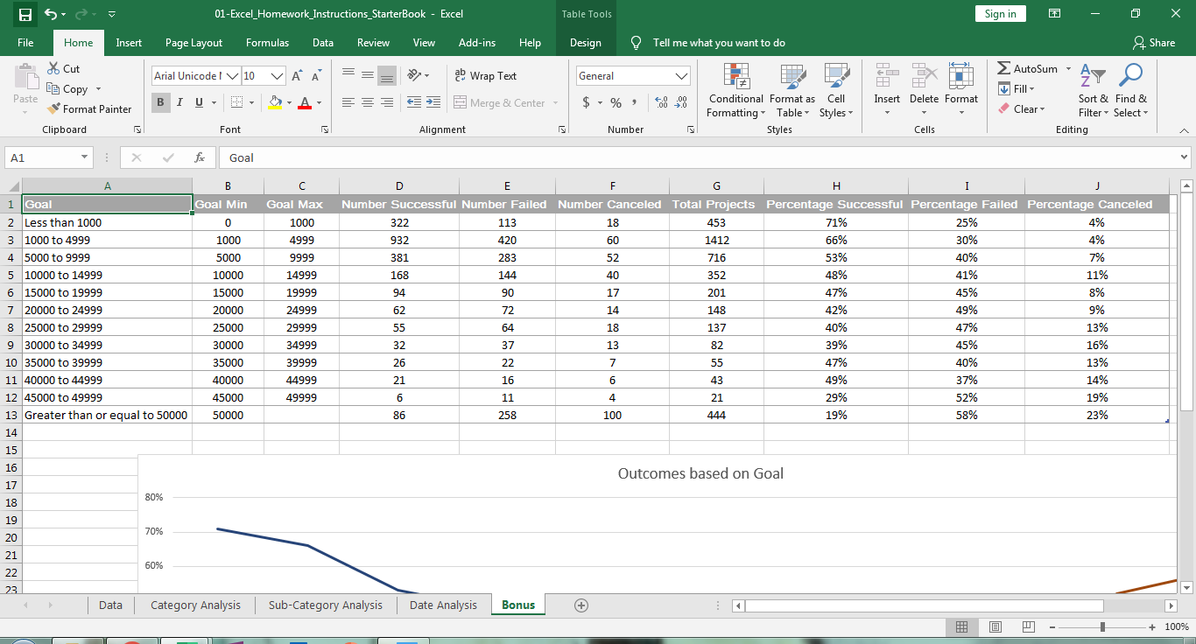

*Figure 5*

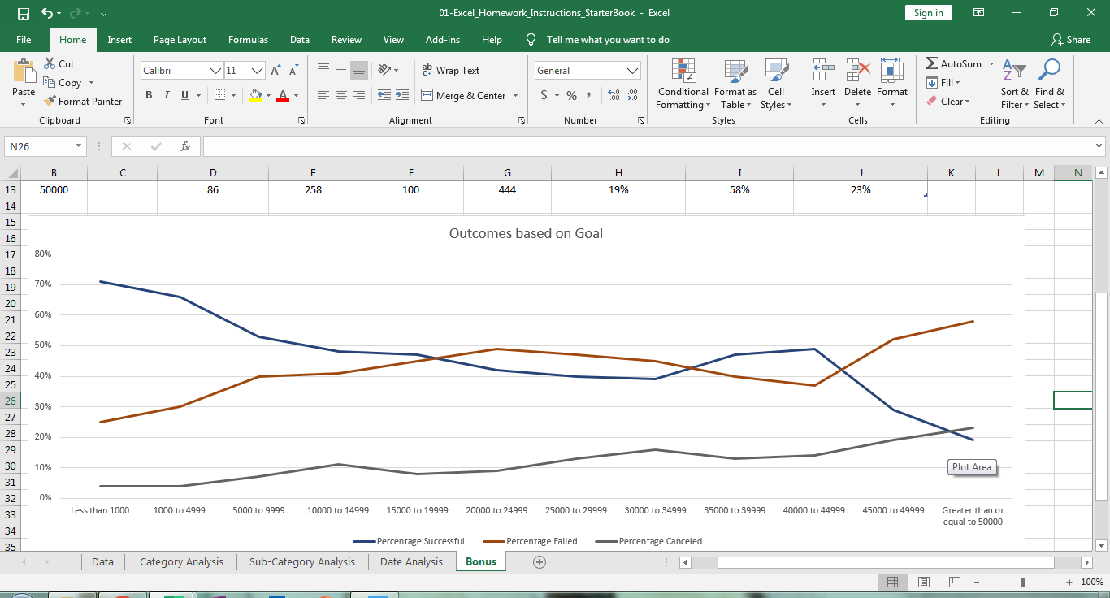 *Figure 6*

Using pivot table and chart analysis, it can be observed that campaigns in the category of theater with a sub-category of plays have been successful in majority of the countries, in the given data. From the bonus sheet it can be observed that highest percentage of successful projects lie in the group where the goal amount is less than 1000. So, it can be said that launching more campaigns in the category of theater with a subcategory of plays and goal amount less than 1000 can play a driving force in ensuring the success of a project.

1. **Given the provided data, what are three conclusions we can draw about Kickstarter campaigns?**
2. Campaigns in the category of theater and sub-category of plays have been successful in majority of the countries.
3. Majority of successful campaigns where in the year 2015.
4. Maximum percentage of successful campaigns were with a goal of less than 1000 and maximum percentage of failed campaigns were with a goal of greater than 50000.
5. **What are some limitations of this dataset?**

Some of the possible limitations can be:

1. The provided data set only gives information about past 4000 projects which is way less than the actual number of projects initiated by Kickstarter which is more than 300,000.
2. The projects included in the data set are up till the year 2017 only, a more updated data set could reveal new insights.
3. The data set provided is from 26 different countries only.
4. **What are some other possible tables and/or graphs that we could create?**

Some of the tables/ graphs that we could have created is analysis between the following:

1. Percent funded and category or sub-category
2. Average Donation and category or sub-category
3. Date of creation and Date of ending
4. Number of backers and category / sub- category

# Additional Links

Analysed dataset: <https://github.com/Vaishali91tanwar/Assignment_1_Excel_VT>