**Asp .Net Core Web API**

I have created WebAPI using ASP .NET Core.

I created database for storing Employee Information in table using SQL Server.

I have used all methods (GET/PUT/POST/DELETE) to store and retrieve data from employee table.

I have created DBContext to Provide connection with database.

**Version :**

<https://localhost:44322/>

**GET All Employees Details**

<https://localhost:44322/api/EmployeeModels/>

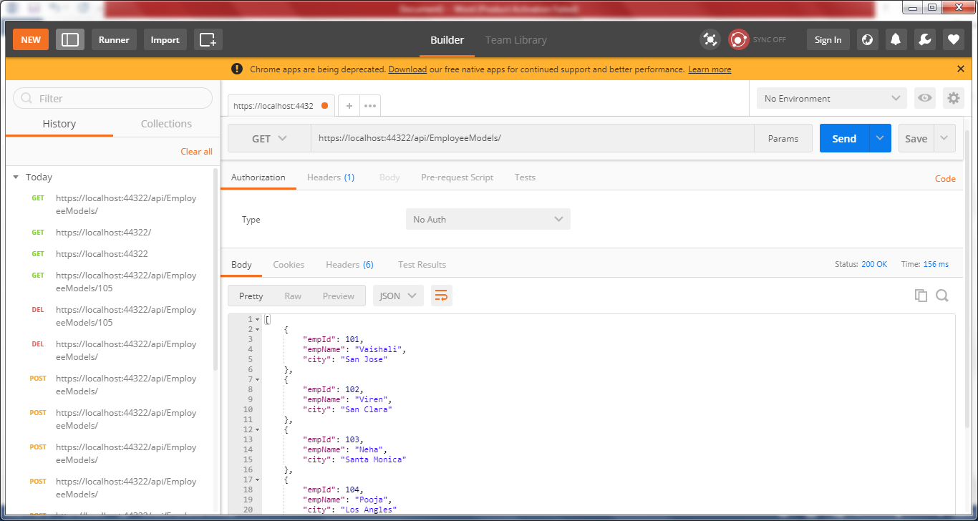

**GET Single Employee Details**

<https://localhost:44322/api/EmployeeModels/103>

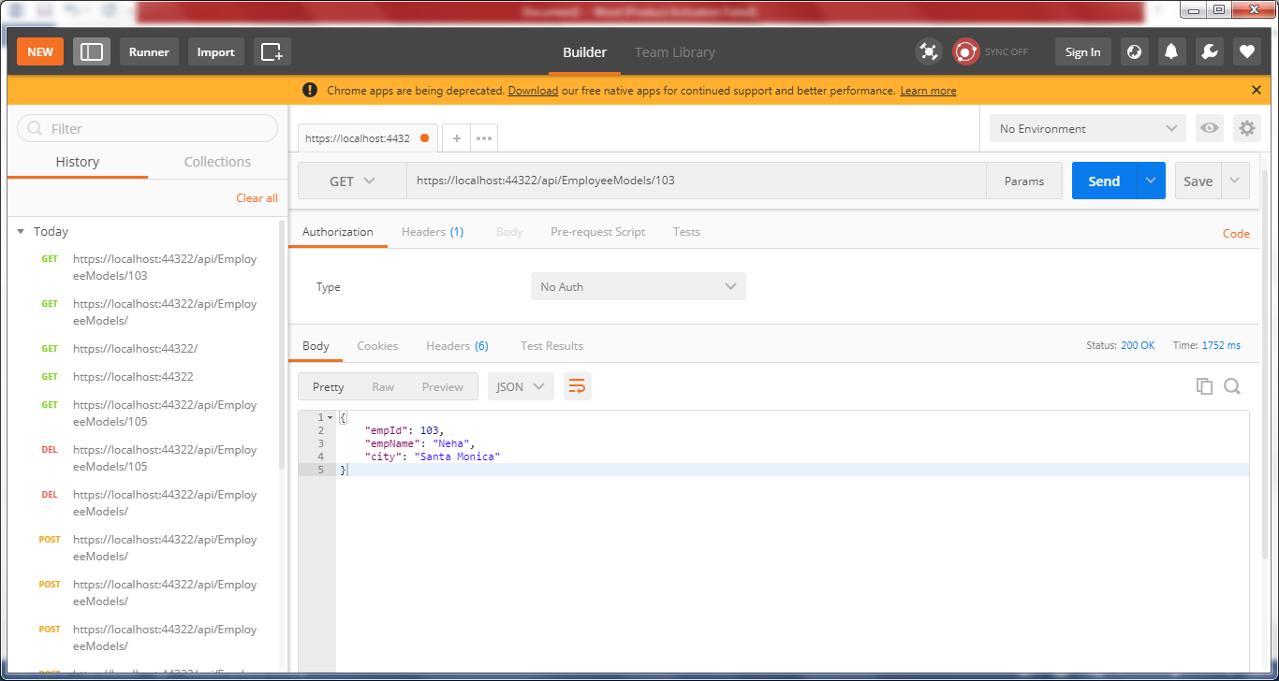

**POST Employee Details**

<https://localhost:44322/api/EmployeeModels/>

{

"empId": 106,

"empName": "Carlos",

"city": "Santa clara"

}

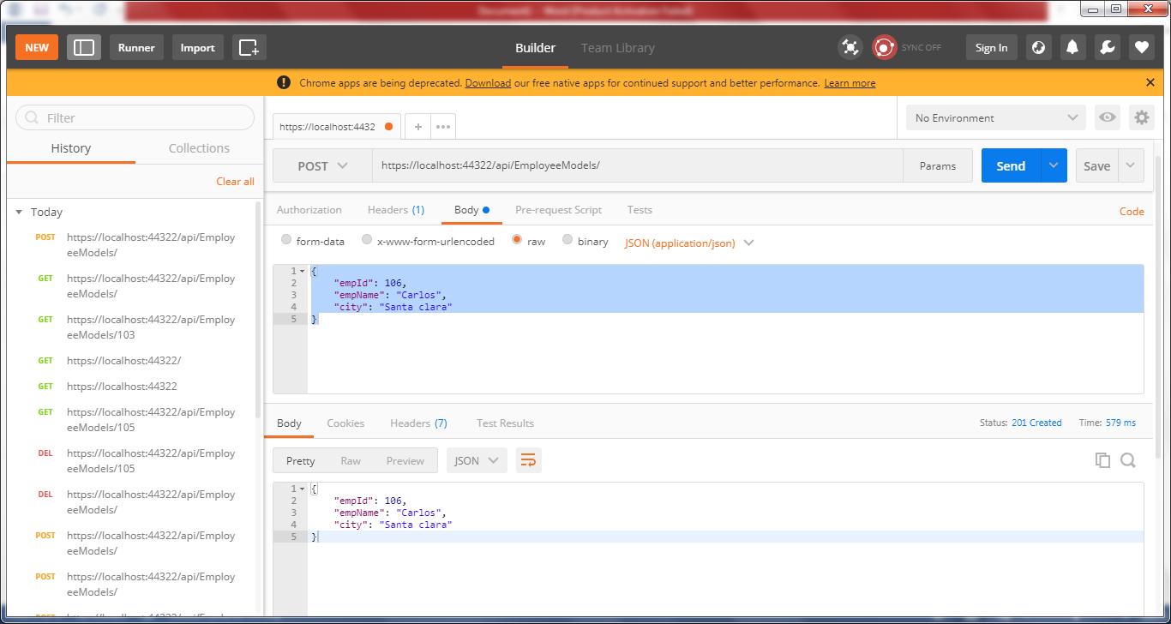

**PUT Employee Details**

<https://localhost:44322/api/EmployeeModels/>103

{

“empid”: 103,

“empname” : “Hemant”,

“city” : “Santa Clara”

}

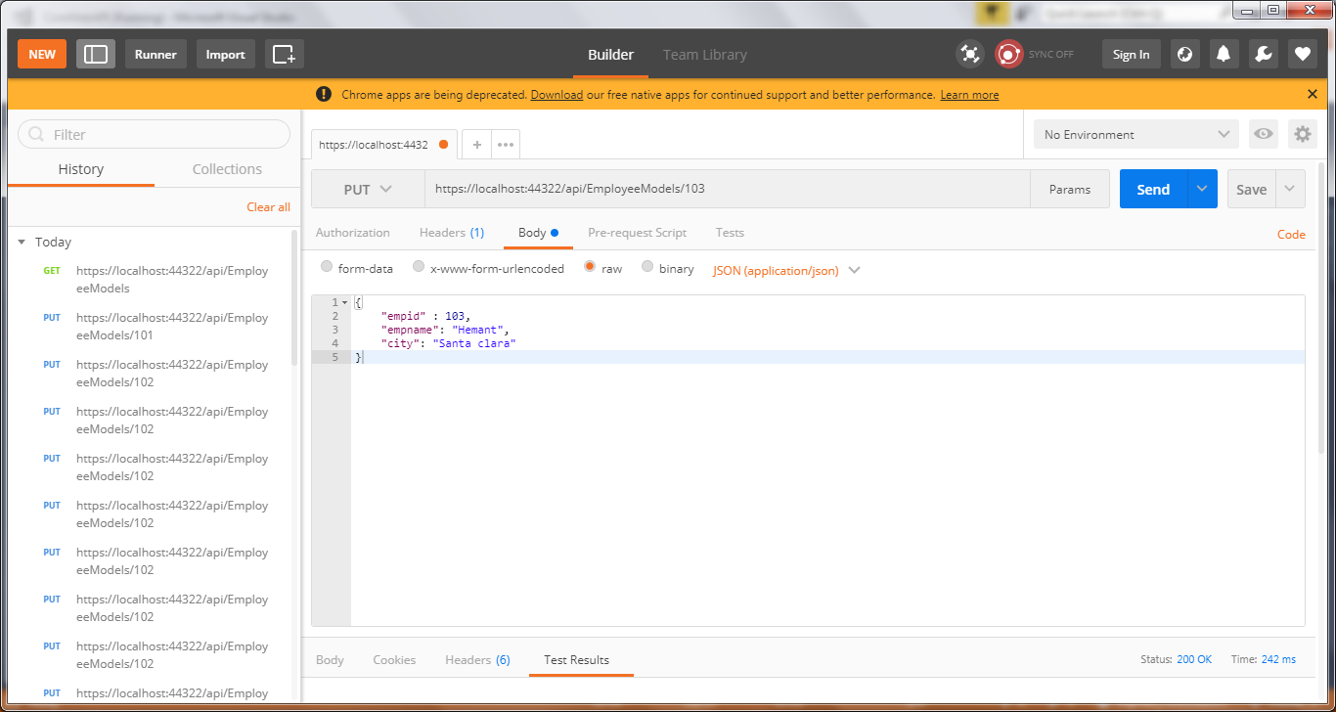

**DELETE Employee Details**

<https://localhost:44322/api/EmployeeModels/105>

