

“TRANSFORMING WORKFORCE INSIGHTS:

A STRATEGIC

HR ANALYTICS DASHBOARD”
Project report Submitted in partial fulfillment of the requirements for
the award of the degree of

Bachelor of Technology

in
CSE - Data Science

by

THATI VAISHALI (21P71A67A5)
P. SREE KARTIKEYA (21P71A6792)
M. PAVAN GUPTA (21P71A6798)
TUSHAR BARUA (21P71A67A2)

Under the Esteemed Guidance of

Mrs. T. Shailaja,

Assistant Professor


Department of CSE – Data Science
(Affiliated to JNTU-H)
2021-2025


Department of CSE – Data Science

CERTIFICATE

This is to certify that the project report entitled “TRANSFORMING WORKFORCE INSIGHTS: A STRATEGIC HR ANALYTICS DASHBOARD” is being submitted by THATI VAISHALI (21P71A67A5),
P. SREE KARTIKEYA (21P71A6792), M. PAVAN GUPTA (21P71A67P8), TUSHAR BARUA (21P71A67A2) in partial fulfillment for the award of Degree of bachelor OF TECHNOLOGY in CSE – Data Science to the Jawaharlal Nehru Technological university is a record of Bonafide work carried out by him/her under my guidance and supervision.

Date:

Internal Guide
(T. Shailaja)

HOD - CSE – Data Science
(M. Supriya)

External Examiner

Principal
(Dr. D. Eshwar)

ACKNOWLEDGEMENT

First of all, we thank our project Guide, Mrs. T. Shailaja, Assistant Professor, and HOD, Mrs. M. Supriya Samuel, of the Department of CSE—Data Science, for giving us this opportunity to develop this project.
This project has really helped us enhance our programming skills, the perspective with which we should view projects, and, above all, our presentation and interpersonal skills.
Last but not least, we also thank the professors of our department for their assistance whenever necessary.

THATI VAISHALI
(21P71A67A5)

P. SREE KARTIKEYA
(21P71A6792)

M. PAVAN GUPATA
(21P71A6798)

TUSHAR BARUA
(21P71A67A2)

DECLARATION

We hereby declare that the work which is being presented in this Mini Project entitled, “TRANSFORMING WORKFORCE INSIGHTS: A STRATEGIC HR ANALYTICS DASHBOARD” submitted to JNTU-H, in the partial fulfilment of the requirements for the award of the degree of BACHELOR OF TECHNOLOGY in CSE – Data Science, is an authentic record of my own work carried out from September 2024 to February 2025 under the supervision of
Mrs. T. Shailaja, Assistant Professor, CSE – Data Science Dept., SVIT, Mahbub Campus
The matter embodied in this project report has not been submitted by me for the award of any other degree.

Place: SECUNDERABAD

Date:

THATI VAISHALI
(21P71A67A5)

P. SREE KARTIKEYA
(21P71A6792)

M. PAVAN GUPTA
(21P71A6798)

TUSHAR BARUA
(21P71A67A2)

INDEX
Abstract vi
List of Figures vii
- Introduction 1
- System Requirements and Analysis 2
  - Existing System 2
  - Proposed System 2
  - Feasibility Study 3
  - Software/Hardware Requirements 4
- System Design 5
  - Introduction to UML 5
  - UML Diagrams 6
- Implementation Details 10
- Code Snippets 13
- Methodology 15
- Testing 19
- Output Screens 22
Conclusion 39
References 41

ABSTRACT

This project focuses on the development of an HR Analytics dashboard in Power BI, designed to transform raw HR data into actionable insights that drive strategic decision-making. By seamlessly integrating data from HR systems—such as employee profiles, attendance patterns, and sick leave rates—the dashboard provides a comprehensive view of workforce metrics. Emphasizing interactive and dynamic visuals, it enables real-time data exploration, allowing HR professionals to identify trends and make informed decisions swiftly. Advanced analytics are leveraged to forecast workforce trends, supporting proactive talent management and planning. The user-friendly design prioritizes self-service capabilities, empowering HR teams to independently explore data and align their efforts with organizational goals. Ultimately, this dashboard enhances workforce planning, improves employee engagement, and boosts HR effectiveness, positioning organizations for success in a data-driven environment.

LIST OF FIGURES

Figure No. Name of the Figure Page No.
    - Use-Case Diagram 6
    - Class Diagram 7
    - Activity Diagram 8
    - Sequence Diagram 9
6.1 Architecture 18
8.1 Power BI 22
8.2 Uploading the Attendance Dataset 22
8.3 Loading the Dataset 23
8.4 Initial Pre-processing of the Dataset 23
8.5 Change Data types, Remove Top rows 24
8.6 Promoting the Headers 24
8.7 Rename and Unpivot Columns 25
8.8 Type conversion 25
8.9 Error Correction 26
8.10 Creating a Parameter 26
8.11 Managing the Parameter 27
8.12 Creating a Function 27
8.13 Passing the Parameter 28
8.14 Invoking the Function 28
8.15 Error leading to Hindrance 29
8.16 Applying Function to all Date sheet 29
8.17 Expanding the Dataset 30
8.18 Final Pre-processed Dataset 31
8.19 Total Working Days 32
8.20 WFH Count 32
8.21 Present Days 33
8.22 Selection of Presence % 33
8.23 Presence % graph 34
8.24 Selection of WFH % 34
8.25 WFH % graph 35
8.26 SL Count 35
8.27 Selection of SL % 36
8.28 SL % graph 36
8.29 Days of the week 37
8.30 Final Dashboard 38

INTRODUCTION
In today’s data-driven business landscape, Human Resources (HR) departments increasingly leverage analytics to enhance decision-making, optimize workforce management, and align HR strategies with broader organizational objectives. This project focuses on developing an advanced HR Analytics dashboard using Power BI, designed to centralize and integrate a wide array of critical data from HR systems, such as employee demographics, attendance patterns, sick leave rates, and performance metrics, into one cohesive platform. By transforming this data into interactive and visually engaging charts, graphs, and heatmaps, the dashboard provides HR professionals with clear and actionable insights into key trends, workforce behavior, and emerging patterns, enabling more informed and timely decision-making. The dashboard’s advanced analytical capabilities not only streamline HR processes but also empower HR teams to engage in strategic workforce planning, identifying potential skill gaps, forecasting staffing needs, and optimizing resource allocation. Furthermore, the dashboard plays a vital role in improving employee engagement and retention by offering insights into metrics such as absenteeism, turnover rates, and employee satisfaction, which can be used to develop targeted retention strategies and enhance overall employee morale. By linking HR metrics directly to business performance, the dashboard ensures that HR initiatives are aligned with organizational goals, supporting long-term strategic planning and organizational success. With its ability to provide a holistic view of the workforce, improve operational efficiency, and foster a culture of data-driven decision-making, the HR Analytics dashboard positions organizations to navigate the complexities of the modern business environment and stay competitive in an ever-changing market. Ultimately, this tool not only enhances the effectiveness of HR activities but also ensures that human capital strategies contribute directly to the sustained growth and success of the organization.

2. SYSTEM REQUIREMENTS AND ANALYSIS
  - Existing System:
Existing HR analytics systems often rely on static reporting, which limits access to real-time data and insights. These systems typically focus on a narrow range of basic metrics such as turnover rates or headcount, without delving into deeper insights into employee engagement or performance trends. Manual data handling is common, increasing the risk of errors and consuming valuable HR resources. Additionally, these tools offer limited visualization options, making it difficult for stakeholders to interpret data effectively and derive actionable insights. HR decisions are often reactive, made in response to issues as they arise, rather than based on predictive insights and trends.
2.1.1Disadvantages:

- Inefficient Data Handling and Risk of Errors: Poor data processing and management lead to inaccuracies and increased chances of mistakes.

- Limited Actionable Insights: The lack of clear, actionable data hinders effective decision-making and strategic planning.

- Lack of Predictive Capabilities and Missed Opportunities: The inability to anticipate challenges and optimize workforce management impacts overall organizational success.

  - Proposed System:
The proposed system features an interactive HR Analytics dashboard in Power BI, offering real-time data visualization and easy access to key metrics like employee satisfaction, engagement, recruitment effectiveness, and training impact. Automation of data collection and analysis reduces manual work and errors, enabling HR to focus on strategic tasks. Power BI’s advanced visualization tools provide an intuitive, interactive format for stakeholders to analyze trends. The system also uses historical data for predictive analytics, helping HR anticipate challenges and make informed decisions.
2.2.1Advantages:

- Real-time insights: Enables quick access to critical HR data for informed decision-making.
- Comprehensive metrics: Offers a holistic view of workforce performance with a wider range of HR metrics.
- Automated data processing: Reduces manual effort and minimizes errors, allowing HR to focus on strategic initiatives.

FEASIBILITY STUDY

The feasibility of the project is analyzed in this phase and business proposal is put forth with a very general plan for the project and some cost estimates. During system analysis the feasibility study of the proposed system is to be carried out. This is to ensure that the proposed system is not a burden to the company. For feasibility analysis, some understanding of the major requirements for the system is essential.
Three key considerations involved in the feasibility analysis are

    - ECONOMICAL FEASIBILITY
    - TECHNICAL FEASIBILITY
    - SOCIAL FEASIBILITY

ECONOMICAL FEASIBILITY

This study is carried out to check the economic impact that the system will have on the organization. The amount of fund that the company can pour into the research and development of the system is limited. The expenditures must be justified. Thus the developed system as well within the budget and this was achieved because most of the technologies used are freely available. Only the customized products had to be purchased.

TECHNICAL FEASIBILITY

This study is carried out to check the technical feasibility, that is, the technical requirements of the system. Any system developed must not have a high demand on the
available technical resources. This will lead to high demands on the available technical resources. This will lead to high demands being placed on the client. The developed system must have a modest requirement, as only minimal or null changes are required for implementing this system.

SOCIAL FEASIBILITY

The aspect of study is to check the level of acceptance of the system by the user. This includes the process of training the user to use the system efficiently. The user must not feel threatened by the system, instead must accept it as a necessity. The level of acceptance by the users solely depends on the methods that are employed to educate the user about the system and to make him familiar with it. His level of confidence must be raised so that he is also able to make some constructive criticism, which is welcomed, as he is the final user of the system.

SYSTEM REQUIREMENTS:

HARDWARE REQUIREMENTS:
- Operating System: Windows
- Processor :intel i5
- Hard Disk : 512 GB.
- Ram : 512 Mb.

SOFTWARE REQUIREMENTS:
- Data Analysis and Reporting Software: Microsoft Excel (or) Any CSV Software
- Business Intelligent and Visualization Software: Power BI
- Programming Languages:
      - Power Query Formula Language (PQFL – M)
      - Data Analysis and Expressions (DAX)

SYSTEM DESIGN

INTRODUCTION TO UML

UML stands for Unified Modeling Language. UML is a standardized general- purpose modeling language in the field of object-oriented software engineering. The standard is managed, and was created by, the Object Management Group.
The goal is for UML to become a common language for creating models of object oriented computer software. In its current form UML is comprised of two major components: a Meta-model and a notation. In the future, some form of method or process may also be added to; or associated with, UML.
The Unified Modeling Language is a standard language for specifying, Visualization, Constructing and documenting the artifacts of software system, as well as for business modeling and other non-software systems.
The UML represents a collection of best engineering practices that have proven successful in the modeling of large and complex systems.
The UML is a very important part of developing objects oriented software and the software development process. The UML uses mostly graphical notations to express the design of software projects.

GOALS:
The Primary goals in the design of the UML are as follows:
    - Provide users a ready-to-use, expressive visual modeling Language so that they can develop and exchange meaningful models.
    - Provide extendibility and specialization mechanisms to extend the core concepts.
    - Be independent of particular programming languages and development process.
    - Provide a formal basis for understanding the modeling language.
    - Encourage the growth of OO tools market.
    - Support higher level development concepts such as collaborations, frameworks, patterns and components.

Use case diagram:

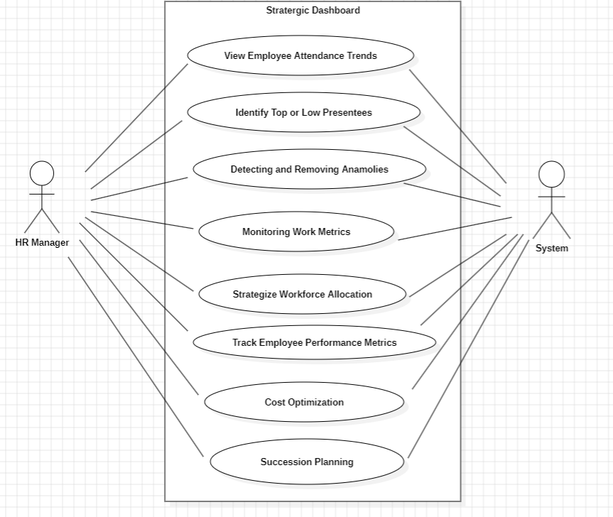
The use case diagram is used to identify the primary elements and processes that form the system. The primary elements are termed as "actors" and the processes are called "use cases." The use case diagram shows which actors interact with each use case.

Figure 3.2.1 Use case diagram

Class diagram:

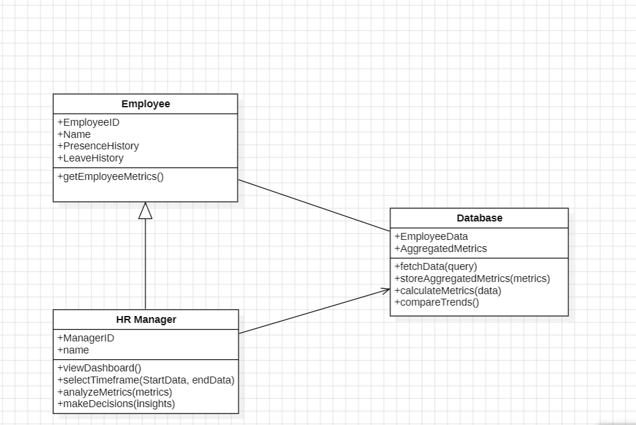
The class diagram is used to refine the use case diagram and define a detailed design of the system. The class diagram classifies the actors defined in the use case diagram into a set of interrelated classes. The relationship or association between the classes can be either an "is-a" or "has-a" relationship. Each class in the class diagram may be capable of providing certain functionalities. These functionalities provided by the class are termed "methods" of the class. Apart from this, each class may have certain "attributes" that uniquely identify the class.

Figure 3.2.2 Class diagram

Activity diagram:

The process flows in the system are captured in the activity diagram. Similar to a state diagram, an activity diagram also consists of activities, actions, transitions, initial and final states, and guard conditions.
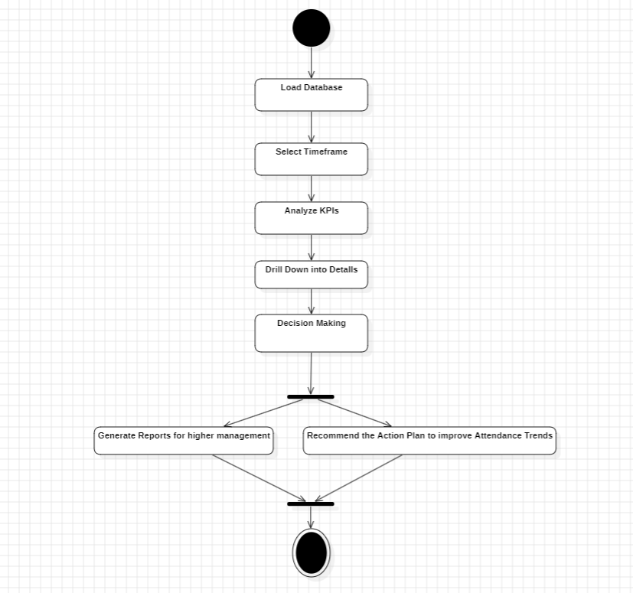

Figure 3.2.3 Activity diagram

Sequence diagram:

A sequence diagram represents the interaction between different objects in the system. The important aspect of a sequence diagram is that it is time-ordered. This means that the exact sequence of the interactions between the objects is represented step by step. Different objects in the sequence diagram interact with each other by passing "messages".
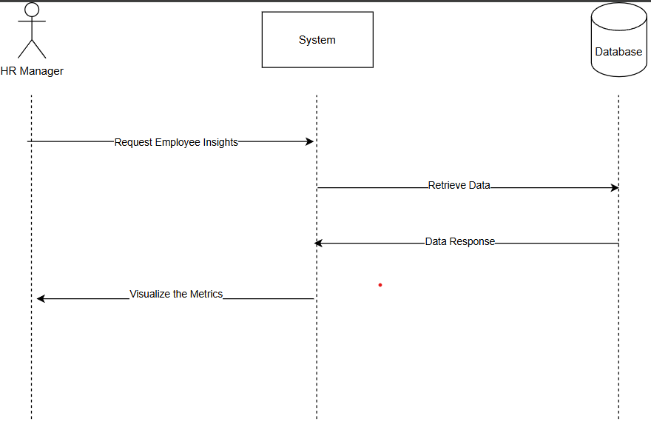

Figure 3.2.4 Sequence diagram

4. IMPLEMENTATION DETAILS

4.1 Microsoft Excel:

Microsoft Excel served as a fundamental tool for data preprocessing, cleaning, and structuring before feeding the data into Power BI for visualization.

Excel was crucial for

- Data Cleaning and Preparation:

  - Removing duplicate entries, fixing inconsistent data formats, and handling missing values.

  - Structuring raw HR data (e.g., attendance logs, sick leave records, and workforce metrics) into a tabular format suitable for analysis.

- Preliminary Analysis:

  - Applying formulas and pivot tables to derive initial insights into metrics like absenteeism, presence, and work-from-home percentages.

  - Checking data accuracy by performing basic validations and summarizations.

Excel's flexibility allowed efficient organization and preparation of datasets, ensuring seamless integration with Power BI.

4.2 Power BI

Power BI is a powerful business analytics tool developed by Microsoft that enables users to visualize data and share insights across their organization.

Power BI was used as the primary platform for building the interactive HR Analytics Dashboard, offering advanced data visualization and analytics capabilities tailored to the project's requirements:

Data Connectivity: Connects to various data sources, including databases, Excel spreadsheets, cloud services, and online services like Salesforce.
Data Transformation: Provides powerful data modeling capabilities to clean, transform, and shape data for analysis using Power Query.

Data Integration and Modeling: Importing cleaned data from Excel into Power BI to create relationships between datasets (e.g., attendance logs and employee profiles).
Designing calculated columns and measures using DAX (Data Analysis Expressions) for advanced metrics like sick leave rates, work-from-home percentages, and presence trends.

Interactive Visualizations: Designing intuitive charts, graphs, and visuals, such as pie charts, trend lines, and KPIs, to represent HR metrics effectively.
Creating filters and slicers to allow dynamic exploration of data (e.g., by date, department, or employee).
Automation and Real-Time Updates: Enabling automated data refreshes to ensure the dashboard provides up-to-date insights.
Establishing live connections with data sources, where applicable, to support real-time tracking of HR metrics.

Advanced Analytics: Forecasting trends in absenteeism and employee presence using Power BI's predictive analytics features.
Generating actionable insights to guide workforce planning and strategy.

Mobile Access and Integration with Microsoft Tools: Provides mobile applications for iOS and Android, enabling users to access reports and dashboards on the go. Seamlessly integrates with other Microsoft products, such as Excel, SharePoint, and Teams, enhancing workflow and productivity.

4.3 Data Analysis and Expressions (DAX):

DAX (Data Analysis Expressions) is a formula language used in Power BI, Excel, and SQL Server to create custom calculations in data models. In this project, DAX was used extensively to generate meaningful metrics and improve the interactivity of the HR Analytics dashboard, providing real-time insights into employee data, attendance, and performance.

Key Features of DAX:
Key DAX features included Calculated Columns to determine employee attendance status, Measures to calculate dynamic metrics like Presence, WFH, and Sick Leave Percentages, and Time Intelligence Functions for tracking trends over time. Logical Functions applied conditional logic to assess employee status, while Aggregations summed data like total days worked

Benefits of DAX:
DAX enhanced the project by providing Dynamic Insights, allowing automatic recalculations when filters were applied. It enabled Advanced Calculations like time-based trends and conditional logic, while improving Interactivity by allowing users to explore data easily. Overall, DAX transformed raw HR data into actionable insights, making it central to the project’s success.

4.4 Power Query Formula Language (PQFL – M)

Power Query Formula Language (M) is a functional programming language used for data transformation and preparation in Power Query, part of Microsoft Power BI, Excel, and other Microsoft products. PQFL is the backbone of Power Query’s data manipulation features, allowing users to clean, merge, filter, and aggregate data from various sources efficiently. It processes data step-by-step, with each transformation building on the previous one.

Key Features of PQFL
PQFL is built on a functional programming paradigm, with a case-sensitive syntax used to create data transformation steps in the Power Query Editor. It includes a wide range of built-in functions for text manipulation, date and time operations, and data aggregation. Additionally, PQFL supports Query Folding, enabling efficient transformations by delegating operations to the source system when possible. The language is dynamic, making it ideal for handling diverse data sources, including databases, Excel files, and APIs.

Benefits of PQFL
The main benefits of PQFL include its ability to simplify data preparation, providing a robust framework for transforming raw data into usable formats. It also offers code reproducibility, allowing users to trace and repeat transformations. PQFL seamlessly integrates with Power BI and Excel, enabling efficient data workflows and making it an essential tool for managing and transforming data in modern analytics projects.

5. CODE SNIPPETS

Total working Days =
Var totaldays = COUNT (‘Final Data’ [Value])
Var nonworkingdays = CALCULATE (COUNT (‘Final Data’ [Value]),
‘Final Data’[Value] in {“WO”, “HO”})
RETURN
totalworkingdays – nonworkingdays

WFH Count = SWITCH (TRUE(),
‘Final Data’[Value] = “WFH”, 1,
‘Final Data’ [Value] = ‘HWFH”, 0.5,
0)

WFH Count = SUM(‘Final Data’[WFH Count])

Present Days =
Var Presentdays = CALCULATE (COUNT (‘Final Data’[Value]), ‘Final Data’ [Value] = “P”)
Return
Presentdays + [WFH Count]

Presence % = DIVIDE ([Present Days], ‘Measure Table’[Total working Days], 0)

WFH % = DIVIDE([WFH Count], [Present Days], 0)

SL Count = Switch(TRUE(),
‘Final Data’[Value] = “SL”, 1,
‘Final Data’{Value] = “HSL”, 0.5,
0)

SL Count = SUM(‘Final Data’[SL Count])

SL% = DIVIDE([SL Count], [Total working Days], 0)

Days of the week = FORMAT(‘Final Data’[Date], “ddd”)

6. METHODOLOGY

Power BI:
Power BI is utilized to design an interactive HR Analytics Dashboard that provides real-time employee attendance, work-from-home (WFH), and sick leave (SL) insights through dynamic visuals like KPI cards, pie charts, and line graphs.

Power Query Formula Language (PQFL) in Power BI:
PQFL (M language) is used in Power BI for data transformation, allowing for tasks like filtering, cleaning, and reshaping data from diverse sources into a format ready for analysis.

Data Analysis Expressions (DAX) in Power BI:
DAX in Power BI enables advanced calculations and aggregations for creating KPIs and dynamic measures such as attendance percentage, WFH trends, and SL rates. It is a combination of conditional statements and SQL queries.

Objective:
The primary objective of this project is to analyze trends in employee attendance, work-from-home (WFH), and sick leave (SL) to uncover actionable insights. These insights are aimed at guiding HR decision-making and optimizing workforce management strategies, ultimately helping HR teams identify patterns, improve attendance policies, and ensure efficient workforce utilization.

Data Preparation:

Collection: The process begins with gathering raw attendance and leave data from HR systems, ensuring that all relevant records, including attendance logs, WFH days, and sick leave records, are compiled accurately. This data serves as the foundation for the analysis.

Cleaning and Transformation: The raw data is then cleaned to remove any inconsistencies, duplicates, or errors. Missing data points are handled using appropriate techniques, such as imputation or removal, and the data is structured into clean, tabular formats that are suitable for analysis in Power BI. This step ensures that the data is reliable and ready for detailed exploration.

Power BI Modeling:

Data Model Creation: A star schema is developed, with fact tables (such as attendance data) at the center and dimension tables (e.g., employee and date details) surrounding it. This structure optimizes data relationships and makes the model easier to query and analyze.

Relationships and Calculations: Relationships between different tables are defined to enable seamless data analysis. DAX (Data Analysis Expressions) is then used to create key performance indicators (KPIs), such as Presence %, WFH %, and SL %, which help measure overall workforce engagement, remote work trends, and sick leave patterns.

Dashboard Design:

Visual Selection: Various visuals are incorporated into the dashboard to provide a comprehensive overview. KPI cards display quick, high-level metrics, while line graphs show trends over time. Pie charts are used to visualize distributions, such as the percentage of WFH days, and detailed tables provide granular data for deeper analysis.

Filters and Slicers: Interactive filters and slicers are added, allowing users to drill down and filter data based on specific criteria such as employee name, date range, or even days of the week. This makes the dashboard more dynamic and user-friendly, enabling stakeholders to explore the data from multiple angles.

Insights:

Trend Analysis: Key trends are identified, including patterns in employee attendance, fluctuations in WFH participation, and irregular occurrences of sick leave. This helps HR teams recognize seasonal or behavioral trends in workforce attendance.

Outliers and Patterns: The analysis also highlights outliers or anomalies, such as unusual spikes in sick leave or specific days where attendance is notably higher or lower. By detecting these patterns, HR can take proactive steps to address potential issues, such as scheduling conflicts or attendance anomalies.

Deployment:

Publish: Once the dashboard is ready, it is published to Power BI Service, ensuring that HR teams have secure, cloud-based access to the data and can view the dashboard in real time.

Accessibility: The dashboard is made accessible on multiple devices, with a mobile-friendly version ensuring that HR teams can access the insights anytime, anywhere. Real-time updates keep the data fresh, providing up-to-date insights that reflect current workforce trends.

Outcome:

The outcome of this project is a user-friendly, interactive HR Analytics dashboard that empowers HR teams to make informed, data-driven decisions. The dashboard provides dynamic and actionable insights into workforce attendance, helping HR teams optimize policies, identify trends, and proactively address issues that may impact overall organizational performance.

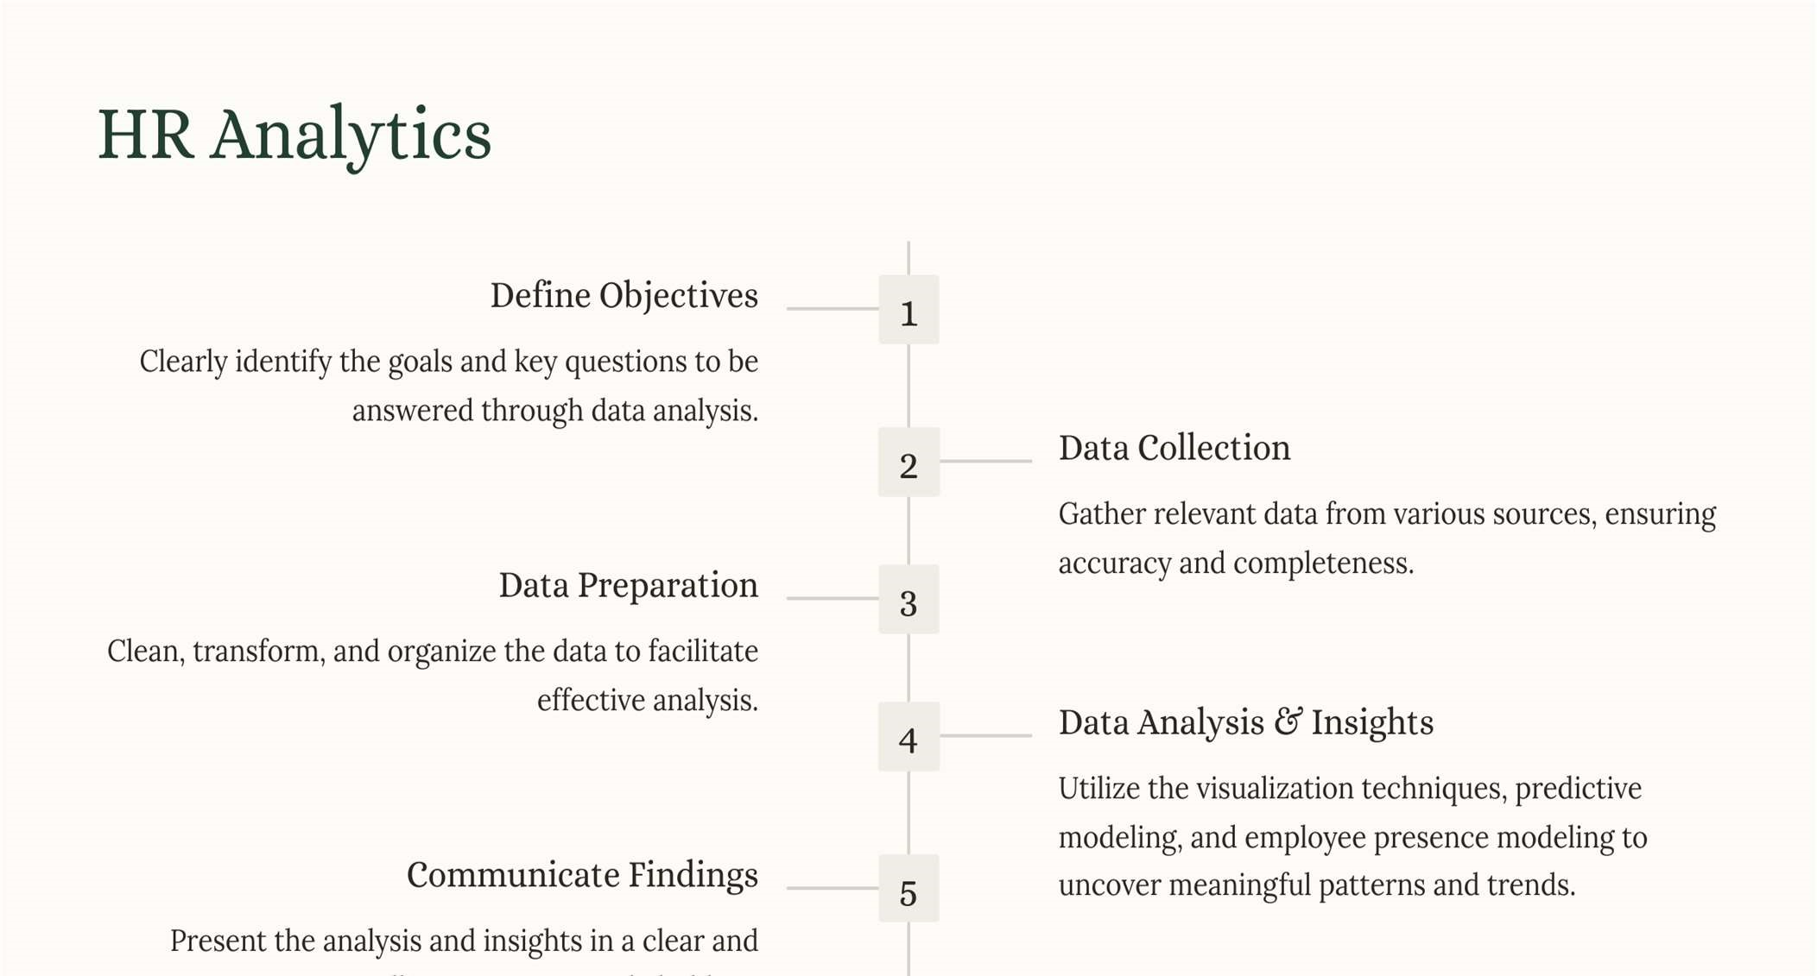
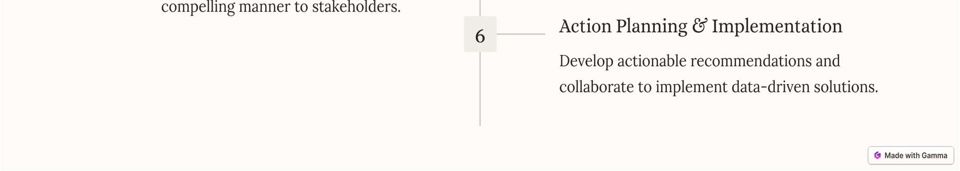
HR ANALYTICS ARCHITECTURE

TESTING

Purpose of Testing: The main goal of testing is to find errors or problems in the software. It checks if the software works as expected and meets users' requirements. Testing helps to identify weaknesses and ensures that the software functions correctly without failures.

Types of Testing:

Unit Testing:

Unit testing involves testing individual components (or units) of software to ensure each function correctly. It is performed after coding a unit but before integrating it with others. The focus is on verifying the internal logic, inputs, outputs, and decision-making paths of the program.

Integration Testing:
Integration testing involves testing how different units of the software work together after they are integrated. It ensures that separate pieces of software function as a cohesive system and interact properly.

Functional Testing:
Functional testing checks whether the software performs its intended functions according to the specified requirements. It focuses on verifying that valid inputs are accepted, invalid inputs are rejected, and the system produces the correct outputs.

System Testing:

System testing tests the entire software system to ensure it meets all the requirements. It examines how the entire system works as a unified whole and ensures it provides predictable and correct results.

White Box Testing:
White box testing involves testing the software with knowledge of its internal structure and code. It focuses on checking parts of the software that cannot be tested externally, such as internal code and logic.

Black Box Testing:
Black box testing tests the software without knowledge of its internal workings, focusing only on inputs and outputs. The goal is to provide inputs and verify if the outputs meet expectations, without considering the internal code.

Acceptance Testing:
Acceptance testing determines if the software meets the user's needs and is ready for real-world use. It serves as the final check before the software goes live, involving significant input from end-users

Test strategy and approach

White-Box Testing
White-box testing focuses on verifying the internal workings, logic, and structure of the dashboard components. The tester has access to the underlying code, Power BI formulas, and data models.

Approach to Conducting White Box Testing in Power BI
The process of conducting white box testing in Power BI involves several key steps. First, review and test the relationships between datasets to ensure accurate joins, filters, and aggregations, validating the integrity of the data models. Next, validate the correctness of calculated fields and measures written in DAX, ensuring that calculations like Presence % or WFH % return accurate results. Query performance and report refresh times should be checked to ensure data loads efficiently and updates dynamically without errors, optimizing performance. Additionally, assess the logic behind slicers, drill-throughs, and other interactive elements to verify that they function as expected. Finally, test each visual, table, and chart individually to confirm they display accurate data from the backend.

Black-Box Testing
Black-box testing evaluates the functionality and usability of the dashboard without knowing its internal code or data model structure. The focus is on inputs, outputs, and user experience.

Approach to Conducting Black Box Testing in Power BI
The process of conducting black box testing in Power BI involves several key steps. Functionality testing involves verifying that all filters, visuals, and navigational features in Power BI work as intended. For example, testing whether selecting a specific date range updates all visuals dynamically. Data validation is also critical, which includes cross-checking visualized data against the source dataset to ensure accuracy and identify discrepancies. Usability testing focuses on evaluating the dashboard’s user-friendliness, such as assessing the clarity of charts, labeling, and the overall design layout. Error handling is another key area, ensuring that the dashboard gracefully manages invalid inputs or missing data, such as preventing broken visuals when certain data is unavailable. Lastly, end-to-end testing simulates real-world scenarios, such as HR professionals exploring metrics, drilling down by department, or exporting reports, to ensure the dashboard functions effectively in practical use cases.
Test Results/Validation
The test cases for the HR Analytics Dashboard were conducted using both white-box testing and black-box testing approaches. Based on the test results, the HR Analytics Dashboard has been thoroughly validated and is functioning as intended. All test cases passed successfully, and the system outputs are accurate, reliable, and aligned with the project objective.

8. OUTPUT SCREENS
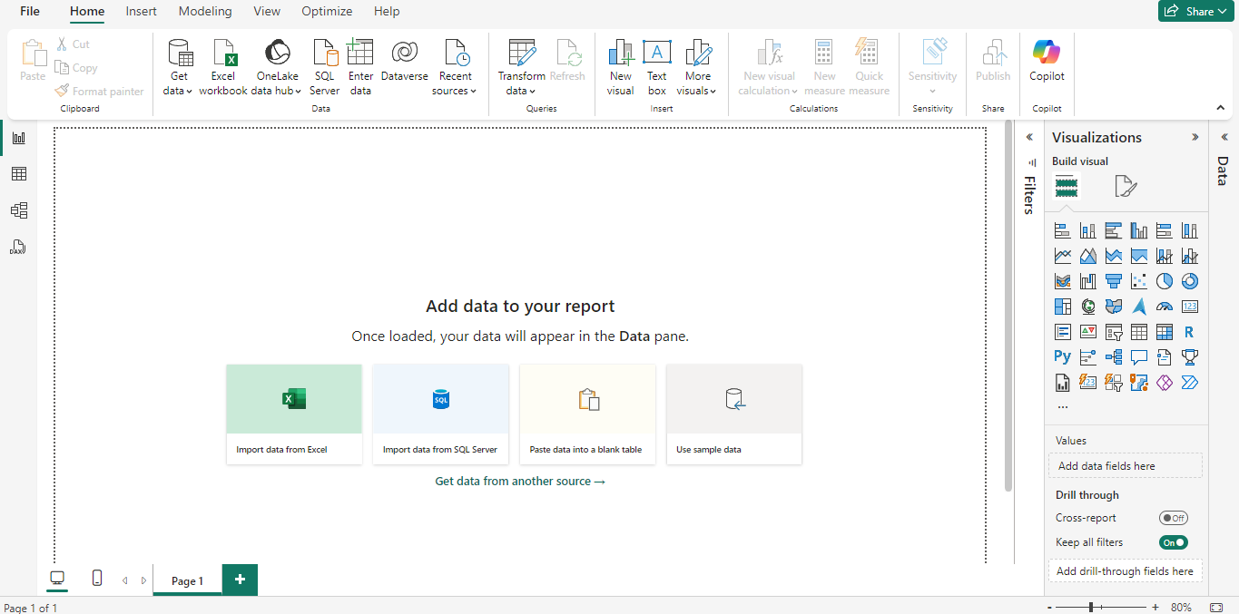
- Open Power BI, and click "Import data from Excel" to load the required dataset.

Figures 8.1 Power BI
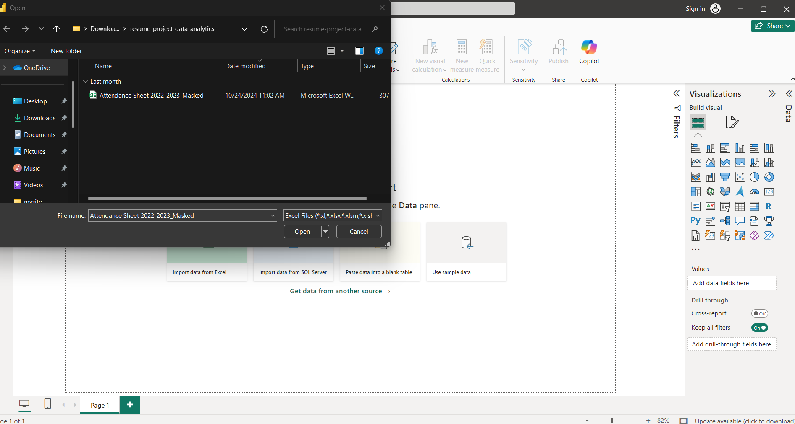

Figure: 8.2 Uploading the Attendance Dataset
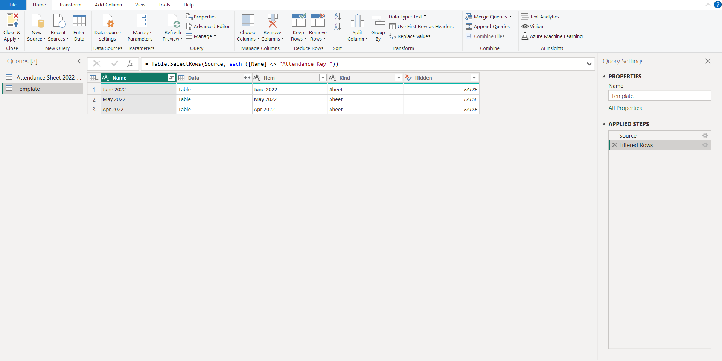
- Select and upload the “Attendance.csv” file, click "Open" to load the dataset, then filter rows and remove unnecessary columns as part of the preprocessing steps.

Figure: 8.3 Loading the Dataset
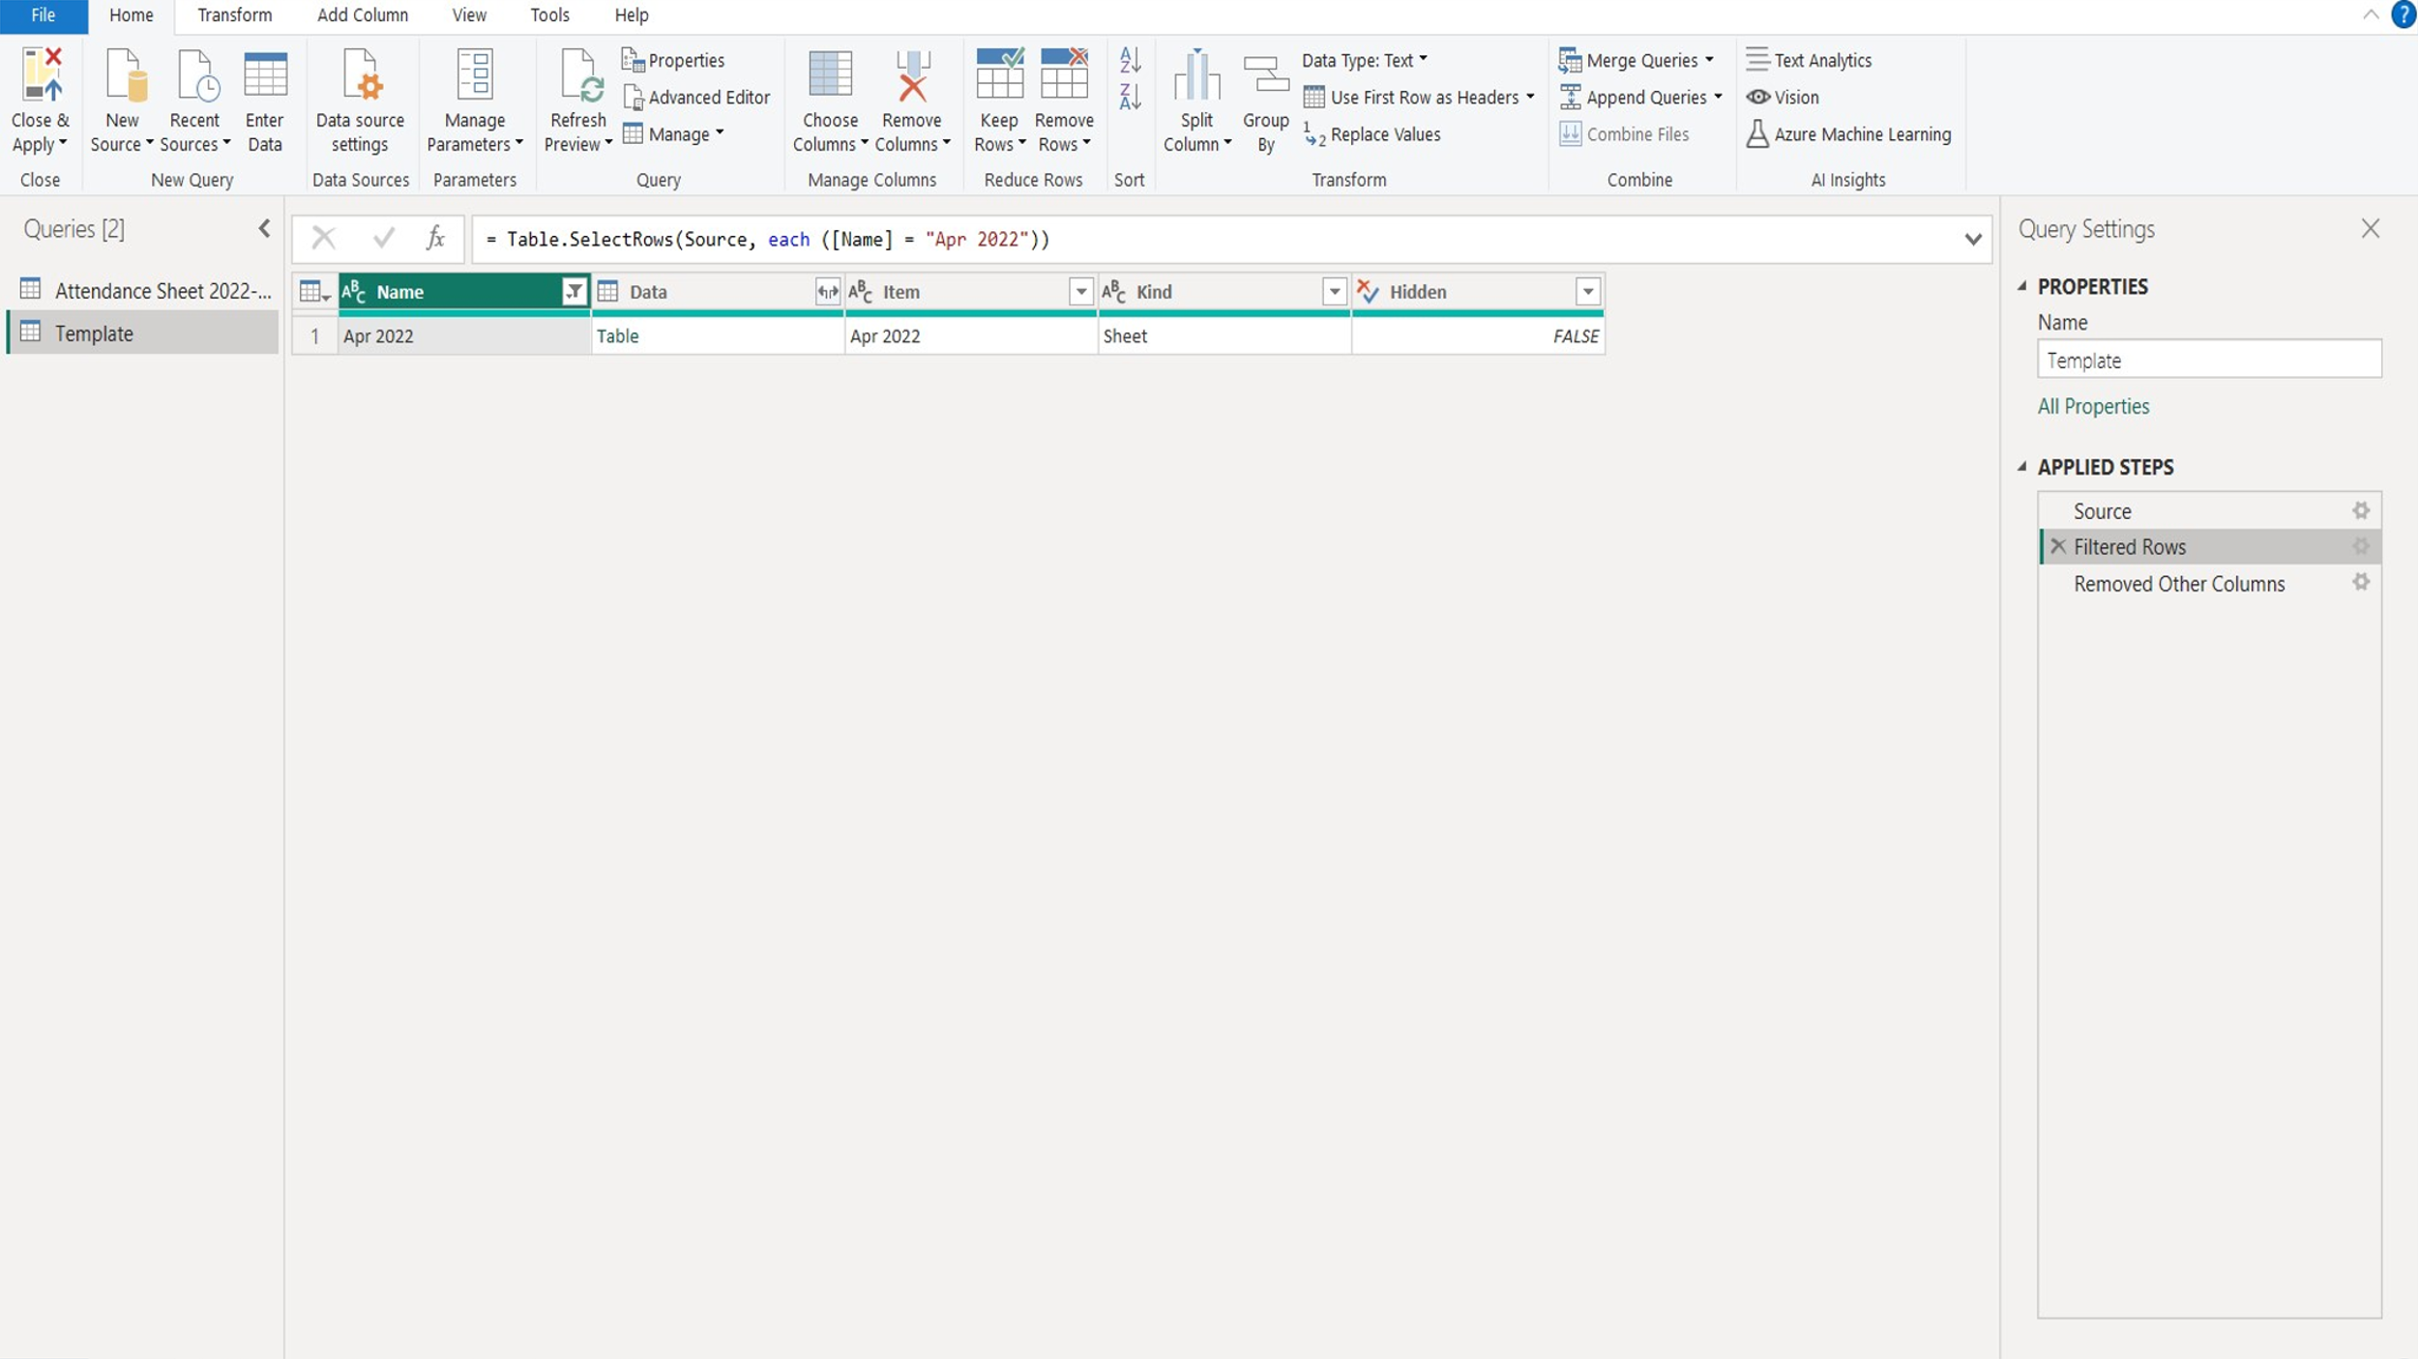

Figure: 8.4 Initial Pre-processing of the Dataset

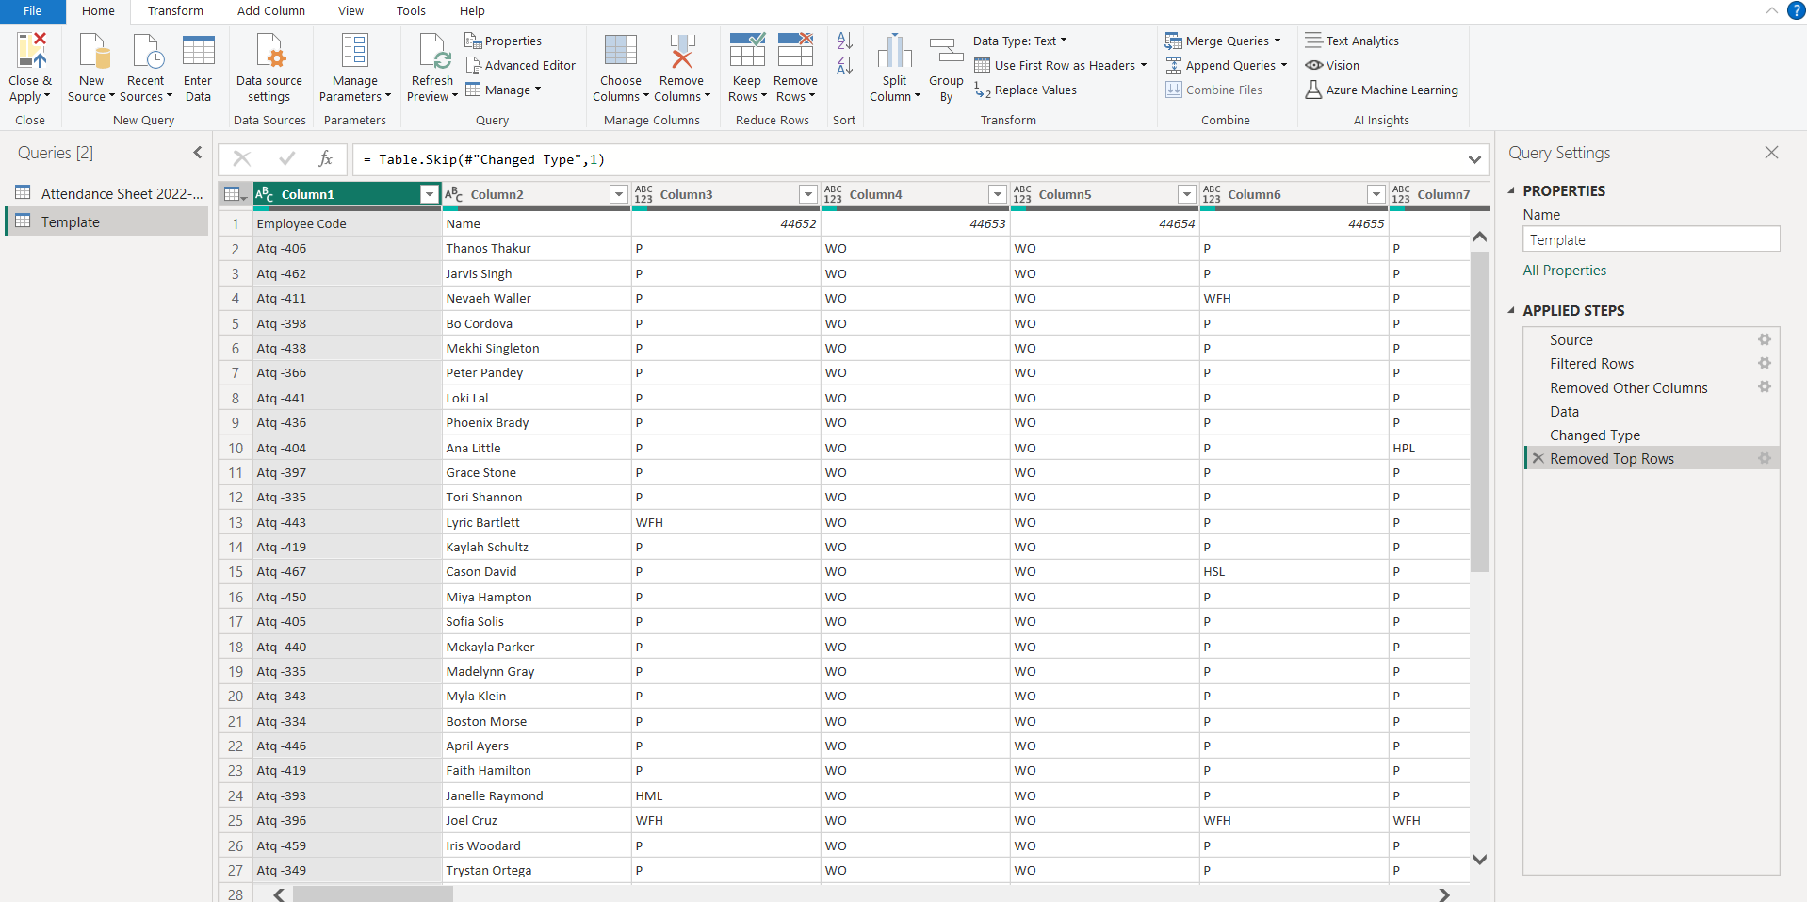
- Perform tasks such as changing data types, promoting headers, removing top rows, renaming, and unpivoting columns.

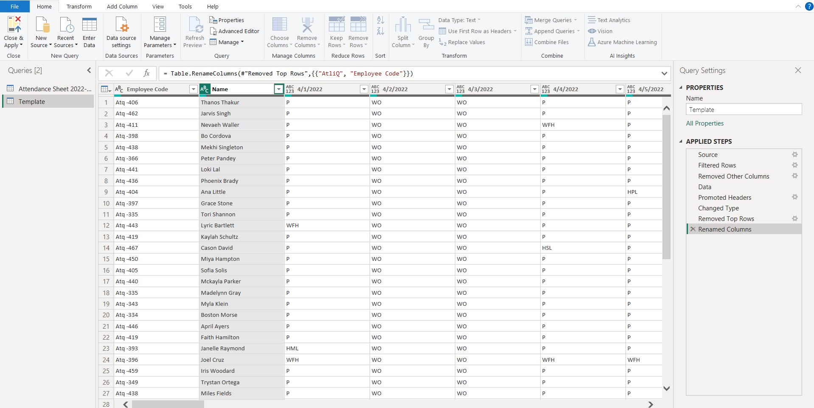
Figure: 8.5 Change data types, and remove top rows.

Figure: 8.6 Promoting the Headers

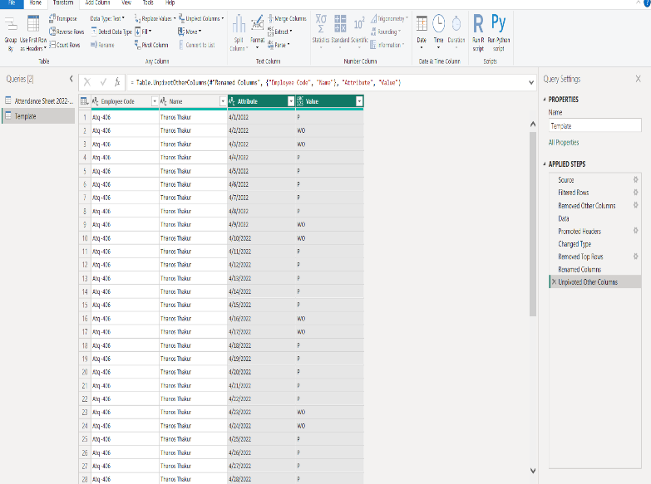
Figure: 8.7 Rename columns and unpivot columns.
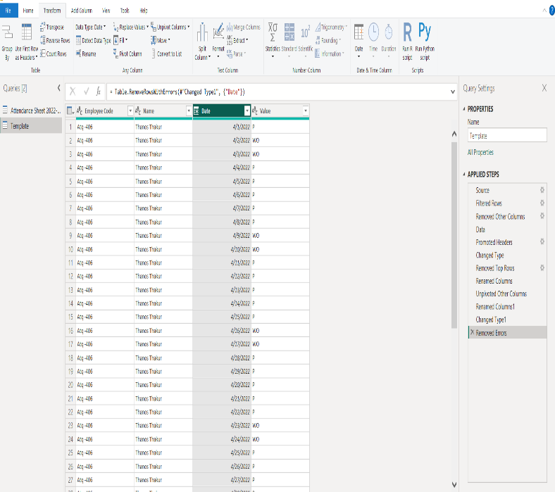
- Execute column renaming, type conversion, and error correction as part of the advanced preprocessing steps.
Figure: 8.8 Column renaming and type conversion.
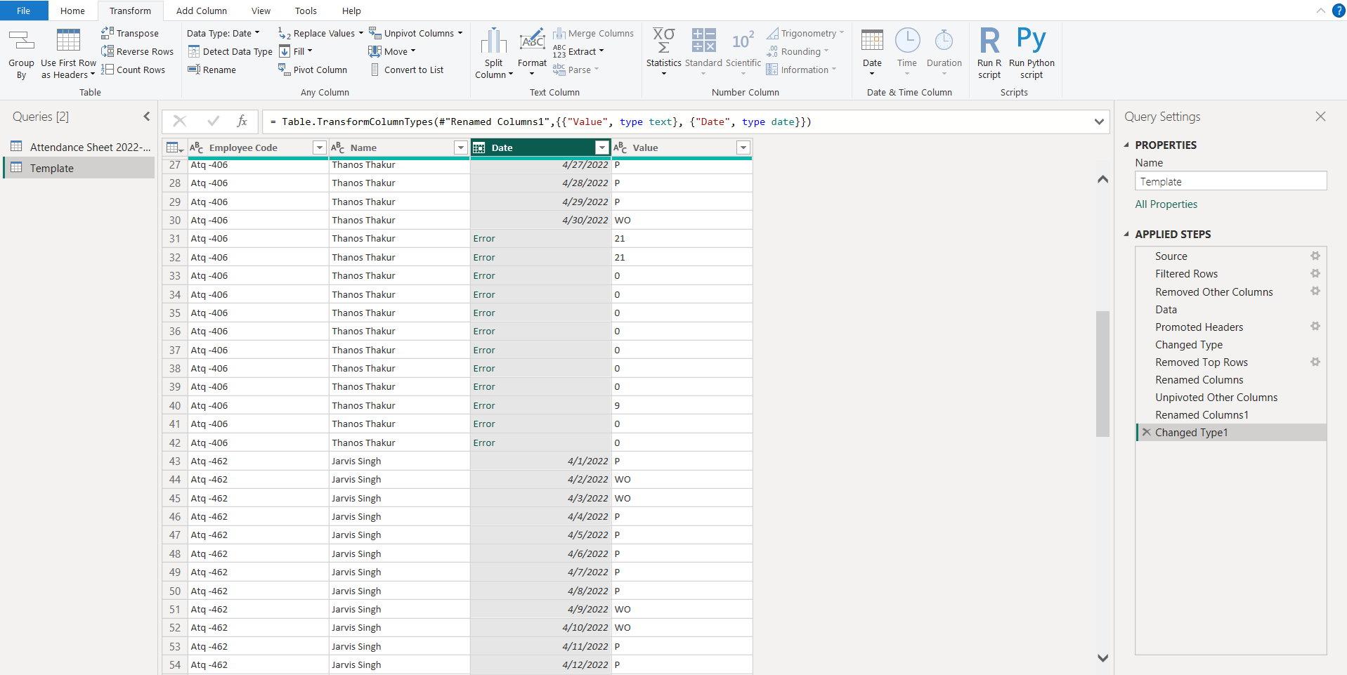
Figure: 8.9 Perform error correction as part of advanced preprocessing.
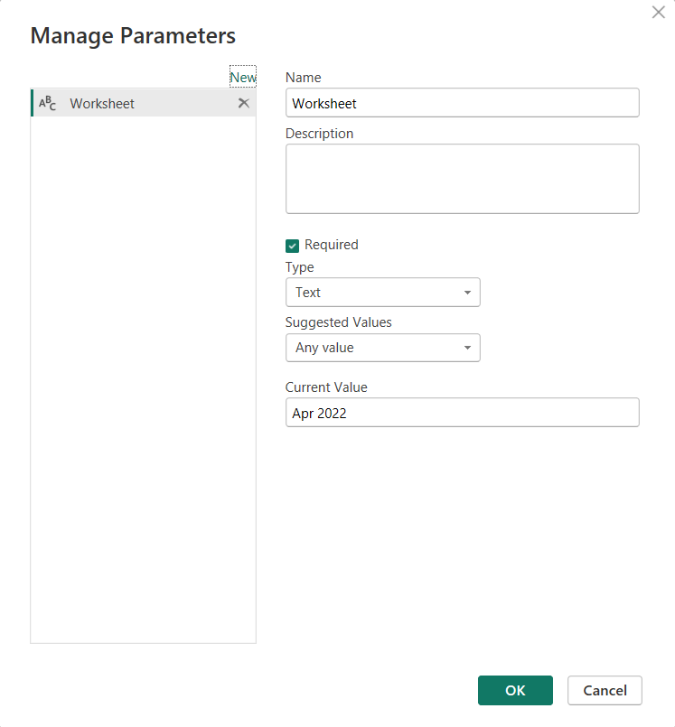
- Define and manage parameters labeled "Worksheet" to facilitate the invocation of functions for subsequent operations, ensuring smooth integration and efficient data handling.

Figure 8.10 Creating a Parameter
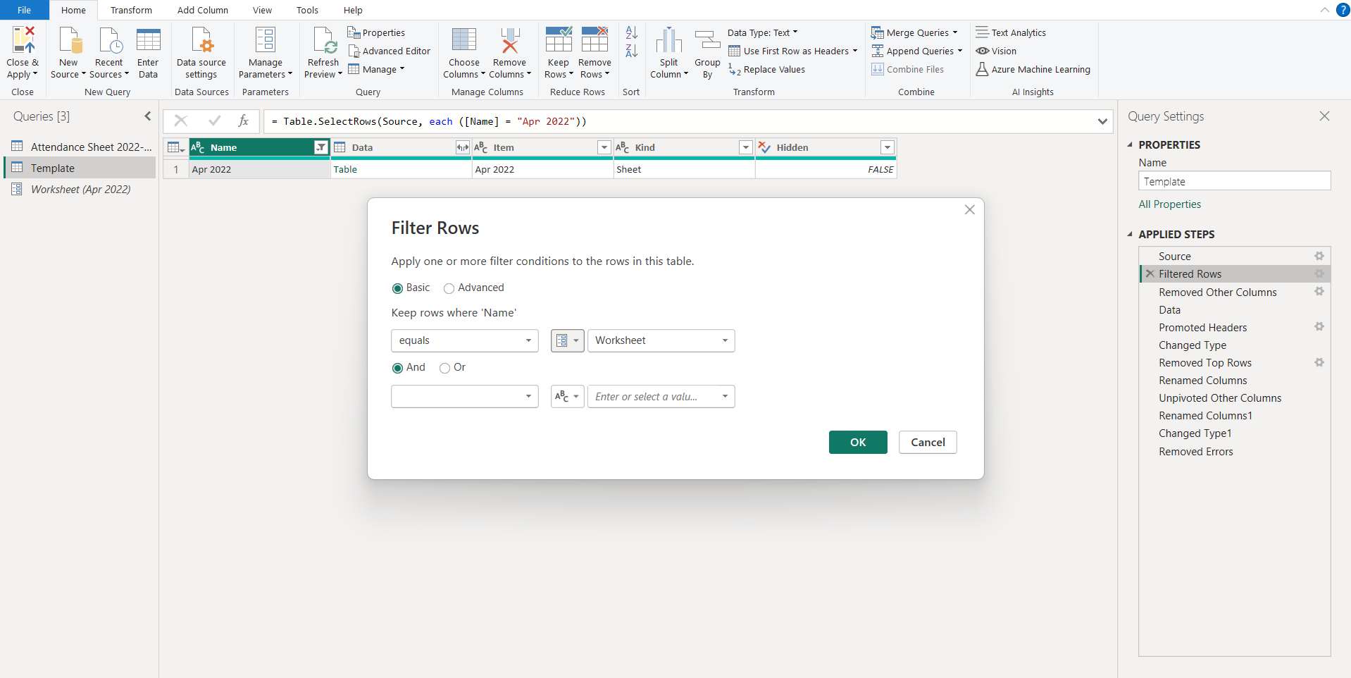
Figure 8.11 Managing the Parameter
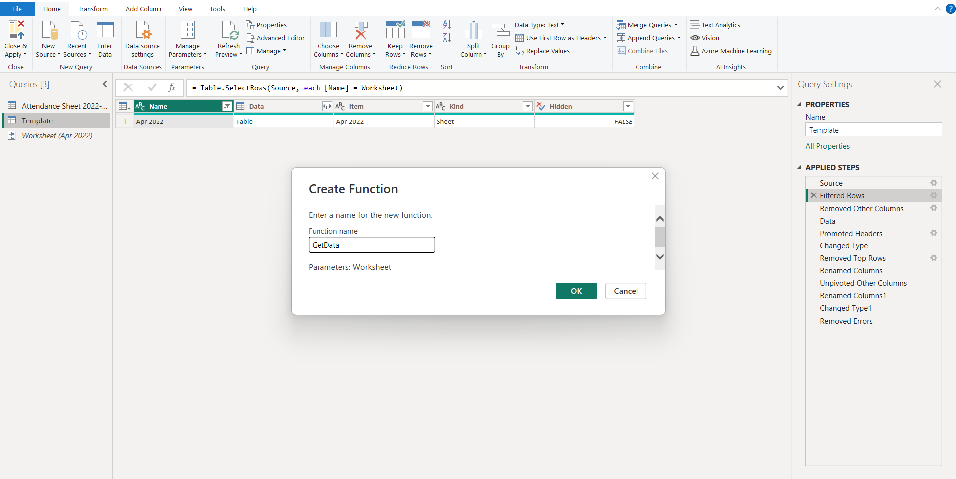
- Create a function called "GetData,", and pass the “Worksheet” parameter to the custom function across all relevant datasheets to ensure accurate and efficient data retrieval for subsequent operations.

Figure 8.12 Creating a Function
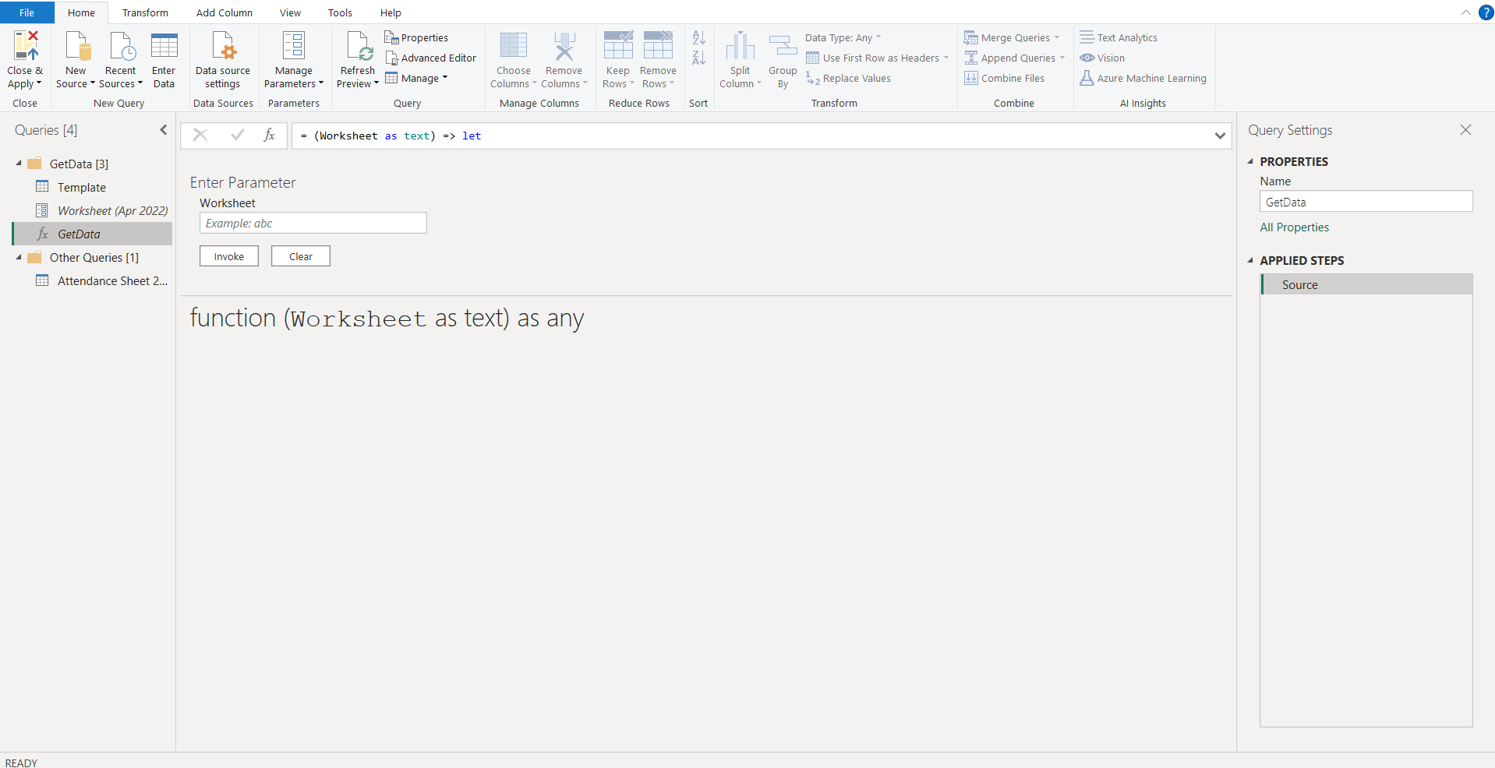
Figure 8.13 Passing the Parameter
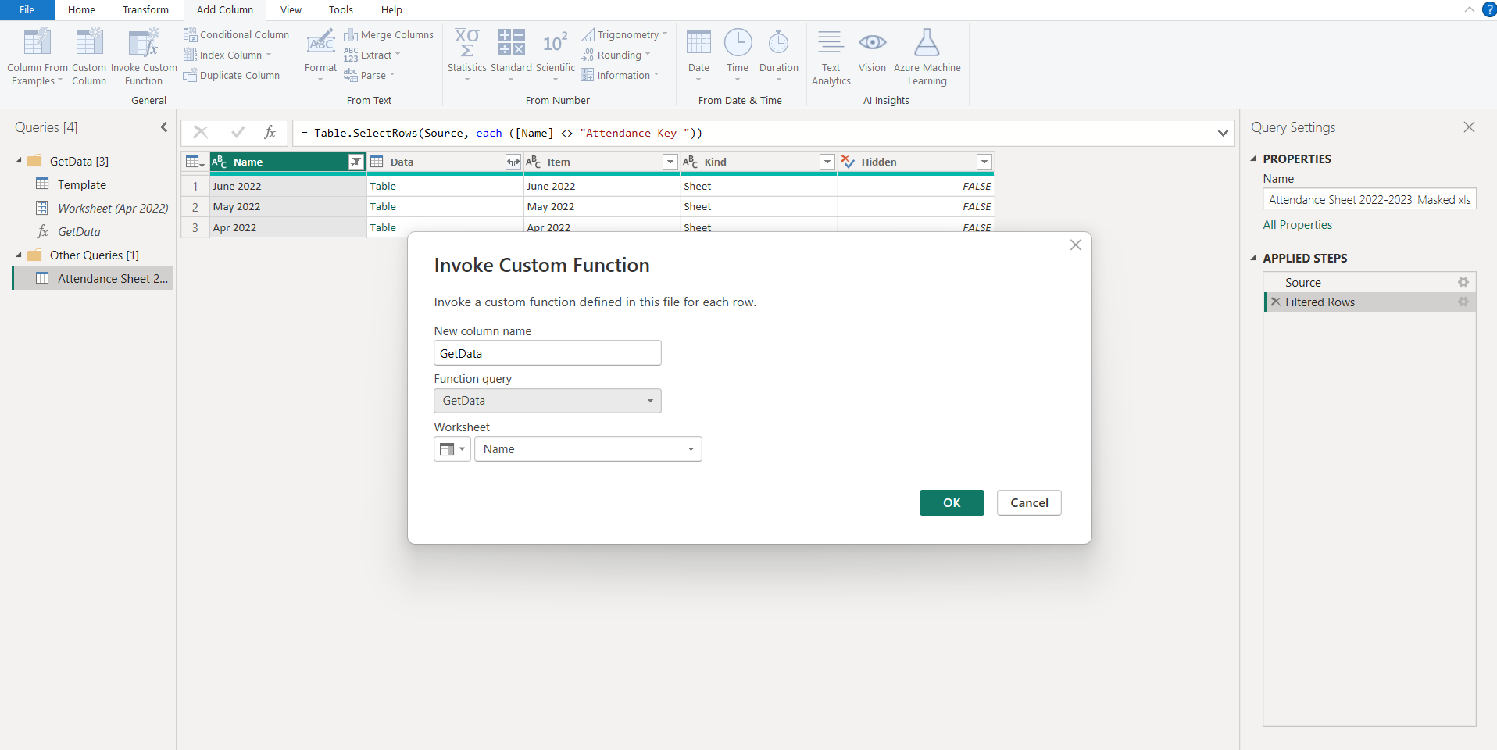
- Invoke the custom function, labeled "GetData," across all datasheets to perform the mentioned preprocessing steps. This approach ensures consistent data handling for existing datasheets and guarantees that the function will work seamlessly if new datasheets are added in the future.

Figure 8.14 Invoking the function
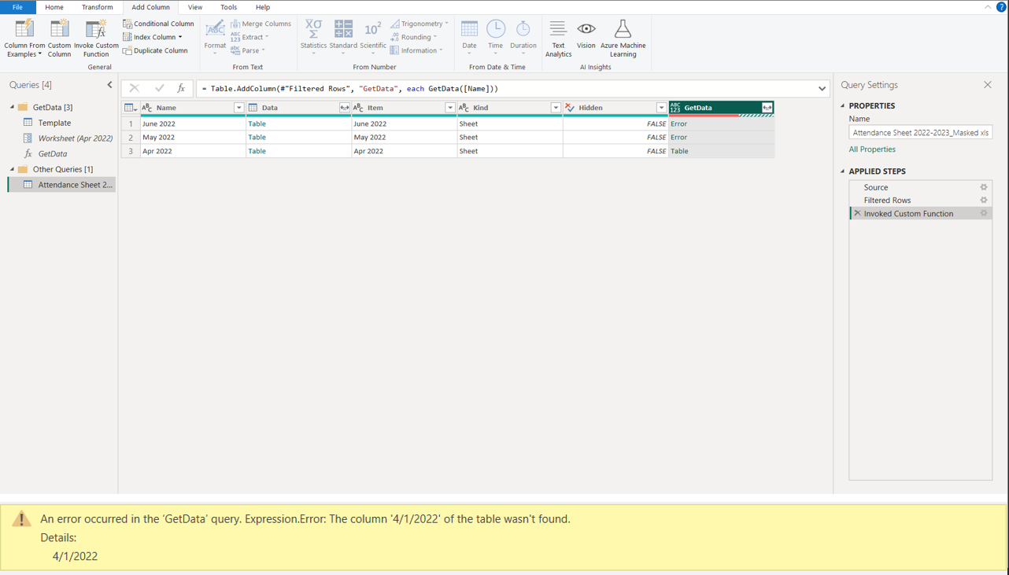
- After applying the function, an error occurred due to inconsistent month formats. This needs to be addressed to ensure smooth processing of the datasets.

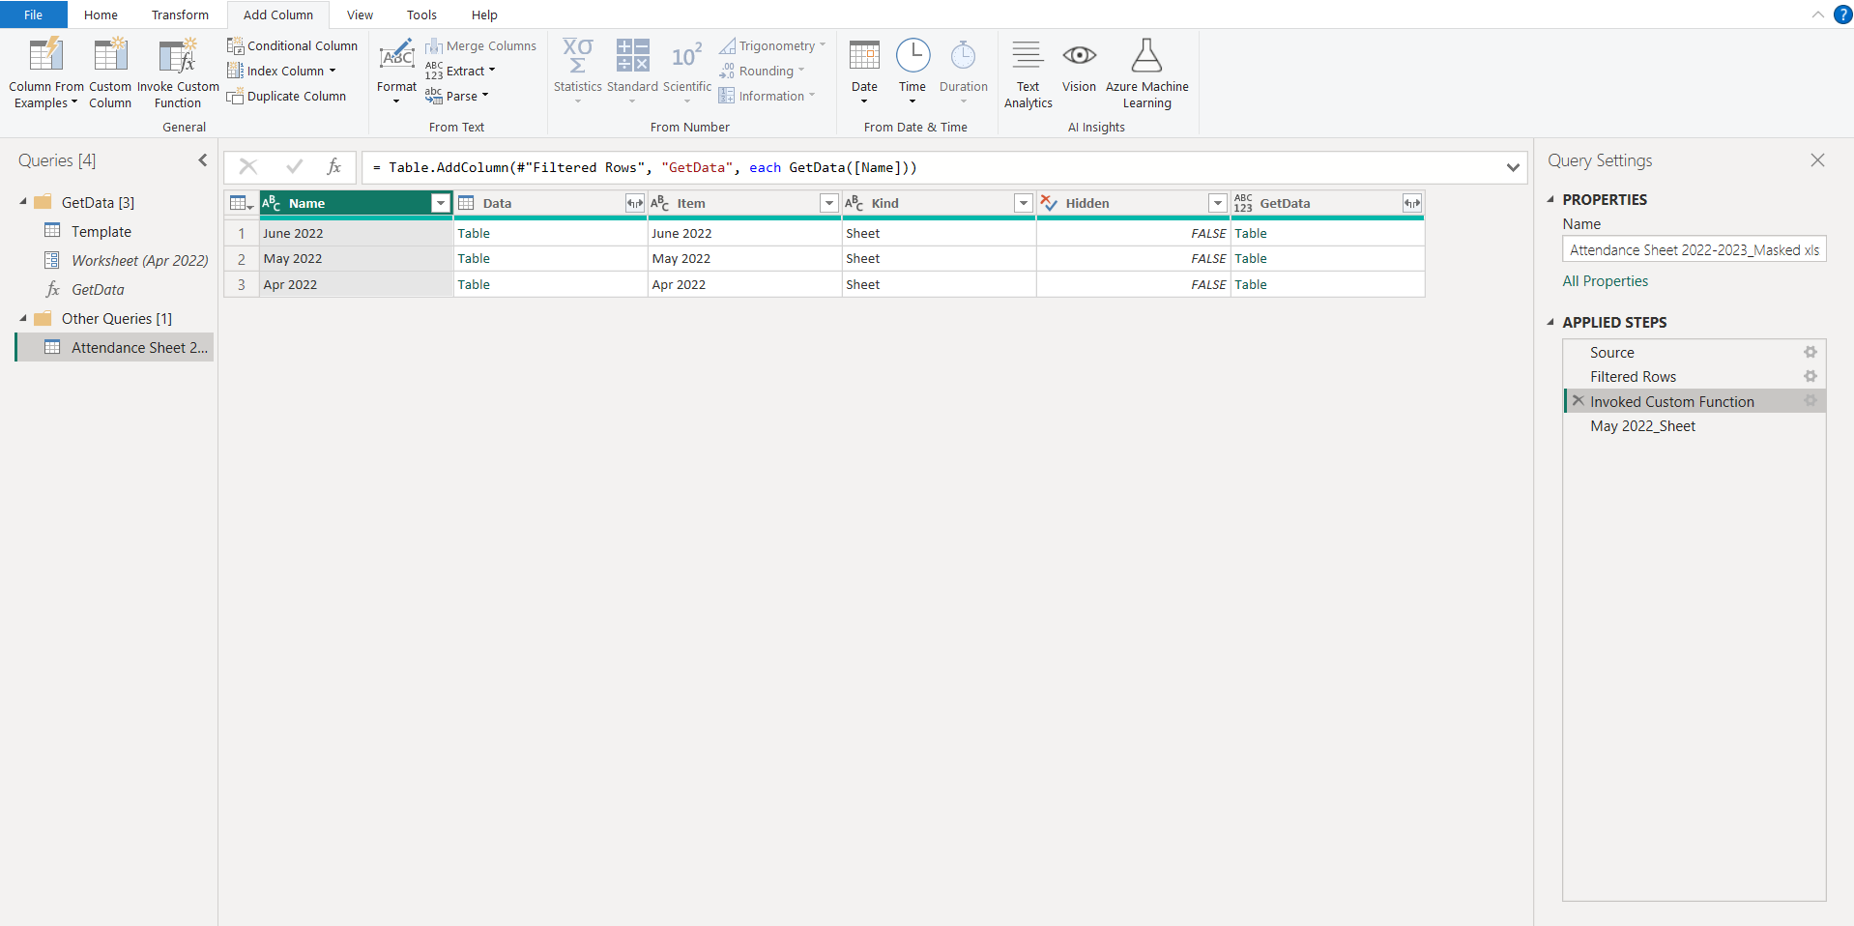
Figure 8.15 Error leading to hindering dataset processing

Figure 8.16 Applying the function to all the date sheets
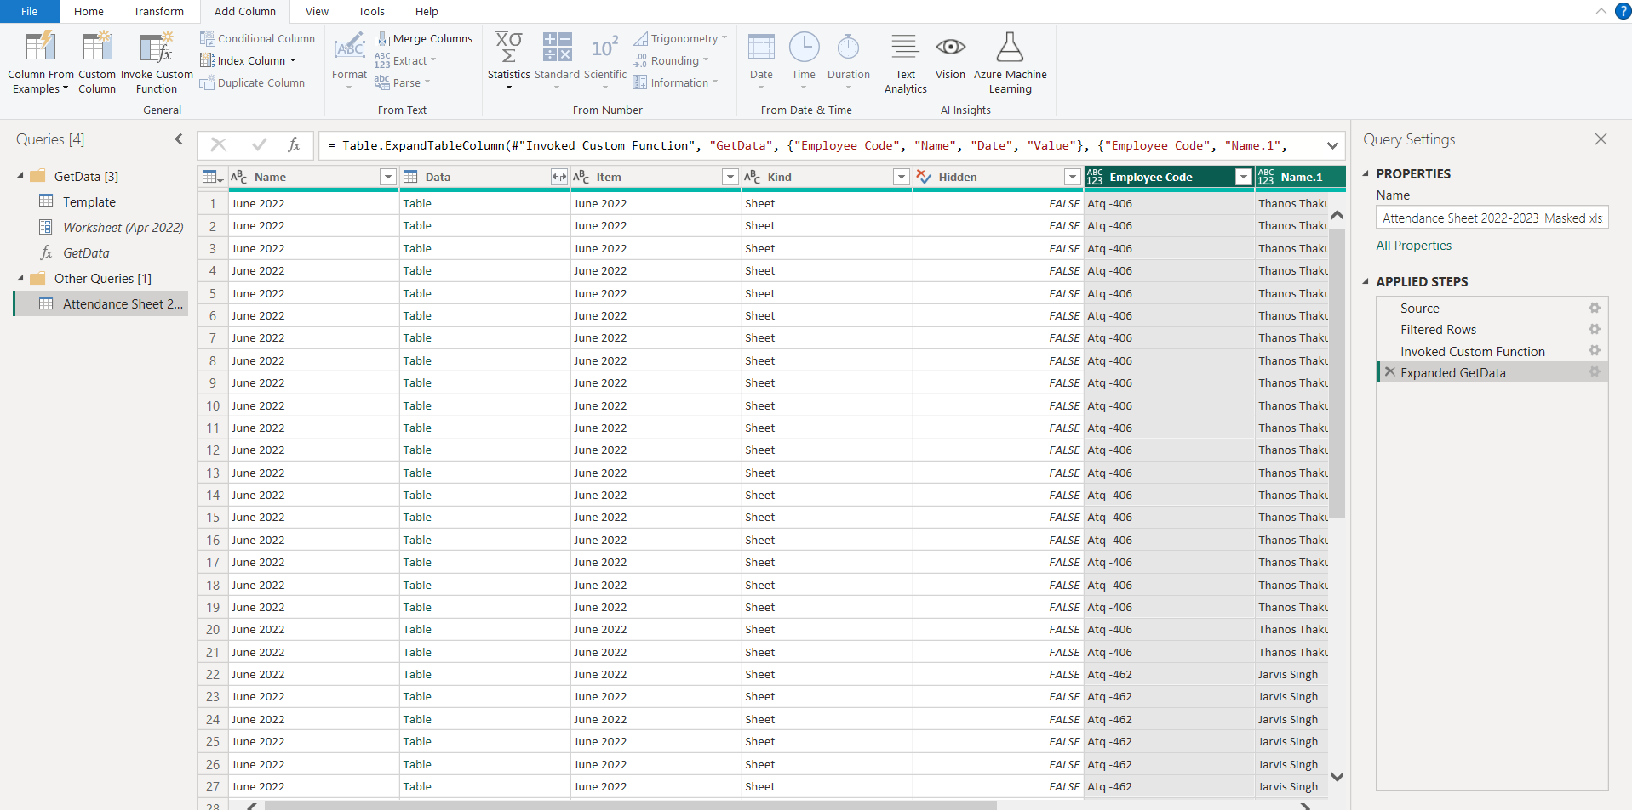
- Expand the datasheet to perform final checks and corrections, ensuring the accuracy and integrity of the data. This process will allow for the refinement of the dataset, ultimately resulting in the creation of a clean, error-free final dataset ready for analysis and reporting.

Figure 8.17 Expanding the Dataset

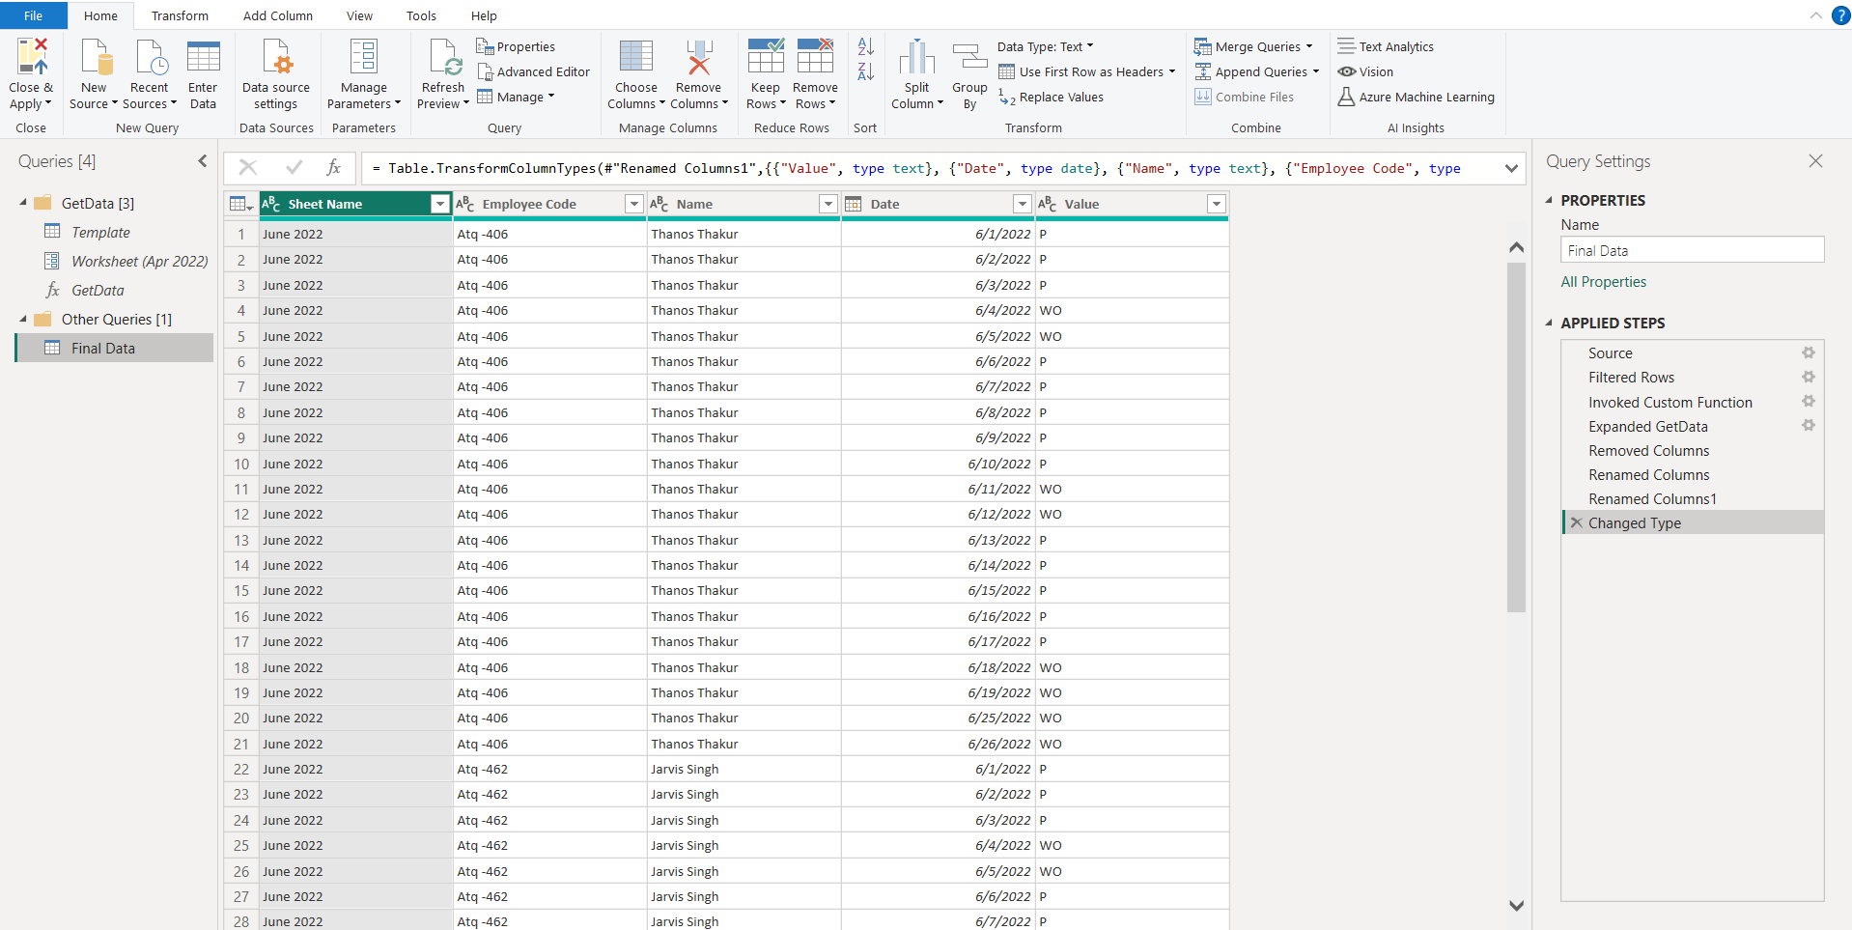
- Therefore, the final dataset, after successfully executing the aforementioned operations, is displayed in the following screen. This dataset has undergone thorough processing, including data validation, transformations, and error corrections, ensuring it is now ready for comprehensive analysis and reporting.

Figure 8.18 Final Pre-processed Dataset

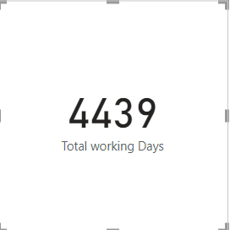
Figure 8.19 Total Working Days
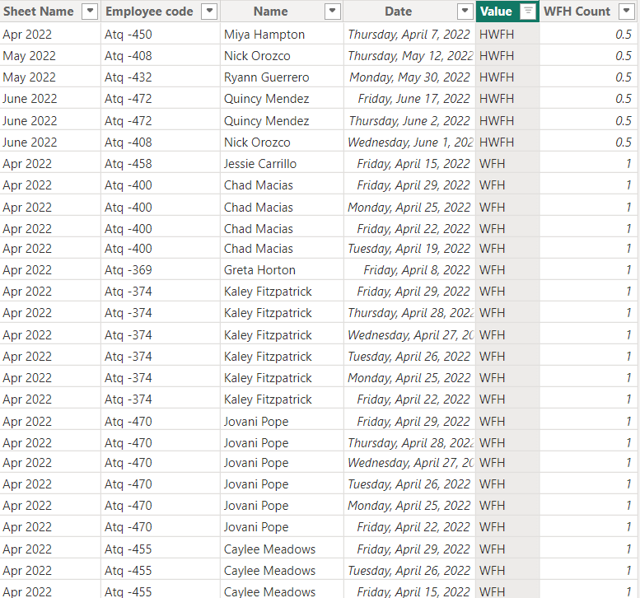

Figure 8.20 WFH Count
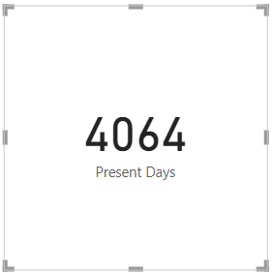
Figure: 8.21 Present Days
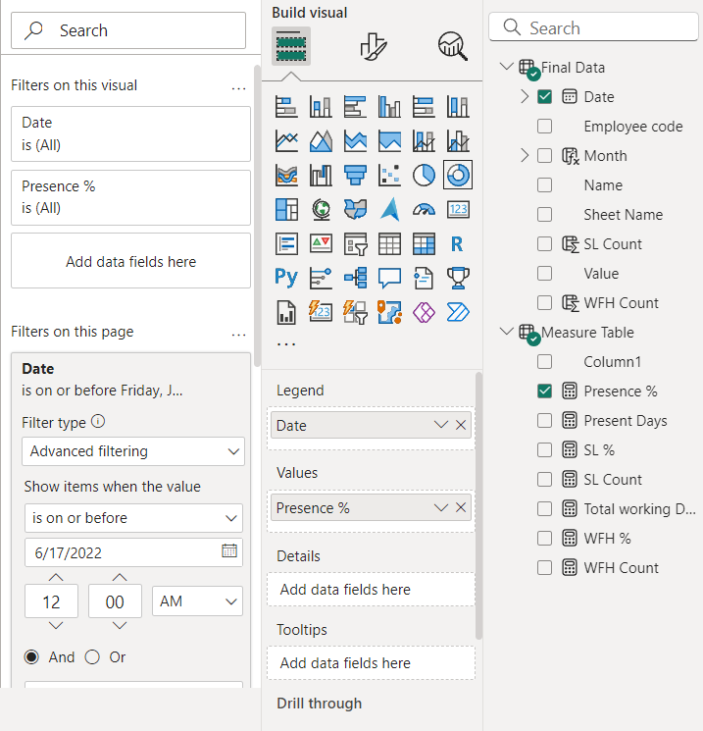

Figure: 8.22 Selection of Presence%

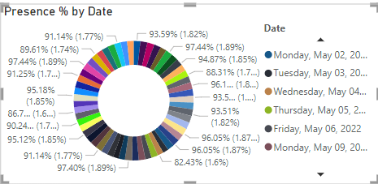
Figure: 8.23 Presence % graph
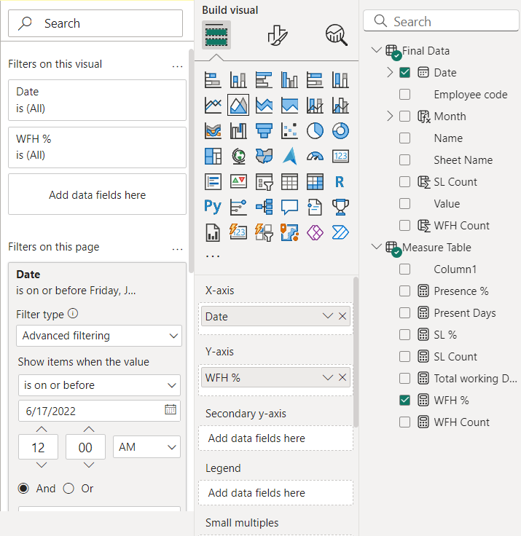

Figure: 8.24 Selection of WFH%
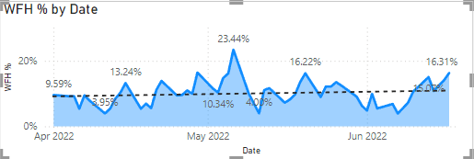

Figure: 8.25 WFH% Graph
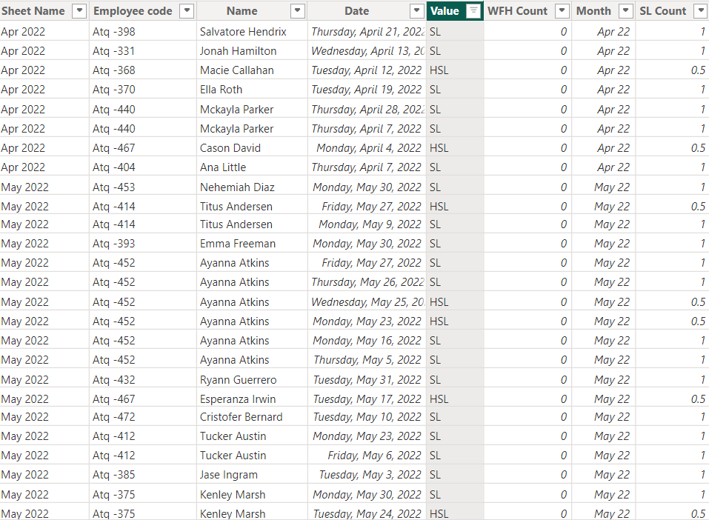

Figure: 8.26 SL Count
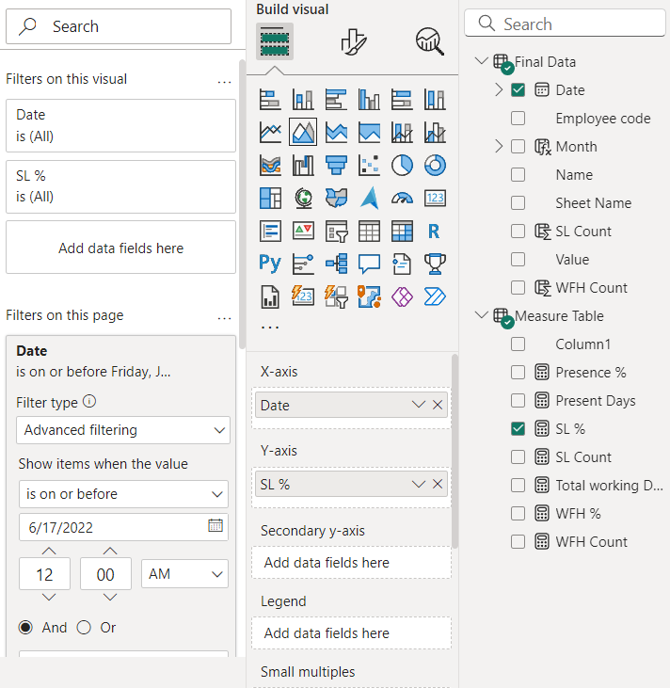
Figure: 8.27 Selection of SL%

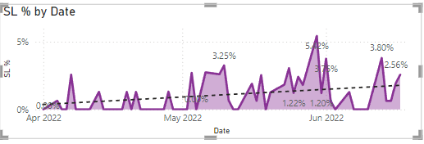
Figure: 8.28 SL% Graph
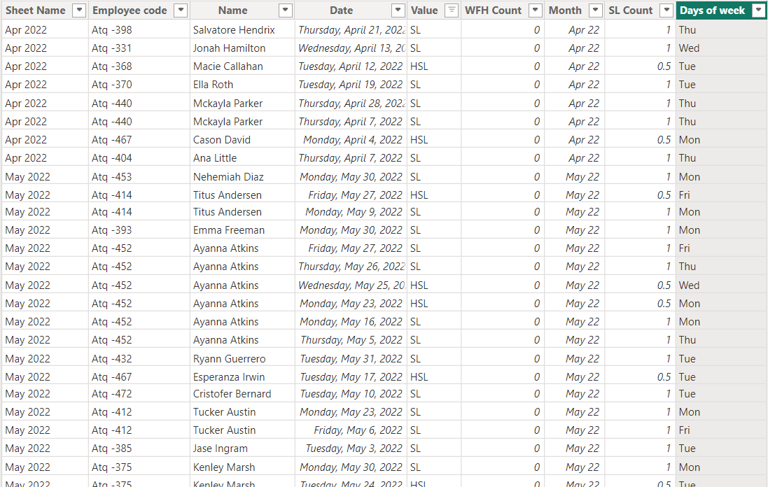

Figure: 8.29 Days of the week

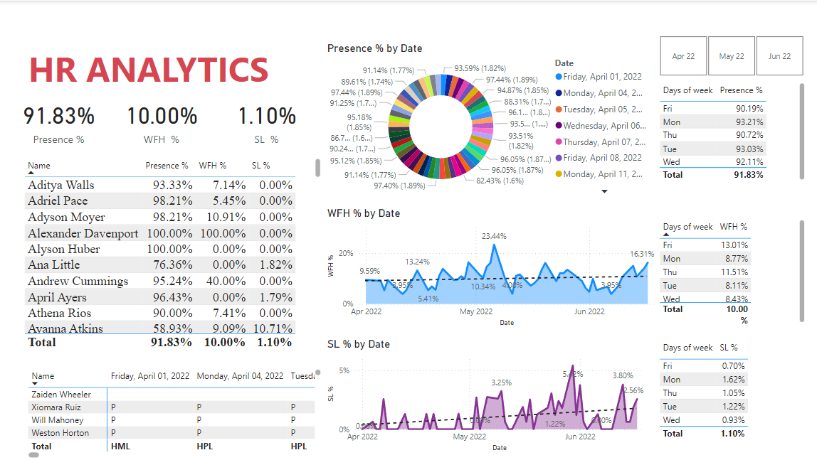
Figure: 8.30 Final Dashboard

CONCLUSION

The HR Analytics project leverages Power BI to empower HR professionals by transforming raw HR data into meaningful and actionable insights. This initiative focuses on enhancing workforce management by providing a comprehensive view of key metrics such as employee attendance, work-from-home patterns, and sick leave trends. By integrating data from multiple HR systems and automating reporting processes, the project addresses inefficiencies in traditional methods and streamlines decision-making. A central feature of this project is the interactive Power BI dashboard, which offers advanced analytics capabilities and dynamic visuals, enabling HR teams to explore data in real time. The primary goal of this project is to equip HR professionals with the tools and insights necessary to engage in strategic workforce management, ultimately driving improved organizational performance and outcomes.

FUTURE ENHANCEMENTS

Future enhancements for the HR Analytics project could include the integration of additional data sources, such as performance management systems, employee satisfaction surveys, and training records, to provide a more comprehensive view of employee performance and engagement. Implementing predictive analytics using machine learning models would allow for better forecasting of absenteeism, turnover, and workforce demand, enabling proactive HR decision-making. Further improvements could focus on making the dashboard mobile-friendly for on-the-go access, enhancing real-time updates for more responsive tracking of attendance and leave metrics, and incorporating employee wellness metrics, such as work-life balance and health indicators, to offer a holistic view of workforce well-being.

Additional features could include role-based access control to protect sensitive information by restricting access to authorized users, while sentiment analysis could be used to gauge employee morale and identify potential issues within teams. To drive engagement, gamification metrics could be added to measure employee participation in workplace initiatives, and expanded reporting features would enable automated report generation and distribution to key stakeholders. Lastly, integrating benchmarking and external comparisons would allow HR teams to evaluate internal performance against industry standards, helping to identify areas for improvement and drive better workforce management strategies.

REFERENCES

Books and Journals:

- Business Intelligence and Analytics: Systems for Decision Support by Ramesh Sharda, Dursun Delen, and Efraim Turban. This book explores business intelligence systems and their role in data analytics and decision-making.

- Human Resource Analytics: A Guide to Optimizing Talent Strategies by Gene Pease, Boyce Byerly, and Jac Fitz-enz. This book offers insights into leveraging HR data to improve workforce planning and decision-making.

Research Papers and Articles:

- Davenport, T. H., Harris, J., & Shapiro, J. (2010). Competing on Talent Analytics. Harvard Business Review. This paper discusses the importance of using analytics in HR to gain a competitive edge.

- Stone, D. L., Deadrick, D. L., Lukaszewski, K. M., & Johnson, R. (2015). The influence of technology on the future of human resource management. Human Resource Management Review, 25(2), 216–231. This article explores the impact of technology and analytics in modern HR management.

Web Resources:

- Microsoft Power BI Blog: https://powerbi.microsoft.com/blog/ This blog contains use cases and guides for developing interactive dashboards like the one in your project.

- Towards Data Science: https://towardsdatascience.com/ Articles on data analytics, visualization techniques, and practical implementations of dashboards.

- Kaggle HR Analytics Datasets: https://www.kaggle.com/ Contains datasets and related project discussions that could provide supplementary material for HR analytics projects.

Case Studies:

- IBM Smarter Workforce Institute (2016). Using workforce analytics to improve employee retention. This case study discusses how advanced analytics can be applied to predict and reduce employee turnover.

- SHRM Foundation (2018). People Analytics: Using Data to Drive HR Strategies. A foundational report offering insights into using data-driven methods to shape HR policies and decisions.

