**DESIGN AND IMPLEMENTATION OF QUAD NOTCH UWB ANTENNA**

**A PROJECT REPORT**

**Submitted by**

**SHEEREEN NISMA M** -  **810020106082**

**VAISHALI M** -  **810020106091**

**GOWTHAM KUMAR Y** -  **810020106303**

***in partial fulfilment for the award of the degree of***

**BACHELOR OF ENGINEERING**

**IN**

**ELECTRONICS AND COMMUNICATION ENGINEERING**



**UNIVERSITY COLLEGE OF ENGINEERING, BIT CAMPUS**

**ANNA UNIVERSITY, TIRUCHIRAPPALLI-620024**

**ANNA UNIVERSITY: CHENNAI- 600 025**

**MAY 2024**

**ANNA UNIVERSITY: CHENNAI- 600 025** 

**BONAFIDE CERTIFICATE**

Certified that this project report **“Design and implementation of Quad Notch UWB Antenna ”** is the bonafide work of **SHEEREEN NISMA M (810020106082), VAISHALI M (810020106091), GOWTHAM KUMAR Y (810020106303)** who carried out the project work under my supervision.

**SIGNATURE SIGNATURE**

Dr P.RAMADEVI Mr S. KULASEKARAPANDIAN

**HEAD OF THE DEPARTMENT SUPERVISOR**

Associate Professor Assistant Professor

Department of ECE Department of ECE

UCE (BIT Campus) UCE (BIT Campus)

Tiruchirappalli - 24 Tiruchirappalli – 24

Submitted to University Viva-Voce examination held on ………..

**INTERNAL EXAMINER EXTERNAL EXAMINER**

**DECLARATION**

We hereby declare that the work entitled “**Design and implementation of Quad Notch UWB Antenna ’’** is submitted for the award of the degree in B.E. Electronics and Communication Engineering, University College of Engineering, BIT Campus, Tiruchirappalli, is a record of our own work carried out by us during the academic year 2023-2024 under the supervision and guidance of **Mr.S.Kulasekarapandian**, Assistant Professor, Department of ECE, University College of Engineering, BIT Campus, Tiruchirappalli. The extent and the source of information are derived from the existing literature and have been indicated through the dissertation at the appropriate places. The matter embodied in this work is original and has not been submitted for the award of any other degree or diploma, either in this or other University.

SHEEREEN NISMA M - 810020106082

VAISHALI M - 810020106091

GOWTHAM KUMAR Y - 810020106303

I certify that the declaration made above by the candidates is true.

**Signature of the Supervisor**

**Mr.S.KULASEKARAPANDIAN**

Assistant Professor,

Department of ECE,

UCE, BIT Campus,

Anna University, Tiruchirappalli-24

**ACKNOWLEDGEMENT**

All praise, glory and honour to the Lord Almighty, for his gracious presence and guidance that enable us to complete this project duly.

We wish to express our profound thanks to **Dr T. SENTHILKUMAR**, Dean, University College of Engineering, BIT Campus, Tiruchirappalli, for granting us permission for doing this project work.

We wish to express our sincere thanks to **Dr P.RAMADEVI,** Head of the Department of Electronics and Communication Engineering, University College of Engineering, BIT Campus, Tiruchirappalli, for her support and ardent guidance.

We owe our special thanks and gratitude to **Dr S.KULASEKARAPANDIAN**, Assistant Professor, Department of ECE, University College of Engineering, BIT Campus, Anna University, Tiruchirappalli, who guided us throughout our project with her timely help, guidance with valuable suggestions.

We express our heartfelt thanks to our project review committee members, Department of Electronics and Communication Engineering for their passionate support, for helping us to identify our mistakes and also for the appreciation they gave us in achieving our goals. We heartily thank our lab assistants and management for their support by way of providing the information and resources that helped us to complete the project successfully. Also, we would like to record our deepest gratitude to our parents and friends for their constant encouragement and support which motivated us to complete our project on time.

**TABLE OF CONTENTS**

|  |  |  |  |  |
| --- | --- | --- | --- | --- |
| **CHAPTER**  **NO.** |  |  | **TITLE** | **PAGE**  **NO.** |
|  |  |  | **ABSTRACT** |  |
|  |  |  | **LIST OF TABLES** |  |
|  |  |  | **LIST OF FIGURES** |  |
| **1.** |  |  | **INTRODUCTION** |  |
|  | 1.1 |  | OBJECTIVES |  |
|  | 1.2 |  | ULTRA WIDE BAND |  |
|  | 1.3 |  | NOTCH |  |
| **2.** |  |  | **LITERATURE SURVEY** |  |
| **3.** |  |  | **SOFTWARE(HFSS)** |  |
|  | 3.1 |  | INTRODUCTION3 |  |
|  | 3.2 |  | HISTORY |  |
|  | 3.3 |  | STEPS OF HFSS SIMULATION |  |
| **4.** |  |  | **HARDWARE STRUCTURES** |  |
|  | 4.1 |  | MICROSTRIP PATCH ANTENNA |  |
|  |  | 4.1.1 | PATCH |  |
|  |  | 4.1.2 | RECTANGULAR PATCH ANTENNA |  |
|  | 4.2 |  | COPLANAR WAVEGUIDE |  |
|  |  | 4.2.1 | FEATURES OF CPW |  |
|  |  | 4.2.2 | ADVANTAGES OF CPW |  |
|  |  | 4.2.3 | DISADVANTAGES OF CPW |  |
|  | 4.3 |  | ULTRA WIDE BAND |  |
|  |  | 4.3.1 | UWB FREQUENCIES |  |
|  |  | 4.3.2 | UWB COMMUNICATION |  |
|  |  | 4.3.3 | FEATURES OF UWB |  |
|  |  | 4.3.4 | UWB ANTENNA DESIGN |  |
|  |  | 4.3.5 | DESIGN CONSIDERATIONS |  |
|  |  | 4.3.6 | ADVANTAGES OF UWB |  |
|  |  | 4.3.7 | DISADVANTAGES OF UWB |  |
|  |  | 4.3.8 | APPLICATIONS OF UWB |  |
|  | 4.4 |  | NOTCH CHARACTERISTICS |  |
|  |  | 4.4.1 | DEFINITION |  |
|  |  | 4.4.2 | WAYS TO IMPLEMENT NOTCH |  |
|  |  | 4.4.3 | VARIOUS SHAPES OF NOTCH |  |
|  | 4.5 |  | EXCITATION |  |
|  |  | 4.5.1 | WAVEPORT |  |
|  |  | 4.5.2 | LUMPED PORT |  |
|  | 4.6 |  | BOUNDARY |  |
|  |  | 4.6.1 | RADIATION BOUNDARY |  |
|  |  | 4.6.2 | PERFECT E BOUNDARY |  |
| **5.** |  |  | **EXISTING WORK** |  |
|  | 5.1 |  | UWB ANTENNA |  |
|  | 5.2 |  | NOTCH |  |
|  | 5.3 |  | INFERENCE |  |
| **6.** |  |  | **PROPOSED WORK** |  |
|  | 6.1 |  | UWB ANTENNA |  |
|  | 6.2 |  | NOTCH |  |
|  | 6.3 |  | SIMULATED RESULTS |  |
| **7.** |  |  | **CONCLUSION AND FUTURE WORK** |  |
| **8.** |  |  | **REFERENCE** |  |

**ABSTRACT**

A novel coplanar waveguide fed UWB antenna with quad notch band characteristics has been proposed in this work .The antenna layout is designed based on a combination of well known geometrical shapes :a half ellipse patch ,rectangle and triangle .The shape of the ground plane is partially tapered rectangular .The overall dimension of the antenna is 41.5 X 32 mm .The antenna uses a U shaped slit and a rectangular slot to create two notch band characteristics.A split ring resonator and a mushroom structure is introduced at the back side of the structure .With the integration of these, additional two notch bands are created in the antenna. The designed antenna has an operating impedance bandwidth (VSWR <=2) ranges from 3.03 to 12.34 GHz except in quad frequency stop bands of 3.7 to 4.2 ,5.15 to 5.35 ,5.725 to 5.825 and 8.025 to 8.4 GHz .The proposed antennas are successfully designed ,prototyped and measured .The simulated and measured results are extensively studied and discussed . The antenna finds application in medical imaging ,military radar systems and other common UWB applications .

**LIST OF TABLES**

|  |  |  |
| --- | --- | --- |
| **TABLE**  **NO.** | **NAME OF THE TABLE** | **PAGE NO.** |
| 6.1 | DIMENSIONS OF U-SHAPED SLIT |  |
| 6.2 | DIMENSIONS OF MUSHROOM STRUCTURE |  |
| 6.3 | DIMENSIONS OF RECTANGULAR SLOT |  |
| 6.4 | DIMENSIONS OF SPLIT RING RESONATOR |  |

**LIST OF FIGURES**

|  |  |  |
| --- | --- | --- |
| **FIGURE**  **NO.** | **NAME OF THE FIGURE** | **PAGE**  **NO.** |
| 3.1 | HFSS SOFTWARE DESIGN |  |
| 4.1 | MICROSTRIP PATCH ANTENNA |  |
| 4.2 | PATCH ANTENNA |  |
| 4.3 | PATCH |  |
| 4.4 | RECTANGULAR PATCH ANTENNA WITH RESULT |  |
| 4.5 | COPLANAR WAVEGUIDE |  |
| 5.1 | UWB ANTENNA |  |
| 5.2 | U SHAPED SLOT ON PATCH |  |
| 5.3 | U SHAPED SLOT ON GROUND2 |  |
| 5.4 | U SHAPED SLOT ON GROUND 1 |  |
| 5.5 | SPLIT RING RESONATOR |  |
| 5.6 | UWB ANTENNA WITH QUAD NOTCH |  |
| 6.1 | BASIC UWB ANTENNA |  |
| 6.2 | UWB ANTENNA STRUCTURE |  |
| 6.3 | SIMULATED RESULT OF UWB ANTENNA |  |
| 6.4 | U SHAPED SLIT |  |
| 6.5 | SIMULATED RESULT OF U SHAPED SLIT |  |
| 6.6 | MUSHROOM STRUCTUE |  |
| 6.7 | SIMULATED RESULT OF MUSHROOM STRUCTURE |  |
| 6.8 | RECTANGULAR SLOT |  |
| 6.9 | SIMULATED RESULT OF RECTANGULAR SLOT |  |
| 6.10 | SPLIT RING RESONATOR |  |
| 6.11 | SIMULATED RESULT OF SPLIT RING RESONATOR |  |
| 6.12 | QUAD NOTCH UWB ANTENNA |  |
| 6.13 | SIMULATED RESULT OF QUAD NOTCH UWB ANTENNA |  |
| 6.14 | RADIATION PATTERN |  |
| 6.15 | GAIN PLOT |  |
| 6.16 | GROUP DELAY PLOT |  |
| 6.17 | CURRENT DISTRIBUTION OF NOTCH 1 |  |
| 6.18 | CURRENT DISTRIBUTION OF NOTCH 2 |  |
| 6.19 | CURRENT DISTRIBUTION OF NOTCH 3 |  |
| 6.20 | CURRENT DISTRIBUTION OF NOTCH 4 |  |

**CHAPTER 1**

**INTRODUCTION**

Quad Notch Ultra Wide Band antenna is an antenna which makes effective use of the available bandwidth and radiates in the ultrawideband range of 3.1 to 10.6 GHz . This antenna exhibits notch characteristics.

This antenna doesn’t radiate in the four notch bands which include 3.7 to 4.2 GHz(C band),5.15 to 5.35 GHz (WLAN1 band),5.725 to 5.825 GHz(WLAN2 band) and 8.025 to 8.4 GHz( X band).

Ultra Wide Band is a technology that has the benefit of offering the ability to carry a wide spectrum of frequency bands on low power.It has a high data rate .It can work on a wide range of frequencies in which we can send short pulses of information at a moment .It is used to send information over a large range of bandwidth approximately 500MHz .It transmits information by generating radio energy for a span of time over a large bandwidth .Lower energy consumption allows transferring a large amount of data.

Since UWB uses wide bandwidth,this technology has issues of co-existence and interference with other radio based technologies.To overcome this limitation,notches are introduced in this UWB antenna .

A notch refers to a specific frequency range within the overall UWB spectrum where the antenna exhibits reduced or suppressed performance .Essentially ,a notch in the antenna’s frequency response means that the antenna intentionally avoids or attenuates the signals within that particular frequency range .

This paper covers the basic principles of microstrip antenna ,ultrawideband technology and notch characteristics.This also studies the advantages and disadvantages of the technologies involved.This paper discusses the design and performance of ultrawideband antenna with notch characteristics.This identifies the application area of the this antenna such as medical imaging,military radar systems and other common UWB applications .

**1.1 OBJECTIVES:**

>To design an Ultra Wide Band angtenna which radiates in the UWB range of 3.1 to 10.6 GHz.

>To introduce notch characteristics in the UWB antenna by designing various notch structures.

>To design a Quad Notch UWB antenna with desired performance.

**1.2 ULTRA WIDE BAND :**

Ultra Wide Band is a technology that has the benefit of offering the ability to carry a wide spectrum of frequency bands on low power.It has a high data rate .It can work on a wide range of frequencies in which we can send short pulses of information at a moment .It is used to send information over a large range of bandwidth approximately 500MHz . Lower energy consumption allows transferring a large amount of data.The range of Ultra Wide Band is from 3.1 to 10.6 GHz.

**1.3 NOTCH :**

A notch refers to a specific frequency range within the overall UWB spectrum where the antenna exhibits reduced or suppressed performance .Essentially ,a notch in the antenna’s frequency response means that the antenna intentionally avoids or attenuates the signals within that particular frequency range.

**METHODS TO INTRODUCE NOTCH CHARACTERISTICS :**

The notch characteristics can be introduced in the antenna by using various shapes .

Common shapes of notch :

Rectangular Notch ;Circular Notch ;Triangular Notch; Curved Notch ;

Stepped Notch ;Trapezoidal Notch ;Comb-line Notch;Crescent Notch

**STOP BANDS:**

1. 3.7 to 4.2 GHz - C band .
2. 5.15 to 5.35 GHz - WLAN1 band.
3. 5.725 to 5.825 GHz - WLAN2 band .
4. 8.025 to 8.4 GHz - X band.

**CHAPTER 2**

**LITERATURE SURVEY**

**2.1** “First report and order ,Revision of part 15 of the commission’s rule regarding ultra wideband transmission system FCC 02-48” .Federal communications Commission;2002.

In this conference paper , they proposed the regulation regarding wideband communication. Ultra-wideband technology allows for the transmission of data over a broad range of frequencies, enabling high-speed communication and precise location tracking without interfering with other wireless systems. The document likely covers technical specifications, operational requirements, and regulatory standards for UWB devices to ensure they operate safely and do not cause interference with other wireless services.

**2.2** “Branch Sr Band notched elliptical slot UWB microstrip antenna with elliptical stub filled by the H shaped slot” .J *Electromagn Waves Appl.*2008;2:1993-2002.

This paper likely presents a novel design of a microstrip antenna for Ultra-Wideband (UWB) applications. The antenna design includes an elliptical slot, which helps achieve the desired bandwidth characteristics required for UWB communication. Additionally, the use of an elliptical stub filled with an H-shaped slot could be a method to further enhance the antenna's performance, such as improving impedance matching or reducing unwanted radiation in specific frequency bands.

**2.3** Kim KH,Park SO. “Analysis of the small band rejected antenna with the parasitic strip for UWB” .*IEEE Trans Antennas Propag.*2006;54(6):1688-1692.

This paper likely presents an analysis of an antenna design tailored for Ultra-Wideband (UWB) communication systems. The focus is on a specific type of antenna known as a "small band-rejected antenna" which typically features a wide operating bandwidth for UWB applications while also incorporating a mechanism to reject or attenuate signals within certain frequency bands, often to comply with regulatory requirements or mitigate interference.

**2.4** Thomas KG Sreenivasan M . “A simple ultrawideband planar rectangular printed antenna with band dispensation” *.IEEE Trans Antenna Propag* .2010;58(1):27-34.

This paper likely presents a straightforward yet effective design of a planar rectangular printed antenna optimized for Ultra-Wideband (UWB) applications. The term "band dispensation" suggests that the antenna may have properties to either cover a wide frequency range without the need for multiple frequency bands or to reject certain frequency bands as needed.The antenna design proposed in this paper is expected to have characteristics suitable for UWB communication systems, such as broad frequency coverage, good impedance matching, and possibly reduced size and complexity compared to other designs.

**2.5** Xu KD ,Zhang HY ,Spiegel RJ,Fan Y ,Joines WT ,Liu QH. “Design of a stub loaded ring resonator slot for antenna applications”. *IEEE Trans Antennas Propag.*2015;63(2):517-524.

This paper likely presents a novel approach to designing an antenna structure using a stub loaded ring resonator slot. The use of a ring resonator slot suggests that the antenna design may involve exploiting the resonant properties of the ring structure to achieve desired frequency characteristics, such as impedance matching, bandwidth enhancement, or radiation pattern control.The incorporation of stubs into the ring resonator slot design could serve various purposes, such as fine-tuning the resonant frequency etc.,

**2.6** Manohar M Kshetrimayum RS ,Gogoi AK . “A compact dual band notched circular ring printed monopole antenna for super wideband applications”.Radio-Eng.2017;26(1):64-70.

This paper likely presents a novel design of a printed monopole antenna optimized for Super Wideband (SWB) applications. The antenna design incorporates dual-band notches, suggesting that it is capable of operating over a wide frequency range while also attenuating or rejecting signals in specific frequency bands.Overall, this work contributes to the field of antenna engineering by offering a compact and efficient solution for super wideband applications, with the capability to operate over a broad frequency range while selectively attenuating or rejecting signals in specific frequency bands.

**2.Top of Form**

**7** Peddakrishna s,Khan T. “Design of UWB monopole antenna with dual notched band characteristics by using p shaped slot and EBG resonator .” *AEU Int J Electron Commun*.2018;96:107-112.

This paper likely presents a design of a monopole antenna optimized for Ultra-Wideband (UWB) applications. The antenna design incorporates features such as a P-shaped slot and Electromagnetic Band Gap (EBG) resonator to achieve dual notched band characteristics.The paper likely provides details on the design process, simulation results, and possibly experimental validation of the proposed antenna configuration.

**2.8** Design of a CPW-fed UWB printed antenna with dual notch band using mushroom structure;2015 TAPAN MANDAL and SANTANU DAS.

In the paper authored by Tapan Mandal and Santanu Das, they propose the design of a CPW-fed (coplanar waveguide-fed) UWB (ultra-wideband) printed antenna with dual notch bands utilizing a mushroom structure.

**2.9** Quadruple Notch UWB Antenna with Decagonal Radiator

and Sierpinski Square Fractal Slots: 2023

The paper you're referring to seems to be focused on a specific design of an ultra-wideband (UWB) antenna with some unique features

**2.10** Design and Analysis of Quad-Band Notch Characteristics UWB

Antenna Using SLR Circuits:2022 Progress In Electromagnetics Research C, Vol. 124, 11–22, 2022, Navamani Parthiban and Mohammed Mohamed Ismail*

It would also include analysis techniques such as simulation, mathematical modeling, or experimental measurements to evaluate the antenna's performance in terms of impedance matching, radiation pattern, efficiency, and notch filtering capabilities.

**Conclusion**: In conclusion, the literature survey shows that the development of UWB antennas with enhanced filtering capabilities, allows improved interference rejection and better compliance with regulatory standards.

**CHAPTER 3**

**SOFTWARE(HFSS)**

**3.1 INTRODUCTION:Top of Form**

High Frequency Structure Simulator (HFSS) is a powerful electromagnetic simulation software developed by Ansys. It is widely used in the field of electromagnetics and RF/microwave engineering for designing and analyzing various types of high-frequency structures and devices.HFSS employs the Finite Element Method (FEM) to solve Maxwell's equations, allowing engineers to accurately predict the behavior of electromagnetic fields in complex geometries and under various operating conditions. It can simulate a wide range of electromagnetic phenomena, including radiation, scattering, transmission, and resonance.One of the key features of HFSS is its ability to handle three-dimensional (3D) structures with high precision, making it suitable for modeling intricate geometries such as antennas, microwave circuits, waveguides, and integrated circuits.



**Fig 3.1 Hfss Software Designs**

Engineers and researchers use HFSS for a variety of applications, including:

1. **Antenna Design:** HFSS enables the design and optimization of antennas for various wireless communication systems, radar systems, satellite communications, and more. Engineers can study antenna parameters such as radiation patterns, impedance matching, bandwidth, and efficiency.
2. **Microwave Circuits:** HFSS facilitates the simulation of microwave components and circuits such as filters, couplers, resonators, and transmission lines. Engineers can analyze the performance of these components in terms of insertion loss, return loss, bandwidth, and coupling.
3. **RF/Microwave Devices:** HFSS can simulate a wide range of RF and microwave devices, including amplifiers, mixers, oscillators, and switches. Engineers can study device characteristics such as gain, noise figure, linearity, and frequency response.
4. **Electromagnetic Compatibility (EMC) Analysis**: HFSS can be used to assess electromagnetic interference (EMI) and electromagnetic compatibility (EMC) issues in electronic systems. Engineers can predict the coupling and radiation of electromagnetic fields, ensuring compliance with regulatory standards.

**3.2 HISTORY :Top of Form**

High Frequency Structure Simulator (HFSS) has a rich history dating back to its development in the late 1970s and early 1980s. Here's a brief overview:

1. **Foundation**: HFSS was originally developed by Dr. Zoltan Cendes at the Georgia Institute of Technology in the United States. Dr. Cendes pioneered the development of numerical techniques
2. **Commercialization**: In 1984, Ansoft Corporation, founded by Dr. Zoltan Cendes and others, was established to commercialize HFSS.
3. **Early Versions**: The initial versions of HFSS were primarily focused on planar and simple 3D structures. Over time, the software evolved to support more complex geometries, advanced material models, and a wider range of electromagnetic simulations.
4. **Advancements**: Throughout the 1990s and early 2000s, Ansoft Corporation continued to enhance HFSS with new features and capabilities
5. **Acquisition by ANSYS**: In 2008, ANSYS, Inc., a global leader in engineering simulation software, acquired Ansoft Corporation, including the HFSS product line.
6. **Integration and Synergy**: Following the acquisition, ANSYS integrated HFSS with its suite of simulation software.
7. **Continued Development**: ANSYS has continued to invest in the development of HFSS, releasing new versions .

**3.3 STEPS OF HFSS SIMULATION:**

* Create model/geometry
* Assign boundaries
* Assign excitations
* Set up the solution
* Solve
* Post-process the results

Every HFSS simulation will involve, to some degree, all six of the above steps. While it is not necessary to follow these steps in exact order, it is good modeling practice to follow them in a consistent model-to-model manner.

**Step One:**

The initial task in creating an HFSS model consists of the creation of the physical model that a user wishes to analyze. This model creation can be done within HFSS using the 3D modeller. The 3D modeller is fully parametric and will allow a user to create a structure that is variable with regard to geometric dimensions and material properties. A parametric structure, therefore, is very useful when final dimensions are not known or design is to be “tuned.”

**Step Two:**

The assignment of “boundaries” generally is done next. Boundaries are applied to specifically created 2D (sheet) objects or specific surfaces of 3D objects. Boundaries have a direct impact on the solutions that HFSS provides; therefore, us- ers are encouraged to closely review the section on Boundaries in this document.

**Step Three:**

After the boundaries have been assigned, the excitations (or ports) should be applied. As with boundaries, the excitations have a direct impact on the quality of the results that HFSS will yield for a given model. Because of this, users are again encouraged to closely review the section on excitations in this docu- ment. While the proper creation and use of excitations is important to obtaining the most accurate HFSS results, there are several convenient rules of thumb that a user can follow. These rules are described in the excitations section.

**Step Four:**

Once boundaries and excitations have been created, the next step is to create a solution setup. During this step, a user will select a solution frequency, the desired convergence criteria, the maximum number of adaptive steps to perform, a frequency band over which solutions are desired, and what particular solution and frequency sweep methodology to use.

**Step Five:**

When the initial four steps have been completed by an HFSS user, the model is now ready to be analyzed. The time required for an analysis is highly de- pendent upon the model geometry, the solution frequency, and available comput- er resources. A solution can take from a few seconds, to the time needed to get a coffee, to an overnight run. It is often beneficial to use the remote solve capability of HFSS to send a particular simulation run to another computer that is local to the user’s site. This will free up the user’s PC so it can be used to perform other work.

**Step Six:**

Once the solution has finished, a user can post-process the results. Post- processing of results can be as simple as examining the S-parameters of the device modelled or plotting the fields in and around the structure. Users can also examine the far fields created by an antenna. In essence, any field quantity or S,Y,Z parameter can be plotted in the post-processor. Additionally, if a parameterized model has been analyzed, families of curves can be created.HFSS generates a solution by exciting each wave port individually, where each desired inci- dent mode contains one watt of time-averaged power. To find a solution to a given port, the desired port is energized with 1 watt of power while all other ports in the simulation are set to zero watts incident power.

**CHAPTER-4**

**HARDWARE STRUCTURES**

**4.1 MICROSTRIP PATCH ANTENNA:**

Microstrip antennas are the low-profile antennas. A metal patch mounted on a ground level with a dielectric material in-between constitutes a Microstrip or Patch Antenna. These are very low size antennas having low radiation. The patch antennas are popular for low profile applications at frequencies above 100MHz.

An antenna that is shaped by simply etching out a piece of conductive material above a dielectric surface is called a microstrip antenna or a patch antenna. On the ground plane of this microstrip antenna, the dielectric material is mounted, where this plane supports the entire structure. In addition, the excitation to this antenna can be provided with feed lines that are connected to the patch. Generally, these antennas are considered low-profile antennas that are used in microwave frequency applications that have above 100 MHz frequency.

Antenna’s micro-strip/patch can be selected to be rectangular, square, elliptical & circular for ease of analysis and fabrication. Some microstrip antennas do not utilize a dielectric substrate but they are made with a metal patch that is mounted on a ground plane with dielectric spacers; thus the resulting formation is less strong but its bandwidth is wider.

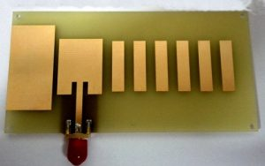

Fig. 4.1 Microstrip patch antenna

**CONSTRUCTION AND GEOMETRY OF MICROSTRIP PATCH ANTENNA:**

A microstrip patch antenna consists of a thin metallic patch of any shape on a dielectric slab whose other side is grounded. The thickness of the dielectric slab is from 0.03λ- 0.05λ.

The dimensions of the patch are in the range λ/3 to λ/2 with the dielectric of the slab varying from 2.2 to 12. The choice of substrate is limited by the RF or Microwave circuit coupled with the antenna that has to be built on the same board.

Microwave circuit and antenna are usually etched together using photo-etching technology.

**MICROSTRIP ANTENNA SPECIFICATIONS :**

The microstrip antenna specifications include the following.

* Its resonant frequency is 1.176 GHz.
* The frequency range of the microstrip antenna is from 2.26 GHz to 2.38 GHz.
* The substrate’s Dielectric constant is 5.9.
* The dielectric substrate’s height is 635um.
* The feeding method is a microstrip line feed.
* The loss tangent is 0.00 12.
* The conductor is silver.
* The thickness of the conductor is 25um.
* Its Bandwidth is fo ± 10 GHz.
* Its gain is above 5dB.

**CHARACTERISTICS OF MICROSTRIP PATCH ANTENNA:**

The major characteristic of microstrip is the radiating patch present on the grounded substrate. It is characterised by properties like light weight, low profile configuration, easy fabrication.The thickness of the substrate lies between 0.03λ- 0.05λ and we generally prefer thick substrate with low dielectric coefficient for better radiation efficiency.It shows both linear and circular polarization unlike microstrip dipole antenna which only shows linear polarization.It has flexibility in shape and can be of any shape like circular, elliptical, triangular, ring sector etc.,It has a narrow bandwidth typically around 5% particularly due to its constraint in size.Sometimes the coupling between the patch and the antenna can result in fringing where the waves begin to emit from edges of patch into space making the patch appear larger than its usual dimensions.

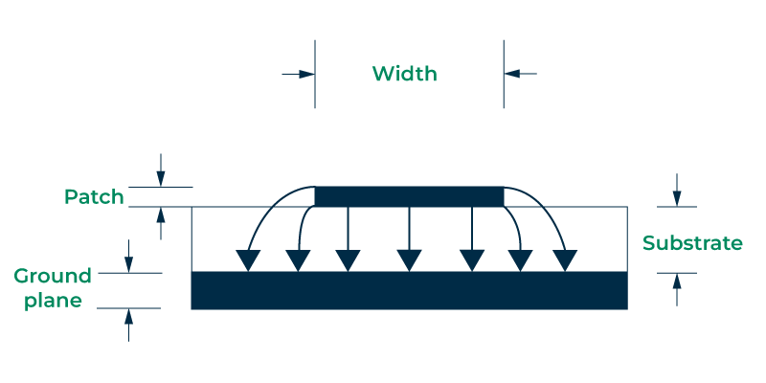

Fig. 4.2 Patch Antenna

**FEEDING METHODS OF MICROSTRIP PATCH ANTENNA:**

The microstrip antenna has two feeding methods; contacting feed and noncontacting feed which are discussed below.

**Contacting Feed:**

The power in contacting feed is provided directly to the radiating element. So this can be done with a coaxial line/microstrip. This type of feeding method is again classified into two types; Microstrip feed and coaxial feed which are discussed below.

**Microstrip Feed:**

Microstrip feed is a conducting strip with a very small width than the radiating element’s width. The feed line provides simple etching above the substrate because of the strip has thinner dimensions. The benefit of this type of feed arrangement is; that the feed can be etched on top of a similar substrate to offer a planar structure. The feed line toward the structure is provided either at the middle, offset, or inset. The main purpose of the inset cut within the patch is to match the impedance of the feed line’ to the patch without requiring any extra matching element.

**Coaxial Feed:**

This feeding method is the most frequently used type and is a non-planar feeding method where z co-axial cable is used for feeding the patch. This feeding method is given to the microstrip antenna in such a way that the inside conductor is directly connected to the patch whereas the external conductor is connected to the ground plane.

The impedance will change with the difference in the arrangement of the coaxial feed. Once the feed line is connected anyplace in the patch thus helps impedance matching. However, the feed line connecting throughout the ground plane is a bit hard because this will need drilling a hole within the substrate.

**Non-contacting Feed:**

The power is given to the radiating element from the feed line with electromagnetic coupling. These feed methods are available in three types; aperture coupled, proximity coupled, and branch line feed.

**Aperture Coupled Feed:**

The aperture feed technique includes two dielectric substrates like antenna dielectric substrate, & a feed dielectric substrate which are divided simply through a ground plane and have a gap in the middle. The metal patch is located above the substrate of the antenna whereas the ground plane is located on another face of the antenna dielectric. To provide isolation, the feed line and feed dielectric are located on another side of the ground plane.

This feeding technique provides an outstanding polarization purity which is unachievable by other feed techniques. Aperture couple feed provides high bandwidth and is extremely helpful in applications where we don’t want to utilize wires from single layer to another. The main drawback of this feeding technique is, it needs multilayer fabrication.

**Proximity Coupled Feed:**

Proximity-coupled feed is also called indirect feed where the ground plane is not present. As compared to an aperture-coupled feed antenna, it is very simple to manufacture. On the conductive face of the antenna, a slot is there & coupling is given with a microstrip line.

**Branch Line Feed:**

In the branch line feed technique, a conducting strip is directly connected to the patch edge of the microstrip. As compared to the patch, the width of the conducting strip is smaller. The main benefit of this feeding technique is; that the feed is etched on a similar substrate to give a planar structure.An inset cut can be integrated into the patch to get excellent impedance matching without the requirement of any extra matching element. This can be attained by controlling the inset position properly, otherwise, we can slice the slot & etch it from the patch with a suitable size. Furthermore, this feeding technique is utilized & called as branch line feed technique.

**ADVANTAGES:**

* It is Light weight, has low volume and thin profile configuration which makes it handy and conformal.
* Since it has low cost of fabrication ,it can readily be used for mass production at convenient cost.
* One can easily perform linear and circular polarization with microstrip antenna by applying a simple feed.
* This antenna can easily be integrated with microwave integrated circuits at industrial level.

**DISADVANTAGES:**

* They have a narrow frequency range. They are applicable in the GHz range (f > 0.5 GHz). For lower frequencies their dimensions become too large.
* They have relatively low efficiency due to dielectric and conductor loss.
* They witness relatively high level of cross-polarization radiation.
* They generate low power.
* There is presence of spurious waves which generate surface waves lowering the effective bandwidth.

**APPLICATIONS:**

* Microstrip antennas are applicable in different fields; in missiles, satellites, space crafts, aircraft, wireless communication systems, mobile phones, remote sensing & radars.
* These antennas have a small size, so used in microwave and satellite communication applications.
* GPS is one of the main benefits of microstrip antennas because it provides ease within vehicles & marines tracking.

**4.1.1 PATCH:**

In antenna engineering, a "patch" typically refers to a specific type of antenna element, commonly used in applications such as patch antennas or microstrip antennas.

A patch antenna consists of a metallic patch (often square, rectangular, circular, or some other geometric shape) mounted on a grounded substrate, typically made of a dielectric material like FR-4, ceramic, or Teflon. The patch is usually fed by a coaxial cable or a microstrip transmission line, which is connected to a feed point on the patch.

**STRUCTURES OF PATCH:**

* **Rectangular Patch:** This is one of the simplest and most common patch shapes. It consists of a rectangular metallic plate mounted on a dielectric substrate. Rectangular patches are easy to fabricate and can be designed to resonate at specific frequencies by adjusting their dimensions.
* **Circular Patch:** Circular patches have a circular shape and offer certain advantages over rectangular patches, such as broader bandwidth and symmetric radiation patterns. They are often used in applications where circular polarization or omnidirectional radiation patterns are desired.
* **Square Patch:** Similar to rectangular patches but with equal sides, square patches are also widely used in patch antenna designs. They offer simplicity in fabrication and can be used in applications where square or symmetrical radiation patterns are required.
* **Triangular Patch:** Triangular patches have a triangular shape and are less common compared to rectangular or circular patches. They can offer unique radiation characteristics and may be used in specialized applications where triangular or sectoral radiation patterns are desired.
* **Circular Sector Patch:** These patches have a circular shape but are divided into sectors. Circular sector patches can provide sectoral radiation patterns, making them suitable for applications such as wireless communication systems that require directional coverage in specific sectors.
* **H-shaped Patch:** H-shaped patches consist of a metallic structure resembling the letter "H" mounted on a dielectric substrate. They can offer improved bandwidth and radiation characteristics compared to simple geometric shapes like rectangles or circles.
* **E-shaped Patch:** E-shaped patches have a structure resembling the letter "E" and are designed to provide additional resonant modes, which can result in enhanced bandwidth and impedance matching.
* **Cross-shaped Patch:** Cross-shaped patches consist of a metallic structure resembling a cross or plus sign (+) mounted on a dielectric substrate. They can offer compact designs with multi-band or broadband characteristics.

These are just a few examples of structures used for patch antennas. The choice of patch structure depends on factors such as the desired operating frequency, bandwidth, polarization, radiation pattern, and physical constraints of the application. Each structure has its own advantages and limitations, and antenna designers select the most suitable structure based on the specific requirements of the application.

**FEATURES OF PATCH ANTENNA:**

* **Patch**: This is the metallic element that radiates or receives electromagnetic waves. It is usually made of a conductive material like copper or aluminum and is typically designed to resonate at the desired frequency of operation.
* **Substrate:** The patch is mounted on a dielectric substrate, which provides mechanical support and insulation. The substrate material and its dimensions affect the antenna's impedance, bandwidth, and radiation characteristics.
* **Ground Plane:** Beneath the substrate, there is usually a ground plane that provides a reference point for the antenna's radiation. This ground plane helps to improve the antenna's radiation pattern and efficiency.
* **Feed Mechanism:** The patch antenna is usually fed by a feed mechanism, such as a coaxial cable or a microstrip transmission line. The feed point is where the RF signal is introduced to the antenna, and its location can affect the antenna's impedance matching and radiation pattern.
* **Dielectric Layer:** In some designs, a dielectric layer may be added on top of the patch to improve bandwidth, reduce losses, or achieve other performance objectives.
* **Radiation Pattern**: The shape and size of the patch, as well as its proximity to the ground plane and other nearby structures, determine the antenna's radiation pattern, which describes how the antenna radiates electromagnetic energy into space.

Patch antennas are widely used in various applications due to their compact size, low profile, and relatively simple design. They are commonly found in wireless communication systems, RFID tags, GPS devices, and other applications where space and weight are limited.

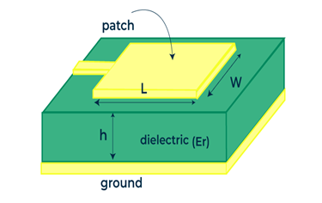

Fig. 4.3 Patch

**4.1.2 RECTANGULAR PATCH ANTENNA :**

A rectangular patch antenna is one of the most commonly used types of microstrip or patch antennas. It consists of a metallic patch in the shape of a rectangle mounted on a dielectric substrate, typically with a ground plane on the opposite side of the substrate.

Rectangular patch antennas are widely used in various wireless communication systems, including WiFi, Bluetooth, RFID, and satellite communication, due to their compact size, low profile, ease of fabrication, and relatively simple design. They are suitable for applications requiring moderate gain, directional radiation patterns, and operation at microwave frequencies.

A rectangular patch antenna is designed with the following specifications:

**PATCH:**

Length=38mm

Breadth=29.4mm

**SUBSTRATE:**

FR4 epoxy

Relative permittivity=4.4

**FEED:**

Strip feed.(Lumped Port)

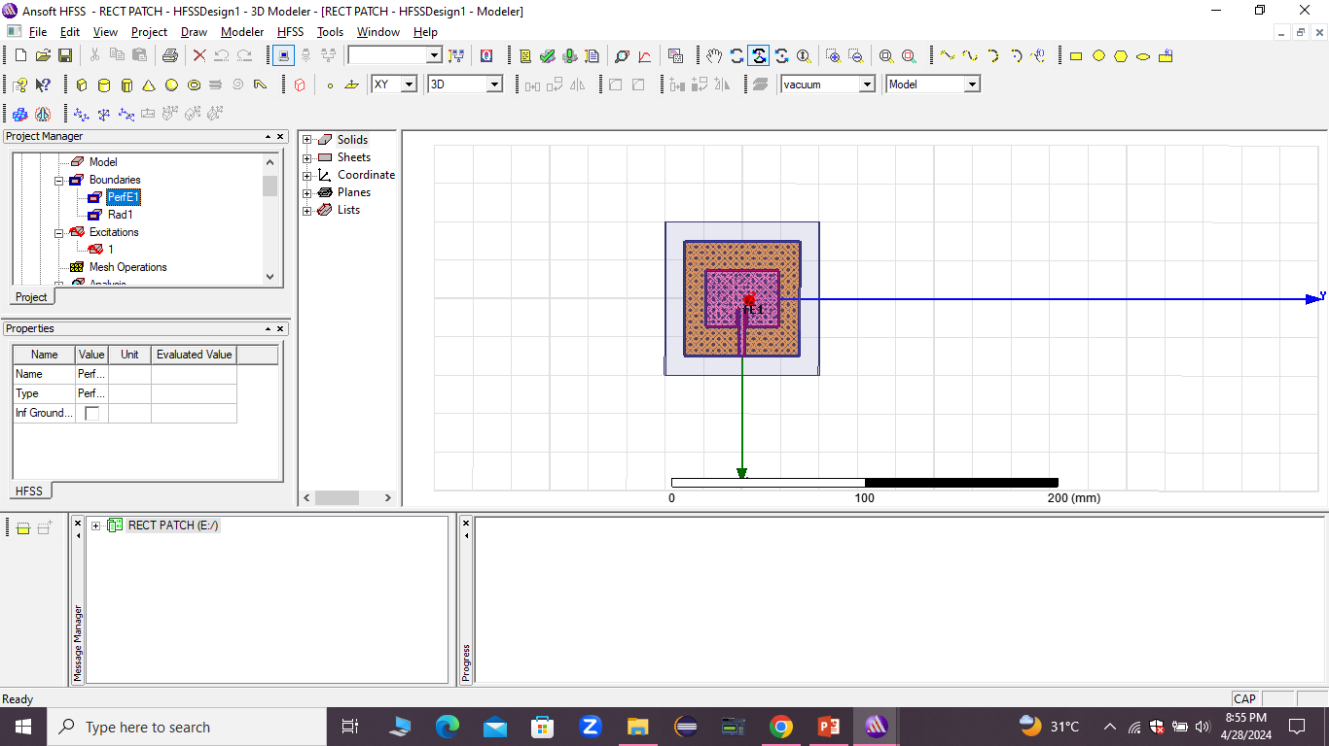 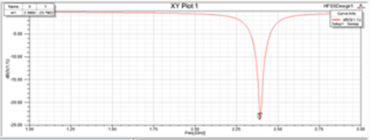

Fig. 4.4 Rectangular patch antenna with simulated results

**4.2 COPLANAR WAVEGUIDE**

A coplanar waveguide (CPW) is a type of transmission line used in microwave circuits, often employed in high-frequency integrated circuits (ICs) and radio frequency (RF) circuits. Unlike traditional waveguides, which are typically three-dimensional structures, CPWs are planar, meaning they lie in the same plane as the substrate on which the circuit is fabricated.

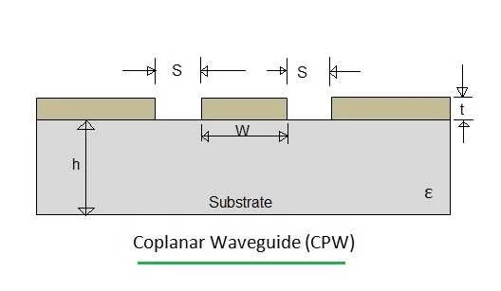

Fig. 4.1 Coplanar Waveguide

The structure of a coplanar waveguide consists of a central signal conductor flanked by two ground planes, with a certain spacing between them. The signal conductor is usually a metal strip or trace, and the ground planes are typically located on either side of the signal trace, with a gap between them. This configuration allows for controlled propagation of electromagnetic waves along the transmission line.

Coplanar Waveguide consists of a conductor strip at the middle and two ground planes are located on either sides of centre conductor. All these lie in the same plane.

In coplanar waveguide, EM energy is concentrated within the dielectric . The leakage of the Electromagnetic energy in the air can be controlled by having substrate height (h) twice that of the width (S).

**4.2.1 FEATURES OF COPLANAR WAVEGUIDE:**

* **Planar Structure**: CPWs are fabricated on the same plane as the substrate, making them compatible with integrated circuit fabrication processes.
* **Low Loss:** CPWs typically exhibit lower loss compared to other transmission line structures, such as microstrip lines, especially at higher frequencies.
* **Ease of Fabrication:** CPWs can be fabricated using standard lithography and etching techniques, making them relatively easy to integrate into microwave and RF circuits.
* **Wideband Performance:** CPWs can offer wideband performance, making them suitable for broadband applications.
* **Tunable Impedance:** The characteristic impedance of CPWs can be easily controlled by adjusting the dimensions of the transmission line, allowing for impedance matching in RF circuits.
* **Good Isolation:** The presence of ground planes on either side of the signal trace helps in reducing crosstalk and providing good isolation between adjacent transmission lines.

**4.2.2ADVANTAGES OF COPLANAR WAVEGUIDE:**

• Low dispersion

• Simple realisation due to etching on one side.

• Broadband performance, as it does not need via holes for shunt and series elements.

**4.2.3 DISADVANTAGES OF COPLANAR WAVEGUIDE:**

• Fabrication of coplanar waveguide is costlier. As gold ribbons are needed to suppress higher order modes at every quarter wavelengths

• Relative thick substrates are needed.

CPWs find applications in various RF and microwave circuits, including filters, amplifiers, mixers, and antennas, among others. They are particularly useful in high-frequency applications where low loss, wideband performance, and compact size are important considerations.

**4.3 ULTRA WIDE BAND ANTENNA**

Ultra-wideband is a radio technology used for a wide range of frequency channels and having low energy short-range. It is used for short-range wireless communication protocols like Bluetooth and Wi-Fi. It can work on a wide range of frequencies in which we can send short pulses of information at a moment. It is used to send information over a large range of bandwidth approximately 500MHz. It transmits information by generating radio energy for a span of time over a large bandwidth. Lower energy consumption allows transferring a large amount of data.

Ultra-wideband is a short-range, high bandwidth wireless technology that offers precise positioning and tracking and highly secure communications. It has become increasingly popular in light of its implementation in various mainstream devices.

Ultra-wideband (UWB) uses radio waves over a wide frequency bandwidth for short-range applications, with the term wideband being directly related to the 6-9GHz range of the spectrum. UWB is a direct connection between two devices that consists of radio wave bursts being transmitted and received; the amount and time it takes for these pulses to travel between the devices is then translated into data.

There are several types of antennas that can be used; however, the monopole antenna is the most widely used design. Either CPW-fed or microstrip-fed UWB monopole is the most prominent solution. UWB monopoles have been used extensively for the implementation of reconfigurable UWB antennas which are capable of filtering out the interfering signals that share parts of the 3.1–10.6 GHz, FCC designated UWB spectrum. Frequency notch bands can be created with the addition of resonators which can be implemented on either the radiator or the feeding line or even the RF ground segments. Quarter-wavelength open stubs, half-wavelength linear segments, half-wavelength slots, and more complex in shape resonators, such as CLLs or SRRs, have been successfully

**4.3.1 ULTRA WIDE BAND FREQUENCIES:**

Incorporating UWB into the design of devices can vary depending on region. As it occupies such a wide frequency band spectrum, there is a possibility that UWB can interfere with other telecommunication services occupying the same frequencies.

The Federal Communications Commission (FCC) of the United States has allocated a band covering of 7.5 GHz (3.1GHz to 10.6GHz) for the unlicensed use of UWB applications. In Europe, the Electronic Communications Committee (ECC) has allocated various frequency ranges of 3.1GHz – 4.8GHz, 6GHz – 8.5GHz, and 8.5GHz – 9GHz across most countries in the region. Other regions and countries vary in permitted frequency bands which must be taken into account when implementing UWB antennas into any design.

The designed antenna has an operating impedance ,**VSWR <=2** .

The designed antenna has a gain i.e **s11<= -10dB.**

**4.3.2 ULTRA WIDE BAND COMMUNICATION:**

Revolutionary advances in impulse technology and low power communication systems, along with the availability of unlicensed frequency bands, have made UWB the leading technology for short-range wireless communication. The inherent characteristics of UWB technology—such as high data rate, wide bandwidth, reduced fading from multipath, low cost, and low power consumption—make it useful for capturing highly accurate spatial and directional data.

UWB wireless communication transmits a huge amount of data over a wide frequency spectrum between 3.1 to 10.6GHz. UWB communication mainly uses low-powered radio signals of short pulses for the transmission and reception of data. UWB antennas enable the effective use of the bandwidth in high data rates—personal area network wireless connectivities, wide-range, low data rate communication, and radar and imaging systems.

**4.3.3 FEATURES OF UWB:**

* Devices using UWB require a high data rate.
* Communication through UWB has secure communication.
* Devices using UWB have robust communication and generally have large processing gain.
* UWB requires large bandwidth of 500 MHz which make it more accurate and fast and transfer one pulse per two nanoseconds.
* UWB devices have potentially high-density use.
* UWB wireless communication transmits a huge amount of data over a wide frequency spectrum.
* The replacement of multiple narrow-band antennas by a single UWB antenna reduces multi-antenna interference and saves antenna space.
* Omni-directional UWB antennas enable efficient communication between a transmitter and receiver in all directions.

**4.3.4 ULTRAWIDEBAND ANTENNA DESIGN:**

The overall performance of a UWB system is dependent on the design of the UWB antenna. UWB antenna design is influenced by the radiation pattern used in a communication system, and UWB antennas can be classified by this pattern. Two of these classifications are:

* **Directional radiation pattern** - In directional UWB antennas, the transmission and reception of signals with high power are confined to specific directions. The directional radiation pattern increases the performance of the antenna and reduces interference. A Vivaldi antenna is an example of a co-planar UWB antenna with a directional radiation pattern.
* **Omni-directional radiation pattern** - Omni-directional UWB antennas enable efficient communication between a transmitter and receiver in all directions. These types of antennas are suitable for indoor wireless communication and mobile devices. Other types of UWB antennas include log periodic, spiral, mono-conical, and biconical antennas.

**4.3.5 DESIGN CONSIDERATIONS OF ANTENNA FOR UWB TECHNOLOGY:**

Some of the main features required for antennas for the application of UWB technology as follows,

* It should have bandwidth ranging from 3.1 GHz to 10.6 GHz in which reasonable efficiency and satisfactory omnidirectional radiationpatterns are necessary.
* In this ultrawide bandwidth ,an extremely low emission power level should be ensured .In 2002,the Federal Communication Commission (FCC) has specified the emission limits of -41.3 dBm/MHz.
* The antenna propogates short pulse signal with minimum distortion over the frequency range.

**4.3.6 ADVANTAGES OF UWB:**

➨Low Power

➨Good noise immunity

➨Signals can penetrate variety of materials easily

➨high immunity to multipath fading

➨potentially very high data rates

Additionally, using UWB antennas eliminates the need for multi-narrow band antennas, as a single UWB antenna can satisfy different frequencies, transmission functions, and operation bands. This reduces multi-antenna interference and saves antenna space.

**4.3.7 DISADVANTAGES OF UWB:**

➨Higher cost.

➨Slower adoption rate.

➨Long signal acquisition times.

➨FCC has limited emission requirements which is less than 0.5 mWatt max power over 7.5 GHz band.

➨The UWB technology has issues of co-existence and interference with other radio based technologies.

**4.3.8 APPLICATIONS:**

Ultra-wideband antenna applications have become increasingly popular and widely used, partly due to the recent boom in wireless communication, wireless portable devices, and smart consumer electronics.

**4.4 NOTCH CHARACTERISTICS**

**4.4.1 DEFINITION:**

A notch in an antenna refers to a specific frequency range where the antenna's performance is significantly reduced or completely attenuated. This can be intentional, where the antenna is designed to operate optimally in certain frequency bands while attenuating or rejecting signals in other bands. Notches can be engineered into antennas for various reasons, such as to minimize interference from nearby frequency bands or to comply with regulatory requirements. In some cases, notches can also occur unintentionally due to design limitations or environmental factors.

**4.4.2 WAYS TO IMPLEMENT NOTCH:**

There are several ways in which notches can be implemented in antennas:

**Slot Notch:** A slot is cut into the conducting material of the antenna, creating a gap that disrupts the flow of electromagnetic waves at specific frequencies.

**Dielectric Loading:** Adding a dielectric material near certain parts of the antenna can alter its resonant frequency, effectively creating a notch at that frequency.

**Resonant Stub:** A small resonant structure, such as a stub or parasitic element, can be added to the antenna design to create a notch at its resonant frequency.

**Defected Ground Structure (DGS):** By introducing patterns or structures in the ground plane beneath the antenna, certain frequencies can be attenuated or rejected.

**Tunable Notch:** Some antennas incorporate components that allow for the tuning of notch frequencies, such as varactor diodes or switched capacitors.

**Printed Circuit Board (PCB) Techniques:** Notches can be created by manipulating the geometry of the antenna traces or by adding additional components directly onto the PCB.

**4.4.3 VARIOUS SHAPES OF NOTCH:**

Notches in antennas can be shaped in various ways to achieve specific frequency rejection characteristics or to fit the overall design requirements. Here are some common shapes of notches:

**Rectangular Notch**: A simple rectangular cutout or slot in the antenna structure, often used for broad frequency rejection.

**Circular Notch**: A circular cutout or slot, sometimes used for circularly polarized antennas or to target specific frequency ranges.

**Triangular Notch**: A triangular cutout or slot, which can provide sharper frequency rejection compared to rectangular notches.

**Curved Notch:** Notches with curved edges, which can offer smoother frequency response and better impedance matching compared to sharp-edged notches.

**Stepped Notch:** A notch with stepped edges, where the width of the notch varies in steps, allowing for more precise control over the notch frequency.

**Trapezoidal Notch:** A notch with trapezoidal shape, providing a compromise between the sharp rejection of triangular notches and the ease of fabrication of rectangular notches.

**Comb-Line Notch:** A series of parallel slots or elements arranged in a comb-like fashion, often used for notch filtering in array antennas.

**Crescent Notch:** A notch with a crescent-shaped cutout, offering a unique radiation pattern and frequency response.

**4.5 EXCITATION**

**4.5.1 WAVEPORT:**

A "waveport excitation" in the context of antennas typically refers to how electromagnetic waves are introduced into a simulation or analysis of an antenna structure. In numerical methods such as finite element method (FEM), finite difference time domain (FDTD), or method of moments (MoM), the physical antenna structure is represented mathematically, and excitation sources are used to simulate the input signal.

A waveport excitation specifies how the electromagnetic field is introduced into the simulation domain. This is crucial for accurately modeling how the antenna operates. The excitation can be defined in various ways depending on the simulation technique and the specific characteristics of the antenna being studied.

**TYPES OF WAVEPORT EXCITATION:**

**Voltage Source Excitation:**

This involves applying a voltage signal at the feed point of the antenna. In simulation software, this is often represented by applying a time-varying voltage waveform at the specified location.

**Current Source Excitation:**

Similar to voltage source excitation, but instead of applying a voltage, a current is injected into the antenna feed. This is commonly used in simulations where the antenna feed impedance is matched to the source impedance.

**Waveguide Excitation:**

In cases where the antenna is fed by a waveguide, the waveguide excitation specifies how the waveguide mode is excited. This could involve specifying the amplitude and phase of the waveguide mode at the interface with the antenna structure.

**Far-Field Excitation:**

In simulations where the antenna is excited by an incident electromagnetic wave, far-field excitation is used. This involves defining the incident electric and magnetic fields at the boundaries of the simulation domain.

**Feed Network Excitation:**

For antenna arrays or complex antenna structures with feed networks, the excitation may involve specifying the feeding network parameters, such as phase shifts and amplitude distributions.

The choice of waveport excitation depends on the specific requirements of the simulation and the characteristics of the antenna being studied. It's essential to select the appropriate excitation method to ensure accurate results.

**WAVEPORT IN HFSS :**

In ANSYS HFSS (High-Frequency Structural Simulator), a widely used electromagnetic simulation software, a "waveport excitation" refers to the method used to couple electromagnetic energy into the simulation domain. HFSS allows users to define waveport excitations at the boundaries of waveguide structures or antenna feeding regions.

**STEPS TO SET UP WAVEPORT EXCITATION IN HFSS:**

* **Define Waveport:** You first define a boundary where you want to excite the electromagnetic field. This boundary could be the aperture of a waveguide, the feed point of an antenna, or any other region where you want to couple energy into the simulation.
* **Excitation Type:** HFSS provides several excitation types, such as voltage source, current source, waveguide port, and far-field wave excitation. Choose the excitation type that best suits your simulation setup. For waveguide structures, you'd typically use the "Waveport" excitation.
* **Port Settings:** Once you select the waveport excitation type, you'll need to specify the port settings. This includes parameters such as port mode (TE or TM mode for waveguides), frequency, amplitude, phase, polarization, and impedance. These settings depend on the characteristics of your simulation and the type of excitation you're applying.
* **Boundary Conditions:** Ensure that appropriate boundary conditions are set for the waveport boundary. These conditions may include perfect electric conductor (PEC) or perfect magnetic conductor (PMC) depending on the type of boundary and the desired behavior of the simulation.
* **Solver Setup:** After defining the waveport excitation, you'll set up the solver options, such as frequency range, mesh settings, and solution setup parameters.
* **Simulation:** Once everything is set up, you can run the simulation to analyze the electromagnetic behavior of your structure with the specified waveport excitation.

Using waveport excitations in HFSS allows you to accurately model how electromagnetic energy is coupled into your simulation domain, whether it's through a waveguide, an antenna feed, or another coupling mechanism. It's essential to understand the principles behind waveport excitations and to properly configure them to obtain reliable simulation results.

**4.5.2 LUMPED PORT:**

Lumped port excitation is a technique used in antenna analysis and simulation, particularly in numerical methods like the Finite Element Method (FEM) or Method of Moments (MoM). In antenna simulations, particularly those involving complex structures, it's often impractical to simulate the entire antenna structure. Instead, engineers use simplified models where the antenna is divided into smaller segments, and each segment is represented by a lumped port.

A lumped port is a mathematical abstraction that represents the behavior of an antenna feed point or connection point in a simplified manner. It simplifies the analysis by reducing the complexity of the antenna structure to a few parameters like impedance, admittance, and excitation.

When using lumped port excitation:

* **Impedance Matching:** The lumped port is designed to match the impedance of the actual feed point of the antenna. This ensures maximum power transfer between the feeding network and the antenna.
* **Excitation:** The lumped port is excited with the desired signal or voltage source, representing the signal that would be applied to the antenna in real-world scenarios.
* **Simulation:** During simulation, the behavior of the entire antenna structure is approximated based on the responses of these lumped ports. This allows engineers to analyze the performance of the antenna without having to model every intricate detail of the structure.
* **Validation:** After simulation, the results obtained from the lumped port model are validated against real-world measurements or more detailed simulations to ensure accuracy.

Lumped port excitation is particularly useful when dealing with large or complex antenna structures, where modeling every detail would be computationally intensive and impractical. It strikes a balance between accuracy and computational efficiency, making it a valuable tool in antenna design and analysis.

**LUMPED PORT EXCITATION IN HFSS:**

In High-Frequency Structure Simulator (HFSS), lumped port excitation is a method used to simulate the excitation of antennas or other electromagnetic structures at specific points using lumped circuit elements.

**STEPS TO SET UP LUMPED PORT EXCITATION IN HFSS:**

* **Setup Geometry:** First, you create or import the geometry of your antenna or electromagnetic structure in HFSS.
* **Define Ports:** Identify the locations on your geometry where you want to apply excitation. These points are typically at the feed points of the antenna.
* **Create Lumped Ports**: In HFSS, you create lumped ports at these identified locations. A lumped port represents the interface between the electromagnetic field and the external circuitry. You specify the port properties such as its location, impedance, and excitation characteristics.
* **Define Excitation:** You specify the excitation signal or source that will be applied to the lumped port. This could be a voltage source, a current source, or other types of excitations depending on your simulation requirements.
* **Simulation Setup:** Configure the simulation settings such as frequency range, boundary conditions, and solver options.
* **Run Simulation:** Once everything is set up, you run the simulation in HFSS. The software solves Maxwell's equations and calculates the electromagnetic field distribution within the structure, including the effects of the lumped port excitations.
* **Analyze Results**: After the simulation completes, you can analyze various parameters such as S-parameters, radiation patterns, impedance matching, and far-field characteristics to evaluate the performance of your antenna or electromagnetic structure.

Lumped port excitation in HFSS allows you to simulate the behavior of antennas and other structures with precision, taking into account the effects of excitation and external circuitry. It's particularly useful for analyzing complex antenna designs and optimizing their performance for specific applications.

**4.6 BOUNDARY**

**4.6.1 RADIATION BOUNDARY:**

In the context of antennas, a radiation boundary refers to the region beyond which the radiated electromagnetic fields can propagate freely into space. It's essentially the boundary where the effects of the antenna's radiation become significant.

When we talk about radiation boundaries, we are often discussing the far-field region of an antenna. This region is characterized by the dominance of the radiated fields over the reactive fields (near-field) surrounding the antenna. In the far-field region, the electric and magnetic fields behave like waves, obeying the laws of radiation, such as the inverse square law.

Determining the radiation boundary is crucial for antenna design and analysis. It helps in understanding the antenna's radiation pattern, gain, and efficiency. In practical terms, for an antenna to operate effectively, the radiation boundary should extend well beyond the physical dimensions of the antenna itself. This ensures that the antenna's performance is not significantly influenced by nearby objects or structures.

**RADIATION BOUNDARY IN HFSS:**

In HFSS (High Frequency Structure Simulator), which is a popular electromagnetic simulation software developed by Ansys, the concept of a radiation boundary is essential for accurately modeling antennas and other RF/microwave structures.

In HFSS, the radiation boundary is typically referred to as the "far-field" boundary. It's the boundary beyond which the simulation assumes that the electromagnetic fields propagate freely into space without any significant reflections or interactions with the simulated structure. HFSS employs various techniques to define and handle the far-field boundary efficiently.

**IMPLEMENTATION OF RADIATION BOUNDARY IN HFSS:**

* **Far-Field Boundary Setup:** When setting up an HFSS simulation, you define the far-field boundary conditions. This involves specifying the distance from the antenna structure at which the far-field boundary is located. Typically, this distance is chosen to be far enough from the antenna so that the fields have fully transitioned into the far-field region.
* **Perfectly Matched Layers (PMLs):** HFSS often employs Perfectly Matched Layers at the far-field boundary. PMLs are absorbing boundary conditions designed to absorb outgoing waves efficiently without causing reflections back into the simulation domain. This helps mimic an open space condition beyond the far-field boundary.
* **Boundary Conditions:** HFSS allows you to specify boundary conditions at the far-field boundary to accurately represent the radiation characteristics of the antenna. For example, you can specify that the fields are radiating outward into free space, ensuring that the simulation accurately captures the antenna's radiation pattern and other performance metrics.
* **Mesh Refinement:** HFSS may automatically refine the mesh near the antenna structure to capture fine details accurately, especially in regions where the fields are rapidly changing, such as near edges or corners. This ensures accurate simulation results, particularly in the transition region between the near-field and far-field regions.

By properly defining the radiation boundary in HFSS simulations, engineers can accurately predict the performance of antennas and other RF/microwave structures, including characteristics such as radiation patterns, impedance matching, and antenna efficiency. This capability is crucial for optimizing antenna designs and ensuring their performance meets the desired specifications for various applications.

**4.6.2 PERFECT E BOUNDARY :**

In the context of antennas, the "E boundary" typically refers to the boundary conditions for the electric field 𝐸.

E at the surface of the antenna. Achieving a perfect electric field boundary condition can be crucial for optimizing the performance of an antenna.

A perfect electric field boundary condition implies that the electric field perpendicular to the surface of the antenna must be zero at the boundary. In practical terms, this means that any electric field that impinges on the surface of the antenna should not be reflected back but should instead be absorbed or transmitted effectively.

**METHODS TO ACHIEVE PERFECT E BOUNDARY:**

* **Absorptive materials:** Materials with high conductivity or specific absorptive properties can be placed around the antenna to absorb incident electromagnetic waves effectively, minimizing reflections.
* **Metamaterials:** Metamaterials are engineered materials with unique electromagnetic properties not found in nature. They can be designed to manipulate electromagnetic waves, including absorbing or redirecting them to achieve desired boundary conditions.
* **Surface treatments:** Surface treatments such as coatings or textures can be applied to the antenna surface to minimize reflections by altering the impedance at the boundary.
* **Graded index materials:** These materials have a continuously varying refractive index, which can be used to gradually change the impedance at the boundary and reduce reflections.
* **Frequency selective surfaces:** These surfaces are designed to reflect or transmit electromagnetic waves selectively based on their frequency. By appropriately designing the surface properties, reflections at specific frequencies can be minimized.

Achieving a perfect electric field boundary condition is often a trade-off between complexity, cost, and performance requirements. Engineers and antenna designers select the most suitable method based on the specific constraints and objectives of the antenna system.

**PERFECT E BOUNDARY IN HFSS:**

In ANSYS HFSS (High-Frequency Structure Simulator), achieving a perfect electric (P-E) boundary condition involves setting up the simulation environment in such a way that the electric field at the boundaries of the computational domain behaves as if it were an infinite free space. This is particularly important in ensuring accurate simulations of antennas and other electromagnetic structures.

To set up a perfect electric boundary condition in HFSS:

* **Boundary Setup:**

In HFSS, go to the "Boundary Setup" menu.Select the boundaries where you want to apply the P-E boundary condition. These are typically the outer boundaries of your simulation domain.

* **Boundary Type:**

Choose the appropriate boundary type. For a perfect electric boundary condition, you typically select "Perfect E" or "PEC" (Perfect Electric Conductor) boundary condition.

* **Solver Setup:**

Ensure that the solver settings are appropriate for accurately capturing the behavior of electromagnetic waves in your simulation. This includes setting the correct frequency range, mesh settings, and convergence criteria.

* **Verify Boundary Conditions:**

Before running the simulation, it's essential to verify that the boundary conditions are correctly applied. You can do this by inspecting the boundary settings in the HFSS project manager and visualizing the boundaries in the HFSS 3D editor.

By applying the perfect electric boundary condition in HFSS, you're essentially telling the simulation software to treat the boundaries as ideal conductors with zero tangential electric field components. This helps in simulating the behavior of antennas and other structures accurately, especially in scenarios where reflections from the boundaries could otherwise affect the results.

It's worth noting that while HFSS offers a "Perfect E" boundary condition for ideal electric conductors, achieving a truly perfect boundary condition in practice (i.e., perfectly absorbing all incident electromagnetic waves) is challenging and often involves additional considerations such as absorptive materials or advanced boundary treatments.

**CHAPTER – 5**

**EXISTING WORK**

The existing work contains the design of an UWB antenna with four notches.

**5.1 UWB ANTENNA:**

An ultra wide band antenna is designed as a microstrip patch antenna with the coplanar waveguide structure.

A coplanar waveguide (CPW) is a type of transmission line used in microwave circuits, often employed in high-frequency integrated circuits (ICs) and radio frequency (RF) circuits.

Coplanar Waveguide consists of a conductor strip at the middle and two ground planes are located on either sides of centre conductor. All these lie in the same plane.

The patch structure is formed by combining various geometrical shapes such as ellipse, rectangle and a triangle.

An ellipse is cut into half forming a half ellipse combined with a rectangular and triangular shape forms the patch of the design.

This antenna radiates in the entire ultrawideband region starting from3.1to10.6GHz .

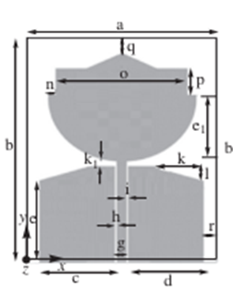

Fig. 5.1 UWB antenna

**5.2 NOTCH:**

A notch in an antenna refers to a specific frequency range where the antenna's performance is significantly reduced or completely attenuated. This can be intentional, where the antenna is designed to operate optimally in certain frequency bands while attenuating or rejecting signals in other bands. Notches can be engineered into antennas for various reasons, such as to minimize interference from nearby frequency bands or to comply with regulatory requirements. In some cases, notches can also occur unintentionally due to design limitations or environmental factors.

**5.2.1 NOTCH STRUCTURES:**

The notch characteristics is introduced by

* U shaped slot in the patch
* U shaped slot in ground 1
* U shaped slot in ground 2
* A split ring resonator at the back side of the antenna structure.

**5.2.2 STOP BANDS:**

1. 3.3 to 3.7GHz-WiMAX
2. 5.15 to 5.35GHz-WLAN1
3. 5.725 to 5.825GHz-WLAN2
4. 7.25 to 7.75GHz-X BAND

**5.2.3 NOTCH 1:**

**U-SHAPED SLOT ON THE PATCH:**

A "slot" in an antenna typically refers to a specific type of notch or gap deliberately introduced into the antenna structure. Slot antennas are antennas that are essentially an aperture in a conducting surface, usually metal. The slot can take various shapes, such as rectangular, circular, or other geometric forms.

A U shaped slot is introduced in the patch of the antenna for rejecting the specific frequency range 3.3 to 3.7 GHz –WiMAX which creates the first notch characteristics.

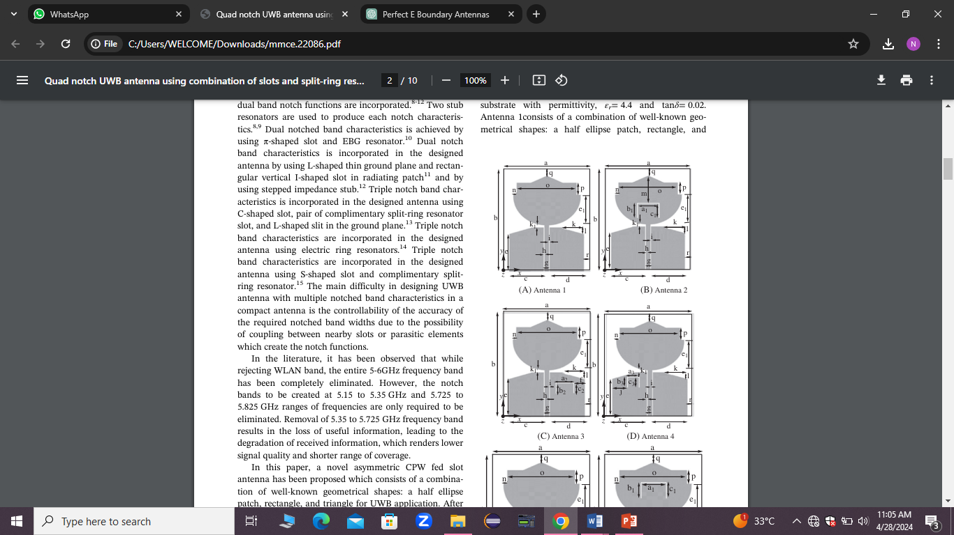

Fig.5.2 U-shaped slot on patch

**5.2.4 NOTCH 2:**

**U-SHAPES SLOT ON GROUND 2:**

A "slot" in an antenna typically refers to a specific type of notch or gap deliberately introduced into the antenna structure. Slot antennas are antennas that are essentially an aperture in a conducting surface, usually metal. The slot can take various shapes, such as rectangular, circular, or other geometric forms.

A U shaped slot is introduced in the ground 2 of the CPW for rejecting the specific frequency range 5.15 to 5.35 GHz –WLAN 1 which creates the second notch characteristics.



Fig. 5.3 U shaped slot on ground 2

**5.2.5 NOTCH 3:**

**U-SHAPED SLOT ON GROUND 1:**

A "slot" in an antenna typically refers to a specific type of notch or gap deliberately introduced into the antenna structure. Slot antennas are antennas that are essentially an aperture in a conducting surface, usually metal. The slot can take various shapes, such as rectangular, circular, or other geometric forms.

A U shaped slot is introduced in the ground 1of the CPW for rejecting the specific frequency range 5.725 to 5.825 GHz –WLAN 2 which creates the third notch characteristics.

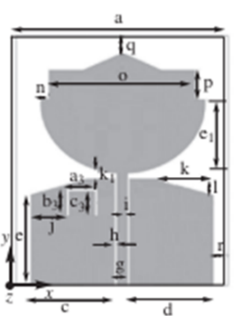

Fig. U shaped slot on ground 1

**5.2.6 NOTCH 4:**

**SPLIT RING RESONATOR:**

A Split Ring Resonator (SRR) is a type of metamaterial structure that exhibits resonant behavior at specific frequencies. In the context of antennas, SRRs are often used as a notch filter to suppress certain frequencies while allowing others to pass through.

A split ring resonator is placed on the back side of the antenna structure to reject the frequency range of 7.25 to 7.85 GHz –X band which forms the fourth notch characteristics.

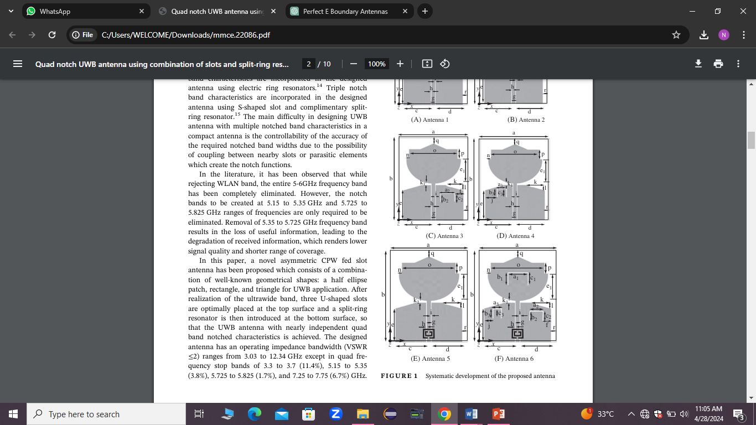

Fig 5.5 Split Ring Resonator

The above mentioned notch structures are incorporated with the basic UWB antenna to implement the notch characteristics.



Fig. 5.6 UWB with quad notch

**5.3 INFERENCE :**

The existing work contains a compact UWB antenna with quad notch band characteristics. Three U-shaped slots and a split-ring resonator are used to generate four notch bands, namely, WIMAX (3.3-3.7 GHz), lower WLAN (5.15-5.35 GHz), upper WLAN (5.725-5.825 GHz), and downlink of X-band satellite communication system (7.25-7.75 GHz).

**CHAPTER-6**

**PROPOSED WORK**

The proposed work contains the design of an UWB antenna with four notches.

**6.1 UWB ANTENNA:**

An ultra wide band antenna is designed as a microstrip patch antenna with the coplanar waveguide structure.

A coplanar waveguide (CPW) is a type of transmission line used in microwave circuits, often employed in high-frequency integrated circuits (ICs) and radio frequency (RF) circuits.Coplanar Waveguide consists of a conductor strip at the middle and two ground planes are located on either sides of centre conductor. All these lie in the same plane.

The patch structure is formed by combining various geometrical shapes such as ellipse, rectangle and a triangle. An ellipse is cut into half forming a half ellipse combined with a rectangular and triangular shape forms the patch of the design.

This antenna radiates in the entire ultrawide band region starting from 3.1 to 10.6 GHz.

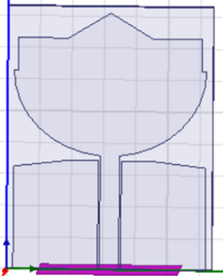

Fig.6.1 Basic UWB antenna

**6.2 NOTCH:**

A notch in an antenna refers to a specific frequency range where the antenna's performance is significantly reduced or completely attenuated. This can be intentional, where the antenna is designed to operate optimally in certain frequency bands while attenuating or rejecting signals in other bands. Notches can be engineered into antennas for various reasons, such as to minimize interference from nearby frequency bands or to comply with regulatory requirements. In some cases, notches can also occur unintentionally due to design limitations or environmental factors.

**6.2.1 NOTCH STRUCTURES:**

The notch characteristics is introduced by

* A U shaped slit in the patch
* A mushroom structure
* A rectangular slot in the patch and
* A split ring resonator

**6.2.2 STOP BANDS:**

1. 3.7 to 4.2GHz-C band.
2. 5.15 to 5.35GHz-WLAN1 .
3. 5.725 to 5.825GHz-WLAN2 .
4. 8.025 to 8.4GHz-X band.

**6.2.3 NOTCH 1:**

**U SHAPED SLIT ON THE PATCH:**

A "slit" in an antenna could refer to a cut or gap in the structure. In some cases, such slits or notches are intentionally designed into antennas for specific purposes, such as improving bandwidth, reducing interference, or achieving certain radiation patterns.

In the context of a microstrip antenna, a "slot antenna" might be mentioned, which has a slit or slot in the conducting material to alter its properties. These slots can change the electrical characteristics of the antenna, affecting its resonance frequency or radiation pattern.

A U shaped slit is introduced in the patch of the antenna for rejecting the specific frequency range **3.7 to 4.2GHz-C band.** which creates the first notch characteristics.

**RESONANT FREQUENCY( fr )OF THE U-SHAPED SLIT:**

**fr = (c/2(L1+L2+W)) (√2/€r+1)**

where ,

fr=resonant frequency

c = 3x10^8 m/s

€r=4.4

L1=length of one arm of the slit

L2=length of another arm of the slit

W=Width of the slit

**DIMENSIONS:**

|  |  |  |
| --- | --- | --- |
| S.NO. | PARAMETERS | DIMENSIONS(mm) |
| 1. | LENGTH OF ARM 1 | 8.35 |
| 2. | LENGTH OF ARM 2 | 8.45 |
| 3. | BREADTH | 7.99 |
| 4. | WIDTH | 4 |

TABLE 6.1 Dimensions of U – Shaped Slit

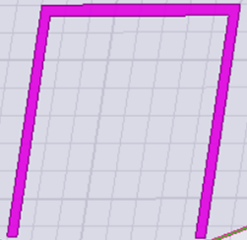

**6.2.4 NOTCH 2:**

**MUSHROOM STRUCTURE:**

The mushroom structure, also known as a mushroom-like EBG (Electromagnetic Band Gap) structure, is another method used in UWB antennas to create notches in the frequency response. The mushroom structure is a type of artificial magnetic conductor (AMC) that is often used to enhance the performance of antennas by suppressing surface waves or unwanted radiation in specific frequency bands.

Mushroom structure as a notch in a UWB antenna:

* **Operating Principle:** The mushroom structure consists of a periodic array of conducting patches (usually metallic) placed on top of a dielectric substrate. Beneath each patch, there's typically a via or pin connecting it to a ground plane.
* **Bandgap Creation:** The periodic arrangement of the conducting patches and the ground plane underneath creates a structure that exhibits electromagnetic bandgap (EBG) characteristics. This means that certain frequencies within the operating range of the antenna are prohibited from propagating through the structure, effectively creating a notch in the frequency response.
* **Notch Positioning**: By designing the dimensions and arrangement of the mushroom structure, its bandgap can be tailored to coincide with the frequency band that needs to be rejected. In the context of UWB antennas, this notch is often placed to suppress interference from specific frequency bands or harmonics.

A mushroom structure is introduced in the UWB antenna. This structure is formed by placing two square structures on the back side of the substrate and two connecting cylinders on the two grounds of the CPW . This creates the second notch rejecting the frequency range **5.15 to 5.35GHz-WLAN1.**

**RESONANT FREQUENCY (fr) OF THE MUSHROOM STRUCTURE:**

**fr=1/2π√(L(Co+C1))**

where,

fr=resonant frequency

L= inductance

Co=coupling capacitance between mushroom structure and feedline

C1=capacitance due to voltage gradients between patch and ground plane.

**DIMENSIONS:**

|  |  |  |
| --- | --- | --- |
| S.NO. | PARAMETERS | DIMENSIONS(mm) |
| 1. | SIZE OF THE SQUARE | 4.5 |
| 2. | RADIUS OF THE CYLINDER | 0.2 |
| 3. | HEIGHT OF THE CYLINDER | 1.6 |

TABLE 6.2 Dimensions of Mushroom Structure

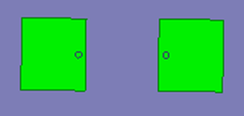

**6.2.5 NOTCH 3:**

**RECTANGULAR SLOT:**

A "slot" in an antenna typically refers to a specific type of notch or gap deliberately introduced into the antenna structure. Slot antennas are antennas that are essentially an aperture in a conducting surface, usually metal. The slot can take various shapes, such as rectangular, circular, or other geometric forms.

**FEATURES:**

* **Radiation Pattern**: Slot antennas radiate electromagnetic waves in a pattern determined by the shape and dimensions of the slot. This radiation pattern can be adjusted by modifying the slot dimensions
* **Bandwidth:** Slot antennas often offer wide bandwidth performance, making them suitable for applications where a broad range of frequencies need to be covered.
* **Design Flexibility**: Slot antennas provide designers with flexibility in terms of size, shape, and orientation, allowing for optimization based on the specific requirements of the application.

A rectangular slot is introduced (cut) in the patch of the antenna to reject the frequency range **5.725 to 5.825GHz-WLAN 2** which creates the third notch characteristics.

**DIMENSIONS:**

|  |  |  |
| --- | --- | --- |
| S.NO. | PARAMETERS | DIMENSIONS(mm) |
| 1. | LENGTH | 15 |
| 2. | BREADTH | 1 |

TABLE 6.3 Dimensions of Rectangular Slot



**2.6 NOTCH 4:**

**SPLIT RING RESONATOR:**

A Split Ring Resonator (SRR) is a type of metamaterial structure that exhibits resonant behavior at specific frequencies. In the context of antennas, SRRs are often used as a notch filter to suppress certain frequencies while allowing others to pass through.

SRR as a notch in a UWB antenna:

* **Resonant Behavior:** The SRR is designed to resonate at a specific frequency or range of frequencies. This resonance occurs due to the interaction between the electric and magnetic fields within the structure.
* **Notch Filter:** By placing the SRR within the antenna design, it can be tuned to resonate at frequencies where attenuation is desired. This creates a notch in the antenna's frequency response curve, effectively suppressing signals within that frequency band.
* **Frequency Selectivity:** The dimensions and properties of the SRR determine the frequencies at which it resonates. By adjusting these parameters, the notch frequency can be tailored to match the frequency band that needs to be rejected.
* **Interference Rejection:** In UWB applications, where interference from other wireless devices or environmental sources can be significant, the notch provided by the SRR helps improve the antenna's performance by rejecting unwanted signals.
* **Design Optimization:** Integrating an SRR into a UWB antenna design requires careful optimization to ensure that it achieves the desired notch characteristics without adversely affecting other aspects of antenna performance, such as impedance matching or radiation efficiency.

Overall, incorporating a Split Ring Resonator as a notch filter in a UWB antenna is a common technique to improve the antenna's performance in crowded electromagnetic environments and ensure reliable communication over a wide frequency range.

The electromagnetic coupling of the SRR with the CPW yields the frequency notch.

A split ring resonator is placed on the back side of the substrate to reject the freq range of **8.025 to 8.4GHz-X** band which forms the fourth notch characteristics.

**RESONANCE FREQUENCY (fo )OF THE SPLIT RING RESONATOR:**

**fo=(1/2π)(√(1/LtCe))**

where,

fo=Resonance frequency .

Ce=Total equivalent capacitance of the structure .

Lt=Total equivalent inductance .

**DIMENSIONS:**

|  |  |  |
| --- | --- | --- |
| S.NO. | PARAMETERS | DIMENSIONS(mm) |
| 1. | SIZE OF THE SQUARE | 4.2 |
| 2. | Cr | 0.6 |
| 3. | Dr | 0.3 |
| 4. | S | 0.5 |
| 5. | gr | 0.7 |

TABLE 6.4 Dimensions of Split Ring Resonator

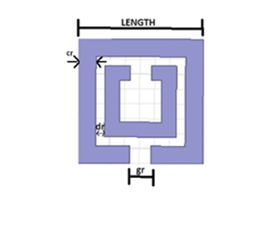

**6.3**  **SIMULATED RESULTS**

**6.3.1 BASIC UWB ANTENNA STRUCTURE:**

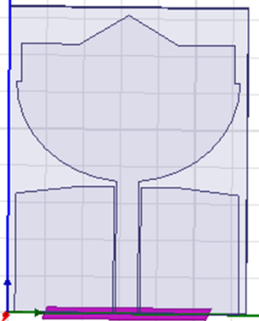

Fig. 6.2 Basic UWB Antenna

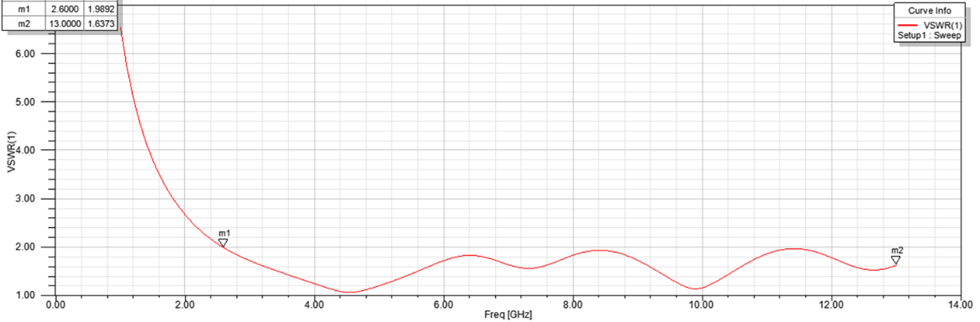

Fig. 6.3 Simulated Result of Basic UWB Antenna

**6.3.2 NOTCH STRUCTURES WITH SIMULATED RESULTS:**

**NOTCH 1 - U-SHAPED SLIT:**

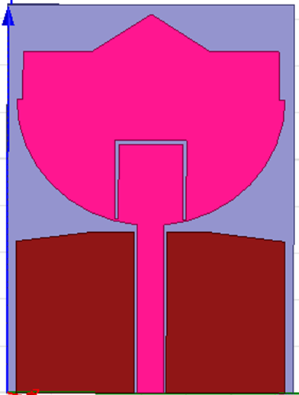

Fig 6.4 U-Shaped Slit

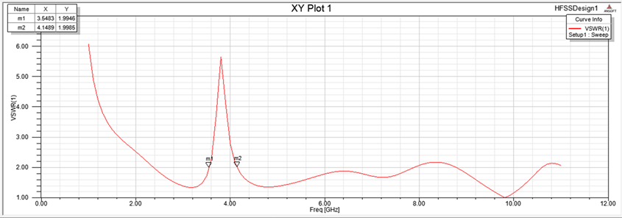

Fig. 6.5 Simulated Result of U-Shaped Slit

**NOTCH 2- MUSHROOM STRUCTURE:**

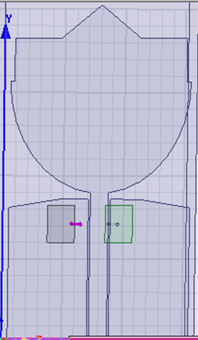

Fig. 6.6 Mushroom Structure

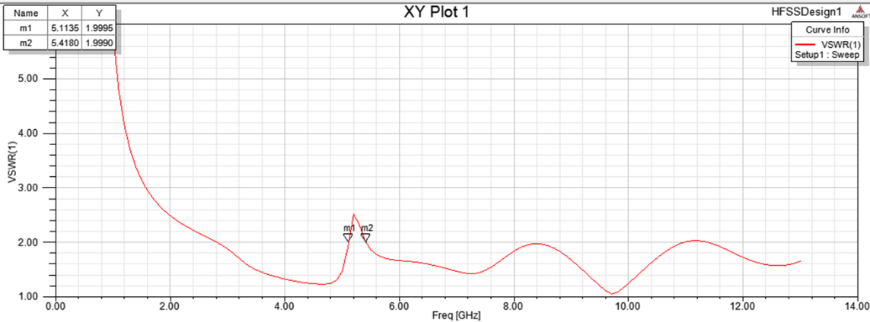

Fig. 6.7 Simulated Result of Mushroom Structure

**NOTCH 3 –RECTANGULAR SLOT:**

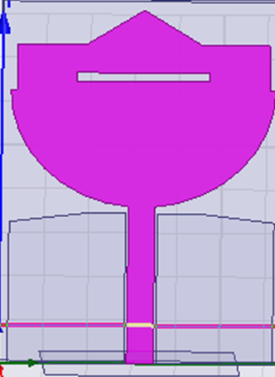

Fig. 6.8 Rectangular Slot

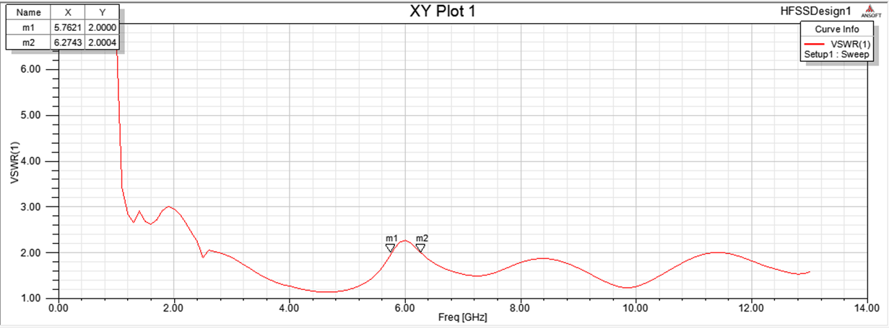

Fig. 6.9 Simulated Result of Rectangular Slot

**NOTCH 4 - SPLIT RING RESONATOR:**

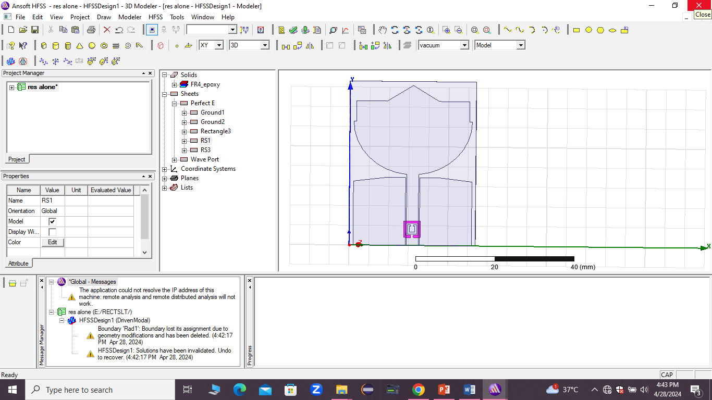

Fig.6.10 Split Ring Resonator

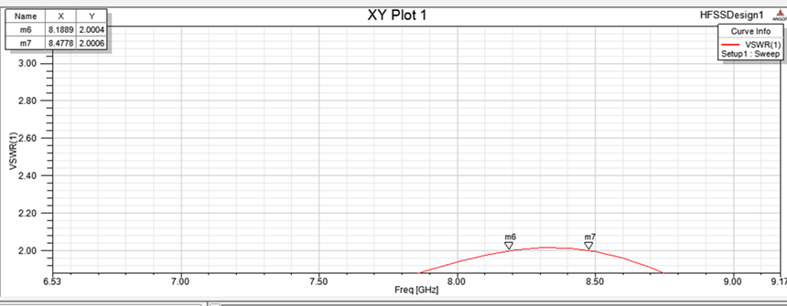

Fig.6.11 Simulated Result of Split Ring Resonator

**QUAD NOTCH UWB ANTENNA:**

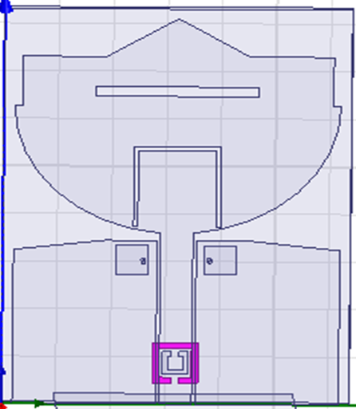

Fig. 6.12 Quad Notch UWB Antenna

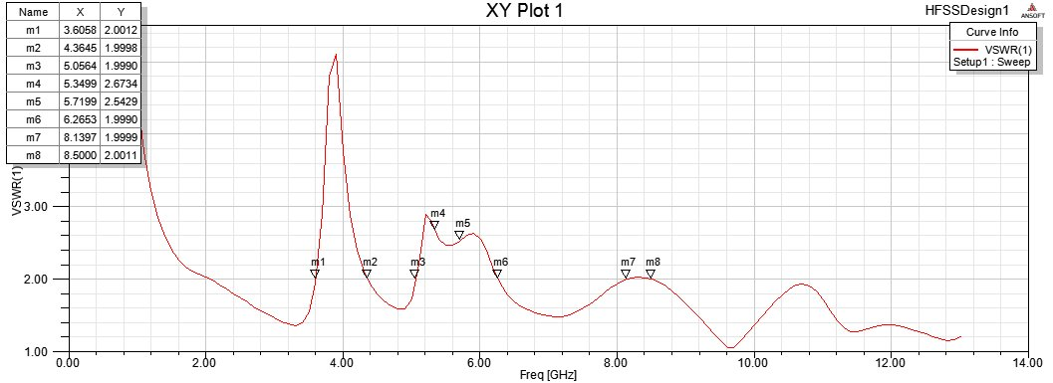

Fig.6.13 Simulated Result of Quad Notch UWB antenna

**6.3.3 RADIATION PATTERN OF QUAD NOTCH UWB ANTENNA:**

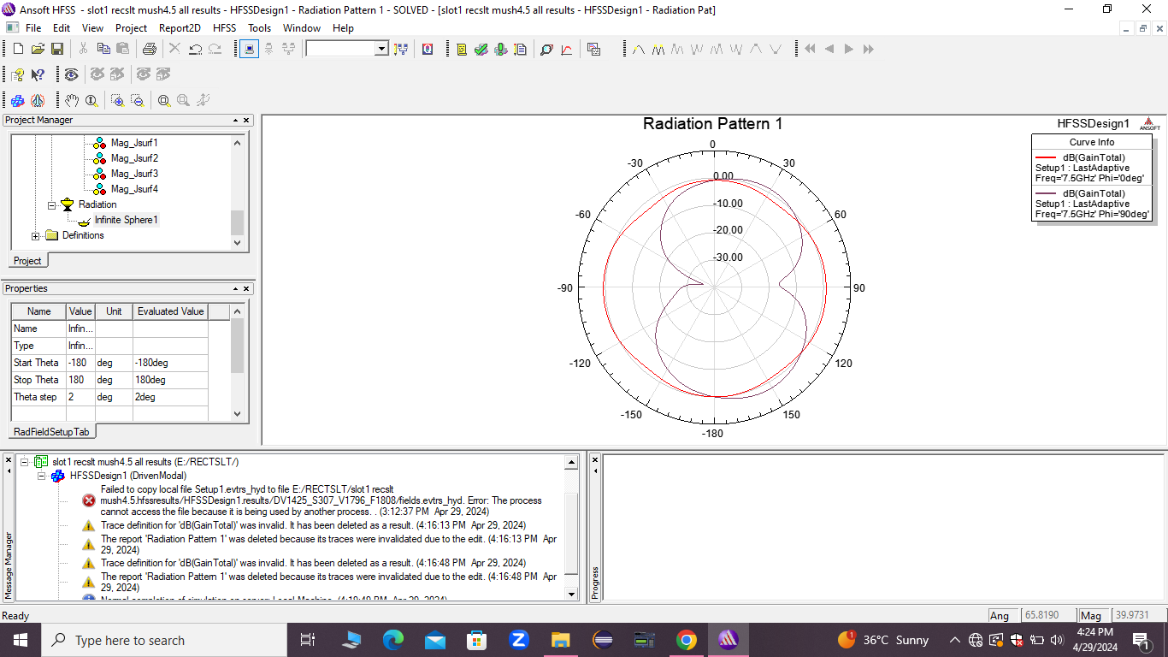

Fig. 6.14 Radiation pattern

**6.3.4 GAIN PLOT(s11):**

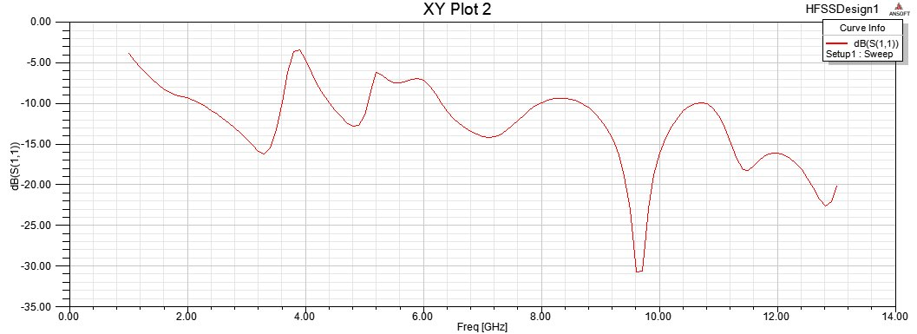

Fig. 6.15 Gain plot

**6.3.5 GROUP DELAY PLOT:**

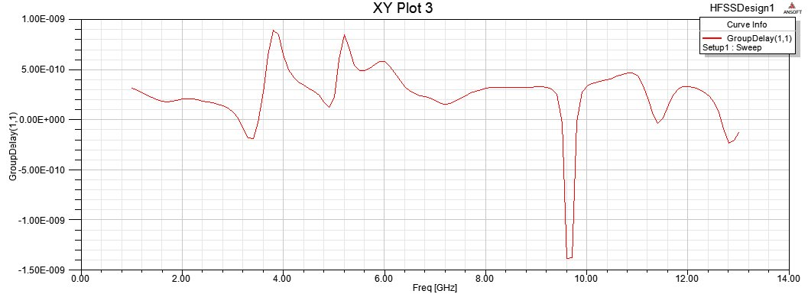

Fig. 6.16 Group Delay Plot

**6.3.6 CURRENT DISTRIBUTION PLOT:**

**CURRENT DISTRIBUTION OF NOTCH 1 (U-SHAPED SLIT):**

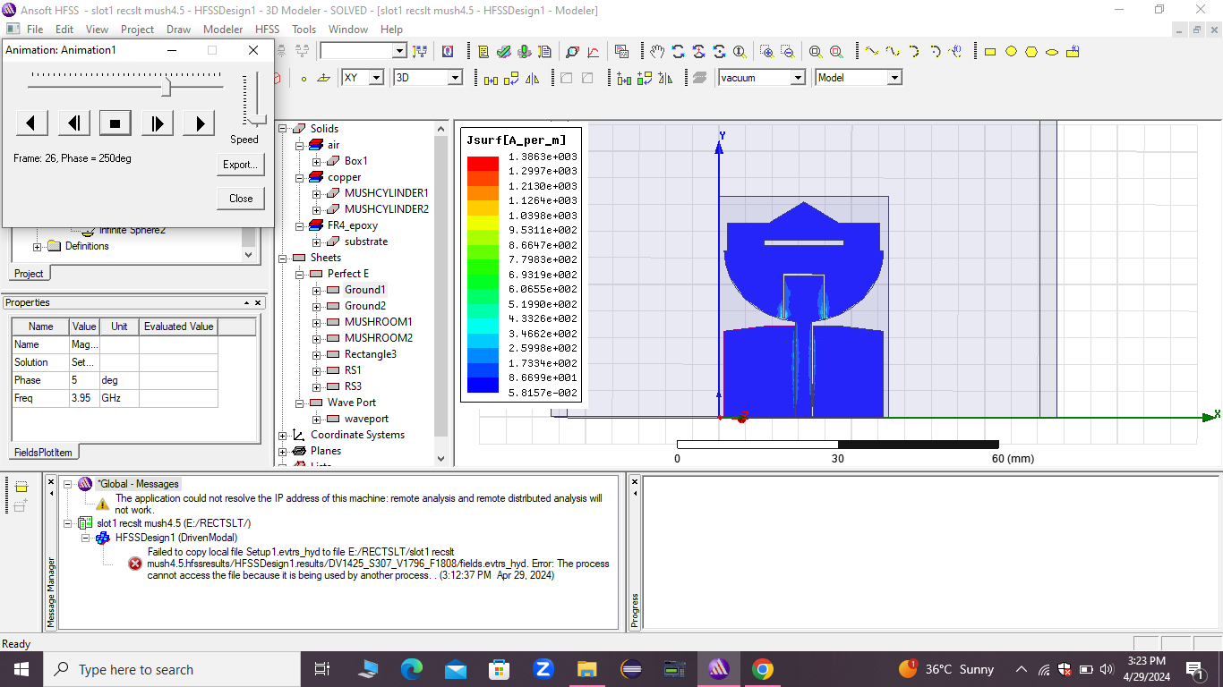

Fig. 6.17 Current Distribution of Notch 1

**CURRENT DISTRIBUTION OF NOTCH 2 (MUSHROOM):**

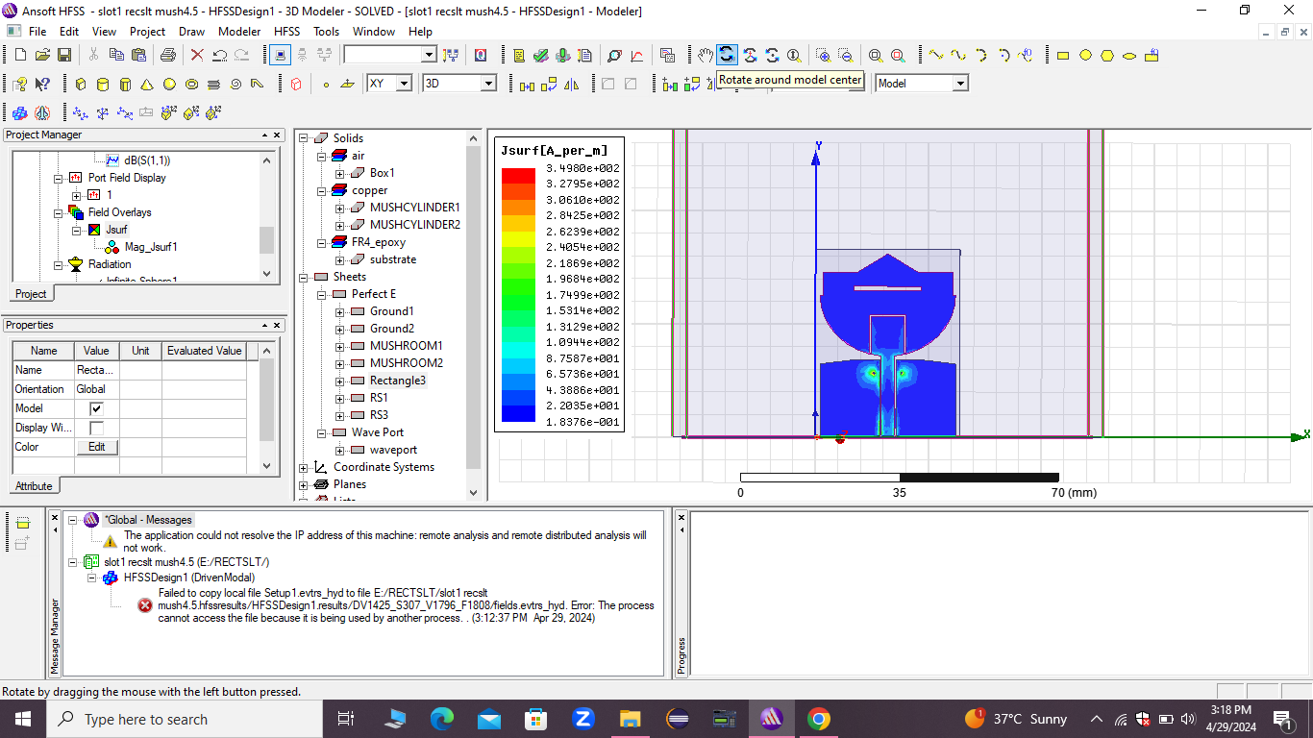

Fig. 6.18 Current Distribution of Notch 2

**CURRENT DISTRIBUTION OF NOTCH 3 (RECTANGULAR SLOT):**

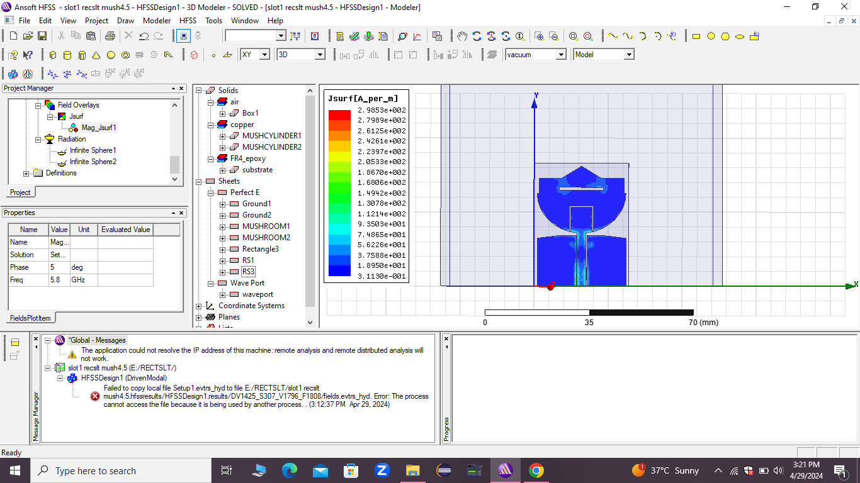

Fig. 6.19 Current Distribution of Notch 3

**CURRENT DISTRIBUTION OF NOTCH 4 (SRR):**

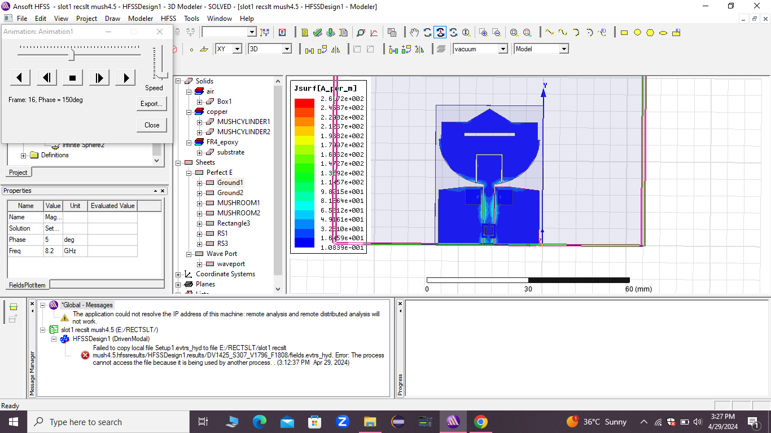

Fig. 6.20 Current Distribution of Notch 4

**CHAPTER -7**

**CONCLUSION AND FUTURE WORK**

In conclusion ,our proposed work Quad Notch UWB Antenna design used structures such as U-Shaped slit, mushroom structure, rectangular slotand split ring resonator to introduce the notch characteristics i.e Quad Notch.

The designed antenna radiates in the entire UWB spectrum except the four notch bands.

The stop bands are:

1. 3.7 to 4.2GHz-C band
2. 5.15 to 5.35GHz-WLAN 1
3. 5.725 to 5.825GHz-WLAN 2
4. 8.025 to 8.4GHz-X band

**FUTURE WORK:**

The future work of this paper may be the design of an extra notch in the existing antenna which forms a penta notch UWB antenna.

**CHAPTER - 8**

**REFERENCES**

1. “First report and order ,Revision of part 15 of the commission’s rule regarding ultra wideband transmission system FCC 02-48” .Federal communications Commission;2002.

2. “Branch Sr Band notched elliptical slot UWB microstrip antenna with elliptical stub filled by the H shaped slot” .J *Electromagn Waves* Appl.2008;2:1993-2002.

3.Kim KH,Park SO. “Analysis of the small band rejected antenna with the parasitic strip for UWB” .IEE Trans Antennas Propag.2006;54(6):1688-1692.

4.Thomas KG Sreenivasan M . “A simple ultrawideband planar rectangular printed antenna with band dispensation” *.IEEE Trans Antenna Propag* .2010;58(1):27-34.

5.Xu KD ,Zhang HY ,Spiegel RJ,Fan Y ,Joines WT ,Liu QH. “Design of a stub loaded ring resonator slot for antenna applications”. *IEEE Trans Antennas* *Propag*.2015;63(2):517-524.

6.Manohar M Kshetrimayum RS ,Gogoi AK . “A compact dual band notched circular ring printed monopole antenna for super wideband applications”.Radio-Eng.2017;26(1):64-70.

7.Peddakrishna s,Khan T. “Design of UWB monopole antenna with dual notched band characteristics by using p shaped slot and EBG resonator .” *AEU Int J Electron Commun*.2018;96:107-112.

8.Li,Y,Li W,Mitra R. “Miniaturized CPW fed UWB Antenna with dual frequency rejection bands using stepped impedance stub and arc shaped parasitic element.”*Microw Opt Technol Lett 2014.*

9.Vendik IB,Rusakov A,Kanjanasit K,Hong J,Filonov D. “Ultra wide band planar antenna with single,dual and triple band notched characteristic based on electric ring resonator”. *IEEE Trans Antennas Wirel Propag lett*.2017;16:1597-1600.

10.Yadav et al. “SRR and S Shaped slot loaded triple band notched UWB antenna*”. AEU Int J Electron commun* 2017;79:192-198.

11.Sidiqui JY Saha C ,Antar Y ,Yahia MM. “Compact SRR;loaded UWB Circular monopole antenna with frequency notch characteristics.” *IEEE Trans Antennas Propag*.2014;62(8):4015-4020.

12.Marques R. Martin F,Sorolla M. “*Metamaterials with Negative parameters:* Theory,*Design and Microwave Applications*”. New Jersey:John Wiley&Sons;2011.

13*.Saha C,Sidiqui J Antar Y. “Mulifunctional Ultra wideband antenna:Trends,techniques and application.”Boca Raton:CRC Press;2016.*

14.Mrinmoy Chakraborty,Sriknta Pal,Neelaj Chattoraj “Quad notch uwb antenna using combination of split ring resonator and slots.”2019.

15.Federal Communication Commission,Revision of part 15 of the commission’s rules regarding ultra -wide-band transmission systems first report and order FCC 02.V48(2002),Washington,DC,Tech.Rep.Srivastava G., Dwari S., Kanaujia K (2014).A compact Triple Band Notch Circular Ring Antenna for UWB Applications. *Microwave and optical Technology letters*,57(3).668-672.

16. Kumar A., Shanmuganantham T. (2014). A CPW fed Octagonal Patch UWB Antenna with WiMAX Band-Notched Characteristics*. International* *Conference on Information Communication & Embedded* *Systems,*doi:10.1109/ICICES.2014.7034023.

17. Fazal A.S., Nasir U., Alimgeer K.S., Shafique M. F., Shubair R.M., Saeed Khan M. (2017). A Compact UWB CPW-fed Antenna with Inverted L- Shaped Slot for WLAN Band Notched Characteristics*. European Conference on* *Antennas & Propagation*, 981-984.

18. Jacob S., V.A.P., Mridula S., Mohanan P. (2014). CPW-FED UWB Antenna with WiMAX Band-Notched Characteristics*. International Journal of* *Research in Engineering & Technology*, 3 (15), 52-56.

19.Nejatijahromi M., Rahman M. U., M. Naghshvarianjahromi. (2018). Continuously Tunable WiMAX Band-Notched UWB Antenna with Fixed WLAN Notched Band. Progress *In Electronics Research Letters*,75, 97- 103.

20.Prashanth K.V., Tejasri A., Sandeep K., Kumar U.S., Swarupa G. (2018). Design of UWB Antenna with WLAN & X-Band Notch for Wireless Communication. *International Journal of Engineering &* *Technology*,7(2,7),484-488.

21.Yadav D., Abegaonkar M.P., Koul S.k., Tiwari V., Bhatnagar D. (2018). A Monopole Antenna with Reconfigurable Notched Characteristics from WLAN-Band Notched UWB to ITU-Band Notched UWB Antenna. *Optical & Wireless Technology, Springer, 647-654,* Doi: 10.1007/978-981-10-7395-3_72*.*

22.Aldhaheri R.W., Babu KJ, Syed A., M.M. Sheikh. (2015). A Novel UWB Rectangular Slot Disk Monopole Antenna with Band-Notch Characteristics. *Microwave & Optical Technology Letters*, 57(10).

23. Singh K.M.J., Mishra R. (2017). Design of A Circular Microstrip Patch Antenna with Single Band Notch Characteristic for UWB Applications. IEEE International WIE Conference on Electrical and Computer Engineering, pp. 262-265.

24. Yadav S., Gautam A.K., Kanaujia B.K. (2016). Design Of Miniaturized Single Band-Notch Micro Strip Antenna With Enhanced UWB Performance. *Microwave & Optical Technology Letters*, 58 (6), 1494-1499.

25. Zhu X.F., Su D.L. (2010). Symmetric E-Shaped Slot for UWB Antenna with Band-Notched Characteristics. *Microwave & Optical Technology Letters,* 52 (7)

26.Bhattacharya A., Roy B., Chowdhury S.K., Bhattacharjee A.K. (2017). Compact Slotted UWB Monopole Antenna with tuneable band-notch characteristics*. Microwave & Optical Technology Letters*, 59(9), 2358- 2365.

27. Jha P.N., Singh B.A., S. Thakur (2016). Compact Printed Single Band- Notched Characteristics Square-Shape UWB Antenna IEEE International Conference on Global Trends in Signal Processing Information Computing & Communication, 607-610, Doi: 10.1109/LAPC.2009.5352396.

28. Yao L., Xiao J., Zhu H., Li N., Li X. (2016). A High Gain UWB Vivaldi Antenna with Band Notched Using Capacitively Loaded Loop (CLL) Resonators. IEEE International Conference on Microwave and Millimeter Wave Technology, Doi: 10.1109/ICMMT.2016.7762454.

29. Xu B., Zhao Y., Zheng Y., Gu L. (2017). WLAN Wideband-Notched UWB Slot Antenna using I-shaped MTM IEEE International Symposium on Antennas & Propagation & USNC/URSI Nat. Radio Sci. Meeting, 1783-1784, Doi: 10.1109/APUSNCURSINRSM.2017,8072934

30.Ruchandani K., Kumar M. (2016). A Novel CPW Fed Octagonal Aperture UWB Antenna with 5 GHz/ 6 GHz Band Rejection by H Shaped Slot. IEEE International Conference on Computer Communication and Control