# AI Automation Workflows using n8n + OpenAI

This document showcases two intelligent automation use cases built using n8n integrated with OpenAI APIs and Pinecone vector database. These workflows are designed to deliver high-value business automation with minimal manual effort.

## Use Case 1: RAG Pipeline with AI Chatbot Integration

An end-to-end automated pipeline was created to turn uploaded documents into a knowledge base accessible by a chatbot. The workflow consists of:

* - 📥 **Trigger**: File uploaded to Google Drive automatically triggers the pipeline.
* - 🧠 **Text Embedding**: Document is preprocessed, split, and converted into vector embeddings using OpenAI.
* - 🗄️ **Storage**: Embeddings are stored in Pinecone, a managed vector database.
* - 💬 **Chatbot**: On user input, chatbot retrieves the most relevant chunks using RAG and responds contextually.

✅ **Outcome**: A smart AI chatbot capable of contextual responses using custom documents. Perfect for internal documentation access, support automation, and knowledge delivery at scale.

## Use Case 2: Talent Inquiry & Customer Support via Gmail

A fully automated workflow for classifying and responding to emails related to talent acquisition or customer queries. Key steps include:

* - 📬 **Trigger**: Gmail monitors incoming emails in real time.
* - 🧠 **Classification**: Email content is analyzed using OpenAI and categorized as 'Talent Inquiry' or 'Other'.
* - 📌 **RAG Response**: For talent queries, the agent retrieves candidate context from Pinecone and generates a detailed reply.
* - 🏷️ **Gmail Actions**: Labels are applied to emails, and replies are automatically sent.

✅ **Outcome**: Eliminates manual email triage. Instantly handles hiring inquiries and customer emails with intelligent, accurate replies — saving time and boosting efficiency.

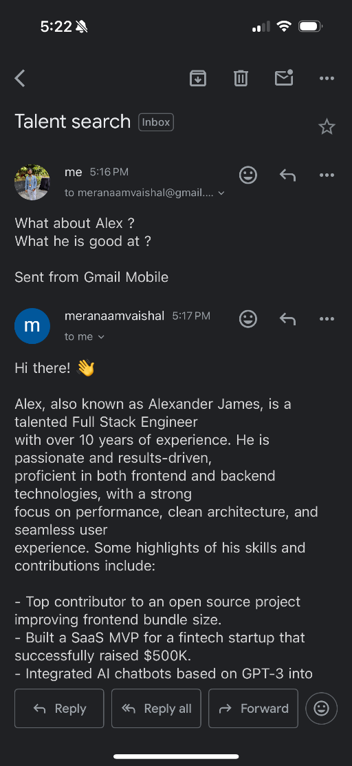

## Conclusion

Both workflows demonstrate advanced automation capabilities using n8n, OpenAI, and Pinecone. By integrating Retrieval-Augmented Generation (RAG) into business workflows, we achieve faster, context-aware decisions with minimal manual effort.

**Vaishal Shah**