# MYSQL – ASSIGNMENT -2

1. Retrieve the details (Name, Salary and dept no) of the emp who are working in department code 20, 30 and 40.

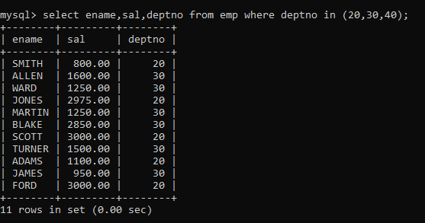

1. Display the total salary of all employees . Total salary will be calculated sal+comm+sal*0.10

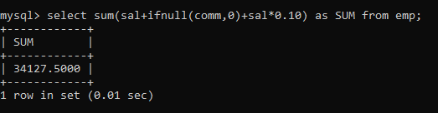

1. Find 3rd highly paid employee

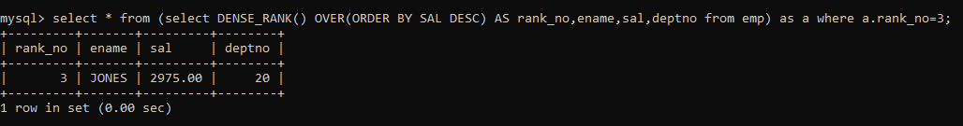

1. Find employee who has earned highest commission

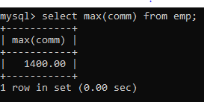

1. List all employees who joined in September.

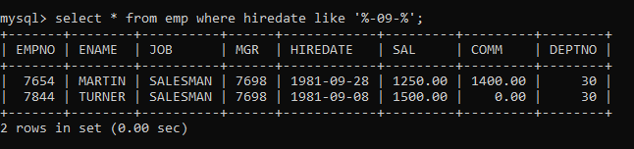

1. Display the employee details who joined on 3rd of any month or any year

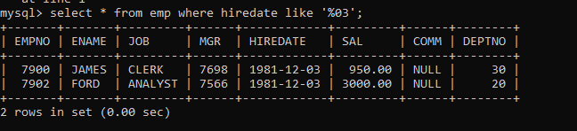

1. Get the Department number, and sum of Salary of all non managers where the sum is

greater than 20000.

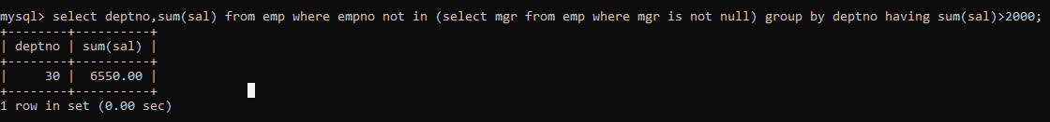

1. List the empno, name, and department number of the emp who have experience of 18 or more years and sort them based on their experience.

