# LAB-4&5

Write SQL statement for the following

1. To find all managers with salary >1500

2. list all employees with sal >1200 and < 2000

2. list all employees with sal is 1600 or sal is 800 or sal is 1900

4. list all employees with R at second last position in name

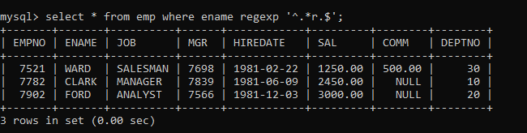

5. List all employees with name starts with A and ends with N

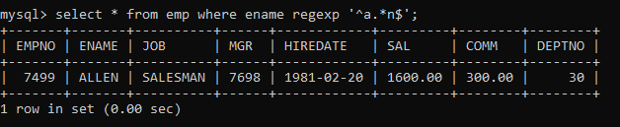

Q2. Solve following

1. list all employees with salary > 1250 and dept no=30

2. list all employees with salary >=1250 and <= 3000

3. list all employees with salary >1250 and < 3000

4. list all employees with salary either equal to 3000 or 1250 or 2500

5. list all employee with name=SMITH

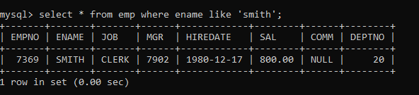

6. list all employees with name starting with S

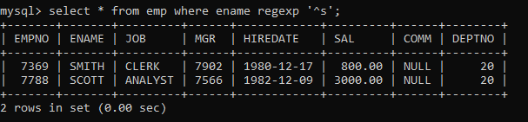

7. list all employees with name ending with S

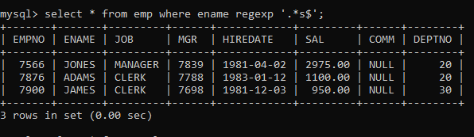

8. list all employees with name contains I at 2nd position

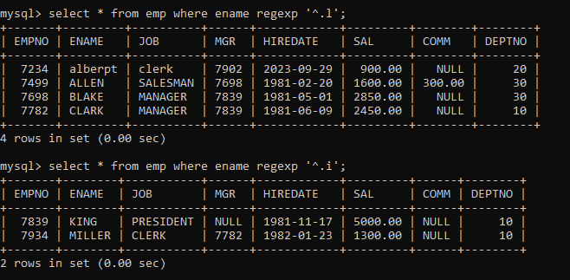

9. list all employees with name starts with A ends with N and somewhere in between L is there

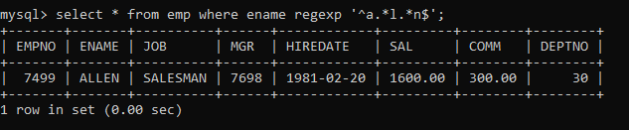

10. list all employees with name starts with A and B at 3 rd position and P at second last position

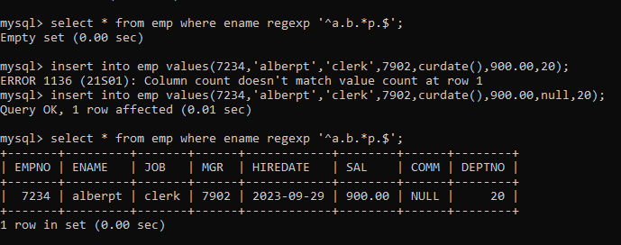

11. List all employees with name starts with either A or starts with S or starts with W

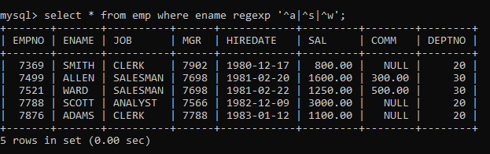

12. find max sal and min sal for each job

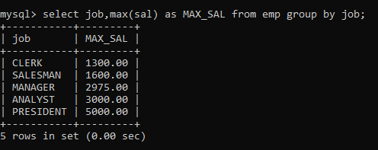

13. find how many employess have not received commission

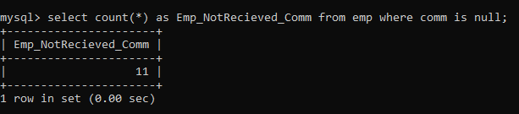

14. find sum of sal of all employees working in dept no 10

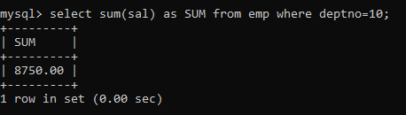

15. find maximum salary,average sal for each job in every department

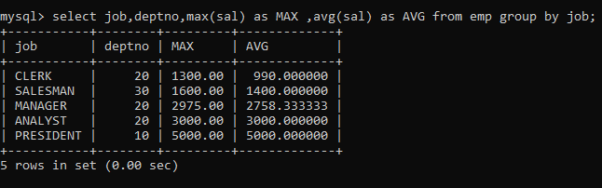

16. find max salary for every department if deptno is >

15 and arrange data in deptno order.

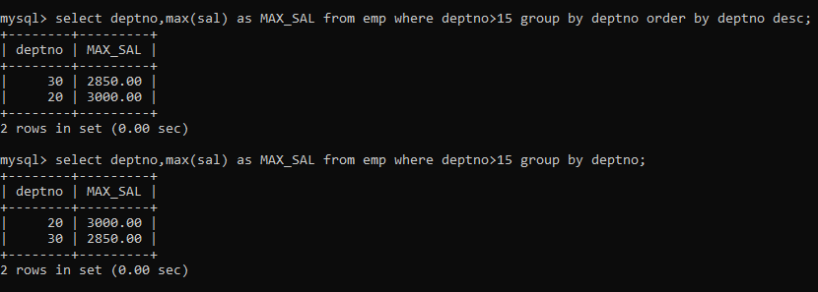

17. find sum salary for every department if sum is > 3000

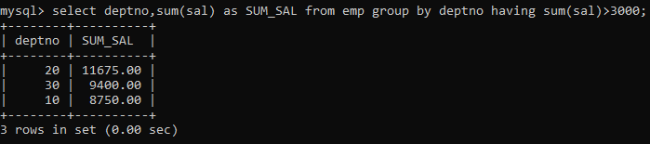

18. list all department which has minimum 5 employees

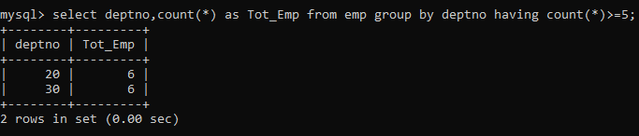

19. count how many employees earn salary more than 2000 in each job

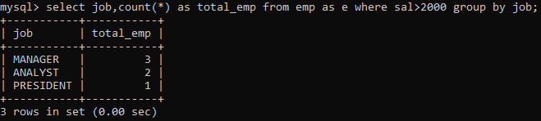

20. list all enames and jobs in small case letter

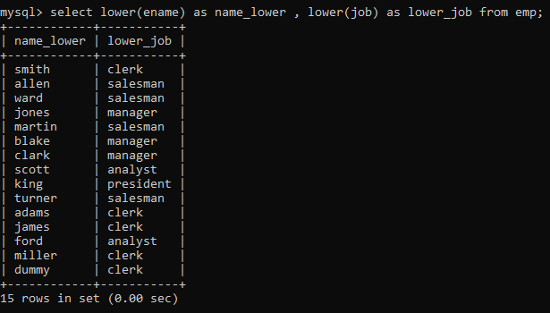

21. list all names and jobs so that the length of name should be 15 if it is smaller then add spaces to left

22. display min sal,max sal, average sal for all employees working under same manager

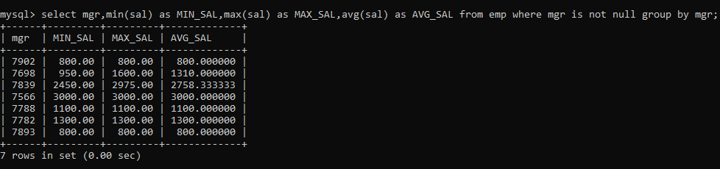

23. find sum of total earnings(sal+comm), average of sal+comm,for all employees who earn sal > 2000 and work in either dept no 10 or 20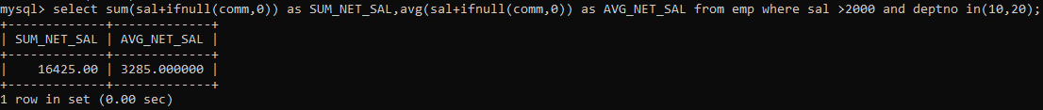

24. list all employees who joined in Aug 1980 and salary is >1500 and < 2500

25. list all employees joined in either aug or may or dec

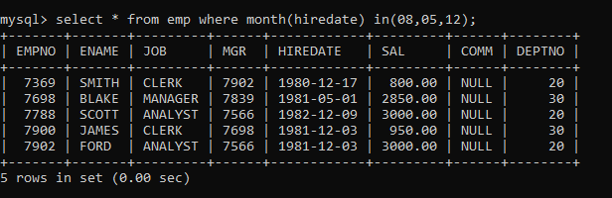

26. display name and hiredate in dd/mm/yy format for all employees whose job is clerk and they earn some commission

27. list empcode,empno,name and job for each employee. (note :empcode is 3 to 5 characters from name and last 2 characters of job)

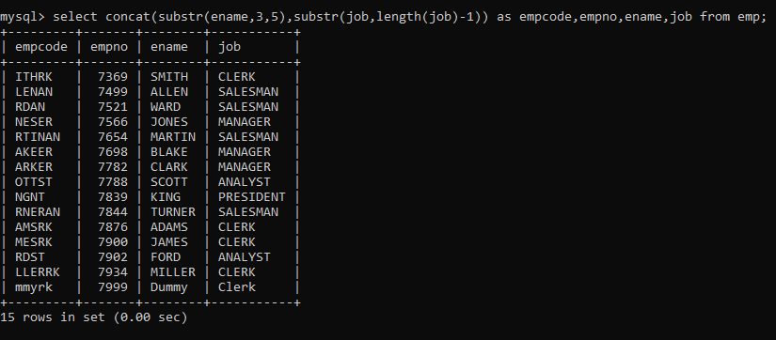

28. display thousand separator and $ symbol for commission if it is null then display it as 0 for all employees whose name starts with A and ends with N

29. Display empid,name,sal,comm,remark Remark should base on following conditions

comm >= 600 "excellent Keep it up"

if it < 600 or not null "good"

otherwise "Need improvement"

30. Display empid, name, deptno and department name by using following conditions.

dept 10 then "Hr"

if 20 then "Admin"

if 30 then "accounts"

otherwise purchase

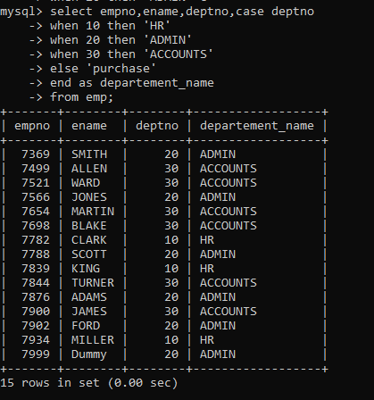

37. increase salary of all employees by 15% if they are earning some commission

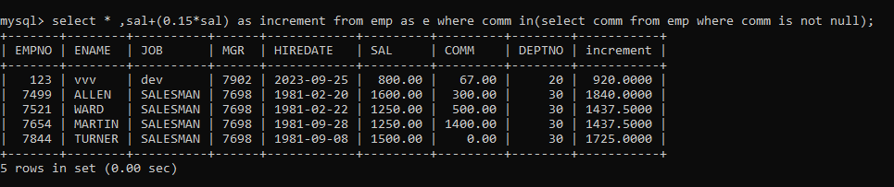

38. list all employees with sal>smith's sal

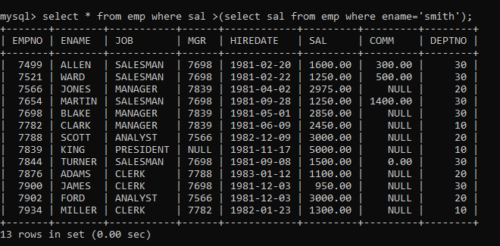

39. list all employees who are working in smith's department

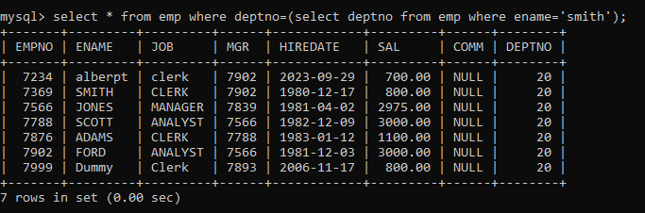

40. list all employees with sal < rajan's sal and salary > revati's sal

41. delete all employees working in alan's department

42. change salary of Alan to the salary of Miller.

43. change salary of all emplees who working in Wall's department to the salary of Miller.

44. list all employees with salary > either Smith's salary or alan's sal

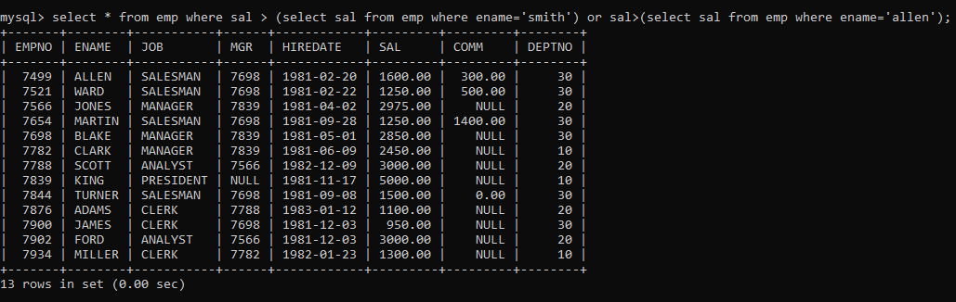

45. list all employees who earn more than average sal of dept 10

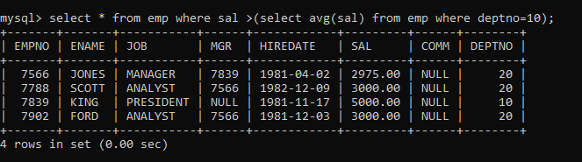

46. list all employees who earn more than average sal of Alan's department

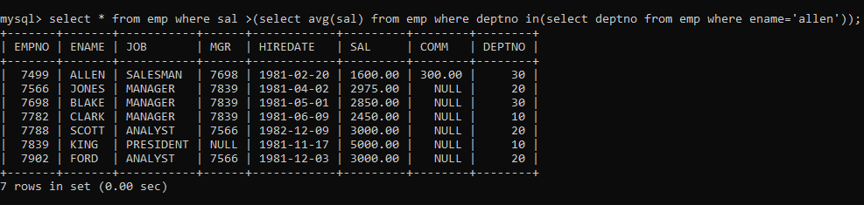

47. list all employees who are working in RESEARCH department

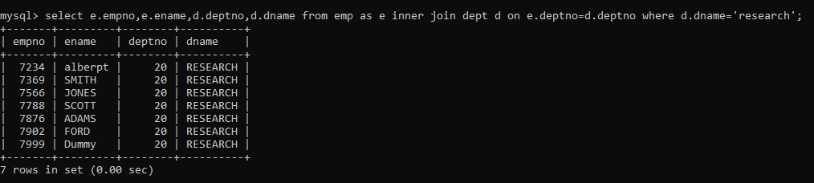

48. list all employees who earn more than average salary of their own department

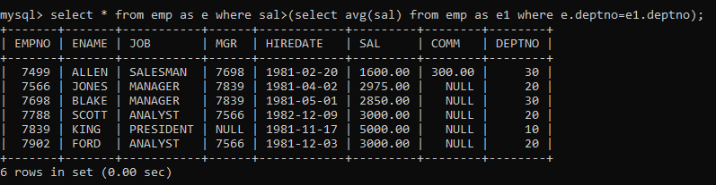

49. list all employees who earn sal < than their managers salary

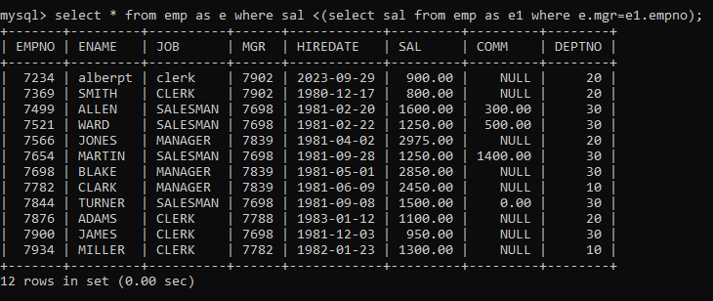

50. list all employees who are earning more than average salary of their job

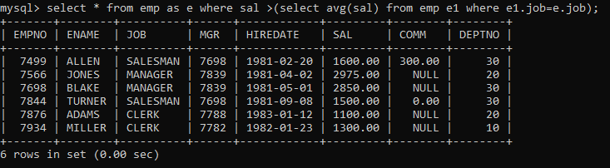

51. display employee name and department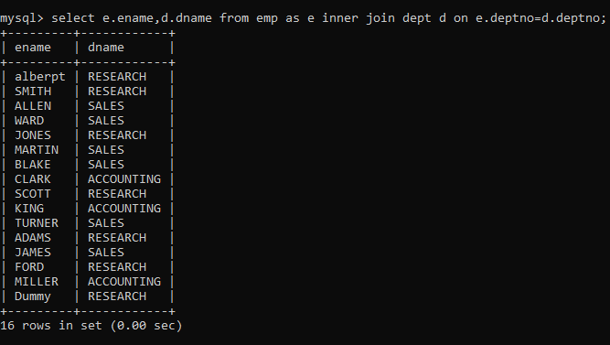

52. display empno,name,department name and grade (use emp,dept and salgrade table)

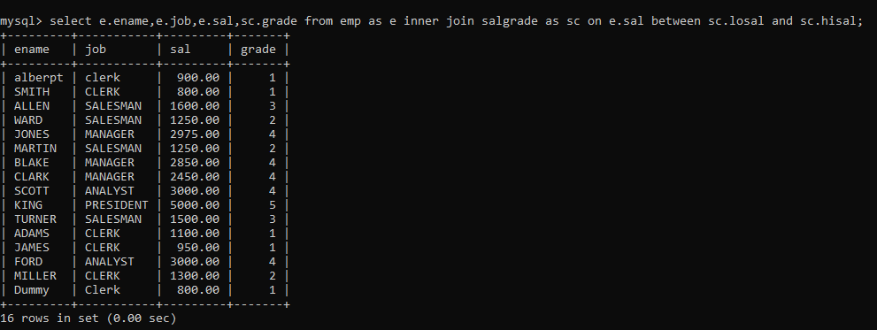

53. list all employees number,name, mgrno and manager name