# OS-ASSIGNMENTS

**Assignment -1 :**

1. Write a Shell Script to find maximum between two numbers.

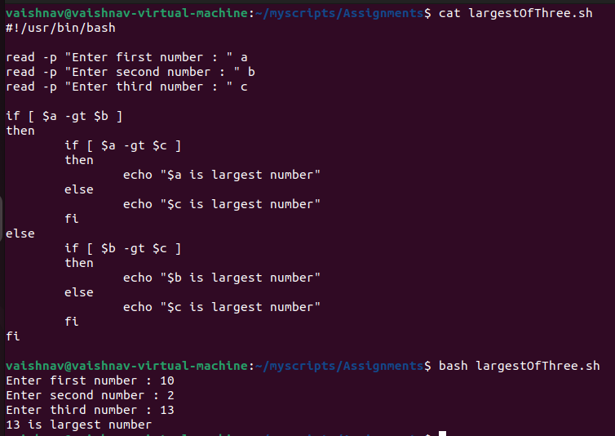

2. Write a Shell Script to find maximum between three numbers. 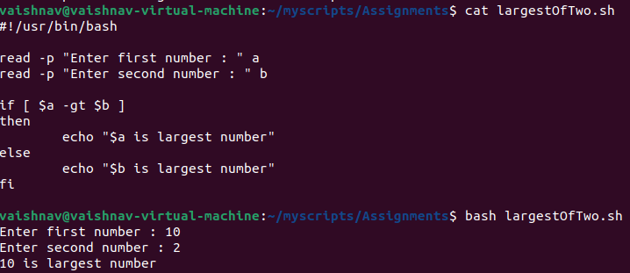3. Write a Shell Script to check whether a number is negative, positive or zero.

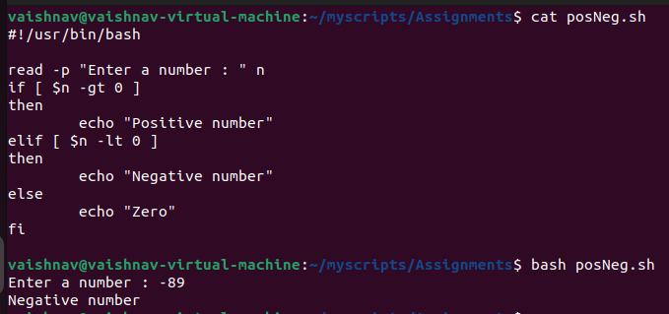

4. Write a Shell Script to check whether a number is divisible by 5 and 11 or not.

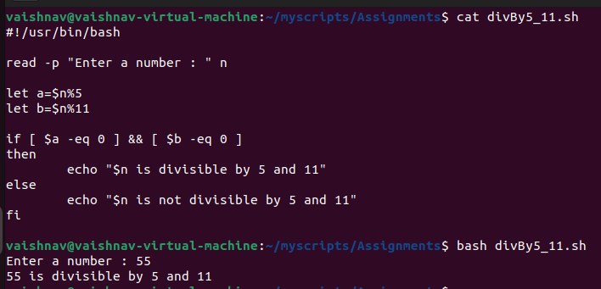

5. Write a Shell Script to check whether a number is even or odd.

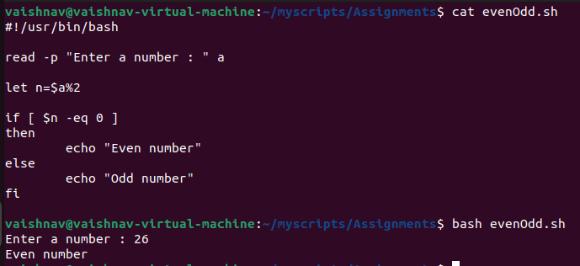

6. Write a Shell Script to check whether a year is leap year or not.

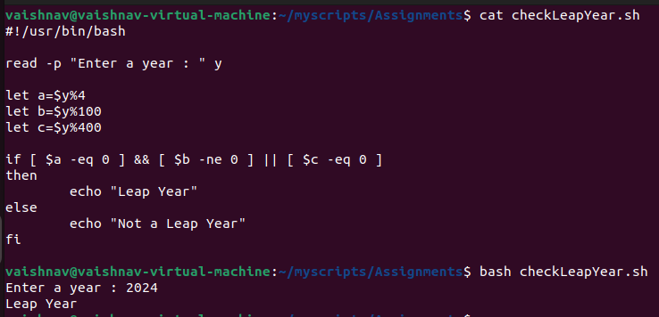

7. Shell Script to print number between 1 to 10 in character format using switch-case.

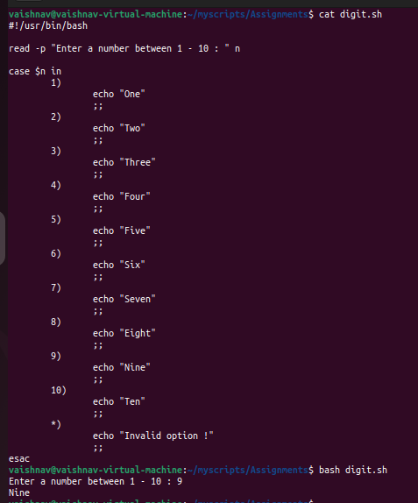

8. Shell Script to accept id from user to confirm department using switch-case.

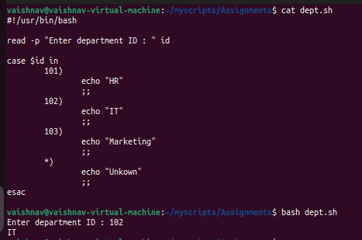

9. Shell Script to check password is correct or incorrect using switch-case.

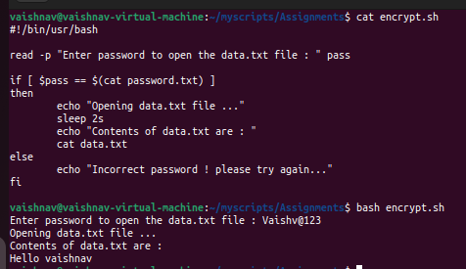

10. Shell Script to print day of week using switch-case.

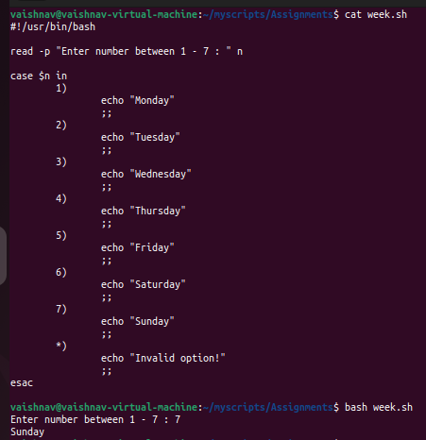

11. Shell Script to create calculator using switch-case.

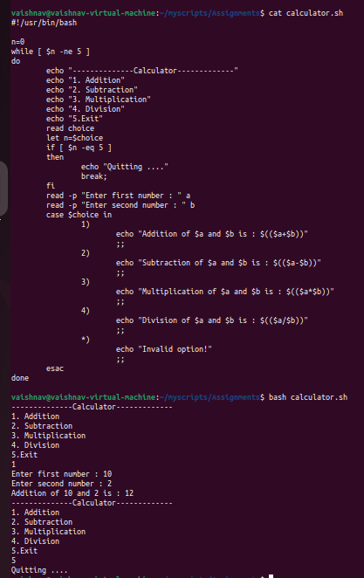

**Assignment -1 :**

1. In your home directory, create sets of empty practice files

Create 6 files with names of the form songsX.mp3.

Create 6 files with names of the form snapX.jpg.

Create 6 files with names of the form filmX.avi.

In each set, replace X with the numbers 1 through 6.

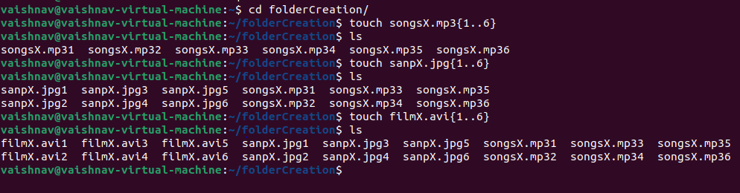

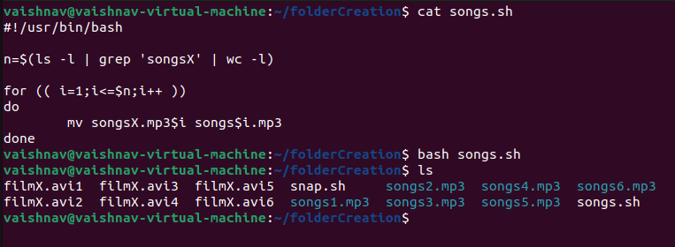

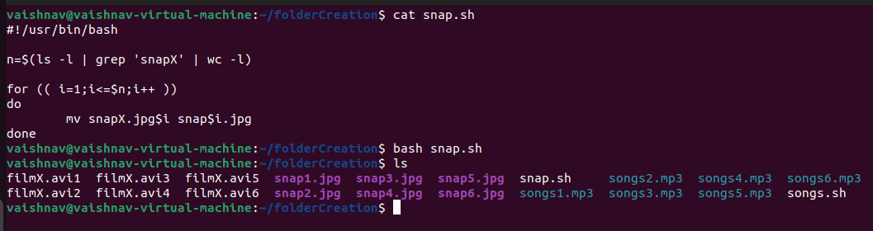

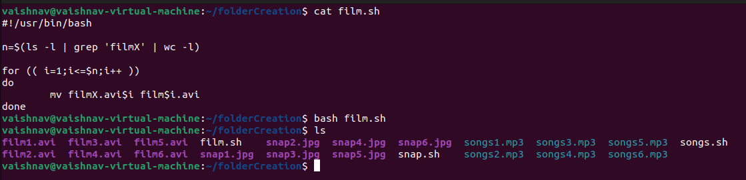

2. From your home directory,

Move songs file into your Music subdirectory.

Move snap file into your Pictures subdirectory.

Move your movie files into Videos subdirectory

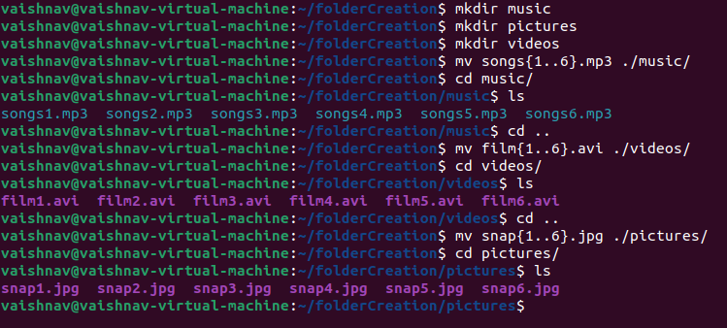

3. Create 3 subdirectories for organizing your files named friends,family,work

4. Copy files (all types ) containing numbers 1 and 2 to the friends folder.

Copy files (all types) containing numbers 3 and 4 to the family folder.

Copy files (all types) containing numbers 5 and 6 to the work folder

**Assignment -4 :**

1. Write a shell script to print your are logged in as which user in which directory you are and in which terminal you are working total number of files and directories in current directory .

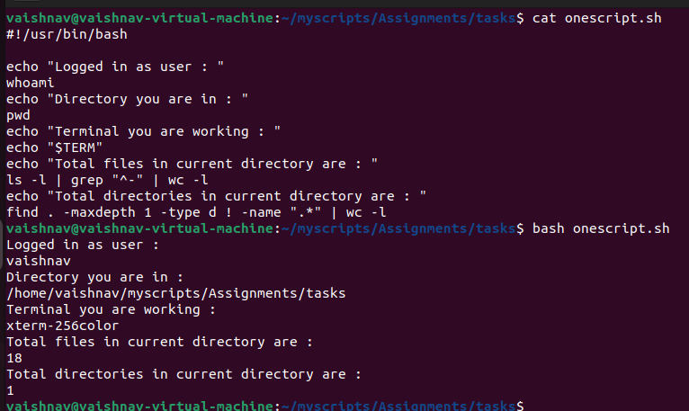

2. Write a shell script to create a menu driven program for adding, deletion or finding a record in a database. Database should have the field like rollno, name, semester and marks of three subjects. Last option of the menu should be to exit the menu.

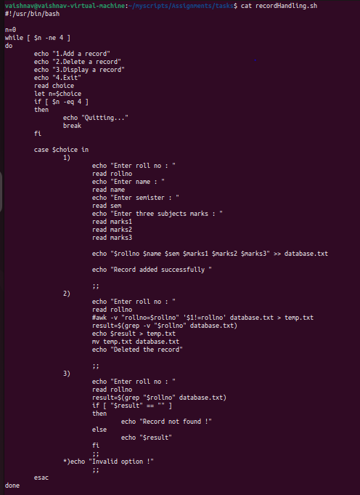

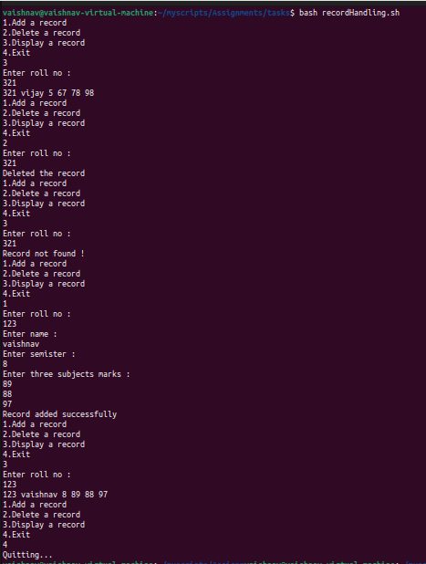

3. Write a Linux shell script to accept 10 number and tell how many are +tive, -tive and zero.

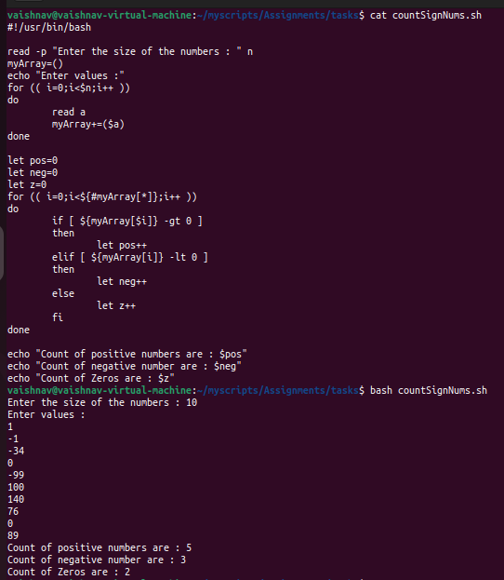

4. Write a shell script to accept five number and display max and min value.

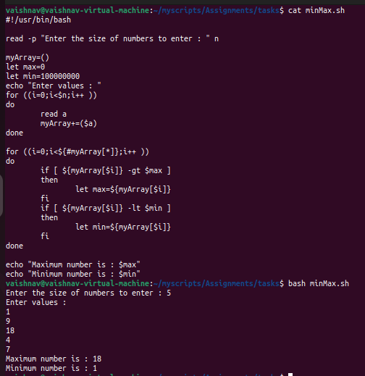

5. Write a script to find out String is palindrome or not.

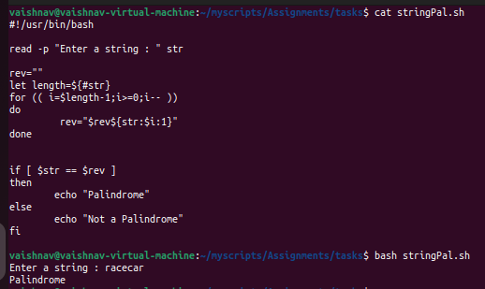

6. Write a shell script to print given number’s sum of all digits (eg. If number is 123, then it’s sum of all digits will be 1+2+3=6)

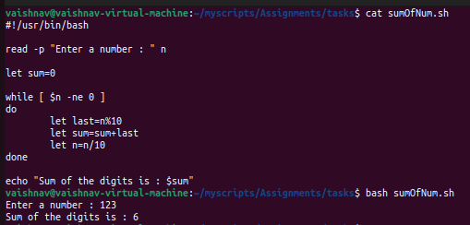

7. Create a script to :

Create user , Delete user , Create group , delete Group using case

**Loop Assignments** :

1. Shell Script to display the first 10 natural numbers.

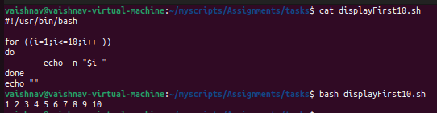

2. Shell Script to compute the sum of the first 10 natural numbers.

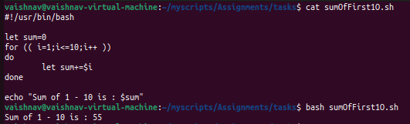

3. Shell Script to display n terms of natural numbers and their sum.

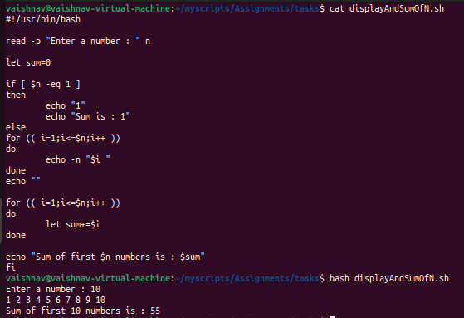

4. Shell Script to read 10 numbers from the keyboard and find their sum and average.

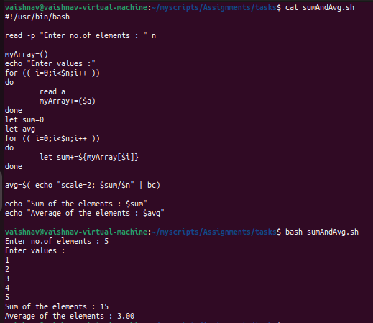

5. Shell Script to display the cube of the number up to an integer.

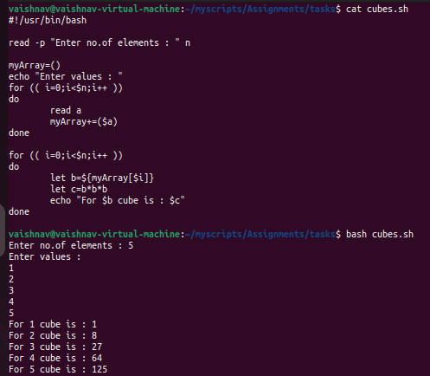

6. Shell Script to display the multiplication table for a given integer.

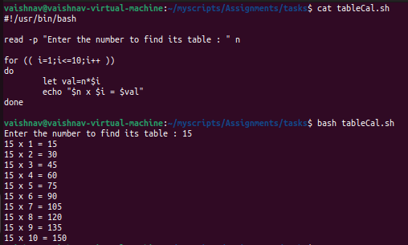

7. Shell Script to display the multiplier table vertically from 1 to n.

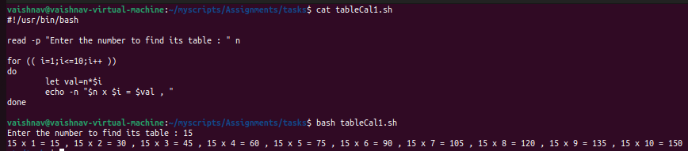

8. Shell Script to display the n terms of odd natural numbers and their sum.

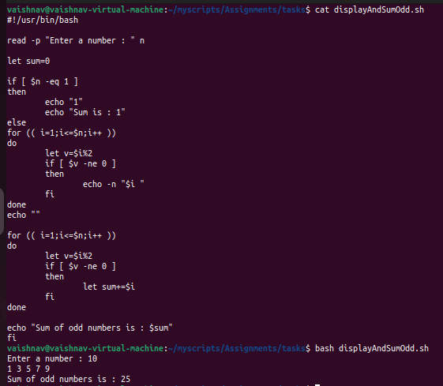

9. Shell Script to display a pattern like :

*

**

***

****

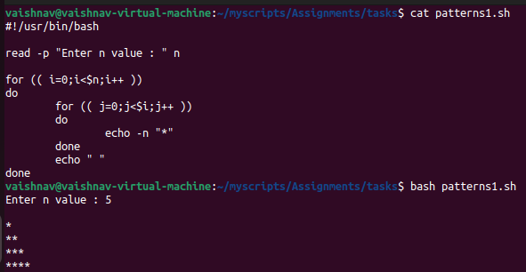

10. Shell Script to display a pattern like :

1

12

123

1234

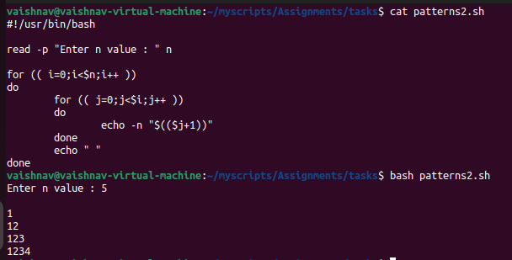

11. Shell Script to make such a pattern like

1

22

333

4444

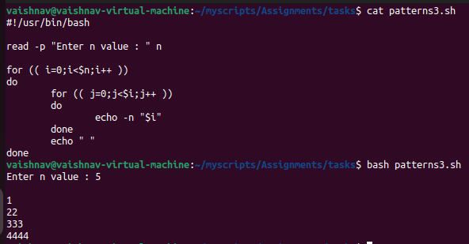

12. Shell Script to make such a pattern like:

1

2 3

4 5 6

7 8 9 10

