**OBJECTIVE:**

To provide better solution for various marketing retail activities, exploring the usage of both structured and unstructured data.

**ARCHITECTURE DIAGRAM:**

Inventory Management

Pricing

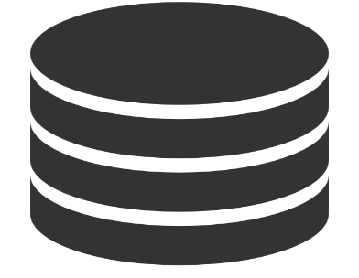

Recommendation

Customer Segmentation

Target Marketing

**APPROACHES USED**

**DESCRIPTIVE ANALYSIS**

Descriptive analytics is the interpretation of historical data to better understand changes that have happened in a business. Descriptive analytics simply describes the past using a range of data to draw comparisons.

**PRESCRIPTIVE ANALYTICS**

Prescriptive Analytics is an advanced analytics technology that can provide recommendations to decision makers and help them achieve business goals by solving complicated optimization problems.

**PREDICTIVE ANALYTICS**

Predictive analysisis a commonly used statistical technique to predict future behaviour.

**LINEAR REGRESSION**

Linear regression is used for finding linear relationship between target and one or more predictors.

**LOGISTIC REGRESSION**

Logistic Regression is a classification algorithm. It is used to predict a binary outcome (1 / 0, Yes / No, True / False) given a set of independent variables.

**RFM SEGEMENTATION**

RFM segmentation allows marketers to target specific clusters of customers with communications that are much more relevant for their particular behaviour

**ASSIOCATION RULE MINING**

Association rule learning is a [rule-based machine learning](https://en.wikipedia.org/wiki/Rule-based_machine_learning) method for discovering interesting relations between variables in large databases.

**CUSTOMER SEGMENTATION**

**PRICING**

**TARGETED MARKETING**

**PRODUCT RECOMMENDATION**

**CUSTOMER BASED RECOMMEDATION**

**INVENTORY MANAGEMENT**

**CONCULSION**

**FUTURE ENHANCEMENT**

In Customer Based Recommendation, if product reviews are available an NLP approach can be used to enhance the recommendation. Information about the age of the customers can be useful in making age-based clusters like Youth, Old Age, kids etc.

In Pricing, instead of telling the retailer whether to give discount or not we can give the discount value to the Retailer.