**A**

**PROJECT REPORT**

**ON**

**“ARDUINO BASED PASSWORD MANAGER”**

Submitted by

**MANALI RITESH AMBATPURE (G51)**

**PRATIKSHA BHAUSAHEB SHELAR (G52)**

**SOLEMAN SHAHANSHA HALDER (G53)**

**SANKET SANJAY BOGLE (G54)**

**F.Y. B. Tech.**

UNDER THE GUIDANCE OF

**Dr. Suhas S. Gajre**

**Mrs. Vinaya V. Khiste**

**Ms. Madhuri M. Baswade**

**Mr. Suraj D. Kulkarni**

(Engineering Exploration Lab)





**Academic Year 2021-22**

**Semester-II**

## 

## CERTIFICATE

This is to certify that, the Project report entitled

**“Arduino Based Password Manager”**

Submitted by

MANALI RITESH AMBATPURE (G51)

PRATIKSHA BHAUSAHEB SHELAR (G52)

SOLEMAN SHAHANSHA HALDER (G53)

SANKET SANJAY BOGLE (G54)

As the partial fulfillment of the Engineering Exploration Lab

For the academic year 2021-22, Sem-II

This project is a record of student’s own work, carried out by them under our supervision and guidance.

**Mrs. V. V. Khiste Ms. M. M. Baswade Mr. S. D. Kulkarni Dr. S. S. Gajre**

# ACKNOWLEDGEMENT

For all the efforts behind the project work, we first & foremost would like to express our sincere appreciation to the staff of Department of Engineering Exploration Lab, for their extended help & suggestions at every stage of this project.

It is with a great sense of gratitude that we acknowledge the support, time to time suggestions and highly indebted to our guide.

Finally, we pay our sincere thanks to all those who indirectly and directly helped us towards the successful completion of this project report.

**ABSTRACT**

When it comes to robust security for a seamless authentication and authorization experience, security keys are considered one of the best ways to prove one’s identity. These security practices add an extra security layer other than passwords and ensure that the right person has access to the right information.

A security key is a physical USB drive that connects with your devices, including computers and laptops, to prove identity to access specific resources on a network.

These kinds of keys can be connected to devices via USB, Bluetooth connection, or a USB-C port and are super simple to use whenever you need to go through an additional identity verification process.

Just like the conventional OTPs and email verification, security keys can be used to authenticate a user whenever they wish to access specific resources or need to log in to their accounts on a website or an application.

**NEED STATEMENT**

The internet age has made us more connected than we ever thought possible. Not only are we capable of connecting to each other, but more and more of our devices are sharing information as well. Networked devices range from phones and computers to cars to household appliances. As more devices join the network, it has become easy, convenient and cost-effective to remotely control many devices in your home or business. Access control is one of the systems that has taken advantage of this new era, including electronic door locking systems and other solutions that administer permissions and control the flow of people to a secure area, building or facility.

But the convenience of digital access control comes with a downside—it’s hackable. In a world where digital locks are becoming the standard, old-fashioned physical keys offer the advantage of not being hackable, giving you surety that someone in another part of the world, or waiting outside your doors, is reprogramming your access control to give them access to your facilities—or using your keys as a jumping point to the network as a whole. Many businesses still utilize physical keys for this and other reasons—and protecting them provides the convenience of digital access control with the security of physical keys.

**PROBLEM STATEMENT**

A security key is a physical USB drive that connects with your devices, including computers and laptops, to prove identity to access specific resources on a network.

These kinds of keys can be connected to devices via USB, Bluetooth connection, or a USB-C port and are super simple to use whenever you need to go through an additional identity verification process.

Just like the conventional OTPs and email verification, security keys can be used to authenticate a user whenever they wish to access specific resources or need to log in to their accounts on a website or an application.

Several organizations encourage their employees to leverage a security key whenever they’re working on sensitive data or logging from a remote location.

**Gantt Chart**

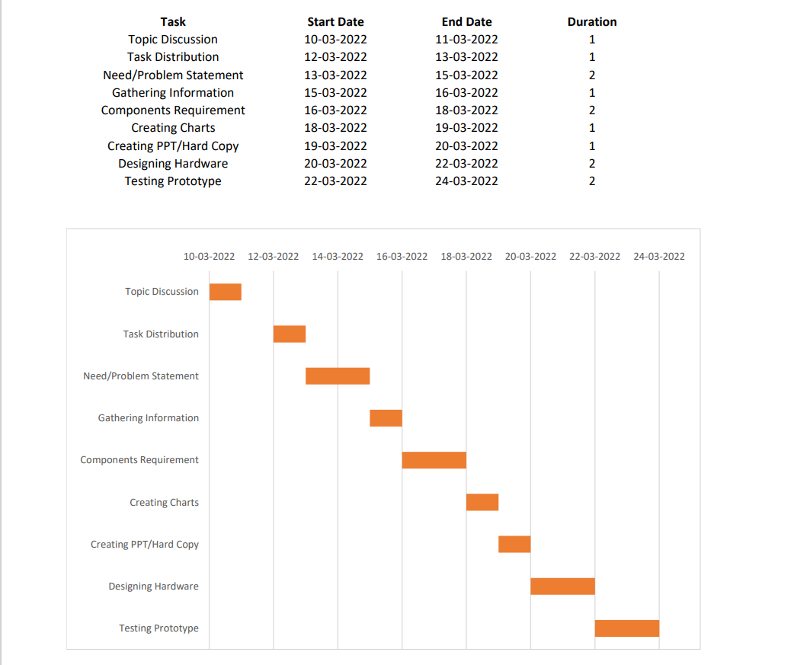

**INDEX**

**CONTENTS PAGE NO.**

**Acknowledgement 3**

**Abstract** **4**

**NEED STATEMENT 5**

**PROBLEM STATEMENT 6**

**GANTT CHART 7**

**Index 8**

**List of Figures 9**

**List of Tables** 10

**Chapter 1. INTRODUCTION 11**

**Chapter 2. LITERATURE REVIEW 12**

**Chapter 3. PCC AND PUGH CHART 14**

**Chapter 4. WORKING PRINCIPLE 16**

4.1 **BASIC CIRCUIT DIAGRAM 17**

* + - * 1. 4.**2 FLOW CHART** 17

**4.3 SCHEMETIC DIAGRAM 18**

**4.4 COMPONENTS 19**

**4.5 PROGRAMMING CODE 23**

* + 1. **Chapter 5. APPLICATIONS 24**

**CONCLUSION**

**FUTURE SCOPE 25**

**REFERENCE 27**

**List of Figures**

**Figure Name of Figure Page**

**No. No.**

**1 Block Digram 17**

**2 Schematic Digram 18**

**3 Arduino Mega 19**

**4 Soil Moisture sensor 20**

**5 DC motor pump 21**

**6 Relay module 22**

**List of Tables**

**Table Table Name Page**

**No. No.**

**1 PCC**

**2 PUGH**

**CHAPTER 1.INTRODUCTION**

In this project, we will learn how to make the Password-Based Security System Using Arduino & Keypad. As thefts are increasing day by day security is becoming a major concern nowadays. So a digital code lock can secure your home or locker easily. It will open your door only when the right password is entered.

The circuit of this project is very simple which contains Arduino, keypad module, buzzer, Servo Motor, and LCD. Arduino controls the complete processes like taking a password from the keypad module, comparing passwords, driving buzzer, rotating servo motor, and sending status to the LCD display. The keypad is used for taking the password. The buzzer is used for indications. Servo motor is used for opening the gate while rotating and LCD is used for displaying status or messages on it.

**CHAPTER 2.LITERATURE REVIEW**

Security keys have become a popular way to store passwords throughout the years. Many people use them for convenience and security purposes.

Since these keys automatically input usernames and passwords, users can enhance their online protection by using long and complex passwords that would take ages to brute force. Security keys also allow users to bypass physical keyloggers since typing on the keyboard is no longer required.

Another reason to use a security key would simply be for convenience. A lot of people are slow and unconfident typers. When typing a password, keying in one wrong character often leads to deleting everything and starting over again. With a security key, users no longer have to worry about making incorrect keystrokes.

To make the security key work, you need to program the Digispark to input your password whenever it is inserted into a USB port in your device. Don't worry; this isn't complicated. The code is already provided below. All you need to do is to set up an IDE (Integrated Development Environment), install the Digistump drivers, and upload the sketch into the Digispark, and you're done.

The Arduino IDE is software intended for programming all kinds of Arduino boards such as the Uno, Leonardo, and Pro Micro. Since you will be using a Digispark (a board not registered by Arduino), you first need to set the IDE for it.

If you are using Linux and unsure which version to get, try using the 64-bit version of the IDE. For Windows and Mac, just go for the first provided option. After the download completes, install the IDE with all the default settings. Then fire up the program.

Since Digispark is by default unsupported by the Arduino IDE, you'll have to communicate to the IDE that you want to use a third-party board by giving it a link to the Digistump database.

You can do this by hovering over **File**and clicking on **Preferences**or by using the shortcut

Programming in Arduino is relatively straightforward. However, it does require a bit of tinkering for you to get used to it.

The sketch (a script in Arduino is called a sketch) works by making the Digispark act like a keyboard. Using the DigisKeyboard library, the sketch will automatically print out your username, hit the enter key, type your password, and hit the enter key again to log you into your account.

The **setup ()**function is used to set up the pins for when you add triggers like buttons on your programable board. You can skip this part since you haven't soldered any extra components to our Digispark. It is added here as a convention, so you can use it whenever you want to add more functionality to your Digispark security key.  
The loop () function allows the sketch to be in a constant feedback loop to let the Digipark security key repeat the functions below at a specified time. The **DigiKeyboard**functions under the loop make the Digispark type your username and password.

Now that you understand how the sketch works, start programming your Digispark security key.

**CHAPTER 3.PCC CHART AND PUGH CHART**

**PCC CHART**

|  |  |  |  |  |  |
| --- | --- | --- | --- | --- | --- |
|  | Durable | Safe | Cost | Ease of use | Total |
| Durable | **_** | **0** | **0** | **1** | **1** |
| Safe | **1** | **_** | **1** | **1** | **3** |
| Cost | **1** | **0** | **_** | **0** | **1** |
| Ease of use | **1** | **0** | **1** | **_** | **2** |

|  |
| --- |
| Ranking of Objectives |
| Safe |
| Ease of use |
| Durable /Cost |

**PUGH CHART**

|  |  |  |  |  |  |
| --- | --- | --- | --- | --- | --- |
| Design  Criteria | Weightage | Design 1 | Design 2 | Design 3 | Design 4 |
| 1.Ease of use | **3** | **1** | **2** | **1** |  |
| 2.Accuracy | **2** | **0** | **1** | **-1** | **.** |
| 3.Safety | **2** | **1** | **1** | **-2** | **D** |
| 4.Maintainance | **3** | **1** | **1** | **0** | **A** |
| 5.Reliability | **2** | **-1** | **-2** | **1** | **T** |
| 6.Cost | **3** | **-2** | **1** | **2** | **U** |
| 7.Durability | **2** | **1** | **0** | **1** | **M** |
|  |  |  |  |  | **.** |
|  | **Plus(+)** | **10** | **14** | **15** | **0** |
|  | **Zero(0)** | **2** | **2** | **3** | **17** |
|  | **Minus(-)** | **8** | **6** | **4** | **0** |
|  | **Total** | **2** | **8** | **11** | **0** |
|  |  |  |  |  |  |

**CHAPTER 4: WORKING PRINCIPLE**

There are two functional components in this paper. They are moisture sensor and motor / pump. Arduino board is programmed using the Arduino IDE software. Humidity sensor is used to detect the soil moisture content. Motor / pump is used to supply water to plants. Soil moisture and temperature predetermined range is set particularly for specific plants requirement, and according to that system is being operated. Microcontroller (ATmega328), is the brain of the system. Both humidity and temperature sensor is connected to the controller's input pin. Pump and servo motor coupled to the output pin. In case of soil_moisture value is less than threshold system automatically triggers water pump on till sensor meets threshold and then sets off automatically. The overall activity is reported to the user using mobile application also .

**4.1 BASIC CIRCUIT DIAGRAM OF AUTOMATED PLANT WATERING SYSTEM**

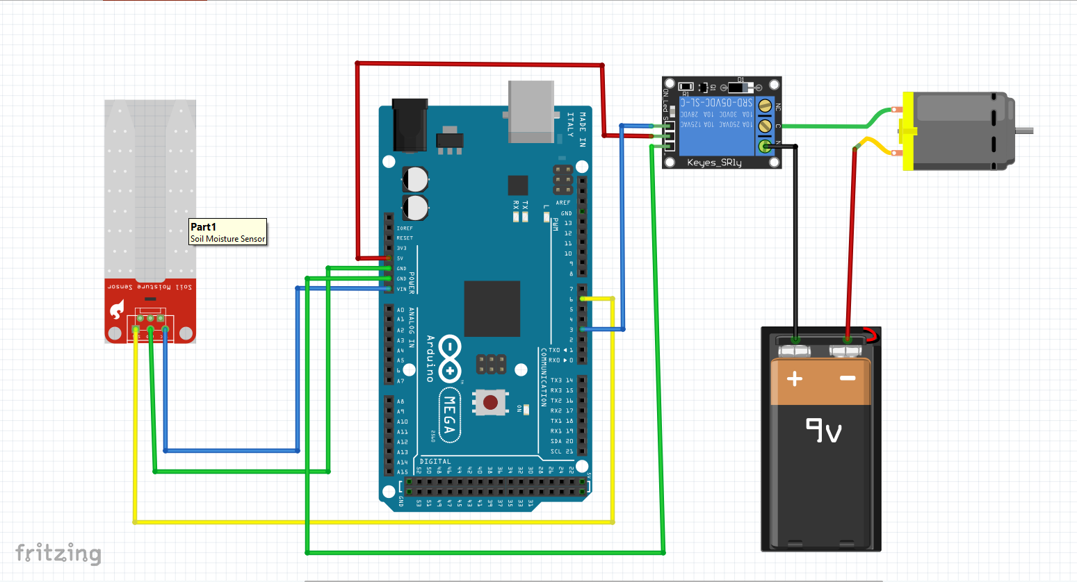

**CHECK MOISTURE LEVEL**

**M<50**

**START IRRIGATION**

**INITIALIZE WATERING TO PLANTS**

**SEND REPORT TO USER**

**4.2 FLOW CHART**

**4.3 SCHEMETIC DIAGRAM**

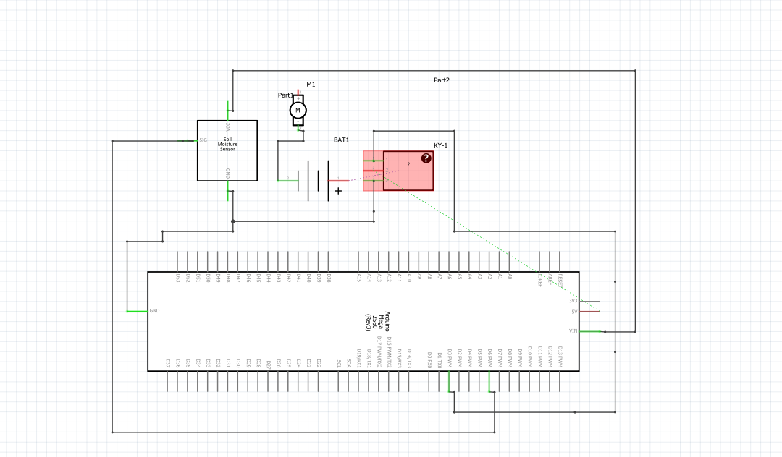

**4.4 COMPONENTS**

**ARDUNIO MEGA**

Arduino Mega 2560 R3 is an open source precise microcontroller board Successor to the Arduino Mega based on the ATmega2560 SMD chip.The Mega 2560 R3 also adds SDA and SCL pins next to the AREF. In addition, there are two new pins placed near the RESET pin. One is the IOREF that allow the shields to adapt to the voltage provided from the board. The other is a not connected and is reserved for future purposes. The Mega 2560 R3 works with all existing shields but can adapt to new shields which use these additional pins.

This Board has 54 digital input/output pins (of which 15 can be used as PWM outputs), 16 analog inputs, 4 UARTs (hardware serial ports), a 16 MHz crystal oscillator, a USB connection, a power jack, an ICSP header, and a reset button. It contains everything needed to support the microcontroller. Using the board is also very easy, simply connect it to a computer with a USB cable or power it with DC adapter or battery to get started. The Mega 2560 R3 board compatible with shields.

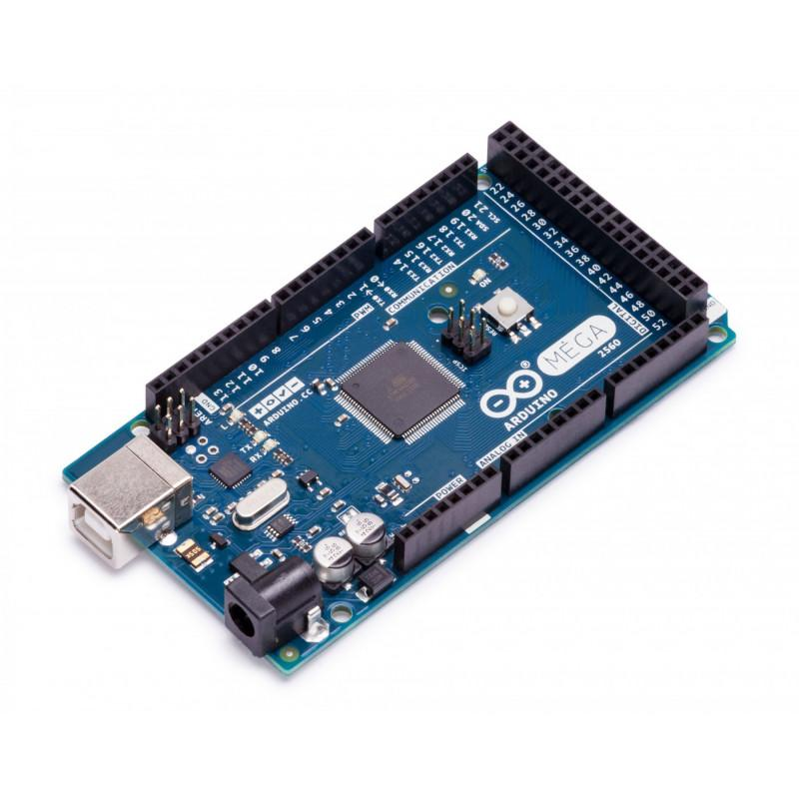

**SOIL MOISTURE SENSOR**

The sensor includes a potentiometer to set the desired moisture threshold. When the sensor measures more moisture than the set threshold, the digital output goes high and an LED indicates the output. When the moisture in the soil is less thatn the set threshold, the output remains low. The digital output can be connected to a micro controller to sense the moisture level. The sensor also outputs an analog output which can be connected to the ADC of a micro controller to get the exact moisture level in the soild.

This sensor is great for making water gardening projects, water sensing, etc.

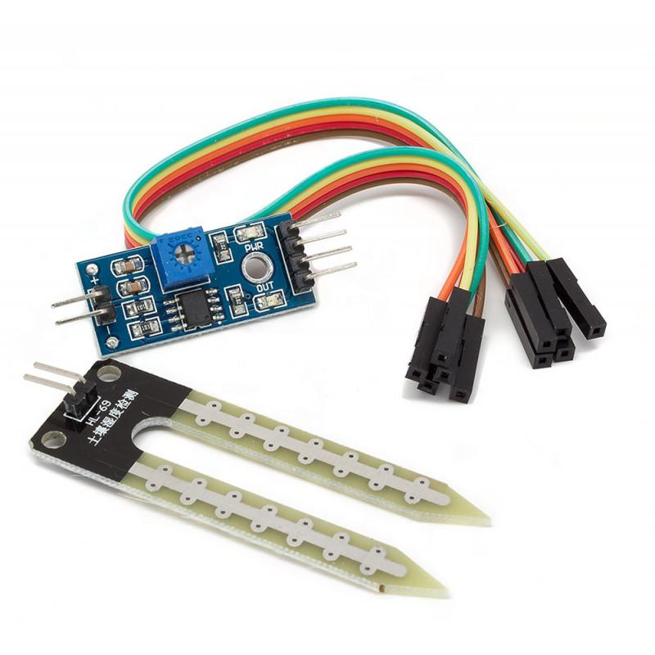

**DC MOTOR PUMP**

Micro DC 3-6V Micro Submersible Pump Mini water pump For Fountain Garden Mini water circulation System DIY project. This is a low cost, small size Submersible Pump Motor which can be operated from a 3 ~ 6V power supply. It can take up to 120 liters per hour with very low current consumption of 220mA. Just connect tube pipe to the motor outlet, submerge it in water and power it. Make sure that the water level is always higher than the motor. Dry run may damage the motor due to heating and it will also produce noise.

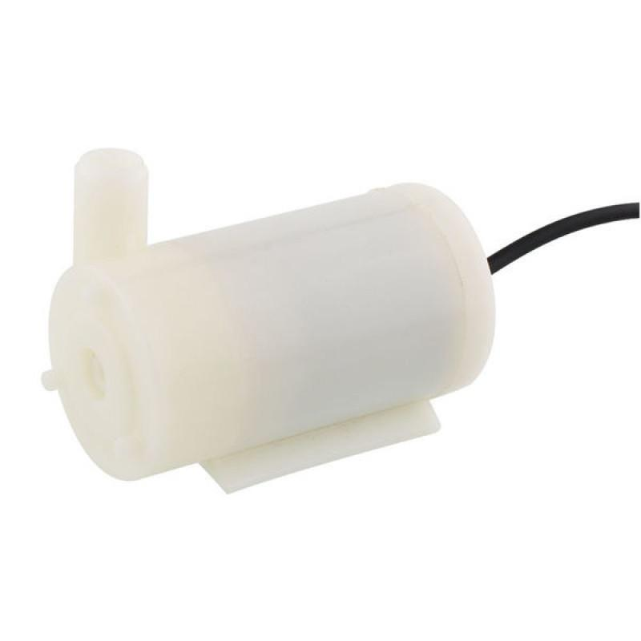

**RELAY MODULE**

This is a small and easy to use 1 channel relay board that operates on 12V. Use it to control one 240V power appliance directly from Arduino, Raspberry Pi, and other microcontrollers or low voltage circuits. Perfect for switching 240V appliances lights, fans, etc, and even high power motors at lower voltages.

The board uses a high-quality relay, which can handle a maximum of 10A/250 V AC or 15A/125V AC. Each relay has all three connections Common, Normally Open, Normally Closed brought out to 3 pin screw terminals which make it easy to make and remove connections. The board has a power indication and a relay status LED to ease debugging. The board can accept control inputs within a wide range of voltages from 4V to 12V.

Power input and relay control signals are brought to header pins on the board. Hence, the board can be easily interfaced with our development boards using our female to female jumper wires.

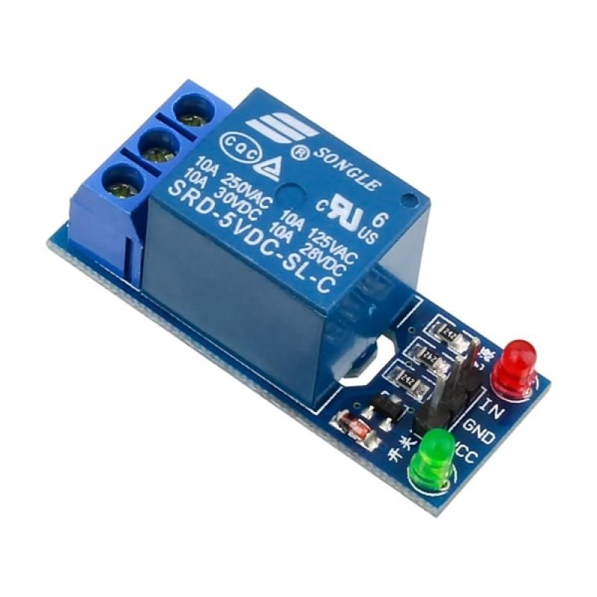

**4.5 PROGRAMMING CODE**

int water; //random variable

void setup() {

pinMode(3,OUTPUT); //output pin for relay board, this will sent signal to the relay

pinMode(6,INPUT); //input pin coming from soil sensor

}

void loop() {

water = digitalRead(6); // reading the coming signal from the soil sensor

if(water == HIGH) // if water level is full then cut the relay

{

digitalWrite(3,LOW); // low is to cut the relay

}

else

{

digitalWrite(3,HIGH); //high to continue proving signal and water supply

}

delay(400);

}

**CHAPTER 5. AREAS OF APPLICATION**

This system can be used in roof gardens in highly populated areas where land is expensive and gardening on rooftops seems like the only viable option left.

The lawns of houses and public buildings can be maintained by these systems, thereby reducing the need for human monitoring.

The greatest application is in agricultural lands, where farmers are assisted greatly by this. There is no need for the farmer to actually be present during operation.

Gardens that need to be monitored in the absence of home owners require systems like APIS. Home gardens that are maintained with large effort by home owners require proper observation and maintenance. It can be provided by APIS.

This system can be used in the field of pisciculture. Fish farming or pisciculture involves raising fish commercially in tanks or enclosures, usually for food. It is the principal form of aquaculture, while other methods may fall under mariculture. The fishes need to be in a depth of 1m in the aquarium and this depth is maintained with the help of APIS. The appropriate threshold value is assigned and the circuit is operated.

Irrigation in parks needs to be done even when people are not there to maintain the grass or trees.

Detection in this manner is cheap, non-invasive and can be applied on a population-wide scale.

The presence of technology in all aspects of life has enabled solutions to real life problem that were either difficult or unfeasible.

**FUTURE SCOPE**

The application certainly is much more advantageous than the manual system. There will be no bias in the regions being covered and the delay is kept as minimal as it can be.

∙ The operator does not require any previous training because of its user friendliness.

∙ The operator is free from any technical issues. Extremely simple design makes the circuit easy to implement and maintain.

∙ Alterations in the system can be done easily if the process of the working changes in future.

∙ In future according to the user’s requirement it can be updated to meet the user requirements.

∙ Smart Wifi Irrigation Controllers are next generation controllers that adjust your irrigation system automatically using real-time weather information. Moreover, you can control it from anywhere, anytime.

**CONCLUSION**

Watering ssbecomes easy, accurate and practical with the idea above shared and can be implemented in agricultural fields in future to promote agriculture to next level. The output from moisture sensor and level system plays major role in producing the output. Thus the “AUTOMATIC PLANT WATERING SYSTEM” (APWS) has been designed and tested successfully. It has been developed by integrating all the features of all the hardware components used. Presence of every module has been reasoned above and placed carefully in order to contribute to the best working of the unit. The system has been tested to function automatically, and to the best of its ability. The moisture sensors measure the moisture level (water content) of the different plants. If the moisture level is found to be below the desired level, the moisture sensor sends the signal to the operational amplifier which triggers the DC Motor pump to turn ON and supply the water to respective field area. When the desired moisture level is reached, the system halts on its own and the DC Motor pump is turned OFF. Thus, the functionality of the entire system has been tested thoroughly and it is said to function successfully

**REFERENCE**

(1) Youtube link :https://youtu.be/iwkE_HWU-6M

(2) Wikipedia

(3) <https://fritzing.org/>

(4) Arduino IDE

(5) ADVERSE IMPACTS OF DROUGHT ON CROPS AND CROP PRODUCERS IN THE WEST James Johnson and Vince Smith Montana State University Department of Agricultural Economics and Economics <http://ageconsearch.umn.edu/bitstream/27974/1/02010009.pdf>

[6] How Drought and Extreme Heat Are Killing the World’s Crops - Justin Worlan <http://time.com/4170029/crop-production-extreme-heat-climate-change>