FINAL-YEAR SOFTWARE ENGINEERING PROJECT
VentureMind AI
Supervisor Brief, System Explanation, and Demonstration Workflow
An explainable AI platform for startup idea evaluation and business planning
Prepared for project presentation
July 2026

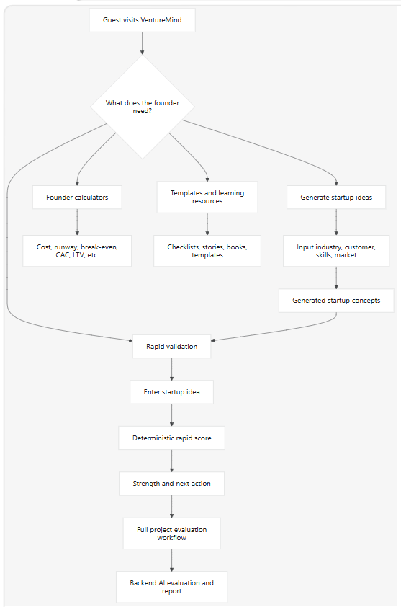

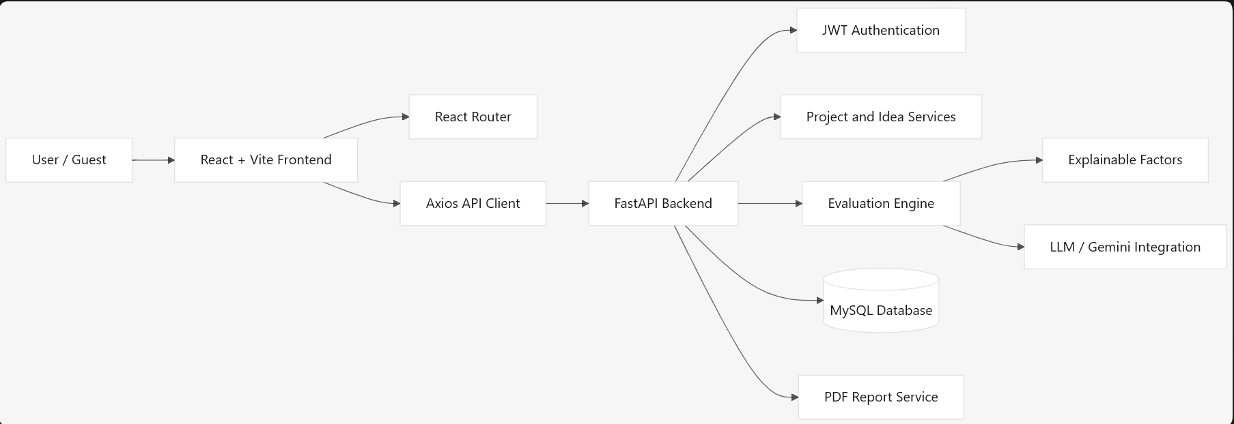

```mermaid

flowchart TD

A[Guest visits VentureMind] --> B{What does the founder need?}

B --> C[Generate startup ideas]

B --> D[Rapid validation]

B --> E[Founder calculators]

B --> F[Templates and learning resources]

C --> G[Input industry, customer, skills, market]

G --> H[Generated startup concepts]

H --> D

D --> I[Enter startup idea]

I --> J[Deterministic rapid score]

J --> K[Strength and next action]

E --> L[Cost, runway, break-even, CAC, LTV, etc.]

F --> M[Checklists, stories, books, templates]

K --> N[Full project evaluation workflow]

N --> O[Backend AI evaluation and report]

```

Here is a clear way to explain VentureMind AI to your supervisor.

Project summary
VentureMind AI is an AI-powered startup idea evaluation and business-planning platform.
It helps entrepreneurs:
- Generate startup ideas
- Quickly validate an idea as a guest
- Calculate startup finance metrics
- Learn startup concepts through templates, stories, checklists, and books
- In the full system: create projects, receive explainable AI evaluations, reports, and recommendations
The main goal is not to claim an idea will succeed. It helps founders identify assumptions, risks, missing information, and practical next actions.

Main user journey
```mermaid
flowchart TD
A[Guest visits VentureMind] --> B{What does the founder need?}
B --> C[Generate startup ideas]
B --> D[Rapid validation]
B --> E[Founder calculators]
B --> F[Templates and learning resources]

C --> G[Input industry, customer, skills, market]
G --> H[Generated startup concepts]
H --> D

D --> I[Enter startup idea]
I --> J[Deterministic rapid score]
J --> K[Strength and next action]

E --> L[Cost, runway, break-even, CAC, LTV, etc.]
F --> M[Checklists, stories, books, templates]

K --> N[Full project evaluation workflow]
N --> O[Backend AI evaluation and report]
```

Current frontend features

1. Landing page
The landing page introduces VentureMind AI, its purpose, core features, validation process, free tools, learning resources, pricing, and contact details.
It is designed for guest users first, so visitors can explore without creating an account.

2. Startup Idea Generator
The Startup Idea Generator asks for:
- Industry
- Target customer
- Founder skills
- Market/country
- Idea style: Practical, Balanced, Bold, or Experimental
It generates input-driven startup concepts with:
- Startup name
- Concept summary
- Revenue approach
- Key risk
- MVP suggestion
Important point: it does not use random scores. It creates reproducible concepts based on user inputs.

3. Rapid Validation
Rapid Validation is for guest users who want a quick result in seconds.
The user enters:
- Startup idea
- Industry, optional
- Country/market, optional
The frontend calculates an indicative score using documented input factors:
- Detail in the idea description
- Whether an industry is provided
- Whether a market is provided
- Whether a customer is mentioned
- Whether a problem/outcome is mentioned
The output is intentionally simple:
- Rapid validation score out of 100
- A strength
- A best next step
It is clearly labelled as an indicative result, not a market forecast or guaranteed business result.

4. Founder Calculators
There are 10 browser-based calculators, all using transparent formulas:
Calculator | Main output
Startup Cost | One-time cost + 12-month operating need
Break-Even | Units and revenue required to cover costs
Runway | Months available before cash runs out
ROI | Return on investment percentage
CAC | Customer acquisition cost
LTV | Customer lifetime value
Market Size | TAM, SAM, SOM
Funding | Estimated funding target
Equity Dilution | Investor and founder ownership
Startup Valuation | Revenue-multiple valuation scenario
Example formula:
Break-even units = Fixed monthly costs ÷ (Sale price − Variable cost per sale)
This is explainable because users can see the formula used for every result.

5. Founder Templates
The Templates page has editable browser-based templates:
- Customer Persona
- Validation Interview
- Competitor Analysis
- Problem Hypothesis
- Experiment Plan
- One-Minute Pitch
The user fills fields, receives a structured draft, and can copy it to their own notes.

6. Learning resources
The learning ecosystem includes:
- Founder checklists
- Startup glossary
- Competitor comparison guide
- Explainable AI methodology page
- Startup success and failure stories
- Startup book library
The success/failure stories use source links. Examples include Airbnb, Slack, Quibi, and Juicero. The platform separates the documented fact from the learning takeaway.
The startup-books page links to legitimate book or publisher pages, including:
- The Lean Startup
- The Mom Test
- Venture Deals
- INSPIRED

Full-system architecture
```mermaid
flowchart LR
U[User / Guest] --> F[React + Vite Frontend]
F --> R[React Router]
F --> A[Axios API Client]

A --> B[FastAPI Backend]
B --> AU[JWT Authentication]
B --> P[Project and Idea Services]
B --> E[Evaluation Engine]
E --> X[Explainable Factors]
E --> L[LLM / Gemini Integration]
B --> DB[(MySQL Database)]
B --> PDF[PDF Report Service]
```

Technology stack

Frontend
- React with Vite
- TypeScript
- Tailwind CSS
- React Router
- React Hook Form
- Axios
- Recharts

Backend
- FastAPI
- Python
- SQLAlchemy
- Alembic migrations
- Pydantic validation
- JWT authentication
- MySQL-ready data model

AI and analysis design
- Deterministic evaluation factors
- Explainable score reasoning
- Gemini-compatible LLM integration for richer business analysis
- Planned NLP, keyword extraction, embeddings, SHAP, and LightGBM architecture

Backend workflow for the complete version
```mermaid
flowchart TD
A[Authenticated user submits startup project] --> B[FastAPI validates request]
B --> C[Store project and startup idea]
C --> D[NLP extracts structured fields]
D --> E[Evaluation engine calculates scores]
E --> F[Explainability layer identifies factors]
F --> G[LLM generates business insights]
G --> H[Store evaluation]
H --> I[Display dashboard results]
I --> J[Generate PDF report]
```

Explainable AI approach
This is one of the strongest points to explain.
A normal AI system may give a score without explaining it. VentureMind is designed to show why.
For each evaluation category, the platform should provide:
- Score
- Positive factors
- Negative factors
- Missing assumptions
- Improvement suggestions
- Reasoning
Example:
Market Opportunity: 68/100

Positive factor:
The idea identifies a specific customer group.

Negative factor:
The market size and customer willingness to pay are not yet evidenced.

Suggested next action:
Interview 10 potential customers and test whether they currently pay for an alternative.

Guest demo mode versus production mode
Be honest about this during the presentation.

Current demo mode
The frontend is configured so guests can use:
- Idea Generator
- Rapid Validation
- Calculators
- Templates
- Checklists
- Learning resources
without login, MySQL, or backend connectivity.
This makes the project easy to demonstrate locally.

Full production mode
The backend architecture already contains:
- Authentication structure
- JWT and refresh-token design
- User roles
- Startup projects
- Evaluations and scores
- Reports
- Feedback
- Chat history
- Notifications
- Admin APIs
To enable full production mode, MySQL must be running and configured, then authentication and project submissions can use the real API instead of demo mode.

Database design
The normalized database design includes:
- Users
- Security tokens
- Projects
- Startup ideas
- Evaluations
- Evaluation scores
- Reports
- Feedback
- Notifications
- Chat conversations
- Chat messages
This separation improves data consistency and supports future scalability.

Roles

Guest
- Browse public pages
- Generate ideas
- Use rapid validation
- Use calculators and templates
- Read resources

User
- Register/login
- Create and manage startup projects
- Submit full ideas
- View evaluations
- Download reports
- Chat with AI assistant

Admin
- Manage users
- Review platform analytics
- View AI usage
- Review feedback

Key design decisions to mention
- Guest-first experience
A founder can test an idea immediately without being blocked by registration.
- No random scores
Rapid Validation uses deterministic factors. Full evaluation is designed around weighted documented factors.
- Clear limitations
The platform does not claim to predict success. It helps users form better questions and run better experiments.
- Explainability
Scores must include reasons, risks, and suggested improvements.
- Incremental development
The project was built module by module: public pages first, then tools, templates, stories, books, calculators, and later full backend workflows.
- Clean separation
React manages the interface; FastAPI manages APIs and business logic; MySQL stores persistent data.

Short demo script
You can say this while presenting:
“First, I will show the guest workflow. A founder can enter a startup idea into Rapid Validation and receive an immediate indicative score, a strength, and a next action. This does not use random values and does not claim to predict business success.”
“Next, I will show the Startup Idea Generator. It uses the founder’s industry, customer type, skills, and market to create possible startup directions.”
“Then, I will show the financial calculators. Each calculator displays its formula, so the user can understand how the result was calculated.”
“Finally, I will show templates, founder checklists, startup stories, and the book library. These resources support the founder before they move into the full authenticated AI evaluation workflow.”

Likely supervisor questions

“Is this a real AI system?”
“Yes. The system architecture supports a Gemini-compatible LLM for business analysis. The rapid guest validator is intentionally deterministic and lightweight, while the full evaluation workflow is designed for backend AI analysis and explainable scoring.”

“Why is the score not random?”
“The score is calculated from explicit factors, such as whether the idea identifies a problem, customer, industry, market, and sufficient detail. In the full system, weighted evaluation factors are used for more detailed dimensions.”

“Can it predict whether a startup will succeed?”
“No. Startup success depends on many uncertain factors. VentureMind is a decision-support tool that helps founders identify assumptions, gaps, and practical next steps.”

“Why have a guest mode?”
“It reduces friction for early users and makes the platform useful immediately. Full project storage, reports, and advanced evaluation remain part of the authenticated backend workflow.”

“What remains before final deployment?”
- Connect MySQL
- Turn off demo mode
- Enable email delivery
- Configure production environment variables
- Complete full AI evaluation with the configured LLM
- Add tests and deployment configuration
- Create the first Git commit

Important files to show in VS Code
- [Frontend routes](C:/Users/USER/OneDrive/Documents/Venture/frontend/src/routes/AppRouter.tsx)
- [Rapid Validation](C:/Users/USER/OneDrive/Documents/Venture/frontend/src/pages/ValidateLandingPage.tsx)
- [Calculators](C:/Users/USER/OneDrive/Documents/Venture/frontend/src/pages/CalculatorsPage.tsx)
- [Templates](C:/Users/USER/OneDrive/Documents/Venture/frontend/src/pages/TemplatesPage.tsx)
- [Stories](C:/Users/USER/OneDrive/Documents/Venture/frontend/src/pages/StartupStoriesPage.tsx)
- [Books](C:/Users/USER/OneDrive/Documents/Venture/frontend/src/pages/StartupBooksPage.tsx)
- [Backend application](C:/Users/USER/OneDrive/Documents/Venture/backend/app)

1.

Project Overview
VentureMind AI is an AI-powered startup idea evaluation and business-planning platform. It helps entrepreneurs transform early ideas into clearer assumptions, evidence-focused questions, and practical next actions. The system does not promise that an idea will succeed. Instead, it supports better founder decisions through transparent scoring, structured learning resources, financial calculators, and an extensible full evaluation workflow.
Core principle: VentureMind is a decision-support platform. It makes assumptions visible and suggests what a founder should validate next.

What the platform currently offers
- Startup Idea Generator for input-driven startup concepts.
- Rapid Validation for a lightweight guest score, strength, and next step.
- Ten browser-based founder calculators with displayed formulas.
- Editable founder templates, checklists, stories, glossary, and book links.
- Public pages for learning, tools, pricing, FAQ, contact, and project methodology.
- Backend-ready architecture for authenticated projects, full evaluations, reports, chat, and administration.

2. Main User Workflow
The current public experience is designed for a guest founder who wants useful guidance without registration or a database connection.
- Visit VentureMind and choose Generate Ideas, Validate, Calculators, Templates, or Learning Resources.
- Enter a startup idea or founder context.
- Receive an immediate input-based result, concept, financial estimate, or structured template draft.
- Use the output to plan customer interviews, experiments, pricing research, or a fuller project evaluation.
- Move to the authenticated workspace when persistent projects, reports, and advanced AI analysis are enabled.
Entry point | Input | Output
Startup Idea Generator | Industry, customer, skills, market, mode | Three startup hypotheses with revenue path, key risk, and MVP suggestion
Rapid Validation | Idea description, optional industry and market | Indicative score, strength, and best next action
Founder Calculators | Financial planning assumptions | Live financial estimate with visible formula
Templates | Founder-provided fields | Copyable structured draft for notes or interviews

3. Rapid Validation Workflow
Rapid Validation is the fastest guest feature. It is deliberately lightweight and clearly labelled as an indicative result rather than a market forecast.
- The user describes a startup idea and may add industry and market context.
- The frontend checks explicit factors: description detail, industry, market, customer references, and problem or outcome references.
- A deterministic score is calculated from those factors. No random score is generated.
- The result shows one useful strength and one evidence-focused next step.
Important presentation point: Explain that the rapid score is an educational first-pass check. The full backend evaluation is the future workflow for detailed scoring, reports, and AI analysis.

4. Founder Tool Suite
The platform includes ten transparent calculators. All calculations run in the browser; visitor values are not stored by VentureMind in demo mode.
Calculator group | Calculators | Purpose
Launch and cash | Startup Cost, Break-Even, Runway | Plan launch costs, sales threshold, and cash duration.
Unit economics | ROI, CAC, LTV | Measure spend efficiency and customer value assumptions.
Market and funding | Market Size, Funding, Equity Dilution, Startup Valuation | Estimate TAM/SAM/SOM, raise target, ownership, and valuation scenarios.

Example formula
Break-even units = Fixed monthly costs / (Average sale price - Variable cost per sale)
Every calculator displays its formula on-screen so the user can understand the result and change the assumptions.

5. Learning and Founder Resources
Resource | Purpose
Founder Templates | Customer Persona, Validation Interview, Competitor Analysis, Problem Hypothesis, Experiment Plan, and One-Minute Pitch.
Founder Checklist | Interactive first-pass checklist for customer, problem, alternative, assumptions, and experiments.
Startup Stories | Source-linked success and failure examples, with documented facts separated from the learning takeaway.
Startup Books | Links to legitimate author, publisher, or official book pages, including The Lean Startup, The Mom Test, Venture Deals, and INSPIRED.
Explainable AI | A plain-language explanation of visible factors, deterministic foundations, and human responsibility.

6. Full-System Architecture
The application follows a modular full-stack architecture. The public demo features can run without a backend, while the production architecture supports persistent user projects and advanced evaluation.
Layer | Technology | Responsibility
Frontend | React, Vite, TypeScript, Tailwind CSS, React Router | Responsive pages, forms, calculators, templates, dashboards, and user interactions.
API | FastAPI, Pydantic, JWT | REST APIs, validation, security boundaries, and consistent responses.
Business services | Python service layer | Project logic, deterministic evaluation, report generation, chat context, and admin services.
Data | SQLAlchemy, Alembic, MySQL | Normalized persistence for users, projects, ideas, evaluations, reports, feedback, and chat history.
AI integration | Gemini-compatible LLM interface | Business analysis and context-aware assistant capabilities when configured.

7. Complete Evaluation Workflow
When the backend and MySQL are enabled, the full evaluation workflow is:
- Authenticated user creates a project and submits structured startup information.
- FastAPI validates the request and stores project and idea data.
- The NLP layer extracts industry, customer, problem, solution, business model, and other structured information.
- The evaluation engine calculates documented weighted scores.
- The explainability layer identifies positive factors, negative factors, missing assumptions, and improvement suggestions.
- The LLM layer generates business analysis, recommendations, roadmap, and contextual assistant responses.
- The system stores the evaluation, displays results, and can generate a downloadable PDF report.

8. Explainable AI Design
Explainability is a central project requirement. A score without a reason is not useful for a founder. Each full evaluation dimension is designed to show the score, the evidence affecting it, the missing evidence, risk factors, and a practical improvement action.
Example evaluation dimension | What the user sees
Market Opportunity | Score, identified target customer, evidence gaps, and suggested market interviews.
Business Model | Revenue model clarity, pricing assumptions, gaps, and a validation recommendation.
Technical Feasibility | Technical scope assumptions, dependencies, risks, and an MVP recommendation.
Investment Readiness | Readiness factors, missing evidence, and practical next actions before fundraising.

Supervisor explanation: The platform uses deterministic evaluation factors for core scoring and uses generative AI for narrative recommendations. This separates measurable logic from generated language.

9. Data Model and Roles
Role | Access
Guest | Public pages, idea generation, rapid validation, calculators, templates, checklists, stories, and books.
User | Projects, stored startup ideas, full evaluations, reports, chat history, and notifications.
Admin | User management, analytics, AI usage review, and feedback administration.

The normalized database design includes Users, Security Tokens, Projects, Startup Ideas, Evaluations, Evaluation Scores, Reports, Feedback, Notifications, Chat Conversations, and Chat Messages.

10. Demo Mode and Production Mode
Demo mode now | Production mode later
Guest-first frontend tools run without login, MySQL, or backend connection. | MySQL, authentication, persistent projects, email delivery, full AI analysis, reports, and admin data are enabled.
Rapid Validation and calculators are intentionally local and transparent. | Full evaluation uses backend services, stored data, explainability output, and LLM-generated analysis.

This distinction is important in the presentation: demo mode makes the system easy to demonstrate locally, while the backend architecture shows how the final deployed platform will scale.

11. Suggested Live Demonstration Script
- Open the landing page and explain that VentureMind supports founders before they invest major time or money.
- Use Rapid Validation with a sample startup idea. Explain that the result is deterministic, fast, and indicative.
- Use the Idea Generator with an industry, customer type, skills, and market. Show the generated hypothesis and MVP suggestion.
- Open one or two calculators, change values, and point out the displayed formula.
- Open a template and show how a founder can create a customer interview or problem hypothesis draft.
- Show Startup Stories and Books to demonstrate the learning ecosystem.
- Explain that a logged-in user will later move into the full backend evaluation and PDF-report workflow.

12. Likely Supervisor Questions
Question | Recommended answer
Can the platform predict startup success? | No. It is a decision-support tool. It helps founders identify assumptions, evidence gaps, and next actions.
Why is the rapid score not random? | It uses explicit input factors such as idea detail, industry, market, customer references, and problem references.
What makes the AI explainable? | The full design exposes positive factors, negative factors, missing assumptions, suggestions, and score reasoning.
Why do you have guest mode? | It reduces friction and makes the platform demonstrable without database setup. Persistent projects remain part of production mode.
What is left before production deployment? | Configure MySQL and environment variables, enable authentication and email delivery, connect the LLM, complete tests, and deploy the API and frontend.

13. Key Files to Show in VS Code
- frontend/src/routes/AppRouter.tsx - all public routes and workspace routes.
- frontend/src/pages/ValidateLandingPage.tsx - rapid guest validation.
- frontend/src/pages/CalculatorsPage.tsx - transparent financial formulas.
- frontend/src/pages/TemplatesPage.tsx - editable founder templates.
- frontend/src/pages/StartupStoriesPage.tsx and StartupBooksPage.tsx - curated learning resources.
- backend/app - FastAPI application, data models, APIs, evaluation services, reports, chat, and admin modules.

14. Presentation Closing
VentureMind AI combines practical founder tools with a scalable backend architecture for explainable startup evaluation. Its central value is not a promise of success; it is helping founders ask better questions, test important assumptions earlier, and make clearer next decisions.

