**Maintain Efficient Process Utilization on Windows**

**1.Terminating a specific process:**

Step 1: Run the Windows PowerShell in Administrative mode and execute the command **Get-Process** to view all the processes that are currently executing.

Step 2: To terminate a process (here, ‘totally_not_malicious.exe’ is considered), search for the process using **Get-Process -Name [process_name]**. This will specify the process ID and other attributes of the process.

Step 3: Terminate the process using **taskkill /F /PID [process_id]**. Termination can be verified using **Get-Process -Name [process_name]** (will show error now).

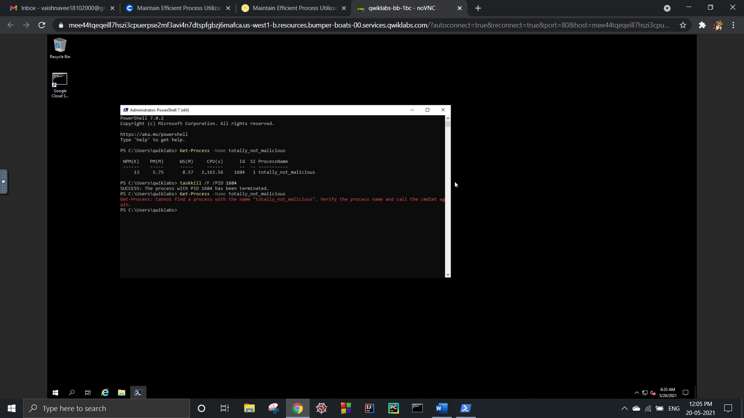

**2.Terminating multiple processes:**

Step 1: To find all the processes containing the string “razzle”, use the wildcard symbol: **Get-Process -Name *razzle*.**

Step 2: Terminate the processes one at a time using taskkill /F /PID [process_id]. Termination can be verified using **Get-Process -Name *razzle\*** (will show no output).

