TrueShield AI
Real-Time AI-Driven Scam Call Detection System
Vaishnavi Trivedi | B.Tech CSE (Cybersecurity) | GHRCE Nagpur

Research Diagrams & System Architecture Figures
◆ Figure 1: TrueShield AI — End-to-End System Architecture
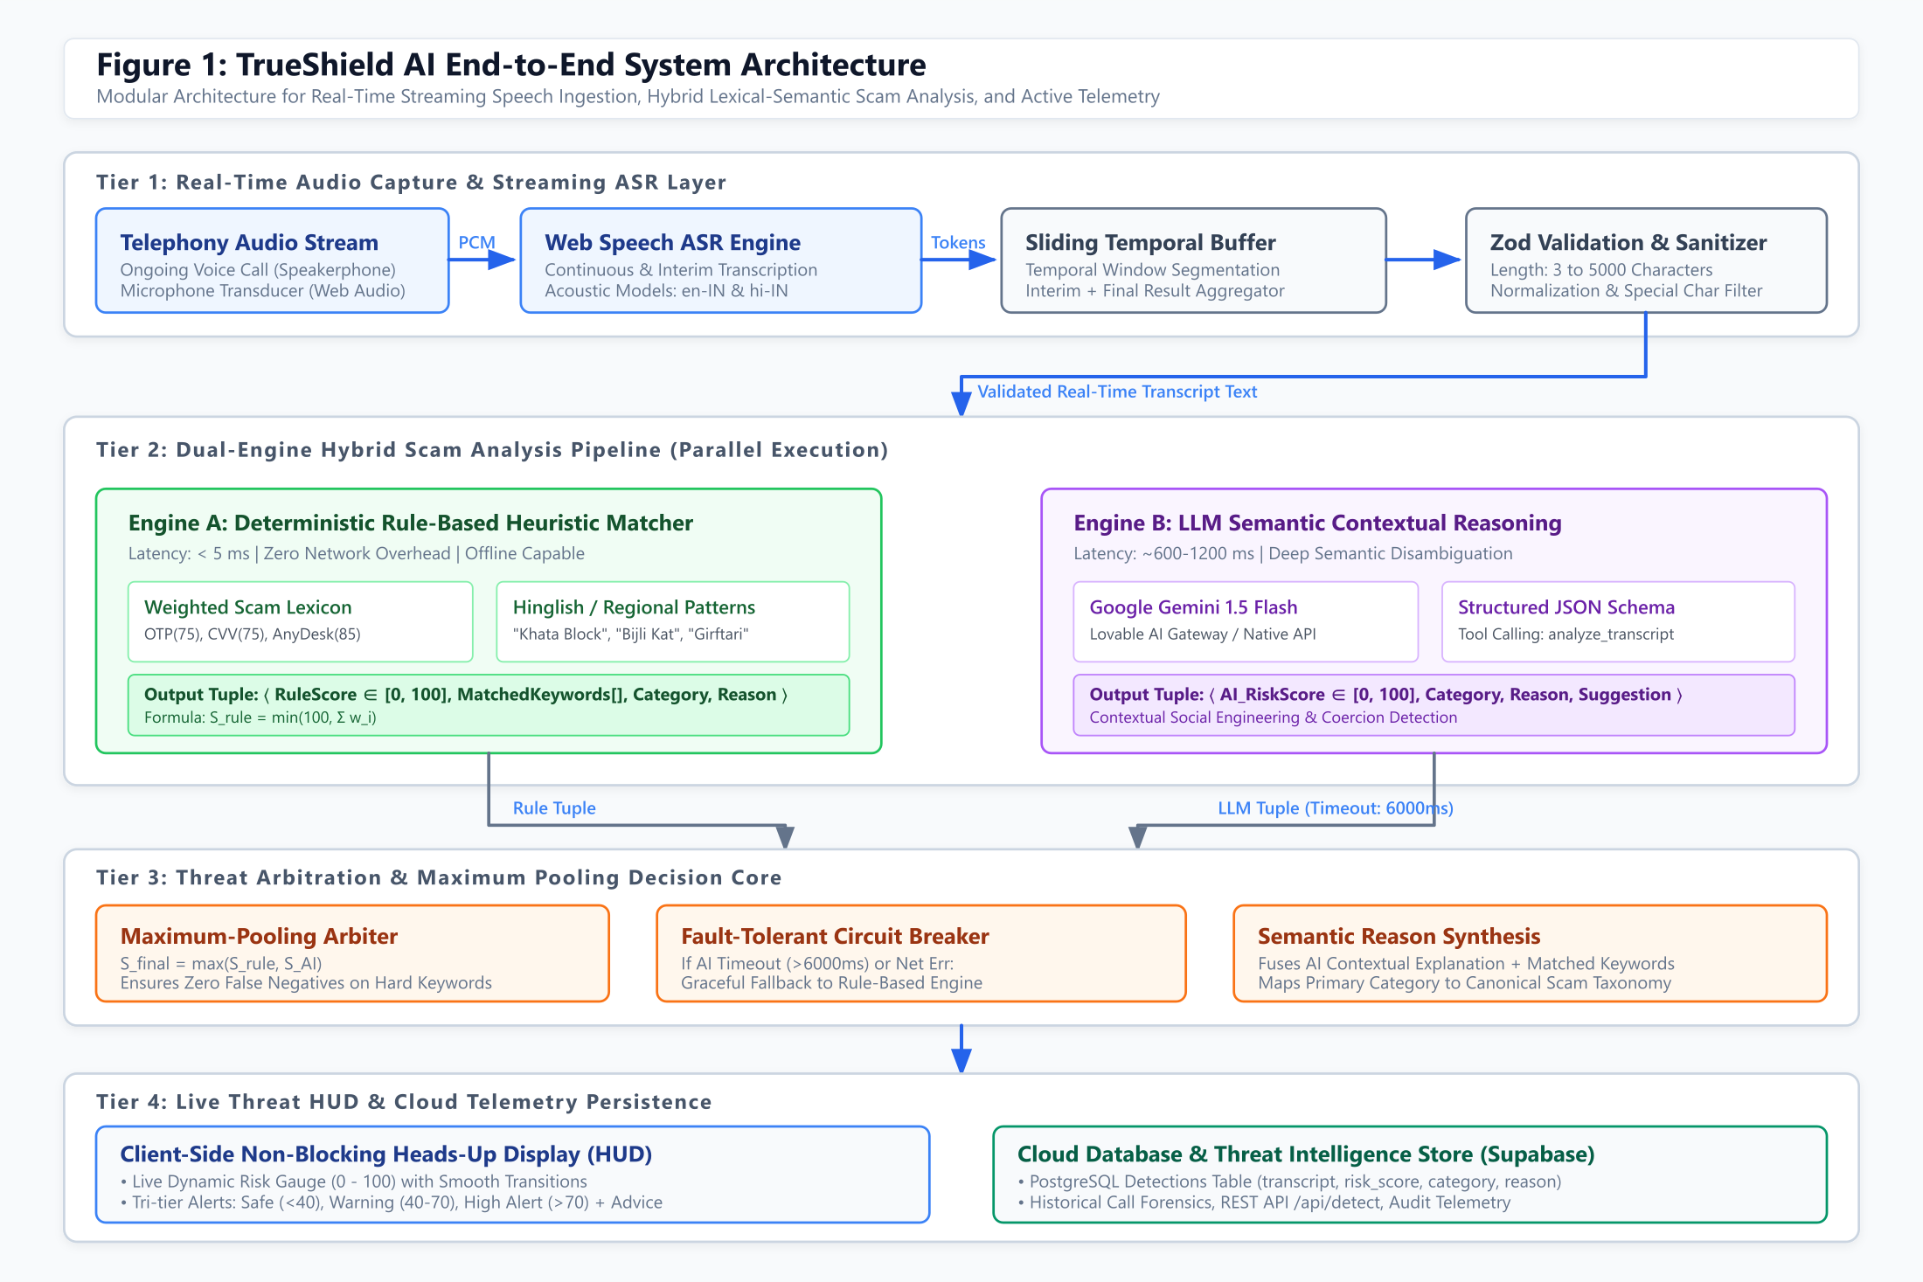
Fig. 1. Complete 4-tier pipeline showing Real-Time Audio Capture & Streaming ASR → Dual-Engine Hybrid Analysis (Rule Matcher + Gemini LLM) → Maximum-Pooling Threat Arbitration → Live HUD & Supabase Cloud Persistence.

◆ Figure 2: Real-Time Detection Workflow & Decision State Machine
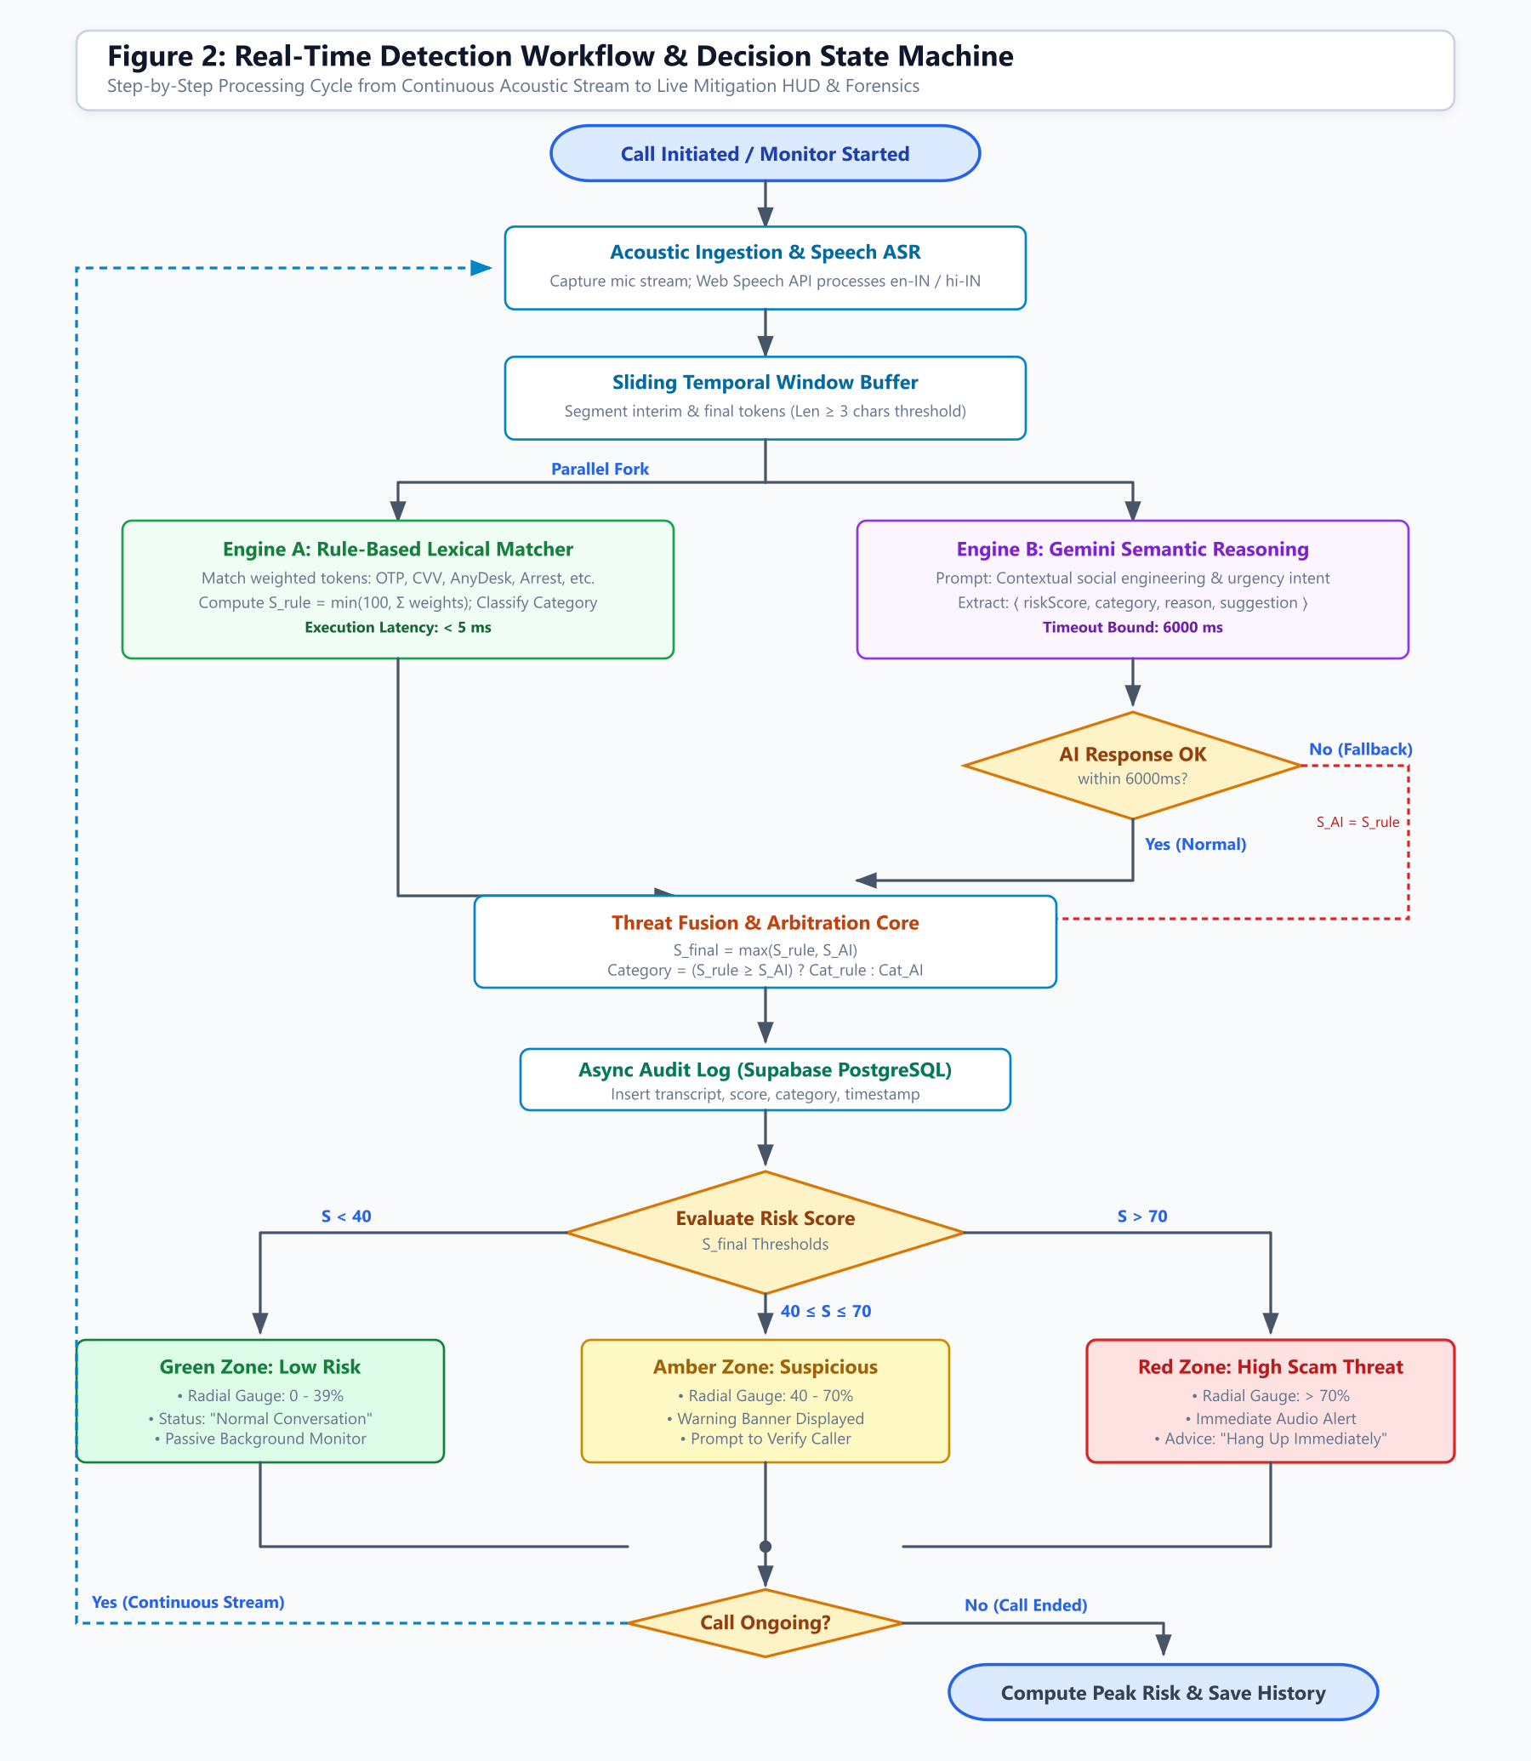
Fig. 2. ISO-standard process flowchart illustrating the continuous acoustic stream loop, parallel dual-engine execution, 6000 ms circuit-breaker timeout fallback, and tri-tier risk threshold routing (Safe / Suspicious / Critical).

◆ Figure 3: Hybrid Threat Fusion Pipeline & Max-Pooling Arbitration Model
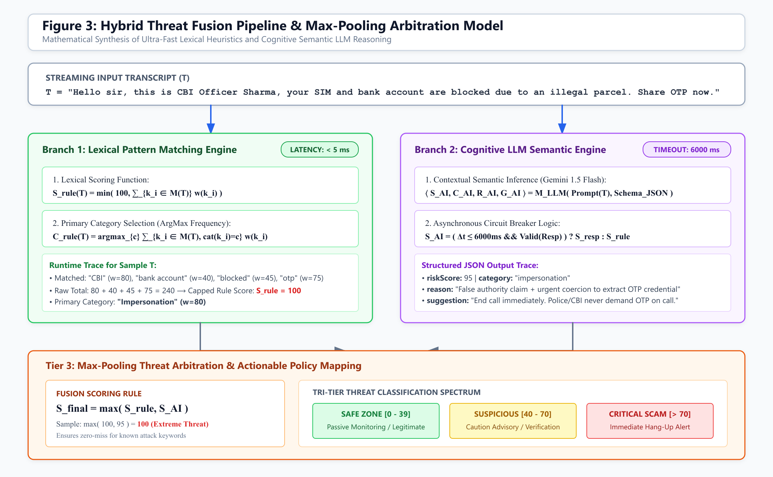
Fig. 3. Mathematical formulation of lexical weight accumulation (Engine A), Gemini LLM structured JSON inference (Engine B), and the Max-Pooling fusion operator: S_final = max(S_rule, S_AI). Includes worked trace for a real-world CBI/OTP scam transcript.

◆ Figure 4: TrueShield AI — Phone Scam Threat Taxonomy & Vector Ontology
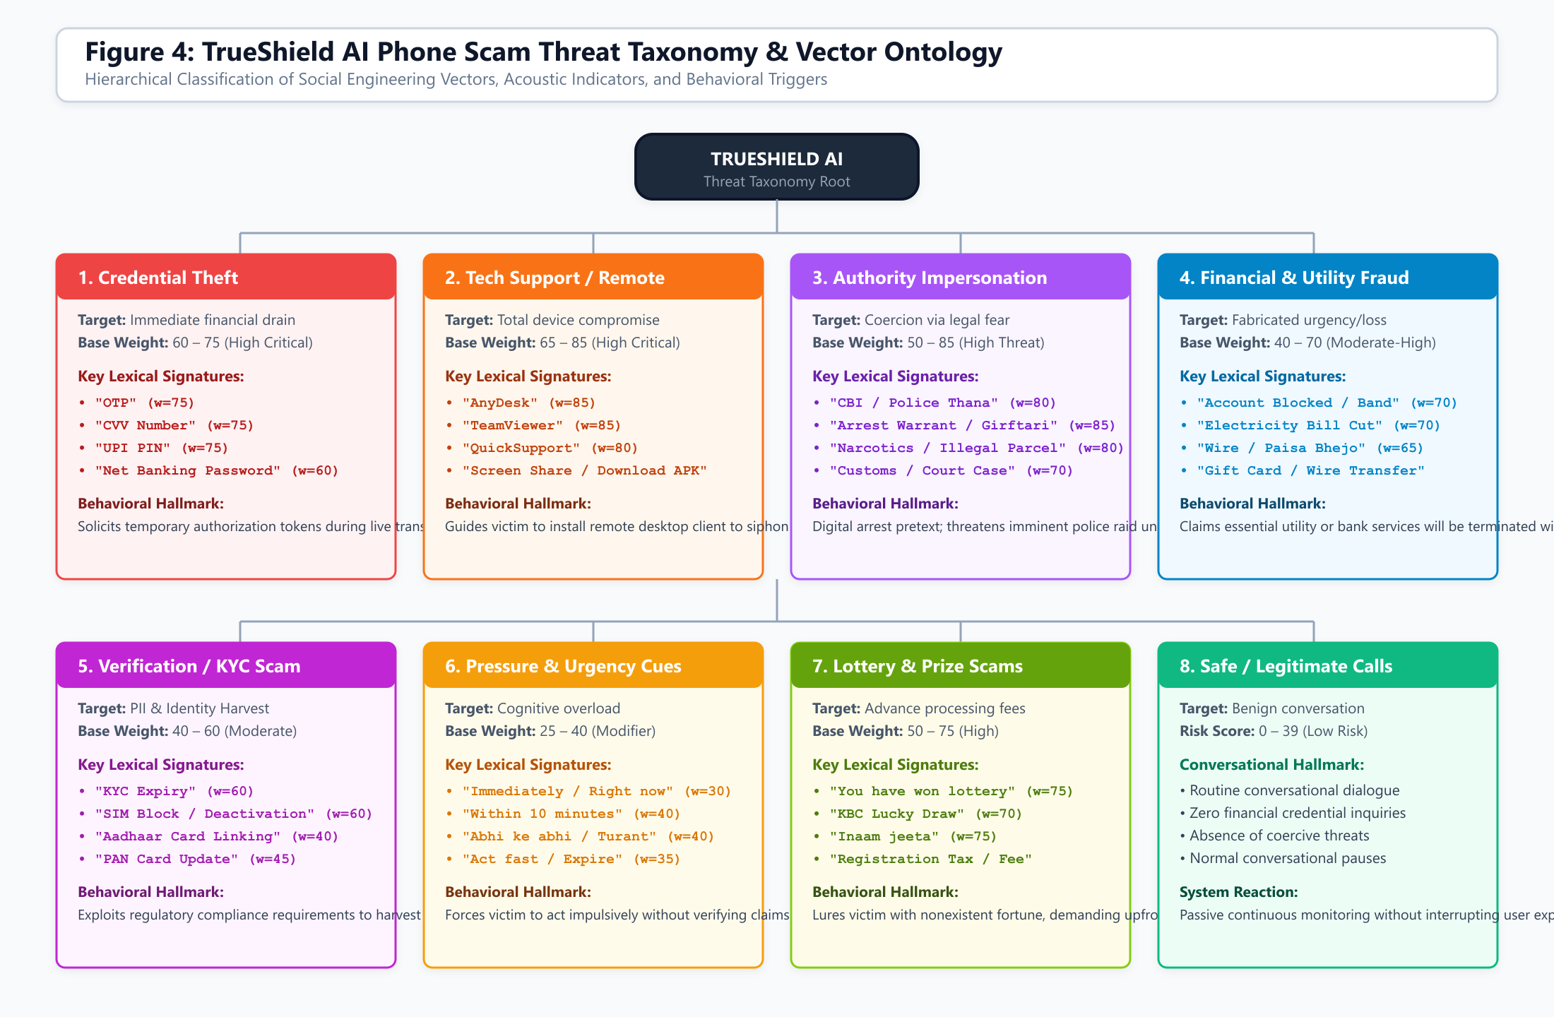
Fig. 4. Hierarchical 8-class taxonomy of phone fraud vectors modeled by TrueShield AI: Credential Theft, Tech Support/Remote Access, Authority Impersonation (CBI/Police), Financial/Utility Fraud, Verification/KYC, Pressure Tactics, Lottery/Prize Scams, and Safe Baseline.

◆ Figure 5: Conceptual Graphical Abstract — TrueShield AI Overview
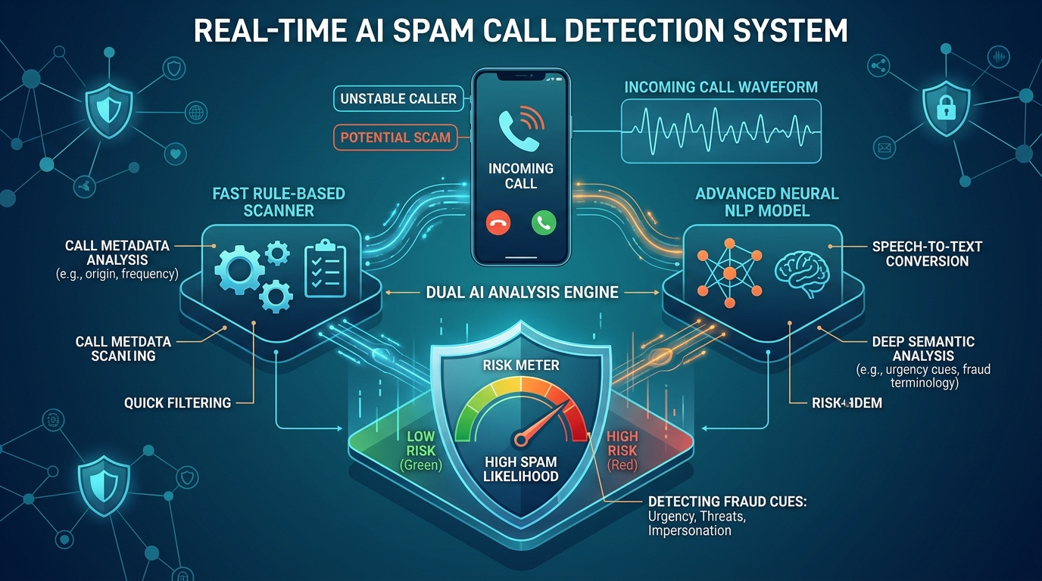
Fig. 5. Conceptual illustration of TrueShield AI real-time in-call acoustic waveform capture, dual AI threat analysis, and holographic cyber-shield HUD.

Quick Legend — TrueShield AI Risk Score Thresholds
🟢 SAFE (Score 0 – 39)
Normal conversation. No suspicious keywords detected. Passive monitoring continues silently.
🟡 SUSPICIOUS (Score 40 – 70)
Warning banner displayed. Caller should be verified through official channels. Do not share personal data.
🔴 CRITICAL SCAM (Score > 70)
Immediate high-priority alert. Hang up now. Block the number. Do not share OTP, PIN, CVV, or Aadhaar.

Core Fusion Formula: S_final = max( S_rule, S_AI )
Maximum-Pooling ensures zero false negatives — if either engine detects a hard keyword (OTP, AnyDesk, Arrest Warrant), the higher score always wins.

