**Cryptography and Network Security**

**Assignment 15 – Snort Installation**

Name: Vaishnavi Santosh Bhajibhakare

PRN: 2019BTECS00039

Batch: B2

**Title:** Snort Installation

**Installed Snort**

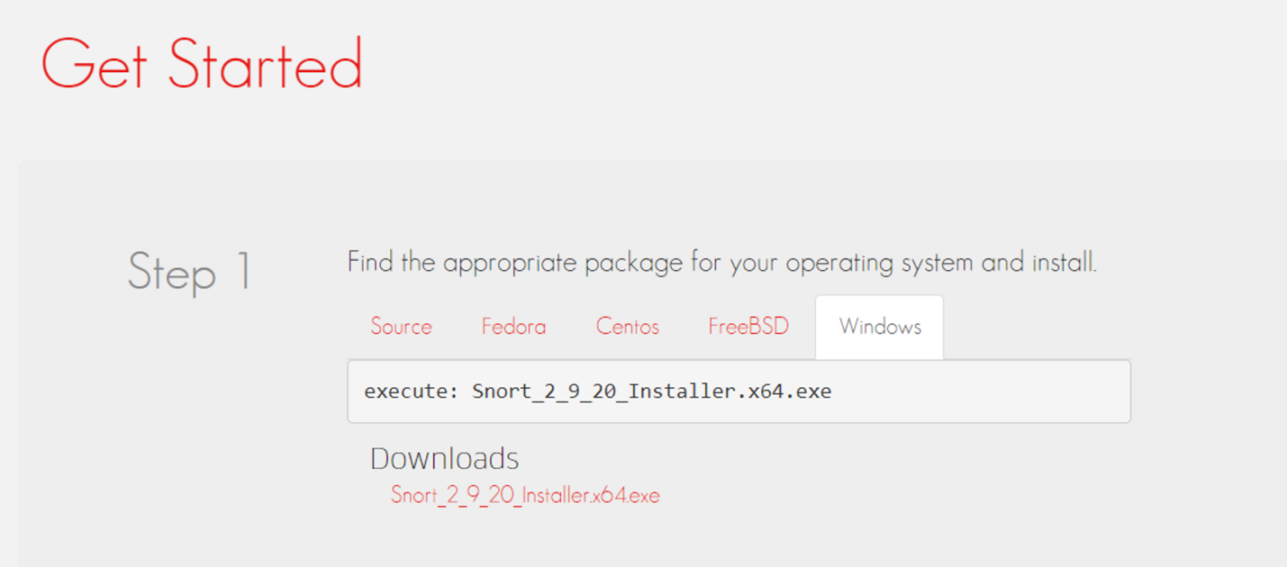

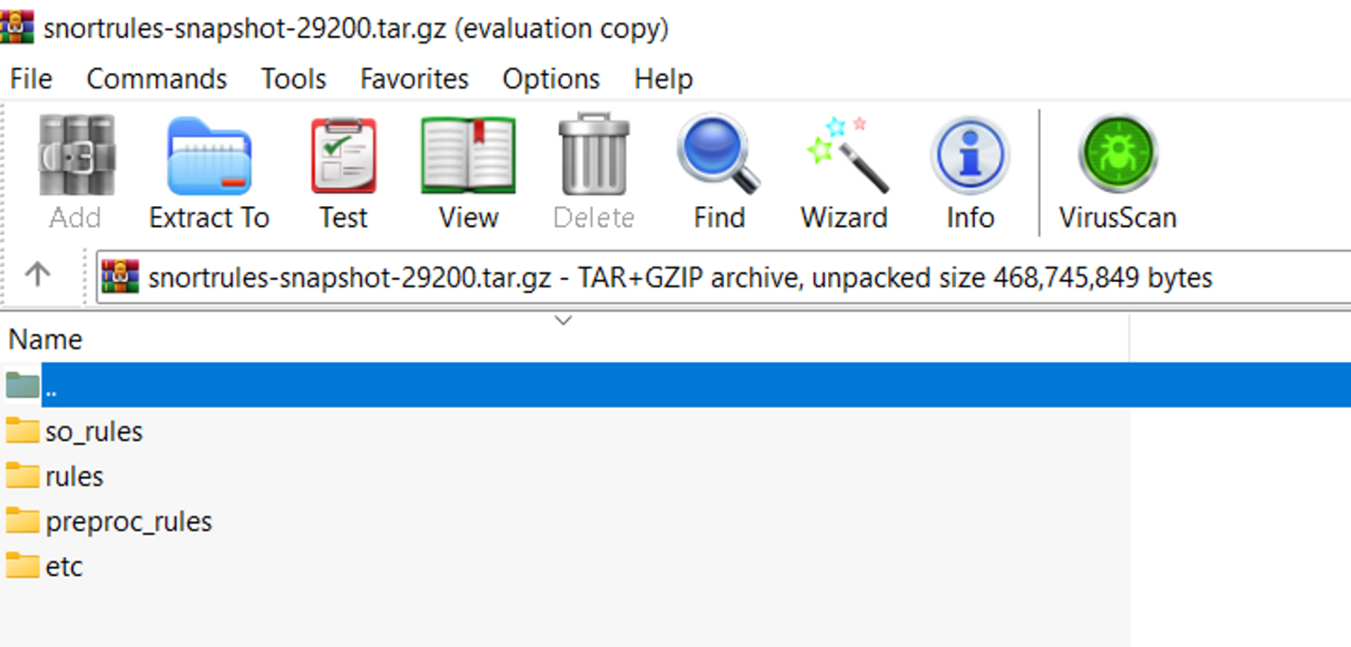

**Add “rules” and “preproc_rules” to the c:\snort\rules and c:\snort\preproc_rules respectively**

**configure the snort.conf file**

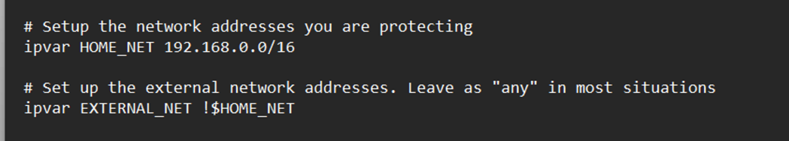

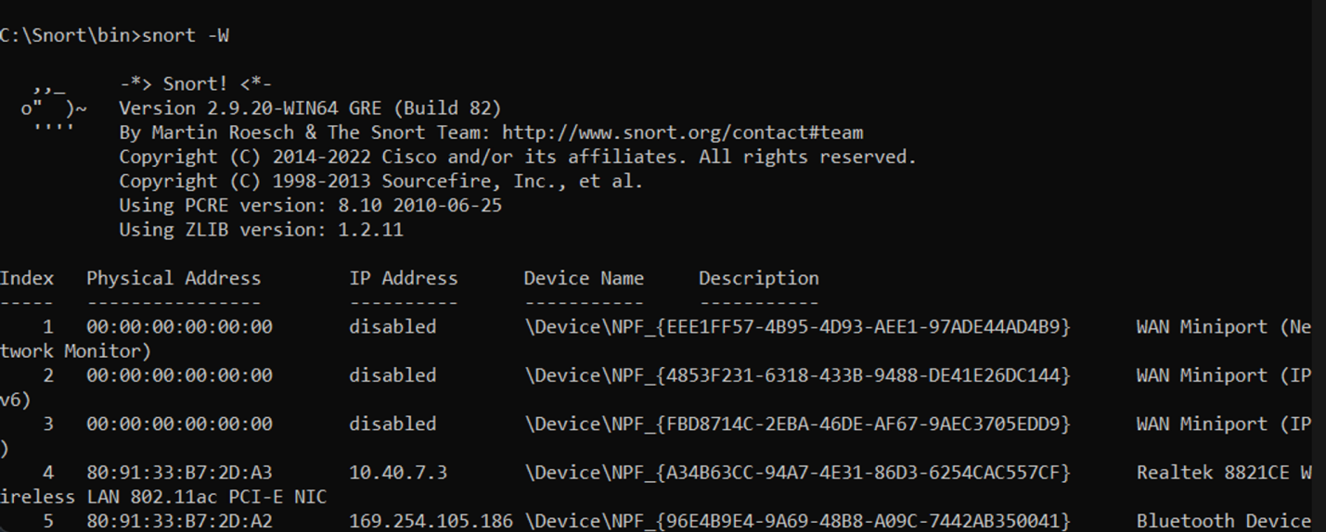

**Testing:**

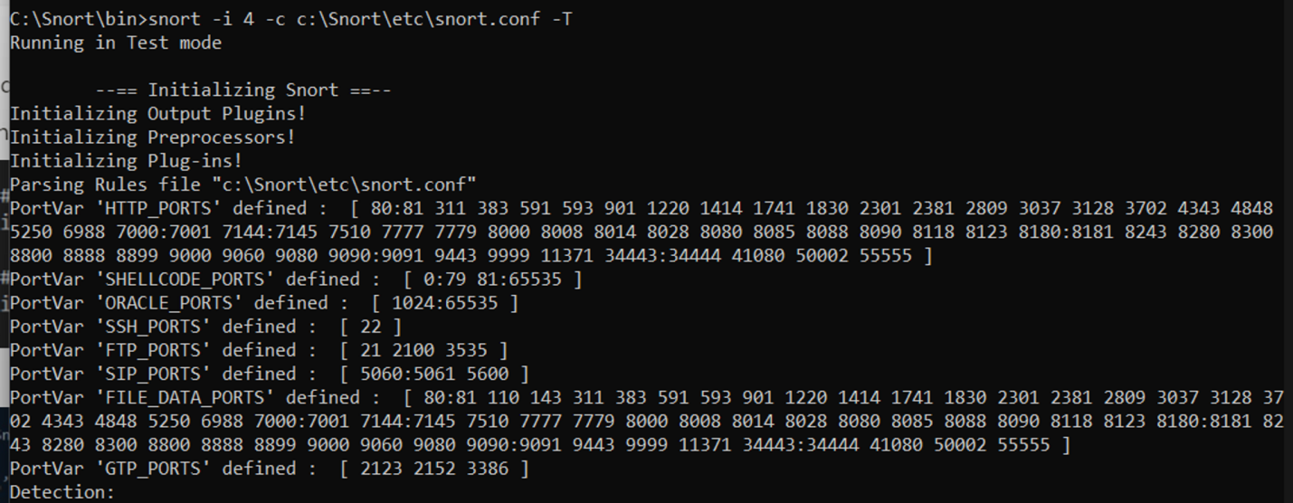

**Add local.rules and**

**Run :**

