Project Log – cap1_haseeb ETL Pipeline with Unity Catalog & DLT
1. Azure Setup
- Created ADLS Gen2 storage account: haseebstore
- Created container:

haseebstore rawraw_data→ retail_iot_data.csv
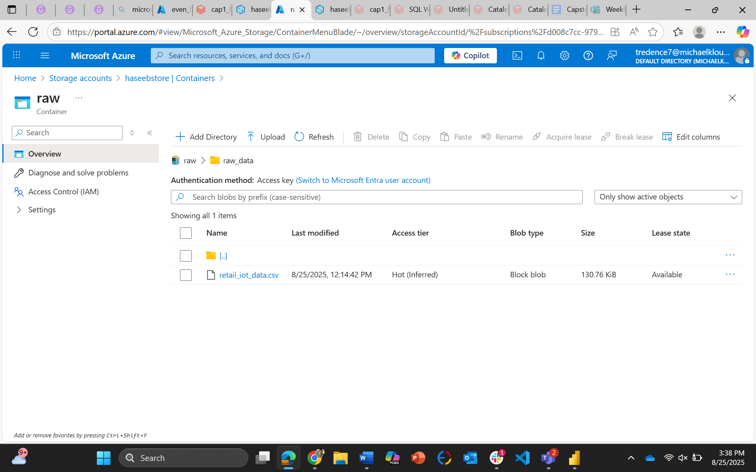

Enable hierarchy in storage account and Add role assigment:-
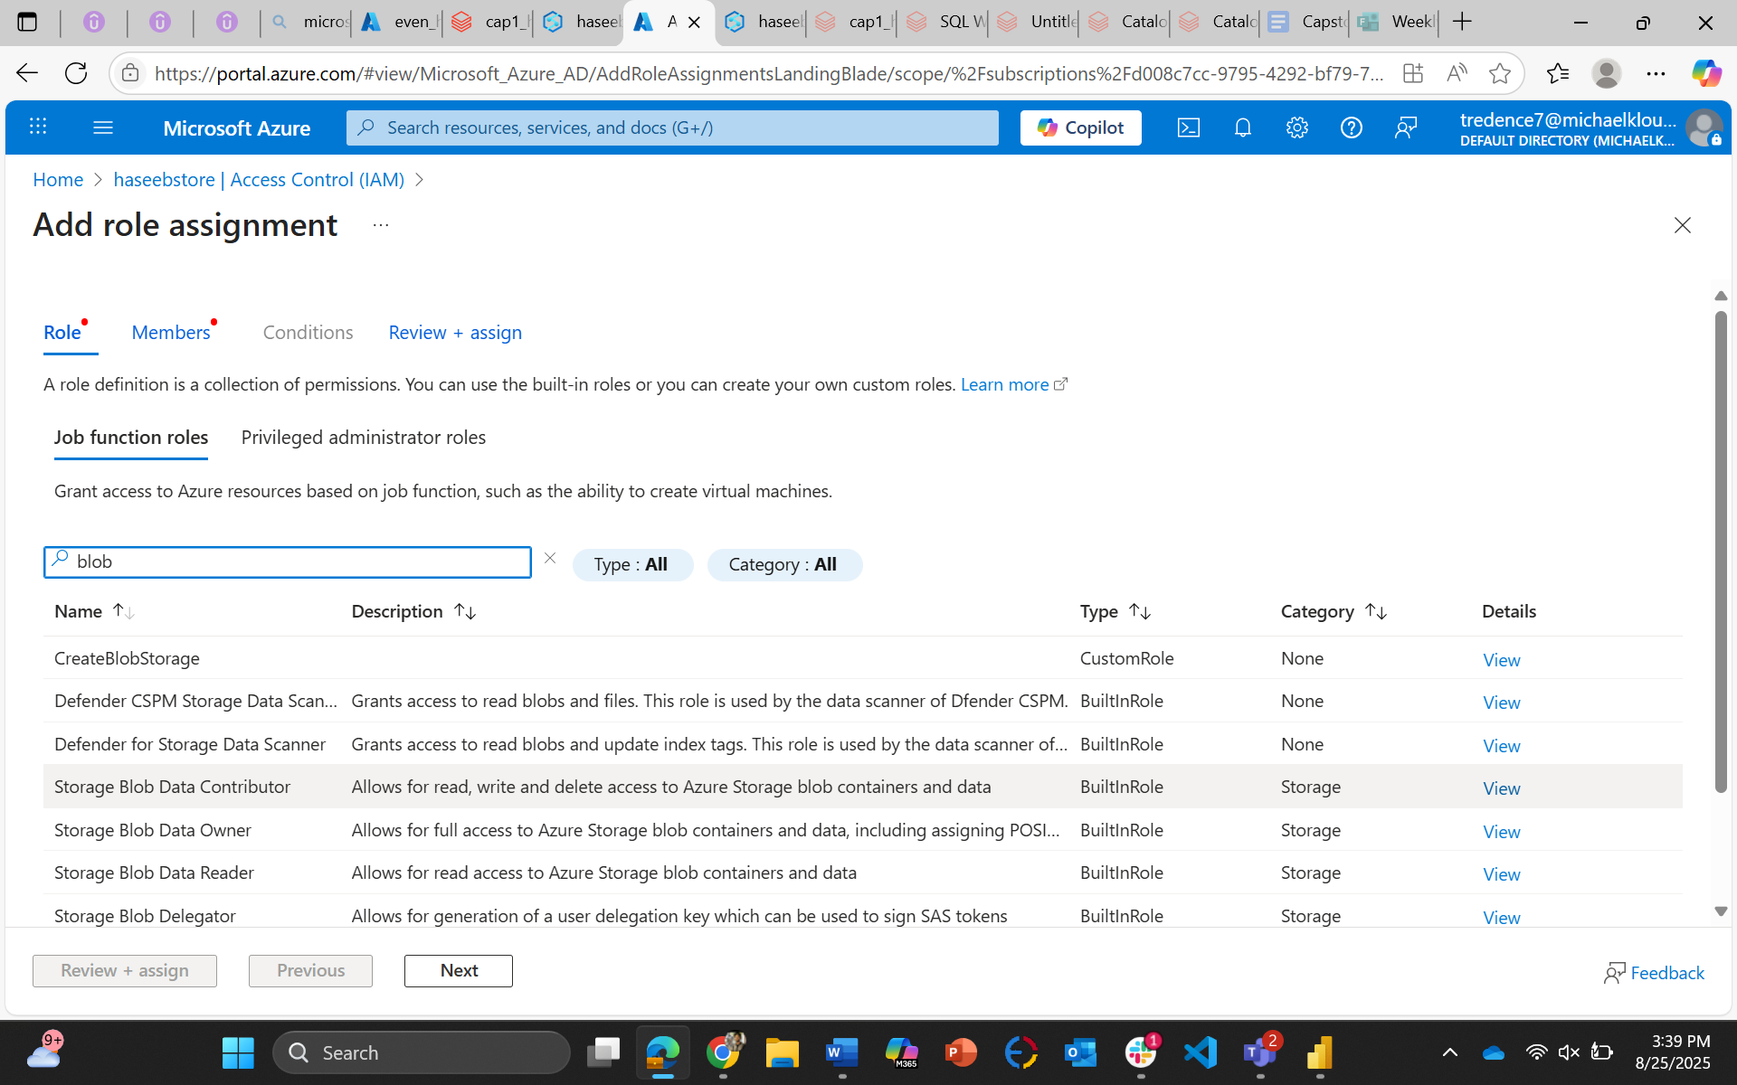

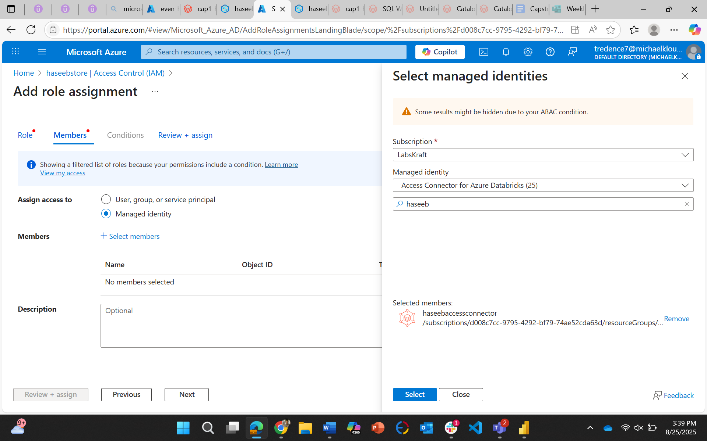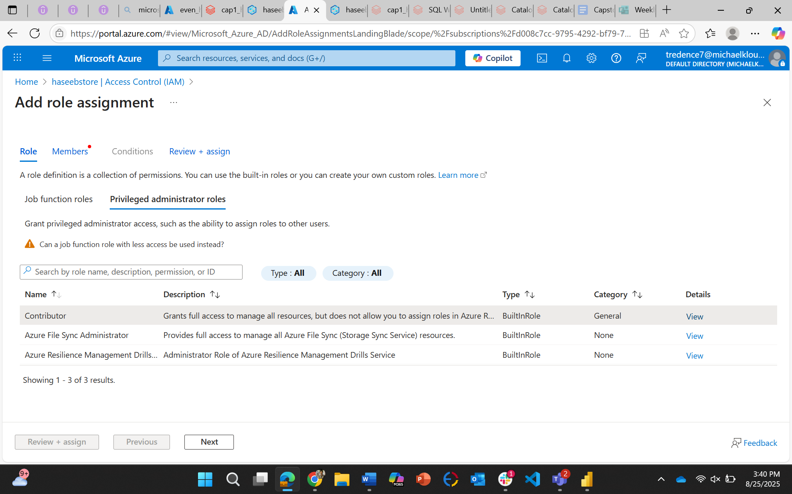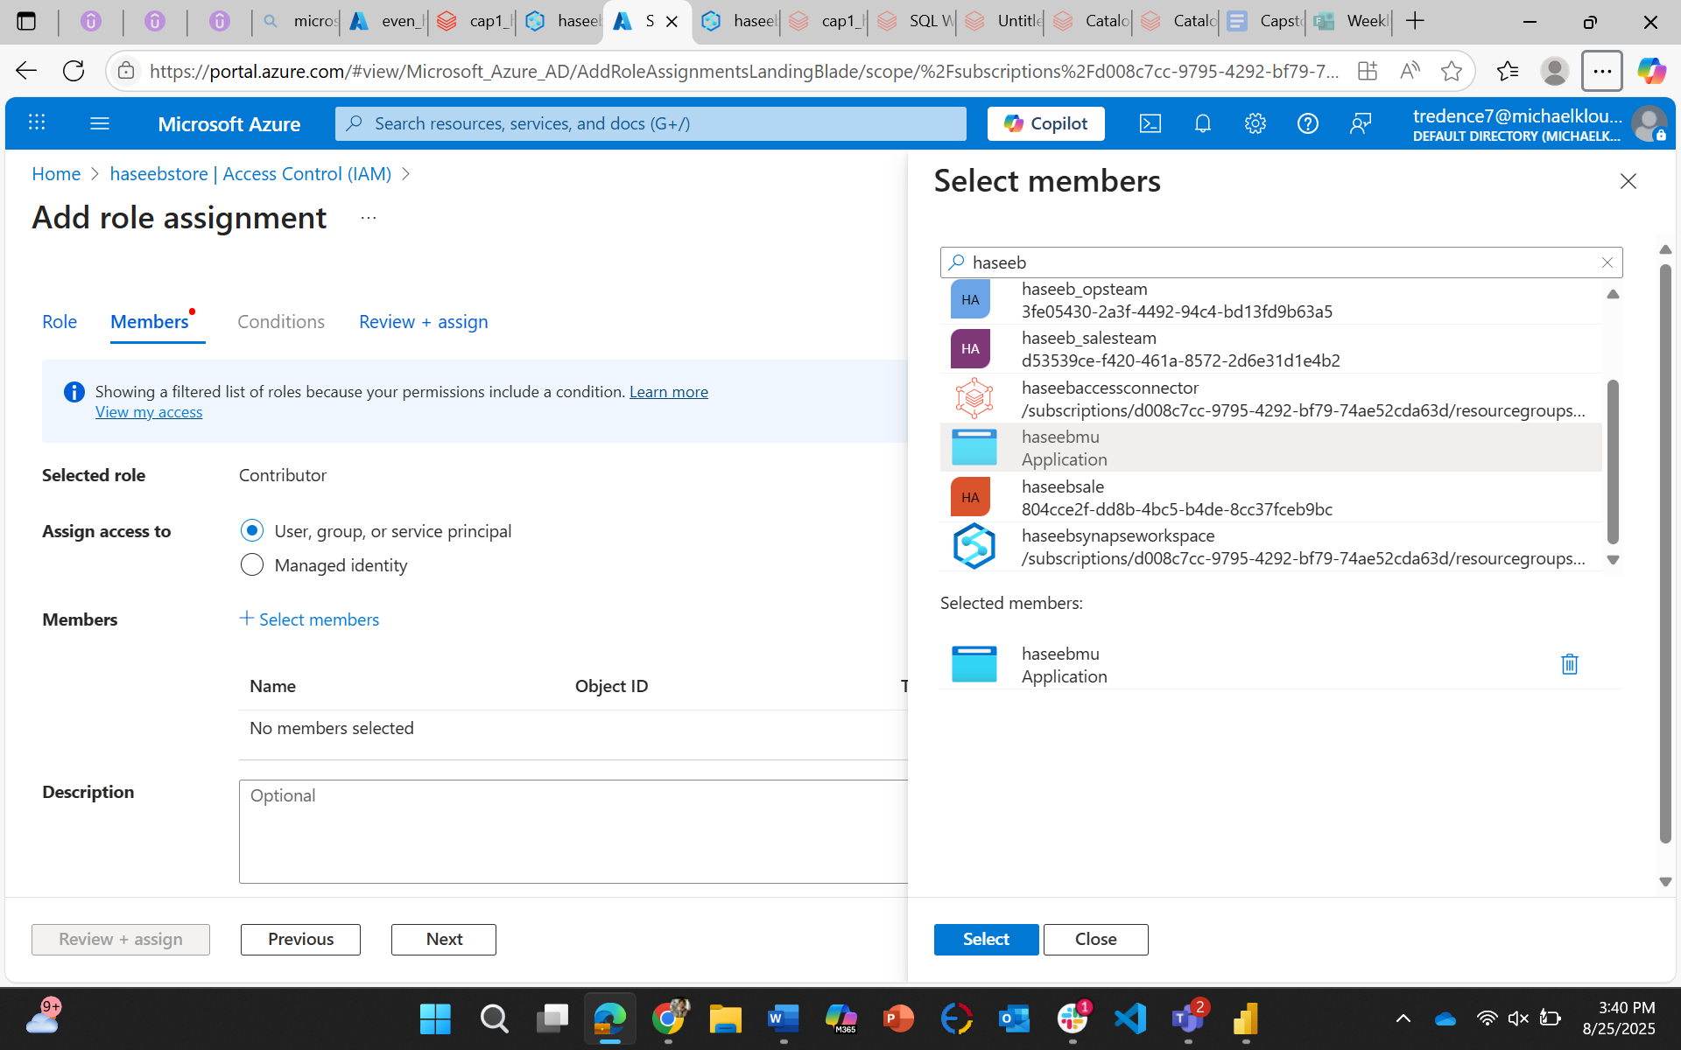

Unity Catalog Setup
- Created Unity Catalog: haseebcat
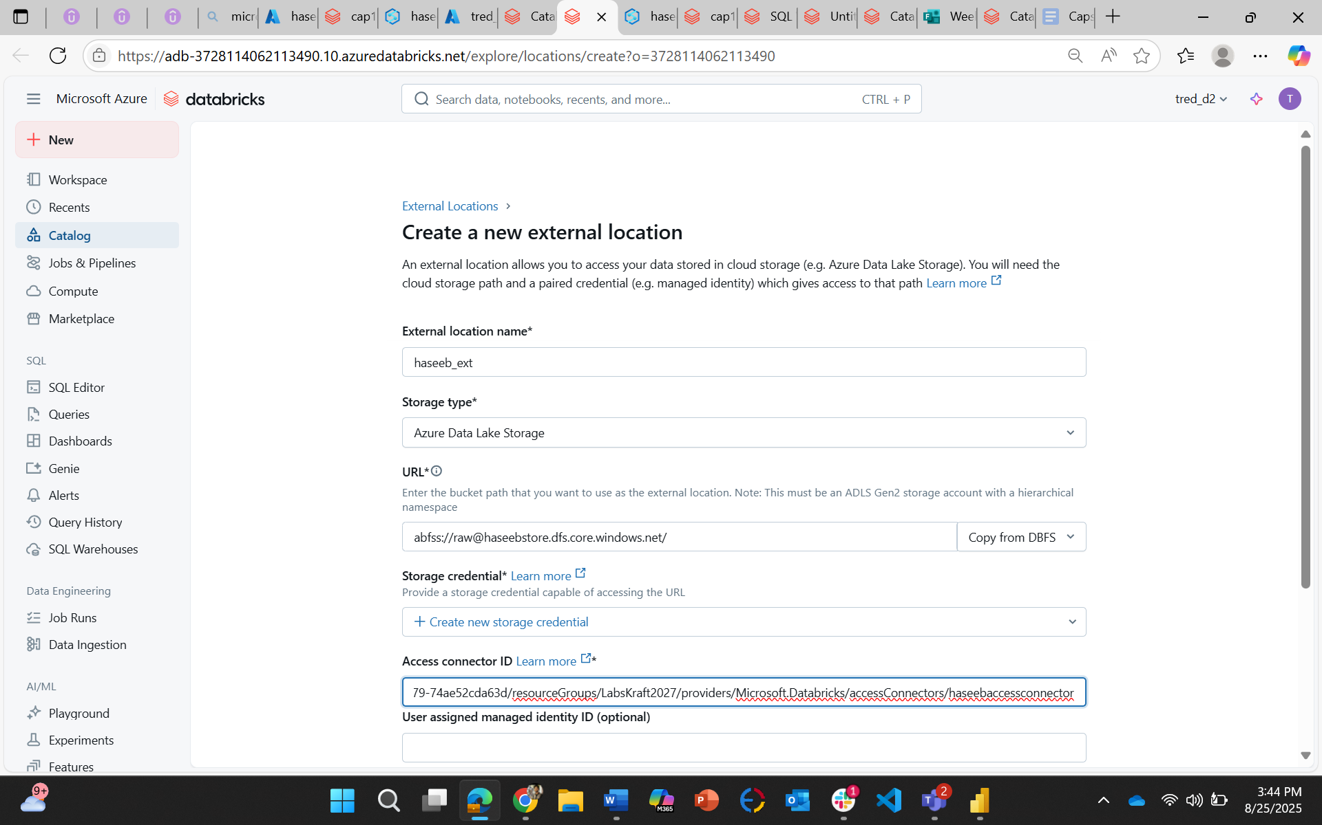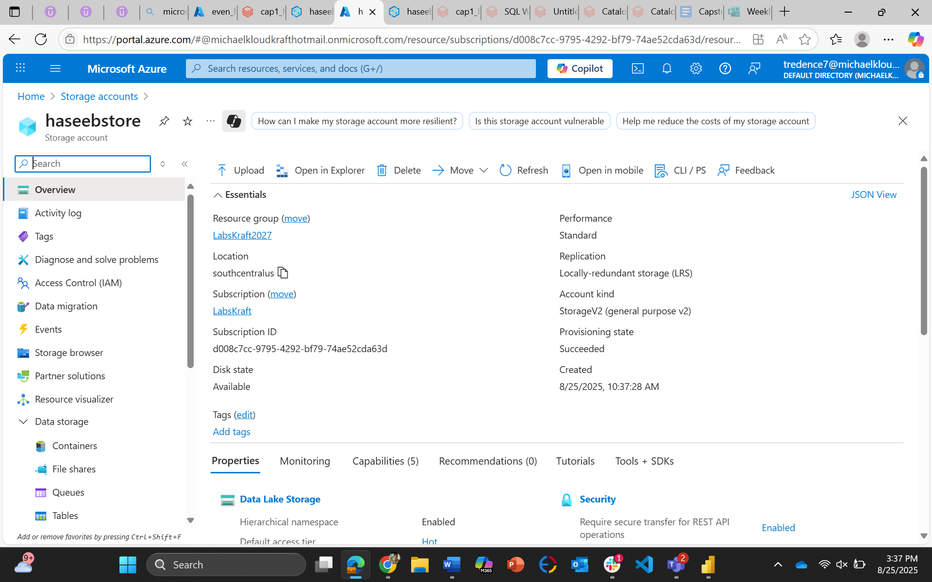
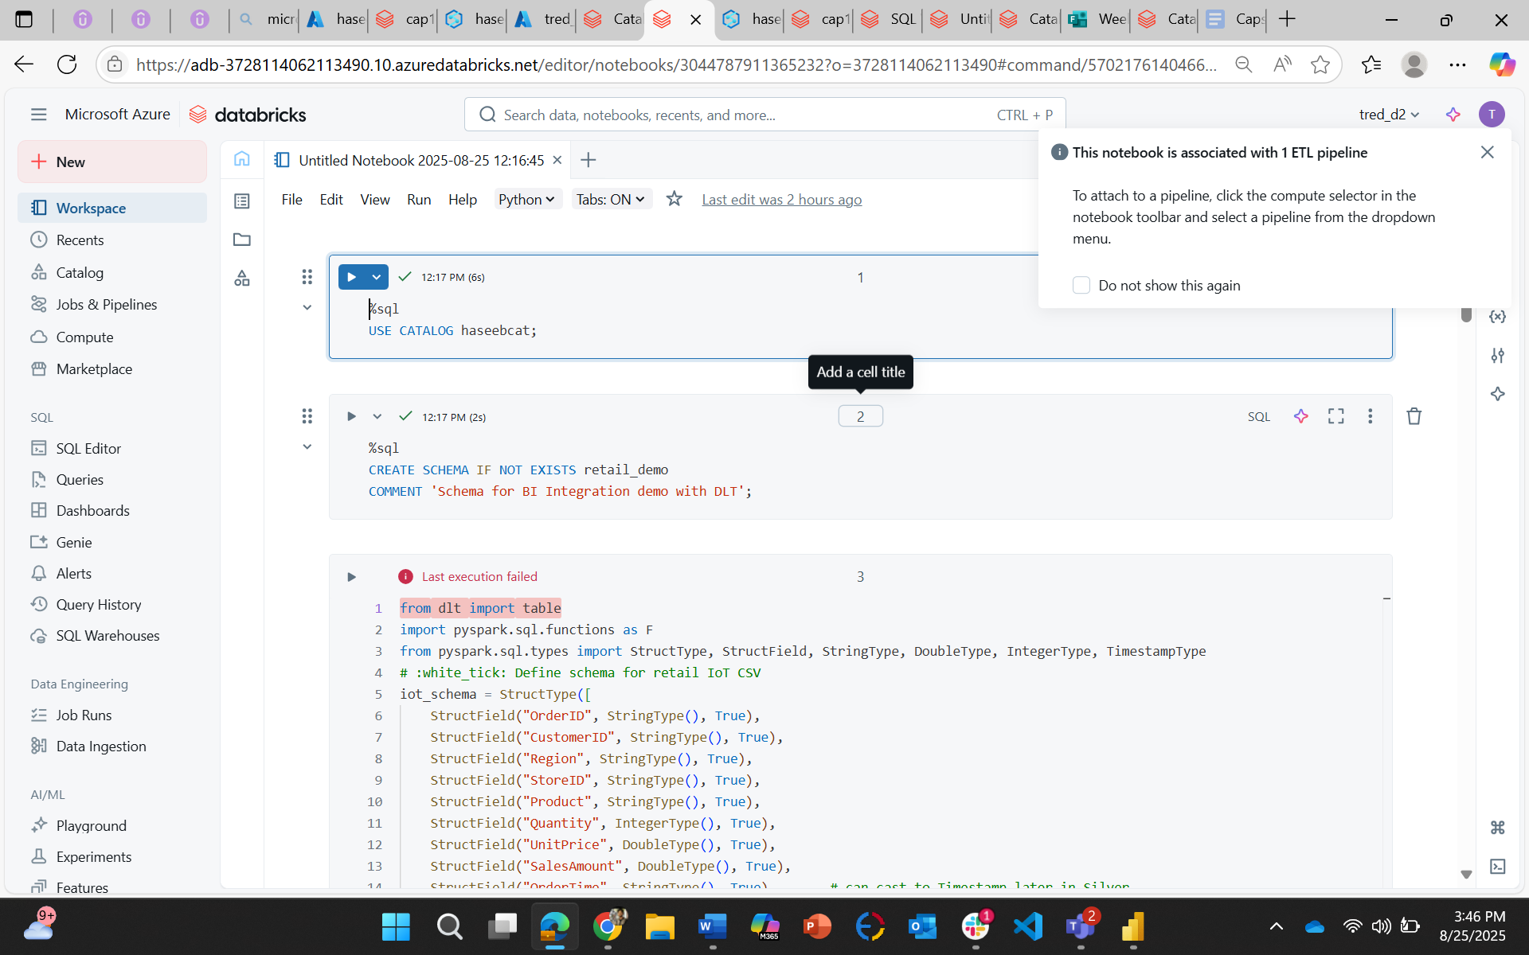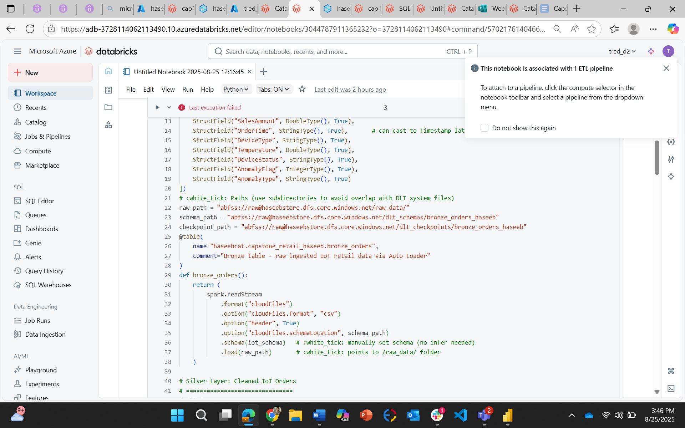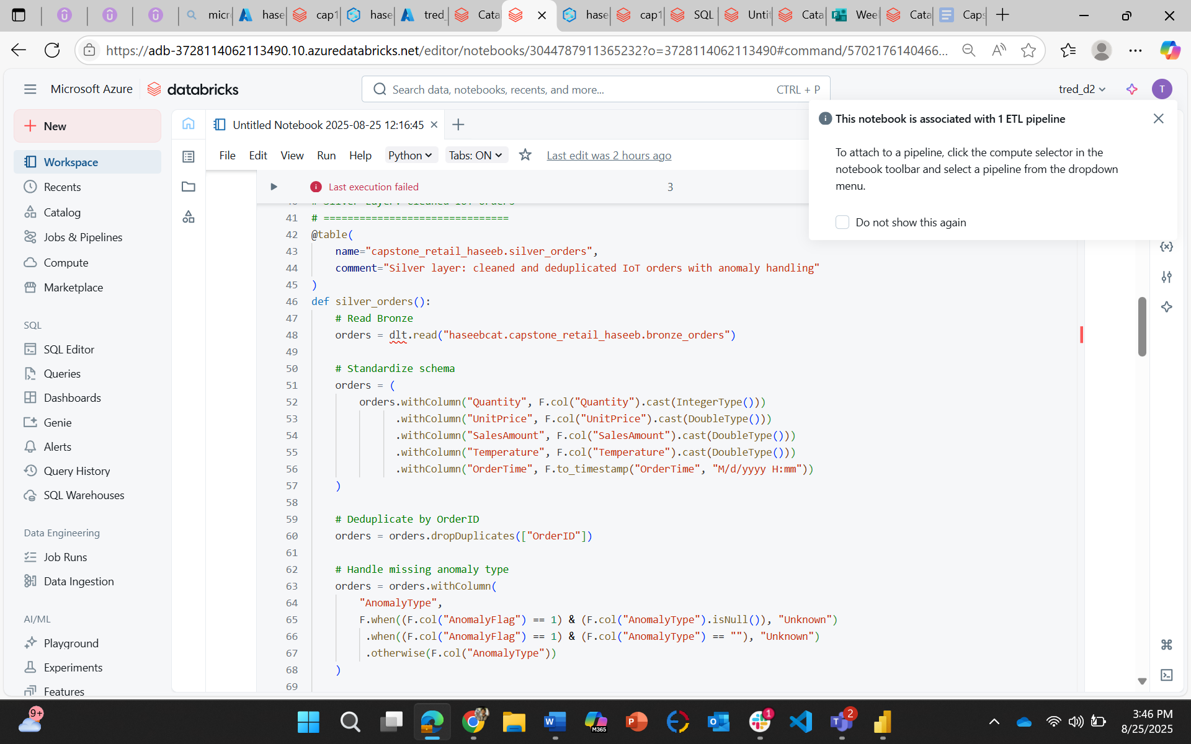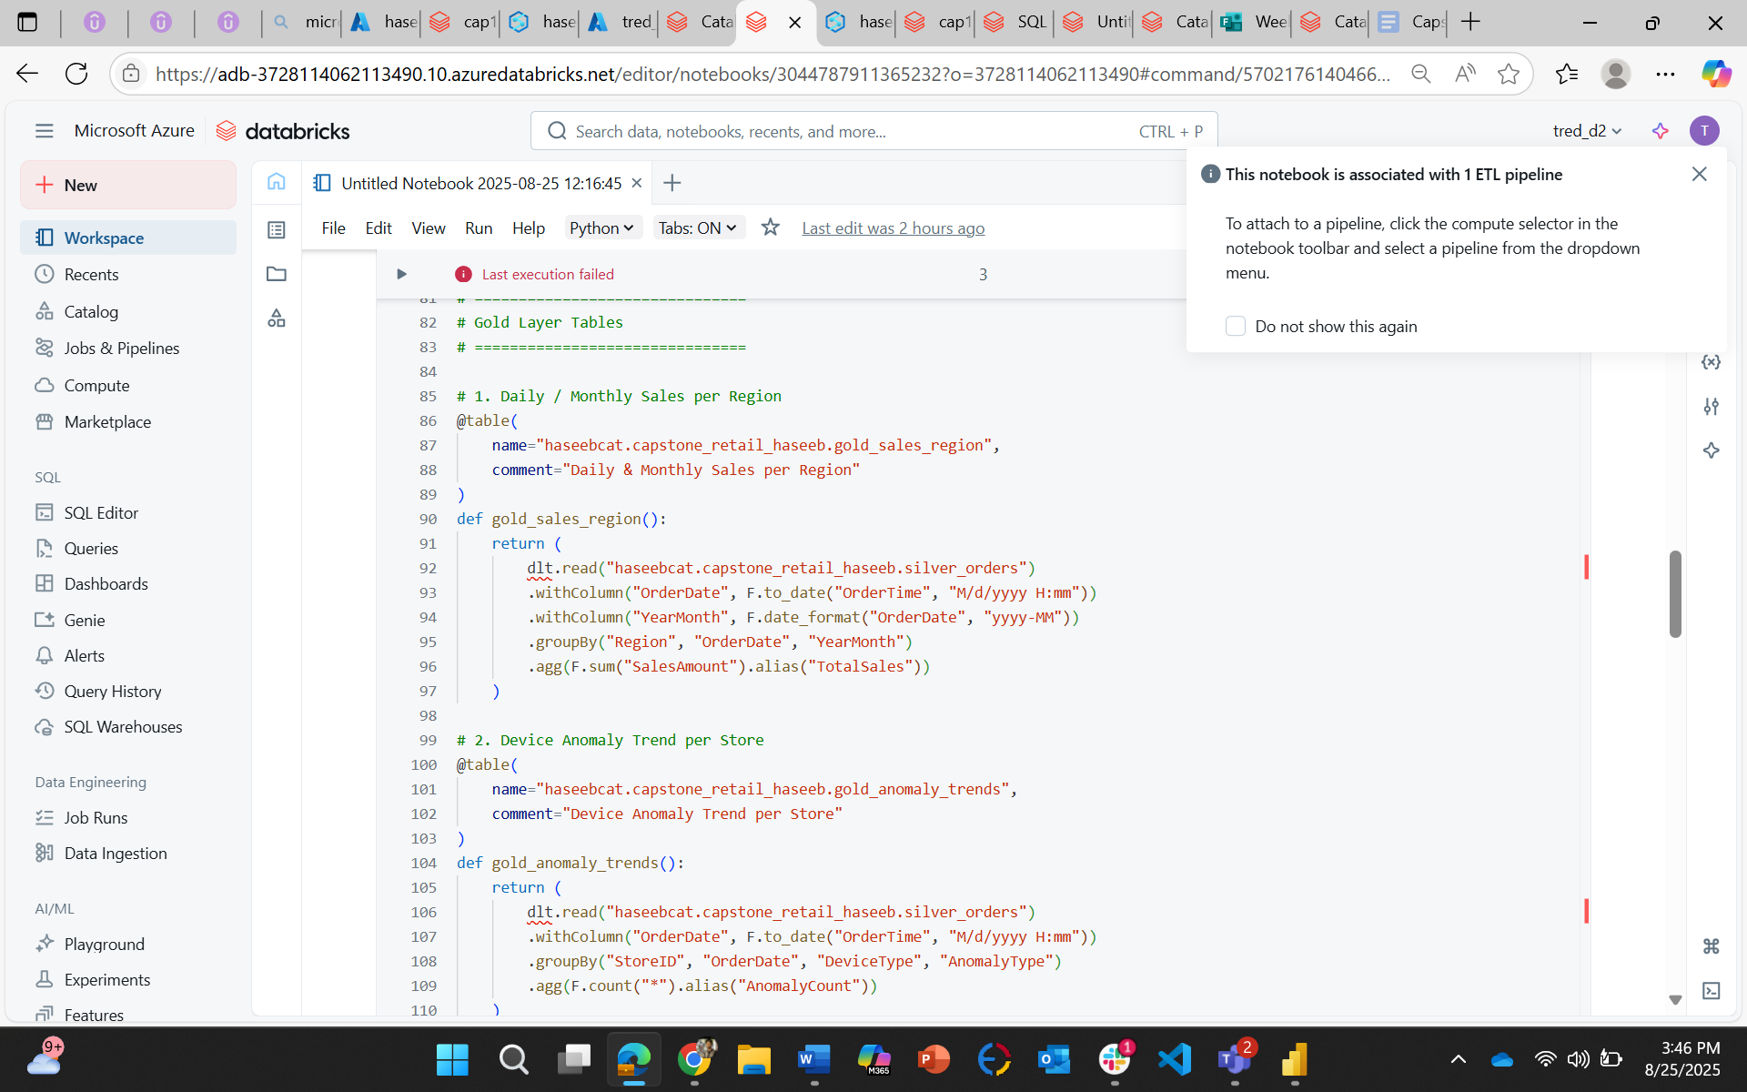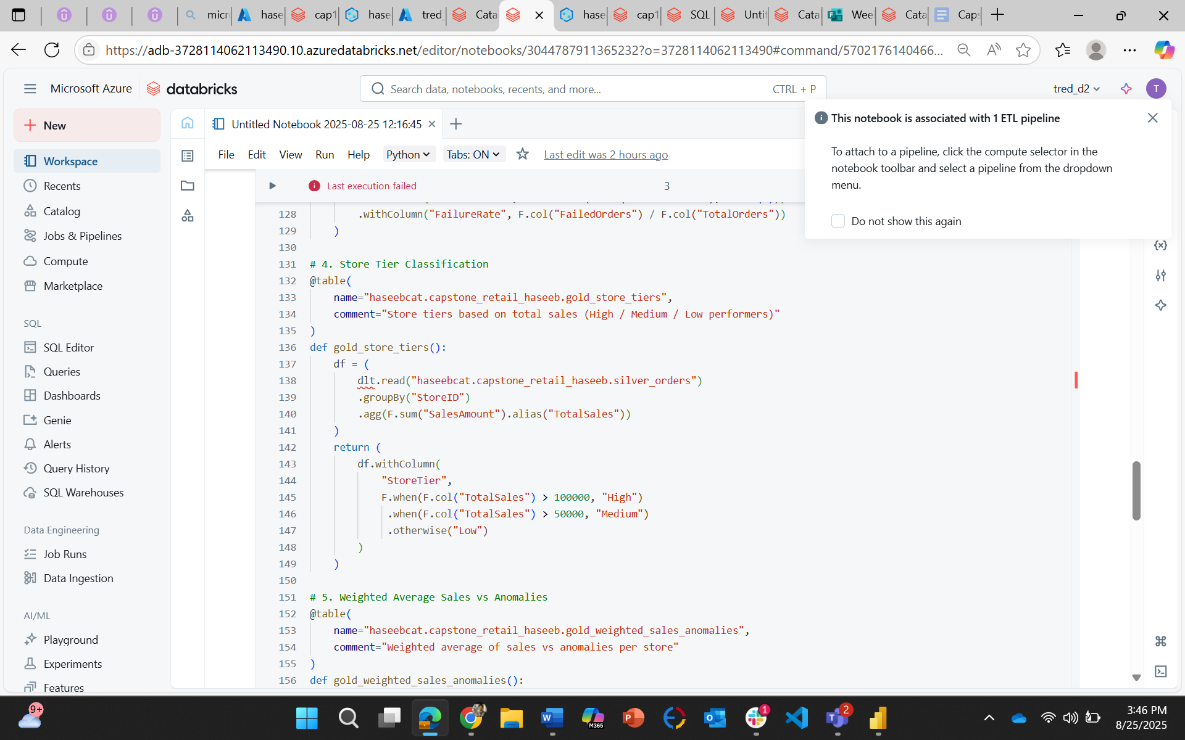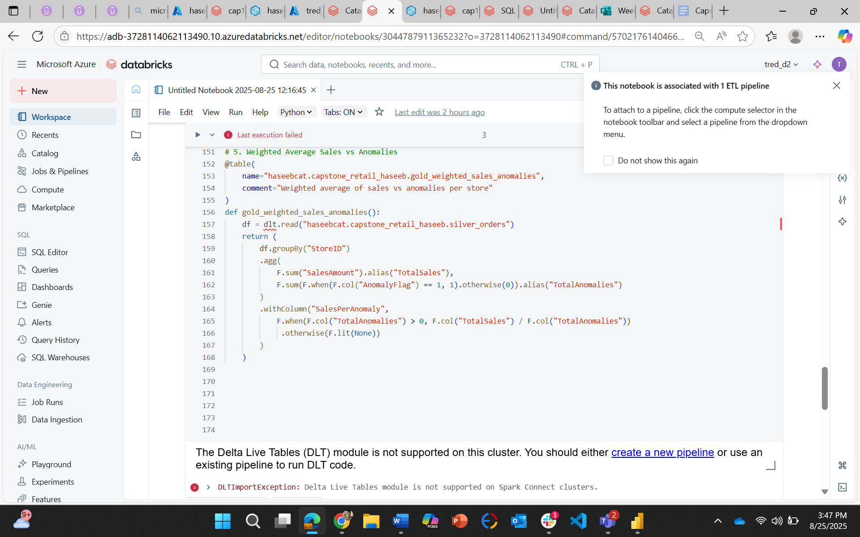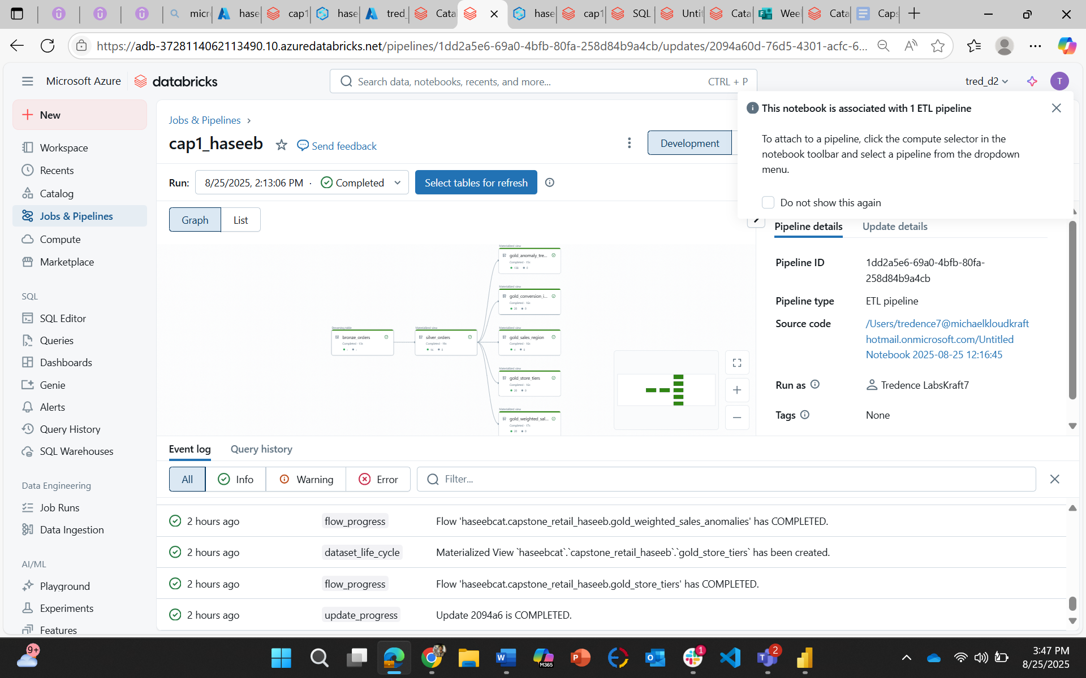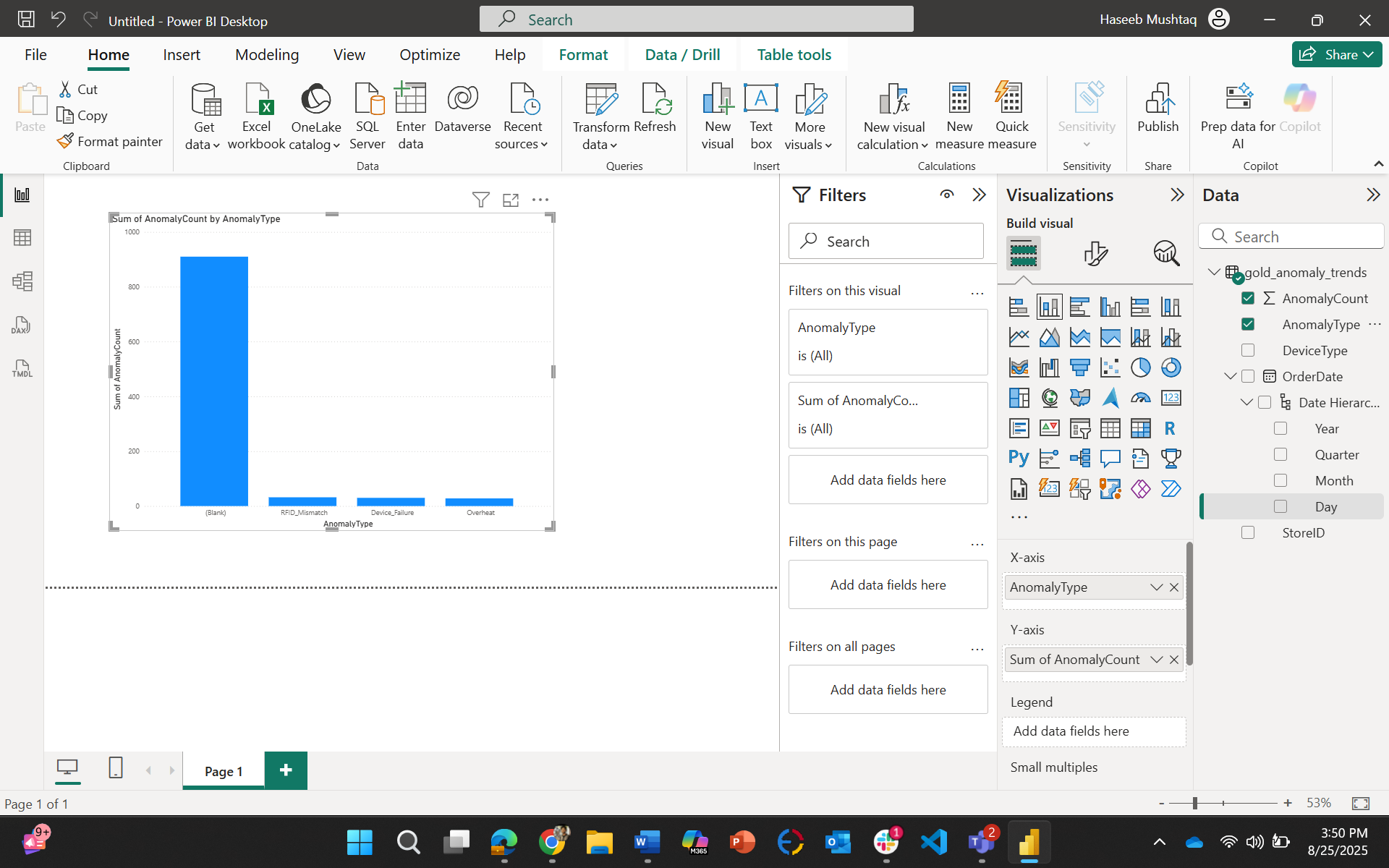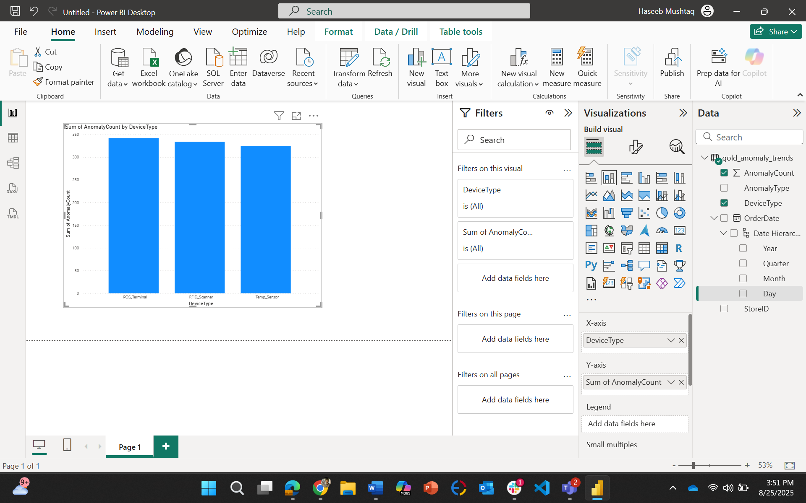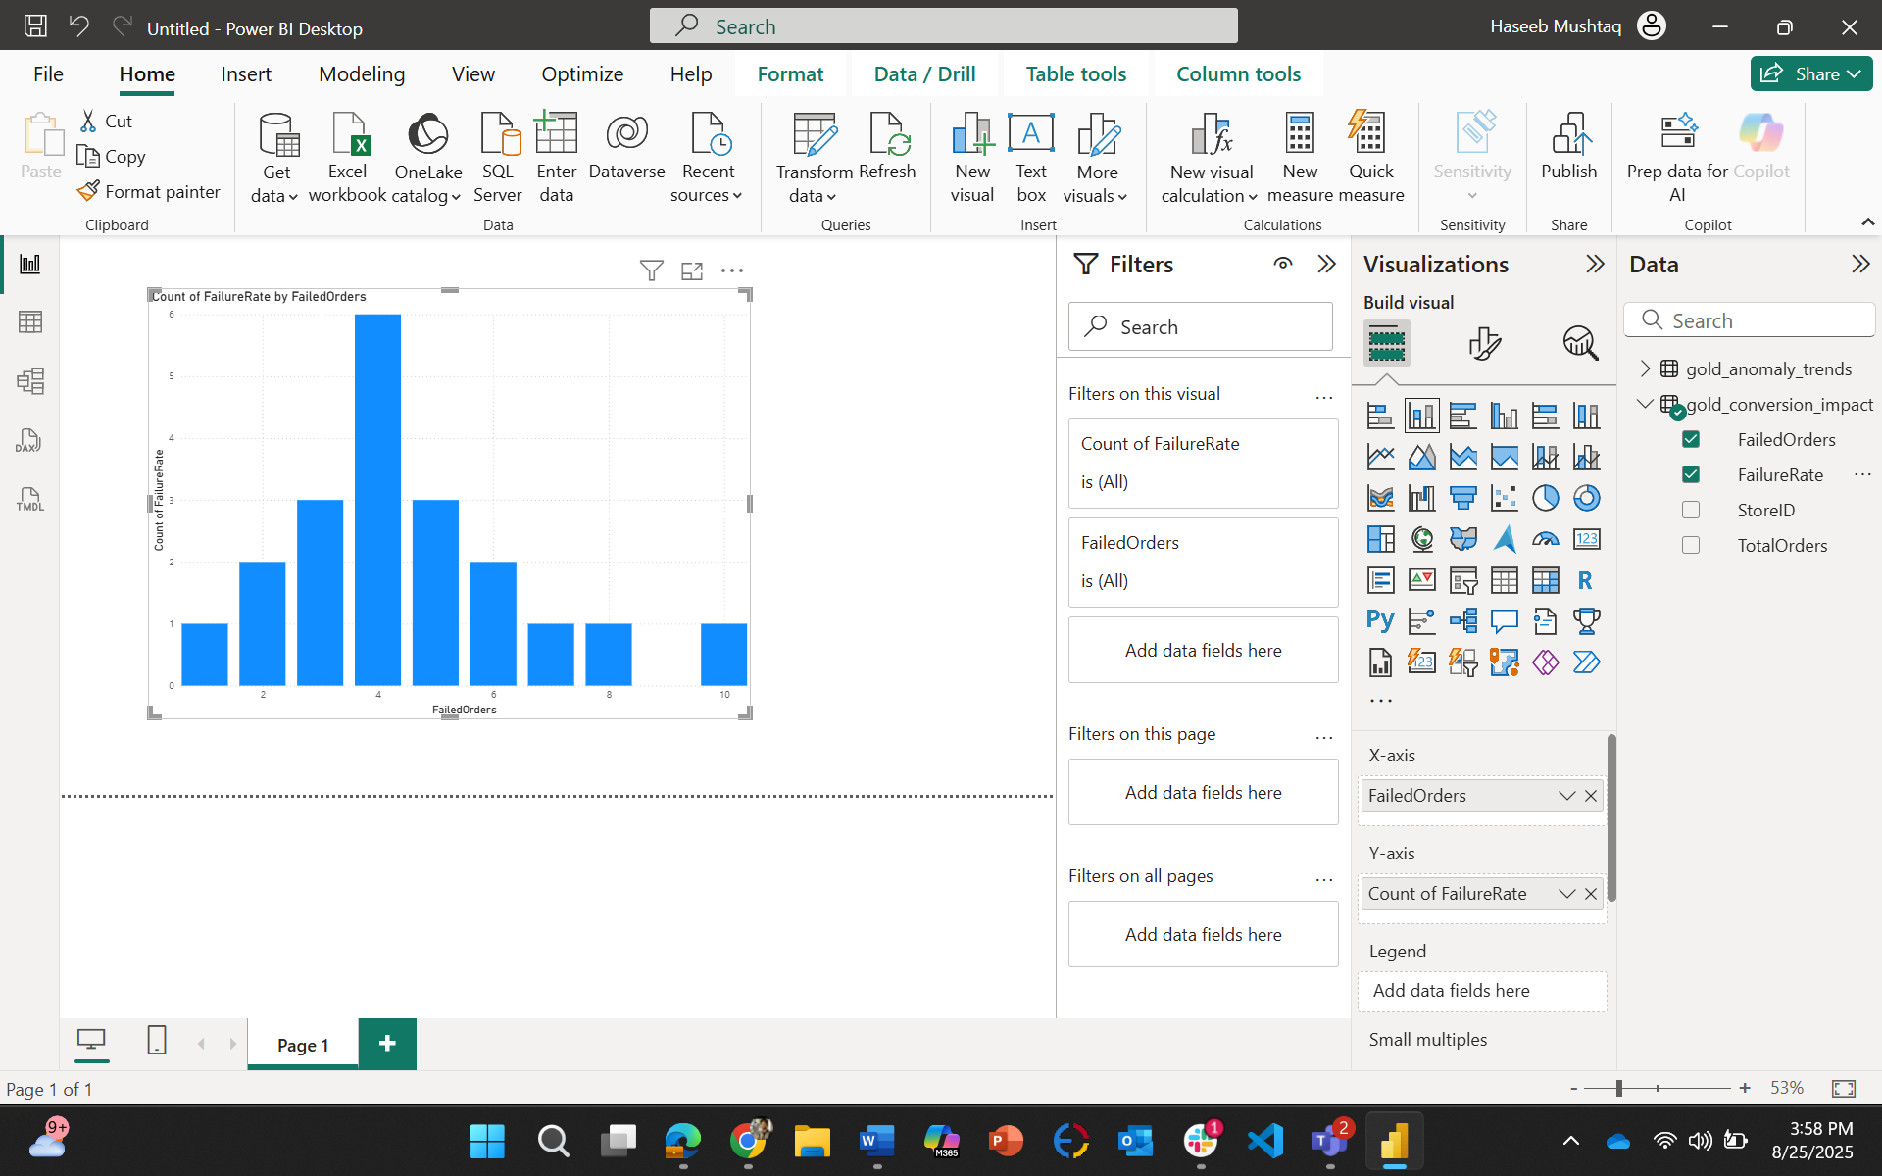

from dlt import table
import pyspark.sql.functions as F
from pyspark.sql.types import StructType, StructField, StringType, DoubleType, IntegerType, TimestampType
# :white_tick: Define schema for retail IoT CSV
iot_schema = StructType([
StructField("OrderID", StringType(), True),
StructField("CustomerID", StringType(), True),
StructField("Region", StringType(), True),
StructField("StoreID", StringType(), True),
StructField("Product", StringType(), True),
StructField("Quantity", IntegerType(), True),
StructField("UnitPrice", DoubleType(), True),
StructField("SalesAmount", DoubleType(), True),
StructField("OrderTime", StringType(), True), # can cast to Timestamp later in Silver
StructField("DeviceType", StringType(), True),
StructField("Temperature", DoubleType(), True),
StructField("DeviceStatus", StringType(), True),
StructField("AnomalyFlag", IntegerType(), True),
StructField("AnomalyType", StringType(), True)
])
# :white_tick: Paths (use subdirectories to avoid overlap with DLT system files)
raw_path = "abfss://raw@haseebstore.dfs.core.windows.net/raw_data/"
schema_path = "abfss://raw@haseebstore.dfs.core.windows.net/dlt_schemas/bronze_orders_haseeb"
checkpoint_path = "abfss://raw@haseebstore.dfs.core.windows.net/dlt_checkpoints/bronze_orders_haseeb"
@table(
name="haseebcat.capstone_retail_haseeb.bronze_orders",
comment="Bronze table - raw ingested IoT retail data via Auto Loader"
)
def bronze_orders():
return (
spark.readStream
.format("cloudFiles")
.option("cloudFiles.format", "csv")
.option("header", True)
.option("cloudFiles.schemaLocation", schema_path)
.schema(iot_schema) # :white_tick: manually set schema (no infer needed)
.load(raw_path) # :white_tick: points to /raw_data/ folder
)

# Silver Layer: Cleaned IoT Orders
# ===============================
@table(
name="capstone_retail_haseeb.silver_orders",
comment="Silver layer: cleaned and deduplicated IoT orders with anomaly handling"
)
def silver_orders():
# Read Bronze
orders = dlt.read("haseebcat.capstone_retail_haseeb.bronze_orders")

# Standardize schema
orders = (
orders.withColumn("Quantity", F.col("Quantity").cast(IntegerType()))
.withColumn("UnitPrice", F.col("UnitPrice").cast(DoubleType()))
.withColumn("SalesAmount", F.col("SalesAmount").cast(DoubleType()))
.withColumn("Temperature", F.col("Temperature").cast(DoubleType()))
.withColumn("OrderTime", F.to_timestamp("OrderTime", "M/d/yyyy H:mm"))
)

# Deduplicate by OrderID
orders = orders.dropDuplicates(["OrderID"])

# Handle missing anomaly type
orders = orders.withColumn(
"AnomalyType",
F.when((F.col("AnomalyFlag") == 1) & (F.col("AnomalyType").isNull()), "Unknown")
.when((F.col("AnomalyFlag") == 1) & (F.col("AnomalyType") == ""), "Unknown")
.otherwise(F.col("AnomalyType"))
)

# Add business rule fields
orders = (
orders.withColumn("IsAnomaly", F.col("AnomalyFlag") == 1)
.withColumn("DeviceStatus", F.upper(F.col("DeviceStatus")))
.withColumn("NormalizedStoreID", F.upper(F.col("StoreID")))
.withColumn("NormalizedProduct", F.upper(F.col("Product")))
)

return orders

# ===============================
# Gold Layer Tables
# ===============================

# 1. Daily / Monthly Sales per Region
@table(
name="haseebcat.capstone_retail_haseeb.gold_sales_region",
comment="Daily & Monthly Sales per Region"
)
def gold_sales_region():
return (
dlt.read("haseebcat.capstone_retail_haseeb.silver_orders")
.withColumn("OrderDate", F.to_date("OrderTime", "M/d/yyyy H:mm"))
.withColumn("YearMonth", F.date_format("OrderDate", "yyyy-MM"))
.groupBy("Region", "OrderDate", "YearMonth")
.agg(F.sum("SalesAmount").alias("TotalSales"))
)

# 2. Device Anomaly Trend per Store
@table(
name="haseebcat.capstone_retail_haseeb.gold_anomaly_trends",
comment="Device Anomaly Trend per Store"
)
def gold_anomaly_trends():
return (
dlt.read("haseebcat.capstone_retail_haseeb.silver_orders")
.withColumn("OrderDate", F.to_date("OrderTime", "M/d/yyyy H:mm"))
.groupBy("StoreID", "OrderDate", "DeviceType", "AnomalyType")
.agg(F.count("*").alias("AnomalyCount"))
)

# 3. Conversion Rate Impact when devices fail
@table(
name="haseebcat.capstone_retail_haseeb.gold_conversion_impact",
comment="Conversion rate impact of device failures"
)
def gold_conversion_impact():
df = dlt.read("haseebcat.capstone_retail_haseeb.silver_orders")
total_orders = df.groupBy("StoreID").agg(F.count("*").alias("TotalOrders"))
failed_orders = (
df.filter(F.col("AnomalyFlag") == 1)
.groupBy("StoreID")
.agg(F.count("*").alias("FailedOrders"))
)
return (
total_orders.join(failed_orders, "StoreID", "left")
.withColumn("FailedOrders", F.coalesce(F.col("FailedOrders"), F.lit(0)))
.withColumn("FailureRate", F.col("FailedOrders") / F.col("TotalOrders"))
)

# 4. Store Tier Classification
@table(
name="haseebcat.capstone_retail_haseeb.gold_store_tiers",
comment="Store tiers based on total sales (High / Medium / Low performers)"
)
def gold_store_tiers():
df = (
dlt.read("haseebcat.capstone_retail_haseeb.silver_orders")
.groupBy("StoreID")
.agg(F.sum("SalesAmount").alias("TotalSales"))
)
return (
df.withColumn(
"StoreTier",
F.when(F.col("TotalSales") > 100000, "High")
.when(F.col("TotalSales") > 50000, "Medium")
.otherwise("Low")
)
)

# 5. Weighted Average Sales vs Anomalies
@table(
name="haseebcat.capstone_retail_haseeb.gold_weighted_sales_anomalies",
comment="Weighted average of sales vs anomalies per store"
)
def gold_weighted_sales_anomalies():
df = dlt.read("haseebcat.capstone_retail_haseeb.silver_orders")
return (
df.groupBy("StoreID")
.agg(
F.sum("SalesAmount").alias("TotalSales"),
F.sum(F.when(F.col("AnomalyFlag") == 1, 1).otherwise(0)).alias("TotalAnomalies")
)
.withColumn("SalesPerAnomaly",
F.when(F.col("TotalAnomalies") > 0, F.col("TotalSales") / F.col("TotalAnomalies"))
.otherwise(F.lit(None))
)
)

