Anomaly Detection System Using Machine Learning

**1Vaishnavi Raje, 2Dnyaneshwar Madake, 3Priyanka Thosar, 4Vishal Kashid**

*1Student, Department of Information Technology, DYPIET FOE, MH, India*

*2, Student, Department of Information Technology, DYPIET FOE, MH, India*

*3 Student, Department of Information Technology, DYPIET FOE, MH, India*

*4 Student, Department of Information Technology, DYPIET FOE, MH, India*

*(Savitribai Phule Pune University)*

________________________________________________________________________________________________________

Abstract:Anomaly activity is predicting the body part or joint locations of a person from an image or video. This project will entail detecting suspicious human activity from real-time CCTV footage using neural networks. Human Anomaly Activity is one of the key problems in computer vision that has been studied for more than 15years. Suspicious human activity recognition from surveillance, human activities is an active research area for image processing and computer vision. Through the visual surveillance, human activities can be monitored in sensitive and public areas such as bus stations, railway stations, airports, banks, shopping malls, school and colleges, parking lots, roads, etc. to prevent terrorism, theft, accidents and illegal parking, vandalism, fighting, chain snatching, crime and other suspicious activities. It is very difficult to watch public places continuously, therefore an intelligent video surveillance is required that can monitor the human activities in real-time and categorize them as usual and unusual activities; and can generate an alert. Mostly, of the research being carried out is on images and not videos.

Index Terms – Machine Learning, Recurrent Neural Network, Convolutional Neural Network.

*________________________________________________________________________________________________________*

# **Introduction**

We plan to build an application for detection of anomaly activity of people in public places in real time. Our application can be used in surveillance at places like malls, airports, railway stations etc. where there is a risk of robbery or a shooting attack. We will be using deep learning and neural networks to train our systems. This model will then be deployed as a mobile and desktop app which will take real time CCTV footage as input and send an alert on the administrator’s device if some suspicious pose is found. Human anomaly activity is related to identifying human body parts and possibly tracking their movements. Real life applications of it vary from gaming to AR/VR, to healthcare and gesture recognition. Compare to image data domain, there is relatively little work on applying CNNs to video classification. This is because, a video is more complex than images since it has another dimension-temporal. Unsupervised learning exploits temporal dependencies between frames and has proven successful for video analysis. Some anomaly activity approaches use CPU instead of GPU so that anomaly activity can run-on low-cost hardware like embedded systems and mobile phones**.** Low-cost depth sensors are another new technology in computer vision. They are present in gaming consoles like the Kinect for Xbox 360. They are motion sensors which allow the user to interact with the console without a game controller, through just hand gestures. These are RGB-D sensors that obtain depth information by structured light technology. The structure light sensors infer the depth values by projecting an infrared light pattern onto a seen and analyzing the distortion of the projected light pattern. However, these sensors are limited to indoor use, and their low resolution and noisy depth information make it difficult to estimate human poses from depth images.

* **OBJECTIVE**

Anomaly detection as its name its name it is to identify the observations or rare events which can raise suspicious by being different from the rest of the observations. By machine learning approach we are going to detect anomaly activities in public places using CCTV footage. By using CNN algorithm which is the class of deep neural networks and applied to analyze visual imaginary.

# **RELATED WORK**

|  |  |  |  |
| --- | --- | --- | --- |
| **Sr.**  **No.** | **Title of Paper and Year** | **Methodology** | **Findings** |
| 1. | Real- Time Anomaly Detection and Localization in Crowded Scenes [1] | Gaussian Classifiers | We purposed a method for real time anomaly detection and localization in crowded scenes. Each video is defined as a set of non-overlapping cubic patches, and is described using two local and global descriptors. These descriptors capture the video properties from different aspects. |
| 2. | Anomaly detection in Video Using Predictive Convolution Long Short- Term Memory Network. [2] | Convolution Long-Short Term Memory | Automating the detection of anomalous events within long video sequences is challenging duo to the ambiguity of how such events are defined. We approach the problem by learning generative models that can identify anomalies in videos using limited supervision. |
| 3. | Abnormal event Detection in Video using Spatiotemporal Autoencoder.[3] | Convolution Neural Networks | We present an efficient method for detecting anomalies in videos. Recent applications of convolution neural networks have shown promises of convolution layers for object detection and recognition, especially in images. |
| 4. | Revisit of Sparse Coding Based Anomaly Detection in Stacked RNN Framework.[4] | Recurrent Neural Network | Motivated by the capability of sparse coding based anomaly detection, we propose a Temporally-coherent Sparse Coding where are enforce similar neighboring frames be encoded with similar reconstruction coefficients. |
| 5. | Human Pose Estimation using Deep Structure Guided Learning.[5] | Convolution Neural Network | It presents an approach to incorporate structure knowledge int CNNs for articulated human pose estimation from a single still image. Recent research on pose estimation adopts CNNs as base blocks to combine with other graphical models. |

*Table-1. Summary of Related work*

Human anomaly activity is one of the key problems in computer vision that has been studied for more than 15 years. It is important because of the sheer number of applications which can benefit from anomaly activity. For example, human anomaly activity is used in applications including video surveillance animal tracking and behavior understanding, sign language detection, advanced human-computer interaction, and marker less motion capturing.

Low-cost depth sensors have limitations like limited to indoor use, and their low resolution and noisy depth information make it difficult to estimate human poses from depth images. Hence, we plan to use neural networks to overcome these problems. Suspicious human activity recognition from surveillance video is an active research area of image processing and computer vision.

Through the visual surveillance, human activities can be monitored in sensitive and public areas such as bus stations, railway stations, airports, banks, shopping malls, school and colleges, parking lots, roads, etc. to prevent terrorism, theft, accidents and illegal parking, vandalism, fighting, chain snatching, crime and other suspicious activities.

It is very difficult to watch public places continuously, therefore an intelligent video surveillance is required that can monitor the human activities in real-time and categorize them as usual and unusual activities and can generate an alert.

.

# **proposed system**

Anomaly Activity is predicting the body part or joint locations of a person from an image or a video. This project will entail detecting Anomaly human Activity from real-time CCTV footage using neural networks. Through the visual surveillance, human activities can be monitored in sensitive and public areas such as bus stations, railway stations, airports, banks, shopping malls, school and colleges, parking lots, roads, etc. to prevent terrorism, theft, accidents and illegal parking, vandalism, fighting, chain snatching, crime and other suspicious activities. It is very difficult to watch public places continuously, therefore an intelligent video surveillance is required that can monitor the human activities in real-time and categorize them as usual and unusual activities; and can generate an alert. Mostly, of the research being carried out is on images and not videos. Also, none of the papers published tries to use CNNs to detect suspicious activities.

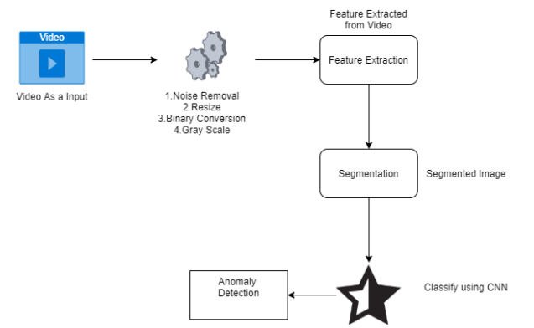

*Figure-1: System Architecture*

**4.1 Project Module:**

We are going to have an overview about how much time does it took to complete each task like- Preliminary Survey Introduction and Problem Statement, Literature Survey, Project Statement, Software Requirement and Specification, System Design, Partial Report Submission, Architecture Design, Implementation, Deployment, Testing, Paper Publish, Report Submission and etcetera. This chapter also gives focus on stakeholder list which gives information about project type, customer of the proposed system, user and project member who developed the system.

NumPy: NumPy is a Python library used for working with arrays. It also has functions for working in domain of linear algebra, Fourier transform, and matrices.

import cv2: All packages contain Haar cascade files. cv2.data. haarcascades can be used as a shortcut to the data folder.

**4.2 Convolutional Neural Network:**

A Convolutional Neural Network is a Deep Learning algorithm which can take in an input image, assign importance (learnable weights and biases) to various aspects/objects in the image and be able to differentiate one from the other. The pre-processing required in a Conv Net is much lower as compared to other classification algorithms. While in primitive methods filters are hand-engineered, with enough training, Conv Nets have the ability to learn these filters/characteristics. CNN utilizes spatial correlations which exist with the input data. Each concurrent layer of the neural network connects some input neurons.

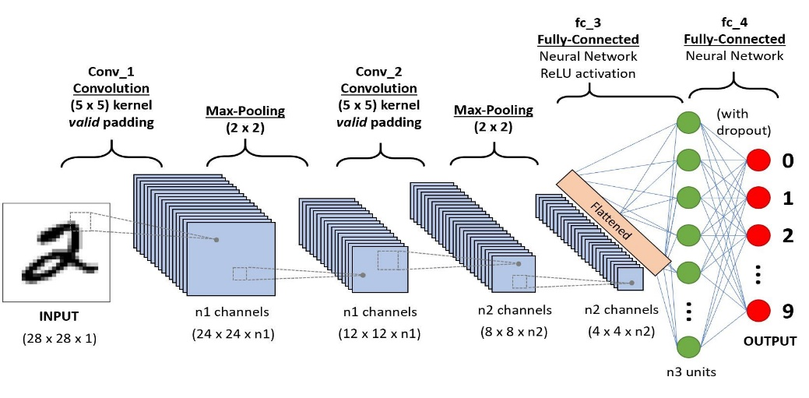

*Figure 2: - Convolution Neural Network*

**4.3 Deep Learning:**

is a subfield of machine learning concerned with algorithms inspired by the structure and function of the brain called **artificial neural networks.** In deep learning, a computer model learns to perform classification tasks directly from images, text, or sound. Deep learning models can achieve state-of-the-art accuracy, sometimes exceeding human-level performance. Models are trained by using a large set of labeled data and neural network architectures that contain many layers.

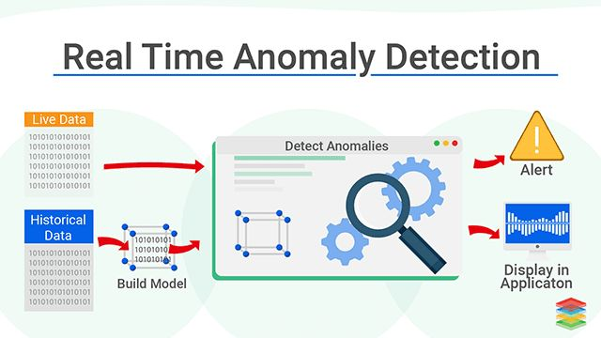

*Figure 3: Deep Learning*

**4.4 RELU Algorithm**

In a neural network, the activation function is responsible for transforming the summed weighted input from the node into the activation of the node or output for that input.

The **rectified linear activation function** or **ReLu** for short is a piecewise linear function that will output the input directly if it is positive, otherwise, it will output zero. It has become the default activation function for many types of neural networks because a model that uses it is easier to train and often achieves better performance.

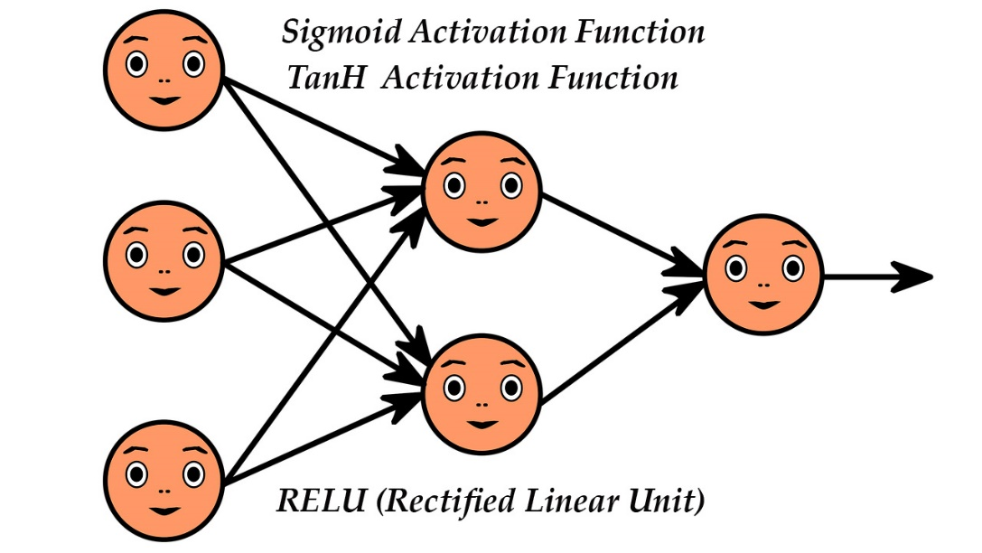

*Figure 4: RELU Algorithm*

**4.5 Pooling**

Pooling layers are used to reduce the dimensions of the feature maps. Thus, it reduces the number of parameters to learn and the amount of computation performed in the network.

The pooling layer summarises the features present in a region of the feature map generated by a convolution layer.

**4.6 Fully Connected Layer**

Fully Connected Layer is simply, feed forward neural networks. Fully Connected Layers form the last few layers in the network. The input to the fully connected layer is the output from the final Pooling or Convolutional Layer, which is flattened and then fed into the fully connected layer.

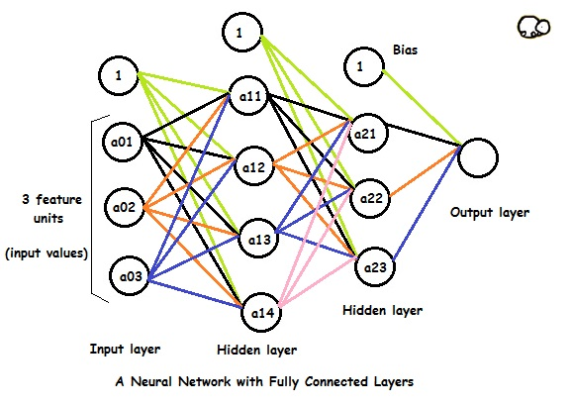

*Figure 5: Fully Connected Network*

1. **Screenshots**



*Figure 6: GUI_Main*

**

*Figure 7: Registration Module*



*Figure 8: Login Module*

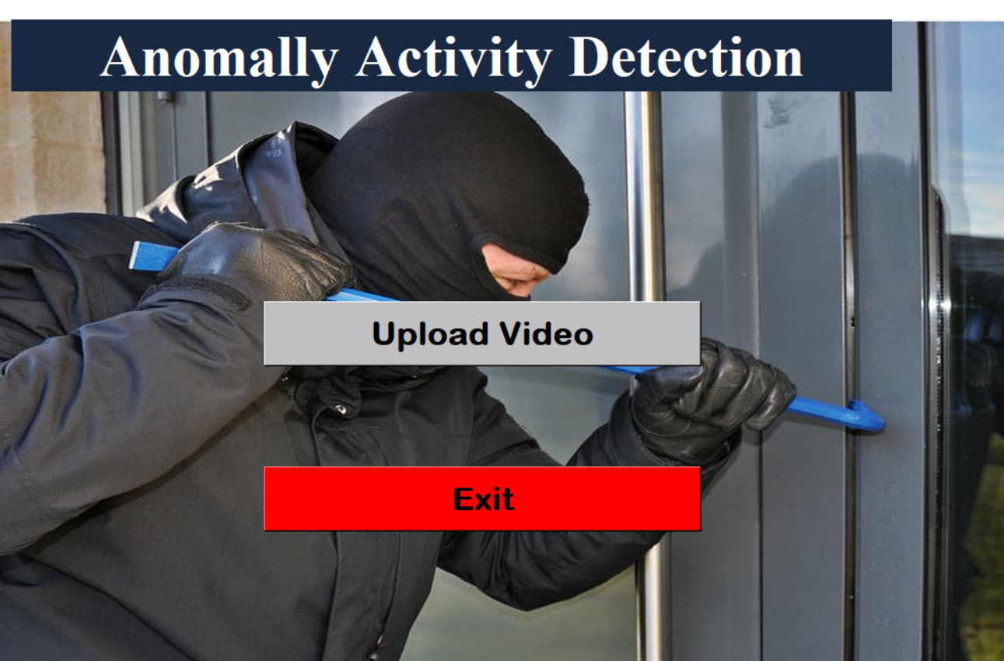

*Figure 9: GUI_Main*

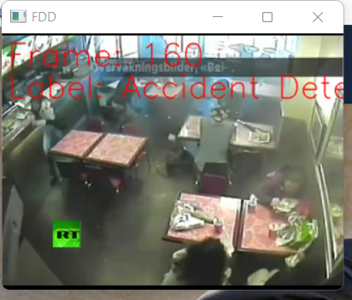

*Figure 10: Frame [Accident Detected]*

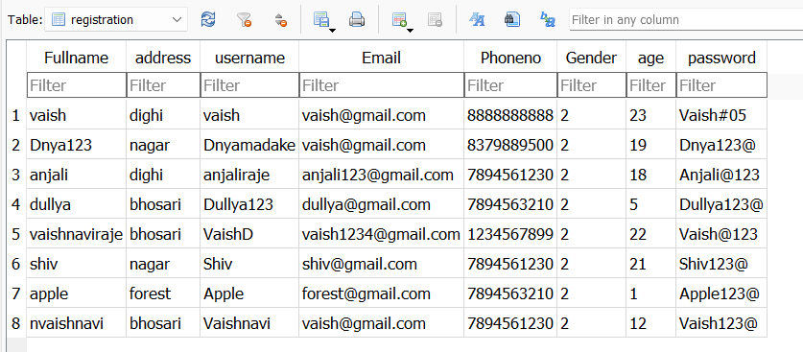

*Figure 11: Database*

1. **CONCLUSION**

A system to process real-time CCTV footage to detect any Anomaly activity will help to create better security and less human intervention. Great strides have been made in the field of human anomaly Activity, which enables us to better serve the myriad applications that are possible with it. Moreover, research in related fields such as Activity Tracking can greatly enhance its productive utilization in several fields

**REFERENCES**

1. Eralda Nishani, Betim Cico : “Computer Vision Approaches based on Deep Learning and Neural Networks” Deep Neural Networks for Video Analysis of Human Pose Estimation- 2017 6th MEDITERRANEAN CONFERENCE ON EMBEDDED COMPUTING (MECO), 11-15 JUNE 2017, BAR, MONTENEGRO
2. Naimat Ullah Khan, Wangen Wan: “A Review of Human Pose Estimation from Single Image”- 978-1-5386-5195-7/18/ 2018 IEEE
3. Qiuhui Chen, Chongyang Zhang, Weiwei Liu, and Dan Wang,” Surveillance Human Pose Dataset and Performance Evaluation for Coarse-Grained Pose Estimation”, Athens 2018.
4. Baole Ai, Yu Zhou, Yao Yu: “Human Pose Estimation using Deep Structure Guided Learning”- 978-1-5090-4822-9/17 2017 IEEE DOI 10.1109/WACV.2017.141
5. Zhe Cao, Tomas Simon, Shih-En Wei, Yaser Sheikh the Robotics Institute, Carnegie Mellon University” Real time Multiperson 2D Pose Estimation using part affinity fields” - 1063-6919/17 2017 IEEE DOI 10.1109/CVPR.2017.143
6. Hanguen Kim, Sangwon Lee, Dongsung Lee, Soonmin Choi, JinsunJu and Huyun Myung “Real-Time Human Pose Estimation and Gesture Recognition from depth Images Using Super pixels and SVM classifier.”- Sensors 2015, 15, 12410-12427; doi:10.3390/s150612410.
7. Tripathi, Rajesh and Jalal, Anand and Agarwal, Subhash (2017).” Suspicious Human Activity Recognition: a Review”. Artificial Intelligence Review. 50.10.1007/s10462- 017-9545-7.
8. E. Eksioglu. Decoupled algorithm for MRI reconstruction using nonlocal block matching model: BM3DMRI. Journal of Mathematical Imaging and Vision, 56(3):430–440, 2016.
9. S. Wang, Z. Su, L. Ying, X. Peng, S. Zhu, F. Liang, D. Feng, and D. Liang. Accelerating magnetic resonance imaging via deep learning. In Proceedings of the IEEE International Symposium on Biomedical Imaging, pages 514–517, 2016.
10. L. Xu, J. Ren, C. Liu, and J. Jia. Deep convolutional neural network for image deconvolution. In Advances in Neural Information Processing Systems, pages 1790–1798, 2014.
11. Y. Yang, J. Sun, H. Li, and Z. Xu. Deep ADMM-Net for compressive sensing MRI. In Advances in Neural Information Processing Systems, pages 10–18, 2016.