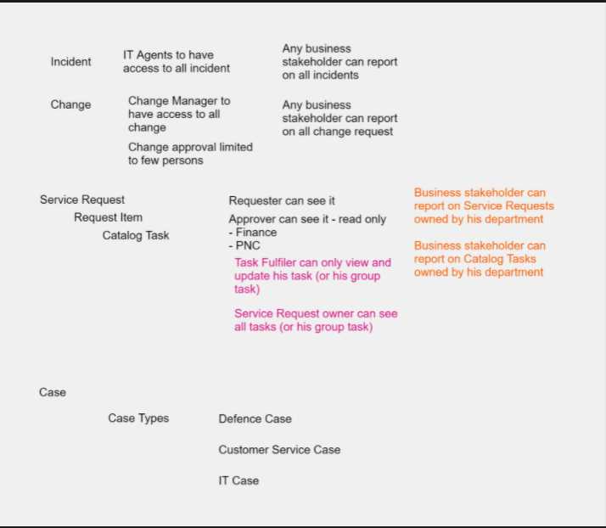

Can report on Service Requests owned by his department

Can report on catalog tasks owned by his department

business stakeholder

has read access - incident, problem, change, request, ritm, catalog task  
by default can see requests,ritms,tasks assigned to him but can remove filter and can see all the entities in read mode  
can view dashboards in read mode

* ***report_admin***: manage reports
* ***report_alias_admin***: maintain field and value aliases
* ***report_global***: create global reports
* ***report_group***: create reports belonging to a group the user is a member of
* ***report_publisher***: make reports available on a public page
* ***report_scheduler***: schedule reports to be delivered by email
* ***report_user***: create reports and view reports shared with the user

