AI-Powered Environmental Intelligence System for Air Quality Prediction
Complete Project Work Summary — Module 2 Submission

1. Project Goal
Build a system that predicts Air Quality Index (AQI) for a user's current location and planned travel route, using historical patterns, live weather, and live traffic — then advises them on healthier routes and times to travel.
2. Data Pipeline Summary
- Collected 5.5 years of hourly AQI data for Delhi (Kaggle dataset) — 38 monitoring stations, ~1.09 million rows
- Added real geographic coordinates for each station (auto-geocoded + manually verified)
- Merged in 5.5 years of hourly weather data (Meteostat), resolving a UTC/IST timestamp mismatch
- Cleaned the data: dropped an unusable 89.5%-missing column (Xylene), interpolated other gaps per-station (zero rows lost), capped unrealistic AQI values at the official max of 500
- Engineered time-based features (hour, day of week, weekend flag) and 3h/24h rolling averages
- Scaled all features and split chronologically (80% train / 20% test) for genuine forecasting evaluation

3. Model Training & Results
Model: LSTM (Long Short-Term Memory) neural network — two stacked LSTM layers + two Dense layers
Input: past 24 hours of pollutant, weather, and time data
Output: predicted AQI for the next hour
Trained on: Google Colab (free GPU)
Evaluated on the held-out 20% test set (data never seen during training):
Accuracy: 96.3%
R² Score: 0.995
MAE: 5.8 AQI points
RMSE: 8.2 AQI points
MAPE: 3.7%
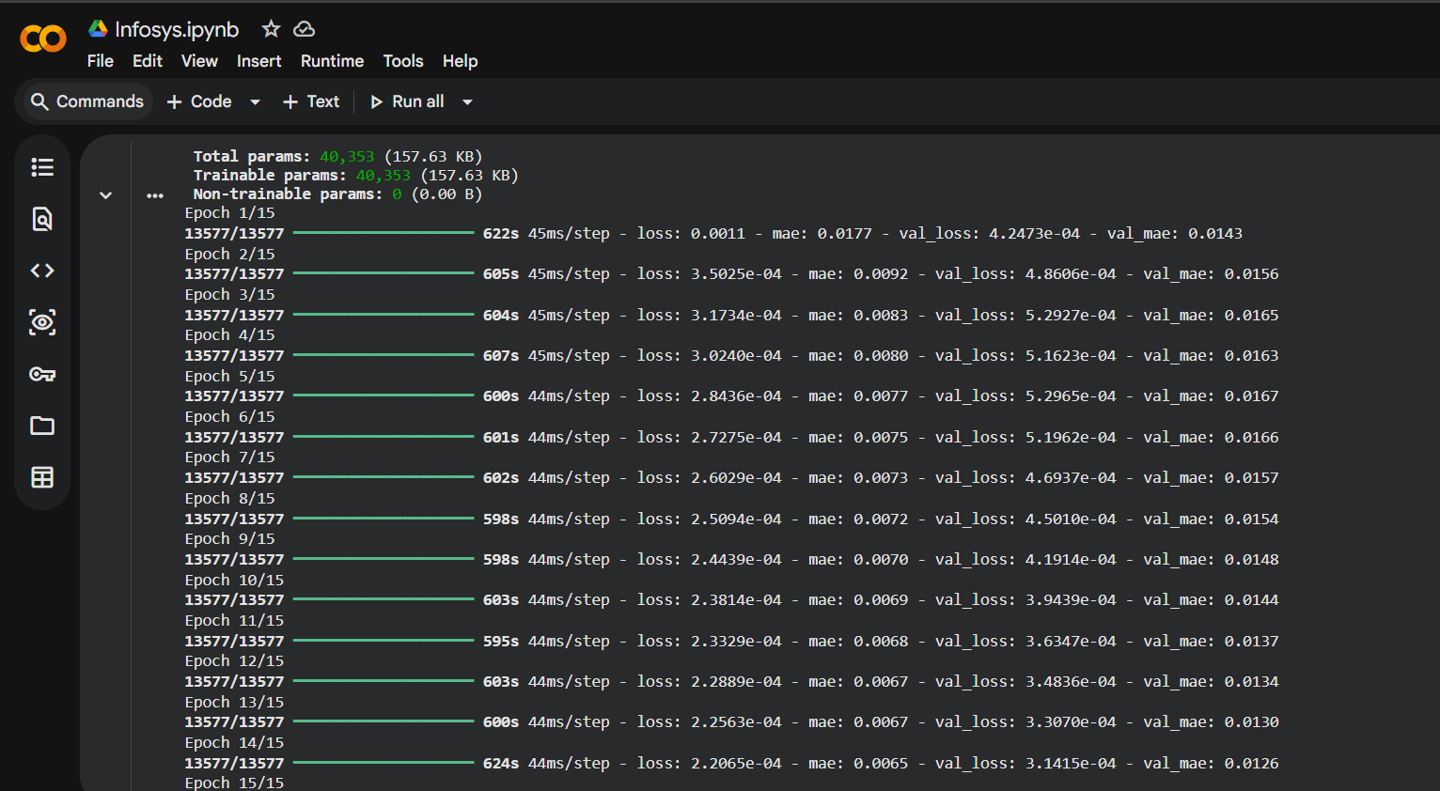
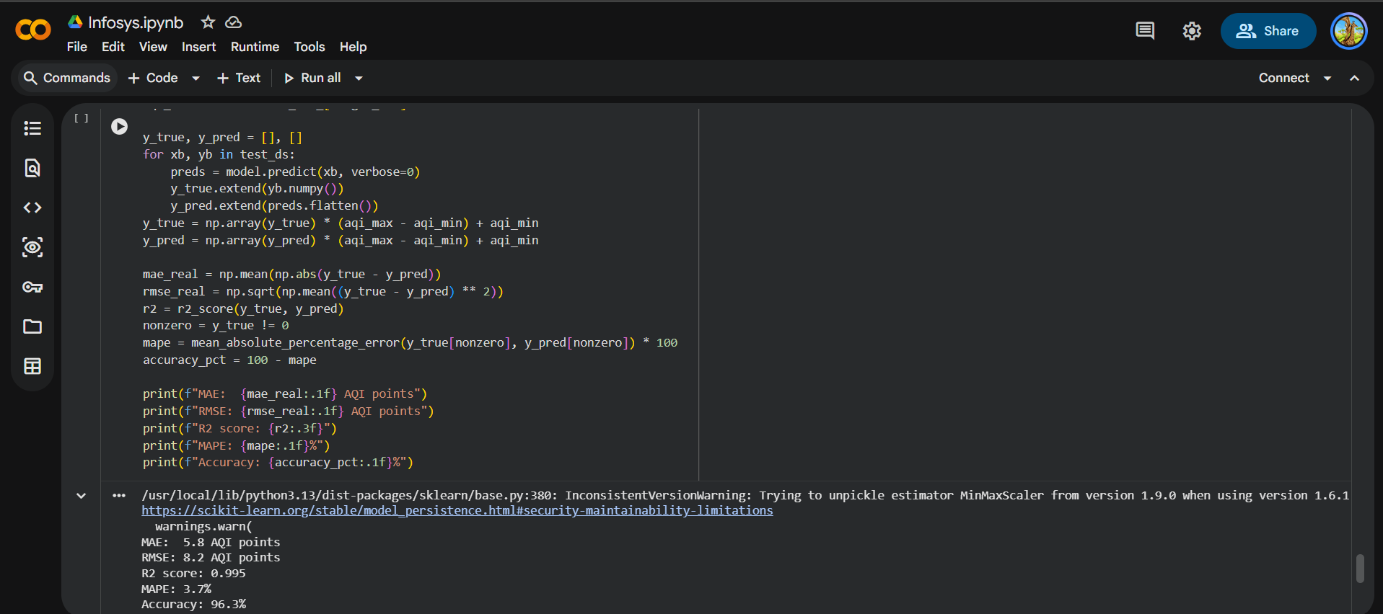
4. Spatial Interpolation (IDW)
- The trained model only knows the 38 specific stations it was trained on — a real user can be anywhere in the city
- Implemented Inverse Distance Weighting (IDW): finds the 4 nearest stations to any given latitude/longitude, predicts AQI at each, then blends the results — giving more weight to closer stations
- Deployed as a live endpoint: /predict_at_location?lat=..&lon=..
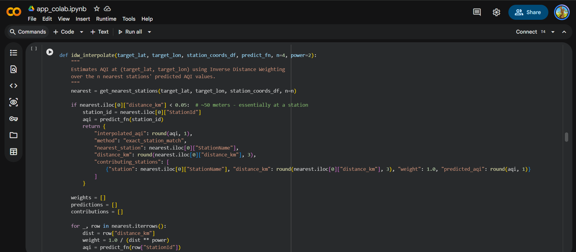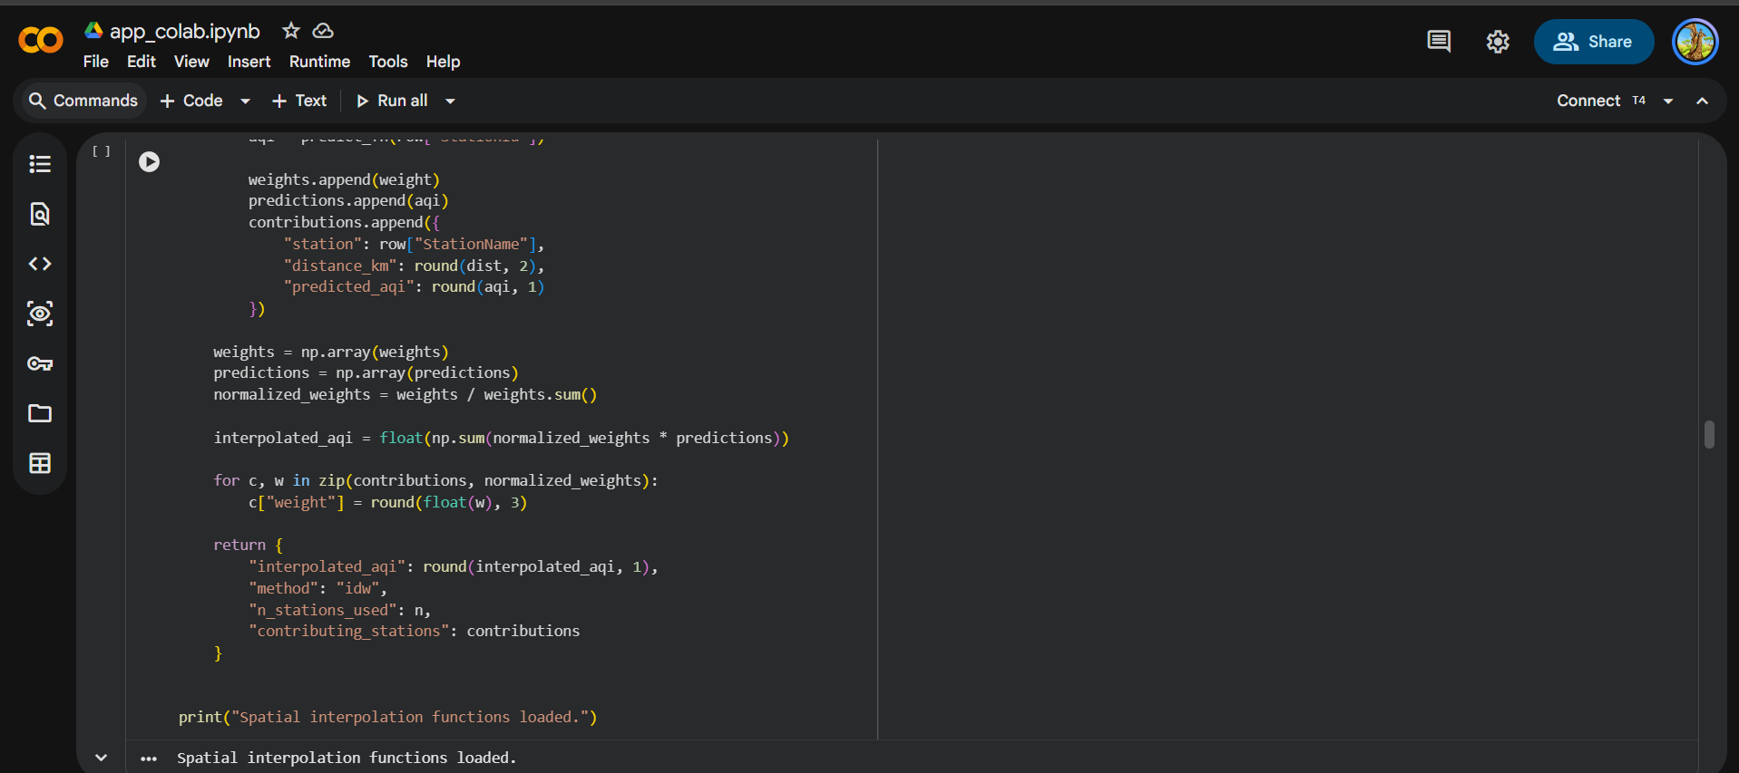
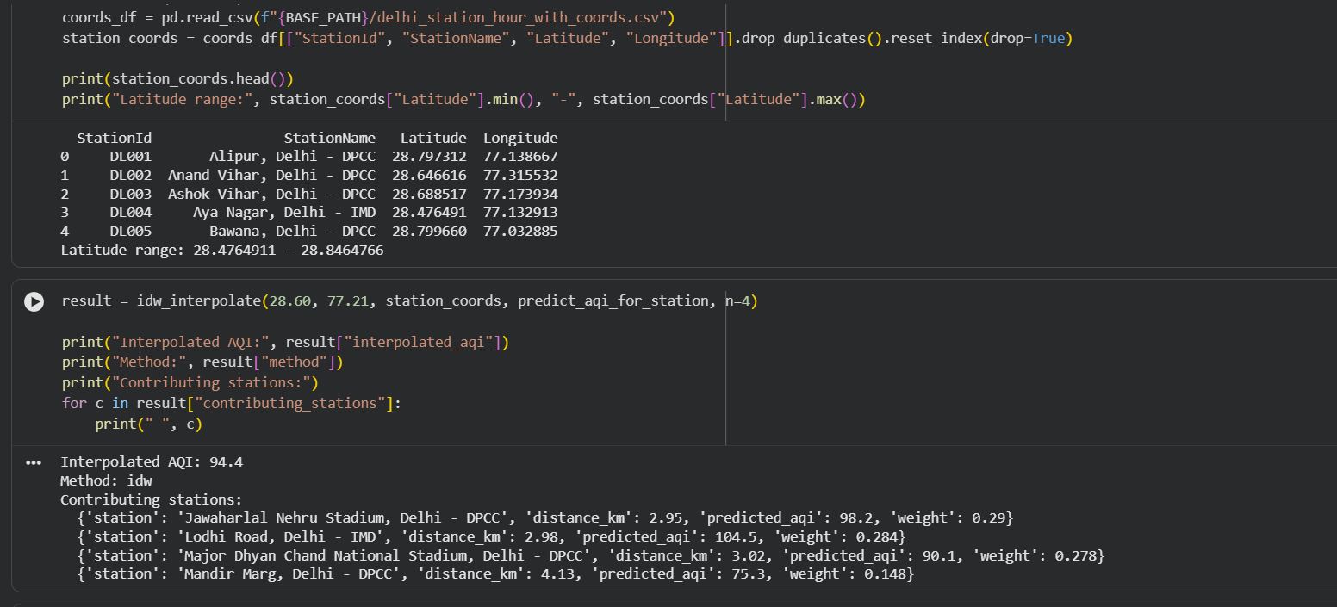

5. Travel Route Pollution Estimator
Combines live routing (OpenRouteService) with the prediction system. Given a source and destination, it:
- Fetches the actual driving route (real roads, not a straight line)
- Samples points every ~2–3 km along the route
- Predicts AQI at each sampled point using spatial interpolation
- Returns average and peak AQI exposure for the entire trip, plus live weather and a traffic-congestion estimate
Endpoint: /route_exposure
Tested example: A 26.75 km Delhi route returned 120.5 average AQI exposure, 137.3 peak, Light traffic at 50.7 km/h, with real-time weather — all verified against the live map.
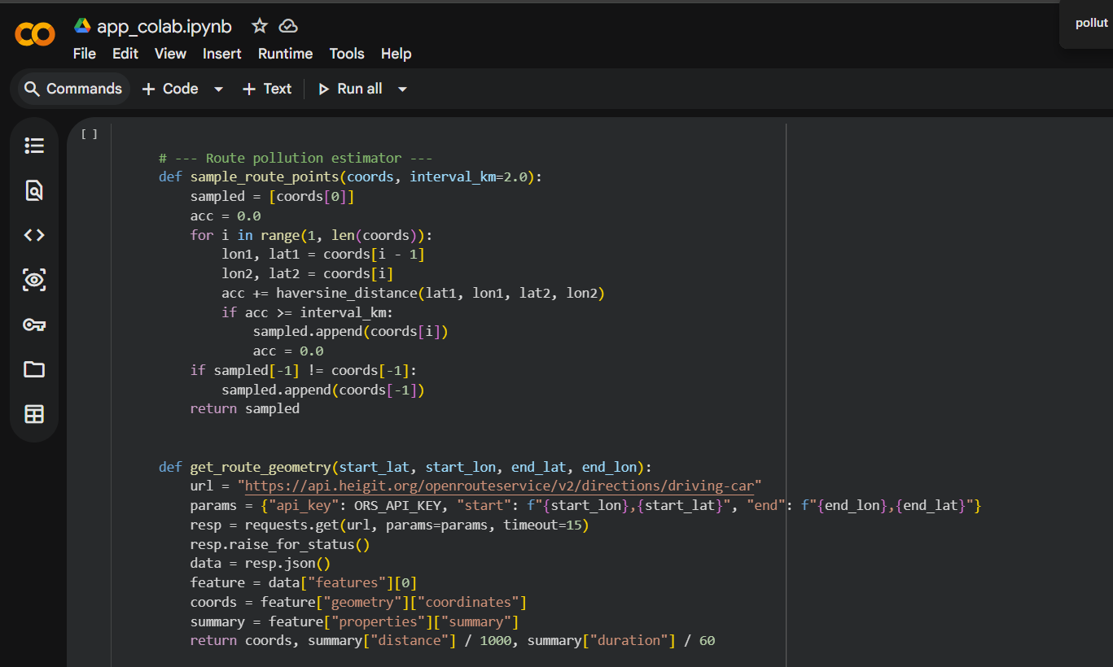
6. Enriched Prediction API
Every prediction response includes, per the project's requirements:
- Predicted AQI
- Health impact category (Good / Satisfactory / Moderate / Poor / Very Poor / Severe) with plain-language advisory text
- A confidence interval (~95%, based on the model's real test-set error)
- The individual pollutant readings (PM2.5, PM10, NO2, CO, SO2, O3, etc.) behind the prediction
- Live weather (temperature, humidity, wind speed, pressure)

7. Live Deployment
- The trained model is wrapped in a FastAPI service — callable on demand, not just usable inside a notebook
- Deployed on Google Colab (TensorFlow compatibility issues prevented running it locally on Windows) and exposed publicly via ngrok, with CORS enabled so a separate frontend can call it directly
- Three live endpoints: /predict/{station_id}, /predict_at_location, and /route_exposure — all tested and confirmed working end-to-end
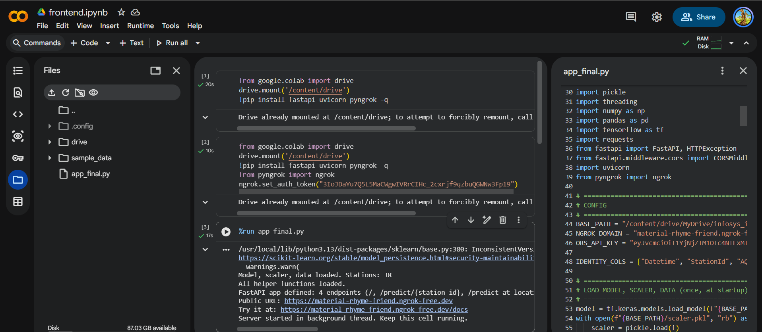
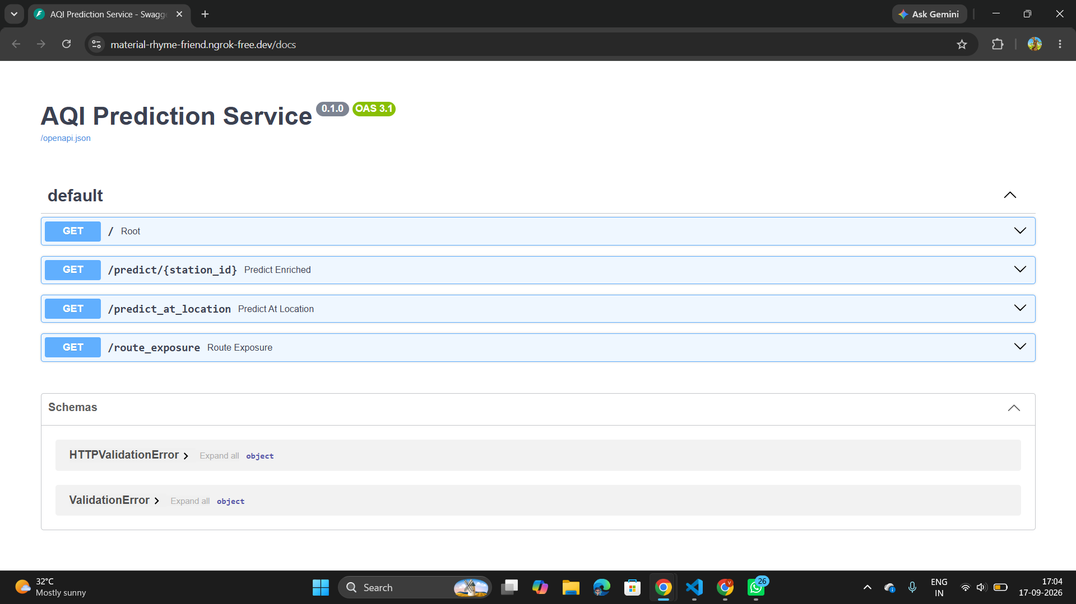
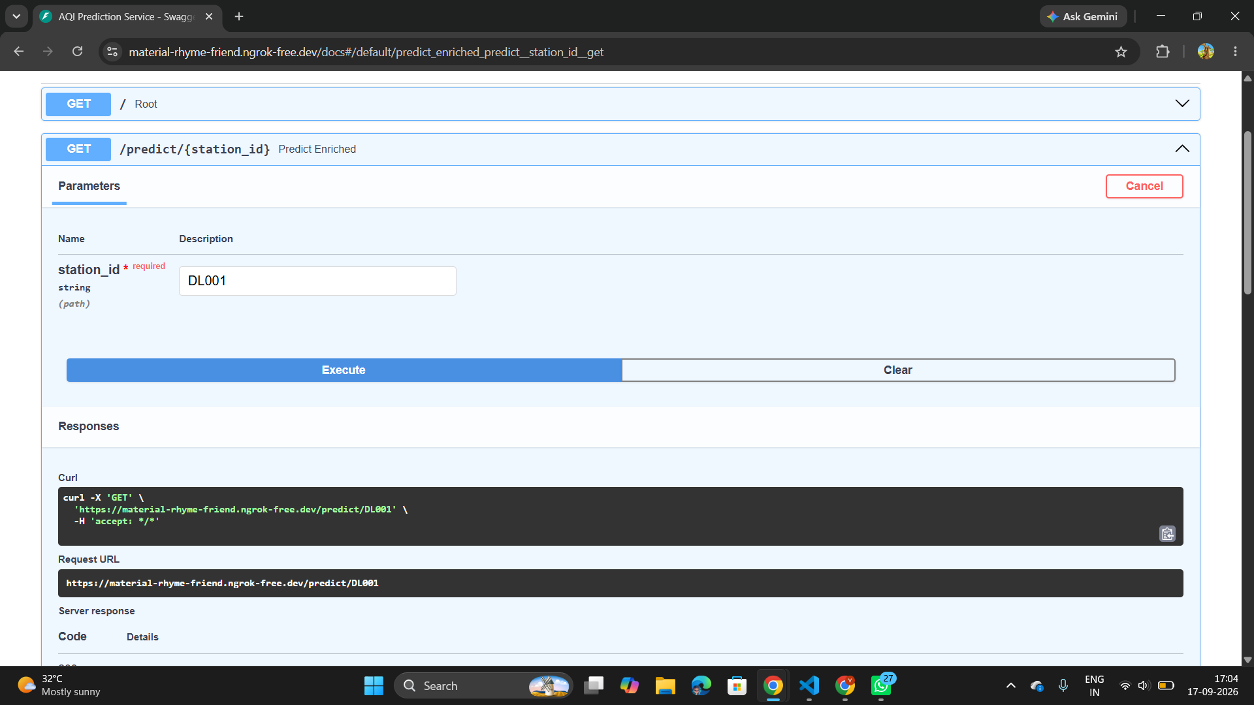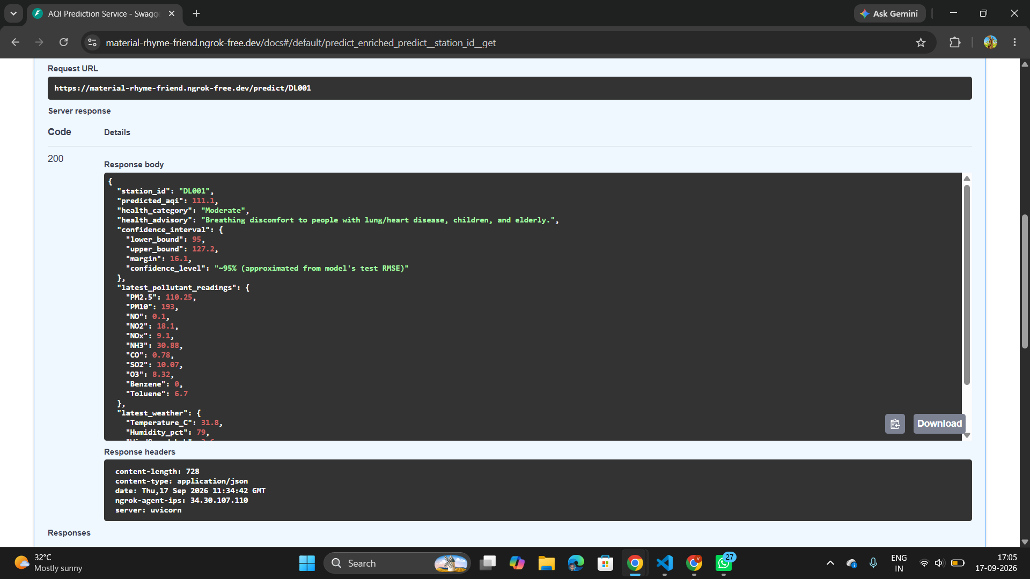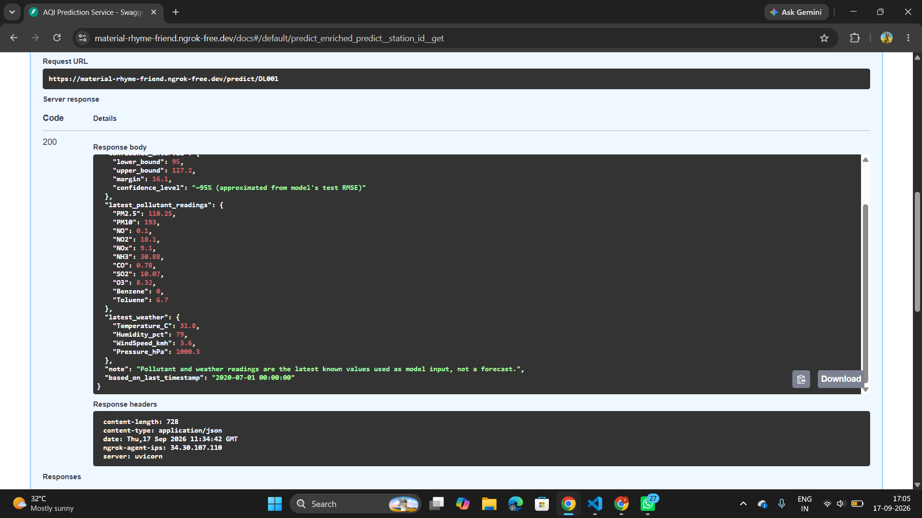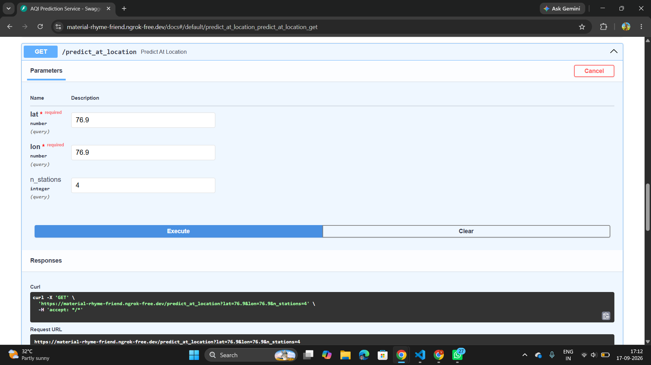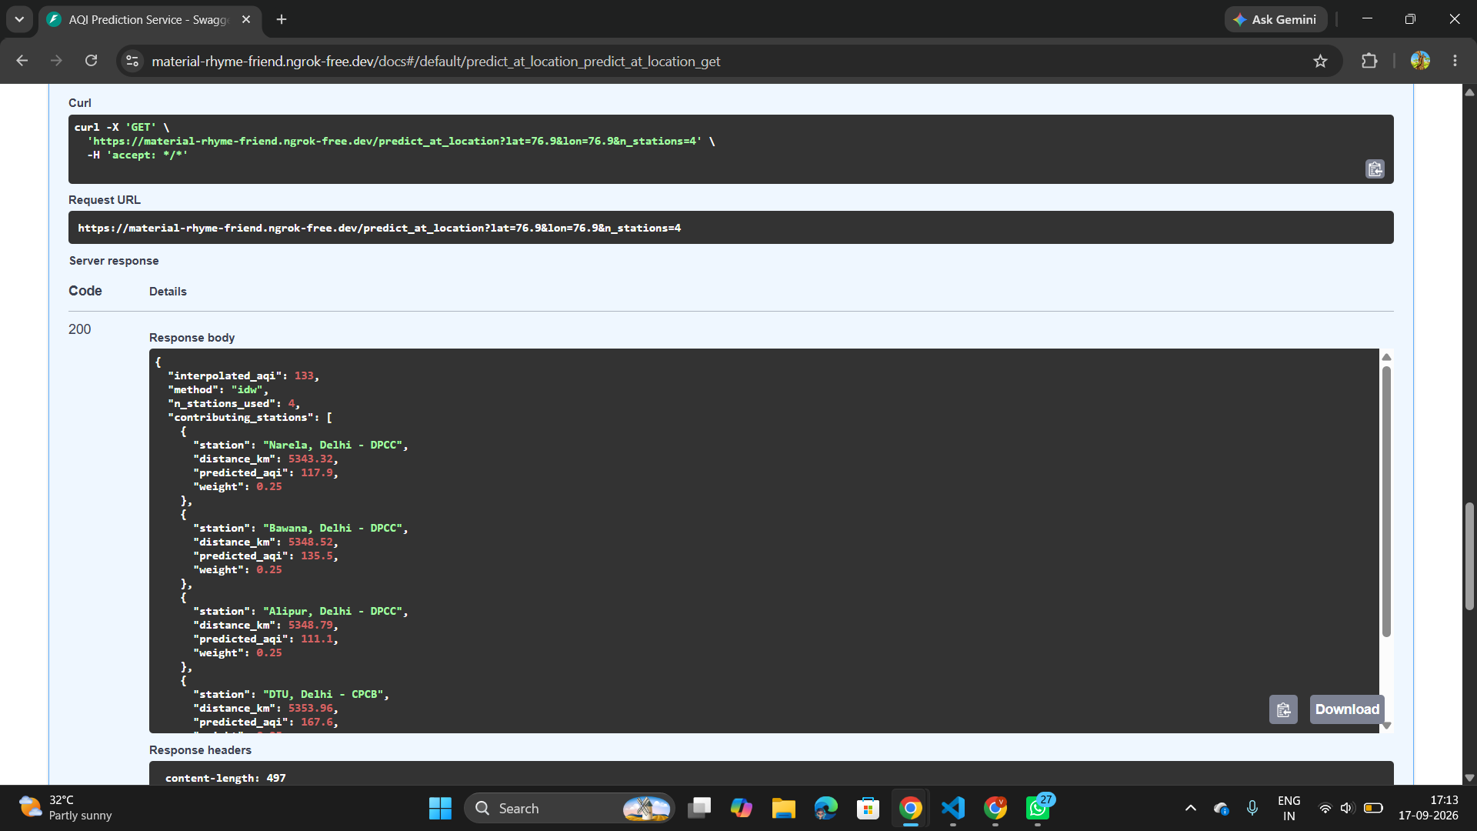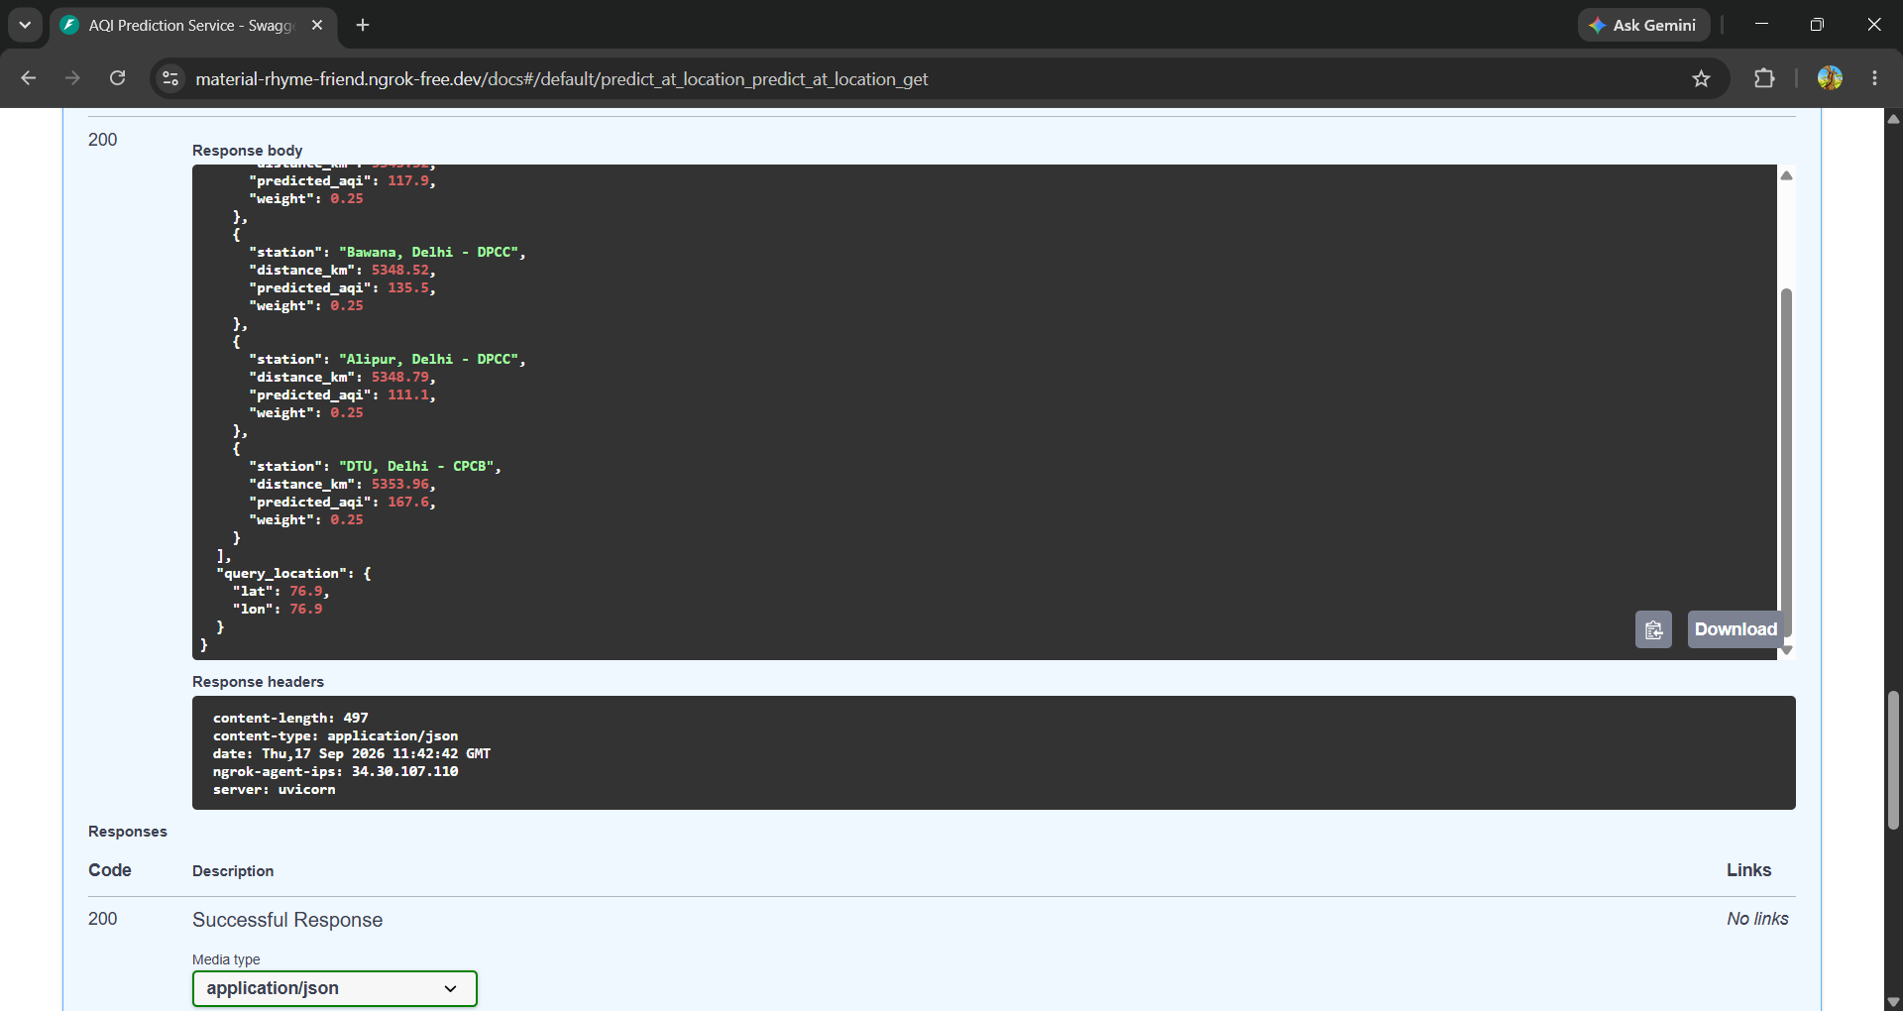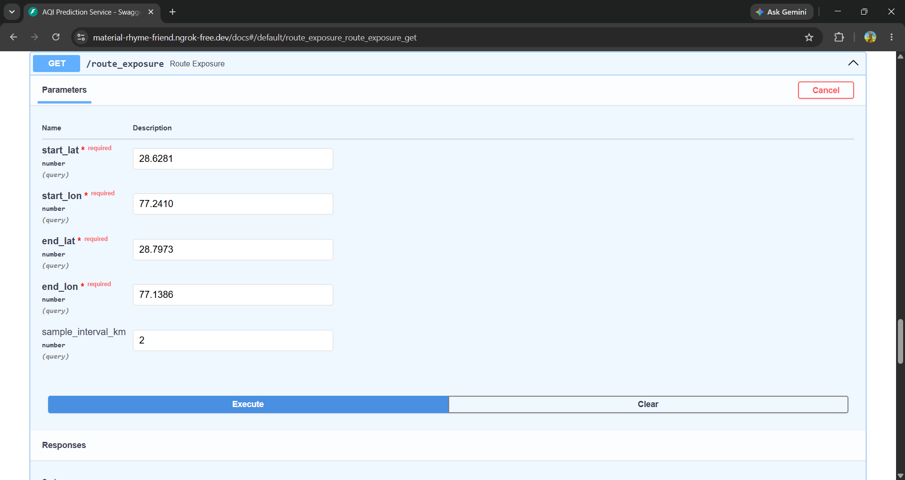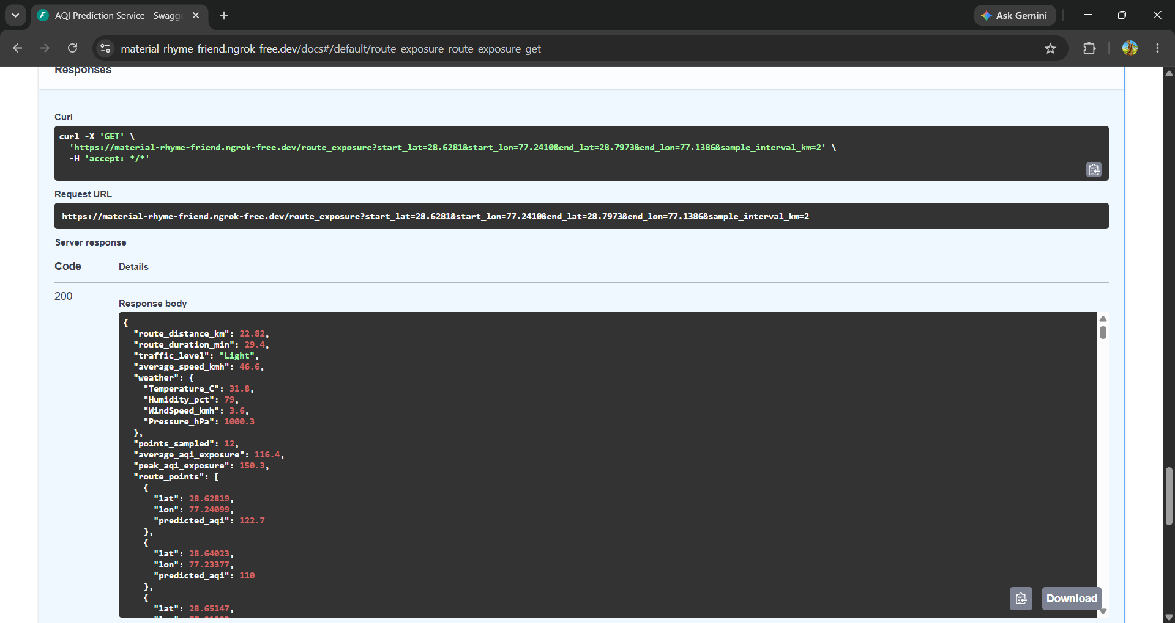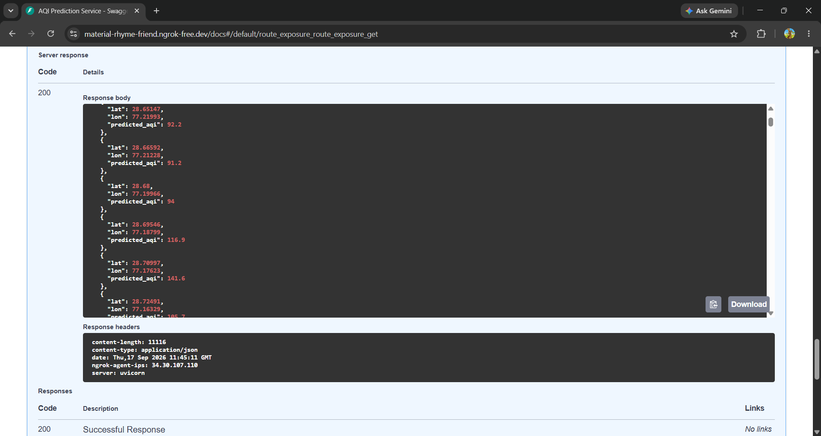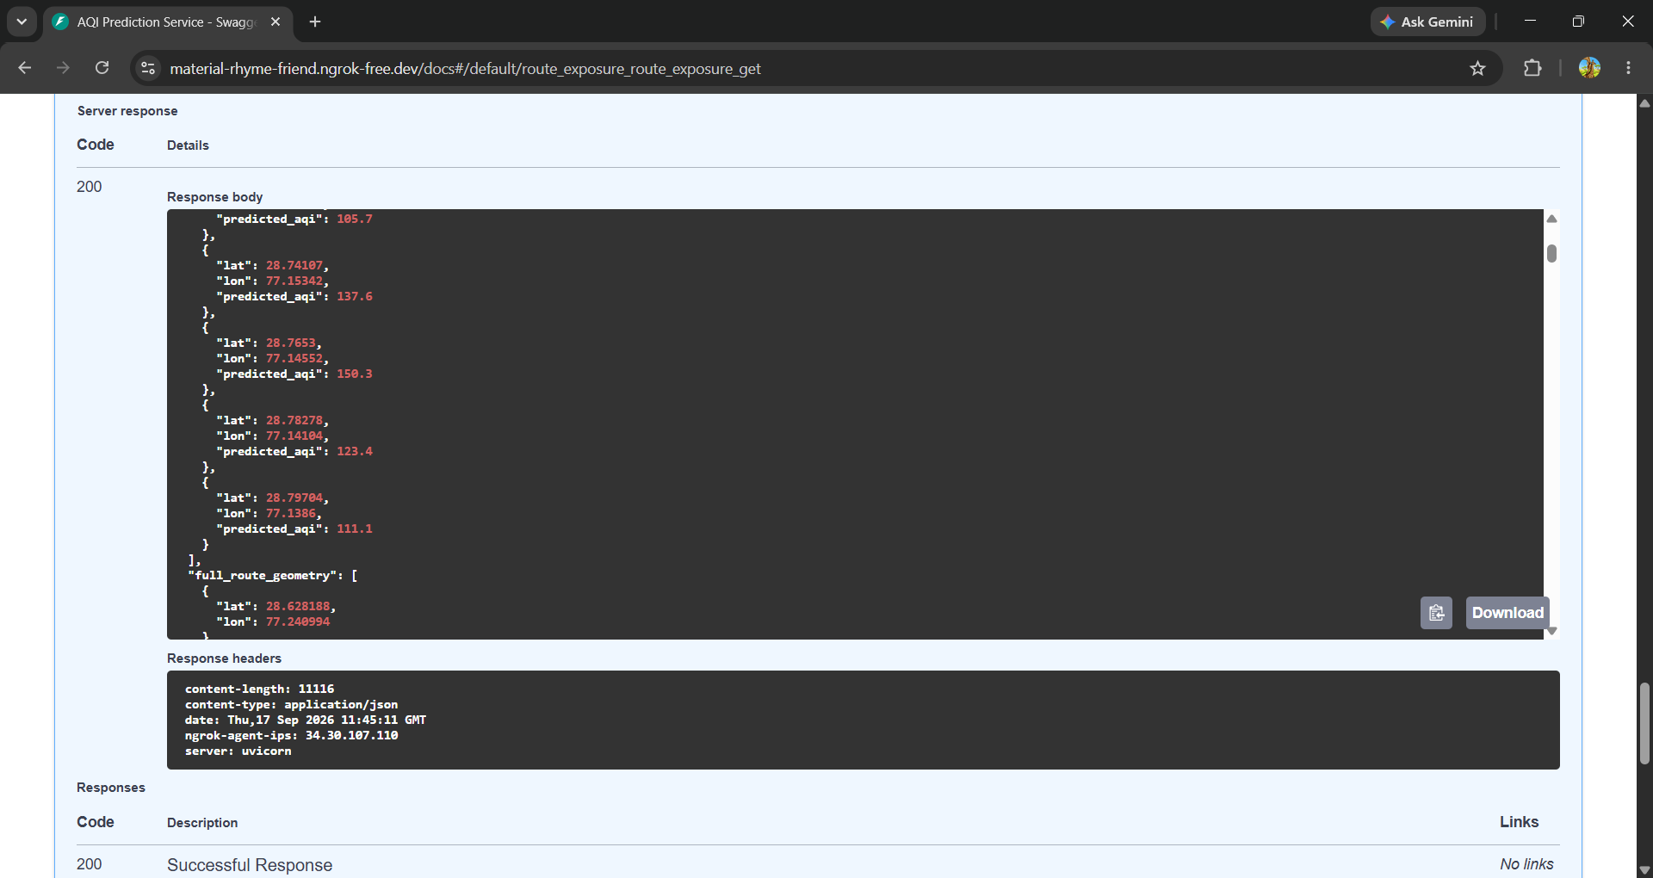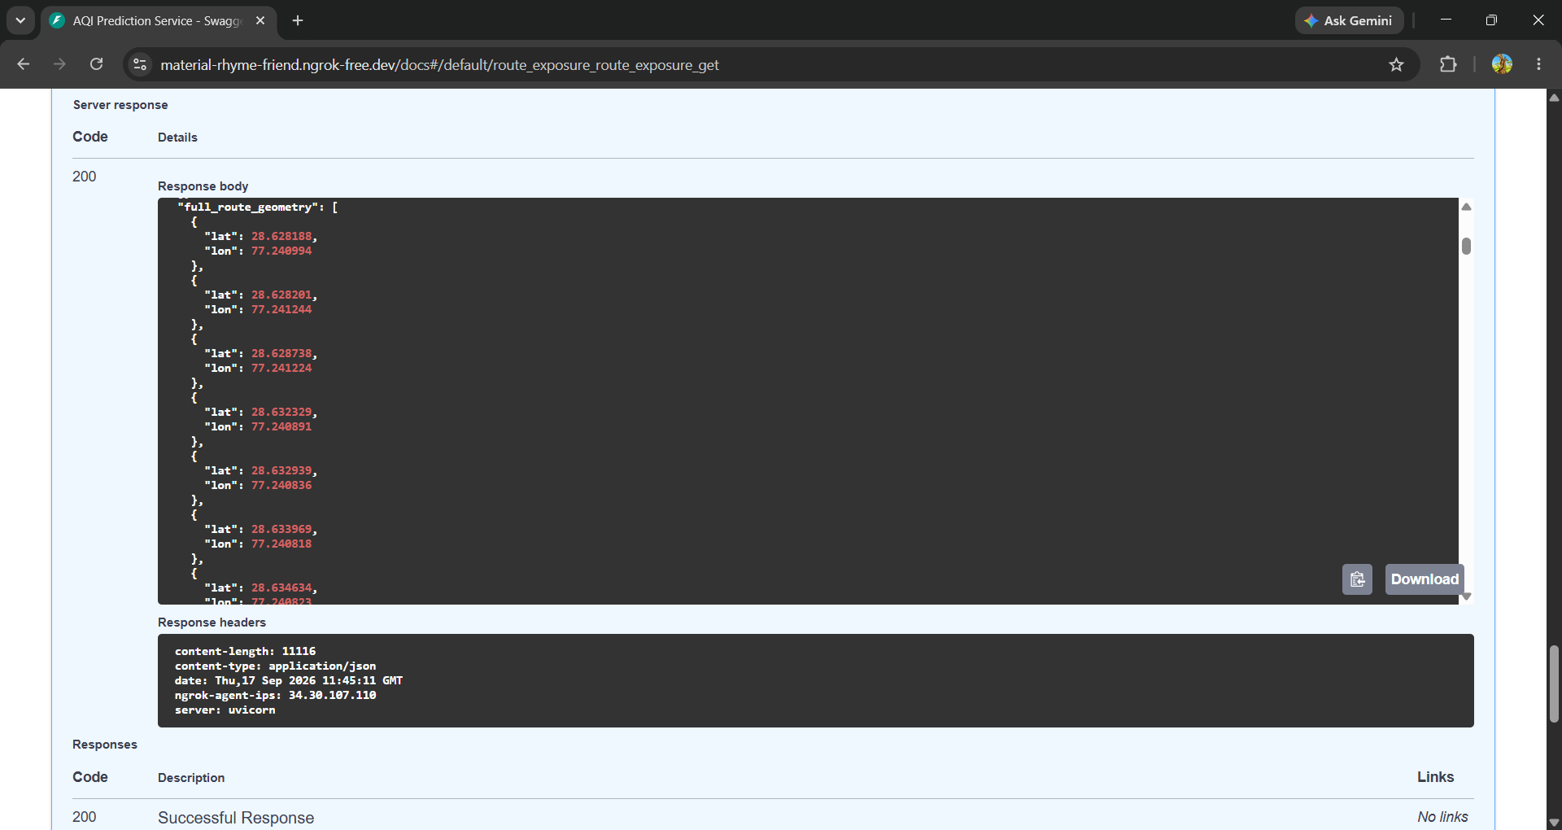
8. Weekly Retraining Pipeline
- Built a script that fine-tunes the existing model on new data batches rather than retraining from scratch
- Evaluates the model before and after fine-tuning, and refuses to overwrite the live model if the update performs worse — a real safety check
- Logs every retraining attempt with before/after accuracy for traceability
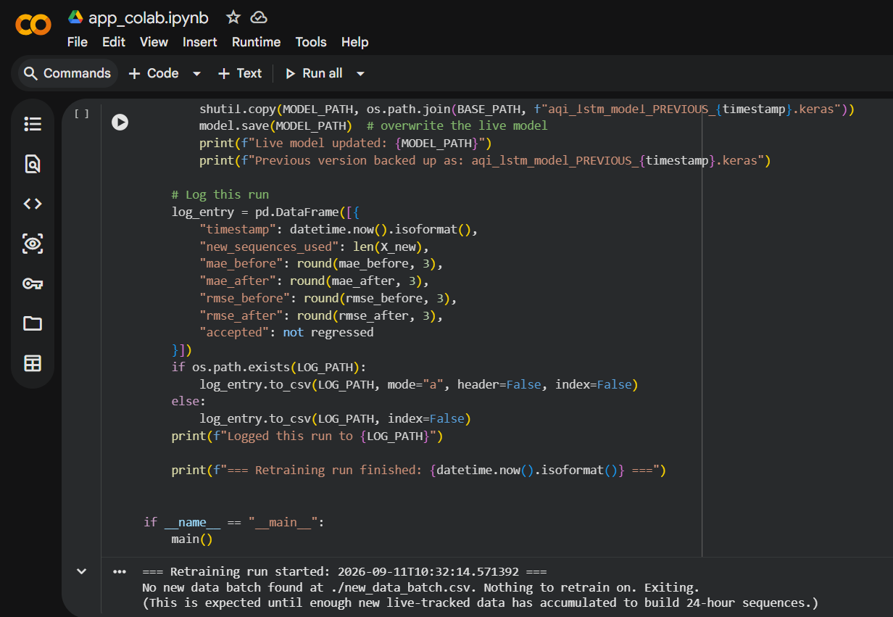
9. Web Frontend (React + Leaflet.js)
A working dashboard connecting to the live backend, built with React and an interactive Leaflet.js map:
- Check-location mode: search by place name, use current GPS location, or click the map to get a live AQI estimate at any point in Delhi
- Route-planning mode: pick a start and destination (search, current location, or map click) and see the real driving route drawn on the map, colored by predicted AQI at each sampled point, with distance, duration, traffic level, and weather
- Age-group personalization: users select Infant / Child / Adult / Elder — the app applies real public-health AQI thresholds and surfaces a tailored advisory
- An optional free-text health note that adds context to the advisory when air quality is a concern
- Location search powered by free OpenStreetMap geocoding (Nominatim) — no paid API required

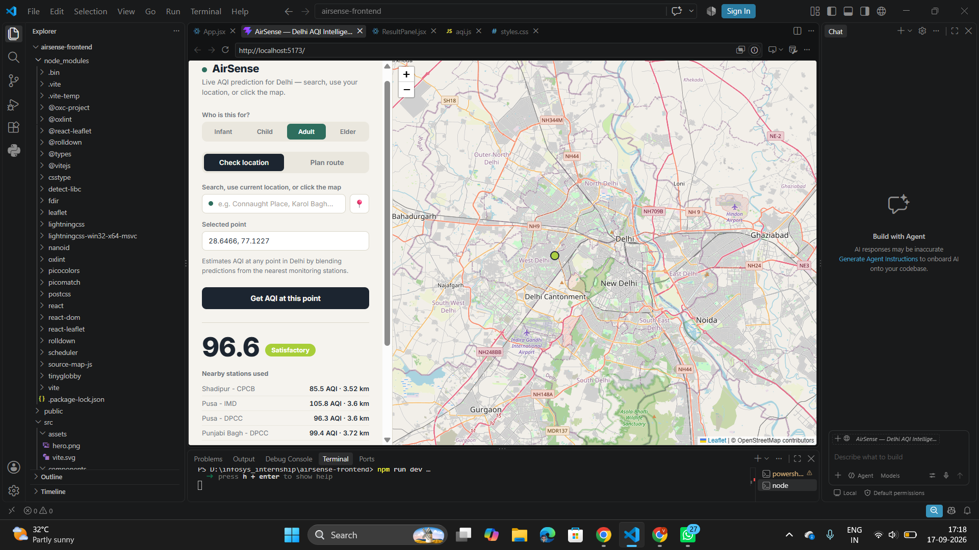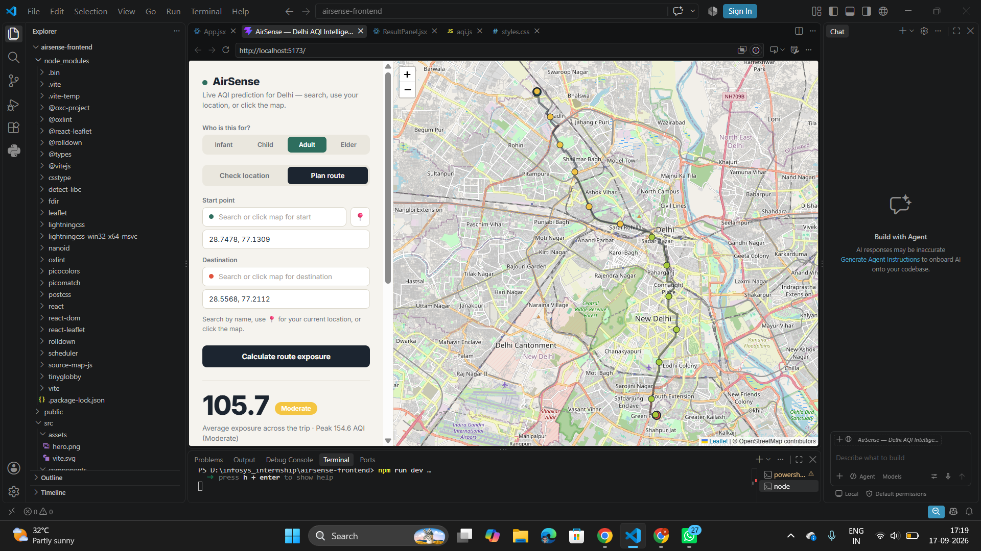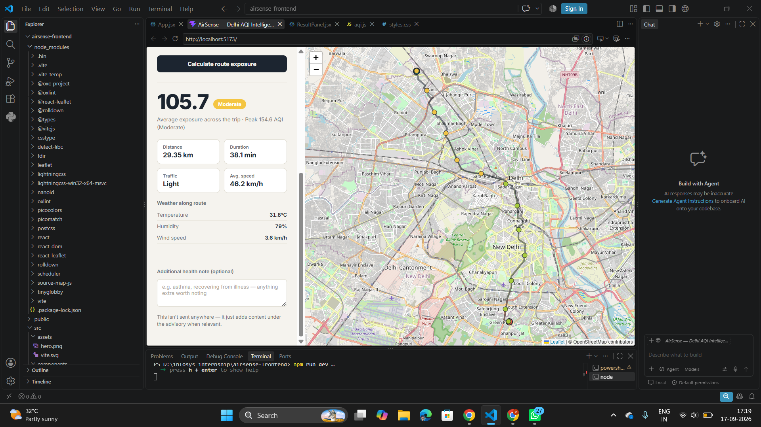

Vaishnavi R Honnagudi

