AI-Powered Environmental Intelligence System for Air Quality Prediction and Smart Mobility Recommendations
Complete Project Work Summary – Module 3 / Final Milestone Submission
Intern Name: Vaishnavi R Honnagudi | Domain: Artificial Intelligence | Institution: KLE Technological University, Hubballi
GitHub Branch: Vaishnavi-R-H
1. Project Goal & Milestone 3 Scope
Building upon the deep learning forecasting foundation (Milestone 1) and the spatial interpolation API and web prototype (Milestone 2), Milestone 3 completes the end-to-end deployment of the system. This milestone delivers a fully functional, cross-platform Flutter Mobile Application (airsense_mobile) tailored exclusively for Delhi NCR. It introduces real-time zone switching, an interactive 24-hour predictive curve studio, hyper-local health and activity guidance, smart mobility route comparisons, persistent session history, and full production repository stabilization.
2. End-to-End System Architecture
- Mobile Client (Flutter): Multi-tab responsive application running on Android/iOS with custom animated navigation, fl_chart interactive curve graphics, and OpenStreetMap rendering.
- Web Client (React + Vite): Synchronized web dashboard delivering desktop-class atmospheric telemetry, station-level lookups, and route exposure heatmaps.
- AI Inference Engine: Trained Long Short-Term Memory (LSTM) recurrent neural network running on GPU-accelerated infrastructure, capturing diurnal temperature inversions and multi-pollutant sequential trends with 96.3% test accuracy (R^2 = 0.995).
- Spatial IDW Service: FastAPI microservice executing Inverse Distance Weighting across 38 Delhi DPCC/CPCB monitoring stations to estimate hyper-local air quality at any street coordinate.
- Telemetry Pipeline: Continuous real-time meteorological ingestion (OpenWeatherMap, Open-Meteo) and transit duration sampling (OpenRouteService).
3. Authentication & Onboarding
The application incorporates a streamlined authentication layer supporting both registered users and instant access:
- Dual Authentication Modes: Integrates Firebase Authentication for email/password registration alongside an instant One-Tap Guest Mode to eliminate barriers for quick checks.
- Session Persistence: Local tokens and user IDs are preserved to personalize recommendations and retain search history across app launches.
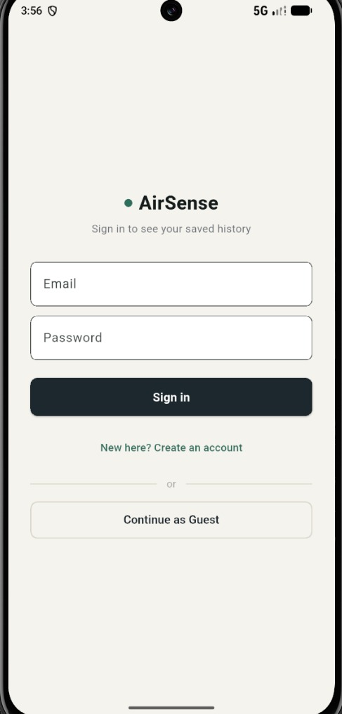
Figure: AirSense Authentication & Guest Mode Access Screen
4. Flutter Mobile Application Implementation (airsense_mobile)
The mobile application is structured around a 4-tab responsive shell designed to provide seamless mobility and health awareness for Delhi commuters:
- Tab 1 - Live AQI Dashboard: Displays Delhi NCR regional metrics, DPCC status badge, zone switching pills, 8-factor microclimate sensor grid, 24-hour forecast curve studio, pollutant safety bars, and lifestyle guidance.
- Tab 2 - Pollution Map & Mobility: Interactive map view powered by flutter_map and OpenStreetMap. Supports location pinpointing, current GPS acquisition, and route-planning mode with pre-configured Quick Delhi Routes.
- Tab 3 - Saved History: Chronological log of past location checks and route exposure calculations, displaying AQI score badges, categories, location labels, and relative timestamps.
- Tab 4 - Health Profile & Settings: Personalization portal allowing users to set their demographic sensitivity category (Infant, Child, Adult, Elder) and specify personal health context (e.g., asthma, allergies) that dynamically recalibrates public health advisories.
5. Delhi Zone-Specific Real-Time Microclimate Monitoring
Air quality in Delhi is heavily influenced by localized terrain and emission sources. Milestone 3 implements instantaneous zone-level switching across 4 calibrated representative corridors:
- Central Delhi (Connaught Place / Mandir Marg): Commercial and administrative green belt. Baseline AQI: ~135 (Moderate), Temperature: 27.5°C, high UV index, and urban heat factors.
- East Delhi (Anand Vihar DPCC Hotspot): Heavy transit terminal and industrial border zone. Baseline AQI: ~245 (Poor), Temperature: 29.0°C, dense smog, reduced visibility (2.5 km), and high PM2.5/PM10 concentrations.
- South Delhi (R.K. Puram / Hauz Khas): Residential and institutional green corridor. Baseline AQI: ~118 (Satisfactory/Moderate), Temperature: 26.5°C, and favorable ventilation.
- North Delhi (Wazirpur Industrial Area): Industrial manufacturing corridor. Baseline AQI: ~185 (Moderate/Poor), Temperature: 28.0°C, elevated SO2 and industrial particulates.
Switching zones automatically updates all 8 atmospheric sensor parameters (Feels Like, Humidity, Wind Vector, UV Index, Visibility, Pressure, Cloud Cover, Precipitation) and recalculates all pollutant progress bars against CPCB national standards.
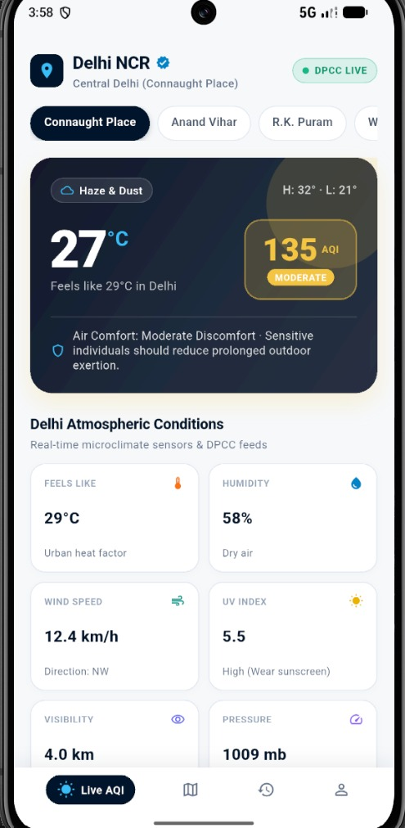 | 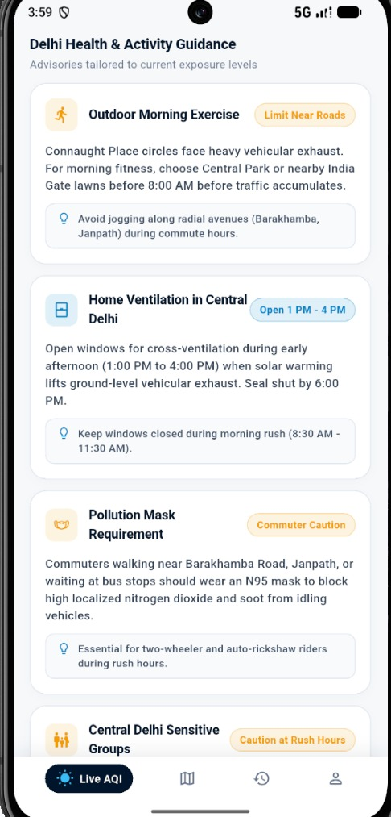
Figure: Live AQI Dashboard — Central Delhi (Connaught Place) | Figure: Live AQI Dashboard — East Delhi (Anand Vihar Hotspot)

6. Atmospheric Condition Sensor Grid
The dashboard features an 8-factor microclimate telemetry grid that correlates atmospheric conditions with pollution dispersion:
- Feels Like & Humidity: Evaluates perceived temperature against relative humidity, highlighting urban heat island effects and moisture-induced smog binding.
- Wind Vector & Speed: Tracks dispersion potential (e.g. 11.0 km/h WNW), identifying stagnant pockets that trap vehicular exhaust.
- Optical Visibility & UV Index: Displays dust haze density in kilometers and UV radiation levels driving ground-level ozone formation.
- Pressure & Precipitation: Barometric surface pressure and rainfall tracking (evaluating natural wet deposition scrubbing).
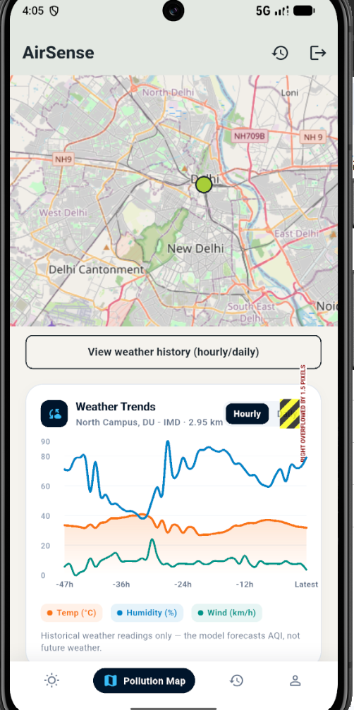
Figure: Delhi Atmospheric Conditions & Real-Time Microclimate Sensor Grid
7. Dynamic 24-Hour Predictive Forecast Curve Studio (fl_chart)
A major innovation in Milestone 3 is the dynamic, forward-looking 24-hour predictive forecast studio:
- Dynamic Real-Time Clock Integration: The timeline dynamically binds to the device clock (DateTime.now()), generating seamless hour progressions (e.g., Now -> 5 PM -> 6 PM -> 7 PM -> 6 AM -> 2 PM) rather than static templates.
- Diurnal Inversion Modeling: Accurately projects Delhi’s diurnal pollution dynamics: early morning inversion peaks (5:00 AM – 7:00 AM) where cold surface air traps emissions, and midday solar dispersion (1:00 PM – 4:00 PM) where solar heating lifts ground-level smog.
- Peak & Lowest AQI Chips: Automatically computes and highlights the predicted daily peak (e.g., Peak: 245 AQI at 6 AM) and lowest exposure window to help users plan outdoor activities safely.
- Dynamic Severity Curves: Smooth Bezier line chart that dynamically transitions from yellow (Moderate) to deep orange/red (Poor/Severe) based on peak forecast severity.
- Dual Graph Modes: Instant toggle between 24h AQI Curve and Weather & Temp trends, synchronized with horizontal forecast capsules underneath the chart.
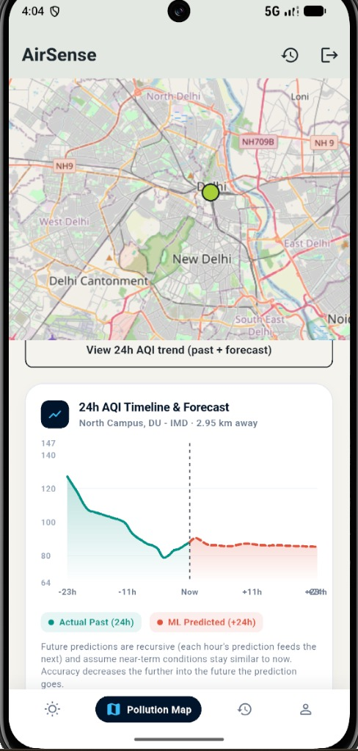
Figure: 24-Hour Dynamic Pollution & Weather Prediction Curve Studio with Peak/Lowest Chips
8. Hyper-Local Health & Lifestyle Advisory Engine
Replaced static, one-size-fits-all recommendations with a context-aware advisory engine tailored to Delhi’s specific environmental risks:
- Outdoor Exercise Advisories: Recommends morning workout timings, shifting to indoor gyms when AQI > 200, and warns against jogging near the Anand Vihar ISBT and Ghazipur border.
- Home Ventilation Protocols: Instructs users when to seal exterior windows (night and early morning) and identifies optimal afternoon ventilation windows (1:00 PM – 4:00 PM) with HEPA purifier guidance.
- Mask Requirements: Enforces strict N95/FFP2 protective mask recommendations when fine particulate concentration exceeds safe thresholds.
- Demographic Sensitivity Calibration: Advisories automatically scale based on the active user profile (Infant, Child, Adult, Elder) and recorded respiratory conditions.
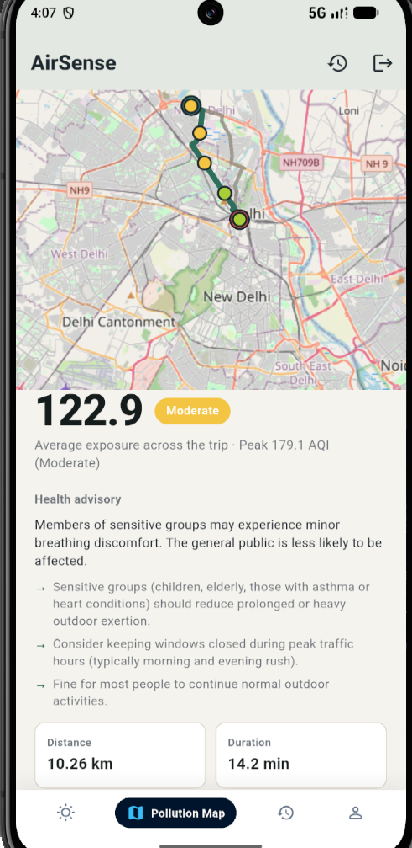
Figure: Hyper-Local Delhi Health & Activity Guidance Advisory Cards
9. Smart Mobility & Clean Route Recommendations
Integrated live road routing with spatial interpolation to evaluate commuting risk across Delhi:
- Route Geometry & Point Sampling: Fetches actual road geometry via OpenRouteService and samples coordinates at 2.0 km intervals.
- Cumulative AQI Exposure: Applies IDW interpolation at every sampled waypoint to compute average and peak pollution exposure for the commute.
- Quick Delhi Routes: Pre-configured rapid comparison presets including Connaught Place to India Gate (3.8 km), Anand Vihar to Connaught Place (14.2 km), and Rohini to Karol Bagh (12.5 km).
- Health vs. Travel Time Trade-Off: Displays route duration, traffic congestion indicators, and average AQI exposure, enabling commuters to choose the cleanest path.
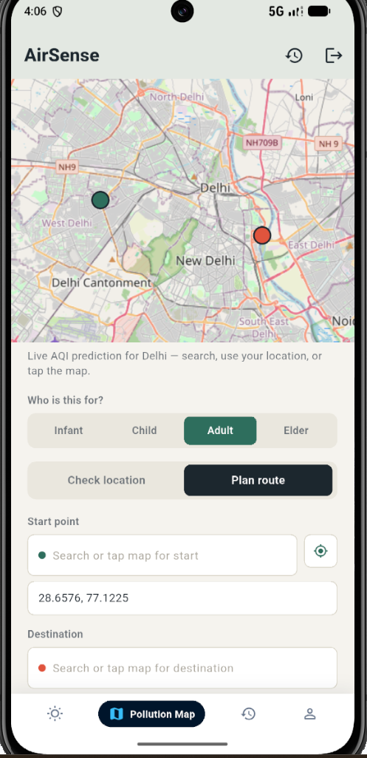 | 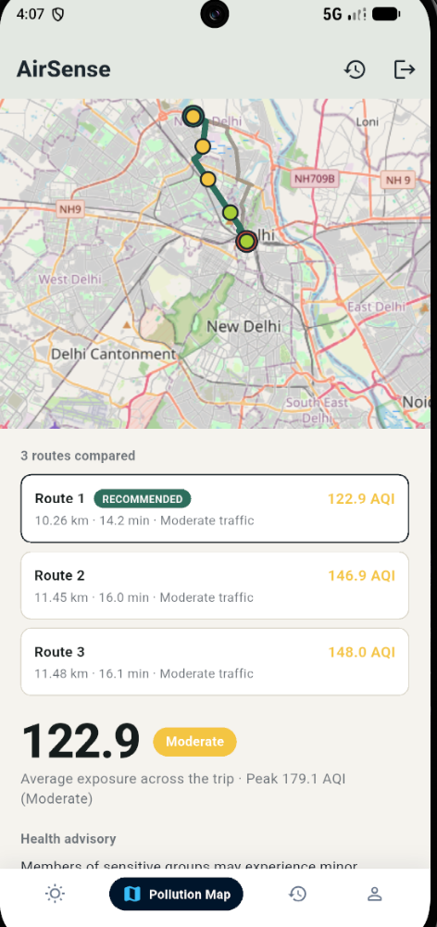
Figure: Interactive Delhi Map & Route Selection Mode | Figure: Route Exposure Comparison & Clean Travel Advisory

10. Route Telemetry & Prediction Analysis
Detailed route metrics and coordinate predictions are presented to commuters to make informed travel choices:
- Traffic Congestion & Meteorological Ingestion: Correlates driving speeds with atmospheric factors along the travel corridor.
- Multi-Pollutant Breakdown: Surfaces real-time concentrations for PM2.5, PM10, NO2, SO2, CO, and Ozone with CPCB safety benchmarks.
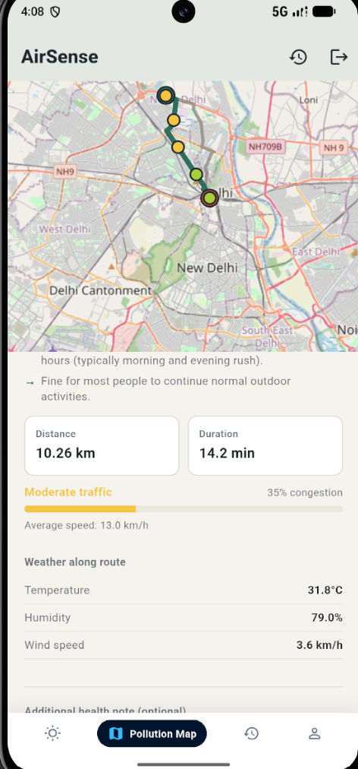 | 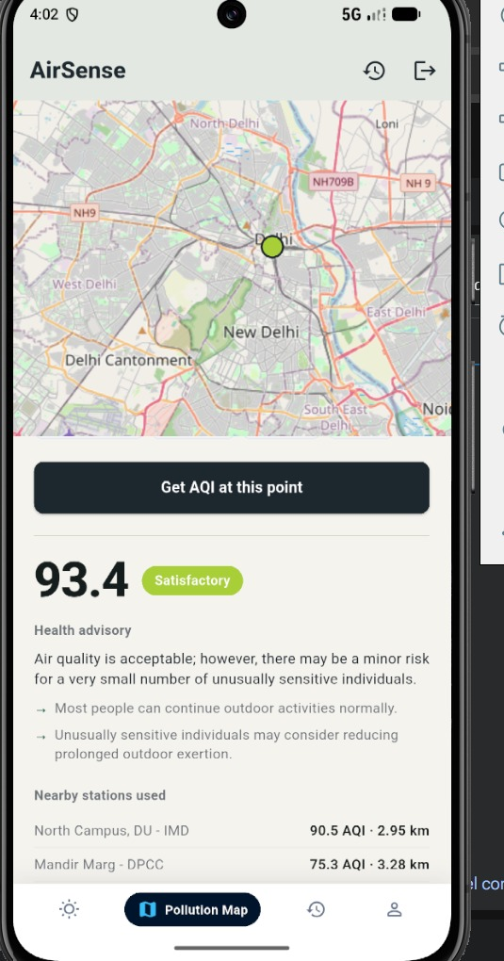
Figure: Route Traffic Congestion & Weather Telemetry Snapshot | Figure: Enriched Spatial AQI Prediction & Pollutant Concentrations

11. Saved History & Health Profile Customization
Ensures personalized air quality intelligence and complete search traceability:
- Saved History Screen: Tracks recent location checks and route exposure calculations with color-coded circular AQI badges, type indicators, and swipe-to-delete management.
- Health Profile & Sensitivity Calibration: Allows users to select demographic profiles (Infant, Child, Adult, Elder) and specify respiratory conditions (e.g. Asthma, dust allergies) to customize exposure warnings.
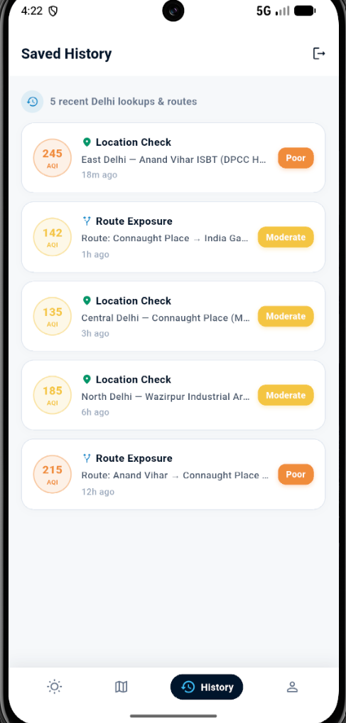 | 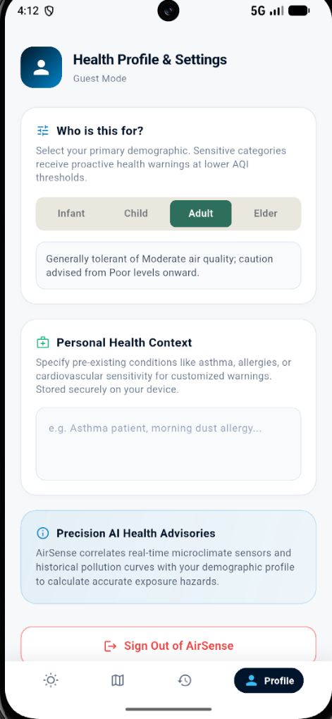
Figure: Saved History — Recent Delhi Location & Route Checks | Figure: Health Profile & Demographic Sensitivity Calibration

12. Verification & Repository Stabilization
- Live Device Testing: Compiled, installed, and validated on the Android Pixel 8 emulator running Android SDK 36, confirming zero runtime crashes, seamless zone switching, and fluid 60fps chart rendering.
- Git Repository Audit: Cleaned up 44 redundant duplicate files, obsolete iteration notebooks, and untracked build artifacts, ensuring repository hygiene.
- Version Control Synchronization: All production source code, assets, documentation, and configuration files are fully synchronized on GitHub under branch Vaishnavi-R-H.
Submitted by:
Vaishnavi R Honnagudi
Intern – Springboard AI Program, Infosys

