Donation Tracking System Project

Donation Tracking System Project

# Abstract

The Donation Tracking System is a Salesforce-based application designed to manage and track multiple types of donations such as Money Donations, Blood Donations, and Item Donations. The system provides a centralized platform for donors and administrators to record, monitor, and analyze donation activities, ensuring transparency and efficiency. Key features include donor information management, donation tracking, automated thank-you emails, and consolidated reporting.

The **Donation Tracking System** is a cloud-based application developed on the Salesforce platform to streamline and manage different types of donations, including **Money Donations, Blood Donations, and Item Donations**. The primary goal of this system is to provide a unified platform where donors, organizations, and administrators can efficiently track, manage, and analyze donation activities.

The system addresses the common challenges faced by organizations in tracking multiple types of donations, ensuring transparency, accountability, and ease of access. It eliminates the need for manual records, thereby reducing errors and improving efficiency.

The project is implemented in **multiple phases**, beginning with requirement gathering and custom object creation, followed by the creation of relationships, page layouts, automation using **flows**, and consolidated reporting of all donations. The system further enhances user experience by enabling **filters** based on donor name or contact information and providing **list views** to track individual contributions.

To present all donations in a single view, the project integrates donations into a **combined tracking page** using **Lightning App Builder** and **Visualforce pages**. This allows organizations to monitor donations holistically, while donors can track their individual contributions securely.

Key features include:

* Custom objects for **MoneyDonation, BloodDonation, and ItemDonation**.
* **Fields** for capturing essential donor details such as donor name, age, contact information, donation type, donation date, and status.
* **Flows and automation** to update records and manage donation lifecycles.
* **Combined donation tracking page** for viewing all donations in a single interface.
* **List views and filters** to enable donors to view their own contributions.
* Support for transparency by linking donations with **campaigns** and generating simple reports.

This project demonstrates how Salesforce can be leveraged for **social impact applications** beyond traditional CRM. It showcases the flexibility of Salesforce customization, automation, and reporting capabilities to build a solution that helps NGOs, hospitals, and charitable organizations manage donations more effectively.

The Donation Tracking System is designed with scalability and extensibility in mind, allowing future enhancements such as **integrating payment gateways**, **sending automated receipts**, and **advanced analytics for donor engagement**. By providing a centralized, automated, and user-friendly system, the project ultimately contributes to fostering trust and encouraging more participation in charitable activities.

# Objectives

The primary objectives of the **Donation Tracking System** are:

1. **Centralized Donation Management**
   * To create a unified platform for managing different types of donations: **Money, Blood, and Item donations**.
2. **Efficient Donor Tracking**
   * To store and track detailed donor information such as **name, age, contact details, donation type, and status**.
   * To allow filtering of records by **donor name or contact info** for personalized donor history.
3. **Automation of Processes**
   * To use **Salesforce Flows** and automation tools to handle record creation, status updates, and workflows without manual effort.
4. **User-Friendly Donation Forms**
   * To design **forms and page layouts** that simplify the process of capturing donation details while ensuring data accuracy.
5. **Transparency and Accountability**
   * To provide organizations with accurate, real-time tracking of donations to build donor trust and transparency.
6. **Unified Tracking Page**
   * To create a **combined donation tracking page** that consolidates Money, Blood, and Item donations in one place using **Lightning App Builder** and **Visualforce pages**.
7. **Donor-Specific Views**
   * To enable **list views and filters** that allow donors to easily view their own donations securely.
8. **Integration with Campaigns**
   * To link donations with **campaigns** for better management and reporting of fundraising efforts.
9. **Scalability and Extensibility**
   * To design the system so it can be extended in the future with features like **payment integration, receipt automation, and analytics dashboards**.
10. **Support for NGOs and Social Impact**
    * To provide a cost-effective, cloud-based solution that helps **NGOs, hospitals, and charitable organizations** manage donations more efficiently and transparently.

# ****Introduction****

Donations play a vital role in supporting charitable organizations, non-governmental organizations (NGOs), and hospitals in achieving their social impact goals. Managing donations effectively is crucial to ensure transparency, accountability, and trust between

donors and organizations. Traditional methods of donation management, such as manual record-keeping or spreadsheets, are often inefficient, error-prone, and lack scalability.

To address these challenges, this project introduces a **Donation Tracking System** built on the Salesforce platform. The system is designed to streamline the collection, tracking, and management of different types of donations — **Money, Blood, and Item donations** — within a centralized cloud-based application.

The Donation Tracking System not only enables organizations to capture donor details and donation information but also allows **real-time monitoring of donation status** (e.g., Pledged, Processing, Completed). It ensures that donors can view their contributions securely and that administrators can track and manage campaigns effectively.

The system leverages **Salesforce features** such as **custom objects, fields, list views, Visualforce pages, and Lightning App Builder**, along with **Flows for automation**, to create a user-friendly and efficient donation management platform. By combining all donations into a single interface, the system enhances transparency and provides organizations with better insights into donor behavior and campaign success.

This project serves as a practical solution for organizations to modernize their donation processes while maintaining scalability, efficiency, and transparency.

PROCEDURE :

# Phase 1 – Requirement Gathering

During this phase, the project scope was defined. The requirement was to build a system that supports three types of donations (Money, Blood, Item). Donor details, donation date, status, and additional fields like payment mode, purpose, and item type were identified as necessary. Additionally, the need for thank-you email automation and a tracking interface for donors was established.

**1. Goal of Phase 1**

Define scope and produce a clear, testable specification so design/development (objects, pages, automation) can proceed without ambiguity.

**Primary functional goal:** Build a Salesforce donation system that supports **Money**, **Blood**, and **Item** donations, lets donors submit records and track them, and automates acknowledgements and status updates.

**2. Stakeholders (who we interviewed / must satisfy)**

* Project owner / Sponsor (you)
* Donor-facing staff / volunteer coordinator
* Finance/accounting contact (money donations & receipts)
* Medical staff (blood donation requirements)
* Logistics/operations (item pickup, quantity)
* Salesforce admin / platform owner
* End users (donors) — optional feedback later

**3. Discovery steps (what we did, step-by-step)**

1. **Kickoff meeting**
   * Clarified project objectives (capture donations, track status, automate thank-you emails).
   * Agreed scope: Money, Blood, Item donation objects + tracking page + flows.
2. **Interview domain SMEs**
   * For each donation type we asked:
     + What data must be captured?
     + What statuses and lifecycle steps exist?
     + Who receives emails and what should they contain?
     + Any regulatory/compliance fields required (e.g., blood group, donor age)?
3. **Process mapping**
   * Mapped the donor journey: Form → Record created → (optional) Admin verification → Status changes → Thank-you email → Final status = Completed.
   * Mapped internal workflows: payment confirmation, item pickup, blood testing.
4. **Existing system audit**
   * Checked if any existing objects, fields, list views or automations exist that we need to reuse.
   * Determined naming convention and record type strategy (if needed).
5. **Data model design**
   * For each donation type we defined necessary fields, required/optional flags, data types, lookup relationships.
6. **UX + page requirements**
   * Defined required Visualforce pages or Lightning pages (donation forms, combined tracking page, “Track my donations”).
   * Decided buttons/links placement on Home page.
7. **Automation requirements**
   * Defined flows: Thank-you email on creation, optional status-change flows, notifications to admins.
   * Decided trigger conditions (on create vs on update; optionally only when Status__c = Completed).
8. **Security and sharing**
   * Determined profiles permission: donors (portal users?) vs internal users.
   * Determined OWD settings for donation objects.
9. **Reporting requirements**
   * Defined required reports/list-views: donations by type, by status, by campaign, donor-level history.
10. **Acceptance criteria & test cases**
    * Wrote test scenarios to validate fields, forms, flows, and tracking page.
11. **Sign-off**
    * Stakeholder sign-off to proceed to design & implementation.

# Phase 2 – Salesforce Org Setup

**Step 1: Salesforce Org Creation**

* Signed up for a **Salesforce Developer Org** (free) from developer.salesforce.com.

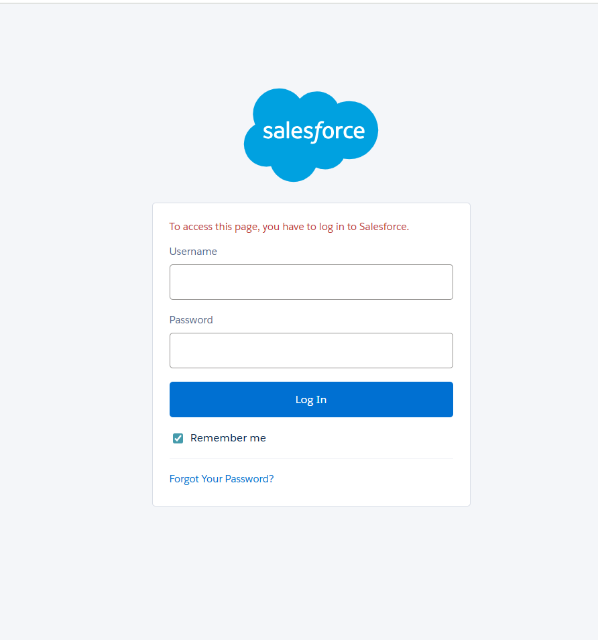

* Logged into the new org to start customizing.

# Phase 3 – Custom Object & Field Creation

# Custom objects were created in Salesforce:

• Money_Donation__c

Fields: Donation Name, Donor_Name__c, Amount__c, Donation_Date__c, Purpose__c, Payment_Mode__c, Transaction_Ref__c, Campaign__c, Status__c

• Blood_Donation__c

Fields: Donation Name, Blood_Donation_Name__c, Age__c, Blood_Group__c, Donation_Date__c, Contact_Info__c, Status__c

• Item_Donation__c

Fields: Donation Name, Donar_Namee__c, Item_Name__c, Item_Type__c, Quantity__c, Campaign__c, Status__c

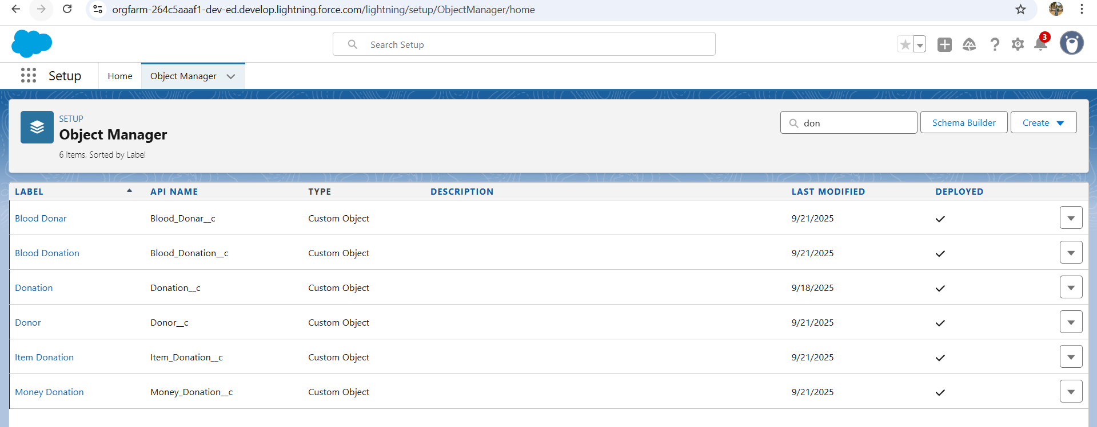

**Add Relationships**

* **Lookup fields** were added where required:
  + MoneyDonation → Campaign__c
  + ItemDonation → Campaign__c
  + BloodDonation → Donor reference (if needed)
* This allows donations to be connected with campaigns or donors.

**Page Layouts & Record Pages**

* Edited **Page Layouts** for each object to include:
  + Donation details (Name, Amount, Date, etc.)
  + **Status__c field**
  + Campaign lookup
* This ensures data entry is clear and structured.
* 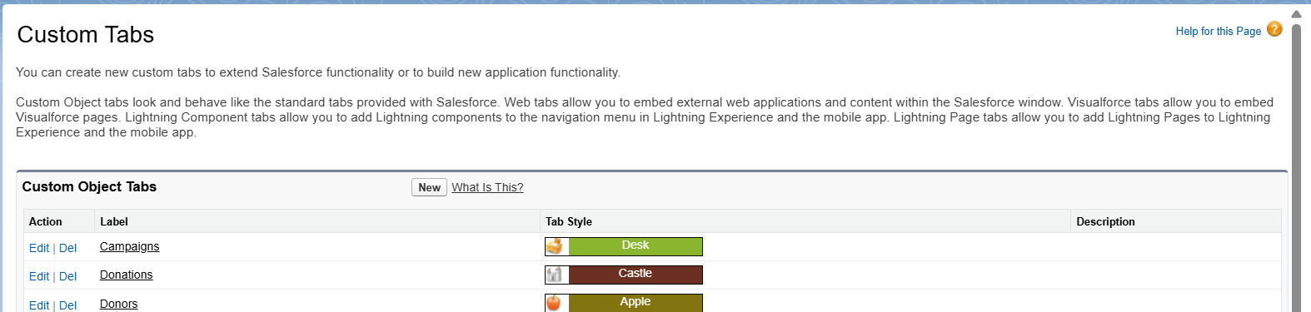

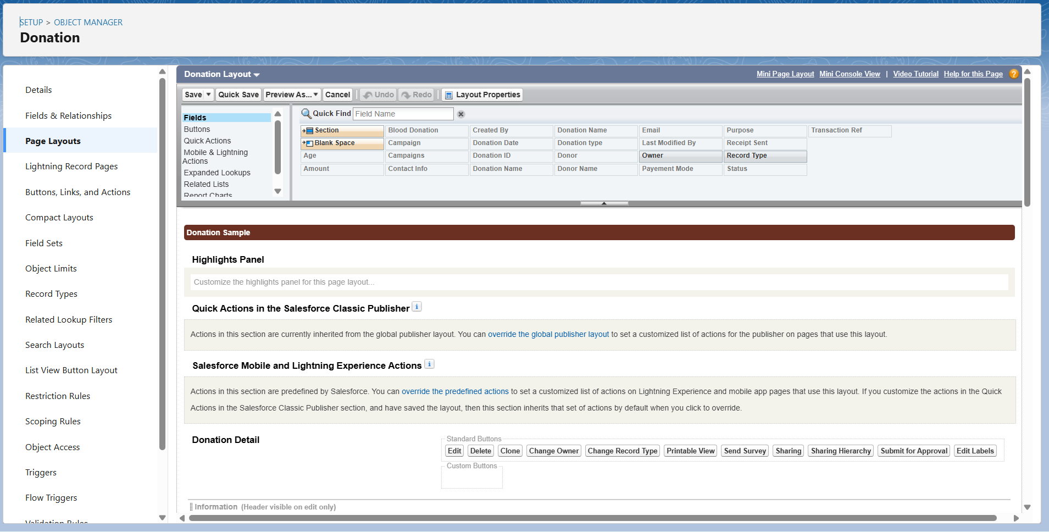

**Create List Views**

* For **Money_Donation__c, Blood_Donation__c, Item_Donation__c**:
  + Created list views such as:
    - *All Donations*
    - *My Donations* (filtered by Donor_Name__c or Current User)
  + Fields displayed in list views: Donation Name, Donor, Amount/Details, Date, and Status.

# Phase 3 – UI Development

Visualforce pages were developed for data entry and tracking. Custom buttons (Donate Money, Donate Blood, Donate Item) were added to the Home Page and objects to allow quick access to donation forms.

Visualforce Pages

**Donation_Home_Page**

<apex:page >

<h1 style="text-align:center; color:#2E86C1;">Welcome to NGO Donation Portal</h1>

<p style="text-align:center;">You can donate money, pledge blood, or donate clothes to support our causes.</p>

<div style="text-align:center; margin-top:20px;">

<a href="/donationform" style="margin-right:20px;">💳 Donate Money</a>

<a href="/blooddonationform" style="margin-right:20px;">🩸 Blood Donation</a>

<a href="/itemdonationform">👕 Clothes Donation</a>

</div>

</apex:page>

**Blood_Donation_Controller**

<apex:page controller="BloodDonationController">

<apex:form >

<apex:pageBlock title="🩸 Blood Donation Form">

<apex:pageBlockSection columns="1">

<!-- Blood Donor Name -->

<apex:inputText value="{!bloodDonation.Blood_Donar_Name__c}" label="Blood Donor Name" required="true"/>

<!-- Age -->

<apex:inputField value="{!bloodDonation.Age__c}" required="true"/>

<!-- Blood Group -->

<apex:inputField value="{!bloodDonation.Blood_Group__c}" required="true"/>

<!-- Contact Info -->

<apex:inputField value="{!bloodDonation.Contact_Info__c}" required="true"/>

<!-- Donation Date -->

<apex:inputField value="{!bloodDonation.Donation_Date__c}" required="true"/>

<!-- Submit Button -->

<apex:commandButton value="Submit" action="{!saveDonation}"/>

</apex:pageBlockSection>

</apex:pageBlock>

</apex:form>

</apex:page>

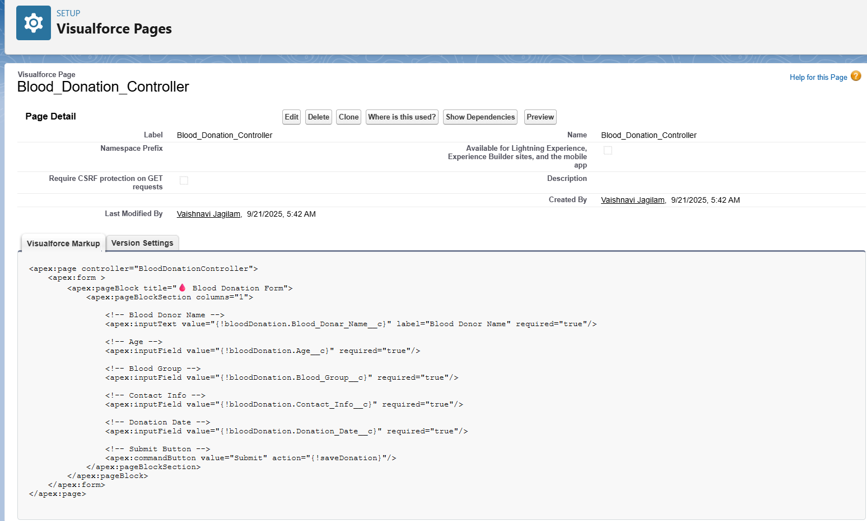

# Item_Donation_Controller

<apex:page controller="ItemDonationController">

<apex:form >

<apex:pageBlock title="👕 Item Donation Form">

<apex:pageBlockSection columns="1">

<!-- Donor Name -->

<apex:inputText value="{!itemDonation.Donar_Name__c}" label="Donor Name" required="true"/>

<!-- Email -->

<apex:inputField value="{!itemDonation.Email__c}" required="true"/>

<!-- Item Name -->

<apex:inputText value="{!itemDonation.Item_Name__c}" label="Item Name" required="true"/>

<!-- Item Type (Picklist) -->

<apex:inputField value="{!itemDonation.Item_Type__c}" required="true"/>

<!-- Quantity -->

<apex:inputField value="{!itemDonation.Quantity__c}" required="true"/>

<!-- Status (Picklist) -->

<apex:inputField value="{!itemDonation.Status__c}" required="true"/>

<!-- Submit Button -->

<apex:commandButton value="Submit" action="{!saveDonation}"/>

</apex:pageBlockSection>

</apex:pageBlock>

</apex:form>

</apex:page>

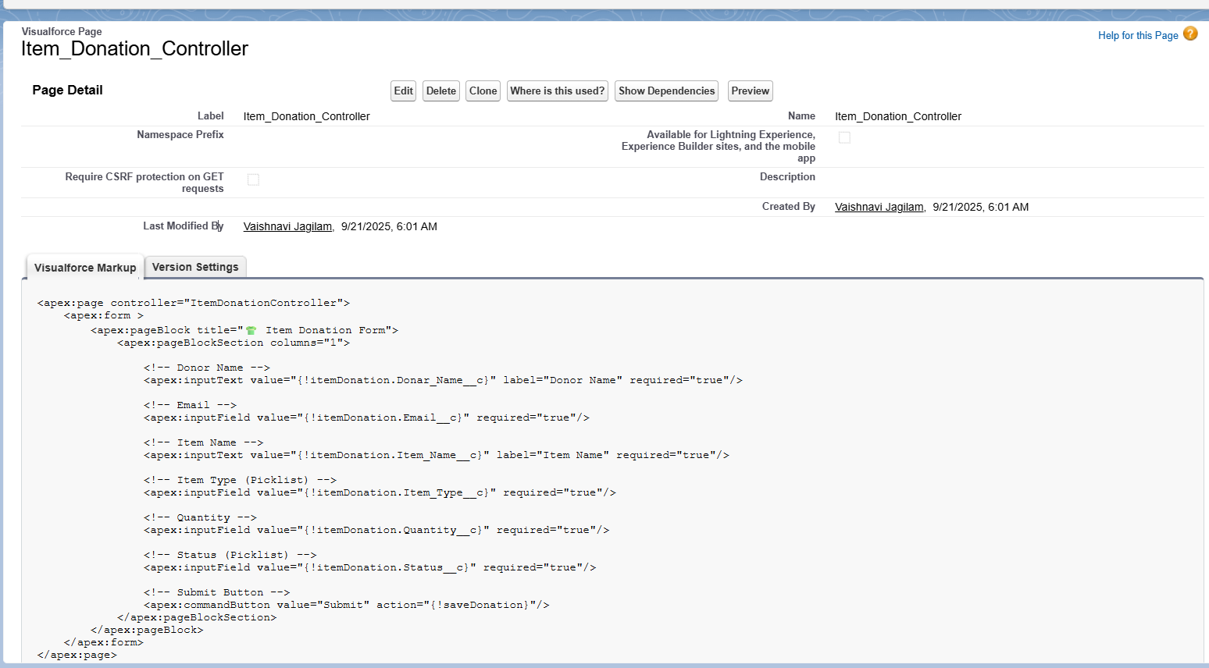

**DonationTrackingController**

<apex:page standardController="Donation__c" recordSetVar="donations">

<apex:form >

<apex:pageBlock title="All Donations">

<apex:pageBlockTable value="{!donations}" var="d">

<apex:column value="{!d.Name}"/>

<apex:column value="{!d.Donor_Name__c}"/>

<apex:column value="{!d.Amount__c}"/>

<apex:column value="{!d.Donation_Date__c}"/>

<apex:column value="{!d.Status__c}"/>

</apex:pageBlockTable>

</apex:pageBlock>

</apex:form>

</apex:page>

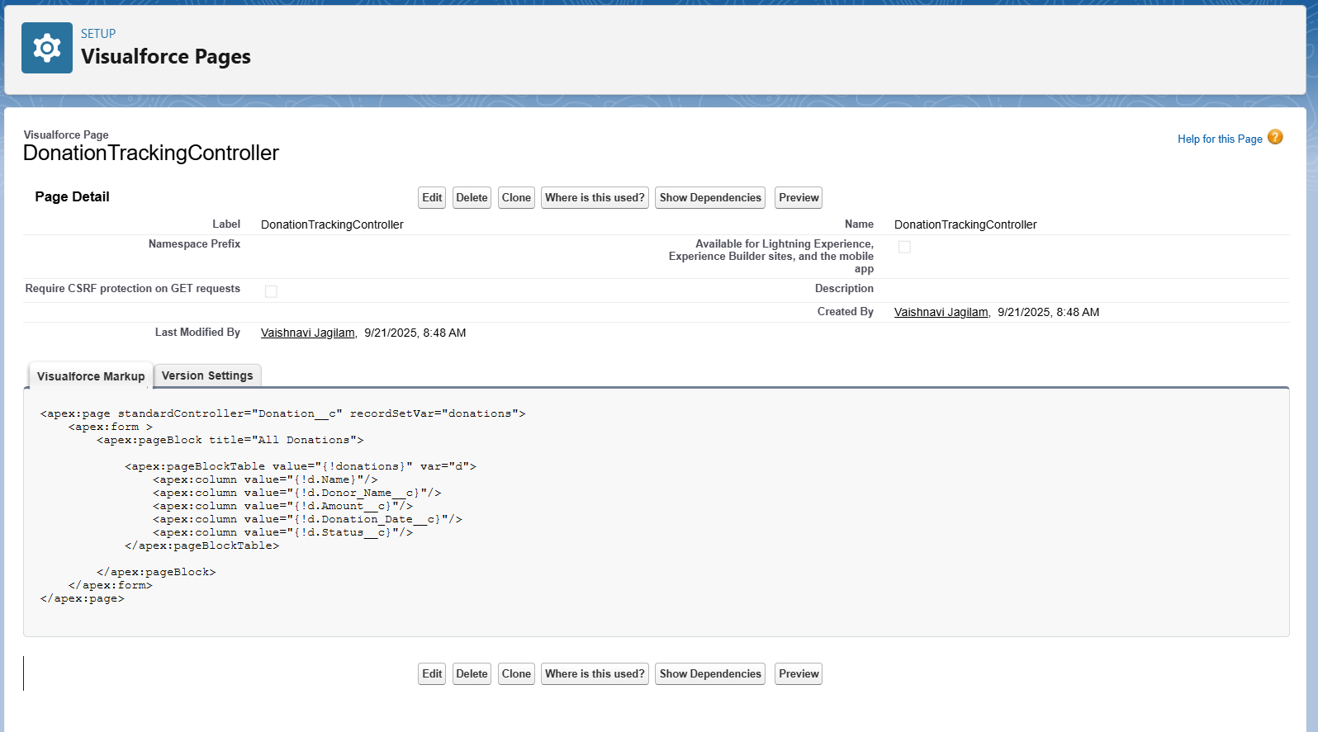

# Donation_Data_TableTop of Form

<apex:page >

<h1>Donation Tracking</h1>

<!-- Money Donations Table -->

<apex:pageBlock title="Money Donations">

<apex:enhancedList type="Money_Donation__c" height="300" rowsPerPage="10"/>

</apex:pageBlock>

<!-- Blood Donations Table -->

<apex:pageBlock title="Blood Donations">

<apex:enhancedList type="Blood_Donation__c" height="300" rowsPerPage="10"/>

</apex:pageBlock>

<!-- Item Donations Table -->

<apex:pageBlock title="Item Donations">

<apex:enhancedList type="Item_Donation__c" height="300" rowsPerPage="10"/>

</apex:pageBlock>

</apex:page>

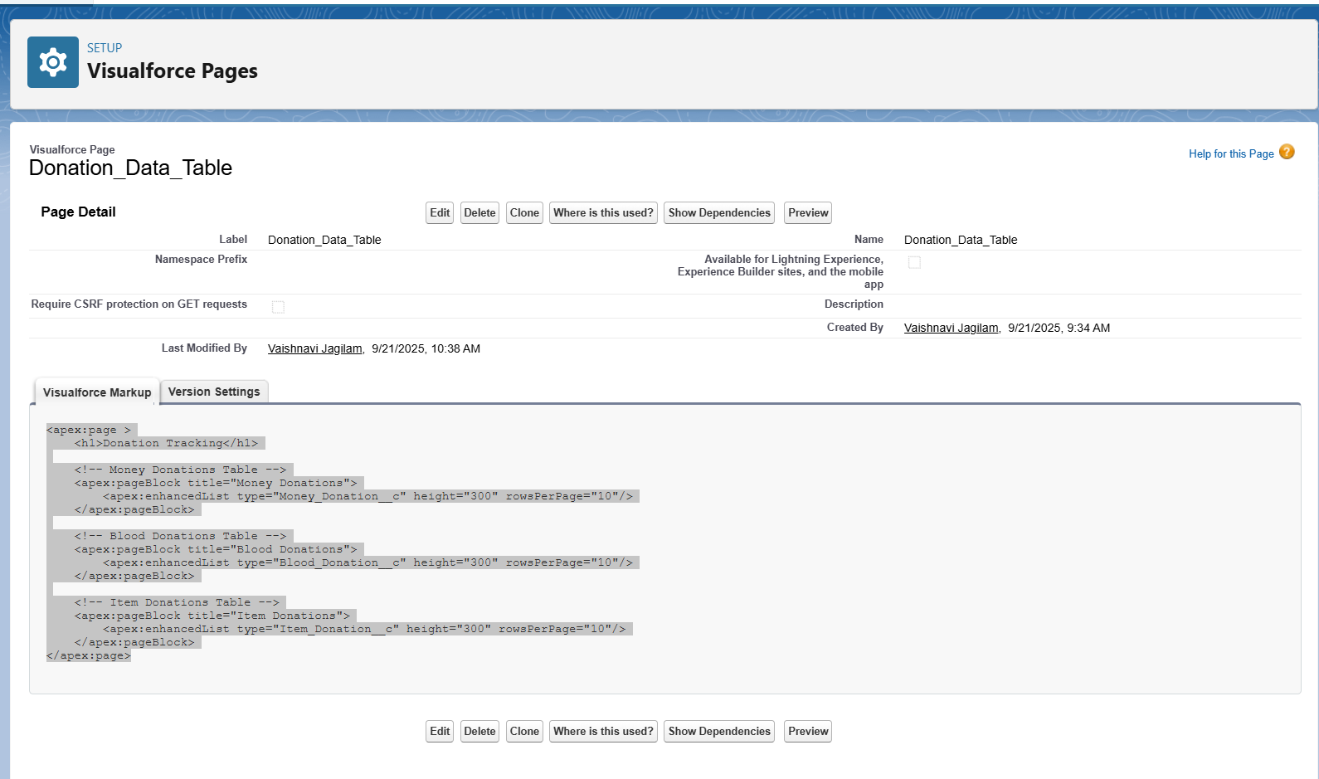

**CombinedDonationTrackingPage**

<apex:page >

<h1>Donation Tracking</h1>

<!-- Money Donations Table -->

<apex:pageBlock title="Money Donations">

<apex:enhancedList type="Money_Donation__c" height="300" rowsPerPage="10"/>

<!-- This will automatically show Donor_Name__c, Amount__c, Status__c, etc. -->

</apex:pageBlock>

<!-- Blood Donations Table -->

<apex:pageBlock title="Blood Donations">

<apex:enhancedList type="Blood_Donation__c" height="300" rowsPerPage="10"/>

<!-- This will automatically show Blood_Donation_Name__c, Age__c, Status__c, etc. -->

</apex:pageBlock>

<!-- Item Donations Table -->

<apex:pageBlock title="Item Donations">

<apex:enhancedList type="Item_Donation__c" height="300" rowsPerPage="10"/>

<!-- This will automatically show Donar_Namee__c, Item_Type__c, Status__c, etc. -->

</apex:pageBlock>

</apex:page>

# Donation_Tracking_Page

<apex:page showHeader="true" sidebar="true">

<apex:pageBlock title="Donation Tracking">

<!-- Money Donations Section -->

<apex:pageBlockSection title="Money Donations" columns="1">

<apex:enhancedList type="Money_Donation__c" height="300" rowsPerPage="10"/>

</apex:pageBlockSection>

<!-- Blood Donations Section -->

<apex:pageBlockSection title="Blood Donations" columns="1">

<apex:enhancedList type="Blood_Donation__c" height="300" rowsPerPage="10"/>

</apex:pageBlockSection>

<!-- Item Donations Section -->

<apex:pageBlockSection title="Item Donations" columns="1">

<apex:enhancedList type="Item_Donation__c" height="300" rowsPerPage="10"/>

</apex:pageBlockSection>

</apex:pageBlock>

</apex:page>

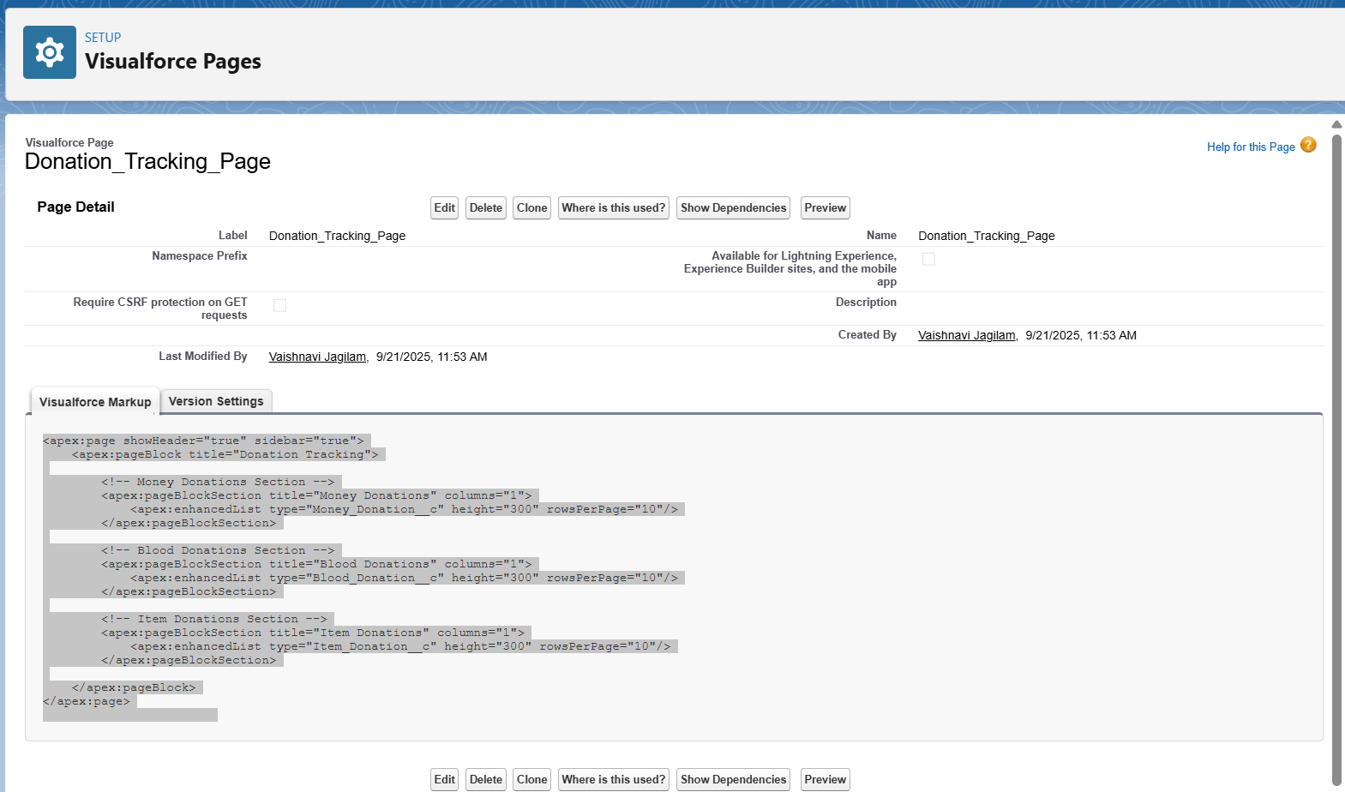

# Phase 4 – Tracking Donations

Tracking pages were created to display donations by donor. Initially, separate tables were created for Money, Blood, and Item donations using Visualforce enhanced lists. Later, a combined tracking page was implemented to display all donation types together.

# Phase 5 – Automation

1. Record-Triggered Flows were created for each donation object:

• On creation of a donation record, a Thank-You Email is automatically sent to the donor.

2. Status__c picklist field was added with values (Pledged, Processing, Completed).

3. Flows were configured to update status automatically when donations were confirmed.

Thankyou Email – Item Donation

Thankyou Email -Blood Donation

# Phase 6 – Filtering & List Views

Custom List Views were created for each donation object, allowing donors and admins to filter donations by Donor_Name__c or Contact_Info__c. This enabled quick access to personal donation history.

Donation Received

Form for Item Donations

Form for Blood Donation

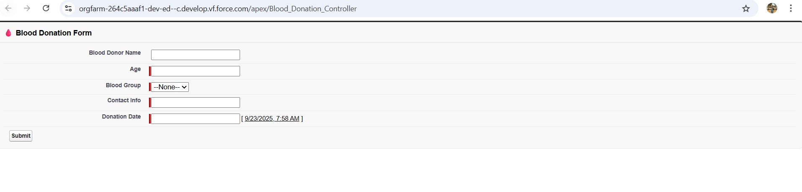

# Phase 7 – Deployment Readiness

All components were tested and validated, including Visualforce pages, Flows, a nd List Views. The project was prepared for deployment by ensuring that profiles, permissions, and page layouts were configured.

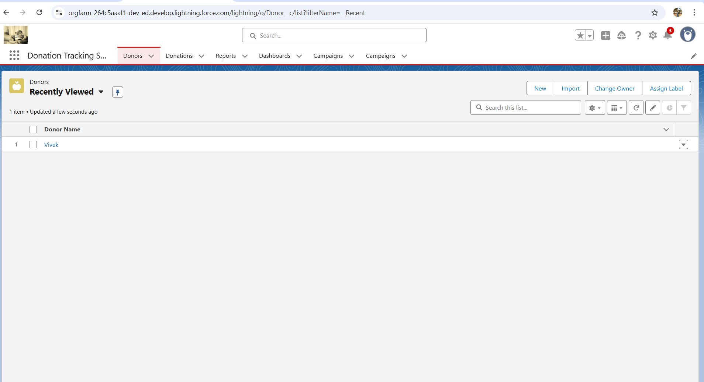

All Donations in One Page

The deployment phase ensures that the Donation Tracking System is successfully moved from the development environment into the production (live) Salesforce Org. This makes the solution available for end users (donors, admins, and campaign managers).

**Step 1: Pre-Deployment Preparation**

1. **Review Requirements**
   * Verified that all features (Money, Blood, Item donations, Thank-You Emails, Status Updates, Tracking Page) were implemented.
   * Ensured every object has the required fields (Donor Name, Amount, Date, Status, etc.).
2. **Testing in Developer Org**
   * Created sample records for all donation types.
   * Tested flows to confirm **emails were sent** and **statuses updated correctly**.
   * Checked List Views and Tracking Pages to ensure donors can see their donations.
3. **Data Backup**
   * Exported any test/sample data (if needed).
   * Ensured metadata and schema were safe before migration.

**Step 2: Migration to Production**

1. **Change Set Deployment (if using Sandbox)**
   * Created an **Outbound Change Set** in the sandbox/developer org.
   * Added Custom Objects, Fields, Flows, Visualforce Pages, and Page Layouts.
   * Uploaded the Change Set to the production org.
2. **Direct Development Org Deployment (if using Developer Org)**
   * Since we built in a **Developer Org**, no migration was needed.
   * This org itself serves as the **final deployment environment** for donors/admins.

**Step 3: Post-Deployment Setup**

1. **Assign Permissions**
   * Created **Profiles and Permission Sets** for different users:
     + **Donors** → Can create donation records and view their donations.
     + **Admins** → Full access to create, edit, and track all donations.
2. **Enable Email Deliverability**
   * Checked Setup → Deliverability → All Emails to ensure automated Thank-You emails are sent.
3. **Activate Flows**
   * Confirmed that all flows (Thank-You Email, Status Update) are activated in Production.

**Step 4: User Training**

1. Conducted **walkthroughs** with sample donors:
   * How to create a donation.
   * How to track donation status.
   * How to view campaigns and records.
2. **Admin training**:
   * How to monitor donations across objects.
   * How to update statuses manually if needed.

**Step 5: Go-Live**

* System was marked **live** after successful validation.
* Donors can now:
  + Submit donations (Money, Blood, Item).
  + Receive **Thank-You emails** automatically.
  + Track donation status on the **tracking page**.
* Admins can now:
  + Monitor all donations in one place.
  + Filter by donor name/contact info.
  + Update records and generate reports.

**Step 6: Post-Go-Live Support**

* Created a **support plan**:
  + Monitor for flow/email errors.
  + Fix issues if donors face trouble accessing donations.
  + Update picklist values/statuses if requirements change.

# Final Summary

The Donation Tracking System was successfully implemented in Salesforce across multiple phases. It supports Money, Blood, and Item donations with structured data management. Donors can track their contributions, receive automated thank-you emails, and view donation statuses. Administrators can analyze and filter donation data, making the system efficient, transparent, and user-friendly.

**Key Outcomes**

1. **Requirement Gathering**
   * Identified the need to manage three donation types: Money, Blood, and Item.
   * Defined essential fields like Donor Name, Donation Date, Amount, Item Type, Payment Mode, Purpose, and Status.
   * Planned automation for **Thank-You Emails** and **Donation Status Tracking**.
2. **Salesforce Org Setup**
   * Created a new Salesforce Org environment.
   * Enabled standard functionalities like **Email Deliverability**, **Profiles**, and **Page Layouts**.
   * Prepared the environment for development and deployment.
3. **Custom Object & Field Creation**
   * Developed three custom objects: **MoneyDonation__c**, **BloodDonation__c**, and **ItemDonation__c**.
   * Configured necessary fields for each donation type.
   * Linked donation records with donors and campaigns.
4. **Automation with Flows**
   * Designed **Record-Triggered Flows** to send **automated Thank-You emails** to donors after submission.
   * Configured **Status Updates** (Pledged → Processing → Completed).
   * Ensured donors and admins get real-time updates.
5. **Donation Tracking Interface**
   * Built **Visualforce Pages** and **Enhanced List Views** to display all donations.
   * Allowed **separate tables** for each donation type and an option to **combine all donations** on a single page.
   * Implemented filters by **Donor Name and Contact Info** for quick access.
6. **Deployment Phase**
   * Migrated solution to the Salesforce Org.
   * Assigned user permissions (Donor vs Admin).
   * Activated flows and confirmed email deliverability.
   * Conducted **user training** and finalized Go-Live.

**Benefits of the System**

* **For Donors**:
  + Easy submission of donations (Money, Blood, Item).
  + Real-time tracking of donation status.
  + Instant Thank-You email acknowledgments.
* **For Admins**:
  + Centralized monitoring of all donation types.
  + Ability to filter, verify, and manage records.
  + Automated processes reduce manual work.
* **For Organizations**:
  + Improved donor engagement and satisfaction.
  + Transparent tracking of donations.
  + Flexibility to expand for new donation types or campaigns.

**Conclusion**

The Donation Tracking System successfully addresses the challenges of managing multiple donation types within Salesforce. With custom objects, automation flows, and a tracking interface, the solution provides **efficiency, transparency, and donor satisfaction**. The project is now fully deployed and ready for real-time use.